Exercise 1

DIVERSITY AND ADAPTATIONS:
MARINE PHYTOPLANKTON

Members of the phytoplankton, tiny photosynthetic organisms that drift in the water, are significant primary producers in the open sea, responsible for nearly all of the photosynthesis in the ocean. They are actually responsible for about half of the primary production on earth and nearly half of the oxygen released into the atmosphere. Marine phytoplankton are also the first link in the food chains of the open sea (see chapter 15, "Life Near the Surface," in Marine Biology, Seventh Edition).

Marine phytoplankton belong to several groups of eukaryotic, single-cell organisms, and as such are members of the Protista. The marine phytoplankton contains chlorophyll. The type of chlorophyll as well as the storage products and the component of the cell wall vary among the different groups (see table 5.2 in Marine Biology, Seventh Edition).

The components of a particular sample of phytoplankton vary depending on geographic location, season of the year, and even depth. The most abundant species are typically included among two groups, the diatoms (division, or phylum, Bacillariophyta) and dinoflagellates (division, or phylum Dinophyta). Diatoms feature a cell wall made mostly of silica (see Fig. 5.6 in Marine Biology, Seventh Edition), whereas cellulose is the main component in dinoflagellates (see Fig. 5.8 in Marine Biology, Seventh Edition). Other groups of eukaryotic phytoplankton are silicoflagellates (division, or phylum Chrysophyta), coccolithophorids (division, or phylum Haptophyta), and cryptophytes (division, or phylum Cryptophyta) (see chapter 5, "The Microbial World" in Marine Biology, Seventh Edition).

Phytoplankton, like other members of the plankton, show several important morphological and ecological adaptations crucial in their survival (see "Living in the Epipelagic" in chapter 15, Marine Biology, Seventh Edition).

Objectives:

1. Recognize and distinguish some common representatives of the marine phytoplankton.

2. Consider some of the important morphological adaptations of the marine phytoplankton.

Materials:

1. Compound microscopes, slides, and coverslips

2. Prepared slides of representative phytoplankton

Notes to the Instructor:

1. The examination of prepared slides and the possibility of slides of live material is a good excuse to familiarize students with the use of the microscope.

2. The brown scum that frequently accumulates on the glass of a marine (or freshwater) aquarium is a good source of diatoms. Another source is the similar scum that is often found on seaweeds and mud flats.
Name _________________________

Identify, mention any significant morphological adaptations to the planktonic existence (see "Living in the Epipelagic" in chapter 15, Marine Biology, Seventh Edition), and sketch the preparations of phytoplankton that are available for study. Label any recognizable structures.

Order:
Genus (if known):
Morphological adaptations to planktonic existence:

Sketch:

Name _________________________

Order:
Genus (if known):
Morphological adaptations to planktonic existence:

Sketch:

Name _________________________

Order:
Genus (if known):
Morphological adaptations to planktonic existence:

Sketch:

Name _________________________

Order:
Genus (if known):
Morphological adaptations to planktonic existence:

Sketch:

Name _________________________

Order:
Genus (if known):
Morphological adaptations to planktonic existence:

Sketch:

Name _________________________

Review Questions:

1. Some diatoms are benthic and live on mud, seaweeds, and other surfaces. What type of adaptations to this particular habitat do you expect them to have?

2. Which group of phytoplankton contains many members that produce light by bioluminescence? Which group or groups are responsible for red tides?

3. Diatoms and dinoflagellates, together with the green and red seaweeds, are usually referred to as "algae." Diatoms and dinoflagellates, however, are not grouped among the seaweeds. Why?

Name _________________________

4. What essential characteristic distinguishes the cyanobacteria (or blue-green algae), some of which are planktonic, from diatoms and dinoflagellates?

5. What are the major differences and similarities between the photosynthetic pigments, storage products, and cell-wall components of diatoms and dinoflagellates?

Exercise 2

DIVERSITY AND ADAPTATIONS:
SEAWEEDS AND MARINE PLANTS

The marine autotrophs are primary producers of crucial importance in the marine environment. Many perform photosynthesis and as a result they manufacture organic matter, which is directly or indirectly the food of animals. Photosynthesis also produces oxygen, which is essential for the survival of life, both on land and at sea.

Not all marine primary producers are plants. Bacteria and archaea are unicellular and prokaryotic and as such included in the Domains Bacteria and Archaea, respectively. In contrast, the unicellular, eukaryotic, photosynthetic algae are included among the Protista in the Domain Eukarya. They are mostly members of the plankton (the phytoplankton) and were covered in exercise 1. The unicellular groups, from bacteria to the phytoplankton, are covered in chapter 5, “The Microbial World,” in Marine Biology, Seventh Edition).

The seaweeds are grouped among three groups: the green algae (phylum Cholorophyta), the brown algae (division, or phylum, Phaeophyta), and the red algae (division, or phylum, Rhodophyta). Like the unicellular algae, seaweeds are included in the Protista (see chapter 6, "Multicellular Primary Producers: Seaweeds and Plants," in Marine Biology, Seventh Edition). Several groups of marine primary producers (seagrasses, salt-marsh plants, mangroves) are flowering plants (division Magnoliophyta) and are included in the kingdom Plantae.

Seaweeds vary widely in size, shape, and complexity. Most of them are attached, or benthic. Their complete body, the thallus, can be in the form of filaments, sheets, crusts over rocks, or several variations of more complex arrangements. In some the thallus consists of flat or leaf-like structures known as blades (Fig. 1). Blades originate from elongate, stem-like structures, the stipes. The holdfast, a root-like structure is used in many seaweeds to anchor the thallus to the substrate, or bottom. True leaves, stems, and roots, however, are only characteristic of flowering plants.

Objectives:

1. Recognize and distinguish the three major groups of seaweeds and some common representatives of these groups.

2. Recognize some common examples of marine plants.

3. Consider some of the important morphological and ecological adaptations of seaweeds and marine plants.

Materials:

1. Fresh, dried or pressed specimens (herbarium sheets) of seaweeds

2. Prepared slides of filamentous seaweeds
Notes to the Instructor:

1. Live seaweeds may be collected from rocky shores, pilings, mud flats, and as drift seaweeds on sandy beaches; seagrasses from rocky shores, subtidally, or even washed ashore, depending on location.

2. Live seaweeds may be kept in a salt-water aquarium or, if available, under running seawater. They are difficult to keep alive so place them in a separate aquarium since they may foul tanks where animals are kept.

3. Packages of dried seaweeds are usually available at health food stores.

4. Identification of the material may be made by using any of the available identification manuals listed in appendix B of Marine Biology, Seventh Edition.

5. As a special activity, students may enjoy tasting fresh edible seaweeds, if available, or dry, packaged seaweeds such as nori or dulse. They may enjoy trying one or more seaweed recipes (see "Seaweeds for Gourmets" in chapter 6, Marine Biology, Seventh Edition).

6. Students can also be involved in preparing specimens to be dried as herbarium mounts. These can be kept permanently as a reference collection. Fresh specimens are flattened in a shallow flat pan containing some seawater. A herbarium sheet or file card is placed under the specimen, gently removed from the pan, and dried overnight among layers of newspaper in a plant press before air-drying.

MATERIAL TO BE STUDIED:

I. Seaweeds

The seaweeds are included among three major groups. Although their color varies a great deal, the three groups usually can be distinguished by the color of the thallus. Color is dependent on the main photosynthetic pigments. Though all contain chlorophyll, which is green, other pigments may mask the green color (see table 6.1 in Marine Biology, Seventh Edition).

A. Division, or phylum, Chlorophyta: green algae

The green algae feature a bright grass green color since they contain the same photosynthetic pigments found in the higher plants that dominate on land. Green algae mostly inhabit fresh water and moist locations on land. Marine representatives are nevertheless common in some environments.

Ulva, also known as sea lettuce, has a sheet-like thallus, while Enteromorpha grows as thin, hollow tubes. Both may be found on rocky shores and mud flats on the Atlantic and Pacific coasts of North America. Other green algae that may be encountered are the dead man's fingers (Codium fragile) and, on subtropical and tropical shores, several species of Caulerpa. Halimeda, a calcareous green alga, is common in western Atlantic coral reefs.

B. Division, of phylum, Phaeophyta: brown algae

The brown seaweeds vary from dark brown to olive green in color. Their color results from the predominance of yellow pigments, particularly fucoxanthin, over chlorophyll. Brown seaweeds are among the most morphologically complex of all seaweeds. This is especially true among the kelps. Some of them feature pneumatocysts, gas-filled bladders that keep blades close to the surface (Fig. 1).

Many brown seaweeds are common and conspicuous inhabitants of rocky shores. Their position on the shore invariably shows a particular pattern of vertical zonation. Common brown seaweeds include the rockweeds, or wracks (Fucus and Pelvetia on the Atlantic and Pacific coasts; Ascophyllum on the Atlantic), and the large kelps (Laminaria on both coasts; Alaria on the Atlantic; the giant kelp Macrocystis, Egregia, Postelsia, and others on the Pacific). Tropical and subtropical species include Sargassum and Padina.

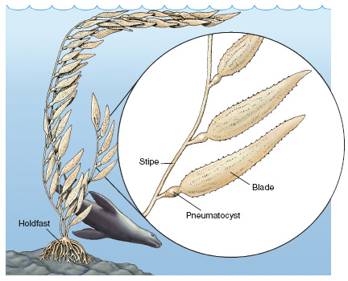

Figure 1 The giant kelp (Macrocystis).

C. Division, of phylum, Rhodophyta: red algae

Red pigments, phycobilins, mask chlorophyll in this group of seaweeds, hence their common name. Red seaweeds, however, are not always red. Their color may vary from olive green to almost black, sometimes as the result of the amount of exposure to light.

This group contains the largest number of species among the seaweeds. Examples are Gelidium, Gracilaria, Porphyra, Rhodymenia, and Gigartina. Coralline algae are common in some areas.

II. Marine Plants (division Magnoliophyta)

Flowering plants are the dominant plants that are familiar to us on land. In contrast to the seaweeds, they have true leaves, stems, and roots. These structures contain specialized tissues to transport the food that is manufactured during photosynthesis, as well as water and nutrients. No such tissues are found in the stipes, blades, and holdfasts of seaweeds.

Marine flowering plants are land plants adapted to various degrees of immersion by seawater. Eelgrass (Zostera), which is rarely exposed at low tide, is a temperate species. Surf grass (Phyllospadix) inhabits rocky coasts in the Pacific and is regularly exposed at low tide. Turtle grass (Thalassia) and other seagrasses are restricted to warm water.

Cord grass (Spartina) is a true grass characteristic of salt marshes. Its roots are covered by seawater at high tide. The same is true for mangroves (Rhizophora), which are restricted to warm water.

Name _________________________

Identify, obtain information about the common name and habitat, and sketch the seaweeds and marine plants that are available for study. Label any recognizable structures such as stipes, blades, holdfasts, and pneumatocysts.

Phylum:
Common name (if any):
Genus and species (if known):
Habitat:

Morphological adaptations to habitat:

Sketch:

Name _________________________

Phylum:
Common name (if any):
Genus and species (if known):

Habitat:

Morphological adaptations to habitat:

Sketch:

Name _________________________

Phylum:
Common name (if any):
Genus and species (if known):
Habitat:

Morphological adaptations to habitat:

Sketch:

Name _________________________

Phylum:
Common name (if any):
Genus and species (if known):
Habitat:

Morphological adaptations to habitat:

Sketch:

Name _________________________

Phylum:
Common name (if any):
Genus and species (if known):
Habitat:

Morphological adaptations to habitat:

Sketch:

Name _________________________

Phylum:
Common name (if any):
Genus and species (if known):
Habitat:

Morphological adaptations to habitat:

Sketch:

Name _________________________

Phylum:
Common name (if any):
Genus and species (if known):
Habitat:

Morphological adaptations to habitat:

Sketch:

Name _________________________

Review Questions:

1. What is the adaptive significance of the pneumatocysts of some seaweeds?

2. How could you tell that a particular seaweed is adapted to live on rocky shores exposed to heavy wave action? How about one adapted to live in a less exposed rocky shore?

3. Some filamentous seaweeds thrive in small, isolated tide pools high up on rocky shores. They are only sprayed with seawater at the highest tide. What type of problems do these seaweeds face?

4. What are some of the possible functions of the accumulation of calcium carbonate in coralline and calcareous green algae?

5. What are some of the problems faced by terrestrial flowering plants that have invaded the marine environment?

Exercise 3

DIVERSITY AND ADAPTATIONS:
SPONGES AND CNIDARIANS

Members of the kingdom Animalia, the animals, are multicellular and eukaryotic organisms. Animals are also heterotrophs and, in contrast to the autotrophic organisms (many bacteria and archaea, algae, plants), must ingest food to obtain energy.

Most animals lack a backbone and are thus known as invertebrates. Humans and the "higher" animals, in contrast, have a backbone and are known as vertebrates. Two common groups of marine invertebrates, the sponges (phylum Porifera) and the cnidarians (phylum Cnidaria) are used to introduce two basic levels of complexity among the "lower" invertebrates (see chapter 7, "Marine Animals Without a Backbone," in Marine Biology, Seventh Edition).

Objectives:

1. Recognize the levels of complexity and the basic characteristics of sponges and cnidarians.

2. Recognize diversity of form and function among sponges and cnidarians.

3. Distinguish between the three classes of cnidarians, paying special attention to adaptations to the sessile and pelagic way of life.

Materials:

1. Dissecting and compound microscopes

2. Prepared whole-mount slides of Grantia

3. Prepared slides or freshly made preparations of spicules of Grantia and/or other sponges

4. Dried and/or live specimens of sponges, including examples of commercial bath sponges, glass sponges (Euplectella), and/or boring sponges (Cliona)

5. Prepared whole-mount slides of Obelia

6. Preserved (including plastic mounts) and/or live specimens of miscellaneous cnidarians such as hydroids, the Portuguese-man-of-war (Physalia), hydrozoan and scyphozoan medusae (Aurelia and others), sea anemones, corals, sea fans, soft corals, and sea pens

Notes to the Instructor:

1. Calcareous sponge spicules may be isolated from live or preserved sponges by placing a small portion of the sponge on a regular or depression slide with a few drops of household bleach. Diluted hydrochloric acid is used to isolate siliceous spicules.

2. Some prepared slides may be used as useful demonstrations: cross-section of leuconoid sponge, miscellaneous sponge spicules, nematocysts, planula larva, medusa of Obelia, and sessile stages of Aurelia.

3. This exercise may be covered during two laboratory periods.

MATERIAL TO BE STUDIED:

I. Phylum Porifera (sponges)

Sponges consist of aggregations of cells that never show true tissues or organs. They thus represent the lowest level of organization among animals: the cellular level of organization (see table 7.1 in Marine Biology, Seventh Edition). Sponges are actually complex colonies of many cells. Each individual sponge consists of a system of canals and chambers through which water circulates. Numerous pores allow the water to enter (Fig. 2). After it is filtered for food particles, water exits by way of the osculum. Sponges are therefore filter feeders since they actively filter the water (see Fig. 7.3 in Marine Biology, Seventh Edition).

Most of the sponge cells are specialized for particular functions. Flat cells form the outer surface of the sponge, while pore cells are tube-like cells that actually form the pores through which water enters. Collar cells, or choanocytes, trap and ingest food particles in the water. Some cells store and transport food; others are involved in reproduction. Some cells form the characteristic spicules, transparent structures that provide support and are present in many sponges. They may be siliceous or calcareous, and vary in shape and size depending on the species. Protein fibers, spongin, may be present alone or in addition to spicules.

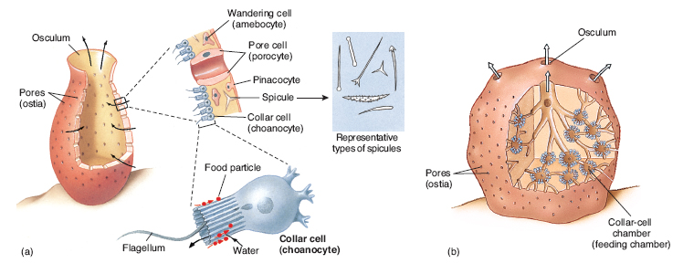

Figure 2 Sponges consist of complex aggregations of cells that carry out specific functions. Collar cells trap food particles in both (a) simple and (b) complex sponges.

II. Phylum Cnidaria (cnidarians)

Cnidarians include, among others, the hydroids, jellyfishes, sea anemones, and corals. In contrast to sponges, cnidarians feature a tissue level of organization since cells are organized into specialized tissues (see table 7.1 in Marine Biology, Seventh Edition). They also share radial symmetry since similar parts of the body are arranged and repeated around a central axis (Fig. 4).

Though cnidarians come in many shapes, their structure falls within one of two basic forms. Sometimes both forms may be observed in the life history of many cnidarians. The polyp, one of the two basic forms, is specialized as an attached, or sessile, form (Fig. 3). The medusa, or jellyfish, is like an upside-down polyp specialized for swimming. It is said to be pelagic since it lives in the water column away from the bottom.

Both polyp and medusa have a centrally located mouth surrounded by tentacles. The mouth and tentacles are directed downward in the medusa. The tentacles contain nematocysts, stinging structures unique to cnidarians (see Fig. 7.9 in Marine Biology, Seventh Edition). Nematocysts are used to capture prey since practically all cnidarians are carnivores. The mouth leads into a blind gut, one that has no anus. There are no true organs or systems, so no circulatory, excretory, or nervous systems (including a brain) to speak of.

A. Class Hydrozoa: hydrozoans

The polyp is the dominant form in most hydrozoans. The polyp may be single or colonial. Colonies vary in size and complexity but are usually feathery or bushy. Polyps are specialized for feeding, reproduction, and even defense. Reproductive polyps release minute medusae (see Fig. 7.8 in Marine Biology, Seventh Edition). This is the case in Obelia, where colonies live attached to pilings or seaweeds. Siphonophores are hydrozoans that form drifting colonies. One good example is the Portuguese man-of-war (Physalia), which causes painful stings in swimmers and divers (see Fig. 7.9 and "The Case of the Killer Cnidarians" in Chapter 7, Marine Biology, Seventh Edition).

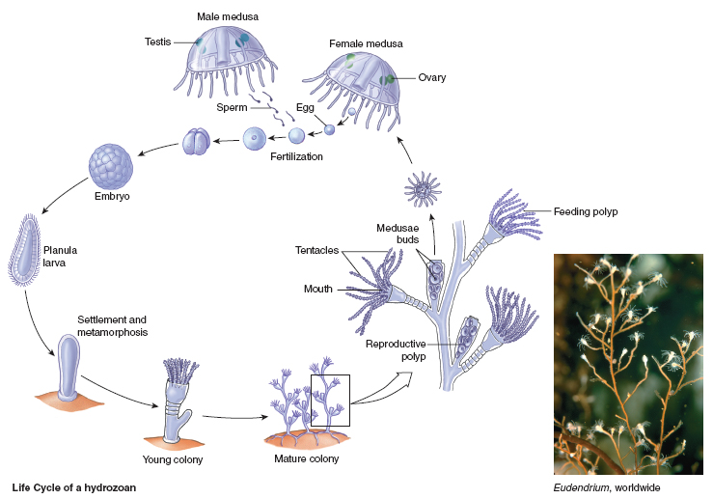

Figure 3 The life cycles of hydrozoans follow different patterns. A common one involves a sessile, asexually reproducing colony of polyps that releases planktonic, sexually reproducing medusae.

B. Class Scyphozoa: jellyfishes

This group includes the large and conspicuous jellyfishes. The medusa, or scyphozoan medusa, is the dominant stage in the life cycle. Minute, attached polyps are found in some species.

C. Class Anthozoa: sea anemones, corals

This is the largest group of cnidarians. A single polyp or a colony of polyps is the only stage; the medusa is always absent. The anthozoan polyp is more complex than that of hydroids. Sea anemones (Metridium, Anthopleura) typically have large and muscular polyps. Most anthozoans are colonial. They include the reef-building corals and other skeleton-forming groups such as gorgonians (which include sea fans and precious corals), and black coral. Sea pens, sea pansies, and soft corals form fleshy colonies.

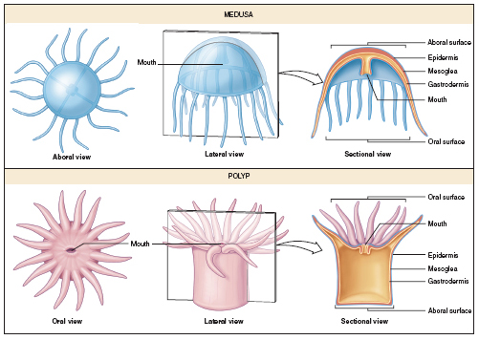
Figure 4 The flower-like appearance of many cnidarians is a consequence of their radial symmetry. In both the medusa and polyp, tentacles are arranged and repeated around a central axis that runs through the mouth.

Name ________________________

Sponges (phylum Porifera)

Cross-section slide of Grantia.

Grantia is a small and simple sponge. Examine under the microscope and sketch the most obvious arrangements of cells that make up the section. Label any cells (outer-surface cells, pore cells, collar cells) and structures (pores, central cavity, spicules) that may be visible. Use arrows to indicate the direction of the water as it enters and exits this section of the sponge. Use Figure 2 as a reference.

Sponge spicules:

Genus:

Name _______________________

Miscellaneous marine sponges:

Genus:
Common name (if any): Color:
Habitat:
Sketch:

Name _______________________

Genus:
Common name (if any): Color:
Habitat:
Sketch:

Name ________________________

Genus:
Common name (if any): Color:
Habitat:
Sketch:

Name ________________________

Genus:
Common name (if any): Color:
Habitat:
Sketch:

Name ________________________

Hydrozoans (Phylum Cnidaria, Class Hydrozoa)

Prepared slide of Obelia

Obelia is a colonial hydroid. “Stems” that consist of an outer transparent layer and an inner cellular layer interconnect polyps. There are two types of polyps: feeding polyps that have a mouth surrounded by tentacles and reproductive polyps with medusa buds that develop into free-living medusae (Fig. 3). Medusae reproduce sexually by producing eggs or sperm.

Sketch part of a colony of Obelia and label feeding polyp, mouth, tentacles, reproductive polyp, and medusa buds.

Name ________________________

Miscellaneous cnidarians:

Sketch and label any recognizable parts (feeding polyp, reproductive polyp, etc.).

Class:
Genus and species:
Common name (if any):
Habitat:
Sketch:

Name ______________________

Class:
Genus and species:
Common name (if any):
Habitat:
Sketch:

Name ______________________

Class:
Genus and species:
Common name (if any):
Habitat:
Sketch:

Name ______________________

Class:
Genus and species:
Common name (if any):
Habitat:
Sketch:

Name ______________________

Class:
Genus and species:
Common name (if any):
Habitat:
Sketch:

Name ______________________

Review Questions:

1. What are some of the advantages that sponges have over single-cell animals? Any disadvantages?

2. How do sponges reproduce?

3. How is it possible to tell the difference between the polyp of a hydrozoan and that of an anthozoan?

4. Mention some of the advantages that the tissue level of organization has over the cellular level of organization.

5. How do colonial hydroids like Obelia transport food throughout the colony when some of the polyps, the reproductive polyps, do not have mouths?

Exercise 4

DIVERSITY AND ADAPTATIONS:
SEGMENTED WORMS, MOLLUSCS,
AND CRUSTACEANS

Many groups of invertebrates inhabit the marine environment. The great majority of these invertebrates are more complex in their structure and function than the sponges and cnidarians that were examined in the previous exercise. These invertebrates have true organs and systems, including circulatory, excretory, and central nervous systems.

Practically all of these invertebrates show bilateral symmetry, where body parts are arranged in a way that there is only one way to cut the body and get two identical halves (see Fig. 7.13 in Marine Biology, Seventh Edition). This means that there is an anterior end with a head and a brain, and a posterior end. There is at the same time a dorsal surface that is different from the ventral surface.

This exercise examines three very successful groups of marine animals: the segmented worms (phylum Annelida), the molluscs (phylum Mollusca), and the crustaceans (one of several groups in the phylum Arthropoda) (see chapter 7, "Marine Animals Without a Backbone," in Marine Biology, Seventh Edition).

Objectives:

1. Recognize the most important characteristics of annelids, molluscs, and arthropods.

2. Recognize diversity of form and function among the polychaetes, molluscs, and crustaceans.

3. Understand the significance of bilateral symmetry.

Materials:

1. Dissecting tools (scissors, blunt probes, scalpels) if dissections are made

2. Preserved specimens of sandworms (Nereis or Neanthes)

3. Preserved (including plastic mounts) and/or live specimens of miscellaneous polychaetes such as fanworms, feather-duster worms, and lugworms, and, if available, preserved marine leeches

4. Preserved specimens or model of a clam such as the hard-shell clam (Mercenaria)

5. Preserved and/or live specimens of miscellaneous molluscs such as marine snails, limpets, nudibranchs, mussels, oysters, shipworms, octopuses, squids, Nautilus, and chitons

6. Preserved specimens or model of the Atlantic lobster (Homarus)

7. Preserved and/or live specimens of miscellaneous crustaceans such as barnacles, beach hoppers and other amphipods, fish lice and other isopods, krill, shrimps, lobsters, and crabs

Notes to the Instructor:

1. This exercise may be best covered during two or even three laboratory periods depending on whether dissections are made and how many miscellaneous preserved and/or live specimens are available for study.

2. Preserved specimens of miscellaneous worms like ribbon worms (nemerteans), peanut worms (sipunculans), and echiurans may be used as supplementary demonstrations.

3. Some prepared slides may be used as effective demonstrations: cross-section of sandworm, parapodium of sandworm, trochophore larva of polychaete and/or mollusc, veliger larva of gastropod and/or bivalve, copepods, and miscellaneous larvae of crustaceans (nauplius, zoea).

4. A preserved specimen of the horseshoe crab (Limulus) will demonstrate a non-crustacean arthropod.

MATERIAL TO BE STUDIED:

I. Phylum Annelida: segmented worms

The body of annelids, or segmented worms, consists of a series of segments, hence the common name of segmented worms (see table 7.1 in Marine Biology, Seventh Edition). Segmentation provides for an additional degree of flexibility in the worm body plan. Segmentation is also internal since segments are internally separated from each other by a membrane.

There is a complete digestive system that runs from an anterior mouth to the posterior anus. The gut, or intestine, lies in a cavity known as a coelom (see Fig. 7.16 in Marine Biology, Seventh Edition). The coelom is filled with fluid. The segments act as a hydrostatic skeleton since the flexible body wall pushes and squeezes against the coelomic fluid. The hydrostatic skeleton, together with sets of muscles along and across the body wall, aids in locomotion.

Annelids also feature a closed circulatory system, one where the blood is always enclosed in blood vessels. Intake of oxygen in marine species is aided by the presence of gills, which are branched extensions of blood vessels.

A. Class Polychaeta: polychaetes

Practically all representatives of the phylum Annelida in the marine world are polychaetes. Each of their body segments is provided with a pair of extensions known as parapodia (Fig. 5). Typical parapodia have stiff bristles, or setae. Parapodia have many functions depending on the lifestyle of the polychaete. They are flattened and are used as a further aid in locomotion in crawling polychaetes (as in Nereis and Neanthes, the sandworms), but may be reduced in burrowing species (as in feather-duster worms and lugworms).

All polychaetes feature a well-developed head with several pair of eyes and sensory structures. Deposit- and suspension-feeding species are provided with various types of tentacles and feeding structures used in the capture of food (see Figs. 7.16 and 13.17 in Marine Biology, Seventh Edition). Carnivorous species often sport a retractable pharynx armed with jaws.

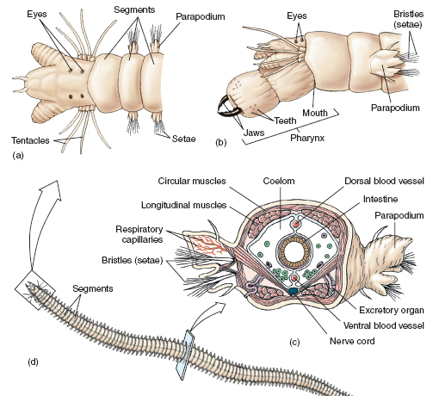

Figure 5 This sandworm (Nereis) illustrates the meaning of the name polychaetes—“many setae, or bristles.” (a) Dorsal view of the head, with the pharynx retracted, showing the sensory tentacles and eyes. (b ) Side view of the head, showing the large pharynx in an extended position. (c) Section across a segment. (d) Dorsal view of the worm.

B. Class Hirudinea: leeches

Leeches represent a group of annelids specialized for blood sucking. They may be found attached to marine fishes and invertebrates. The mouth and the posterior end are modified as suckers. They have no parapodia.

II. Phylum Mollusca: molluscs

A soft body that is covered by a mantle characterizes molluscs, a very large and diverse group of marine invertebrates. The mantle produces a shell, which is absent or reduced in some groups. A ventral and muscular foot is used in locomotion, but it also may be reduced. Another feature found only in molluscs is the radula, a ribbon of tiny teeth found in the mouth cavity. It is used in rasping food but it can be modified or absent in some groups.

The digestive system is complete. Digestive glands are actively involved in the digestion and absorption of food. The circulatory system is open since blood flows out of vessels into specialized spaces in the body. A heart aids in pumping blood through the system. The nervous system of molluscs varies from a series of aggregations of nervous tissue and a few nerves (as in clams and oysters) to a complex brain and well-developed nerves in octopuses and related forms.

A. Class Gastropoda: snails

Typical gastropods feature a single, coiled shell that protects the vital organs (see Fig. 7.20 in Marine Biology, Seventh Edition). The stomach rests over the foot, which explains the name of the group, "stomach footed." The gills are enclosed by a mantle cavity. There are more species in the class Gastropoda than in any other group of molluscs. Gastropods include not only the common marine snails but the nudibranchs, or sea slugs.

B. Class Bivalvia: clams, mussels, oysters

Bivalves have two shells that protect a laterally compressed body (Fig. 6). The expanded gills are used to obtain oxygen as well as for filtering and sorting out food. The head is reduced, the radula absent.

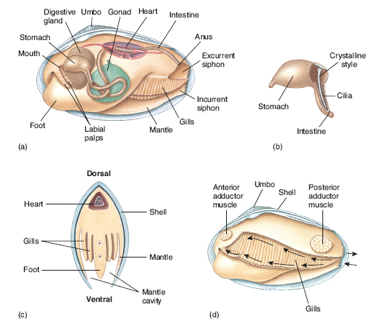
Figure 6 A laterally compressed body is the most distinctive feature of bivalves, illustrated here by a clam. The gills, which hang on both sides of the body (a, c), sort out food particles and transport them to the mouth with the help of cilia and mucus. The palps then push the food into the mouth. Food is digested in the stomach with the help of the crystalline style (b). The path of the particles from the incurrent siphon to the mouth is indicated by arrows (d).

C. Class Cephalopoda: octopuses, squids, Nautilus

Cephalopods are molluscs adapted to be fast swimming predators. The shell is almost always absent (except in Nautilus) or internal (as in squids). The head features a pair of large eyes. A series of arms, eight in octopuses (see Figs. 7.25 and 7.27 in Marine Biology, Seventh Edition) and ten in squids, lies below the head. This arrangement explains the meaning of the group's name: "head-footed." Water enters the mantle cavity, which encloses the gills, by a funnel, or siphon. Swimming in cephalopods is accomplished by forcing water out of the mantle cavity through the flexible funnel.

D. Class Polyplacophora: chitons

Chitons have a shell that consists of eight overlapping shell plates (see Fig. 7.27 in Marine Biology, Seventh Edition). A large foot lies on the ventral surface.

III. Phylum Arthropoda: crustaceans and other arthropods

Arthropods, the largest of all animal phyla, are invertebrates that show segmentation, bilateral symmetry, and a hard, external skeleton, or exoskeleton (Fig. 7). Growth is accomplished by shedding, or molting, the exoskeleton. A series of jointed appendages, most of which are specialized as legs, are also segmented. Arthropods include the insects, spiders, and other groups familiar on land. Most marine arthropods, however, are crustaceans (subphylum Crustacea). Other marine arthropods are the horseshoe crab, not a true crab, and a few marine insects.

A. Subphylum Crustacea: crustaceans

Crustaceans include shrimps, lobsters, crabs, and other invertebrates common in most marine environments. All crustaceans have appendages adapted for crawling, swimming, feeding, and other functions. They all have gills to take oxygen from the water and two pairs of antennae to sense their environment.

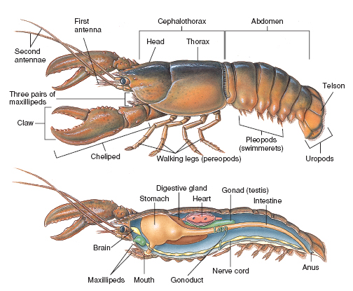

Figure 7 The American lobster (Homarus americanus ) illustrates the basic body plan of decapod crustaceans. One significant omission from this drawing is the feathery gills, which lie in a chamber on each side of the cephalothorax. The ducts from the gonads, the gonoducts, open at the base of the last pair of walking legs in males and at the base of the second pair in females. Be sure to check next time you eat a lobster.

Name ______________________

Segmented worms (phylum Annelida)

Sandworm (Nereis or Neanthes)

Sandworms, also known as clamworms, are common polychaetes that spend most of their time hiding under rocks or burrowing in soft bottoms. They emerge at night to feed. Study the external morphology of a preserved specimen using Figure 4 as a reference. Sketch the head and some of the body segments. Label the following structures: eyes, tentacles, mouth, pharynx, jaws, teeth, segment, parapodium, and setae.

Name ______________________

Miscellaneous marine annelids:

Class:
Genus and species:
Common name (if any):
Habitat:
Sketch:

Name ______________________

Class:
Genus and species:
Common name (if any):
Habitat:
Sketch:

Name ______________________

Class:
Genus and species:
Common name (if any):
Habitat:
Sketch:

Name ______________________

Class:
Genus and species:
Common name (if any):
Habitat:
Sketch:

Name ______________________

Molluscs (phylum Mollusca)

Clam (hard-shell clam, Mercenaria, or another bivalve mollusc)

Clams and other bivalves are adapted for filter feeding. The body is enclosed in a calcareous two-valved shell. The area where the hinge of the shell is located represents the dorsal region. The shell basically consists of an outer and an inner layer. The inner layer, which is in contact with the mantle, is the shiny nacreous layer.

If a specimen is being dissected, carefully pry open the shell and remove one of the valves following the instructor's instructions. Examine the specimen (or a model) and identify and sketch the most important parts using Figure 5 as a reference.

The gills hang in the mantle cavity, which is ventral. The rest of the body (the visceral mass) lies dorsal to the gills. Use scissors to remove the mantle that covers the gills and the visceral mass. Identify the following: mantle, gills, mantle cavity, foot, shell muscles (or adductor muscles), excurrent and incurrent siphons (how can you tell which one is which?), palps, and mouth (use a probe to locate it). Sketch the path that food particles take from the incurrent siphon to the mouth using Figure 5 as a reference.

The visceral mass can be dissected across (in an anterior to posterior direction) and the following internal structures can be observed: stomach (which contains a typically transparent and long crystalline style), digestive gland, heart, and gonad.

Name ______________________

Miscellaneous marine molluscs:

Class:
Genus and species:
Common name (if any):
Habitat:
Sketch:

Name ______________________

Class:
Genus and species:
Common name (if any):
Habitat:
Sketch:

Name ______________________

Class:
Genus and species:
Common name (if any):
Habitat:
Sketch:

Name ______________________

Class:
Genus and species:
Common name (if any):
Habitat:
Sketch:

Name ______________________

Crustaceans (phylum Arthropoda, subphylum Crustacea)

American lobster (Homarus)

Lobsters are decapods, which can be easily identified by their five pairs of appendages. In lobsters the first pair is modified as large chelipeds, or pincers; the remaining four pairs are walking legs. Three pairs of additional appendages, the maxillipeds, are located anterior to the chelipeds. The body is divided into a cephalothorax (which includes the head and the thorax fused as a carapace) and the abdomen, or "tail." The abdomen is provided with five pairs of appendages, the swimmerets. They are all similar in females; in males the first two pairs are stiff and oriented forward. What is their function in the two sexes?

Identify and sketch the most obvious external features using a preserved specimen or a model. Similarly identify the most important internal structures. Carefully cut across the carapace following your instructor's instructions if specimens are to be dissected. Use Figure 6 as a reference. Be sure to identify the external structures indicated above as well as the first and second antennae, telson (the last segment of the abdomen), and uropods. Indicate as many internal structures as possible: stomach, digestive gland, intestine, heart, testes (or ovary), brain, and nerve cord. Also indicate the sex of your specimen. How can you tell?

Name ______________________

Miscellaneous marine crustaceans:

Class:
Genus and species:
Common name (if any):
Habitat:
Sketch:

Name ______________________

Class:
Genus and species:
Common name (if any):
Habitat:
Sketch:

Name ______________________

Class:
Genus and species:
Common name (if any):
Habitat:
Sketch:

Name ______________________

Class:
Genus and species:
Common name (if any):
Habitat:
Sketch:

Name ______________________

Class:
Genus and species:
Common name (if any):
Habitat:
Sketch:

Name ______________________

Class:
Genus and species:
Common name (if any):
Habitat:
Sketch:

Name ______________________

Review Questions:

1. What are some of the advantages that bilaterally symmetrical animals have over radially symmetrical ones?

2. Briefly compare how segmented worms and crustaceans move, paying particular attention to the crawling forms.

3. Nudibranchs, or sea slugs, are gastropods that lack a shell. How are the advantages of having a shell compensated in nudibranchs?

Name ______________________

4. Compare the type of circulatory systems in segmented worms, molluscs, and crustaceans.

5. What kind of modifications to the typical molluscan plan (typified by gastropods) do we find in the bivalves?

Exercise 5

DIVERSITY AND ADAPTATIONS:
ECHINODERMS AND CHORDATES

Two very dissimilar groups are chosen to end our survey of marine life. One of the two groups, the echinoderms (phylum Echinodermata), include the sea stars, brittle stars, sea urchins, sea cucumbers, and crinoids (see chapter 7, "Marine Animals Without a Backbone," in Marine Biology, Seventh Edition). The second, the chordates (phylum Chordata), is a successful and remarkably diverse group that embraces animals as different as sea squirts, fishes, birds, and mammals (see chapter 8, "Marine Fishes," and chapter 9, "Marine Reptiles, Birds, and Mammals," in Marine Biology, Seventh Edition). Echinoderms and chordates certainly look very different from each other. Both are actually distantly related, however, a fact that becomes evident only when their embryological development is examined.

Echinoderms are unique in a number of ways. They feature radial symmetry as in cnidarians. Radial symmetry in echinoderms is pentamerous since it is based on five parts. Another unique feature is their water vascular system, a network of water-filled canals used in locomotion or feeding (see table 7.1 in Marine Biology, Seventh Edition).

Chordates are bilaterally symmetrical animals, typically with a well-developed head. Three characteristics separate chordates from other animal phyla. They all have, at least during part of their lives, a single dorsal nerve cord, gill (or pharyngeal) slits, and a notochord, a support rod found below the nerve cord (see Fig. 7.53 in Marine Biology, Seventh Edition).

Objectives:

1. Recognize the most important characteristics of echinoderms and chordates.

2. Recognize diversity of form and function among the echinoderms and marine chordates.

Materials:

1. Dissecting tools (scissors, blunt probes, scalpels) if dissections are made

2. Preserved specimens or model of sea star (Asterias)

3. Preserved (including plastic mounts) and/or live specimens of miscellaneous echinoderms (sea stars, brittle stars, sea urchins [including sand dollars and/or heart urchins], sea cucumbers, feather stars, and sea lilies)

4. Preserved specimens or model of dogfish shark (Squalus)

5. Preserved specimens of miscellaneous chordates: tunicates, lancelets (Amphioxus), lamprey, and bony and cartilaginous fishes
Notes to the Instructor:

1. This exercise may be best covered during two laboratory periods depending on whether dissections are made and how many miscellaneous specimens are available for study.

2. Some prepared slides may be used as demonstrations: cross-section of arm of Asterias, pedicellariae of Asterias and/or sea urchins, larvae of miscellaneous echinoderms, spicules of sea cucumbers, tadpole larvae of tunicates, and lancelets (Amphioxus).

3. Live fishes (even if freshwater) and preserved specimens of representative groups of marine reptiles, birds, and mammals (sea snake, mounted skins of seabirds, skulls of sea mammals) will provide an excellent illustration of diversity among vertebrates.

4. Preserved specimens or model of a bony fish, even if freshwater (Perca), may be used in addition or instead of the dogfish shark.

MATERIAL TO BE STUDIED:

I. Phylum Echinodermata: echinoderms

The pentamerous radial symmetry of echinoderms becomes evident in their basic body plan: five arms radiating from a central disk or five rows of ambulacral grooves along the body. Radial symmetry is also evident by the fact that there is no head and no anterior and posterior ends (refer to Fig. 7.12 in Marine Biology, Seventh Edition). The surface where the mouth is located is known as oral and the opposite surface as aboral.

The water vascular system is externally evident in the tube feet that extend along the ambulacral grooves. Also visible in many echinoderms is the madreporite, a porous plate that serves as the entry point of the water that circulates through the water vascular system.

Echinoderms show no segmentation. Though the body is typically hard, the skeleton is actually internal (it is covered by skin, even in sea urchin spines) and as such known as an endoskeleton. The digestive tract is complete and there is no specialized circulatory system. The coelomic cavity is well developed, and the fluid it contains, the coelomic fluid, transports nutrients.

A. Class Asteroidea: sea stars

Sea stars perhaps best display the characteristic architecture of the phylum Echinodermata. Five arms, though sometimes can be more, radiate from a central disk. The oral surface of each arm shows a distinctive ambulacral groove through which tube feet protrude (Fig. 8). The tube feet are contracted when the water in then is forced into the muscular ampullae that extend inside the body. Minute pincer-like pedicellariae found through the aboral surface help keep the surface clean of settling debris.

Most sea stars are carnivores. The mouth is located on the center of the oral surface. Part of the stomach is extended through the mouth to begin digesting the prey. Digestive enzymes are produced by digestive glands that extend into the arms. Digested food is then moved into the digestive glands for absorption. A short intestine that ends in an aboral anus follows the stomach.

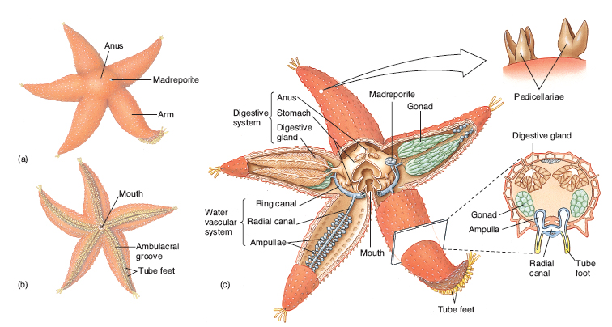

Figure 8 (a) Aboral and (b) oral surfaces of a sea star (Asterias vulgaris) common on the Atlantic and Gulf coasts of North America. (c) Internal structure, with an arm cut across to show the relationship between tube feet, the internal sacs (ampullae), and the canals that make up the water vascular system. This and other carnivorous sea stars evert their thin-walled stomach and begin digesting prey without having to eat it.

B. Class Ophiuroidea: brittle stars

Brittle stars differ from sea stars in that their five arms are very flexible and clearly demarcated from a well-defined central disk (see Fig. 7.47 in Marine Biology, Seventh Edition). Most brittle stars use their tube feet to feed on small organic particles.

C. Class Echinoidea: sea urchins

The endoskeleton takes the form of a round test in typical sea urchins; it is flattened in sand dollars and heart urchins (see Fig. 7.47 in Marine Biology, Seventh Edition). Movable spines cover the test (Fig. 9). Tube feet protrude from five rows of ambulacral grooves that are best observed in clean tests. Most sea urchins are herbivores. The Aristotle's lantern, a set of jaws and muscles, is used in feeding.

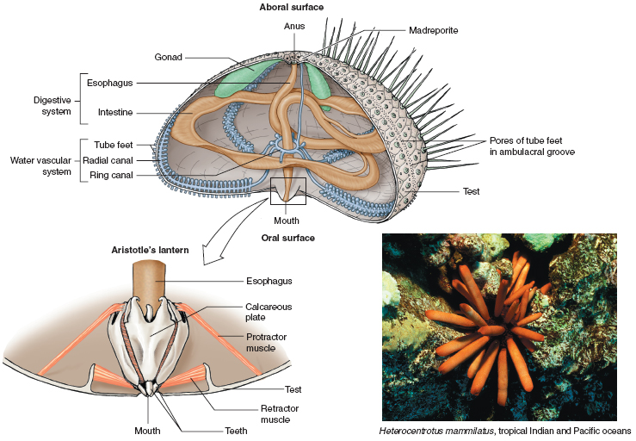

Figure 9 Internal structure of a typical sea urchin, with a simplified diagram of the Aristotle’s lantern. Five pairs of protactor muscles push the lantern down,exposing the teeth; fi ve pairs of retractor muscles move the lantern and teeth in. Additional muscles are responsible for grasping and other movements of the teeth.

D. Class Holothuroidea: sea cucumbers

The pentamerous symmetry of echinoderms is drastically modified in sea cucumbers. The body is worm-like, so there are true anterior and posterior ends. Five rows of ambulacral grooves extend along the body. Sea cucumbers are deposit feeders since they extract organic matter from the sediment (see Fig. 7.3 in Marine Biology, Seventh Edition).

E. Class Crinoidea: feather stars, sea lilies

Feather stars and sea lilies have feathery arms that are used to obtain food from the water (see Fig. 7.50 in Marine Biology, Seventh Edition). Tube feet along the ambulacral grooves are involved in the capture of food particles.

II. Phylum Chordata: chordates

The arrangement of the three basic chordate characteristics (dorsal nerve cord, gill slits, and notochord) and the presence or absence of a backbone are used to define the different groups of chordates.

A. Subphylum Urochordata: tunicates

All three chordate characteristics are found only in the larva, the tadpole larva (see Fig. 7.51b in Marine Biology, Seventh Edition). Tunicates, or sea squirts, are sessile filter feeders as adults, and lack the nerve chord and notochord. There is no backbone so tunicates are invertebrate chordates.

B. Subphylum Cephalochordata: lancelets

Lancelets are small, fish-like invertebrates that live in soft bottoms. All three chordate characteristics are found in the adult (see Fig. 7.53 in Marine Biology, Seventh Edition). The backbone is absent.

C. Subphylum Vertebrata: vertebrates

The presence of a backbone (or vertebral column or spine), a dorsal row of hollow skeletal elements that encloses a nerve cord, is the defining feature of vertebrates. Of the three chordate characteristics, only the dorsal nerve cord remains in the adult of practically all vertebrates.

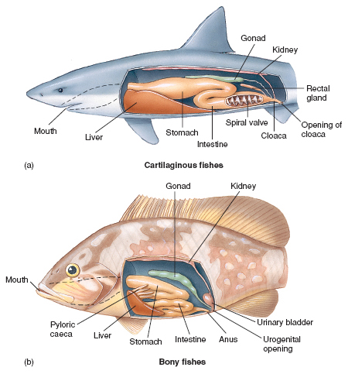

Figure 10 The digestive systems of (a) cartilaginous and (b) bony fishes display many of the basic features found in all vertebrates.

Name ______________________

Echinoderms (phylum Echinodermata)

Sea star (Asterias)

Sea stars are good examples of the echinoderm body plan. Study the external and internal morphology of a preserved specimen or model using Figure 8 as a reference. Sketch both the oral and aboral surfaces and label the following structures: arm, madreporite, anus (if visible), mouth, ambulacral groove, and tube feet. Carefully cut a large section of the endoskeleton across and along the aboral surface of an arm and another section around the aboral surface of the central disk. Sketch and label visible structures such as ampullae, radial canal, ring canal, stomach, digestive gland, and gonad.
Name ______________________

Miscellaneous echinoderms:

Class:
Genus and species:
Common name (if any):
Habitat:
Sketch:

Name ______________________

Class:
Genus and species:
Common name (if any):
Habitat:
Sketch:

Name ______________________

Class:
Genus and species:
Common name (if any):
Habitat:

Name ______________________

Class:
Genus and species:
Common name (if any):
Habitat:
Sketch:

Name ______________________

Class:
Genus and species:
Common name (if any):
Habitat:
Sketch:

Name ______________________

Class:
Genus and species:
Common name (if any):
Habitat:
Sketch:

Name ______________________

Chordates (phylum Chordata)

Dogfish shark (Squalus)

Study the external and internal morphology of a preserved specimen or model. Sketch the following structures using Figure 8.8a in Marine Biology, Seventh Edition as a reference: dorsal fins, pectoral fin, pelvic fin, anal fin, tail (or caudal fin), gill slits, and mouth. Carefully dissect the specimen following the instructor's instructions or study a previously dissected specimen or a model. Sketch and label the following internal structures using Fig. 10 as a reference: stomach, intestine, spiral valve, cloaca, anus, liver, gonad, and kidney.

Name ______________________

Miscellaneous chordates:

Genus and species:
Common name (if any):
Habitat:
Sketch:

Name ______________________

Genus and species:
Common name (if any):
Habitat:
Sketch:

Name ______________________

Genus and species:
Common name (if any):
Habitat:
Sketch:

Name ______________________

Genus and species:
Common name (if any):
Habitat:
Sketch:

Name ______________________

Genus and species:
Common name (if any):
Habitat:
Sketch:

Name ______________________

Genus and species:
Common name (if any):
Habitat:
Sketch:

Name ______________________

Review Questions:

1. How has radial symmetry affected the evolution as well as the lifestyle of echinoderms?

2. How do we know that sea cucumbers are actually radially symmetrical animals?

3. Briefly compare any advantages that chordates may have over echinoderms.

Name ______________________

4. Of the three basic chordate characteristics, which do you think has been the most influential in the evolution of chordates in general? Why?

5. What do you think is the reason why some chordates have all three chordate characteristics only in the larval stage?

Exercise 6

FIELD EXERCISE:
GENERAL CHARACTERISTICS OF THE ROCKY
INTERTIDAL ECOSYSTEM

A rocky shore is an ideal living laboratory to become familiar with the marine environment. It can be easily studied without any sophisticated gear or without actually getting wet. The intertidal, or littoral zone, is that part of the sea floor that is located between the highest high and lowest low tides. The many organisms that often live on the rocky intertidal are adapted to exposure to air, or emersion, as well as other types of stresses.

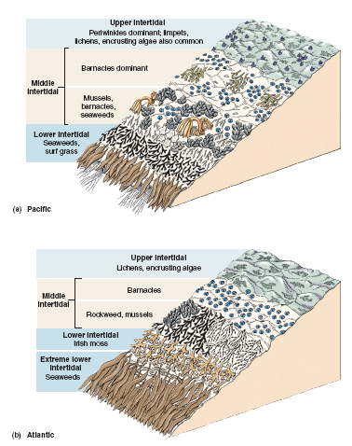

Figure 11 Generalized patterns of zonation on temperate rocky shores on the (a) Pacifi c and
(b) Atlantic coasts of North America. At any particular place on the coast the exact pattern will probably
be different. Only organisms that characteristically dominate the various zones are shown. Hundreds of
other species live in the intertidal.

Objectives:

1. Recognize the most significant physical and chemical factors affecting the rocky shore ecosystem.

2. Become familiar with the dominant inhabitants of rocky shores.

3. Recognize vertical zonation in rocky shore communities.

4. Recognize some of the most obvious adaptations of marine organisms to desiccation and wave action in rocky shores.

5. Become acquainted with tide tables.

Materials:

1. Salinity refractometer

2. Thermometer

3. Field identification manuals or lists (see foldout at the end of Marine Biology, Seventh Edition)

4. Small bucket (optional)

Notes to the Instructor:

1. The class should arrive at the site to be explored at least half an hour prior to a good low tide. This is an ideal span of time to briefly introduce students to the most important characteristics of the rocky shore environment, particularly tides and wave action. This introduction may also serve to introduce tide tables to students. Tide level (in meters and feet) and the time of the low tide(s) can be obtained from tide tables on line (http://www.saltwatertides.com) or those published by the U.S. Department of Commerce (Tide Tables, High and Low Water Predictions, East Coast of North and South America and Tide Tables, High and Low Water Predictions, West Coast of North and South America). Local tide tables are sometimes available at dive shops, and newspapers often print the tides predictions for several days.

2. The survey of the rocky shore should begin at the low tide level. Students should record the general weather conditions. A reading of the temperature and salinity of the open water should be taken directly from the water (depending on wave action) or from a water sample taken with a small bucket.

3. The group should proceed to move up the shore, stopping to observe representative organisms of each of the major zones depending on the amount of time available. The instructor should point out some of the most significant adaptations of these organisms, particularly those that can be used by students to infer on their role in minimizing the stress to dessication due to emersion, or the exposure to air, and wave action.

4. Time permitting, students (preferably in groups) should be asked to use identification manuals, lists, or simple keys to identify representative dominant organisms.

5. The temperature, salinity, relative height (or relationship to tide levels), and the dominant forms of life will be recorded for 3 to 5 tide pools. One of the tide pools should be as high as possible on the intertidal. Salinity can be easily and quickly estimated by the use of a refractometer, a small field instrument that measures the degree of refraction of light in a few drops of liquid.

6. Depending on availability and accessibility, students should at least observe some of the species that inhabit sites that are more exposed to wave action. This information will be most useful in the next two exercises.

Name _________________________

Procedure:

ROCKY SHORE SURVEY: PHYSICAL FACTORS

1. Begin your survey of the rocky shore at the water level just before the time of the predicted low tide indicated by the tide table. Record the following information:

Date: _________________ Location: ______________________________

Predicted low tide (in relation to MLLW): _______ m (= _______ ft)

Time of the low tide: __________

General weather conditions:

sunlight:

rain:

wind :

ocean conditions (wave action, spraying of waves on tide pools):

2. Record the temperature and salinity of a sample of seawater taken at the water's edge. The salinity of a few drops of water will be determined by using a refractometer, a field instrument that estimates salinity by measuring the degree of refraction of light that is produced by the salts in the water.

Open-water sample:

Temperature: _____ºC Salinity: _____º/_{oo}

Name _________________________

VERTICAL DISTRIBUTION
3. Starting at the water's edge at the time of the low tide given in the tide table and gradually moving toward the highest levels of the shore, identify the most common species that are seen as you move up the shore. Look at the underside of rocks but be sure to turn them back to their original position. The instructor may request you (individually or in a group) to find the specific name (genus and species) of some of the most common organisms.

Rocky shore section | Most common species | Adaptations of these species to life on rocky shores
Lower intertidal
Middle intertidal
Upper
intertidal
(splash zone)

Name _________________________

TIDE POOLS

4. Record the following information for the tide pools indicated by your instructor:

Tide pool  location | Temperature | Salinity | Most characteristic forms of life

Additional observations:

Name _____________________

Review Questions:

1. What are some of the morphological adaptations to wave action that have been observed among the organisms? Any examples of adaptations to exposure to air (emersion)?

2. Other than the lack of oxygen dissolved in water, what kind of problems do invertebrates and seaweeds have to confront when exposed to air?

3. Have you observed any behavioral adaptations to wave action? To exposure to air?

Name _____________________

4. In addition to exposure to wave action and air, are there any other challenges that organisms of the intertidal must confront? Have you observed any adaptations to these challenges?

5. How do you account for the differences in temperature, salinity, the number of species, and the abundance of organisms in each of the tide pools that were sampled?

6. Did you observe any particular patterns in the distribution of different species of organisms as you moved from the low-tide level to the highest level, one which is covered only by very high tides?

7. Why is it important to record the general weather conditions? Give some possible differences in what you have observed if the weather conditions were different today’s.

Exercise 7

FIELD EXERCISE:
ZONATION AND COMMUNITY STRUCTURE
IN ROCKY SHORE COMMUNITIES

This field exercise is a follow-up to exercise 6. It should be carried out on the same rocky shore studied in the previous exercise. By now you should be familiarized with the dominant species and the general patterns of vertical zonation. The exercise will take you a step further by quantifying the diversity of species and their vertical distribution on the shore.

Objectives:

1. Recognize species diversity in rocky shore communities.

2. Demonstrate vertical zonation in rocky shore communities.

3. Become familiar with the transect sampling technique.

4. Recognize the possible effects of environmental factors (physical, disturbance) on the vertical distribution of rocky shore organisms.

Materials:

1. Yardsticks (one per group)

2. String (helpful if brightly colored)

3. Small carpenter, or line, levels (one per group; optional)

4. Identification manuals or lists (see foldout at the end of Marine Biology, Seventh Edition)

Notes to the Instructor:

1. The exercise can be easily modified to be used in other intertidal environments that may be available locally such as mud flats, salt marshes, and even mangrove forests.

2. The class should arrive at the site to be surveyed with ample time for you to give detailed instructions before the start of the exercise at low tide. Transects need to be established at approximately the time of the predicted low tide. The lower the tide, the longer the students have to work!

3. The class should be divided into 3 to 4 groups. This will allow for some division of labor within a group. Each group will establish a transect line perpendicular to the water's edge (and extending up into the splash zone) and parallel to a particular section of the shore. If possible, these sections should be as different as possible to allow comparisons. Some differences may be the degree of exposure to wave action, angle of inclination, the flow of fresh water, higher abrasion by a nearby sandy beach, and any type of human disturbance (the building of a pipe, a concrete surface, etc.).

4. Students should record the distribution of only the most common species along their transects, depending on the available time. The instructor should move between groups to be sure that all groups are identifying the species correctly in order to facilitate comparisons afterward. Precise identifications are not necessary as long as all groups use the same name ("barnacle 1," "barnacle 2," etc.) for the same species.

5. Comparing and explaining the results of this exercise makes an ideal subject for class discussion. Before discussion, distribute photostatic copies of standardized representations of the distribution of organisms in each of the transects (see example). Be sure that the scale for the x-axis (tidal height) is the same in all graphs for easier comparisons.

Procedure:

1. Record the tide and weather conditions:

Date:__________ Location:____________________

Predicted low tide (in relation to MLLW):_____ m (_____ ft)

Time of the predicted low tide:__________

General weather conditions (sun, rain, ocean conditions):

2. The instructor will assign a particular section of the shore to each group. Each group will establish a transect line starting at the water's edge at the time of the low tide as predicted by the tide table. The height given in the tide table refers to the water level in reference to a standard mean lower low water, or MLLW. For example, a value of -0.5 meters means that the low tide will be 0.5 m below the mean low tide, which is 0.0 m.

3. At approximately the time of the low tide, place a yardstick (preferably calibrated in centimeters, or any long stick calibrated in centimeters or inches) at approximately the water's edge. This point (Point 1) is then at about the height given in the tide table, or 0.5 m (50 cm) below MLLW in our example.

4. Measure the height in reference to MLLW of an easily identifiable second point (Point 2) in the transect about
1 m or more from the starting point. This is done by extending a string from Point 2 to the yardstick in Point 1, which represents -0.5 m at the base in our example. Keep the string straight by using a small carpenter, or line, level. Another possibility is to level the string by eyesight.

5. You are now ready to begin estimating the vertical distribution of the most common species in reference to MLLW along the transect from Point 1 to Point 2. Remember that the tide will begin to rise very quickly so you must work as quickly and efficiently as possible! One way of doing this is to divide the work among group members. Some students should immediately begin to estimate the height of a third reference point (Point 3) above Point 2 by placing the yardstick immediately on Point 2 and carrying out the same steps used to estimate the height of Point 2.

6. Summarize the vertical distribution of the species as in this graphic representation of a purely hypothetical transect:

2.5 m - species
5
species
2.0 m - 4
species
3
1.5 m -

1.0 m -

species
0.5 m - 2
species
1
0 m -

-0.5 m -

7. As part of class discussion, compare the summary of the results of your transect with those of the other transects.

Name _____________________

Vertical zonation: summary of results

Name _____________________

Review Questions:

1. Were the weather conditions different than those during the first field exercise on rocky shores? If so, did you observe any differences in the activity or condition of some of the organisms?

2. In exercise 6 the rocky shore was divided for convenience into "lower," "middle," and "upper intertidal". Does this division hold for all of the species found in your transect? Can you suggest a better division of the particular rocky intertidal you surveyed?

3. What would be the advantages of establishing a transect line with permanent stainless steel or concrete markings so that it could be surveyed year-round, year after year? What kind of factors would you be able to investigate?

Name _____________________

4. How does the distribution of species in your transect compare with the distribution of the same species in transects made by the other groups in different sections of the same rocky shore? Were there any species that were found in only some of the transects? Present some hypotheses that may help explain any differences in the relative vertical distribution and/or presence or absence of organisms on the different sections of the shore.

5. Even if you were not asked to estimate the relative abundance of particular organisms, did students of different groups observe any marked differences? How do you think your group could have quantified (using numbers, that is) the abundance of a particular organism in the transect?

Exercise 8

FIELD EXERCISE:
HORIZONTAL DISTRIBUTION AND COMMUNITY STRUCTURE IN ROCKY SHORE COMMUNITIES

The analysis of the horizontal distribution of rocky shore organisms is an ideal way to follow the study of the vertical distribution undertaken in the preceding exercise. It should also be carried out on the same rocky shore so that the class can discuss and test or verify some of the hypotheses that may have been proposed to explain differences in vertical distribution.

Objectives:

1. Recognize horizontal distribution in rocky shore communities.

2. Become familiar with the quadrat sampling technique.

3. Recognize the possible effects of biological and physical factors on the horizontal distribution of rocky shore organisms.

4. Quantify density, frequency, species diversity, and other parameters.

Materials:

1. String or rope, at least 10 feet long (one per group)

2. Rulers (in centimeters)

3. Circular quadrats made from plastic coffee-can lids

4. Table of random numbers (one per group)

5. Identification manuals

Notes to the Instructor:

1. This exercise can also be used to sample mud flats and/or salt marshes.

2. The class should be divided into two or three groups. Each group will establish a horizontal transect, that is, one that is more or less parallel to the shore. Each transect should be at least 10 feet along a relatively flat section of ground. For comparative purposes, the transects must extend along approximately the same height in relation to MLLW.

3. The tidal height of the transects can be estimated from the figures obtained in exercise 7, or it can be accurately determined by the method outlined in that exercise. Otherwise, there is no need to start the exercise at precisely the time of the low tide.

4. The upper levels of the middle intertidal zone (the "barnacle zone") and the lower reaches of the splash zone are ideal for horizontal transects since there are fewer species than in the lower levels. Transects should be established along zones that are as different as possible while still within the same tidal level. Some differences may be the relative exposure to sunlight, exposure to wave action, the flow of fresh water, sand abrasion, and human intrusion. An excellent possibility already tested in a class is comparing one area that is along the path that many people take at low tide with one that is much less accessible (in the class in question an "island" that is formed at low tide) and therefore relatively untouched by humans. Results of the vertical transects done in the previous exercise can help the class, as a whole, suggest what these factors may be. Other possible factors are the presence vs. absence of fresh water flowing from land, differences in the type of substrate (such as flat rock vs. rough rock), presence or absence of sand that accumulates as the tide goes down (thus testing the potential effect of sand abrasion), etc.

5. Circular, flexible quadrats can be easily made by completely cutting out the center of 6-inch, plastic coffee-can lids so that only the flexible rim remains. The type and number of organisms present in ten (or less if time is limited) quadrats along the transect will be recorded. The ten quadrats will be selected at random: a rope marked with 6-inch intervals (or the diameter of the quadrats) is extended along the transect, the intervals are numbered beginning with 1, and the first two-digit ten numbers chosen from a table of random numbers will correspond to the quadrats to be sampled. A table of random numbers can be found in most statistics texts or in laboratory manuals such as:

Cox, G. W., 2001. Laboratory Manual of General Ecology, 8th ed., McGraw-Hill.

Brower, J. E., J. H. Zar and C. N. von Ende, 1997. Field and Laboratory Methods for General Ecology, 4th ed., McGraw-Hill.

6. Tide pools, which are extensions of the lower intertidal, cannot be included in any of the quadrats to be sampled and so must be ignored.

7. Each group will record the number of individuals of each species (or the most common species). Only the sessile and slow-moving organisms will be quantified. These data will be used to estimate density, relative density, frequency, relative frequency, and the importance value. The data can also be used to estimate the Simpson's diversity index for each of the zones (which will help to make comparisons), and to estimate the possible association (or avoidance) of two species.

8. Seaweeds having an erect thallus can be quantified by determining the number of thalli per quadrat while ignoring their relative size. Encrusting seaweeds, however, can be better quantified by estimating the area covered. Extending a sheet of semi-transparent graph paper over the quadrat and sketching the outline of the thallus can accomplish this.

Procedure:

1. Record the tide and weather conditions:

Date:________________________ Location:______________________

Predicted low tide (in relation to MLLW):_____ m (_____ ft)

Time of the low tide:__________

General weather conditions (sun, cloud cover, rain, ocean conditions):

2. The instructor will assign a particular section of the shore to each of two or three groups. Each group will establish a horizontal transect line at a particular stretch of the same tidal level. Each transect should extend at least 10 feet along a relatively flat section of the shore.

3. Estimate the height in relation to MLLW of the section chosen for the transect by using, if possible, the figures the class obtained for this shore in exercise 7. Your group does not have to be very exact in estimating the height but you must be sure that for comparative purposes the different groups will be sampling the same zone of the intertidal.

4. Ten segments, or quadrats, along the transect line will be sampled. The quadrats to be sampled will be determined by chance, or at random, so that the group is in no way biased as to where to sample. A round and flexible frame will limit the area sampled in each quadrat. Record the diameter of the quadrat and its area: if the quadrat has a diameter of 6 inches, its area is equal to 28.3 square inches (area of a circle = π r²).

5. Ten two-digit numbers, one for each quadrat to be sampled, are drawn using a table of random numbers: close your eyes, point to any spot on the sheet, and begin to read the next two digits up, down, to the right, or to the left. Select as many two-digit numbers as possible: ten of them will have to correspond with intervals equal to the diameter of the quadrat to use.

6. Extend a heavy string or rope along the transect line. Starting at one end of the string (and at the beginning of the transect), mark intervals equal to the diameter of the transect beginning with 1. If for example the ten lowest random numbers obtained from the table are 02, 03, 07, 09, 11, 14, 15, 16, 18, and 20, the first 6-inch segment to be sampled will be no. 2, or one that begins 6 inches from the starting point. Ignore any quadrats that may fall completely or partly in a tide pool - these tide pools are small extensions of an environment found much lower in the intertidal.

7. Count the number of individuals of each of the species (or the most common species) in each of the ten quadrats. Do not count crabs, isopods, and other fast-moving animals.

8. Summarize your data in a table:

Name ______________________

Number of individuals per quadrat

Species | 1 | 2 | 3 | 4 | 5 | 6 | 7 | 8 | 9 | 10 | 11

9. Pool the data for all of the ten quadrats, and for each of the species present calculate the following:

density = 

relative density = 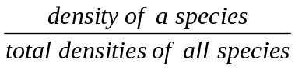 x 100

frequency =  x 100

relative frequency =  x 100

importance value =

Name ______________________

10. Summarize your data in a table.

Species | Density | Relative  Density | Frequency | Relative Frequency | Importance Value

11. Carefully compare your results with those obtained by the other groups. Contrast the total number of species (or the species diversity), the type of species, and any other that is summarized in the table above. Discuss the significance of the data and how you can explain it. One way of numerically estimating species is by calculating a species diversity index. One example is the Simpson's diversity index (D):

D = 

where: N = total number of species in all 10 quadrats
n = number of individuals of a species in all 10 quadrats

Area sampled | Number of species | Diversity index

Name ______________________

12. The Cole's coefficient of association (C_{a}) tests the possibility that in your 10 quadrats a particular species (A) tends to be associated with another (B), or that the species avoid each other. To do so, determine the number of quadrats where both species are present (a), where species A is present but B is absent (b), where A is absent but B present (c), and where both are absent (d) as follows:

a  present  Species A | b
c  absent | d
present
absent

Species B

C_{a} = 

If: C_{a} = + = suggestion of an association

= – = suggestion of avoidance

= 0 = distribution independent from each other

Species tested:

Species A =

Species B =

C_{a} =

Result =

Possible reason for results =

Name ________________________
Review Questions:

1. Did the results of this exercise support any hypotheses or suggestions you or your group made earlier concerning the distribution of organisms in the rocky shore you have studied? What additional experiments or investigations do you think can be made to provide additional information?

2. Were you able to observe any particular patterns in the distribution, or spacing, that individuals of a species displayed on the surface of the rock-- distribution that may have been classified as random, regular, or patchy? Hint: see Figure 13.4 in Marine Biology, Seventh Edition.

3. Suppose that by mistake your transect deviates a bit into a surface that is lower in the intertidal. Can you tell by the type of organisms that you begin to find in quadrats? Any particular species?

Name ________________________

4. Quadrats along a transect were selected at random. How can we randomly select an area along a particular intertidal height?

5. The Simpson's diversity index can be useful under certain conditions. Under what conditions do you think it is of little help?

