Chapter 1
The Study of Body Function

Chapter Scope
After introducing physiology, chapter 1 presents a basic review of human organs, tissues, and control systems. Also featured here is a description of the biological methods of communication and controls that exist between these various organs, tissues, and systems in the body. The four primary tissues of the body — muscle, nerve, epithelium, and connective tissues — are all present in skin, an example of an organ. As you read the descriptions of how these tissues function independently, remember that they also perform in concert with other tissues in the body as smoothly operating systems. Most of these systems will be presented in the chapters that follow.
The underlying theme of any physiology course is summed up in the critical, but difficult-to-describe term homeostasis. Homeostasis can be defined as the ability of the body to keep almost all internal body processes within normal limits, despite the many wide variety of forces and changes that occur externally. Each subsequent chapter will allude to, if not directly demonstrate, homeostasis at work. Operating through negative feedback mechanisms, homeostasis will oppose the initial stress on the body and conditions will return toward normal. Here, you will be introduced to the concept of homeostasis through examples of the nervous (electrical signals with neurotransmitter chemicals) system and the endocrine (hormone chemicals) system.

I. Introduction to Physiology
Human physiology is the study of how the human body functions, with emphasis on specific cause-and-effect mechanisms. Knowledge of these mechanisms has been obtained experimentally through applications of the scientific method.

A. Multiple Choice
You will find multiple choice questions in each section of this study guide. Select the letter of the best choice to answer each of the following questions or to complete each phrase. Write that letter in the space provided. Answer all of the questions in each section, then check your work with the correct answers provided at the end of this chapter. Remember, if you are having difficulty, be sure to reread the corresponding section in your textbook before going on to the next set of questions. These exercises will help prepare you for similar questions you may see on “scantron”-type examinations. Good luck!
- Physiology is the study of
a. biological function
b. how the body works
c. cause-and-effect sequences in the body
d. observations that overlap many other sciences
e. All of these are correct.
- Which of the following statements about physiology is not correct?
a. The ultimate objective is to understand the normal functioning of the human body.
b. Pathophysiology is a related science that complements normal physiology.
c. The study of disease processes has helped our understanding of physiology.
d. Because animals are so different from humans, the study of comparative physiology has very little direct application to human physiology.
e. All of these statements are correct.
- According to scientific theory, all observations must be
a. published
b. reproducible
c. clinical
d. predictable
e. None of these is correct.
- In the development of new pharmaceutical drugs, which phase of human or clinical trials is the drug tested on the target human population (for example, those with hypertension?)
a. phase I clinical trials
b. phase II clinical trials
c. phase III clinical trials
d. phase IV clinical trials

B. True or False/Edit
Decide whether the following statements are true or false. In the space provided write “T” if the statement is true and “F” if the statement is false. For statements that are false, edit (rewrite) the statement so that it now becomes true. As an example, the first statement is false and is edited for you. Notice that there are many ways to “edit” or rewrite the false statement to make it true. Always try the simplest method, and remember, that the answers and sample “edits” are provided for you at the end of each chapter.
- Physiology is the study of disease processes in the body. (False/Edit: Physiology is the study of how the body works normally at tasks essential for life [to maintain homeostasis].)
- The scientific method is based on a confidence in our rational ability, honesty, and humility.
- Fact: All athletes have lower resting pulse rates than sedentary people.
- Only 10% of all newly developed drugs are considered safe enough to advance from preliminary testing on experimental animals to clinical trials on humans.

II. Homeostasis and Feedback Control
The regulatory mechanisms of the body can be understood in terms of a single, shared function: that of maintaining constancy of the internal environment. A state of relative constancy of the internal environment is known as homeostasis, and it is maintained by effectors that are regulated by sensory information from the internal environment.

A. Multiple Choice
- In homeostasis, the critical concept describing the body's response to any deviation from some particular setpoint (such as temperature rising when exercising), which results the activation of mechanisms to oppose that deviation (return temperature toward normal), is known as
a. negative feedback
b. the integrating center
c. positive feedback
d. milieu interior
- Which of the following mechanisms of homeostasis is analogous to the house thermostat setting that operates to regulate the temperature in the house?
a. sensor
b. the set point
c. effector
d. integrating center
- Arrange the following terms in the sequence that best reflects how the body maintains homeostasis (for example, during a fever). (1) effector activated; (2) integrating center process; (3) negative feedback loops activated; (4) sensor activated; (5) return to set point
a. 2 4 3 1 5
b. 5 3 2 4 1
c. 4 3 1 5 2
d. 4 2 1 3 5
e. 1 2 4 5 3

- During homeostasis, increasing or decreasing the activity of particular effectors is the primary role of the
a. integrating center
b. sensor
c. muscle or gland
d. positive feedback loops
e. negative feedback loops
- The term, innervate means to
a. activate glands to release hormones
b. inactivate glands
c. activate nerve impulses in nerve fibers
d. inactivate nerve fibers
e. inactivate both glands and nerve fibers
- Hormone secretion can result from stimulation of endocrine glands by
a. nerves (releasing neurotransmitter chemicals)
b. other specific body chemicals
c. stimulation by other hormones
d. a and c only
e. All of these are correct.

B. True or False/Edit
- Most of our present knowledge of human physiology in the twentieth century has been gained through the expansion in the fields of biotechnology and molecular genetics.
- In medicine, illness occurs when the body is unable to maintain constancy within the internal environment.
- In homeostasis, the activation of effectors generally refers to the specific activation of muscles or bones.
- An initial rise in blood glucose level followed by a subsequent further increase in blood glucose is an example of negative feedback.
- Bleeding from a cut activates a positive feedback “cascade,” whereas the subsequent formation of a blood clot represents the completion of a negative feedback loop.
- The regulation of homeostasis by messages sent from the nervous and endocrine systems to a target organs somewhere else in the body, is an example of intrinsic control.
- Although hormones are carried by the blood to all organs in the body, only those target organs displaying receptor proteins specific for those hormones will respond.

III. The Primary Tissues
The organs of the body are composed of four different primary tissues each of which has its own characteristic structure and function. The activities and interactions of these tissues determine the physiology of the organs.

A. Multiple Choice
- Which primary tissue features intercalated discs?
a. epithelial
b. nervous
c. muscle
d. connective
e. None of these is correct.
- Which of the following is not considered epithelial tissue?
a. simple membranes
b. exocrine glands
c. endocrine glands
d. brain and spinal cord
e. All of these are considered epithelial tissue.

- The type of epithelium best adapted for diffusion and filtration is
a. simple squamous
b. simple cuboidal
c. columnar
d. ciliated columnar
- The type of epithelium that lines the ducts of exocrine glands and part of the tubules of the kidney nephron is
a. simple squamous
b. simple cuboidal
c. columnar
d. ciliated columnar
- Which of the following is not characteristic of epithelium?
a. It may be simple or stratified.
b. It may contain goblet cells.
c. It may be keratinized (or cornified).
d. It is constantly lost (exfoliated) and replaced.
e. All of these are characteristic of epithelium.
- Which of the following is not an exocrine gland?
a. liver
b. pancreas
c. spleen
d. prostate
e. sebaceous gland
- Tendons (muscle to bone) and ligaments (bone to bone) are examples of
a. dense irregular connective tissue
b. dense regular connective tissue
c. loose (areolar) connective tissue
d. cartilage
- Lamellae, lacunae, and canaliculi are characteristic of
a. connective tissue proper
b. cartilage
c. bone
d. blood
- Cells that have similar function are grouped into categories, called
a. systems
b. organs
c. primary tissues
d. tissues
- Organs that work together, performing functions in common, may be grouped into
a. systems
b. organisms
c. primary tissues
d. tissues
- Which of the following is not a primary tissue?
a. muscle tissue
b. bone tissue
c. nervous tissue
d. epithelial tissue
e. connective tissue
- Which of the following cell types is actually a syncytium, that is, a multinucleate mass formed from the union of separate cells during embryonic development?
a. myofibers
b. osteocytes
c. adipocytes
d. neurons

B. True or False/Edit
- Histology is the study of microscopic anatomy.
- Smooth and cardiac muscles are voluntarily controlled.
- Each skeletal muscle cell or fiber (myofiber) is controlled individually by nerve fibers so that the overall muscle strength of contraction can be varied or “graded.”
- Intercalated discs couple myocardial cells mechanically and electrically.
- Heart muscle (myocardial) cells can be stimulated to contract individually, like skeletal muscle fibers.
- Peristalsis is a process requiring skeletal muscle contractions.
- Supporting cells are more numerous than neurons, do not conduct impulses, and are able to divide by mitosis throughout life.
- Columnar epithelial cells with projecting cilia are located in many respiratory passages and in the uterine (fallopian) tubes of females.
- Structures collectively called junctional complexes and the basement membrane are also features of epithelial tissues.
- The digestive tract is considered an outside or external body surface.
- The numerous eccrine (or merocrine) sweat glands secrete a dilute salt solution that evaporates and cools the skin during thermoregulation.
- Epithelial tissue consists of cells that form membranes, that cover and line the body surfaces, and consists of glands which are derived from these membranes.
- Endocrine glands secrete chemicals through a duct that leads to the outside of a membrane and thus, leads to the outside of a body surface.
- Endothelium is a unique single layer of squamous epithelial cells that forms a thin membrane lining found along the lumen of all blood vessels.
- The characteristic body odor of the axillae (underarms) and pubic regions is due to the presence of bacteria that thrives on a protein-rich fluid secreted by local apocrine sweat glands.
- Bile is an exocrine secretion of the pancreas.
- Adipose tissue is a specialized type of loose connective tissue, composed of cells known as adipocytes.

IV. Organs and Systems
Organs are composed of two or more primary tissues that serve the different functions of the organ. The skin is an organ that has numerous functions provided by its constituent tissues.

A. Multiple Choice
- Which of the following glands is not exocrine?
a. hair follicle
b. apocrine sweat gland
c. eccrine sweat gland
d. sebaceous gland
e. All of these are exocrine.
- The largest organ in the body in terms of its surface area, is the
a. liver
b. stomach
c. skin
d. brain
e. heart
- Which of the following is not a cutaneous sensation?
a. pain
b. pressure
c. heat/cold
d. taste
e. touch

- Which substance is a hormone secreted by the endocrine glands of the skin into the bloodstream?
a. melanin
b. vitamin D
c. hemoglobin
d. keratin
e. collagen
- Which of the following organ systems of the body primarily functions in the regulation of blood volume and composition?
a. endocrine system
b. circulatory system
c. urinary system
d. digestive system
e. reproductive system
- Which of the following organ systems of the body primarily functions in defense of the body against invading pathogens?
a. immune system
b. circulatory system
c. integumentary system
d. digestive system
e. respiratory system
- Tissue fluid, or interstitial fluid, is an aqueous compartment that belongs to the
a. intracellular compartment
b. extracellular compartment

B. True or False/Edit
- Sebaceous glands secrete oily sebum into hair follicles, which transport the sebum to the cornified surface of the skin to aid in lubrication.
- Both sensory and motor nerve fibers (neurons) are found in the skin.
- Blood flow to the skin is partially controlled by motor nerve fibers to smooth muscle in the walls of cutaneous blood vessels that regulate the degree of constriction or dilation.
- The connective tissue found in most organs is an ideal location for blood vessels, nerve endings, scattered cells for fighting infection, and possibly glandular tissue as well.
- As major organs of the circulatory system, bone marrow and lymphoid organs function primarily in the defense of the body against invading pathogens.
- Skin, hair, and nails are major organs of the integumentary system.
- Within the two major aqueous compartments that can be identified in tissues, organs, and systems, only the extracellular compartment is subdivided into blood plasma and tissue (interstitial) fluid.

C. Label the Figure and Application An Organ: The Skin
The skin is an excellent example of an organ that is composed of the four tissue types. Figure 1.1 is a diagram of the skin with structures numbered 65-77. Identify each structure and write the correct term in the space provided after the number in the figure. If you need help, see figure 1.21 in the text.

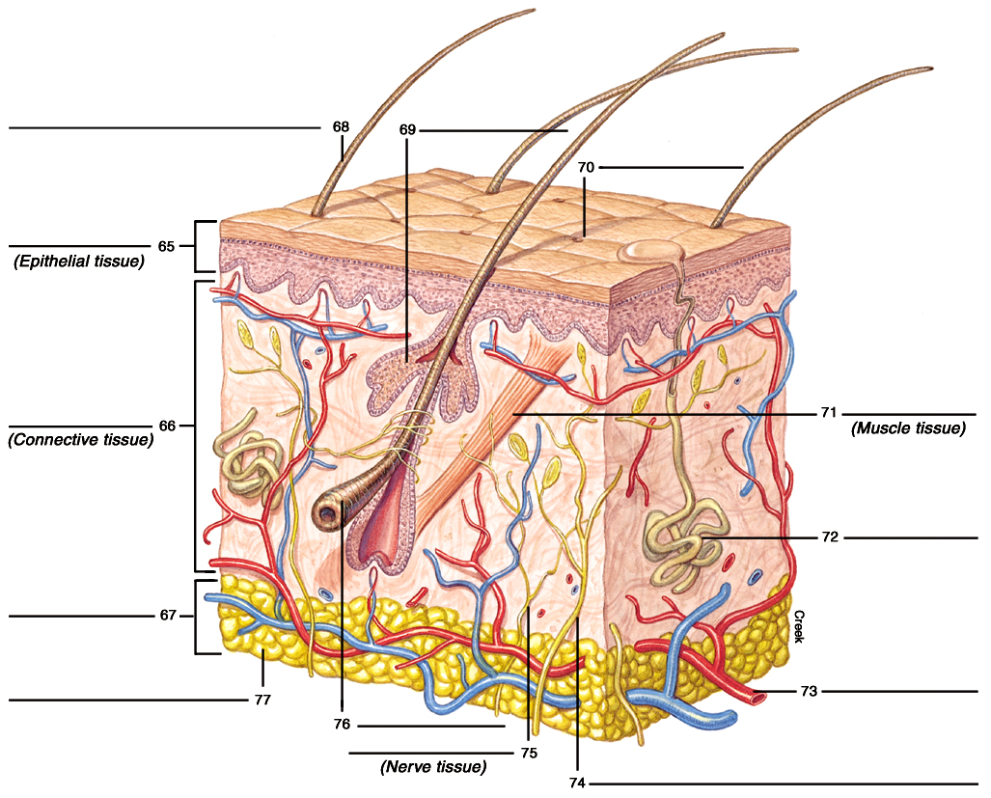

Figure 1.1 Diagram of skin. The skin is an organ that contains all four types of primary tissues.

Using Figure 1.1 as a reference, read questions 78-82 that follow and fill in the blanks with the correct word or phrase that applies to the skin.
78. The three examples of exocrine glands are the _______________ gland, which secretes sebum, the _______________ gland, whose watery secretion cools the skin, and the _______________ (two words).
79. The blood supply to skin arrives from the _______________ tissue level, then branches into the layer, but does not enter the _______________ layer of the skin, which is fed by diffusion.
80. Notice the ideal location of the Pacinian corpuscle for the sensation of ____________.
81. The subcutaneous tissue, which contains adipose or ____________ cells, nerves, and blood vessels, is also known as the _______________.
82. Adipose tissue is a type of _______________ (primary) tissue.

Chapter Review

A. Completion
83. Physiology is the study of how the body works - from _______________ to _______________, to _______________, to systems.
84. By asking questions beginning with “_______________,” scientists studying physiology discover answers that involve _______________-and-_______________ sequences during experiments.
85. The four primary tissues are _______________, _______________, _______________, and _______________.
86. The three types of muscle tissue are _______________, _______________, and _______________; of which only _______________muscle is not striated.
87. Epithelial membranes provide a protective barrier of cells tightly joined by _______________ _______________ (two words), as they cover and line the body surfaces. These membranes may be simple or _______________; and consist of _______________, _______________, or _______________cell shapes.
88. Invaginated epithelial tissue may form exocrine glands with _______________, or form endocrine glands secreting _______________ into the bloodstream.
89. Four types of connective tissue are _______________ _______________ _______________, _______________, _______________, and _______________.
90. Skin is a good example of a (an) _______________.
91. Three exocrine glands found in the dermis of the skin are _______________ _______________, _______________ _______________, and _______________ _______________.
92. Also in the dermis of the skin are the _______________ pili muscles and muscles constricting and dilating the walls of _______________; both of these muscles are composed of __________ muscle fiber type.
93. Homeostasis is maintained through _______________feedback loops involving sensors, integrating centers, and _______________, which communicate extrinsically through messengers of the _______________ and _______________ systems.
94. Both neurotransmitters and hormones bind with unique membrane _______________ proteins and control specific _______________ organs.

B. Crossword Puzzle — Tissues, Organs, and Control Systems
Across

1. Dense, regular type of connective tissue connecting muscle to bone
6. Maintaining a constant internal environment
9. Opposing a rise or fall in body temperature or blood glucose during homeostasis (2 words)
12. 37°C is an example of _________ point in homeostasis
13. Homeostasis strives to maintain all values at their _______________ (2 words)
15. Adipose tissue of the hypodermis
16. Fibrous protein common to most connective tissue
19. Nerve fiber control over muscle or gland effector activity
21. Property of muscle in which the strength of its contraction can vary from weak to strong
22. The muscle or gland cell that receives nerve impulses
23. Single cytoplasmic extension of the neuron cell body
24. Connective tissue containing lamellae, lacunae, and canaliculi
25. Study of biological function emphasizing body mechanisms that involve cause-and-effect
26. Clusters of secretory ducts in exocrine glands that are squeezed by myoepithelial cells sequences
27. Rhythmic contractions of circular and longitudinal muscle, pushing food through the digestive tract
28. Oily secretion on hair follicles and cornified skin—prevents drying and cracking

Down

1. Watery secretion from lacrimal (exocrine) gland
2. The largest organ in the body
3. Homeostatic process that supports and worsens body changes rather than opposes and returns to normal
4. Cells of stomach or intestine that secrete mucus
5. Receiver of relayed sensory information to process and help maintain homeostasis (examples: brain and spinal cord)
7. Characteristic of exocrine glands
8. Water-resistant protein in dead cells of the cornified epidermis of the skin
10. Physiology seeks answers to help explain cause-and-_______ sequences
11. Study of microscopic anatomy
14. Physiology typically asks the question ______?
17. Cavity or space within an organ or structure—like the inner space within blood vessels or the stomach
18. Simple squamous membrane lining blood vessels; specifically adapted for diffusion and filtration
20. Cells (fibers) of the nervous system that conduct impulses



C. Essay

Essay Tutorial
This essay tutorial will answer the first essay question found in the “Review Activities” section of each chapter in your Human Physiology textbook. Please look for essay question 1. at the end of each text chapter, read it carefully, and let me guide you through one possible answer in this section. Watch for helpful tips and general suggestions on writing the essay or short-answer questions. Learn to spot key words in the questions such as those that I indicate in bold-face type, and to outline your ideas quickly on a separate piece of paper. This will help you organize your thoughts, express yourself clearly, and — since it will be easier to read — result in better scores! Using similar techniques, try the bonus essay questions I have written that follow. Enjoy!
95. Describe the structure of various epithelial membranes, and explain how their structures relate to their functions.

Answer. First, write the bold-faced key words as column headings. Next, list the membranes separately and then complete the descriptions of structure and function. Study Table 1.2 in your textbook for a sample table format.
Epithelial | Membranes | StructureFunction
Simple squamous | Flat | Diffusion and filtration (endothelium)
Simple cuboidal | Cube | Line exocrine ducts and kidney tubules; → transport
Simple columnar | Tall | Stomach and intestinal lining (goblet cells) → barrier
Ciliated columnar | “Oars” | Uterine (fallopian) tubes and respiratory passages;→ movement and filtration
Stratified squamous (many  layers) | Esophagus (nonkeratinized)  Skin (keratinized) | →protection  → protection
Glandular, exocrine | Ducts | Secretions to outside
Glandular, endocrine | No ducts | Hormone release into the blood

Note: Don’t be frustrated if your answer didn’t look like this at first. Be patient — and with practice, your skills will improve. Now, refer to the text for help in answering the remainder of these bonus essay questions, organize your thoughts based on key words in the question, then write your answer clearly and concisely. Good luck!
96. List and describe the structures of the skin that represent the four primary tissues. Include the function of each structure.

97. Blood levels of calcium are held constant (at a set point) by hormones. Parathyroid hormone is one hormone that helps raise the blood calcium concentration. Draw a flow diagram that shows how this hormone would act after you consumed a tall, frothy glass of calcium-rich milk (hint: similar to the glucose-insulin figure).

98. Draw a flow diagram showing how the parasympathetic nerve stimulation to the heart slows the average heart rate of 70 beats per minute (bpm), while sympathetic nerve stimulation speeds up the average heart rate (hint: see figure 1.4 for help).

Answers — Chapter 1

- Introduction
- 1. e, 2. d, 3. b, 4. b
- 5. F, 6. T, 7. F—Replace “fact” with “hypothesis,” 8. T
- Homeostasis and Feedback Control
- 9. a, 10. b, 11. d, 12. a, 13. c, 14. e
- 15. T, 16. T, 17. F—Replace “bone” with “glands,” 18. F—Replace “negative” with “positive,” 19. T,
20. F—Replace “intrinsic” with “extrinsic,” 21. T
- The Primary Tissues
- 22. c, 23. d, 24. a,
25. b, 26. e, 27. c,
28. b, 29. c, 30. d,
31. a, 32. b, 33. a,
- 34.T, 35. F—Replace “voluntarily” with “involuntarily,” 36. T, 37. T, 38. F—Replace “can be” with “cannot be,” 39. F—Replace “skeletal” with “smooth,” 40. T,
41. T, 42. T, 43. T,
44. T, 45. T, 46. F—Replace “Endocrine” with “Exocrine,” 48. T, 49. F—Replace “pancreas” with “liver,” 50. T
- Organs and Systems
- 51. e, 52. c, 53. d,
54. b, 55. c, 56. a, 57. b
- 58. T, 59. T, 60. T,
61. T, 62. F—Replace “circulatory” with “immune,” 63. T,
64. T
- 65. epidermis,
66. dermis,
67. hypodermis, 68. hair,
69. sebaceous gland,
70. sweat pore,
71. arrector pili muscle, 72. sweat gland,
73. blood vessel (arteriole), 74. sensory nerve, 75. motor nerve, 76. hair bulb,
77. adipose tissue,
78. sebaceous; sweat; hair follicle,
79. subcutaneous; dermis; epidermis,
80. pressure, 81. fat; hypodermis,
82. connective
Chapter Review
- 83. cells; tissues; organs, 84. how?; cause; effect, 85. connective; epithelial; nervous; muscle, 86. smooth; skeletal; cardiac; smooth, 87. junctional complexes; stratified, squamous; cuboidal; columnar, 88. ducts; hormones, 89. connective tissue proper; cartilage; bone; blood, 90. organ, 91. hair follicles; sweat glands; sebaceous glands,
92. arrector; blood vessels; smooth,
93. negative; effectors; endocrine; nervous,
94. receptor; target

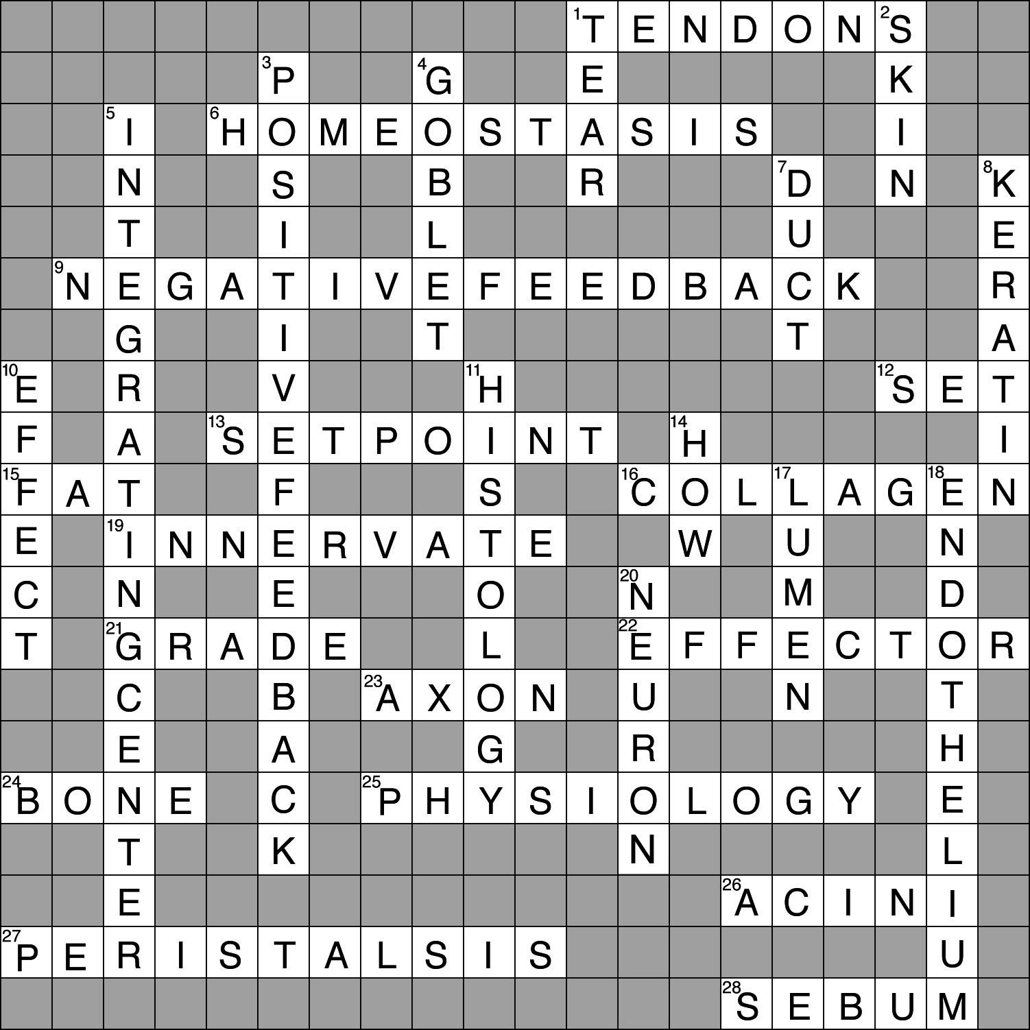
- Crossword Puzzle

