Chapter 8
The Central Nervous System

Chapter Scope
The brain and spinal cord are structural and functional nervous tissue of the body that together compose the central nervous system (CNS). The action potentials (nerve impulses) that come into the brain via sensory (afferent) neurons and exit via motor (efferent) neurons are interconnected by numerous association neurons. Within specific portions of the brain these action potentials are interpreted, giving us the ability to speak, express emotion, be motivated, move muscles, and remember things.
The deeper structures of the brain, such as the thalamus, hypothalamus, and medulla oblongata, are critical interpretive and relay centers for information traveling into and out of the brain. In addition, this more primitive area of the brain provides an essential link to the complex endocrine system. Triggered by nerve impulses, endocrine glands release many hormones that ultimately control many of the body's homeostatic processes, especially those of the viscera (internal tissues).
The spinal cord can be subdivided into ascending (sensory) and descending (motor) tracts (axon bundles). The spinal cord houses the pathways for the motor neurons originating in the motor cortex (precentral gyrus), that controls voluntary muscle contractions. This route directs nerve impulses down through important brain regions such as the basal nuclei (or basal ganglia) and the cerebellum, where rough, voluntary commands are modulated into smooth, coordinated contractions. Selected spinal cord tracts (and cranial nerves) also carry sensory action potentials in the opposite direction. Many of these ascending pathways ultimately arrive at the sensory cortex (postcentral gyrus) for interpretation of the various senses. The sensory system will be described in more detail in the next chapter. Of further interest is the simple reflex arc, a pathway of both sensory and motor neurons joined at the spinal cord, that is an integral part of all voluntary muscle movements.

I. Structural Organization of the Brain
The brain is composed of an enormous number of association neurons and accompanying neuroglia, arranged in regions and subdivisions. These neurons receive sensory information, direct the activity of motor neurons, and perform such higher brain functions as learning and memory.

A. Multiple Choice
- The embryonic tissue layer that eventually forms the epidermis of the skin and the nervous system is the
a. ectoderm
b. mesoderm
c. endoderm
- The telencephalon and diencephalon are subdivisions of the
a. prosencephalon
b. mesencephalon
c. rhombencephalon
- Neuron cell bodies and dendrites deep within the brain form gray aggregations or gray matter known as
a. the cortex
b. ventricles
c. the cerebrum
d. nuclei

B. True or False/Edit
- Eventually, the neural tube will become the central nervous system in the growing embryo.
- The hindbrain, or mesencephalon, eventually divides into the metencephalon and myelencephalon brain regions.
- The hollow center of the neural tube eventually forms the ventricle cavities of the brain and central canal of the spinal cord.
- The adult brain receives about 20% of the total blood flow from the heart each minute.

II. Cerebrum
The cerebrum, consisting of five paired lobes within two convoluted hemispheres, contains gray matter in its cortex and in deeper cerebral nuclei. Most of what are considered to be the higher functions of the brain are performed by the cerebrum.

A. Multiple Choice
- The largest portion of the brain (80% of its mass) is the
a. cerebellum
b. cerebrum
c. hypothalamus
d. basal ganglia
e. None of these is the largest portion of the brain.
- Which of the following is not a lobe of the cerebral cortex?
a. occipital
b. parietal
c. insula
d. cerebellar
e. temporal
- Which of the following does not send somatesthetic sensory information to the cerebral cortex sensory area located in the postcentral gyrus?
a. skin (cutaneous)
b. muscle fibers
c. tendons
d. joints
e. All of these regions are somatesthetic sensory areas.
- Somatesthetic sensory information is interpreted in the
a. cerebellum
b. precentral gyrus
c. basal ganglia
d. postcentral gyrus
e. occipital cortex
- The size of the sensory and motor maps on the cerebral cortex are determined by the
a. size of the area represented in square meters
b. precise location of the area represented in the body
c. highest density of receptors or greatest number of effectors in the area represented
d. time of development during embryonic growth
- The lobe interpreting sensory information from the cochlea, and for processing both auditory and visual information, is the
a. frontal
b. parietal
c. temporal
d. occipital
e. insula
- Which of the following new techniques for visualizing the brain utilizes complex manipulation of x-ray absorption data obtained from tissues of different densities?
a. computer tomography (CT)
b. positron-emission tomography (PET)
c. magnetic resonance imaging (MRI)
- Which of the following new techniques for visualizing the brain creates excellent images by detecting emitted radio wave signals released from stimulated protons aligned in the tissues?
a. computer tomography (CT)
b. positron-emission tomography (PET)
c. magnetic resonance imaging (MRI)
- The EEG pattern recorded from the parietal and occipital regions that is characteristic in an awake, yet relaxed person whose eyes are closed, is
a. alpha
b. beta
c. theta
d. delta
- The basal nuclei (or basal ganglia) are masses of gray matter that function primarily in the
a. perception of auditory and visual stimuli
b. control of voluntary movements
c. relay of sensory and motor information
d. synthesis and release of important regulatory hormones
- The study of speech and language disorders (aphasias) have contributed greatly to our understanding of the brain, particularly that region known as
a. basal ganglia
b. cerebellum
c. Broca's and Wernicke's areas
d. limbic system
- That brain region formerly known as the “smell brain” but now known as a center for basic emotional drives is the
a. hypothalamus
b. pituitary
c. limbic system
d. basal ganglia
e. Broca's and Wernicke's areas
- Which of the following processes is not thought to be regulated by the hypothalamus and limbic system?
a. absolute fear
b. language interpretation
c. feeding and satiety
d. sexual drive and sexual behavior
e. aggression (rage)
- That portion of the brain thought to be involved primarily in the consolidation of short-term into long-term memory, is the
a. cerebral cortex
b. hypothalamus
c. limbic system
d. medial temporal lobe
e. basal ganglia
- That portion of the brain most involved in the memory of emotional responses and particularly in the memory of fear, is the
a. hippocampus
b. amygdala portion of the limbic system
c. cerebellum
d. basal nuclei
e. cerebral cortex
- Long-term potentiation (LTP) is a type of synaptic learning that is proposed to involve all of the following events, except
a. use of a glutamate as a neurotransmitter
b. binding of neurotransmitter to NMDA receptors
c. stimulation of stem cells to divide, forming new neurons
d. opening channels, allowing Ca²⁺ to enter
e. nitric oxide is produced to stimulate neurotransmitter release

B. True or False/Edit
- Contrary to early belief, the brains of adult mammals have neural stem cells, located next to the ventricles (cavities), that are able to differentiate into new neurons and glial (supporting) cells.
- The elevated folds of the cerebral surface are sulci, and the depressed grooves are called gyri.
- The precentral gyrus is located in the frontal lobe and is involved in control of motor neuron activity.
- The fingers and face have a higher density of sensory receptors and more muscles for innervation, and so, have a correspondingly larger representation on the sensory and motor regions of the cerebral cortex, respectively.
- The parietal lobe is the primary area for vision and for the coordination of eye movements.
- That portion of the cerebrum most implicated in memory encoding and in pain sensation (visceral) and in coordinating the cardiovascular responses to stress, is the temporal lobe.
- The upper caudate nucleus and the lower lentiform nucleus make up the corpus striatum, a prominent portion of the basal nuclei (ganglia).
- Each cerebral hemisphere ultimately receives information from both sides of the body as they intercommunicate via the corpus callosum tracts.
- Cerebral lateralization refers to the specialty of function delegated to one hemisphere or the other, while cerebral dominance is related to the concept of handedness (right or left).
- The left hemisphere is more adept than the right hemisphere at visuospatial tasks, such as reading maps or finding the way around an unfamiliar house.
- People with Broca’s aphasia produce incomprehensible speech that has been described as a “word salad”.
- The Papez circuit refers to the closed pathways that interconnect the limbic system, the thalamus, and the hypothalamus for processing information regarding emotion.
- Long-term memory may involve relatively permanent changes in the neurons and synapses involved, such as the synthesis of new proteins.

C. Label the Figure — Lobes and Important Regions of the Left Cerebral Cortex
The cerebral cortex is characterized by numerous folds and grooves called convolutions. The elevated folds of the convolutions are called gyri, and the depressed grooves are the sulci (fissures). Each cerebral hemisphere is subdivided by deep sulci, or fissures, into five lobes, four of which are visible from the surface. Study figure 8.1 below and label the four lobes and the two sulci (the lateral sulcus and the central sulcus). Next, on the lines of the figure that point to the various cortical brain regions, write the important general function attributed to that area of the brain. Then, compare your answers with those in figure 8.6 in your text. Pay particular attention to the sensory and motor areas that located adjacent to the central sulcus. Study hard!
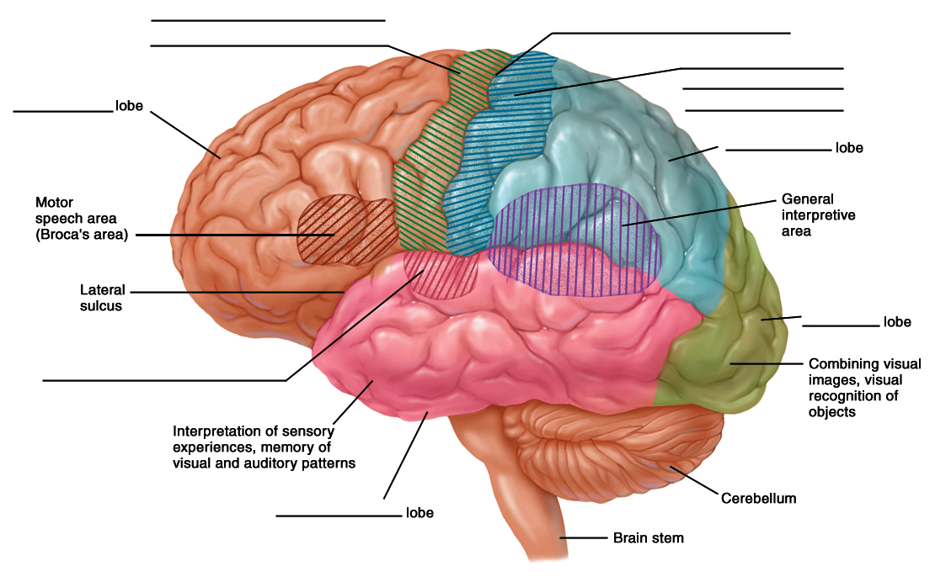
Figure 8.1
The lobes of the left cerebral hemisphere showing the principle motor and sensory areas of the cerebral cortex.

III. Diencephalon
The diencephalon is the part of the forebrain that contains such important structures as the thalamus, hypothalamus, and pituitary gland. The hypothalamus performs numerous vital functions, most of which relate directly or indirectly to the regulation of visceral activities by way of other brain regions and the autonomic nervous system.

A. Multiple Choice
- That portion of the brain acting primarily as a relay center through which all sensory information (except smell) passes on the way to the cerebrum, is the
a. thalamus
b. hypothalamus
c. hippocampus
d. limbic system
e. basal nuclei (ganglia)
- Melatonin is a hormone secreted by the
a. thalamus
b. hypothalamus
c. pituitary gland
d. pineal gland
e. None of these brain regions secrete melatonin.
- The choroid plexus located in each of the cerebral ventricles is primarily responsible for
a. relaying sensory information to the cortex
b. altering motor control over voluntary muscle action
c. synthesizing neurotransmitters for cranial nerves
d. secreting cerebrospinal fluid (CSF)
- Which of the following vital physiologic functions is not centered in the hypothalamus?
a. hunger
b. thirst
c. control over heart rate and blood pressure
d. control over body temperature (“thermostat”)
e. control over pituitary gland secretion of hormones
- A “somatic response” refers to a response by the
a. whole body
b. sensory system only
c. skeletal (voluntary) muscles only (for example, shivering)
d. visceral glands of the autonomic (involuntary) nervous system only
e. skin and connective tissues (muscle and bone)

B. True or False/Edit
- The only sensation that is not relayed through the thalamus en route to the cerebrum for interpretation is the sense of taste.
- The hormone melatonin may play a role in the hormonal control of reproduction.
- With regard to hunger, the hypothalamus has opposing “feeding” and “satiety” (fullness) centers that are located in the lateral and medial regions, respectively.
- The supraoptic and paraventricular nuclei are specialized neurons located in the hypothalamus where the important hormones vasopressin (ADH) and oxytocin are made.
- The anterior pituitary is known as the neurohypophysis, while the posterior pituitary is known as the adenohypophysis.
- The hypothalamo-hypophyseal tract connects the hypothalamus to the posterior pituitary gland.

IV. Midbrain and Hindbrain
The midbrain and hindbrain contain many important relay centers for sensory and motor pathways, and are particularly important in the control of skeletal movements by the brain. The medulla oblongata, a vital region of the hindbrain, contains centers for the control of breathing and cardiovascular function.

A. Multiple Choice
- That portion of the brain housing the “four bodies” known as the corpora quadrigemina is the
a. midbrain
b. hindbrain
c. diencephalon
d. prosencephalon
e. cerebellum
- The positive reinforcement that encourages drug abuse – including nicotine, heroin, morphine, cocaine, and amphetamines – involves the release of dopamine from the ______ of the midbrain region.
a. mesolimbic system
b. nigrostriatal system
c. cerebral penduncles
d. corpora quadrigemina
e. red nucleus
- The apneustic center and pneumotaxic center that work together to influence respiratory movements, are located in the
a. hypothalamus
b. cerebellum
c. midbrain
d. pons
e. medulla oblongata
- Damage to the cerebellum, the second largest structure in the brain, usually results in
a. long-term and short-term memory loss
b. loss of visual and auditory reflexes
c. loss of respiratory and cardiovascular control
d. ataxia or lack of muscular coordination
- Which of the following is not a vital center within the medulla oblongata portion of the myelencephalon?
a. vasomotor center (diameter of blood vessels)
b. center for rage and aggression (deep emotion)
c. parasympathetic inhibitory control of the heart rate
d. respiratory center (with the pons) for control of breathing
e. All of these are vital centers in the medulla oblongata.
- That portion of the brain most responsible for the general arousal of the cerebral cortex when a variety of sensory sources are activated, is the
a. cerebellum
b. hypothalamus
c. limbic system
d. medulla oblongata
e. reticular activating system (RAS)

B. True or False/Edit
- The superior colliculi of the corpora quadrigemina portion of the midbrain are involved in visual reflexes, while the inferior colliculi are involved in auditory reflexes.
- The mesencephalon is also known as the hindbrain and contains the cerebral peduncles, red nucleus, and the substantia nigra.
- The metencephalon is composed of the pons and the cerebrum.
- The pons contains several nuclei (cell bodies of neurons) associated with the control and interpretation of specific cranial nerves.
- The cerebellum receives sensory information from proprioceptors and, through relays with other nuclei, coordinates muscle movements.
- Skeletal muscle (motor) learning and coordination needed to touch your nose with your finger, bring a fork of food to your mouth, or find your keys in your pocket requires proper functioning of the cerebellum.
- The pyramids of the medulla are characterized by crossing-over or decussation of nerve fiber tracts to the contralateral (opposite) side of the medulla.
- Falling asleep and loss of consciousness due to anesthesia perhaps both involve suppression of the reticular activating system (RAS).

V. Spinal Cord Tracts
Sensory information from receptors throughout most of the body is relayed to the brain by means of ascending tracts of fibers that conduct impulses up the spinal cord. When the brain directs motor activities, these directions are in the form of nerve impulses that travel down the spinal cord in descending tracts of fibers.

A. Multiple Choice
- The term “funiculi” refers to
a. specific clusters of motor and sensory nuclei (cell bodies) in the spinal cord
b. spinal cord ascending and descending columns of axons (myelinated, white matter)
c. regions of gray matter crossovers (decussations) in the spinal cord
d. autonomic vital centers located in the spinal cord
- Which of the following descending tracts is not extrapyramidal?
a. reticulospinal
b. corticospinal
c. rubrospinal
d. vestibulospinal
e. All of these tracts are extrapyramidal.

B. True or False/Edit
- Unlike the brain, the spinal cord white matter is located in a central “H” pattern, with gray matter found on the outside.
- The spinothalamic and corticospinal tracts are both descending tracts in the spinal cord.
- All descending motor tracts from the brain eventually cross over and, thus, innervate muscles on the contralateral side of the body.
- The two major groups of descending tracts from the brain are the corticospinal (pyramidal) and extrapyramidal tracts.
- The positive Babinski sign, or reflex (upward movement of the toes) indicates damage to the extrapyramidal motor pathway.

VI. Cranial and Spinal Nerves
The central nervous system communicates with the body by means of nerves that exit the CNS from the brain (cranial nerves) and spinal cord (spinal nerves). These nerves, together with aggregations of cell bodies located outside the CNS, constitute the peripheral nervous system.

A. Multiple Choice
- How many pairs of cranial nerves exit the brain?
a. twelve
b. eighteen
c. twenty-four
d. thirty-eight
e. forty-six
- How many pairs of spinal nerves exit the spinal cord?
a. twelve
b. twenty-four
c. thirty-one
d. forty-six
e. fifty-two
- The dorsal root ganglion region of the spinal cord contains the
a. axons of motor (efferent) and sensory (afferent) spinal neurons
b. cell bodies of motor and sensory spinal neurons
c. cell bodies of sensory spinal neurons only
d. axons of sensory spinal neurons only
e. cell bodies of motor spinal neurons only
- The ventral root portion of the spinal cord is composed of
a. axons of sensory (afferent) spinal neurons
b. nuclei (cell bodies) of sensory spinal neurons
c. axons of motor (efferent) spinal neurons
d. nuclei (cell bodies) of motor spinal neurons

B. True or False/Edit
- Most cranial nerves are classified as mixed nerves because they contain both sensory and motor fibers.
- All spinal nerves are classified as mixed nerves.
- The cell bodies of all somatic motor neurons are located in the dorsal root ganglia.
- A reflex arc occurs when some sensory stimulus produces an unconscious (that is, the brain is not directly involved) motor response.

Chapter Review

A. Completion
77. The embryonic brain develops into: a forebrain made up of the __________ and the __________; the midbrain which is the __________; and the hindbrain, which contains the __________ and the __________.
78. Cerebrospinal fluid (CSF) is secreted by capillaries called __________, which are found in brain cavities called __________. The large neuron tract that connects the two hemispheres is the__________ __________, which links the __________ (left/right)hemisphere, which is normally dominant in language and analytical ability, with the __________ (left/right) hemisphere, which is normally strong in pattern and face recognition, music, and song creativity.
79. The cerebral cortex and basal ganglia are __________ (gray/white) matter due to collections of cell bodies, whereas the __________ (gray/white) matter is primarily __________. Damage to the __________ (left/right) cerebral cortex produces speech disabilities called __________, involving two specific areas. The area involved in speech comprehension is __________’s area, whereas __________'s area is required for the act of speaking.
80. The two brain regions most associated with emotion are the __________ __________ and the __________. The two forms of memory are __________ -__________ and __________ - __________, which appear to involve various brain areas in a very complex way.
81. In the diencephalon the important sensory relay center is the __________; the epithalamus contains a __________ for CSF production and the __________ gland synthesizing the hormone __________. The diencephalon includes the hypothalamus and pituitary gland.
82. The hypothalamus houses centers for control of __________, __________, __________, and emotions. It also has direct neuron contact with the __________ (anterior/posterior) pituitary and indirect contact via __________ with the __________ (anterior/posterior) pituitary gland.
83. Visual reflexes are coordinated in the __________ __________of the corpora __________, whereas auditory reflexes involve the __________ __________.
84. The pons has two centers for breathing control called the __________ and __________ centers. A few __________ nerves have cell bodies originating in the pons. The medulla oblongata __________ also regulates __________ and controls cardiovascular functions as well.
85. Sensory information travels up __________ tracts, while the two motor tracts are __________. These motor tracts are the __________ or corticospinal tracts—which are nonstop neurons, crossing over or __________ in the medulla oblongata controlling fine muscle movement — and the __________ tracts — composed of many indirect connections among various brain regions and the muscles.
86. There are __________ (#) pairs of cranial nerves which are either __________ (sensory or motor) only or mixed. All __________ (#) pairs of spinal nerves are __________, with cell bodies of sensory neurons in the __________ ganglion, and motor neurons exiting the spinal cord along the __________ root. Sensory, association, and motor neurons may all interact in the subconscious pathway known as the __________.

B. Crossword Puzzle — The Central Nervous System

Across
1. part of the diencephalon—control over the pituitary gland
5. cerebral gray matter
6. descending (motor) tracts may be _________- pyramidal or pyramidal
9. mesencephalon region
10. this system may be a center for various emotions
11. metencephalon region for control and coordination of skeletal muscle movements
12. fluid produced by the choroid plexus of the ventricles
13. area required for mechanical performance of speech
16. afferent neurons of the reflex arc, for example
18. the telencephalon and diencephalon
20. function common to the limbic system and hypothalamus
21. a word for internal tissue functions—controlled by the hypothalamus
24. language disability
25. dorsal or ventral __________
26. important relay center for sensory information
27. a visceral function of the hypothalamus (seek water!)
28. in most people one or the other of these is dominant
29. sensory and motor neurons are part of the __________ arc
Down
2. gland controlled mainly by the hypothalamus
3. hormones from the hypothalamus control the __________ pituitary
4. area of the cortex involved in speech comprehension
5. cerebral hemispheres are joined by the corpus __________
6. test used to measure electrical activity in the brain
7. that part of the neuron that makes brain matter “gray” is the cell __________
8. the metencephalon and the myelencephalon combined
9. important function of the medial temporal lobes, especially the hippocampus
12. consists of two hemispheres
14. important function of the left cerebral cortex—Wernicke's and Broca's areas
15. fluid-filled brain cavities
17. a visceral function controlled by the hypothalamus
19. the thalamus is an important __________ center for sensory information
22. twelve pair of __________ nerves
23. metencephalon source of cranial nerves V through VIII

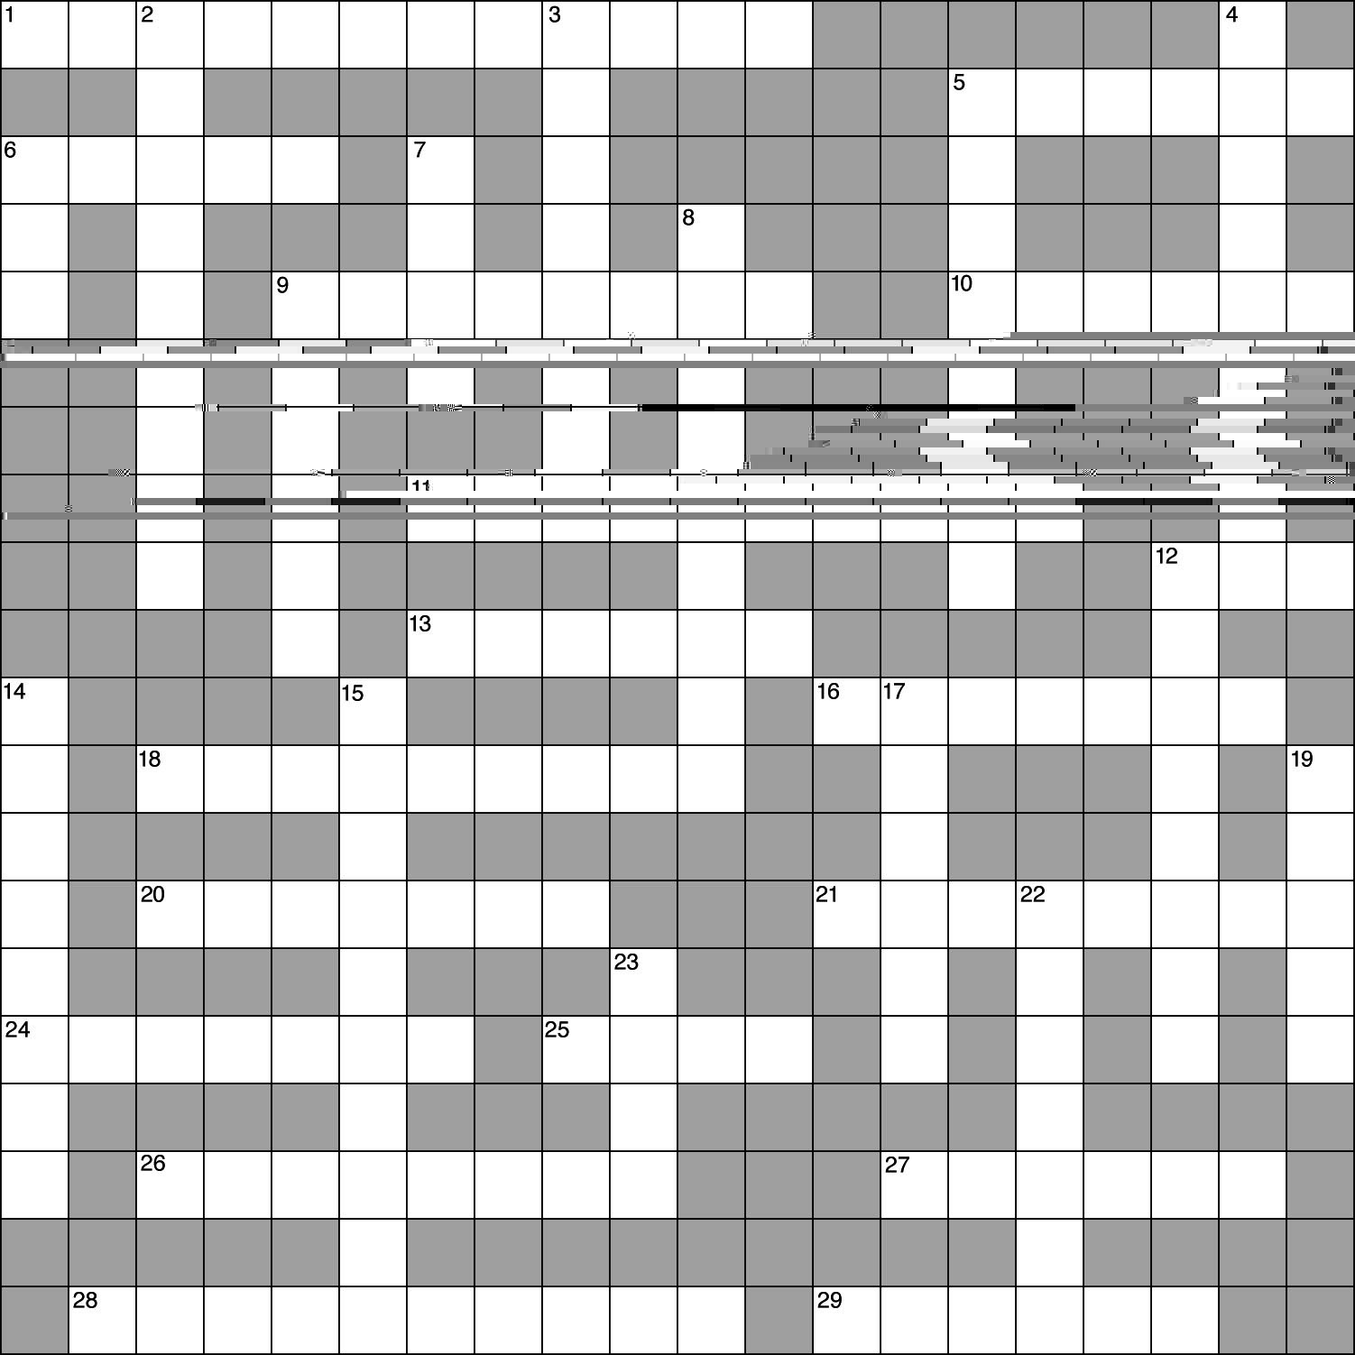
C. Essay

Essay Tutorial
This essay tutorial will answer the first essay question found in the “Review Activities” section of your Human Physiology textbook. Please look for Essay Question 1. at the end of chapter 8, read it carefully, and let me guide you through one possible answer. Watch for key terms in bold-face type, helpful tips and general suggestions on writing the essay or short-answer questions. Enjoy!
87. Define the term decussation and explain its significance in terms of the pyramidal motor system.

Answer: First, define the term decussation as the crossover of neuron fibers from one side of the brain or spinal cord to the other. The pyramidal tracts are exclusively descending and originate primarily from the motor (precentral gyrus) cortex, traveling nonstop to the spinal cord. Along the way, however, these neurons decussate in the medulla oblongata, forming visible triangular patterns on the dorsal surface of the medulla—hence the name pyramids. The major significance of this crossing-over means that the right cerebral hemisphere controls the muscles of the left half of the body, while the left hemisphere controls muscles of the right side of the body.
[You see, some “essay” answers can be short and sweet. However, always reread the question to be sure that all parts of the question have been answered. Too many of my students have needlessly lost important points with incomplete answers. Have you? For extra practice, try a couple more, OK?]
88. What does EEG stand for? Explain the neuron events that are responsible for the erratic cycles recorded on the EEG.

89. Describe the location of the cerebellum, its size, and explain how it functions in the indirect control over the coordination of voluntary muscle movements.

90. Describe the location of Wernicke’s and Broca’s areas in the cerebral cortex, and explain the evidence from neurosurgery and from damage to these areas which led to our current understanding of how speech is formed and interpreted.

91. A pesky mosquito lands on your left arm! Trace the action potentials that originate in your motor cortex (precentral gyrus) along the pyramidal tracts to the muscles of the opposite arm to swat the insect. Note: Keep track of left and right.

Answers — Chapter 8

- Structural Organization of the Brain
- 1. a, 2. a, 3. d
- 4. T, 5. F—Replace “mesencephalon” with “rhombencephalon,” 6. T, 7. T
- II. Cerebrum
- 8. b, 9. d, 10. e, 11. d, 12. c, 13. c, 14. a, 15. c, 16. a, 17. b, 18. c, 19. c, 20. b,
21. d, 22. b, 23. c
- 24. T, 25. F—Switch “sulci” and “gyri,” 26. T, 27. T, 28. F—Replace “parietal” with “occipital,” 29. F—Replace “temporal lobe” with “insula,” 30. T,
31. T, 32. T, 33. F—Switch “left” and “right,” 34. F—Replace “Broca’s” with “Wernicke’s,” 35. T, 36. T
- Label the Figure — Lobes and Important Regions of the Left Cerebral Cortex. See figure 8.6 in the text.
- Diencephalon
- 37. a, 38. d, 39. d, 40. c, 41. c
- 42. F—Replace “taste” with “smell,”
43. T, 44. T, 45. T, 46. F—Switch “anterior” and “posterior,” 47. T
- Midbrain and Hindbrain
- 48. a, 49. a, 50. d, 51. d, 52. b, 53. e
- 54. T, 55. F—Replace “hindbrain” with “midbrain,” 56. F—Replace “cerebrum” with “cerebellum,” 57. T, 58. T, 59. T, 60. T, 61. T

- Spinal Cord Tracts
- 62. b, 63. b
- 64. F—Switch “white” and “gray,”
65. F—“Spinothalamic” tracts are ascending, 66. T, 67. T, 68. F—Replace “extrapyramidal” with “pyramidal”
- Cranial and Spinal Nerves
- 69. a, 70. c, 71. c, 72. c
- 73. T, 74. T, 75. F—Cell bodies of somatic motor neurons are located in the spinal cord, 76. T
Chapter Review
- 77. telencephalon, diencephalon, mesencephalon, metencephalon, myelencephalon, 78. choroid plexi, ventricles; corpus callosum, left, right, 79. gray, white, axons; left, aphasias; Wernicke, Broca, 80. limbic system, hypothalamus; short-term, long-term, 81. thalamus, choroid plexus, pineal, melatonin, 82. hunger, thirst, temperature; posterior, hormones, anterior, 83. superior colliculi, quadrigemina, inferior colliculi,
84. apneustic, pneumotaxic; cranial; oblongata, breathing, 85. ascending, descending; pyramidal, decussating; extrapyramidal, 86. twelve, sensory; thirty-one, mixed, dorsal root, ventral; reflex arc

- Crossword Puzzle


