2

the entrepreneurial and
intrapreneurial mind

Learning Objectives

1
To explain the aspects of the entrepreneurial process.

2
To explain the differences between entrepreneurial and managerial domains.

3
To explain the organizational environment conducive for intrapreneurship.

4
To identify the general characteristics of an intrapreneur.

5
To explain the process of establishing intrapreneurship in an organization.

CHAPTER OUTLINE AND TEACHING NOTES
OPENING PROFILE— Ewing Marion Kauffman  I. THE ENTREPRENEURIAL PROCESS  A. Intrapreneurship is entrepreneurship within an existing organization.  B. The entrepreneurial process involves finding, evaluating, and developing an opportunity by overcoming the strong forces that resist the creation of something new.  C. Phase 1: Identify and Evaluate the Opportunity.  1. Opportunity identification: Most good business opportunities result from an entrepreneur being alert to possibilities.  a. Fruitful sources include consumers and business associates.  b. Channel members in the distribution system—retailers, wholesalers, or manufacturer’s reps—are also helpful.  c. Technically-oriented individuals often identify business opportunities when working on other projects.  2. Each opportunity must be carefully screened and evaluated—this is the most critical element of the entrepreneurial process.  3. The evaluation process involves looking at:  a. The length of the opportunity.  b. Its real and perceived value.  c. Its risks and returns.  d. Its fit with the skills and goals of the entrepreneur.  e. Its uniqueness or differential advantage in its competitive environment.  4. The market size and the length of the window of opportunity are the primarily bases for determining risks and rewards.  a. The risks reflect the market, competition, technology, and amount of capital involved.  b. The amount of capital forms the basis for the return and rewards.  c. The return and reward of the present opportunity needs to be viewed in light of any possible subsequent opportunities as well.  5. The opportunity must fit the personal skills and goals of the entrepreneur.  a. The entrepreneur must be able to put forth the necessary time and effort required for the venture to succeed.  b. He or she must believe in the opportunity enough to make the necessary sacrifices.  6. Opportunity assessment should focus on the opportunity and provide the basis to make the decision, including:  a. A description of the product or service.  b. An assessment of the opportunity.  c. Assessment of the entrepreneur and the team.  d. Specifications of all the activities and resources needed.  e. The source of capital to finance the initial venture.  D. Phase 2: Develop a Business Plan.  1. A good business plan must be developed in order to exploit the opportunity defined.  2. This plan is essential to developing the opportunity and in determining the resources required, obtaining those resources, and successfully managing the venture.  E. Phase 3: Determine the Resources Required.  1. Assessing the resources needed starts with an appraisal of the entrepreneur’s present resources.  2. Any resources that are critical need to be differentiated from those that are just helpful.  3. Care must be taken not to underestimate the amount and variety of resources needed.  4. Acquiring needed resources, while giving up as little control as possible, is difficult.  a. The entrepreneur should try to maintain as large an ownership position as possible, particularly in the start-up stage.  b. As the business develops, more funds will probably be needed, requiring more ownership be relinquished.  c. Alternative resource suppliers should be identified, along with their needs and desires, in order to structure a deal with the lowest cost and loss of control.  F. Phase 4: Manage the Enterprise.  1. The entrepreneur must use them to implement the business plan.  2. This involves implementing a management structure, as well as identifying a control system. |   Intrapreneurship.  Entrepreneurship within an exiting organization.  PowerPoint Slide 2-1  Entrepreneurship Title (See PowerPoint slide show beginning on page 78 of this manual.)    PowerPoint Slide 2-2  Chapter Title (See PowerPoint slide show beginning on page 78 of this manual.)  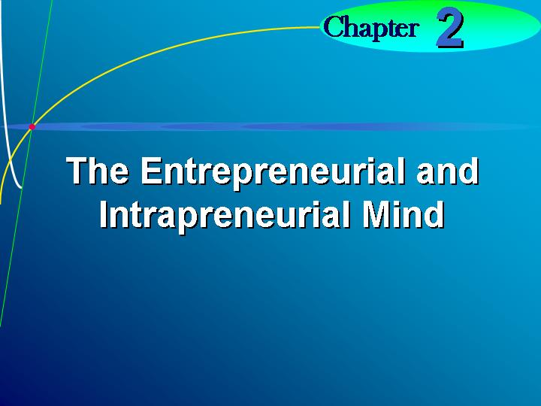  Entrepreneurial process.  The process through which a new venture is created by an entrepreneur.  Opportunity identification.  The process by which an entrepreneur comes up with the opportunity for a new venture.  Learning Objective 1.  To explain the aspects of the entrepreneurial process.  Window of opportunity.  The time period available for creating the new venture.  Text Table 2.1 “Aspects of the Entrepreneurial Process” (Text table on page 38.)  PowerPoint Slide 2-3 (Transparency 2-1)  “Entrepreneurial Process” (See PowerPoint slide show beginning on page 78 of this manual.)  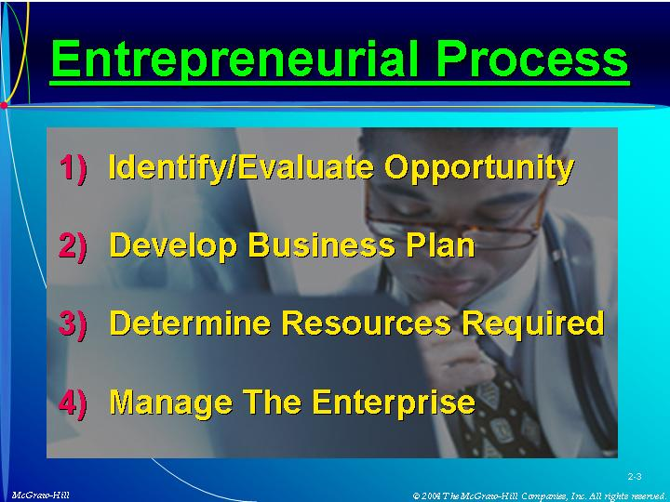  As Seen in Entrepreneurship Magazine: Hot or Not?  Does the Digital Frig technology represent an opportunity? Does “small world” technology represent an opportunity? (Box in text on page 41.)  PowerPoint Slide 2-4  “Opportunity Analysis” (See PowerPoint slide show beginning on page 78 of this manual.)  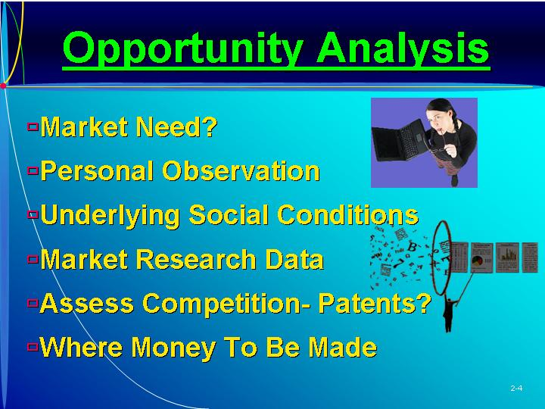  Business plan  The description of the future direction of the business.
II. MANAGERIAL VERSUS ENTREPRENEURIAL DECISION MAKING  A. The difference between the entrepreneurial style and the managerial style (administrative domain) involves five business dimensions.  B. Strategic Orientation.  1. The entrepreneur’s strategic orientation depends on his or her perception of the opportunity.  2. When the use of planning systems is the strategic orientation, the administrative domain is operant.  C. Commitment to Opportunity.  1. The entrepreneurial domain is pressured by the need for action and has a short time span in terms of opportunity commitment.  2. The administrative domain is not only slow to act on an opportunity, but the commitment is usually for a longer time span.  D. Commitment of Resources.  1. An entrepreneur is used to having resources committed at periodic intervals, often based on certain tasks or objectives being reached.  2. In acquiring these resources the entrepreneur is forced to maximize resource use.  3. In the administrative domain, the commitment of resources is for the total amount needed.  4. Administrative-oriented individuals receive personal rewards by effectively administering the resources under their control.  E. Control of Resources.  1. The administrator is rewarded by effective resource administration and has a drive to own or accumulate as many resources as possible.  2. The entrepreneur, under pressure of limited resources, strives to rent resources on an as-needed basis.  F. Managerial Structure.  1. In the administrative domain, the organizational structure is formalized and hierarchical in nature.  2. The entrepreneur employs a flat organizational structure with informal networks. | Administrative domain.  The ways managers make decisions.  Entrepreneurial domain.  The ways entrepreneurs make decisions.  PowerPoint Slide 2-5 (Transparency Master 2-2)  “Decision Making Manager vs. Entrepreneur” (See PowerPoint slide show beginning on page 78 of this manual. Also presented as a transparency master in Section 6 of this manual.)  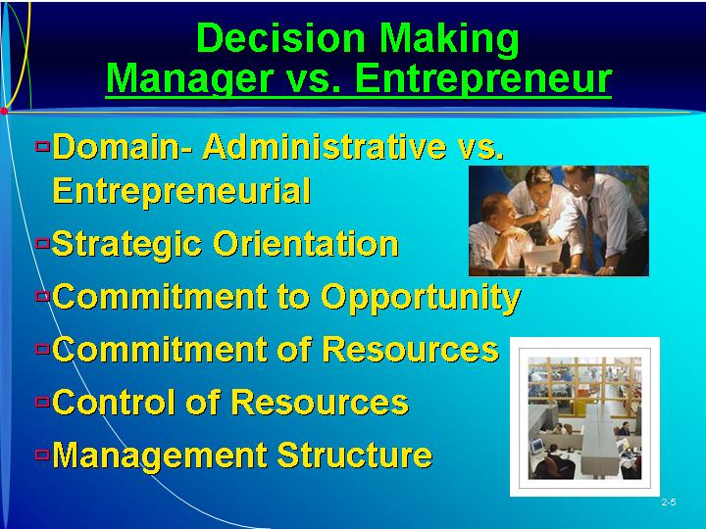  Learning Objective 2.  To explain the differences entrepreneurial and managerial domains.  As Seen in Entrepreneurship Magazine: Provide Advice to an Entrepreneur About the Leadership Skills Required of an Entrepreneur.  Scott Adams, creator of Dilbert, discusses leadership and entrepreneurship. (Box in text on page 43.)
III. CAUSES FOR RECENT INTEREST IN INTRAPRENEURSHIP  A. Interest in intrapreneurship has resulted from events occurring on social, cultural, and business levels.  1. There is an increasing interest in “doing your own thing.”  a. Individuals frequently desire to create something of their own.  b. They want responsibility and want more freedom in their work environment.  c. Frustration can develop and result in the employee becoming less productive or leaving the organization.  d. This has recently caused more discontent in structured organizations.  e. When meaning is not provided within the organization, individuals often search for an institution, such as intrapreneurship, that will provide it.  2. Intrapreneurship is one method for stimulating and capitalizing on those who think that something can be done differently and better, such as Xerox Corporation’s commitment to Xerox Technology Ventures.  B. It is important to instill the entrepreneurial spirit in an organization in order to innovate and grow.  1. In a large organization problems occur that thwart creativity and innovation.  2. This growth and diversity that can result are critical, since large corporations are more efficient in a competitive market than are smaller firms.  C. The resistance against flexibility, growth, and diversification can be overcomed by developing a spirit of entrepreneurship, called intrapreneurship, within the existing organization.  D. There are social, cultural, and business pressures for intrapreneurship.  1. Hypercompetition has forced companies to focus on new product development, increased productivity, and decreasing costs.  E. Entrepreneurial endeavors consist of four key elements.  1. New business venturing refers to the creation of new business within an existing organization.  2. Organizational innovativeness refers to product and service innovation with an emphasis on development and innovation in technology.  3. Self-renewal reflects the transformation of organizations through the renewal of the key ideas on which they are built.  4. Proactiveness includes initiative and risk taking, as well as competitive aggressiveness and boldness. | PowerPoint Slide 2-6  “Intrapreneur” (See PowerPoint slide show beginning on page 78 of this manual.)  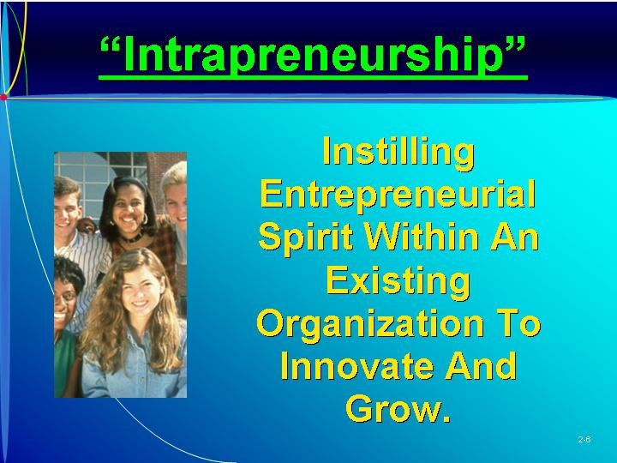
IV. CORPORATE VERSUS INTRAPRENEURIAL CULTURE  A. Smaller, aggressive entrepreneurial firms are developing more new products and becoming dominant in selected markets.  1. Many companies are attempting to create the same spirit, culture, and rewards of entrepreneurship in their organizations.  2. The typical corporate culture has a climate and reward system that favors conservative decision making.  a. Emphasis is on gathering large amounts of data as the basis for a rational decision.  b. Risky decisions are often postponed until hard facts are gathered or a consultant is hired.  c. Often there are so many approvals required that no individual feels personally responsible for the project.  d. The guiding principles in a traditional corporate culture are:  (i) Follow instructions given.  (ii) Do not make mistakes.  (iii) Do not fail.  (iv) Do not take initiative.  (v) Stay within your turf and protect your backside.  e. This restrictive environment is not conducive to creativity, flexibility, independence, ownership, or risk taking—the guiding principles of intrapreneurs.  3. The goals of an intrapreneurial culture are quite different:  a. Develop visions, goals, and action plans.  b. Be rewarded for actions taken.  c. Suggest, try, and experiment.  d. Create and develop.  e. Take responsibility and ownership.  4. There are differences in the norms of the two cultures.  a. The traditional culture is hierarchical in nature, with established procedures, lines of authority, and control mechanisms.  b. These support the present corporate culture, but inhibit new venture creation.  c. An intrapreneurial firm has a flat organizational structure with networking, teamwork, sponsors, and mentors.  d. Close working relationships help establish an atmosphere or trust that facilitates accomplishment of visions.  e. Individuals make suggestions across functional areas, resulting in cross-fertilization of ideas.  B. The two cultures produce different types of individuals and management styles.  1. Motivation.  a. Traditional managers are motivated primarily by promotion and typical corporate rewards.  b. Entrepreneurs and intrapreneurs thrive on independence and the ability to create.  c. Intrapreneurs expect their performance to be suitably rewarded.  2. There are also time orientation differences.  a. Managers emphasize the short run, entrepreneurs the long run, and intrapreneurs somewhere in between.  b. Intrapreneurs and entrepreneurs are moderate risk takers; managers are much more cautious.  c. Most entrepreneurs fail at least once, and intrapreneurs learn to conceal risky projects from management until the last possible moment.  3. Traditional managers tend to be most concerned about those at higher levels, entrepreneurs serve self and customers, and intrapreneurs add sponsors. | Corporate culture.  The environment of a particular organization.  PowerPoint Slide 2-7 (Transparency Master 2-3)  “Organizational Culture” (See PowerPoint slide show beginning on page 78 of this manual. Also presented as a transparency master in Section 6 of this manual.)  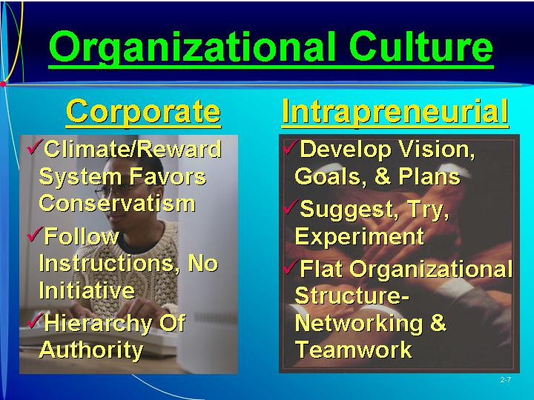  Intrapreneurial culture.  The environment of an entrepreneurial-oriented organization.  PowerPoint Slide 2-8 (Transparency Master 2-4)  “Cultural Norms/Values” (See PowerPoint slide show beginning on page 78 of this manual. Also presented as a transparency master in Section 6 of this manual.)  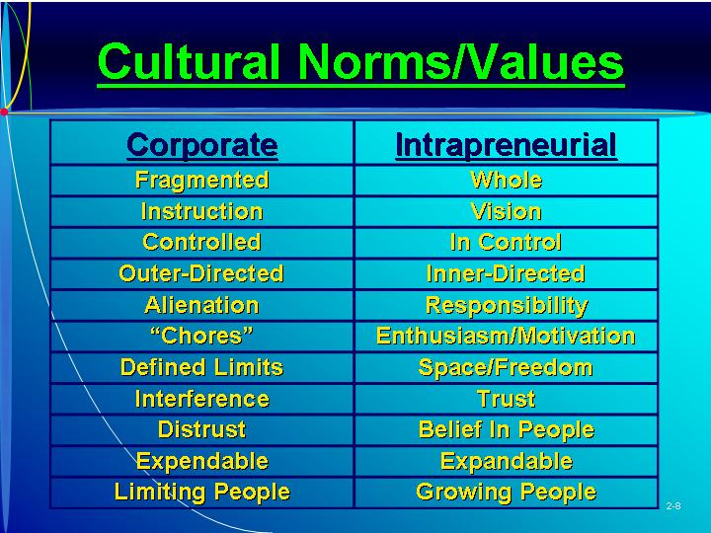  Text Table 2.2 “Comparison of Entrepreneurs, Intrapreneurs, and Traditional Managers” (Text figure on page 46)  PowerPoint Slide 2-9  “Interest in Intrapreneurship” (See PowerPoint slide show beginning on page 78 of this manual.)  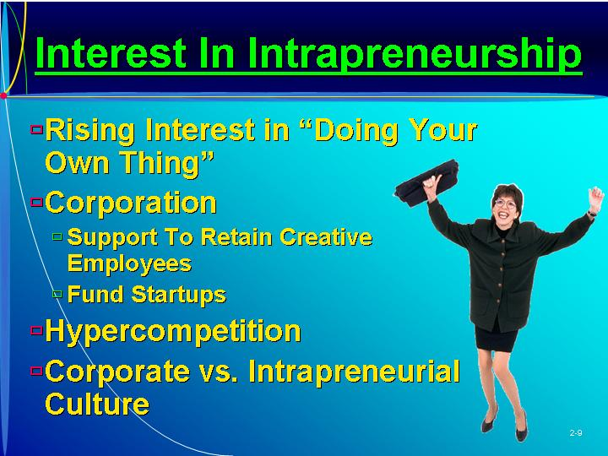  Traditional managers.  Managers in a non-intrapreneurial-oriented organization.    ETHICS.  Many companies are developing codes of ethics for all employees. Key components of an effective program are presented in this box. (Box in text on page 47.)
V. CLIMATE FOR INTRAPRENEURSHIP  A. In establishing an intrapreneurial environment, certain factors and leadership characteristics need to be present.  B. The organization operates on the frontiers of technology.  1. Research and development are key sources for new product ideas.  2. The firm must operate on the cutting edge of technology and encourage and support new ideas instead of discouraging them.  C. Experimentation, or trial and error, is encouraged.  1. Successful new products usually do not appear fully developed; instead they evolve.  2. A company has to establish an environment that allows mistakes and failures.  3. Without the opportunity to fail, few corporate intrapreneurial ventures will be developed.  D. An organization should make sure that there are no initial opportunity parameters, such as turf protection, inhibiting creativity in new product development.  E. The resources of the firm need to be available and easily accessible.  1. Often, insufficient funds are allocated to creating something new.  2. Available resources are committed instead to problems that have an immediate effect on the bottom line.  3. Some companies, such as Xerox, 3M, and AT&T have established separate venture capital areas for funding new internal and external ventures.  4. When available, the reporting requirements can become obstacles to obtaining resources.  F. A multidisciplinary team approach needs to be encouraged.  1. One key to intrapreneurial success is the existence of “skunkworks” involving key people.  2. Another complication is the fact that a team member’s promotion within the corporation is based on performance in the current position, not in the new venture.  3. The corporate environment must establish a long time horizon for evaluating the success of the overall program.  G. The spirit of intrapreneurship cannot be forced on individuals; it must be voluntary.  1. Most managers in a corporation are not capable of being successful intrapreneurs.  2. Those that emerge must be allowed to carry a project through to completion.  3. An intrapreneur falls in love with the new venture and will do almost anything to ensure its success.  H. The seventh characteristic is a reward system.  1. The intrapreneur needs to be appropriately rewarded for the energy and effort expended on the new venture.  2. An equity position in the new venture is one of the best motivational rewards.  I. A corporate environment favorable for intrapreneurship has sponsors and champions throughout the organization who support the creative activity and resulting failures.  J. The intrapreneurial activity must be whole-heartedly supported by top management. | Learning Objective 3.  To explain the organizational environment conducive for intrapreneurship.  PowerPoint Slide 2-10  “Intrapreneurial Activities” (See PowerPoint slide show beginning on page 78 of this manual.)  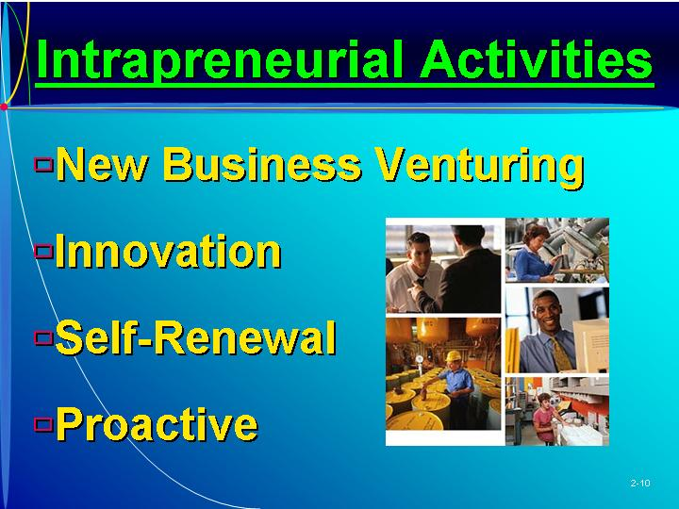  Text Table 2.3 “Intrapreneurial Environment” (Text table on page 48.)  Opportunity parameters.  Barriers to new product creation and development.  PowerPoint Slide 2-11 (Transparency Master 2-5)  “Climate for Intrapreneurship” (See PowerPoint slide show beginning on page 78 of this manual. Also presented as a transparency master in Section 6 of this manual.)  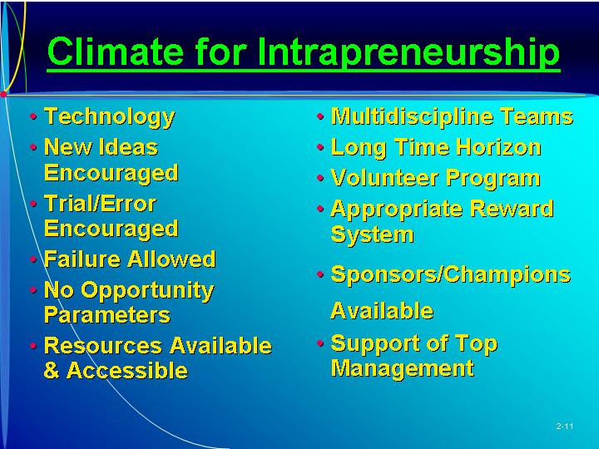
VI. INTRAPRENEURIAL LEADERSHIP CHARACTERISTICS  A. There are certain individual characteristics needed for a person to be a successful intrapreneur, including:  1. Understanding the environment.  2. Being visionary and flexible.  3. Creating management options.  4. Encouraging teamwork.  5. Encouraging open discussion.  6. Building a coalition of supporters, and persisting.  B. An intrapreneur needs to understand all aspects of the environment.  1. Creativity tends to decrease with age and education.  2. The individual must be creative and have a broad understanding of the internal and external environments of the corporation.  C. The intrapreneur must be a visionary leader—a person who dreams great dreams.  1. Leadership is the ability to dream great things and communicate them in a way that people say “yes” to being part of the dream.  2. To establish a successful new venture, the intrapreneurial leader must have a dream and overcome all obstacles to achieve it.  D. The intrapreneur must be flexible and create management options.  1. An intrapreneur is open to and encourages change.  2. By challenging the beliefs and assumptions of the corporation, an intrapreneur can create something new in the organization structure.  E. He or she needs the ability to encourage teamwork and use a multidisciplined approach.  1. Every new company formation requires a broad range of business skills.  2. Recruiting those in the organization requires crossing established departmental structure.  3. The intrapreneur must be a good diplomat to minimize disruption.  F. Open discussion must be encouraged to develop a good team for creating something new.  1. Many corporate managers have forgotten that frank, open discussion is part of the learning process.  2. A successful venture can be formed only when the team feels the freedom to disagree and to critique an idea.  3. The degree of openness among the team depends on the degree of openness of the intrapreneur.  G. Openness leads to a strong coalition of supporters and encouragers.  1. The intrapreneur must encourage each team member, particularly during hard times.  2. A good intrapreneur makes everyone a hero.  H. Only through persistence will a new venture be created and successful commercialization result. | Learning Objective 4.  To identify the general characteristics of an intrapreneur.  Text Table 2.4 “Intrapreneurial Leadership Characteristics” (Text Table on page 50)  PowerPoint Slide 2-12 (Transparency Master 2-6)  “Intrapreneurial Leaders” (See PowerPoint slide show beginning on page 78 of this manual. Also presented as a transparency master in Section 6 of this manual.)  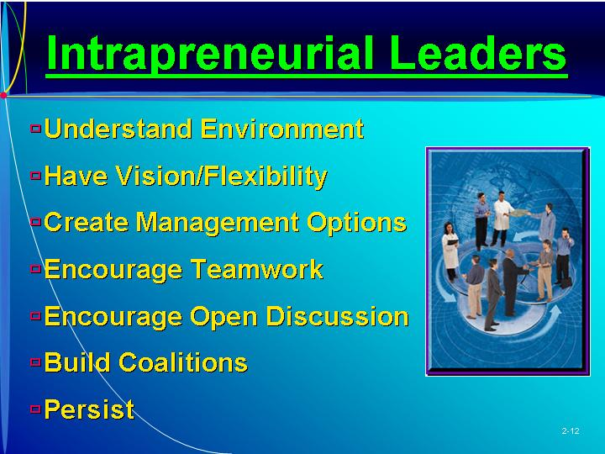
VII. ESTABLISHING INTRAPRENEURSHIP IN THE ORGANIZATION  A. To establish an intrapreneurial environment, the organization must implement a procedure.  1. This can be done internally, but it is easier to use an outsider to facilitate the process.  2. This is particularly true when the environment is very traditional.  B. Step 1: The first step is to secure a commitment to intrapreneurship in the organization by top, upper, and middle management.  1. Without top management commitment, the organization will never be able to make the necessary changes.  2. Once top management has committed to intrapreneurship for a sufficient length of time, the concept is introduced throughout the organization.  a. This is effectively accomplished through seminars.  b. General guidelines need to be established for intrapreneurial venture development.  3. Next, intrapreneurial leaders need to be identified, selected, and trained.  C. Step 2: Ideas and general interest areas should be identified, along with the amount of risk money that is available.  1. The overall expectations and target results should be established, specifying time frame, profitability requirements, and impact of the organization.  2. A mentor/sponsor system needs to be established.  D. Step 3: A company needs to use technology to make itself more flexible.  1. Technology has allowed small companies to act like they are big ones.  2. Large companies can use technology to make themselves responsive and flexible.  E. Step 4: The organization can use a group of managers to train and share their experiences with other members.  1. These sessions should be conducted one day per month for a specified period of time.  2. Information about intrapreneurship and about the company’s specific activities should be well publicized.  F. Step 5: The organization needs to develop ways to get closer to its customers by tapping the data base, hiring from smaller rivals, and helping the retailer.  G. Step 6: An organization must learn to be more productive with fewer resources.  1. With middle management cutbacks, more control has been given to lower levels of the organization.  2. The span of control should be increased.  H. Step 7: The organization needs to establish a strong support structure.  1. Because they do not immediately affect the bottom line, intrapreneurial activities can be overlooked and receive little funding.  2. These ventures require flexible, innovative behavior, with the intrapreneurs having total authority over expenditures and access to funds.  I. Step 8: The support must involve tying the rewards to the performance of the intrapreneurial unit.  1. This encourages team members to work harder and compete more effectively.  2. The equity portion of the compensation is particularly difficult to handle.  J. Step 9: The organization needs to implement an evaluation system that allows successful units to expand and unsuccessful ones eliminated. | Learning Objective 5.  To explain the process of establishing intrapreneurship in an organization.  Top management commitment.  Managers in an organization strongly supporting intrapreneurship.  PowerPoint Slide 2-13 (Transparency Master 2-7)  “Establishing Intrapreneurship” (See PowerPoint slide show beginning on page 78 of this manual. Also presented as a transparency master in Section 6 of this manual.)  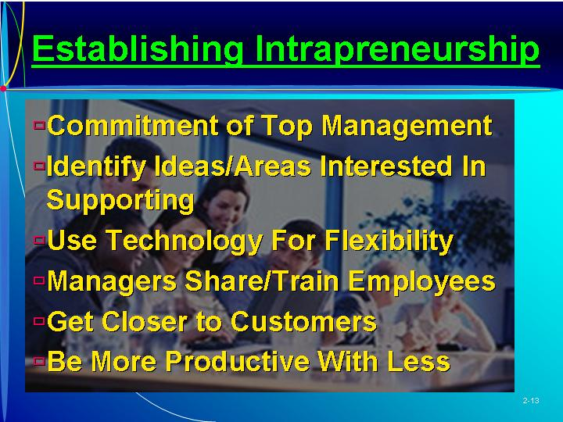  PowerPoint Slide 2-14  “Evaluating Intrapreneurship Proposals” (See PowerPoint slide show beginning on page 78 of this manual.)  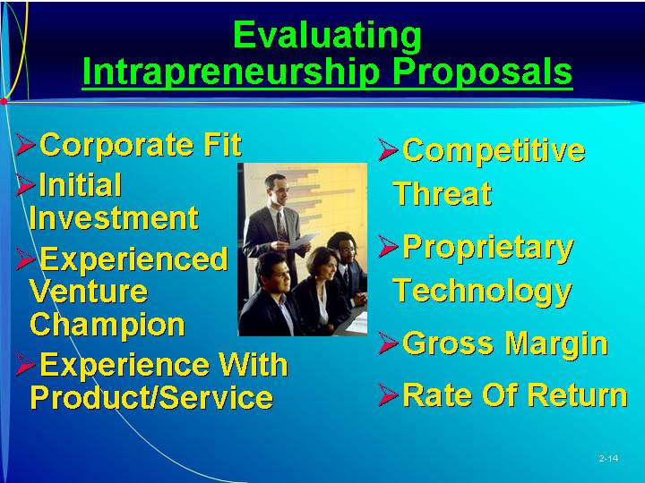
VIII. PROBLEMS AND SUCCESSFUL EFFORTS  A. Intrapreneurship, also called corporate venturing, is not without problems.  1. One study found that new ventures started within a corporation performed worse than those started independently.  2. Independent start-ups tend to outperform corporate start-ups.  B. There are many examples of companies that have successfully implemented intrapreneurship.  1. 3M allows employees to devote a percent of their time to independent projects.  2. After failing to recognize the potential of Wozniak’s personal computer, Hewlett-Packard has taken steps to take advantage of future opportunities.  3. Even IBM has developed the independent business unit concept.  C. The problems of intrapreneurship are not insurmountable, and implementing intrapreneurship can lead to new products, growth, and the development of an entirely new corporate environment and culture. | PowerPoint Slide 2-15  “Barriers to Intrapreneurship” (See PowerPoint slide show beginning on page 78 of this manual.)  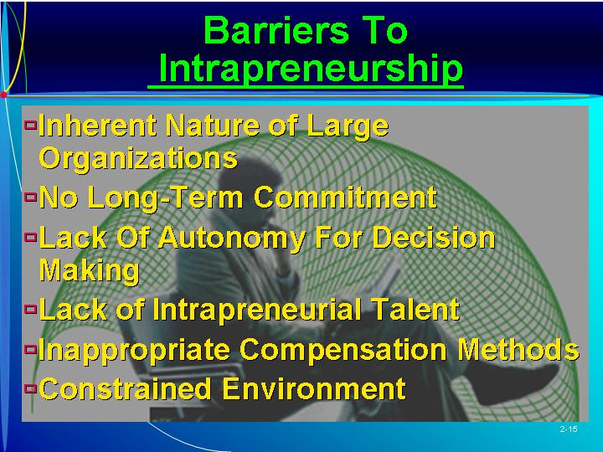
IX. IN REVIEW: SUMMARY.
See “Learning Objectives Revisited” below.

learning objectives revisited

Learning Objective 1. To explain the aspects of the entrepreneurial process.
  - The entrepreneurial process involves finding, evaluating, and developing an opportunity by overcoming the strong forces that resist the creation of something new.
  - Phase 1 – Identify and Evaluate the Opportunity.
  - Phase 2 – Develop a Business Plan.
  - Phase 3 – Determine the Resources Required.
  - Phase 4 – Manage the Enterprise.

Learning Objective 2. To explain the differences between corporate and intrapreneurial domains.
  - The corporate culture has a climate and reward system that favors conservative decision making.
  - The guiding principles in a corporate culture include:
    - Follow instructions given.
    - Do not make mistakes.
    - Do not fail.
    - Do not take initiative.
    - Stay within your turf and protect your backside.
  - Aspects of an intrapreneurial culture are:
    - Develop visions
    - Goals, and action plans
    - Be rewarded for actions taken
    - Suggest, try, and experiment
    - Create and develop
    - Take responsibility and ownership.
  - The traditional culture is hierarchical in nature, with established procedures, lines of authority, and control mechanisms.
  - An intrapreneurial firm has a flat organizational structure with networking, teamwork, sponsors, and mentors.

Learning Objective 3. To explain the organizational environment conducive for intrapreneurship.
  - The organization operates on the frontiers of technology.
  - Experimentation, or trial and error, is encouraged.
  - There are no initial opportunity parameters inhibiting creativity in new product development.
  - The resources of the firm are available and easily accessible.
  - A multidisciplinary team approach is encouraged.
  - The spirit of intrapreneurship cannot be forced on individuals; it must be voluntary.
  - The intrapreneur is appropriately rewarded for the energy and effort expended on the new venture.
  - The environment has sponsors and champions who support the creative activity and resulting failures.
  - The activity is whole-heartedly supported by top management.

Learning Objective 4. To identify the general characteristics of an intrapreneur.
  - An intrapreneur needs to understand all aspects of the environment.
  - The intrapreneur must be a visionary leaderCa person who dreams great dreams.
  - The intrapreneur must be flexible and create management options.
  - He or she needs the ability to encourage teamwork and use a multidisciplined approach.
  - Open discussion must be encouraged to develop a good team for creating something new.
  - The intrapreneur must encourage each team member, particularly during hard times.

Learning Objective 5. To explain the process of establishing intrapreneurship in an organization.
  - Step 1: The first step is to secure a commitment to intrapreneurship by top, upper, and middle management.
  - Step 2: Ideas and general interest areas should be identified, along with the amount of risk money that is available.
  - Step 3: A company needs to use technology to make itself more flexible.
  - Step 4: The organization can use a group of managers to train and share their experiences with other.
  - Step 5: The organization needs to develop ways to get closer to its customers.
  - Step 6: An organization must learn to be more productive with fewer resources.
  - Step 7: The organization needs to establish a strong support structure for intrapreneurship.
  - Step 8: Support must involve tying the rewards to the performance of the intrapreneurial unit.
  - Step 9: The organization needs to implement an evaluation system that allows successful intrapreneurial units to expand and unsuccessful ones eliminated.

key terms

Administrative domain. The ways managers make decisions.
Business plan. The description of the future direction of the business.
Corporate culture. The environment of a particular organization.
Entrepreneurial domain. The ways entrepreneurs make decisions.
Entrepreneurial process. The process through which a new venture is created by an entrepreneur.
Intrapreneurial culture. The environment of an entrepreneurial-oriented organization.
Intrapreneurship. Entrepreneurship within an existing business organization.
Opportunity identification. The process by which an entrepreneur comes up with the opportunity for a new venture.
Opportunity parameters. Barriers to new product creation and development.
Top management commitment. Managers in an organization strongly supporting intrapreneurship.
Traditional managers. Managers in a non-intrapreneurial-oriented organization.
Window of opportunity. The time period available for creating the new venture.

research tasks and class discussions

The text includes several topics for student research and class discussions. These questions are open-ended, and the answers will be different for each student. There are no “correct” answers.

Research tasks:
- Interview three individuals employed within the research and development (R&D) departments of large, well established companies. From the interview, gain an understanding of what the company does to foster intrapreneurship, what it does that inhibits intrapreneurship, and what it could be doing better toward further enhancing entrepreneurship throughout the whole organization.
- Search on the Internet for four accounts of intrapreneurial success. What key factors for success are common across all these accounts? Which are unique? If one company can foster an intrapreneurial climate, what stops another company from copying its process and taking away the initial advantage?
- Interview three people—one person whom you believe to be a traditional manager, one you believe to be an intrapreneur. Ask each questions about their primary motives, time orientation, activities, risk, status, failure/mistakes, decision, who serves, family history, and collected relate to that proposed in Table 2.3?

Class Discussions
- Isn’t “corporate entrepreneurship” an oxymoron? Do the characteristics of an established organization, such as its routines and structure, increase efficiency but at the same time kill any entrepreneurial spirit? Is there any way that a company can have the best of both worlds?
- Is increasing the entrepreneurial orientation of a firm always a good thing? Or are there circumstances or environments in which the further pursuit of opportunities can diminish firm performance?
- Do you believe that an entrepreneur enters and completes one stage of the entrepreneurial process before moving on to the next one? Or is it a case of moving backward and forward in an iterative fashion?
- Why does an entrepreneur need to be aware of the dynamics associated with time? How can entrepreneurs manage time and/or use it to their own advantage? Are there ways that entrepreneurs can change time—that is, make a clock start ticking earlier, make it tick faster or slower, or make it tick at a different rate for them relative to that for competitors/

Visual Resources

The PowerPoint presentation for this chapter, shown on the following pages, includes the following slides.
Slide 2-1 Entrepreneurship Title
Slide 2-2 Chapter Title
Slide 2-3 Entrepreneurial Process *
Slide 2-4 Opportunity Analysis
Slide 2-5 Decision Making Manager vs. Entrepreneur *
Slide 2-6 Intrapreneurship
Slide 2-7 Organizational Culture *
Slide 2-8 Cultural Norms/Values *
Slide 2-9 Interest in Intrapreneurship
Slide 2-10 Intrapreneurial Activities
Slide 2-11 Climate for Intrapreneurship *
Slide 2-12 Intrapreneurial Leaders *
Slide 2-13 Establishing Intrapreneurship *
Slide 2-14 Evaluating Intrapreneurship Proposals
Slide 2-15 Barriers to Intrapreneurship
* Also included as a Transparency Master.

The following are included as transparency masters in Section 6 of this manual.
Transparency Master 2-1 Entrepreneurial Process
Transparency Master 2-2 Decision Making Manager vs. Entrepreneur
Transparency Master 2-3 Organizational Culture
Transparency Master 2-4 Cultural Norms/Values
Transparency Master 2-5 Climate for Intrapreneurship
Transparency Master 2-6 Intrapreneurial Leaders
Transparency Master 2-7 Establishing Intrapreneurship

powerpoint slide show

Slide 2-1  Entrepreneurship Title | Slide 2-2  Chapter Title
Slide 2-3  Entrepreneurial Process (Also presented as Transparency Master 2-1 in Section 6 of this manual.) | Slide 2-4  Opportunity Analysis
Slide 2-5  Decision Making Manager vs. Entrepreneur (Also presented as Transparency Master 2-2 in Section 6 of this manual.) | Slide 2-6  “Intrapreneurship”
Slide 2-7  Organizational Culture (Also presented as Transparency Master 2-3 in Section 6 of this manual.) | Slide 2-8  Cultural Norms/Values (Also presented as Transparency Master 2-4 in Section 6 of this manual.)
Slide 2-9  Interest in Intrapreneurship | Slide 2-10  Intrapreneurial Activities
Slide 2-11  Climate for Intrapreneurship (Also presented as Transparency Master 2-5 in Section 6 of this manual.) | Slide 2-12  Intrapreneurial Leaders (Also presented as Transparency Master 2-6 in Section 6 of this manual.)

Slide 2-13  Establishing Intrapreneurship (Also presented as Transparency Master 2-7 in Section 6 of this manual.) | Slide 2-14  Evaluating Intrapreneurship Proposals
Slide 2-15
Barriers to Intrapreneurship

