4

INTERNATIOnal entrepreneurial opportunities

Learning Objectives

1
To identify the aspects and importance of international entrepreneurship.

2
To identify the important strategic issues in international entrepreneurship.

3
To identify the available options for entering international markets.

4
To present the problems and barriers to international entrepreneurship.

CHAPTER OUTLINE AND TEACHING NOTES
OPENING PROFILE—A. Malachi Mixon, III  I. THE NATURE OF INTERNATIONAL ENTREPRENEURSHIP  A. As more countries become market oriented and developed, the distinction between foreign and domestic markets is becoming less pronounced.  B. International entrepreneurship is the process of an entrepreneur conducting business activities across national boundaries.  1. It is exporting, licensing, or opening a sales office in another country.  2. When an entrepreneur executes his or her business model in more than one country, international entrepreneurship occurs.  C. The U.S. is a relative newcomer to the international business arena.  1. Foreign investors helped build much of the early industrial trade and the early industrial base of the U.S.  2. The future strength of the U.S. will depend on the ability of U.S. entrepreneurs to take advantage of markets outside its borders. | PowerPoint Slide 4-1  “Entrepreneurship Title” (See PowerPoint slide show beginning on page 115 of this manual.)    PowerPoint Slide 4-2  “Chapter Title” (See PowerPoint slide show beginning on page 115 of this manual.)  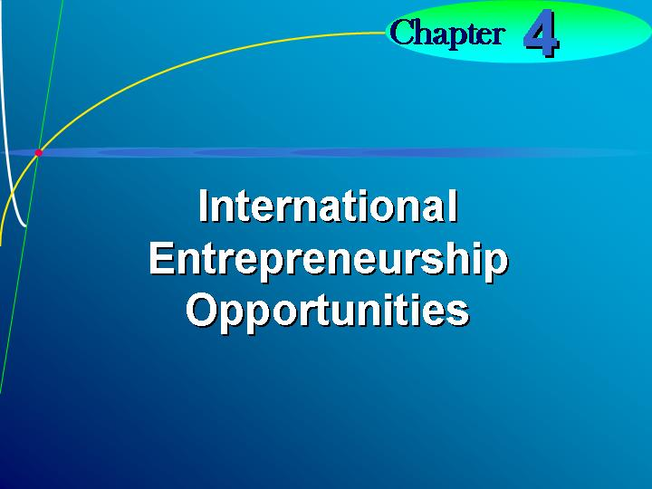    International entrepreneurship.  An entrepreneur doing business across his or her national boundary.  Learning Objective 1.  To identify the aspects and importance of international entrepreneurship.
II. THE IMPORTANCE OF INTERNATIONAL BUSINESS TO THE FIRM
A. International business has become increasingly important to firms of all sizes.
B. The successful entrepreneur will be someone who understands how international business differs from domestic business and is able to act accordingly.
III. INTERNATIONAL VERSUS DOMESTIC ENTREPRENEURSHIP  A. Whether international or domestic, an entrepreneur is concerned about the same basic issues—sales, costs, and profits.  1. What varies is the relative importance of the factors affecting each decision.  2. International entrepreneurial decisions are more complex due to uncontrollable factors.  B. Economics.  1. A domestic business strategy is designed under a single economic system and has the same currency.  2. Creating a business strategy for multiple countries means dealing with different levels of economic development and different distribution systems.  C. Stage of Economic Development.  1. The U.S. is an industrially developed nation with regional differences in income.  2. An entrepreneur doing business only in the U.S. does not have to worry about lack of infrastructure, such as roads, and established business ethics and norms.  D. Balance of Payments.  1. A country’s balance of payments affects the valuation of its currency.  2. The valuation of a country’s currency affects business transactions between countries.  E. Type of System.  1. Barter or third-party arrangements have been used to increase business activity with the former U.S.S.R. and Eastern and Central European countries.  2. There are still many difficulties in doing business in developing and transition economies due to:  a. Gaps in the knowledge of the Western system regarding business plans, marketing, and profits.  b. Widely variable rates of return.  c. Nonconvertibility of the currencies.  d. Differences in the accounting system.  e. Nightmarish communications.  F. Political-Legal Environment.  1. Multiple political and legal environments create different business problems.  2. Each element of the international business strategy can potentially be affected by multiple legal environments.  3. Laws governing business arrangements also vary greatly with 150 different legal systems and sets of national laws.  G. Cultural Environment.  1. The impact of culture on entrepreneurs and strategies is significant.  2. An important cultural concern is bribery and corruption.  3. Another problem is finding a translator.  H. Technological Environment.  1. Technology varies significantly across countries.  2. New products in a country are created based on the conditions and infrastructure of that country.  I. Strategic Issues.  1. Four strategic issues are important to the international entrepreneur:  a. The allocation of responsibility between the U.S. and foreign operations.  b. The nature of the planning, reporting, and control systems to be used.  c. The appropriate organizational structure for conducting international operations.  d. The degree of standardization possible.  2. Responsibility is generally allocated in stages.  a. Stage 1: In the first stages the entrepreneur typically follows a highly centralized decision-making process.  b. Stage 2: When success occurs, it is no longer possible to use completely centralized decision-making process.  c. Stage 3: Decentralization is scaled back and major strategic decisions are again centralized.  J. To understand what is required for effective planning, reporting, and control, the entrepreneur should consider:  1. Environmental analysis.  2. Strategic planning.  3. Structure.  4. Operational planning.  5. Controlling the marketing program.  K. The first step in identifying markets is to analyze data in the following areas:  1. Market characteristics.  2. Marketing institutions.  3. Industry conditions.  4. Legal environment.  5. Resources.  6. Political environment. | PowerPoint Slide 4-3  “Questions about International Business” (See PowerPoint slide show beginning on page 115 of this manual.)  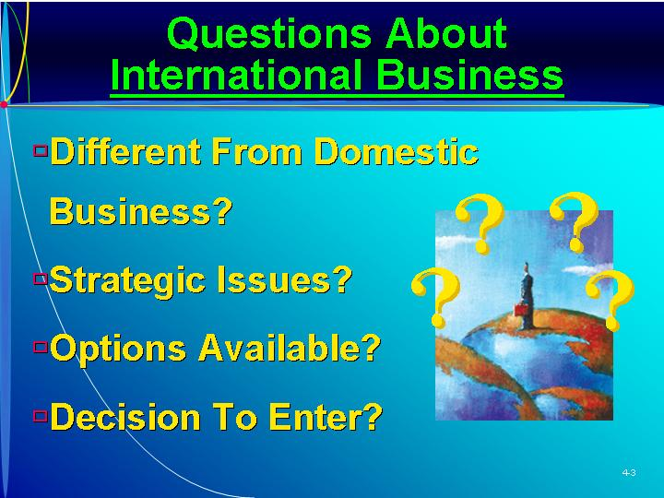  PowerPoint Slide 4-4 (Transparency Master 4-1)  “Strategic Issues” (See PowerPoint slide show beginning on page 115 of this manual. Also presented as a transparency master in Section 6 of this manual.)  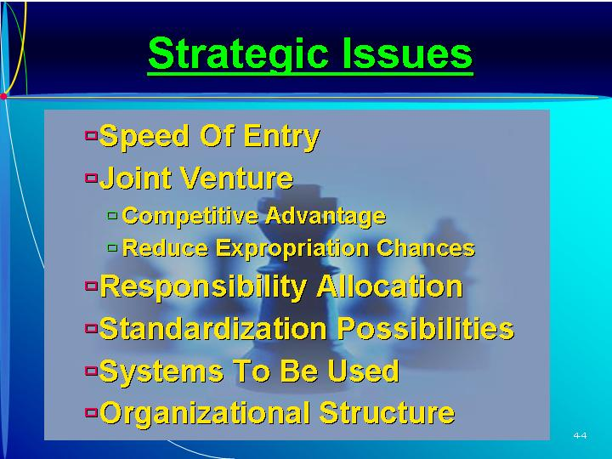  Balance of payments.  The trade status between countries.  Barter.  A method of payment using nonmonetary items.  Third-party arrangements.  Paying for goods indirectly through another source.  PowerPoint Slide 4-5 (Transparency Master 4-2)  “International vs. Domestic” (See PowerPoint slide show beginning on page 115 of this manual. Also presented as a transparency master in Section 6 of this manual.)  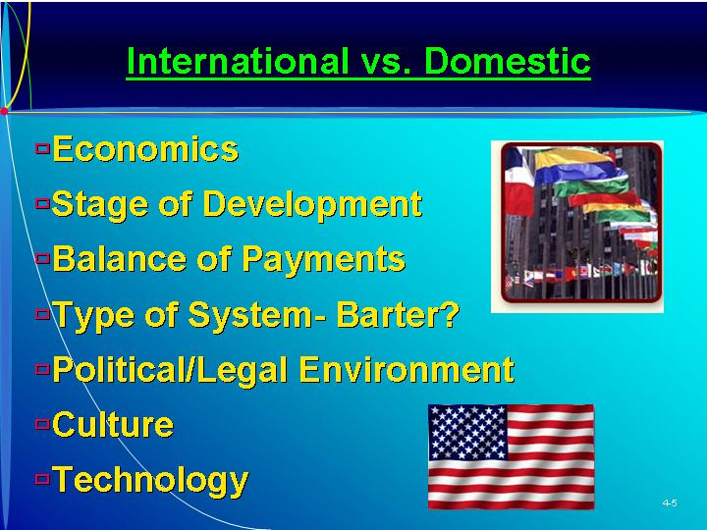  Text Table 4.1  “Lost in Translation” (Text figure on page 89)  Learning Objective 2.  To identify the important strategic issues in international entrepreneurship.  PowerPoint Slide 4-6 (Transparency Master 4-3)  “Strategic Issues” (See PowerPoint slide show beginning on page 115 of this manual. Also presented as a transparency master in Section 6 of this manual.)  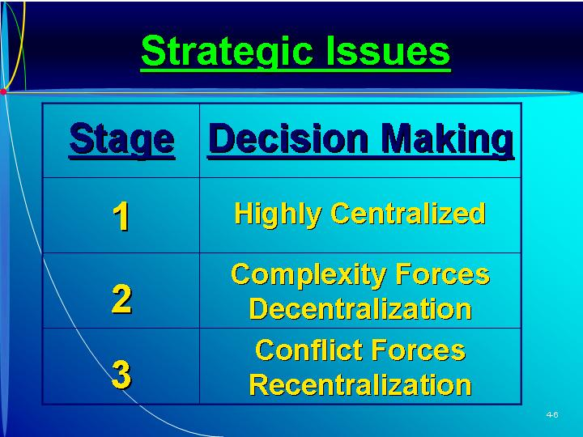    ETHICS.  International high-technology firms are investing in facilities in China creating new ethical difficulties and challenges. (Box in text on page 89.)  As Seen in Entrepreneurship Magazine: Generalizing from One Country to Another.  Mashti Malone’s Ice Cream flourishes by bringing the exotic flavors of Iran to the U.S. (Box in text on page 92)  PowerPoint Slide 4-7  “Environmental Analysis of National Market” (See PowerPoint slide show beginning on page 115 of this manual.)    PowerPoint Slide 4-8  “Strategic Planning” (See PowerPoint slide show beginning on page 115 of this manual.)  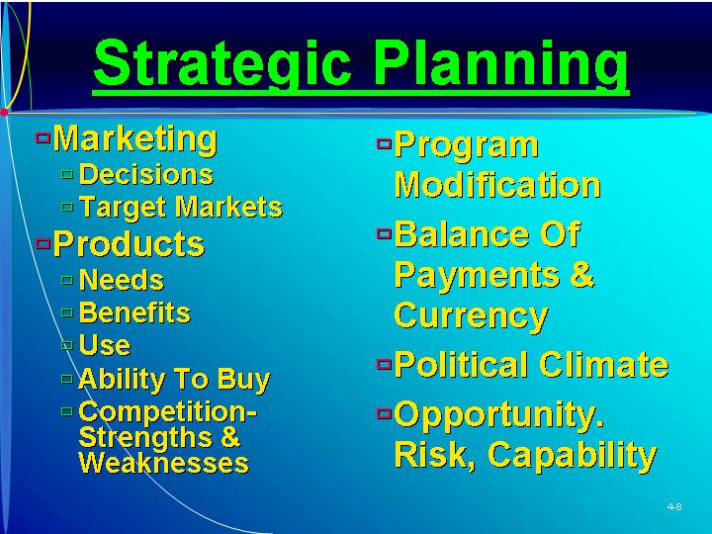  PowerPoint Slide 4-9  “Structure” (See PowerPoint slide show beginning on page 115 of this manual.)  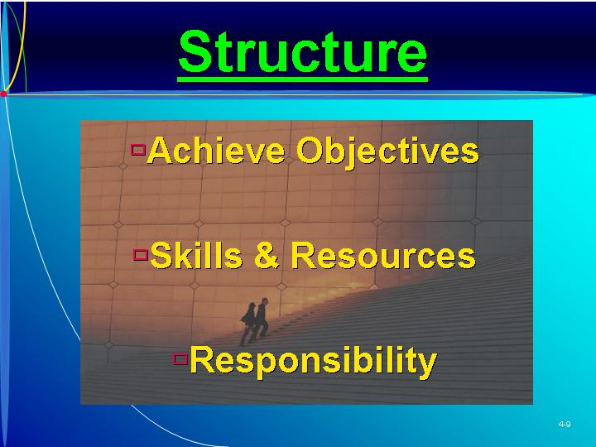  PowerPoint Slide 4-10  “Operational Marketing” (See PowerPoint slide show beginning on page 115 of this manual.)    PowerPoint Slide 4-11 (Transparency Master 4-4)  “Country Data Analysis” (See PowerPoint slide show beginning on page 115 of this manual. Also presented as a transparency master in Section 6 of this manual.)  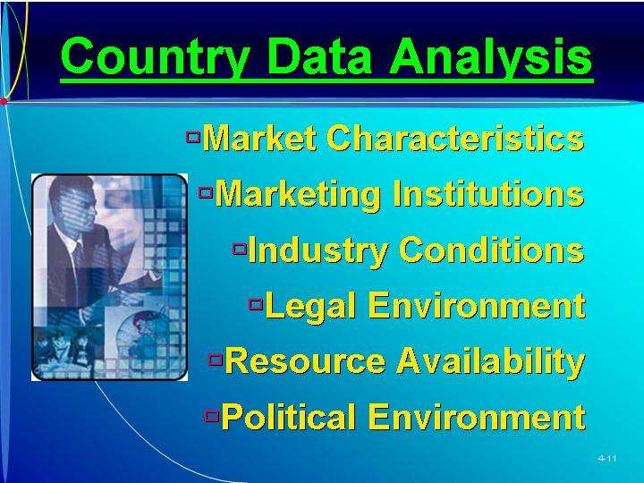
IV. ENTREPRENEURIAL ENTRY INTO INTERNATIONAL BUSINESS  A. The choice of entry method depends on the goals of the entrepreneur and the company’s strengths and weaknesses.  B. Exporting.  1. Usually, an entrepreneur starts doing international business through exporting.  2. Indirect exporting involves a foreign purchaser in the local market or using an export management firm.  a. For certain commodities, foreign buyers seek out sources of supply.  b. Export management firms, another indirect method, are located in most commercial centers.  3. Direct exporting through independent distributors or through one’s own overseas sales office is another way to enter international business.  a. An independent foreign distributor directly contacts foreign customers and takes care of all technicalities.  b. Entrepreneurs can open their own overseas sales offices and hire their own salespeople.  C. Nonequity Arrangements.  1. Nonequity arrangements allow the entrepreneur to enter a market without direct equity investment in the foreign market.  2. Licensing involves an entrepreneur who is a manufacturer giving a foreign manufacturer the right to use a patent, trademark, or technology in return for a royalty payment.  a. This arrangement is most appropriate when the entrepreneur has no prospect of entering the market through exporting or direct investment.  b. The process is usually low risk and an easy way to generate incremental income.  c. Without careful analysis, licensing arrangements have several pitfalls.  3. Turn-key projects.  a. Lesser developed countries are able to obtain manufacturing technology without surrendering economic control through turn-key projects.  b. A foreign entrepreneur builds a facility, trains the workers, and trains the management to run the installation.  c. Once the operation is on-line, it is turned over to local owners.  d. Initial profits can lead to follow-up sales.  e. Financing is provided by the local company or government.  4. Management contracts.  a. Entrepreneurs can contract their management techniques and skills.  b. The management contract allows the purchasing country to gain foreign expertise without turning ownership over to a foreigner.  D. Direct Foreign Investment.  1. The wholly-owned foreign subsidiary has been a preferred mode of ownership for direct investment.  2. Minority interests.  a. The minority interest can provide the firm with either a source of raw materials or a captive market for products.  b. Entrepreneurs have used minority positions to gain a foothold in the market before making a major investment.  3. Joint ventures.  a. Two firms get together and form a third company in which they share the equity.  b. Joint ventures have been used by entrepreneurs in two situations:  (i) When the entrepreneur wants to purchase local knowledge and an established facility.  (ii) When rapid entry into a market it needed.  c. The keys to success of joint ventures have not been well understood.  d. Reasons for forming a joint venture today are different than those in the past.  (i) Previously, joint ventures were viewed as partnerships and often involved firms whose stock was owned by several other firms.  (ii) Joint ventures in the U.S. were first vertical joint ventures used by mining concerns and railroads.  e. Reasons for the significant increase in the use of joint ventures:  (i) To share the costs and risks of an uncertain project.  (ii) To gain synergy between firms.  (iii) To obtain a competitive advantage.  (iv) To enter markets that pose entrance difficulties.  4. Majority interest.  a. Another equity method is to purchase a majority interest in a foreign business.  b. The majority interest allows the entrepreneur to obtain managerial control while maintaining the company’s local identity.  5. One hundred percent ownership assures control.  a. One form of 100 percent ownership involved mergers and acquisitions.  (i) The benefits and costs of a merger need to be considered.  (ii) The entrepreneur must understand mergers as a strategic option and the complexity of integrating one company into another.  b. A horizontal merger is the combination of two firms that produce closely related products in the same area.  c. A vertical merger is the combination of firms in successive stages of production.  d. A product extension merger occurs when acquiring and acquired companies have related production but do not have directly competing products.  e. A market extension merger is when two firms produce the same products but sell them in different geographic markets.  f. A diversified activity merger is a conglomerate merger involving the consolidation of two unrelated firms.  g. Mergers are a sound strategic option for an entrepreneur when synergy is present.  (i) Economies of scale are the most common reason for mergers.  (ii) A second factor that causes synergy is taxation, or unused tax credits.  (iii) The final factor is the benefits received in combining complementary resources. | Learning Objective 3.  To identify the available options for entering international markets.  Exporting.  Selling goods made in one country to another country.  Indirect exporting.  Selling goods to another country through a person in the entrepreneur’s home country.  Direct exporting.  Selling goods to another country by taking care of the transaction.  PowerPoint Slide 4-12 (Transparency Master 4-5)  “International Market Entry” (See PowerPoint slide show beginning on page 115 of this manual. Also presented as a transparency master in Section 6 of this manual.)  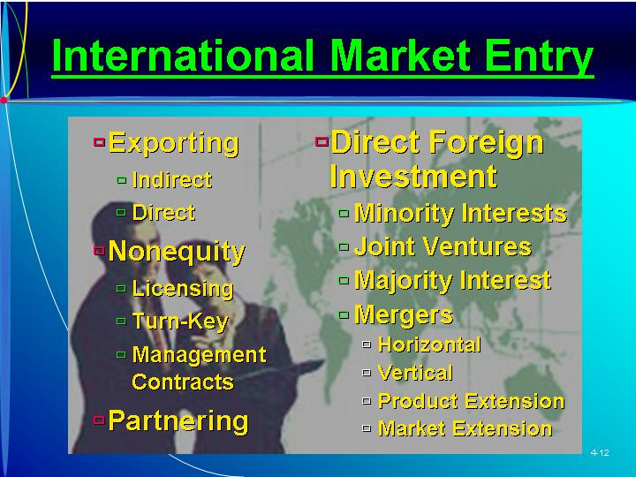  Nonequity arrangements.  Doing international business through an arrangement that does not involve any investment.  Licensing.  Allowing someone else to use something of the company’s.  Turn-key projects.  Developing and operationalizing something in a foreign country.  Management contract.  A method for doing a specific international task.  Minority interest.  Having less than 50 percent ownership position.  Joint venture.  Two companies forming a third company.  Synergy.  Two parties having things in common.  Majority interest.  Having more than 50 percent ownership interest.  Horizontal merger.  Combination of at least two firms doing business at the same market level.  Vertical merger.  Combination of at least two firms at different market levels.  Product extension merger.  Combination of two firms with noncompeting products.  Market extension merger.  Combination of at least two firms with similar products in different geographic markets.  Diversified activity merger.  Combination of at least two totally unrelated firms.  As Seen in Entrepreneurship Magazine: Provide Advice to an Entrepreneur about Outsourcing to Foreign Companies.  Small businesses can take advantage of offshore outsourcing, but it might not be the best alternative. (Box in text on page 97)
V. BARRIERS TO INTERNATIONAL TRADE  A. There has been a positive attitude toward free trade, starting about 1947 with the development of general trade agreements and reduction of trade barriers.  B. General Agreement on Tariffs and Trade (GATT.)  1. GATT is a multilateral agreement with the objective of liberalizing trade by eliminating tariffs, subsidies, and import quotas.  2. In each round, mutual tariff reductions are negotiated between member nations.  3. Members can ask for investigation of violations.  4. While GATT has helped develop more unrestricted trade, its voluntary membership gives it little authority.  C. Increasing Protectionist Attitudes.  1. Support of free trade increased significantly in the 1980s due to the rise in protectionist pressures in many countries.  2. The persistent U.S. trade deficit has strained the world trading system.  3. The economic success of a country (Japan) perceived as not playing by the rules has also strained the trading system.  4. In response many countries have established bilateral voluntary export restrictions to circumvent GATT.  D. Trade Blocs and Free Trade Areas.  1. Groups of nations are banding together to increase investment between nations in the group and exclude others.  2. Free trade areas have been established between the U.S. and Israel and between the U.S. and Canada.  3. The North American Free Trade Agreement (NAFTA) between the U.S., Canada, and Mexico reduces barriers and encourages investment.  4. The Americas, Argentina, Brazil, Paraguay, and Uruguay have created the Mercosul trade zone, a free trade zone between the countries.  5. The European Community (EC) is founded on the principle of supra-nationality—member nations are not able to enter into trade agreements on their own that are inconsistent with EC regulations.  E. Entrepreneur’s Strategies and Trade Barriers.  1. Trade barriers pose problems for entrepreneurs who want to become involved in international business.  2. Trade barriers increase the costs of exporting projects to a country.  3. Voluntary export restrictions may limit the ability to sell products in a country from production facilities outside the country.  4. An entrepreneur may have to locate assembly or facilities in a country to conform to the local content regulations. | Learning Objective 4.  To present the problems and barriers to international entrepreneurship.  PowerPoint Slide 4-13 (Transparency Master 4-6)  “Barriers to International Trade” (See PowerPoint slide show beginning on page 115 of this manual. Also presented as a transparency master in Section 6 of this manual.)  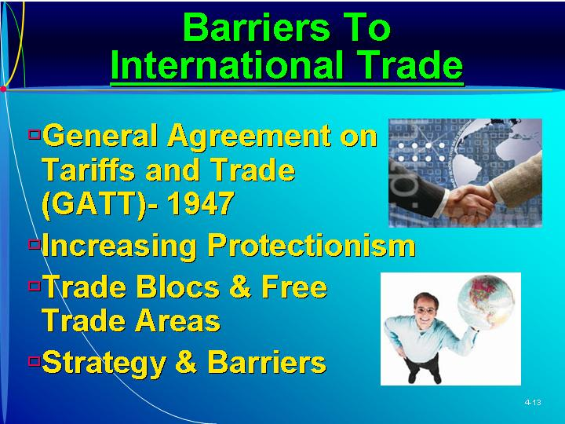  Trade barriers.  Hindrances to doing international business.
VI. ENTREPRENEURIAL PARTNERING
A. One of the best methods to enter an international market is to partner with an entrepreneur in that country.
B. A good partner shares the entrepreneur’s vision and is unlikely to exploit the partnership.
C. Selecting a good partner.
1. Collect information about the industry and potential partner.
2. Check references for each potential partner.
3. Meet with the potential partner to get to know the individual and company before any commitment is made.
VII. IN REVIEW: SUMMARY.
See “Learning Objectives Revisited” below.

learning objectives revisited

Learning Objective 1. To identify the aspects and importance of international entrepreneurship.
  - Foreign investors helped build much of the early industrial trade and the early industrial base of the U.S.
  - The future strength of the U.S. will depend on the ability of U.S. entrepreneurs to take advantage of markets outside its borders.
  - International business has become increasingly important to firms of all sizes.

Learning Objective 2. To identify the important strategic issues in international entrepreneurship.
  - Whether international or domestic, an entrepreneur is concerned about the same basic issues—sales, costs, and profits.
  - Uncontrollable factors complicate international entrepreneurial decisions.
    - Levels of economic development.
    - Stage of economic development.
    - Balance of payments.
    - Type of economic system.
    - Political and legal environments.
    - Cultural environment.
    - Technological development.
  - Four strategic issues are important to the international entrepreneur:
    - The allocation of responsibility between the U.S. and foreign operations.
    - The nature of the planning, reporting, and control systems to be used.
    - The appropriate organizational structure for conducting international operations.
    - The degree of standardization possible.

Learning Objective 3. To identify the available options for entering international markets.
  - The choice of entry method depends on the goals of the entrepreneur and the company’s strengths and weaknesses.
  - Indirect exporting involves a foreign purchaser in the local market or using an export management firm.
  - Direct exporting through independent distributors or through one’s own overseas sales office is another entry method.
  - Nonequity arrangements include licensing, turn-key projects, and management contracts.
  - Direct foreign investments include minority interests, joint ventures, majority interest, and 100 percent ownership such as:
    - horizontal mergers
    - vertical mergers
    - product extension mergers
    - market extension mergers
    - diversified activity mergers

Learning Objective 4. To present the problems and barriers to international entrepreneurship.
  - Protectionist pressures rose in the 1980s because of U.S. trade deficits, negative perceptions about Japan, and voluntary export restraints.
  - Groups of nations have banded together to increase trade forming trade blocks and free trade areas.
  - Trade barriers also pose problems.

key terms

Balance of payments. The trade status between countries.
Barter. A method of payment using nonmonetary items.
Direct exporting. Selling goods to another country by taking care of the transaction.
Diversified activity merger. Combination of at least two totally unrelated firms.
Exporting. Selling goods made in one country to another country.
Horizontal merger. Combination of at least two firms doing similar businesses at the same market level.
Indirect exporting. Selling goods to another country through a system in the entrepreneur’s home country.
International entrepreneurship. An entrepreneur doing business across his or her national boundary.
Joint venture. Two companies forming a third company.
Licensing. Allowing someone else to use something of the company’s.
Majority interest. Having more than 50 percent ownership position.
Management contracts. A method for doing a specific international task.
Market extension merger. Combination of at least two firms with similar products in different geographic markets.
Minority interest. Having less than 50 percent ownership position.
Nonequity arrangements. Doing international business through an arrangement that does not involve any investment.
Product-extension merger. Combination of two firms with noncompeting products.
Synergy. Two parties having things in common.
Third-party arrangements. Paying for goods indirectly through another source.
Trade barriers. Hindrances to doing international business.
Turn-key projects. Developing and operationalizing something in a foreign country.
Vertical merger. Combination of at least two firms at different market levels.

research tasks and class discussions

The text includes several topics for student research and class discussions. These questions are open-ended, and the answers will be different for each student. There are no “correct” answers.

Research tasks:
- Interview three managers of multinational businesses to ascertain the benefits generated from engaging in international business as well as some of the challenges (problems).
- Choose a country. Research, and be prepared to report on, that country’s (a) stage of economic development, (b) political-legal environment, (c) cultural environment, and (d) technological environment. If you were advising an entrepreneur who was considering entering this country to sell his or her products, what would you say were the major strategic issues? (Be specific to the country chosen.)
- Choose a specific industry in a specific country. Which mode of entry has been the most used by foreign firms entering this industry in this country? Explain why, using examples of successful entry and examples of unsuccessful entry.
- Choose a transition economy. Research that country and its recent economic progress. Do you believe its economy will flourish or stagnate? Why? What can that country’s government do (if anything) to “help” the economy flourish?

Class Discussions
- Make sure there is one foreign student in each small group. The group needs to discuss, and then report back to class on, the nature of business and entrepreneurship in the foreign student’s home country. Such a discussion should include the country’s (a) stage of economic development, (b) political-legal environment, (c) cultural environment, and (d) technological environment. Also explore how entrepreneurship and business failure are perceived in this country.
- Is going international something that only large and established firms should pursue after they have achieved success in its domestic market, or should entrepreneurs think about international markets “right off the bat?” Which sorts of products are more amenable for going international by small and new firms?
- We typically focus on firms from well-developed economies entering markets of less developed economies. Do firms from less developed economies have a chance of success if they enter developed markets, such as the United States? What competitive advantage could a firm from a less developed economy rely on in entering developed markets? What would likely be the best entry mode?

Visual Resources

The PowerPoint presentation for this chapter, shown on the following pages, includes the following slides.
Slide 4-1 Entrepreneurship Title
Slide 4-2 Chapter Title
Slide 4-3 Questions about International Business
Slide 4-4 Strategic Issues *
Slide 4-5 International vs. Domestic *
Slide 4-6 Strategic Issues *
Slide 4-7 Environmental Analysis of National Market
Slide 4-8 Strategic Planning
Slide 4-9 Structure
Slide 4-10 Operational Marketing
Slide 4-11 Country Data Analysis *
Slide 4-12 International Market Entry *
Slide 4-13 Barriers to International Trade *
* Also included as a Transparency Master.

The following are included as transparency masters in Section 6 of this manual.
Transparency Master 4-1 Strategic Issues
Transparency Master 4-2 International vs. Domestic
Transparency Master 4-3 Strategic Issues
Transparency Master 4-4 Country Data Analysis
Transparency Master 4-5 International Market Entry
Transparency Master 4-6 Barriers to International Trade

powerpoint slide show

Slide 4-1  Entrepreneurship Title   | Slide 4-2  Chapter Title
Slide 4-3  Questions about International Business | Slide 4-4  Strategic Issues (Also presented as Transparency Master 4-1 in Section 6 of this manual.)
Slide 4-5  International vs. Domestic (Also presented as Transparency Master 4-2 in Section 6 of this manual.) | Slide 4-6  Strategic Issues (Also presented as Transparency Master 4-3 in Section 6 of this manual.)
Slide 4-7  Environmental Analysis of National Market | Slide 4-8  Strategic Planning
Slide 4-9  Structure | Slide 4-10  Operational Marketing
Slide 4-11  Country Data Analysis (Also presented as Transparency Master 4-4 in Section 6 of this manual.) | Slide 4-12  International Market Entry (Also presented as Transparency Master 4-5 in Section 6 of this manual.)
Slide 4-13
Barriers to International Trade (Also presented as Transparency Master 4-6 in Section 6 of this manual.)

