8

the marketing plan

Learning Objectives

1
To understand the relevance of industry and competitive
analysis to the market planning process.

2
To describe the role of marketing research in determining
market strategy for the marketing plan.

3
To illustrate an effective and feasible procedure for the entrepreneur
to follow in engaging in a market research study.

4
To define the steps in preparing the marketing plan.

5
To explain the marketing system and its key components.

6
To illustrate different creative strategies that may be used to differentiate
or position the new venture’s products or services.

CHAPTER OUTLINE AND TEACHING NOTES
OPENING PROFILE—Michael S. Dell  I. INDUSTRY ANALYSIS  A. The industry analysis section of the business plan is completed prior to the preparation of the marketing plan.  1. The primary focus of the industry analysis is to provide sufficient knowledge of the environment that can affect marketing strategy decision making.  2. It begins with the broadest based assessment of environmental and industry trends then proceeds to more local market trends.  3. Secondary sources can provide much of the information needed.  4. To secure more specific information the entrepreneur may also want to undertake a market research initiative.  5. The upside down pyramid approach to industry analysis helps the entrepreneur understand the competitor strengths and weaknesses.  B. Competitor Analysis.  1. This step begins with documenting the current strategy.  a. This information can be gathered using as much public information as possible then complementing this with a marketing research project.  b. Articles on competitors can be found using a computer search.  c. These articles should be scanned to identify names of individuals who can be contacted for further information.  2. All of this information can then be utilized to formulate the market positioning strategy of the new venture. | PowerPoint Slide 8-1  “Entrepreneurship Title” (See PowerPoint slide show beginning on page 203 of this manual.)    PowerPoint Slide 8-2  “Chapter Title” (See PowerPoint slide show beginning on page 203 of this manual.)  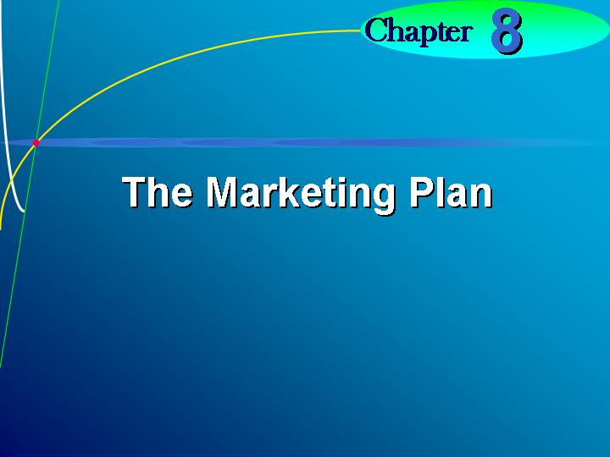  Learning Objective 1.  To understand the relevance of industry and competitive analysis to the market planning process.  Text Figure 8.1  “An Assessment of Competitor Marketing Strategies and Strengths and Weaknesses” (Text figure on page 222)  PowerPoint Slide 8-3 (Transparency Master 8-1)  “Industry Analysis” (See PowerPoint slide show beginning on page 203 of this manual. Also presented as a transparency master in Section 6 of this manual.)  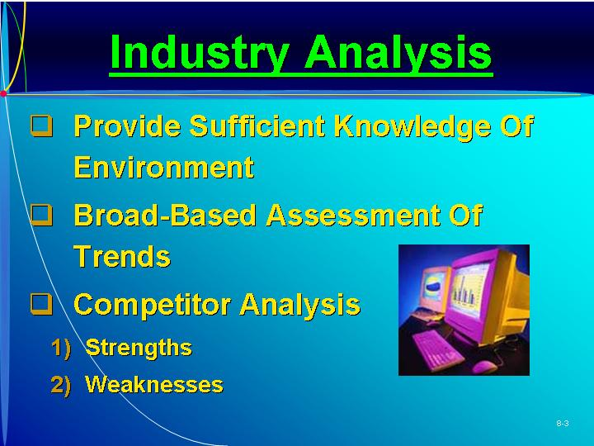
II. MARKET RESEARCH FOR THE NEW VENTURE  A. Information for developing the marketing plan may require some marketing research.  1. Marketing research involves the gathering of data in order to determine such information as:  a. Who will buy the product?  b. What price should be charged?  c. What is the most effective promotion strategy?  2. Marketing research may be conducted by the entrepreneur or by an external supplier or consultant.  3. Market research begins with definition of objectives or purpose.  4. Many entrepreneurs don’t know what they want to accomplish from a research study.  B. Step 1: Defining the Purpose or Objectives.  1. One effective way to begin the marketing plan is to make a list of the information that will be needed to prepare the marketing plan.  2. Possible objectives:  a. Determine what people think of the product or service and if they would buy it.  b. Determine how much customers would be willing to pay for the product or service.  c. Determine where the customer would prefer to purchase the product or service.  d. Determine where the customer would expect to hear about such a product or service.  C. Step 2: Gathering Data from Secondary Sources.  1. Secondary sources such as trade magazines, newspaper articles, and government agencies can provide information on the industry market and competition.  2. The Internet can be used to gather informal primary data through chat groups.  3. Commercial data may also be available, but the cost may be prohibitive.  4. Free secondary information is available through:  a. The U.S. Bureau of Census and the Department of Commerce.  b. State Departments of Commerce, Chambers of Commerce, and local banks.  c. Private sources of data, such as Reuters Business Insight, Dun and Bradstreet’s Million Dollar Directory, and the SBA’s Directory of Business Development Publications, can be found in a good business library.  D. Step 3: Gathering Information from Primary Sources.  1. Information that is new is primary data.  2. Observation is the simplest approach.  a. Networking, an informal method to gather primary data from experts in the field, can be a valuable low-cost research method.  b. One study of new ventures found that the most successful ventures were focused on information about competitors, the customer, and the industry.  c. Less successful ventures were more focused on gathering information on general economic and demographic trends.  3. Interviewing or surveying is the most common approach; it is more expensive, but more likely to generate meaningful information.  4. The questionnaire used by the entrepreneur should include questions designed to fulfill one or more of the objectives of the entrepreneur.  a. Questions should be designed so they are clear and concise, without bias, and easy to answer.  b. If the entrepreneur has no experience in designing questionnaires, they should seek assistance for this important step.  5. Focus groups.  a. A focus group is a sample of 10 or 12 potential customers who participate in a discussion.  b. Groups discuss issues in an informal, open format.  c. These groups should be led by an experienced monitor or by someone other than the entrepreneur.  E. Step 4: Analyzing and Interpreting the Results.  1. The entrepreneur can enter the results on a computer or hand tabulate the results.  2. Summarizing the answers to questions will give preliminary insights.  3. Data can then be cross tabulated to provide more focused results. | PowerPoint Slide 8-4 (Transparency Master 8-2)  “Market Research Steps” (See PowerPoint slide show beginning on page 203 of this manual.)  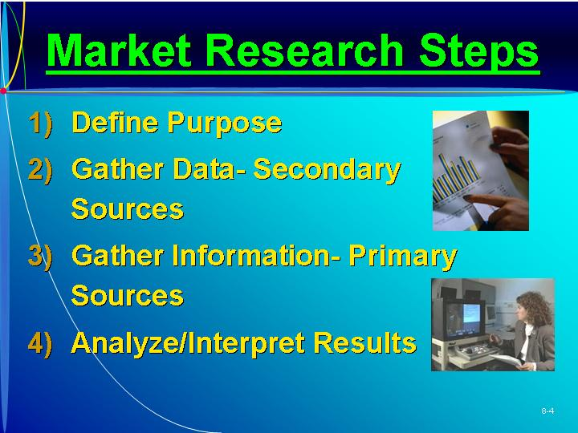  Learning Objective 2.  To describe the role of marketing research in determining market strategy for the marketing plan.  Learning Objective 3.  To illustrate an effective and feasible procedure for the entrepreneur to follow in engaging in a market research study.  Text Table 8.1  “A Comparison of Survey Methods” (Text table on page 224)  Text Table 8.2  “Sample Questionnaire for Personal Errand Service” (Text table on page 225)
III. UNDERSTANDING THE MARKETING PLAN  A. The marketing plan serves a number of important functions or purposes.  1. It establishes how the entrepreneur will compete and operate in the marketplace.  2. Once the strategies have been established, the entrepreneur can assign costs to these strategies.  B. The marketing plan should answer three basic questions:  1. Where have we been?—The history of the marketplace, marketing strengths and weaknesses, and market opportunities and threats.  2. Where do we want to go in the (short term)?—Marketing objectives and goals of the new venture in the next twelve months.  3. How do we get there?—Specific marketing strategy that will be implemented.  C. The marketing plan should be a guide for implementing marketing decision making and not a superficial document.  D. Organizing the thinking process in order preparing a marketing plan helps in understanding and recognizing critical issues. | PowerPoint Slide 8-5  “Marketing Plan” (See PowerPoint slide show beginning on page 203 of this manual.)  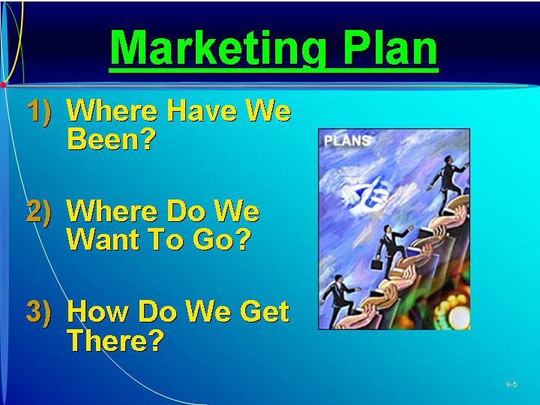  Text Table 8.3  “Outline for a Marketing Plan” (Text table on page 227)
IV. CHARACTERISTICS OF A MARKETING PLAN  A. An effective marketing plan should:  1. Provide a strategy to accomplish the company mission.  2. Be based on facts and valid assumptions.  3. Describe an organization to implement the plan.  4. Provide for continuity.  5. Be simple and short.  6. Be flexible.  7. Specify performance criteria that can be monitored and controlled.  B. The marketing plan is the statement of marketing objectives, strategies, and activities to be followed in the business plan.  C. The marketing system identifies the major interacting components, both internal and external, that enable the firm to provide products to the marketplace.  D. Environment factors, although largely uncontrollable, should be identified and discussed in the Industry Analysis section of the marketing plan.  E. Internal environmental factors are more controllable by the entrepreneur:  1. Financial resources. The financial plan should outline the financial needs for the venture.  2. Management team. The entrepreneur must build an effective management team and assign responsibilities to implementing the marketing plan.  3. Suppliers. Suppliers used are generally based on a number of factors, such as price, delivery time, and quality.  4. Company mission. Every new venture should define the nature of its business and what it hopes to accomplish. | Learning Objective 5.  To explain the marketing system and its key components.  Text Table 8.4  “Facts Needed for Market Planning” (Text figure on page 228)    Marketing plan.  Written statement of marketing objectives, strategies, and activities to be followed in business plan.  Marketing system.  Interacting internal and external factors that affect venture’s ability to provide goods and services to meet customer needs.  PowerPoint Slide 8-6 (Transparency Master 8-3)  “Characteristics of Marketing Plan” (See PowerPoint slide show beginning on page 203 of this manual. Also presented as a transparency master in Section 6 of this manual.)  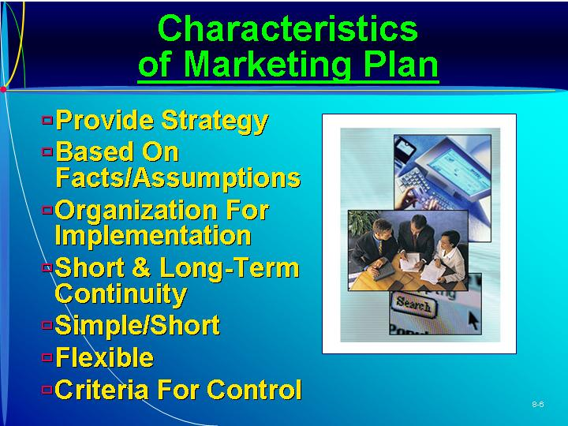  PowerPoint Slide 8-7  “Environmental Factors” (See PowerPoint slide show beginning on page 203 of this manual.)  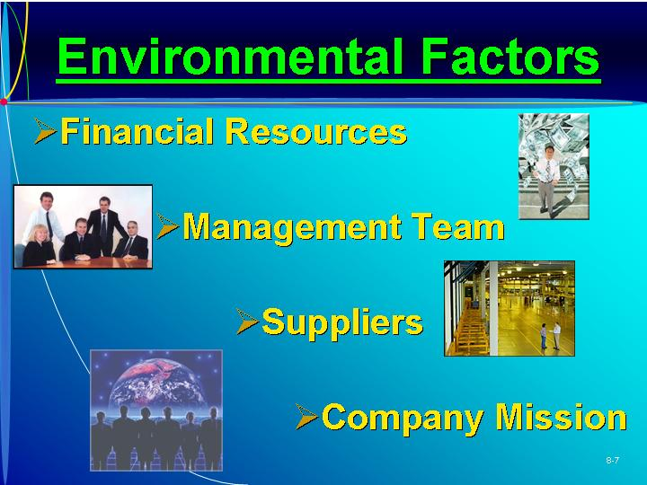  Text Figure 8.2  “The Marketing System” (Text figure on page 229)  Text Table 8.5 “Critical Decisions for Marketing Mix” (Text table on page 231)  As Seen in Entrepreneurship Magazine: Provide Advice to an Entrepreneur About Websites.  To get your company’s name and URL out on the Web you can write content for online newsletters and post messages on chat sites. (Box in text on page 230)
V. THE MARKETING MIX  A. The actual short-term marketing decisions in the marketing plan will consist of four important marketing variables, called the marketing mix:  1. Product or service.  2. Pricing.  3. Distribution.  4. Promotion.  B. Each variable should be described in detail in the strategy section of the marketing plan. | Marketing mix.  Combination of product, price, promotion, and distribution and other marketing activities needed to meet marketing objectives.
VI. STEPS IN PREPARING THE MARKETING PLAN  A. Step 1: Defining the Business Situation.  1. The situation analysis is a review of where the company has been and considers many of the above environmental factors.  2. The entrepreneur should provide a review of past performance of the product and the company.  3. This section simply reviews key elements of the Industry and Competitive Environment section of the plan.  B. Step 2: Defining Target Market/Opportunities and Threats.  1. The entrepreneur should have a good idea of who the customer or target market will be.  2. The defined target market will usually represent one or more segments of the entire market.  3. Market segmentation is the process of dividing the market into smaller homogeneous groups.  4. The process of segmenting and targeting customers is:  a. Decide what general market or industry you wish to pursue.  b. Divide the market into smaller groups based on characteristics of the customer or buying situation.  c. Select segment or segments to target.  d. Develop marketing plan integrating the parts of the marketing mix.  C. Step 3: Considering Strengths and Weaknesses. It is important for the entrepreneur to consider its strengths and weaknesses in the target market.  D. Step 4: Establishing Goals and Objectives.  1. Before strategy decisions can be outlined, the entrepreneur must establish realistic marketing goals and objectives.  2. These objectives answer the question “Where do we want to go?”  3. These goals should specify such things as market share, profit, sales, market penetration, pricing policy, and advertising support.  4. Not all goals and objectives must be quantified—nonquantitative goals can be set (i.e., change the name of the product or find a new distributor.)  5. It is a good idea to limit the number of goals to between six and eight.  E. Step 5: Defining Marketing Strategy and Action Programs.  1. Marketing strategy and action programs answer the question “How do we get there?”  2. Product or Service.  a. This includes a description of the product and may include more than the physical characteristics.  b. It involves packaging, brand name, price, warranty, image, service, features, and style.  3. Pricing.  a. Prior to setting the price the entrepreneur will need to consider three important elements: costs, margins or markups, and competition.  b. Costs.  (i) An important initial consideration in any pricing decision is to determine the costs directly related to the product or service.  (ii) The entrepreneur would then need to ascertain the approximate costs for overhead.  (iii) Based on sales estimates, the entrepreneur would then add the unit costs of overhead to the cost of manufacture or cost of goods to determine the final price.  (iv) It may also be necessary to consider the role of competition and markups.  c. Markups or Margins.  (i) In some industries retailers use a standard markup to price goods in their stores.  (ii) Standard markups can be ascertained from trade publications or asking suppliers.  (iii) Lower markup in relation to competitors can increase demand in the short term.  d. Competition.  (i) When products cannot be easily differentiated, the entrepreneur is generally forced to charge the same price as the competition.  (ii) If the product has unique benefits, the product may warrant a higher price.  (iii) New innovations may warrant a higher price or skimming strategy in order to recover some of its high development costs.  (iv) In a nondifferentiated product market, the only justification for charging a higher price would be additional services provided to the consumer.  (v) If the product or service is unique in the marketplace, the entrepreneur has more flexibility.  (vi) The final price is a combination of total cost and profit margins; changing one of these will impact the other two.  4. Distribution.  a. This factor provides utility, or makes the product convenient to purchase when it is needed.  b. Market concentration.  (i) If the market is highly concentrated, the entrepreneur may consider direct sales to the customer.  (ii) If the market is dispersed across a wide geographic area, the use of a longer channel with wholesalers and retailers may be necessary.  c. Attributes of the product (expensive, perishable, or bulky) also affect the channel decision.  d. Middlemen such as wholesalers and retailers can add important value to the product.  (i) Their costs of providing these benefits are much lower because they operate with economies of scale.  (ii) They can provide functions such as storage, delivery, and sales staff that would not be feasible for a start up venture.  e. Environmental issues: Special considerations and regulations regarding such products as chemicals or food and drug products are too costly for a small start up to absorb.  f. Manufacturer’s representatives.  (i) Manufacturer’s representatives do not take title or physical possession of any products, but act on behalf of noncompeting companies.  (ii) They are only paid a commission and only when a sale is made.  (iii) Brokers are more common in food or dry goods businesses.  g. It may be necessary to use more than one channel to service customers more efficiently and increase sales potential.  h. Channel decisions will also change over time.  5. Promotion.  a. The entrepreneur needs to inform customers about the product’s availability using advertising media such as print, radio, or television.  b. Usually television is too expensive unless cable television is a viable option.  c. Larger markets can be reached using direct mail, trade magazines, or newspapers.  d. A website may also create awareness and promote the product and services of the venture.  e. The entrepreneur sometimes has to be creative buying media space or time.  f. Press releases about the venture or its products or services are often of interest to media.  (i) Local media are always looking for interesting stories about new venture or entrepreneurs.  (ii) It is a good strategy to send out professionally written news releases on a regular basis.  6. The marketing strategy and action programs should be specific and detailed enough to guide the entrepreneur through the next year.  F. Marketing Strategy: Consumer versus Business-to-Business Markets.  1. Marketing strategy decisions for a consumer product may be very different from the decisions for a business-to-business product.  2. Consumer markets involve sales to households for personal consumption.  3. Usually business-to-business marketing strategy involves a more different channel of distribution than the consumer market.  a. Advertising and promotions for the business-to-business market involve more trade magazine advertising and direct sales.  b. Attendance at trade shows can be one of the most effective means to reach potential buyers in one location.  G. Step 6: Budgeting the Marketing Strategy.  1. Planning decisions must also consider the costs involved in the implementation of these decisions.  2. This budgeting will be useful in preparing the financial plan.  H. Step 7: Implementation of the Marketing Plan.  1. The marketing plan is meant to be a commitment to a specific strategy.  2. A commitment to make adjustments as needed by market conditions is also valuable.  3. Someone in the venture should be assigned the responsibility of coordinating and implementing the plan.  I. Step 8: Monitoring Progress of Marketing Actions.  1. Monitoring of the plan involves tracking specific results of the marketing effort.  2. What is monitored is dependent on the specific goals and objectives outlined. | Learning Objective 4.  To define the steps in preparing the marketing plan.  Text Figure 8.3  “Sample Flowchart of a Marketing Plan” (Text figure on page 232)  Situation analysis.  Describes past and present business achievements of new venture.  Target market.  Specific group of potential customers toward which venture aims its marketing plan.  Market segmentation.  Process of dividing a market into definable and measurable groups for purpose of targeting marketing strategy.  PowerPoint Slide 8-8 (Transparency Master 8-4)  “Steps in Plan Preparation” (See PowerPoint slide show beginning on page 203 of this manual. Also presented as a transparency master in Section 6 of this manual.)  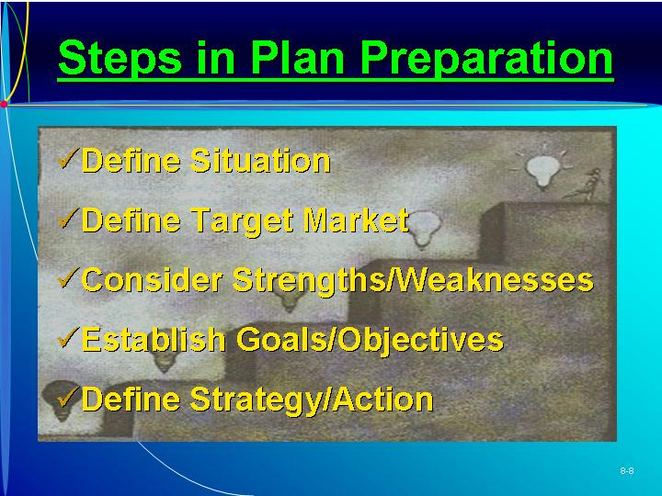  Marketing goal and objectives.  Statements of level of performance desired by new venture.  Marketing strategy and action programs.  Specific activities outlined to meet the venture’s business plan goals and objectives.  PowerPoint Slide 8-9 (Transparency Master 8-5)  “Target Marketing” (See PowerPoint slide show beginning on page 203 of this manual. Also presented as a transparency master in Section 6 of this manual.)  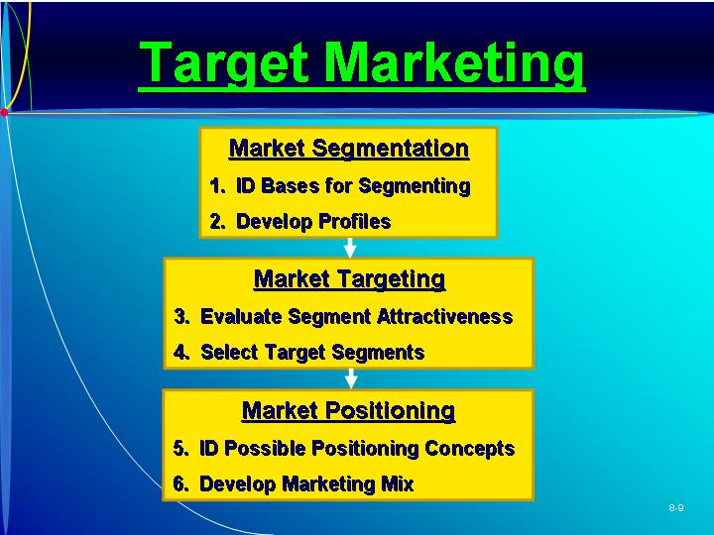  PowerPoint Slide 8-10  “Market Segmentation” (See PowerPoint slide show beginning on page 203 of this manual.)    PowerPoint Slide 8-11  “Consumer Market Segmentation” (See PowerPoint slide show beginning on page 203 of this manual.)  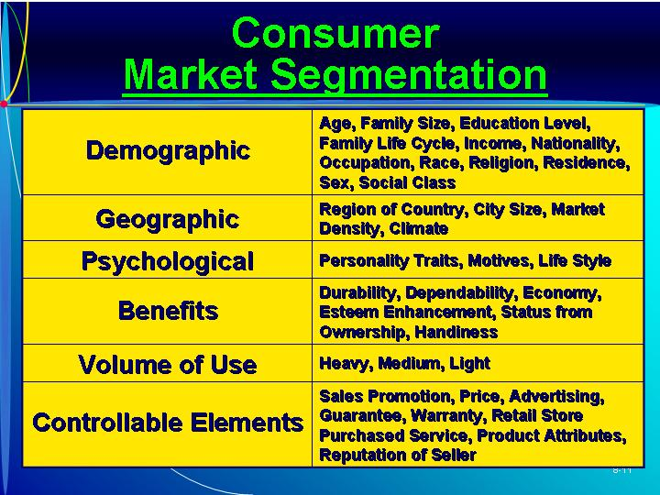  PowerPoint Slide 8-12  “Industrial Market Segmentation” (See PowerPoint slide show beginning on page 203 of this manual.)  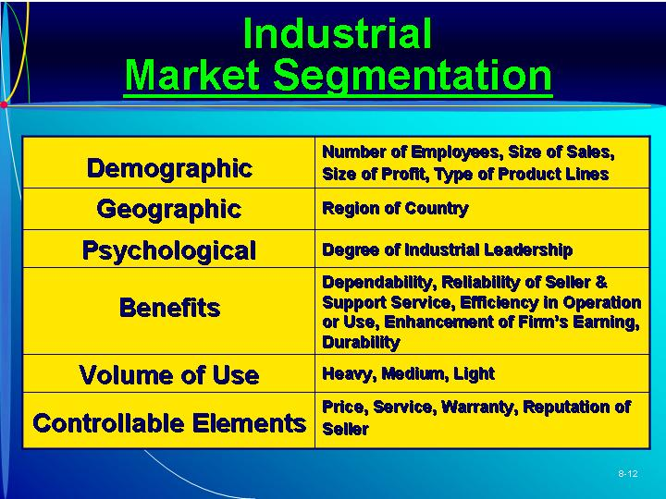  PowerPoint Slide 8-13  “Government Market Segmentation” (See PowerPoint slide show beginning on page 203 of this manual.)  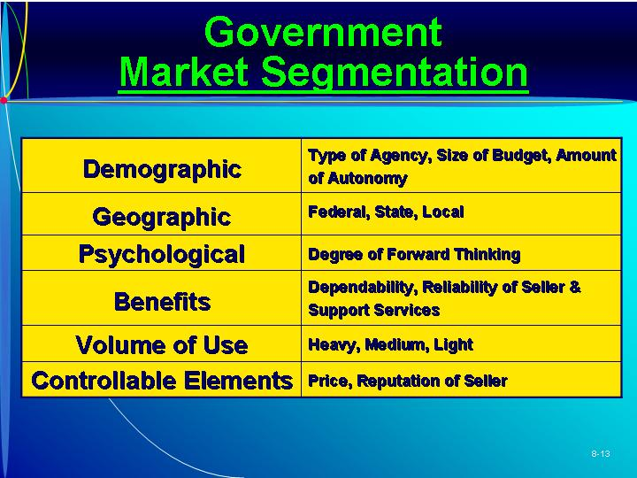  PowerPoint Slide 8-14 (Transparency Master 8-6)  “Marketing Strategy” (See PowerPoint slide show beginning on page 203 of this manual. Also presented as a transparency master in Section 6 of this manual.)  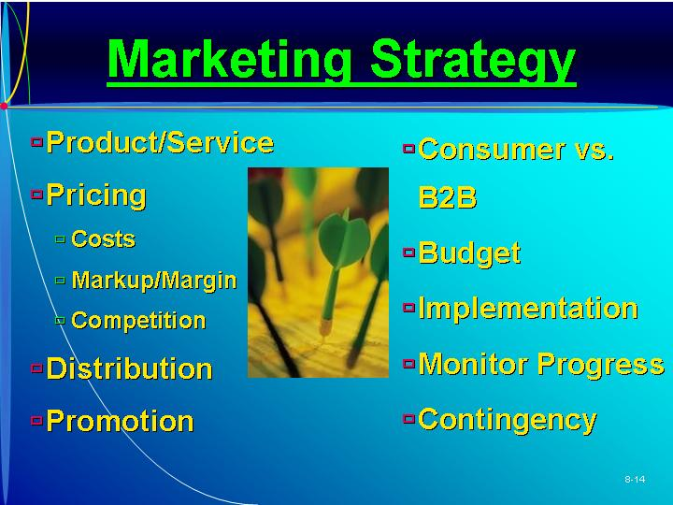  PowerPoint Slide 8-15  “Product Mix” (See PowerPoint slide show beginning on page 203 of this manual.)  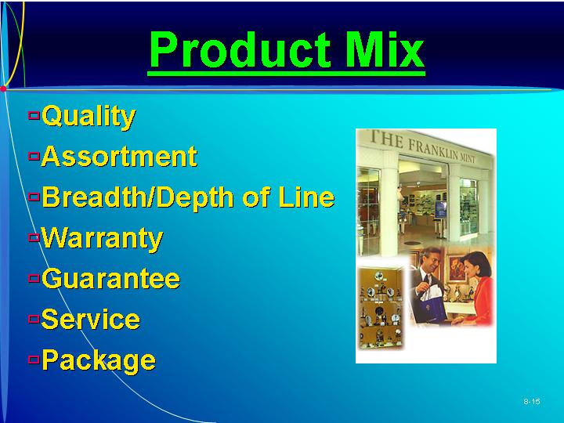  Learning Objective 6.  To illustrate different creative strategies that may be used to differentiate or position the new venture’s products or services.    ETHICS.  Devil’s Advocate  Ethics in sales may not be the quickest route to success but selling with a conscience makes good balance-sheet sense over time. (Box in text on page 235)  PowerPoint Slide 8-16  “Price Mix Relationships” (See PowerPoint slide show beginning on page 203 of this manual.)  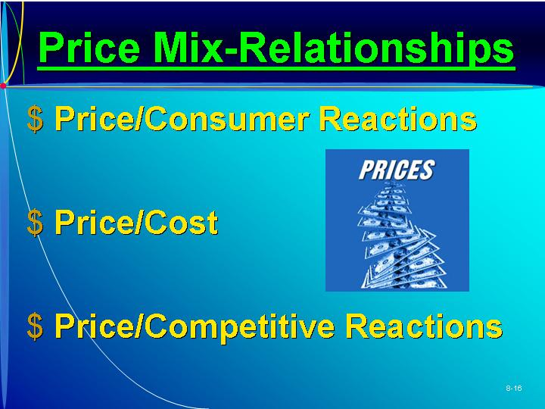  PowerPoint Slide 8-17 (Transparency Master 8-7)  “Distribution Mix” (See PowerPoint slide show beginning on page 203 of this manual. Also presented as a transparency master in Section 6 of this manual.)  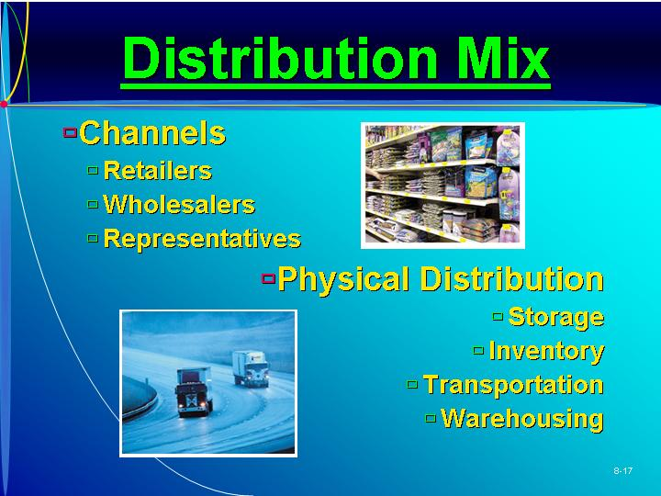  Text Table 8.6  “Major Considerations in Channel Selection” (Text table on page 237)  As Seen in Entrepreneurship Magazine: Analysis and Advice on Simple Images.  To counter increasing competition, Breckenridge Brewery revamped its marketing efforts, using the philosophy that “simpler is better.” (Box in text on page 239)  PowerPoint Slide 8-18  “Distribution Channel Selection” (See PowerPoint slide show beginning on page 203 of this manual.)  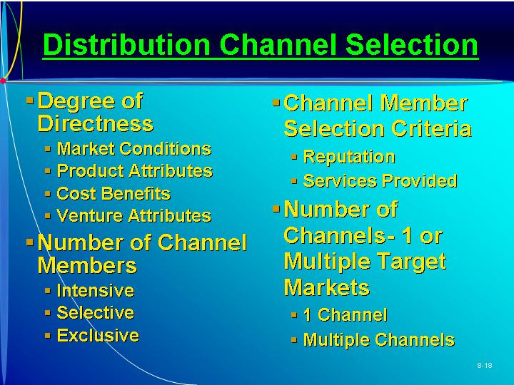  PowerPoint Slide 8-20  “Promotion Mix” (See PowerPoint slide show beginning on page 203 of this manual.)  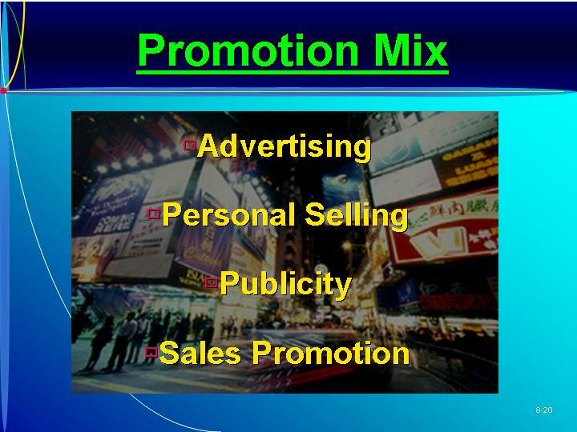
VII. CONTINGENCY PLANNING
A. It is important for the entrepreneur to be flexible and prepared to make adjustments.
B. Few marketing plans succeed exactly as planned.
VIII. WHY SOME PLANS FAIL  A. Marketing plans can be ineffective in meeting marketing goals for different reasons.  B. Some of the more common reasons for failure:  1. Lack of a real plan.  2. Lack of an adequate situation analysis.  3. Unrealistic goals.  4. Unanticipated competitive moves, product deficiencies, and acts of God. | PowerPoint Slide 8-19 (Transparency Master 8-8)  “Why Plans Fail” (See PowerPoint slide show beginning on page 203 of this manual. Also presented as a transparency master in Section 6 of this manual.)  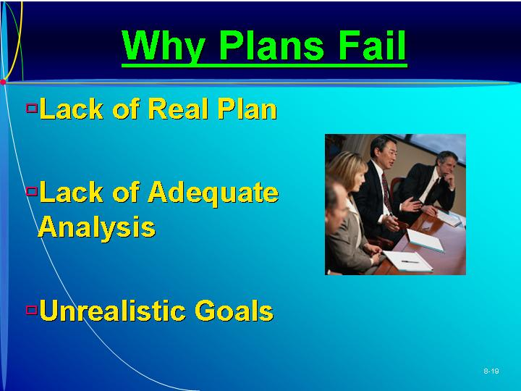
IX. IN REVIEW: SUMMARY.
See “Learning Objectives Revisited” below.

learning objectives revisited

Learning Objective 1. To understand the relevance of industry and competitive analysis to the market planning process.
  - The industry analysis section begins with broad based assessments of environmental and industry trends then proceeds to more local market trends.
  - In addition to secondary source the entrepreneur may also want to undertake a market research initiative to secure more specific information.
  - Information for competitor analysis can be gathered using public information; this can be complemented with a marketing research project.

Learning Objective 2. To describe the role of marketing research in determining market strategy for the marketing plan.
  - Marketing research may be conducted by the entrepreneur or by an external supplier or consultant.
  - Market research begins with definition of objectives.

Learning Objective 3. To illustrate an effective and feasible procedure for the entrepreneur to follow in engaging in a market research study.
  - Step 1: Defining the purpose or objectives.
  - Step 2: Gathering data from secondary sources.
  - Step 3: Gathering information from primary sources.
  - Step 4: Analyzing and interpreting the results.

Learning Objective 4. To define the steps in preparing the marketing plan.
  - Step 1: Defining the business situation.
  - Step 2: Defining target market/opportunities and threats.
  - Step 3: Considering strengths and weaknesses.
  - Step 4: Establishing goals and objectives.
  - Step 5: Defining marketing strategy and action programs.
  - Step 6: Budgeting the marketing strategy.
  - Step 7: Implementing of the marketing plan.
  - Step 8: Monitoring progress of marketing actions.

Learning Objective 5. To explain the marketing system and its key components.
  - The marketing system identifies the major interacting components, both internal and external, that enable the firm to provide products to the marketplace.
  - Environmental factors, although largely uncontrollable, should be identified.
  - Internal environmental factors—such as financial resources, management team, suppliers, and company mission—are more controllable by the entrepreneur.

Learning Objective 6. To illustrate different creative strategies that may be used to differentiate or position the new venture’s products or services.
  - Product or service includes a description of the product or service and involves packaging, brand name, price, warranty, image, service, features, and style.
  - Pricing must consider factors such as costs, markups, and competition.
  - Distribution provides utility to the customer and is affected by variable such as market concentration, middlemen, and environmental issues.
  - Through promotion the entrepreneur informs customers about the product’s availability using advertising media such as print, radio, or television.

key terms

Marketing goal and objectives. Statements of level of performance desired by new venture.
Marketing mix. Combination of product, price, promotion, and distribution and other marketing activities needed to meet marketing objectives.
Marketing plan. Written statement of marketing objectives, strategies, and activities to be followed in the business plan.
Market segmentation. Process of dividing a market into definable and measurable groups for purposes of targeting marketing strategy.
Market strategy and action plan. Specific activities outlined to meet the venture’s business plan goals and objectives.
Marketing system. Interacting internal and external factors that affect venture’s ability to provide goods and services to meet customer needs.
Situation analysis. Describes past and present business achievements of new venture.
Target market. Specific group of potential customers toward which venture aims its marketing plan.

research tasks and class discussions

The text includes several topics for student research and class discussions. These questions are open-ended, and the answers will be different for each student. There are no “correct” answers.

Research tasks:
- Participate in an online focus group. Then conduct research on the advantages and disadvantages of conducting a focus group online versus a “face-to-face” focus group.
- Choose an industry and then use the library or the Internet to find data from secondary sources that will be highly useful in developing a marketing plan.
- Find five examples of product advertising (e.g., advertisements cut out of a magazine or recorded on video tape). Bring them to class and be prepared to explain how they fit in with the rest of the marketing mix and which groups of customers were being targeted.
- Find a marketing strategy that is being used now that you believe will be ineffective. Be prepared to justify your answer.

Class Discussions
- What are the three most effective advertisements on television? Why are they effective? What are the three least effective advertisements on television? Why are they ineffective? Are they really ineffective if you have been able to recall them?
- Define a customer group and then invent a product and come up with a price, promotion, and distribution strategy. Have some fun in coming up with a particularly creative marketing mix.
- Segment the class into groups, label those groups, and determine a specific demand that is unique to each group. You may be asked to reveal your market (class) segmentation to the rest of the class, and people will have a chance to respond to your classification.
- Is marketing segmentation just a nice way of using “stereotypes” to sell your products? Can people really be classified so easily into groups that share common needs, wants, and demands?

Visual Resources

The PowerPoint presentation for this chapter, shown on the following pages, includes the following slides.
Slide 8-1 Entrepreneurship Title
Slide 8-2 Chapter Title
Slide 8-3 Industry Analysis *
Slide 8-4 Market Research Steps *
Slide 8-5 Marketing Plan
Slide 8-6 Characteristics of Marketing Plan *
Slide 8-7 Environmental Factors
Slide 8-8 Steps in Plan Preparation *
Slide 8-9 Target Marketing *
Slide 8-10 Market Segmentation
Slide 8-11 Consumer Market Segmentation
Slide 8-12 Industrial Market Segmentation
Slide 8-13 Government Market Segmentation
Slide 8-14 Marketing Strategy *
Slide 8-15 Product Mix
Slide 8-16 Price Mix Relationships
Slide 8-17 Distribution Mix *
Slide 8-18 Distribution Channel Selection
Slide 8-19 Why Plans Fail *
Slide 8-20 Promotion Mix
* Also included as a Transparency Master.

The following are included as transparency masters in Section 6 of this manual.
Transparency Master 8-1 Industry Analysis
Transparency Master 8-2 Market Research Steps
Transparency Master 8-3 Characteristics of Marketing Plan
Transparency Master 8-4 Steps in Plan Preparation
Transparency Master 8-5 Target Marketing
Transparency Master 8-6 Marketing Strategy
Transparency Master 8-7 Distribution Mix
Transparency Master 8-8 Why Plans Fail

powerpoint slide show

Slide 8-1  Entrepreneurship Title   | Slide 8-2  Chapter Title
Slide 8-3  Industry Analysis (Also presented as Transparency Master 8-1 in Section 6 of this manual.) | Slide 8-4  Market Research Steps (Also presented as Transparency Master 8-2 in Section 6 of this manual.)
Slide 8-5  Marketing Plan | Slide 8-6  Characteristics of Marketing Plan (Also presented as Transparency Master 8-3 in Section 6 of this manual.)
Slide 8-7  Environmental Factors | Slide 8-8  Steps in Plan Preparation (Also presented as Transparency Master 8-4 in Section 6 of this manual.)
Slide 8-9  Target Marketing (Also presented as Transparency Master 8-5 in Section 6 of this manual.) | Slide 8-10  Market Segmentation
Slide 8-11  Consumer Market Segmentation  \ | Slide 8-12  Industrial Market Segmentation
Slide 8-13  Government Market Segmentation | Slide 8-14  Marketing Strategy (Also presented as Transparency Master 8-6 in Section 6 of this manual.)
Slide 8-15  Product Mix | Slide 8-16  Price Mix Relationships
Slide 8-17  Distribution Mix (Also presented as Transparency Master 8-7 in Section 6 of this manual.) | Slide 8-18  Distribution Channel Selection
Slide 8-19  Why Plans Fail (Also presented as Transparency Master 8-8 in Section 6 of this manual.) | Slide 8-20  Promotion Mix

