11

sources of capital

Learning Objectives

1
To identify the types of financing available.

2
To understand the role of commercial banks in financing new ventures,
the types of loans available, and bank lending decisions.

3
To discuss Small Business Administrative (SBA) loans.

4
To understand the aspects of research and development limited partnerships.

5
To discuss government grants, particularly small business innovation research grants.

6
To understand the role of private placement as a source of funds.

CHAPTER OUTlINE AND TEACHING NOTES
OPENING PROFILE—CWalt Disney  I. AN OVERVIEW  A. Different sources of capital are generally used at different times in the life of the venture.  B. Debt or Equity Financing.  1. Debt financing involves an interest-bearing instrument, usually a loan, the payment of which is only indirectly related to sales and profits.  a. Debt financing (also called asset-based financing) requires some asset be used as collateral.  b. The entrepreneur has to pay back the amount of funds borrowed plus a fee, expressed in terms of the interest rate.  c. Short-term money is used to provide working capital—funds are usually repaid from resulting sales.  d. Long term debt (lasting more than a year) is frequently used to purchase some asset, using part of the value of the asset as collateral.  e. Debt lets the entrepreneur retain a large ownership position and have greater return on equity.  f. If the debt is too great, payments become difficult to make and growth is inhibited.  2. Equity financing offers the investor some form of ownership position in the venture.  a. The investor shares in the profits of the venture.  b. Factors in choosing the type of financing are availability of funds, assets of the venture, and prevailing interest rates.  c. Usually a combination of debt and equity financing is used.  3. In a market economy all ventures will have some equity, as all are owned by some person or institution.  a. The equity may be entirely provided by the owner or may require multiple owners.  b. This equity funding provides the basis for debt financing, which makes up the capital structure of the venture.  C. Internal or External Funds.  1. The most often used type of funds is internally generated funds.  a. These funds come from sources within the company, such as profits, sale of assets, reduction in working capital, extended payment terms, and accounts receivable.  b. In the start-up years all the profits are usually plowed back into the venture.  c. Sometimes little-used assets can be sold or leased.  d. Assets, whenever possible, should be on a rental basis, not an ownership basis.  e. One short-term internal source of funds is reducing short-term assets, often through extended payments from suppliers.  f. Another method is by collecting accounts receivable more quickly.  2. Other general sources are external to the venture.  a. Alternative sources should be evaluated by:  (i) Length of time the funds are available.  (ii) Costs involved.  (iii) Amount of control lost.  b. The more frequently used sources of start up capital as listed in Entrepreneurship magazine are:  (i) savings (61%)  (ii) private investor (31%)  (iii) friends and family (18%)  (iv) home equity line of credit (17%)  (v) bank loan (16%)  (vi) credit cards (10%)  (vii) sale of another business (1%)  (viii) SBA loan (1%)  (ix) other sources (2%) | PowerPoint Slide 11-1  “Entrepreneurship Title” (See PowerPoint slide show beginning on page 275 of this manual.)  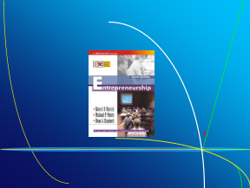  PowerPoint Slide 11-2  “Chapter Title” (See PowerPoint slide show beginning on page 275 of this manual.)  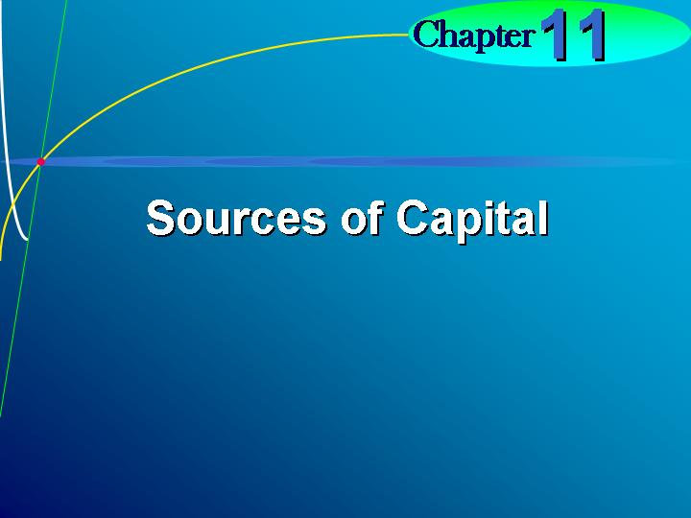  Learning Objective 1.  To identify the types of financing available.    Debt financing.  Obtaining borrowed funds for the company.  Equity financing.  Obtaining funds for the company in exchange for ownership.  PowerPoint Slide 11-3 (Transparency Master 11-1)  “Overview” (See PowerPoint slide show beginning on page 275 of this manual. Also presented as a transparency master in Section 6 of this manual.)  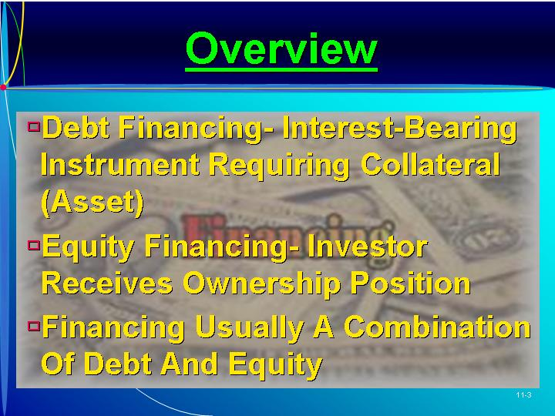  PowerPoint Slide 11-4  “Factors Affecting Type of Financing” (See PowerPoint slide show beginning on page 275 of this manual.)  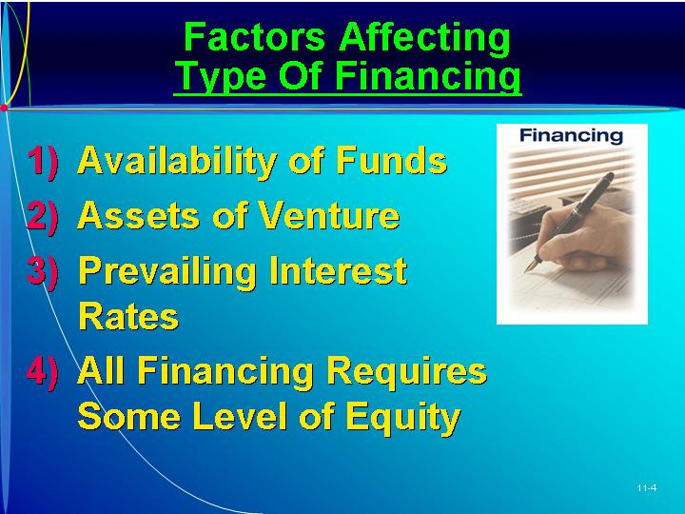  PowerPoint Slide 11-5 (Transparency Master 11-2)  “Internal Funds” (See PowerPoint slide show beginning on page 275 of this manual. Also presented as a transparency master in Section 6 of this manual.)  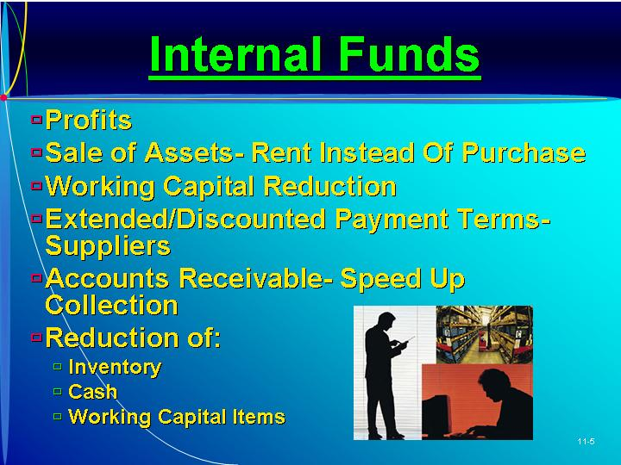  PowerPoint Slide 11-6 (Transparency Master 11-3)  “External Funds” (See PowerPoint slide show beginning on page 275 of this manual. Also presented as a transparency master in Section 6 of this manual.)  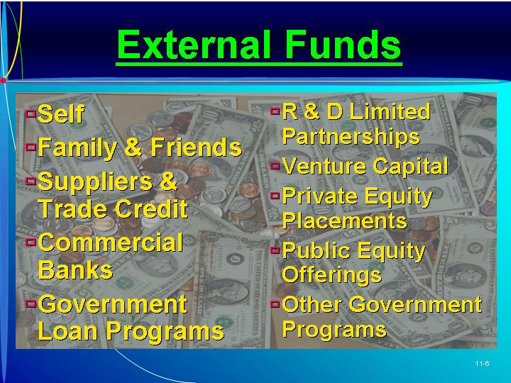    ETHICS.  Signs of trouble—such as serious cash flow difficulties, doctored financial transactions, and extravagant spending—are typically present but simply missed by the persons involved. (Box in text on page 326)
II. PERSONAL FUNDS  A. Few new ventures are started without the personal funds of the entrepreneur.  1. Personal funds are the least expensive in terms of cost and control; they are also essential in attracting outside funding.  2. Typical sources include savings, life insurance, or mortgage of a house or car.  B. Outside investors want the entrepreneur to demonstrate financial commitment.  1. This level of commitment is shown by the percentage of total assets available the entrepreneur has committed.  2. An outside investor wants an entrepreneur to have committed all available assets.  3. It is not the amount but the fact that all monies available are committed that makes outside investors feel comfortable. | Text Table 11.1  “Alternative Sources of Financing” (Text table on page 325.)  PowerPoint Slide 11-7 (Transparency Master 11-4)  “Personal Funds” (See PowerPoint slide show beginning on page 275 of this manual. Also presented as a transparency master in Section 6 of this manual.)  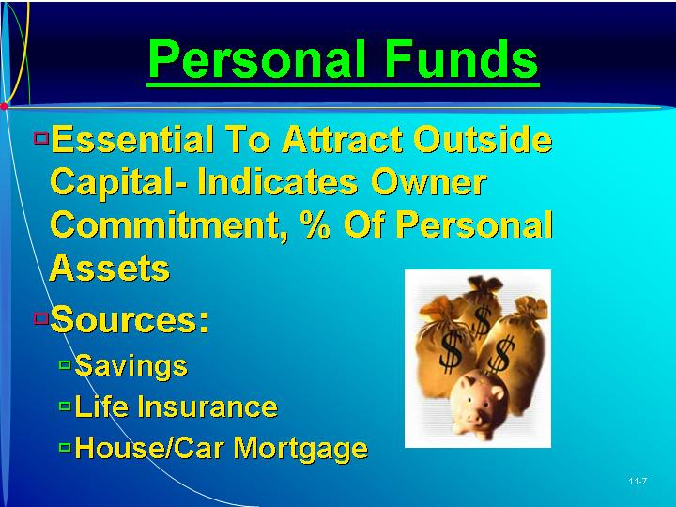
III. FAMILY AND FRIENDS  A. After the entrepreneur, family and friends are a common source of capital.  B. Family and friends provide a small amount of equity funding for new ventures.  1. It is relatively easy to obtain money from family and friends, but the amount of money provided may be small.  2. If it is in the form of equity funding, the family member or friend has an ownership position in the venture.  3. If they have direct input into operations of the venture, it may have a negative effect on employees or profits.  C. To avoid potential future problems, the entrepreneur must present the positive and negative aspects and the nature of the risks of the investment.  1. To minimize any future problems, the entrepreneur should keep the business arrangements strictly business.  2. Any loan should specify the rate of interest and the proposed repayment schedule of interest and principal.  3. The entrepreneur should settle everything up front and in writing.  4. A formal agreement specifying details of the funding helps avoid future problems.  D. The entrepreneur should carefully consider the impact of the investment on the family member or friend before it is accepted. | PowerPoint Slide 11-8  “Family and Friends” (See PowerPoint slide show beginning on page 275 of this manual.)  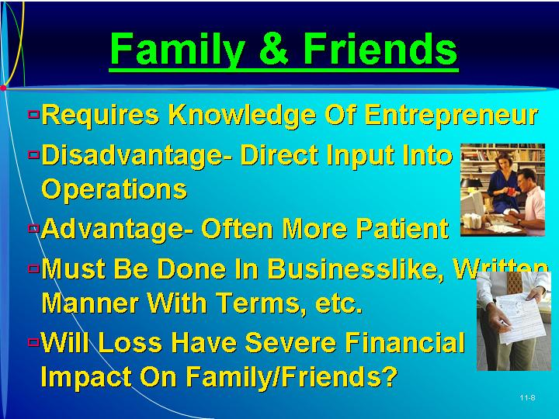  As Seen in Entrepreneurship Magazine: Elevator Pitch for Jack Black.  Is this a business opportunity? Jack Black is a retailer of high-end men’s grooming products. (Box in text on page 328)
IV. COMMERCIAL BANKS  A. Commercial banks are the most frequently used source of short-term funds when collateral is available.  1. This is debt financing and requires some tangible guaranty or collateral, some asset with value.  2. This collateral can be business assets, personal assets, or the assets of the cosigner of the note.  B. Types of Bank Loans.  1. The asset base for loans is usually accounts receivable, inventory, equipment, or real estate.  2. Accounts Receivable Loans.  a. Accounts receivable provide a good basis for a loan, especially if the customer base is creditworthy.  b. A bank may finance up to 80% of the value of the accounts receivable.  c. A factoring arrangement can be developed whereby the factor (bank) actually buys the accounts and collects the money.  d. If any of the receivables are not collectible, the factor sustains the loss, not the business.  e. The cost of factoring is higher than the cost of securing a loan against the accounts receivable.  3. Inventory Loans.  a. Inventory is often a basis for a loan, particularly when inventory is liquid and can be sold easily.  b. Finished goods inventory can be financed up to 50% of value.  c. Trust receipts are a type of inventory loan used to finance floor plans of retailers such as auto dealers.  d. The bank advances a large percentage of the invoice price of the goods and is paid a pro rate basis as the inventory is sold.  4. Equipment Loans.  a. Equipment can be used to secure longer term financing up to 3 to 10 years.  b. When new equipment is purchased, 50 to 80% of value can be financed.  c. In sale-leaseback financing the entrepreneur “sells” the equipment to a lender and then leases it back.  5. Real estate loans are easily obtained to finance land, plant, or building, usually up to 75% of value.  C. Cash Flow Financing.  1. Cash flow financing, or conventional bank loans, include lines of credit, installment loans, straight commercial loans, long-term loans, and character loans.  a. Lines of credit financing are the most frequently used by entrepreneurs.  b. The company pays a “commitment fee” at the start then pays interest on outstanding borrowed funds.  2. Installment Loans.  a. Installment loans can be obtained by a going venture with a track record of sales and profits.  b. These funds are used to cover working capital needs, usually for 30 to 40 days.  3. Straight Commercial Loans.  a. In this hybrid of the installment loan, funds are advanced to the company for 30 to 90 days.  b. These self-liquidating loans are used for seasonal financing.  4. Long-Term Loans.  a. These loans are usually only available to strong, mature companies.  b. Funds are available for up to 10 years with the debt repaid according to a fixed interest and principle schedule.  5. Character Loans.  a. When the business does not have assets to support a loan, the entrepreneur may need a character loan.  b. These loans must have assets of an individual pledged as collateral, or have the loan cosigned by another.  D. Bank Lending Decisions.  1. Banks are very cautious in lending money, particularly to new ventures.  a. Commercial loan decisions are made only after the loan officer does a careful review of the borrower.  b. Decisions are made based on quantifiable and subjective judgments.  2. Bank lending decisions can be summarized by the five C’s—Character, Capacity, Capital, Collateral, and—Conditions.  a. Past financial statements are reviewed in terms of key ratios and the entrepreneur’s capital invested.  b. Future projections on market size, sales, and profitability are evaluated.  c. Intuitive factors—Character and Capacity—are also taken into account and become more important when there is little or no track record.  3. The loan application format is generally a “mini” business plan.  a. This provides the loan officer and loan committee information on the creditworthiness of the individual and the ability of the venture to repay the loan.  b. Presenting a positive business image and following procedure are important in obtaining the funds.  4. The entrepreneur should borrow the maximum amount possible that can be repaid, as long as the prevailing interest rates and terms are satisfactory.  a. The venture must make sure that it will generate enough cash flow to repay the interest and principal on the loan.  b. The entrepreneur should evaluate the track record and lending policies of several banks in the area. | Learning Objective 2.  To understand the role of commercial banks in financing new ventures, the types of loans available, and bank lending decisions.  PowerPoint Slide 11-10 (Transparency Master 11-5)  “Commercial Banks” (See PowerPoint slide show beginning on page 275 of this manual. Also presented as a transparency master in Section 6 of this manual.)  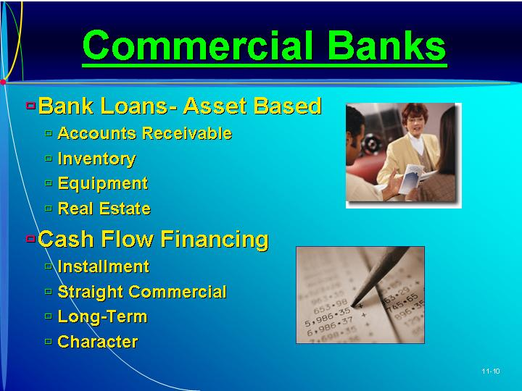  Asset base for loans.  Tangible collateral valued at more than the amount of money borrowed.  Conventional bank loans.  Standard ways banks lend money to companies.  PowerPoint Slide 11-11 (Transparency Master 11-6)  “Lending Decisions” (See PowerPoint slide show beginning on page 275 of this manual. Also presented as a transparency master in Section 6 of this manual.)  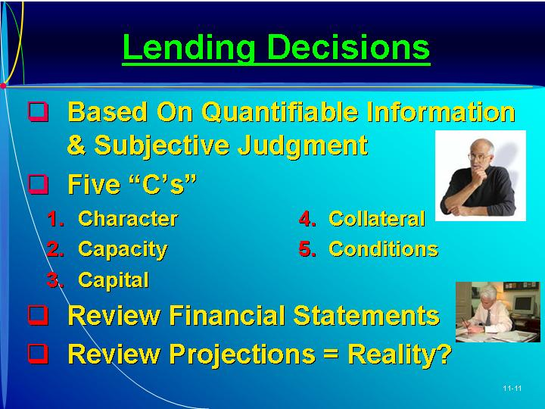  PowerPoint Slide 11-12  “Lending Questions” (See PowerPoint slide show beginning on page 275 of this manual.)  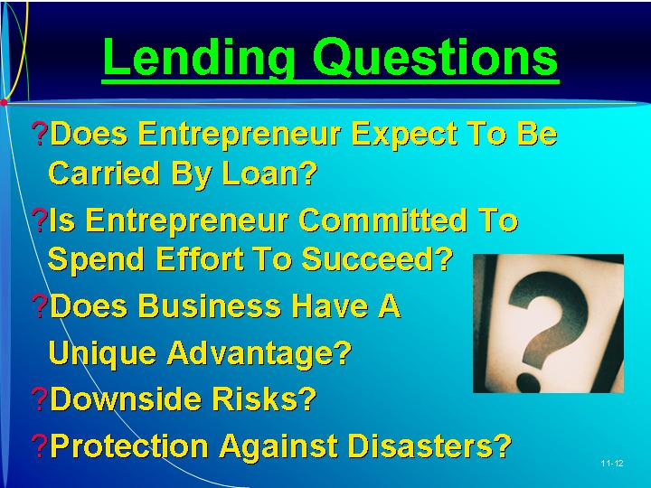  PowerPoint Slide 11-13  “Bank ‘Shopping’ Process” (See PowerPoint slide show beginning on page 275 of this manual.)  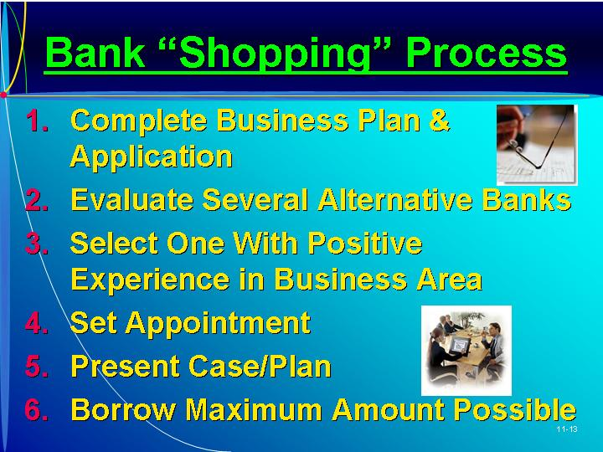
V. ROLE OF SBA IN SMALL BUSINESS FINANCING  A. When the entrepreneur is unable to secure a regular commercial bank loan, an alternative is a guarantee from the Small Business Administration (SBA).  1. The SBA is primarily a guarantor of loans made by private and other institutions.  2. The Basis 7(a) Loan Guaranty helps qualified small businesses obtain financing when they cannot obtain loans through regular lending channels.  B. To get a 7(a) loan, the small business person or entrepreneur must be eligible.  1. Criteria include good character, management capability, collateral, size, type of business, use of proceeds, and the availability of funds from other sources.  2. The SBA 7(a) loan program has a maximum loan amount of $2 million with the SBA’s maximum exposure of $1 million.  3. The interest rates on the loan are negotiated between the borrower and the lender, but are subject to SBA maximums.  C. Most of the loans have the same guarantee features.  1. The SBA can guarantee 85% of loans of $150,000 or less and 75% of loans above $150,000 to a maximum of $1 million.  2. SBA Express loans have a maximum guarantee of 50%, and export working capital loans have a maximum guarantee of 90%.  3. Lenders are charged a guaranty and servicing fee for each approved loan.  D. Other SBA Programs.  1. The 504 Loan Program provides fixed-rate financing to enable small businesses to acquire machinery, equipment, or real estate.  2. The loan can include a loan from a Community Development Company (CDC) backed by a 100% SBA guaranteed debenture.  E. SBA Microloan is a 7(m) loan program.  1. This program provides short-term loans of up to $35,000 to small businesses for working capital or the purchase of assets.  2. The small business receives the loan from a lender, with the loan being guaranteed by the SBA.  3. Other loans include Home and Personal Property Disaster Loans, Physical Disaster Business Loses Loans, and Military Reservist Economic Injury Disaster Loans. | Learning Objective 3.  To discuss Small Business Administrative (SBA) loans.  PowerPoint Slide 11-14 (Transparency Master 11-7)  “SBA Financing” (See PowerPoint slide show beginning on page 275 of this manual. Also presented as a transparency master in Section 6 of this manual.)  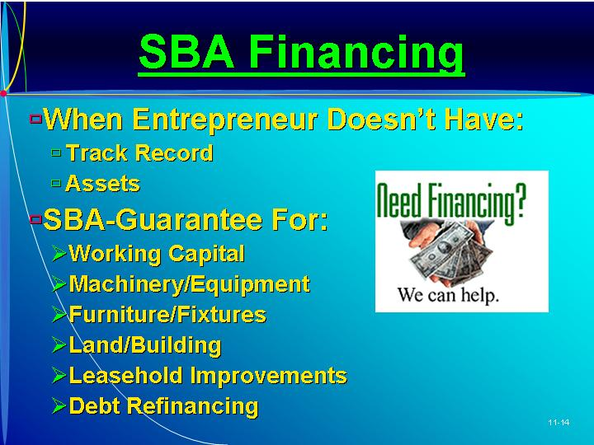  PowerPoint Slide 11-15  “SBA Conditions” (See PowerPoint slide show beginning on page 275 of this manual.)  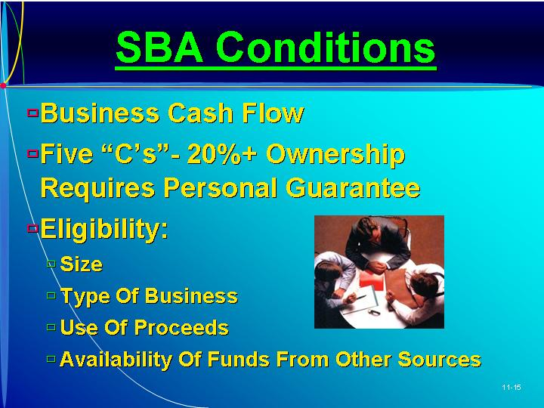  PowerPoint Slide 11-16  “SBA 7(a) Loan” (See PowerPoint slide show beginning on page 275 of this manual.)  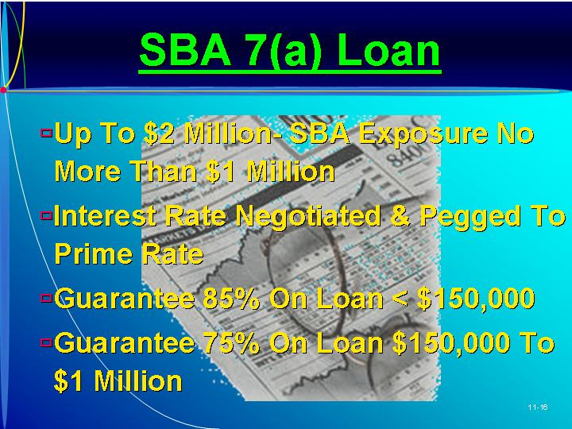  PowerPoint Slide 11-17  “Other SBA Programs” (See PowerPoint slide show beginning on page 275 of this manual.)  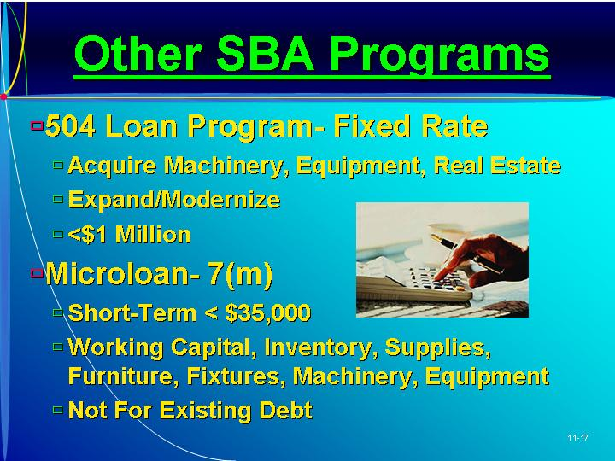
VI. RESEARCH AND DEVELOPMENT LIMITED PARTNERSHIPS  A. This method of financing provides funds from inventors looking for tax shelters.  1. A typical R&D partnership arrangement is established between a sponsoring company developing the technology with funds provided by a limited partnership of individual investors.  2. Research and development limited partnerships are particularly good when the project involves a high degree of risk or significant expense.  B. Major Elements.  1. The three components are the contract, the sponsoring company, and the limited partnership.  2. The contract specifies the agreement between the sponsoring company and the limited partnership.  a. The sponsoring company does not guarantee results, but performs work on a best-effort basis.  b. The typical contract specifies that the liability for any loss be borne by the limited partners.  c. There are some tax advantages for both the partnership and the company.  3. The next component is the limited partners.  a. The limited partners have limited liability but are not a taxable entity.  b. Any tax benefits of the losses are passed directly to the limited partners.  c. When the technology is successfully developed, the partners share in the profits.  4. The sponsoring company acts as the general partner developing the technology.  a. The sponsoring company usually has the base technology but needs funds for commercial success.  b. The company usually retains the rights to use this technology to develop other products.  C. Procedure.  1. In the funding stage, a contract is established and the money invested for the proposed R&D effort.  2. In the development stage, the sponsoring company performs the actual research, using the funds of the limited partners.  3. If the technology is successfully developed, the exit stage begins, with both parties reaping the benefits.  a. In the typical agreement, the sponsoring company and limited partners form a new jointly owned corporation.  b. An alternative exit strategy is a royalty partnership in which a royalty based on the sale of the products is paid by the company to the limited partnership.  c. The company and limited partners may form a joint venture to manufacture and market the product.  D. Benefits and Costs.  1. Benefits.  a. R&D limited partnerships provide needed funds with a minimum of equity dilution while reducing the risks involved.  b. The sponsoring company’s financial statements are strengthened through the attraction of outside capital.  2. Costs.  a. Considerable time and money are expended.  b. An R&D limited partnership takes a minimum of six months and $50,000 in professional fees.  c. Most R&D limited partnership are unsuccessful.  d. The restrictions placed on the technology may be substantial.  e. The exit from the partnership may be too complex.  E. Examples.  1. Successful R&D limited partnerships include Syntex Corporation, Genetech, and Trilogy Limited.  2. R&D limited partnerships offer one alternative to funding technological development. | Learning Objective 4.  To understand the aspects of research and development limited partnerships.  PowerPoint Slide 11-18 (Transparency Master 11-8)  “R&D Limited Partnerships” (See PowerPoint slide show beginning on page 275 of this manual. Also presented as a transparency master in Section 6 of this manual.)  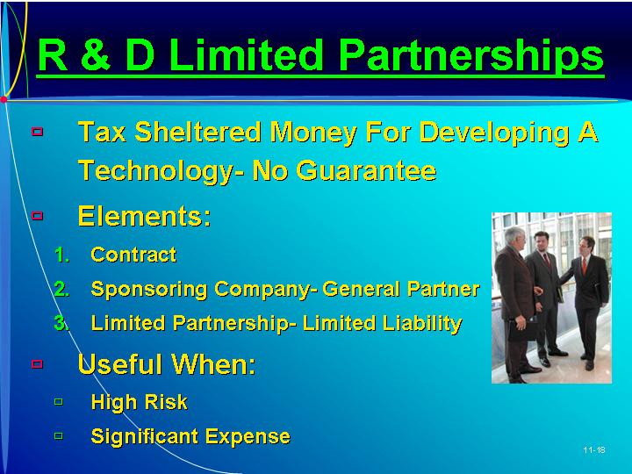  Research and development limited partnerships.  Money given to a firm for developing a technology that involves a tax schedule.  Limited partners.  A party in a partnership agreement that usually supplies money and has a few responsibilities.  General partner.  The overall coordinating party in a partnership agreement.  PowerPoint Slide 11-19  “R&D Contract Features” (See PowerPoint slide show beginning on page 275 of this manual.)  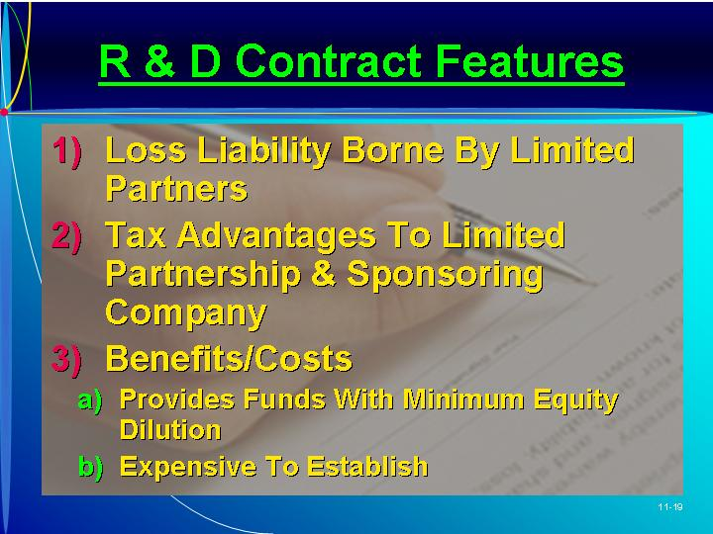  PowerPoint Slide 11-21 (Transparency Master 11-9)  “R&D Limited Liability Stages” (See PowerPoint slide show beginning on page 275 of this manual. Also presented as a transparency master in Section 6 of this manual.)  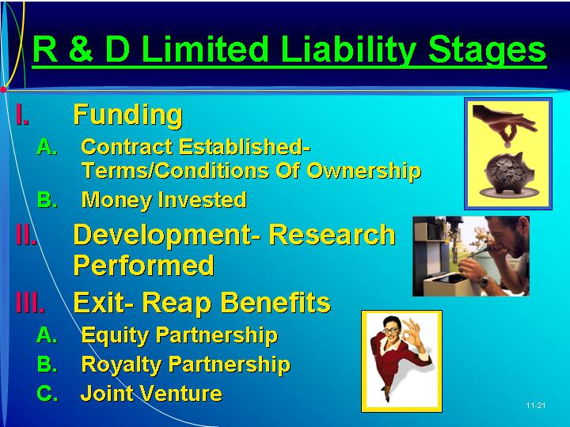
VII. GOVERNMENT GRANTS  A. The Small Business Innovation Development Act requires all federal agencies to award a portion of the R&D funds to small businesses through the Small Business Innovation Research (SBIR) grant program.  1. This provides a uniform method of soliciting, evaluating, and selecting research proposals.  2. Ten agencies are involved in the program.  a. Small businesses submit proposals directly to each agency.  b. Each agency evaluates each proposal on a competitive basis and makes awards.  B. The SBIR grant program has three phases.  1. Phase I: awards are up to $100,000 for six months of feasibility-related experimental or theoretical research.  2. Phase II is the principal R&D effort.  a. Phase II awards are up to $750,000 for 24 months of further research and development.  b. The money is to be used to develop prototype products.  3. In Phase III funds from other sources, such as the private sector or regular government contracts, are needed to commercialize the developed technologies.  C. Procedure.  1. The agencies publish solicitations describing the areas of research they will fund.  2. The second step is submission of the proposal by a company or individual.  3. Each agency screens the proposals it receives, and those passing are evaluated on a technology basis by experts.  4. Awards are granted to those projects that have the best potential for commercialization.  5. Any patent rights, research data, and software generated are owned by the company, not the government.  D. The SBIR grant program is one alternative for a technically-based entrepreneurial company that is independently owned and operated and employs 500 or fewer individuals.  E. The Small Business Technology Transfer (STTR) program was established by the Small Business Technology Transfer Act of 1992.  1. Federal agencies with budgets over $1 billion are required to set aside 0.3% for small businesses.  2. Five agencies participate in the STTR program:  a. The Department of Defense (DOD)  b. The Department of Energy (D)E)  c. Department of Health and Human Services (DHHS)  d. The National Aeronautics and Space Administration (NASA)  e. The National Science Foundation (NSF)  3. SBIR and STTR programs differ in two ways:  a. In the SBIR program, the borrower must be employed by the venture; there is no employment stipulation in the STTR program.  b. The STTR program requires at least 40% of the research be conducted by the small business concern and at least 30% conducted by the partnering nonprofit institution. | Learning Objective 5.  To discuss government grants, particularly small business innovation research grants.  SBIR grants.  Grants from the U.S. government to small technology-based businesses.  Text Table 11.2  “Federal Agencies Participating in Small Business Innovation Research Program” (Text table on page 334)  PowerPoint Slide 11-20  “Government (SBIR) Grants” (See PowerPoint slide show beginning on page 275 of this manual.)  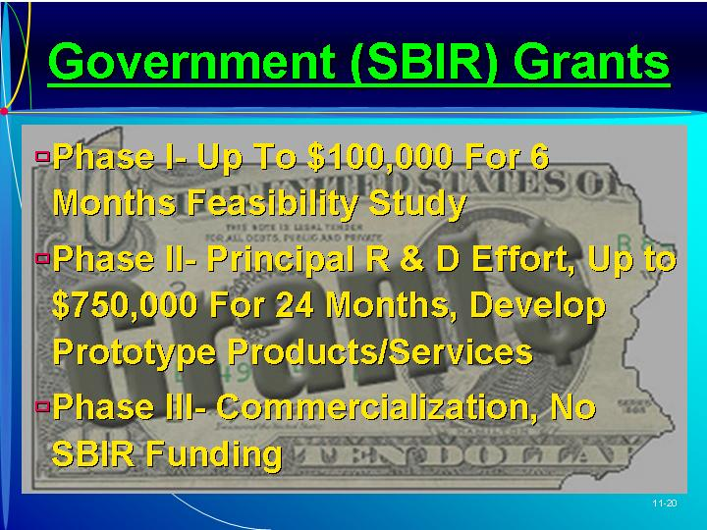  Text Table 11.3  “Comparison of SBIR and STTR Programs” (Text Table on page 336)
VIII. PRIVATE PLACEMENT  A. Another source of funds is private placement with investors who may be family and friends or wealthy individuals.  B. Type of Investors.  1. An investor usually takes an equity position and can influence the nature of the business to an extent.  2. The investors’ degree of involvement is important for the entrepreneur to consider.  3. Some investors want to be actively involved in the business, and others are more passive.  C. Private Offerings.  1. Public offerings involve much time and expense.  2. Registering the securities with the Securities and Exchange Commission (SEC) requires a number of reporting procedures once the firm has gone public.  3. This public process was established to protect unsophisticated investors.  4. A private offering is faster and less costly than other funding.  5. These sophisticated investors still need access to material information about the company.  D. Regulation D.  1. Regulation D contains:  a. Broad provisions designed to simplify private offerings.  b. General definitions of what constitutes a private offering.  c. Specific operating rulesCRule 504, Rule 505, and Rule 506.  2. Regulation D requires the issuer of a private offering to file five copies of Form D with the SEC on a strict timetable.  3. The entrepreneur carries the burden of proving that the exemptions granted have been met.  a. Each offering memorandum needs to be numbered and contain instructions that the document should not be disclosed.  b. The date that the investor reviews the company’s information and dates of any discussions between the company and entrepreneur should be recorded.  c. The book documenting all specifics of the offering should be placed in the firm’s permanent file.  3. Under Rule 504 a company can sell up to $500,000 of securities to any number of investors in any 12-month period.  4. Rule 505 permits the sale of $5 million of unregistered securities in the private offering in any 12-month period.  a. These can be sold to any 35 investors, and an unlimited number of accredited investors.  b. “Accredited investors” include:  (i) Institutional investors.  (ii) Investors who purchase over $150,000 of the issuer’s securities.  (iii) Investors whose net worth is $1 million or more.  (iv) Investors with incomes in excess of $200,000 in the last two years.  (v) Directors, officers, and general partners of the issuing company.  c. Rule 505 permits no general advertising or solicitation through public media.  d. When only accredited investors are involved, no disclosure is required under Rule 505.  e. Two-year financial statements must be available.  f. All companies selling private-placement securities must:  (i) Furnish appropriate company information to both accredited and unaccredited investors  (ii) Allow any questions to be asked prior to the sale.  5. Rule 506 allows an issuing company to sell an unlimited amount of securities to 35 investors and an unlimited number of accredited investors.  E. In securing outside funding, the entrepreneur must accurately disclose all information.  1. If the business turns sour, both investors and regulators scrutinize the company’s disclosures.  2. When a violation of security law is discovered, management and sometimes the principal equity holders can be held liable.  3. Lawsuits under securities law by damaged investors have almost no statute of limitations.  4. The entrepreneur needs to be careful to make sure all disclosures are accurate.  5. The SEC can also take administrative, civil, or criminal action, without any individual lawsuit involved. | Learning Objective 6  To understand the role of private placement as a source of funds.  PowerPoint Slide 11-9 (Transparency Master 11-10)  “Private Placement” (See PowerPoint slide show beginning on page 275 of this manual. Also presented as a transparency master in Section 6 of this manual.)  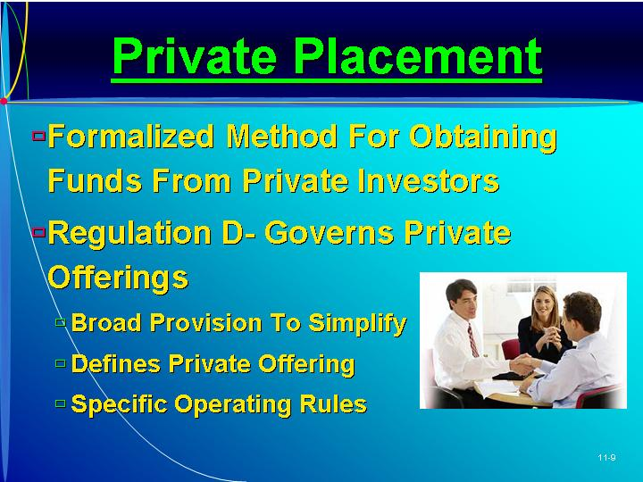  Private offerings.  A formalized approach for obtaining funds from private investors.  Regulation D.  Laws governing a private offering.  As Seen in Entrepreneur Magazine: Provide Advice to an Entrepreneur About Small Business Investment Companies  Small Business Investment Companies use their own capital, plus funds borrowed from the federal government, to provide equity capital and long-term loans to small businesses. (Box in text on page 338)
IX. BOOTSTRAP FINANCING
A. Bootstrap financing is particularly important at start-up and early years of the venture when capital from debt financing or equity financing is more expensive.
B. Outside capital has many costs.
1. It takes three to six months to raise outside capital when the company can least afford the time.
2. Outside capital often decreases a firm’s drive for sales and profits.
3. The availability of capital increases the impulse to spend.
4. Outside capital can decrease the company’s flexibility and hamper the creativity of the entrepreneur.
5. Outside capital may cause more disruption and problems in the venture than without it.
C. Bootstrap financing involves using any possible method for conserving cash.
1. This can involve delaying payment (with caution) to suppliers.
2. Also possible: discounts for volume, frequent customer discounts, promotional discounts, “obsolescence money,” and bulk packaging.
3. Consignment financing involves placing a standing order for the entire amount of goods but taking shipment and making payment only as needed.
D. In spite of these potential problems, an entrepreneur at times needs equity funding.
1. Outside capital should only be sought after all possible internal sources of funds have been explored.
2. When outside funds are obtained, the entrepreneur should not forget the basics of the business.
X. IN REVIEW: SUMMARY.
See “Learning Objectives Revisited” below.

learning objectives revisited

Learning Objective 1. To identify the types of financing available.
  - Debt financing involves an interest-bearing instrument, usually a loan, the payment of which is only indirectly related to sales and profits.
    - Short-term money is used to provide working capital.
    - Long term debt (lasting more than a year) is frequently used to purchase some asset, with part of the value of the asset being used as collateral.
  - Equity financing offers the investor some form of ownership position.
  - The most often used type of funds is internally generated funds, from sources within the company, such as profits, sale of assets, reduction in working capital, extended payment terms, and accounts receivable.
  - External financing is obtained from sources outside the venture.
    - In terms of cost and control, personal funds are the least expensive.
    - Family and friends can provide a small amount of equity funding.

Learning Objective 2. To understand the role of commercial banks in financing new ventures, the types of loans available, and bank lending decisions.
  - Commercial banks are the most frequently used source of short-term funds when collateral is available.
  - Types of bank loans include accounts receivable loans, inventory loans, equipment loans, and real estate loans.
  - Conventional bank loans include lines of credit, installment loans, straight commercial loans, long-term loans, and character loans.
  - Bank lending decisions can be summarized by the five C’sCCharacter, Capacity, Capital, Collateral, and Conditions.

Learning Objective 3. To discuss Small Business Administrative (SBA) loans.
  - The SBA is primarily a guarantor of loans made by private and other institutions.
  - The Basis 7(a) Loan Guaranty helps qualified small businesses obtain financing when they cannot obtain loans through regular lending channels.
  - SBA Express loans have a maximum guarantee of 50 percent.
  - The 504 Loan Program provides fixed-rate financing to enable small businesses to acquire machinery, equipment, or real estate.
  - The SBA Microloan program provides short-term loans of up to $35,000 to small businesses for working capital or the purchase of assets.
  - Other loans include:
    - Home and Personal Property Disaster Loans
    - Physical Disaster Business Loses Loans
    - Military Reservist Economic Injury Disaster Loans.

Learning Objective 4. To understand the aspects of research and development limited partnerships.
  - A research and development partnership arrangement is established between a sponsoring company developing the technology with funds being provided by a limited partnership.
  - The three components are the contract, the sponsoring company, and the limited partnership.
  - The procedure includes:
    - The funding stage, in which a contract is established and the money invested for the proposed R&D effort.
    - The development stage, in which the company performs the actual research, using the funds of the limited partners.
    - The exit stage, in which both parties reap the benefits.
  - There are benefits and costs—most R&D limited partnerships are unsuccessful.

Learning Objective 5. To discuss government grants, particularly small business innovation research grants.
  - The Small Business Innovation Research (SBIR) grant program requires all federal agencies to share a portion of the R&D funds with small businesses.
  - The SBIR program provides a uniform method of soliciting, evaluating, and selecting research proposals.
  - This grant program is one alternative for a technically-based entrepreneurial company that is independently owned and operated and employs 500 or fewer individuals.
  - Under the Small Business Technology Transfer (STTR) program federal agencies with budgets over $1 billion are required to set aside 0.3% for small businesses.

Learning Objective 6. To understand the role of private placement as a source of funds.
  - Another source of funds is private investors who may be family and friends or wealthy individuals.
  - An investor usually takes an equity position and can influence the nature of the business to an extent.
  - A private offering is faster and less costly than other funding.
  - Regulation D contains a number of broad provisions designed to simplify private offerings and specific operating rules.

key terms

Asset base for loans. Tangible collateral valued at more than them amount of money borrowed.
Conventional bank loans. Standard ways banks lend money to corporations.
Debt financing. Obtaining borrowed funds for the company.
Equity financing. Obtaining funds for the company in exchange for ownership.
General partner. The overall coordinating party in a partnership agreement.
Limited partners. A party to a partnership agreement that usually supplies money and has a few responsibilities.
Private offering. A formalized approach for obtaining funds from private investors.
Regulation D. Laws governing a private offering.
Research and development limited partnerships. Money given to a firm for developing a technology that involves a tax shelter.
SBIR grants. Grants from the U.S. government to small technology-based businesses.

research tasks and class discussions

The text includes several topics for student research and class discussions. These questions are open-ended, and the answers will be different for each student. There are no “correct” answers.

Research tasks:
- Interview a business loan officer at a bank to determine the bank’s lending criteria for small businesses and for new businesses. Do they use the five Cs? Which of the five Cs appears to be the most important?
- Obtain a loan application from the local bank and categorize each question in terms of which of the five Cs it is attempting to assess.
- Choose a type of business you would like to run. Then search the Internet for government grants that might be applicable for you and your business.
- Interview three small business owners about things they do (or have done) to bootstrap the financing of their business. How effective were these techniques? Be prepared to present this list to class and describe how the techniques work.

Class Discussions
- What is the cheapest source of funds? When all other sources turn down your request for funding, what source is most likely to say yes? Why is this the case? Is the entrepreneur exploiting a personal relationship with this potential source of capital? What are the consequences of using this source of capital if the business goes bankrupt?
- Should the government provide grants for entrepreneurs starting new businesses? Should the government guarantee loans for small businesses that are missing the necessary track record, assets, or other ingredients to obtain a commercial bank loan/ What benefit do we, as a nation of tax payers, receive from such grants and loan guarantees?
- Why don’t all firms use bootstrap financing? Are there any dangers with this approach? What are the benefits of having some financial slack (e.g., some extra cash in reserve)? What are the costs of that financial slack?

Visual Resources

The PowerPoint presentation for this chapter, shown on the following pages, includes the following slides.
Slide 11-1 Entrepreneurship Title
Slide 11-2 Chapter Title
Slide 11-3 Overview *
Slide 11-4 Factors Affecting Type of Financing
Slide 11-5 Internal Funds *
Slide 11-6 External Funds *
Slide 11-7 Personal Funds *
Slide 11-8 Family and Friends
Slide 11-9 Private Placement *
Slide 11-10 Commercial Banks *
Slide 11-11 Lending Decisions *
Slide 11-12 Lending Questions
Slide 11-13 Bank “Shopping” Process
Slide 11-14 SBA Financing *
Slide 11-15 SBA Conditions
Slide 11-16 SBA 7(a) Loans
Slide 11-17 Other SBA Programs
Slide 11-18 R&D Limited Partnerships *
Slide 11-19 R&D Contract Features
Slide 11-20 Government (SBIR) Grants
Slide 11-21 R&D Limited Liability Stages *
* Also included as a Transparency Master.

The following are included as transparency masters in Section 6 of this manual.
Transparency Master 11-1 Overview
Transparency Master 11-2 Internal Funds
Transparency Master 11-3 External Funds
Transparency Master 11-4 Personal Funds
Transparency Master 11-5 Commercial Banks
Transparency Master 11-6 Lending Decisions
Transparency Master 11-7 SBA Financing
Transparency Master 11-8 R&D Limited Partnerships
Transparency Master 11-9 R&D Limited Liability Stages
Transparency Master 11-10 Private Placement
powerpoint slide show

Slide 11-1  Entrepreneurship Title   | Slide 11-2  Chapter Title
Slide 11-3  Overview (Also presented as Transparency Master 11-1 in Section 6 of this manual.) | Slide 11-4  Factors Affecting Type of Financing
Slide 11-5  Internal Funds (Also presented as Transparency Master 11-2 in Section 6 of this manual.) | Slide 11-6  External Funds (Also presented as Transparency Master 11-3 in Section 6 of this manual.)
Slide 11-7  Personal Funds (Also presented as Transparency Master 11-4 in Section 6 of this manual.) | Slide 11-8  Family and Friends (Also presented as Transparency Master 11-5 in Section 6 of this manual.)
Slide 11-9  Private Placement (Also presented as Transparency Master 11-10 in Section 6 of this manual.) | Slide 11-10  Commercial Banks (Also presented as Transparency Master 11-5 in Section 6 of this manual.)
Slide 11-11  Lending Decisions (Also presented as Transparency Master 11-6 in Section 6 of this manual.) | Slide 11-12  Lending Questions
Slide 11-13  Banks “Shopping” Process | Slide 11-14  SBA Financing (Also presented as Transparency Master 11-7 in Section 6 of this manual.)
Slide 11-15  SBA Conditions | Slide 11-16  SBA 7(a) Loan
Slide 11-17  Other SBA Programs | Slide 11-18  R&D Limited Partnerships (Also presented as Transparency Master 11-8 in Section 6 of this manual.)
Slide 11-19  R&D Contract Features | Slide 11-20  Government (SBIR) Grants
Slide 11-21
R&D Limited Liability Stages (Also presented as Transparency Master 11-9 in Section 6 of this manual.

