14

Strategies for growth and
managing the implications of growth

Learning Objectives

1
To know where to look for (or how to create) possible growth opportunities.

2
To understand the implications of business growth on a national economy.

3
To understand the primary challenges for managing business growth
and to be prepared to effectively manage these challenges.

4
To recognize that people differ and to understand how these
differences impact their intentions to grow a business.

CHAPTER OUTlINE AND TEACHING NOTES
OPENING PROFILE—Brian and Jennifer Maxwell  I. growth strategies: where to look for growth opportunities  A. A successful new entry provides the opportunity for the entrepreneur to grow his or her business.  1. The chapter presents a step-by-step process for generating growth opportunities.  2. Opportunities for new entry are generated by the knowledge of the entrepreneur and from organizational knowledge.  3. The analysis assumes that the entrepreneur and the firm have knowledge about the existing product and the existing market.  4. Different combinations of different levels of these types of knowledge create different growth strategies.  B. Penetration Strategies.  1. A penetration strategy focuses on the firm’s existing product in its existing market.  2. The entrepreneur attempts to penetrate this market further by encouraging existing customers to buy more of the firm’s current products.  3. This strategy relies on taking market share from competitors and/or expanding the existing market.  C. Market Development Strategies.  1. Market development strategies involve selling the firm’s existing products to new groups of customers.  2. New Geographical Market.  a. This strategy suggests selling the existing product in new locations.  b. This can increase sales by offering the product to customers that have not previously had the chance to purchase the products.  3. New Demographic Market.  a. Demographics are used to characterize customers based upon:  (i) their income  (ii) where they live  (iii) their education, age, and sex, and so on.  b. The business might grow by offering the same product to a different demographic group.  4. New Product Use.  a. An entrepreneur might find out that people use its product in a way that was not expected.  b. This may show how the product may be valuable to new groups of buyers.  c. The text uses the example of how consumers found new uses for four-wheel-drive vehicles.  d. Knowledge of this new use allowed the producers to modify their product to better satisfy customers.  D. Product Development Strategies.  1. Product development strategies for growth involve developing and selling new products to people who are already purchasing the firm’s existing products.  2. Customer experience provides knowledge on the problems customers have with existing technology.  3. Another benefit is capitalizing on existing distribution systems and on the corporate reputation of the firm.  E. Diversification Strategies.  1. Diversification strategies involve selling a new product to a new market.  2. The value chain captures the steps it takes to develop raw materials into a product and get it into the hands of the customers.  a. Value is added at every stage of the chain.  b. Each firm makes some profit.  3. Backward integration refers to taking a step back (up) on the value-added chain toward the raw materials.  4. Forward integration is taking a step forward (down) on the value-added chain toward the customers.  5. These two strategies provide opportunities to grow the business.  a. The entrepreneur could have some advantage over others because of the firm’s existing knowledge base.  b. Being one’s own supplier and/or buyer creates synergy by conducting these transactions more efficiently than independent firms.  c. Operating as a supplier and/or buyer provides learning opportunities that can lead to new processes or new product improvements.  6. Horizontal integration occurs at the same level of the value-added chain but simply involves a different, but complementary, value-added chain.  a. If the products are complementary, the firm will likely have some competences in the new product.  b. Horizontal integration provides the opportunity to increase sales of the existing product, for example through bundling.  7. Some entrepreneurs seek to diversify into unrelated products or markets to diversify their risk; this is usually a mistake.  F. Example of Growth Strategies ( Head Ski Company)  1. A penetration strategy could be achieved through an increase in its marketing budget focused on encouraging existing customers to upgrade.  2. A market development strategy could involve Head’s selling its skis in Europe, Argentina, and New Zealand.  3. To pursue a product development strategy, Head could develop and sell new products to people who buy its skis.  4. Diversification strategies.  a. Backward integration could involve the design and manufacture of equipment used to make skis.  b. Forward integration could involve control of a chain of retail ski shops.  c. Horizontal integration could involve ownership of ski mountains.  5. This model offers a tool for entrepreneurs, to force them to think and look in different directions for growth opportunities. | PowerPoint Slide 14-1  “Entrepreneurship Title” (See PowerPoint slide show beginning on page 352 of this manual.)    PowerPoint Slide 14-2  “Chapter Title” (See PowerPoint slide show beginning on page 352 of this manual.)  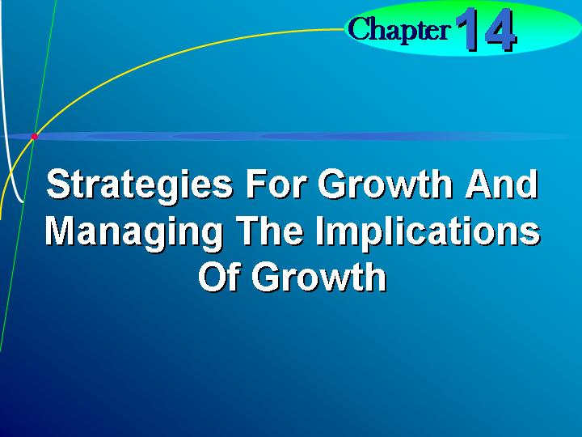    Penetration strategy.  A strategy to grow by encouraging existing customers to buy more of the firm’s current products.  Market development strategy.  Strategy to grow by selling the firm’s existing products to new groups of customers.  Learning Objective 1.  To know where to look for (or how to create) possible growth opportunities.  PowerPoint Slide 14-3 (Transparency Master 14-1)  “Growth Strategies” (See PowerPoint slide show beginning on page 352 of this manual. Also presented as a transparency master in Section 6 of this manual.)  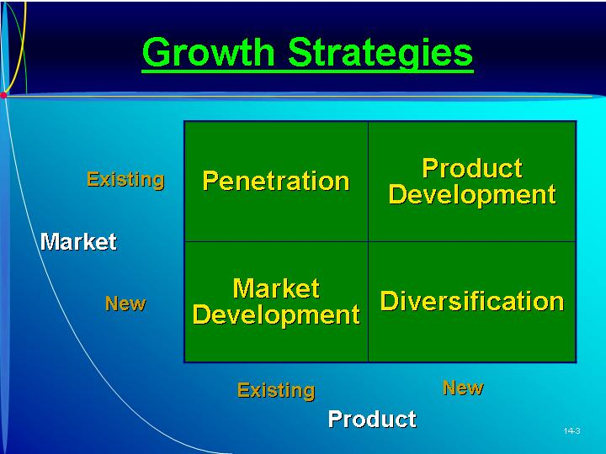  Text Figure 14.1  “Growth Strategies Based upon Knowledge of Product and/or Market” (Text figure on page 453)  PowerPoint Slide 14-4 (Transparency Master 14-2)  “Strategies” (See PowerPoint slide show beginning on page 352 of this manual. Also presented as a transparency master in Section 6 of this manual.)  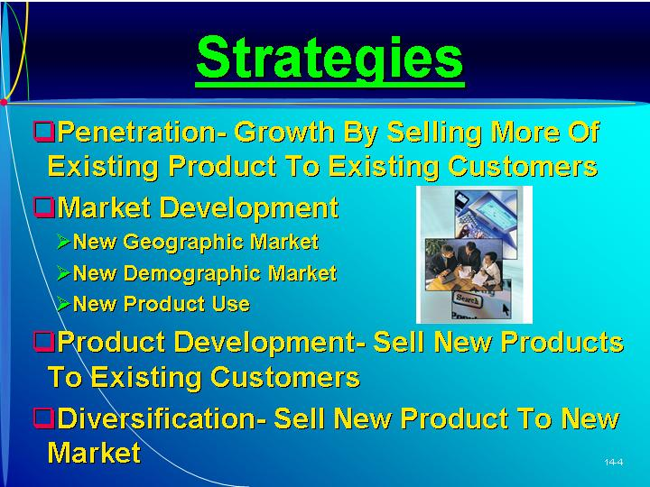  Product development strategy.  A strategy to grow by developing and selling new products to people who are already purchasing the firm’s existing products.  Diversification strategy.  A strategy to grow by selling a new product to a new market.  Text Figure 14.2  “Example of a Value-Added Chain and Types of Related Diversification” (Text figure on page 455)  Backward integration.  A step back (up) in the value added chain toward the raw materials.  Forward integration.  A step forwarde (down) on the value added chain toward the customers.  PowerPoint Slide 14-5 (Transparency Master 14-3)  “Product Integration” (See PowerPoint slide show beginning on page 352 of this manual. Also presented as a transparency master in Section 6 of this manual.)  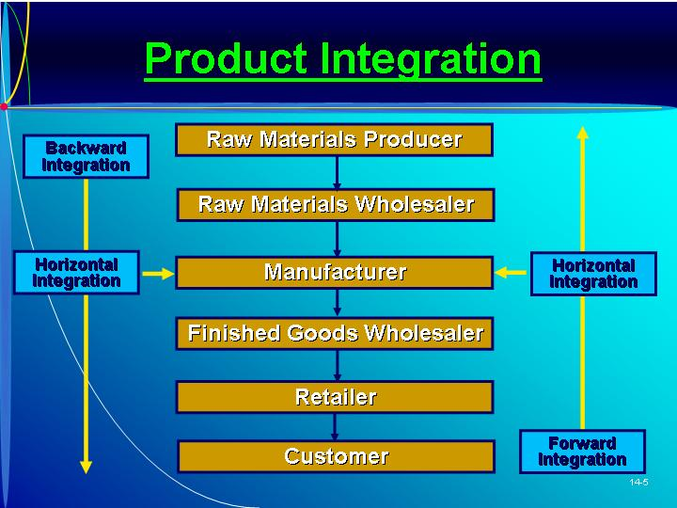  Horizontal integration.  Occurs at the same level of the value added chain but simply involves a different, but complementary, value-added chain.  As Seen in Entrepreneur Magazine: Provide Advice to an Entrepreneur About Growing into New Markets Using the Internet.  The online market grew by about 30 percent in 2002. Continuing growth and a changing market calls for evolving business strategies. (Box in text on page 457)
II. ECONOMIC IMPLICATIONS OF GROWTH.  A. In 1996 Inc. magazine conducted a study of the 500 fastest growing ventures in 1984 to see what happens to ventures entering a growth phase.  1. By 1995, there had been 95 failures or shutdowns, and 135 more had been sold to new owners.  2. The remaining 233 companies, however, more than made up for the failure in jobs created and revenue generated.  3. These firms represented revenue and total employment significantly larger than the original 500 ventures.  B. Ownership.  1. Forty-eight percent were still privately held under the same ownership, and only six percent had actually gone public.  2. The ventures that did go public achieved much larger growth than those that did not go public.  C. The sample does not represent businesses that grow more modestly, especially small businesses.  1. The majority of new jobs in most industrialized economies are created by small business.  2. There are so many small firms that even when a small percentage of them do grow the impact on an economy is still significant.  D. The study revealed that some rapidly growing firms later failed.  1. Failure is not necessarily all bad.  2. In pursuing growth opportunities, even if they result in failure, generates knowledge that stimulates improvements in technology.  3. A failed attempt provides information for the entrepreneur and other entrepreneurs.  4. An economy made up of entrepreneurs that do not fail does not have entrepreneurs willing to pursue high-risk high-potential-growth opportunities. | Learning Objective 2.  To understand the implications of business growth on a national economy.  Text Figure 14.3  “A Follow Up of Inc. Magazine’s 1984 Fastest Growing Ventures”  (Text figure on page 459)
III. Implications of Growth for the Firm  A. As a firm gets bigger it begins to benefit from the advantages of size.  1. Higher volume increases production efficiency.  2. Size also enhances the legitimacy of the firm.  3. But as the firm grows, it changes, introducing a number of managerial challenges.  B. Pressures on Existing Financial Resources.  1. Investing in growth means that the firm’s financial resources are stretched thin.  2. Resource slack is required to insure against environmental shocks.  C. Pressures on Human Resources.  1. If employees are spread too thin by growth, then the firm will face problems of employee morale, employee burn out, and an increase in employee turn over.  2. An influx of a large number of new employees will likely dilute the corporate culture.  D. Pressures on the Management of Employees.  1. Many entrepreneurs find that as the venture grows, they need to change their management style.  2. If the entrepreneur retains exclusive decision making, the success of a growing venture can be endangered.  3. In order to survive, the entrepreneur will need to consider some managerial changes.  E. Pressures on the Entrepreneur’s Time.  1. Time pressures are especially common to entrepreneurs who are growing their businesses.  2. Time is the entrepreneur’s most precious yet limited resource—it is totally perishable and irreplaceable.  3. Time devoted to growth must be diverted from other activities. | Learning Objective 3.  To understand the primary challenges for managing business growth and to be prepared to effectively manage these challenges.  PowerPoint Slide 14-6 “Pressures on Firm Growth” (See PowerPoint slide show beginning on page 352 of this manual.  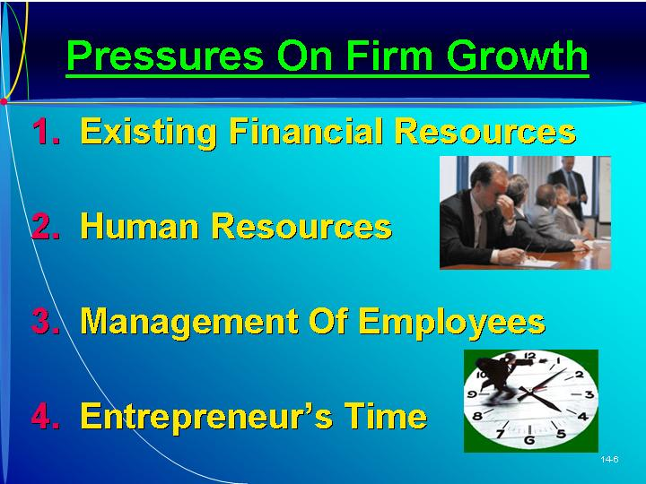
IV. overcoming pressures on existing financial resources  A. To overcome pressures on existing resources, the entrepreneur could acquire new resources.  B. New resources required can be reduced through better management of existing resources. | PowerPoint Slide 14-7 (Transparency Master 14-4)  “Overcoming Financial Resources Pressure” (See PowerPoint slide show beginning on page 352 of this manual. Also presented as a transparency master in Section 6 of this manual.)  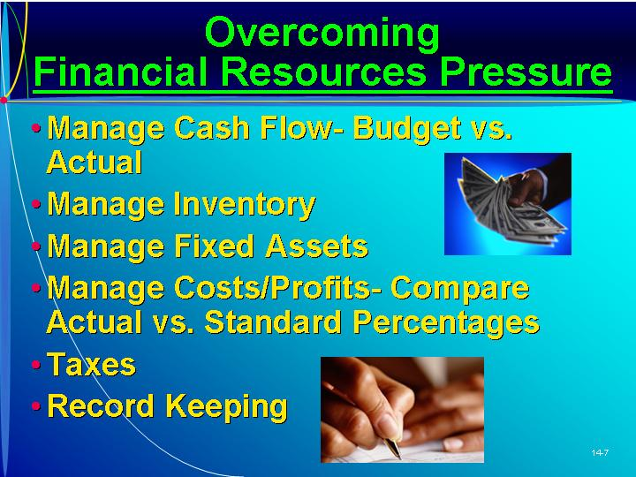
V. FINANCIAL CONTROL  A. The entrepreneur needs to know how to provide appropriate controls to ensure that projections and goals are met.  1. Some financial skills are needed for the entrepreneur to manage during early years.  2. The cash flows, income statement, and balance sheet are key areas needing careful management and control.  B. Managing Cash Flow.  1. An up-to-date assessment of cash position, such as a monthly cash flow statement, is needed.  2. The cash flow statement may show the actual amounts next to the budgeted amounts.  3. It is useful for adjusting the pro forma and indicating potential cash flow problems.  4. The text uses a sample statement of cash flow with budgeted and actual amounts.  5. Cash flow analysis can also involve sensitivity analysis: for each monthly expected cash flow the entrepreneur can use a +/- of 5% that would provide a pessimistic and optimistic cash estimate.  6. For the very new venture it may be necessary to prepare a daily cash sheet.  7. Comparison of budgeted or expected cash flows with actual cash flows can provide an assessment of potential cash needs and indicate possible problems in the management of assets and control of costs.  C. Managing Inventory.  1. An inventory control system allows the company to monitor key figures, such as inventory turnover and percentage of customer complaints.  2. Growing ventures typically tie up more cash in inventory than in other parts of the business.  3. An inventory control system allows the company to monitor key figures, such as inventory turnover and percentage of customer complaints.  4. The entrepreneur will need to determine the value of inventory and determine how it affects the cost of goods sold.  a. Most firms use a FIFO (first-in, first-out) system since it reflects truer inventory and cost values.  b. There are good arguments for the use of LIFO (last-in, first-out) in times of inflation.  c. The decision to convert from a FIFO to a LIFO system is complex and requires careful evaluation.  d. The text uses the example of Dacor Corporation’s conversion from FIFO to LIFO.  (i) It is necessary to decide if inventory is to be grouped into categories or to cost each item individually.  (ii) All inventory must be costed by searching through historical records.  (iii) An average inventory cost must be calculated.  e. After the conversion is made, management must notify the IRS.  f. Conversion to LIFO can typically be beneficial if the following conditions exist:  (i) Rising labor, materials, and other production costs are anticipated.  (ii) The business and inventory are growing.  (iii) The business has some computer-assisted inventory control method capability.  (iv) The business is profitable.  5. The entrepreneur must keep careful records of inventory using perpetual inventory systems followed by a periodic physical count.  6. Efficient electronic data interchanges (EDI) between producers, wholesalers, and retailers can help these firms communicate with one another.  7. Linking firms in a computerized system is possible using a software system called ECR (Efficient Consumer Response.)  a. Supply chain members work together to manage demand, distribution, and marketing.  b. Computerized checkout machines are usually part of these systems.  8. Transportation mode selection is also important in inventory management.  a. Some transportation modes, such as air, are very expensive.  b. Careful management of inventory can minimize transportation costs.  c. Anticipating customer needs can avoid stock-outs and the unexpected costs of meeting customers’ immediate needs.  D. Managing Fixed Assets.  1. Fixed assets generally involve long-term commitments and large investments for the new venture.  2. Fixed assets have certain costs related to them, such as depreciation.  3. If the entrepreneur can not afford to buy equipment or fixed assets, leasing could be an alternative.  a. Leasing may be a good alternative to buying depending on the terms of the lease and type of asset.  b. Leases for automobiles may be more expensive than a purchase.  c. However, lease payments represent an expense and can be used as a tax deduction.  d. Leases are also valuable for equipment that becomes obsolete quickly.  e. The entrepreneur should consider all costs associated with a lease-or-buy decision as well as the impact on cash flows.  E. Managing Costs and Profits.  1. An interim income statement helps to compare the actual with the budgeted amount for that period.  2. The most effective use of the interim income statement is to establish cost standards and compare the actual with the budgeted amount for that time period.  a. Costs are budgeted based on percentages of net sales.  b. These percentages can be compared with actual percentages to see where tighter cost controls may be necessary.  c. This lets the entrepreneur manage and control costs before it is too late.  3. The text uses a sample balance sheet and income statement to show how costs can be managed.  4. In later years, it is also helpful to look back on the first year of operation and make comparisons month-to-month.  5. When expenses or costs are much higher than budgeted, the entrepreneur may need to determine the exact cause.  6. Comparison of actual and budgeted expenses can be misleading for ventures with multiple products or services.  a. For financial reporting purposes, the income statement summarizes expenses across all products and services.  b. This does not indicate the marketing cost for each product nor the most profitable product.  7. Allocating expenses over product lines should be done as effectively as possible to avoid arbitrary allocation of costs.  F. Taxes.  1. The entrepreneur will be required to withhold federal and state taxes for employees and make deposits to the appropriate agency.  a. Federal taxes, state taxes, social security, and Medicare are withheld from employees’ salaries and are deposited later.  b. The entrepreneur should be careful not to use these funds since there are penalties for late payment.  2. The new venture may also be required to pay state and federal unemployment taxes, matching FICA and Medicare tax, and other business taxes.  3. Federal and state governments will require the entrepreneur to file end-of-the-year returns of the business.  G. Record Keeping.  1. Using a software package can enhance the flow of financial information.  2. It may also be necessary to enlist the support and services of an accountant.  3. A system for storing and using customer information becomes vitally important for a growing firm.  a. As the number of customers increases, it is no longer feasible to rely on the memory of individual sales people.  b. A database can increase the capacity to hold and process information and accumulate bits of knowledge contained within different individuals.  c. Thus organizational knowledge is accessible to everyone within the firm.  d. Customer information should be retained in a database, which includes information on a contact person as well as important account details. | Text Figure 14.4  “MPP Plastics Inc. (Statement of Cash Flow) July, Year 1 (000s)” (Text figure on page 461)  Text Figure 14.5  “Daily Cash Activity (Date)” (Text figure on page 463)  PowerPoint Slide 14-8 (Transparency Master 14-5)  “Inventory Valuation” (See PowerPoint slide show beginning on page 352 of this manual. Also presented as a transparency master in Section 6 of this manual.)  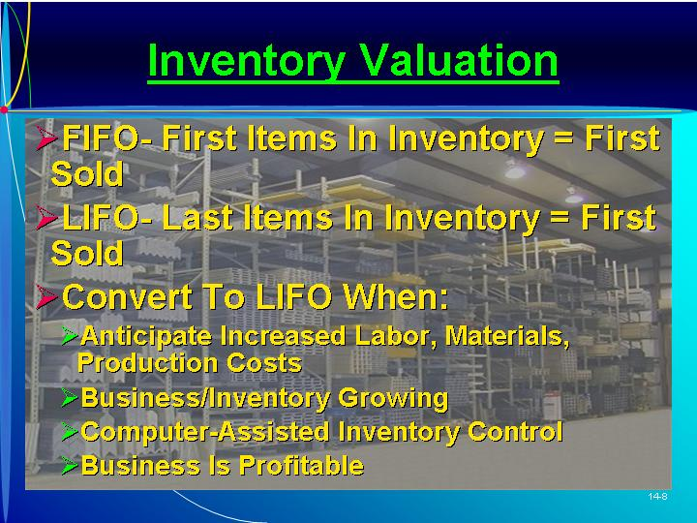  FIFO.  Inventory costing method whereby first items into inventory are first items out.  LIFO.  Inventory costing method whereby last items into inventory are first items out.  Text Figure 14.6  “MMP Plastics Inc., Income Statement, First Quarter Year 1 (000s)” (Text figure on page 466)  Text Figure 14.7  “MMP Plastics Inc., Balance Sheet, First Quarter Year 1” (Text figure on page 467)  As Seen in Entrepreneur Magazine: Elevator pitch For eVest.  Is this a business opportunity? Scott Jordan founded eVest, a clothing and licensing company featuring a line of vest/jackets with 16 to 22 pockets that discreetly hold tech gadgets. (Box in text on page 469)
VI. OVERCOMING PRESSURES ON EXISTING HUMAN RESOURCES  A. Most new ventures do not have the luxury of a human resource department that can interview, hire, and evaluate employees.  1. Most of these decisions will be the responsibility of the entrepreneur and key employees.  2. Some entrepreneurs are using professional employer organizations (PEOs) which handle recruiting, hiring, setting up benefit programs, payroll, and even firing decisions.  B. Another key decision is what proportion of the workforce should be permanent and what proportion should be part time.  1. A greater percentage of part-time workers represent a lower fixed cost, which provides greater flexibility.  2. However, personnel instability is more likely because turnover is typically higher and part-time workers are less committed to the firm.  3. Building a functional organizational culture is more difficult when depending on part-time workers.  C. A difficult decision for an entrepreneur to make is the firing of incompetent employees.  1. Employees should be given feedback on a regular basis, and any problems should be identified.  2. Continued problems with the employee that necessitated a firing decision should be well documented.  D. The firm’s human resource strategy also must address how to maintain the corporate culture despite the influx of new employees.  1. The entrepreneur must be the role model for the culture.  2. In cases of rapid growth, the entrepreneur’s work can be complemented by the work of a cultural ambassador. | PowerPoint Slide 14-9 (Transparency Master 14-6)  “Overcoming Human Resources Pressure” (See PowerPoint slide show beginning on page 352 of this manual. Also presented as a transparency master in Section 6 of this manual.)  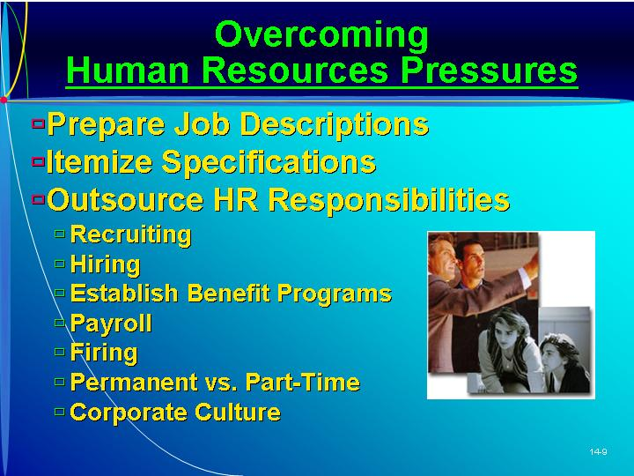
VII. OVERCOMING PRESSURES ON THE MANAGEMENT OF EMPLOYEES  A. Managing change is often a complex task, one better undertaken with a participative style of management.  1. A participative style of management is one in which the entrepreneur involves others in the decision-making process.  2. Advantages:  a. Involving others in decision making is a way of reducing the information-processing demands on the entrepreneur.  b. Highly qualified managers and employees help find new ways to tackle current problems.  c. If employees are involved in the decision-making process, they are more motivated to implement the decided course of action.  d. In most cultures employees enjoy the added responsibility of making decisions, enhancing job satisfaction.  B. Activities to Institute Participative Management.  1. Establish a team spirit, which involves the belief by everyone in the organization that they are “in this thing together.”  2. Communicate with Employees.  a. Open and frequent communication with employees builds trust and diminishes fear.  b. This communication is a two-way street—the entrepreneur must listen to what is on the minds of his or her employees.  3. Provide Feedback.  a. The entrepreneur should frequently provide constructive feedback to employees.  b. The entrepreneur should also seek feedback from others.  4. Delegate Some Responsibility to Others.  a. Key employees must be given the flexibility to take the initiative and make decisions without the fear of failure.  b. The entrepreneur must create a culture that values and rewards employees for taking initiative.  5. Provide Continuous Training for Employees.  a. Employees’ ability and capacity to improve their own performance is increased by training.  b. The employees should be involved in the decision about training session topics. | Participative style of management.  The manager involves others in the decision making process.  PowerPoint Slide 14-10 (Transparency Master 14-7)  “Overcoming Employee Management Pressure” (See PowerPoint slide show beginning on page 352 of this manual. Also presented as a transparency master in Section 6 of this manual.)  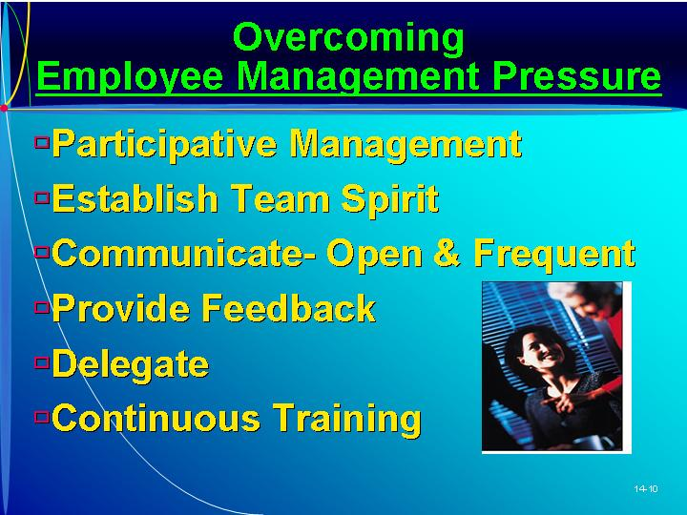    ETHICS: Lessons from Enron  Lessons have been learned from the Enron collapse—the failure of even the smallest of businesses impacts many people. (Box in text on page 471)
VIII. OVERCOMING PRESSURES ON ENTREPRENEURS’ TIME  A. Time management is the process of improving an individual’s productivity through more efficient use of time.  B. Benefits of Time Management.  1. One benefit, increased productivity, reflects the fact that there is always enough time to accomplish the most important things.  2. Increased job satisfaction comes from getting more important things done and being more successful.  3. There will be improved interpersonal relationships, and others in the company will experience less time pressure, better results, and greater job satisfaction.  4. The entrepreneur will experience less time anxiety and tension.  5. All of these benefits culminate in better health for the entrepreneur.  C. Basic Principles of Time Management.  1. Principle of Desire. The first step is recognizing that one is a time waster, that time is an important resource, and that a change in personal attitudes may be needed.  2. Principle of Effectiveness. The entrepreneur should focus on the most important issues, even under pressure.  3. Principle of Analysis. This provides information to the entrepreneur about how time is currently being allocated.  4. Principle of Teamwork.  a. The entrepreneur has only a small amount of time that is actually under his/her control—it is taken up by others.  b. Delegation becomes increasingly important.  c. The entrepreneur must help members of the management team be more sensitive to time management.  5. Principle of prioritized planning requires the entrepreneur to categorize his or her tasks by their degree of importance then allocate time to tasks based on this categorization.  a. Each day the entrepreneur should list tasks and give each a priority.  b. This focus on key issues allows one to accomplish the most important things.  6. Principle of Reanalysis.  a. The principle of reanalysis requires the entrepreneur to periodically review his or her time management process.  b. Entrepreneurs can often improve their time management by finding opportunities for delegation. | Time management.  The process of improving an individual’s productivity through more efficient use of time.  Principle of desire.  A recognition of the need to change personal attitudes and habits regarding the allocation of time.  Principle of effectiveness.  A focus on the most important issues.  Principle of analysis.  Understanding how time is currently being allocated, and where it is being inefficiently invested.  Principle of teamwork.  Acknowledgement that only a small amount of time is actually under one’s control and is taken up by others.  PowerPoint Slide 14-11 (Transparency Master 14-8)  “Overcoming Entrepreneur’s Time Management Pressure” (See PowerPoint slide show beginning on page 352 of this manual. Also presented as a transparency master in Section 6 of this manual.)  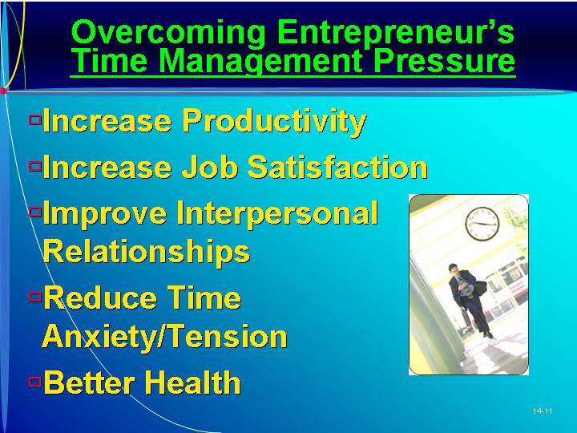  Principle of prioritized planning.  Categorization of tasks by their degree of importance and then the allocation of time to tasks based on this categorization.  Principle of reanalysis.  Periodic review of one’s time management process.  PowerPoint Slide 14-12 (Transparency Master 14-9)  “Time Management Principles” (See PowerPoint slide show beginning on page 352 of this manual. Also presented as a transparency master in Section 6 of this manual.)  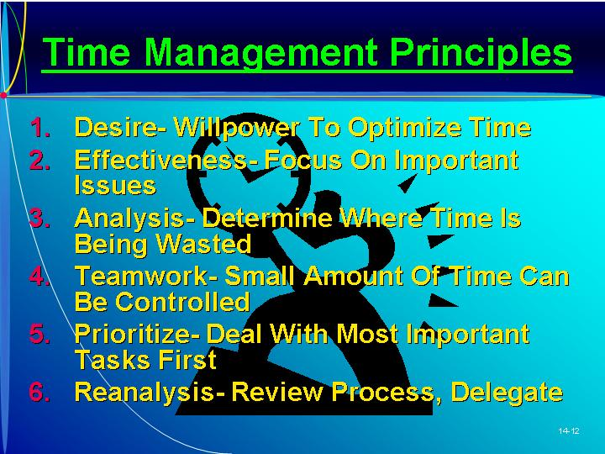
IX. IMPLICATIONS OF FIRM GROWTH TO THE ENTREPRENEUR  A. Firm growth introduces a number of managerial challenges for the entrepreneur.  1. Some entrepreneurs lack the ability to make the transition to a more professional management approach.  2. Others aren’t willing to focus on the tasks necessary to successfully grow the firm.  3. The text uses the example of Design Edge, which controlled growth by putting a halt on all growth for one full year.  4. Some entrepreneurs do not pursue growth because they believe profitability and survival are sacrificed.  5. Others avoid growth so as not to yield equity or incur debt.  B. A Categorization of Entrepreneurs and their Firms’ Growth.  1. Entrepreneurs can be categorized in terms of two dimensions:  a. An entrepreneur’s ability to successfully make the transition to more professional management practices  b. An entrepreneur’s growth aspirations.  2. Four types of firm growth outcomes are identified. (See Text Figure. 14.8)  a. Actual Growth of the Firm.  (i) Entrepreneurs in the upper-right quadrant have both the necessary abilities to make transition and the aspiration to grow the business.  (ii) These are the most likely to achieve firm growth.  b. Unused Potential for Growth.  (i) Entrepreneurs in the upper left quadrant possess the necessary abilities, but do not aspire to do so.  (ii) A relatively large proportion of all lifestyle firms fall here.  c. Constrained Growth.  (i) Entrepreneurs in the lower right quadrant want to grow their business but do not possess sufficient abilities to do so.  (ii) These entrepreneurs are in the most danger of failure because growth may outstrip the entrepreneur’s ability to cope.  (iii) One option is for the entrepreneur to replace himself or herself as the CEO with a professional manager.  d. Little Potential for Firm Growth.  (i) Entrepreneurs in the lower left quadrant neither possess the necessary abilities to make the transition nor the aspirations to grow their businesses.  (ii) These firms may actually perform better if they remain at a smaller scale.  3. Although the entrepreneur’s abilities and existing resources can limit growth, the resources necessary can be acquired externally.  a. External growth mechanisms include joint ventures, acquisitions, and mergers.  b. Each provides different advantages and disadvantages but require the entrepreneur to negotiate a new relationship. | Learning Objective 4.  To recognize that people differ and to understand how these differences impact their intentions to grow a business.  Text Figure 14.8  “Four Types of Entrepreneurs and Firm Growth” (Text Figure on page 476)  PowerPoint Slide 14-13 (Transparency Master 14-10)  “Growth Categories” (See PowerPoint slide show beginning on page 352 of this manual. Also presented as a transparency master in Section 6 of this manual.)  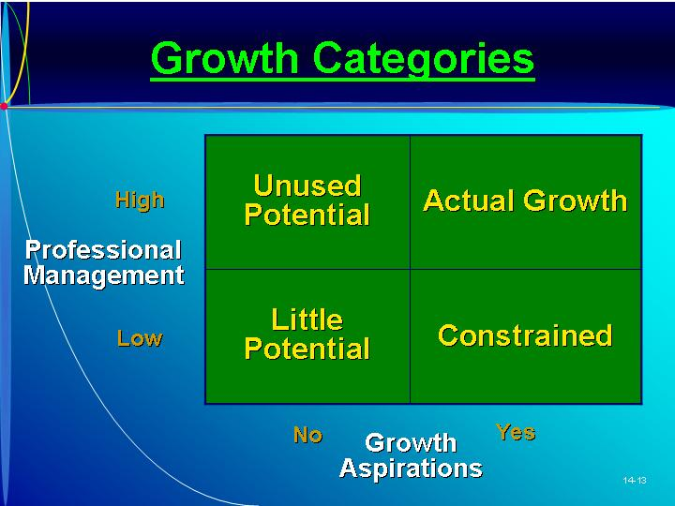
X. IN REVIEW: SUMMARY.
See “Learning Objectives Revisited” below.

learning objectives revisited

Learning Objective 1. To know where to look for (or how to create) possible growth opportunities.
  - A penetration strategy focuses on the firm’s existing product in its existing market.
  - Market development strategies involve selling the firm’s existing products to new groups of customers.
    - One strategy is to sell existing products in new geographic markets.
    - The business might grow by offering the same product to a new demographic market.
    - The venture might find that people have a new use for an existing product.
  - Product development strategies for growth involve developing and selling new products to people who are already purchasing the firm’s existing products.
  - Diversification strategies involve selling a new product to a new market.
    - Backward integration refers to taking a step back (up) on the value-added chain toward the raw materials.
    - Forward integration is taking a step forward (down) on the value-added chain toward the customers.
    - Horizontal integration occurs at the same level of the value-added chain but simply involves a different, but complementary value-added chain.

Learning Objective 2. To understand the implications of business growth on a national economy.
  - In 1996 Inc. magazine conducted a study of the 500 fastest growing ventures in 1984 to see what happens to ventures entering a growth phase.
    - By 1995 there had been 95 failures, 135 had been sold to new owners, but the remaining 233 more than made up for the failure in jobs created and revenue generated.
    - Forty-eight percent were still privately held; only six percent had gone public.
  - The sample does not adequately represent businesses that grow more modestly, especially small businesses.
    - The majority of new jobs are created by small businesses.
    - There are so many small businesses that even when a small percentage of them go, the impact on the economy is significant.
    - Even when firms fail, knowledge is generated, stimulating improvements in technology.

Learning Objective 3. To understand the primary challenges for managing business growth and to be prepared to effectively manage these challenges.
  - Growth puts pressure on existing financial resources.
    - Investing in growth means that the firm’s financial resources are stretched thin.
    - To overcome pressures on existing resources, the entrepreneur could acquire new resources or better manage existing resources.
    - Cash flow positions should be monitored closely and carefully managed.
    - An inventory control system should be developed.
    - Fixed assets involve long-term commitments and large investments; they have certain costs related to them.
    - Interim income statements can be used to establish cost standards and compare the actual with budgeted amounts.
    - The venture is required to withhold payroll taxes; the entrepreneur also must file end-of-the-year tax returns.
    - To enhance the flow of information, the venture can use a financial software package and accountant services.
    - A customer database should be developed to capture key account information.
  - Growth puts pressure on human resources.
    - If employees are spread too thin by growth, then the firm will face problems of employee morale, employee burn out, and an increase in employee turn over.
    - In smaller firms, the responsibilities of recruiting, hiring, payroll, and firing fall to the entrepreneur.
    - A key concern is how to maintain the corporate culture despite the influx of new employees.
  - Growth puts pressure on the management of employees.
    - As the firm grows, the entrepreneur will need to change their management style and adopt a more participative management style.
    - Involving employees in decision making has several key advantages.
  - Growth put pressure on the entrepreneur’s time.
    - Time is the entrepreneur’s most precious yet limited resource.
    - Time management is the process of improving an individual’s productivity through more efficient use of time.

Learning Objective 4. To recognize that people differ and to understand how these differences impact their intentions to grow a business.
  - Four types of firm growth outcomes can be idenfitied based on the entrepreneur’s ability to make the transition to more professional management practices and the entrepreneur’s desire to grow the venture.
  - Actual growth of the firm occurs when the entrepreneur has both the necessary abilities and the desire to grow.
  - Unused potential for growth occurs when entrepreneurs possess the necessary abilities, but do not aspire to grow.
  - Constrained growth occurs when entrepreneurs want to grow their business but do not possess sufficient abilities to do so.
  - When entrepreneurs neither possess the necessary abilities nor the desire to grow, there is little potential for firm growth.

key terms

Backward integration. A step back (up) in the value added chain toward the raw materials.
Diversification strategy. A strategy to grow by selling a new product to a new market.
FIFO. Inventory costing method whereby first items into inventory are first items out.
Forward integration. A step forward (down) on the value added chain toward the customers.
Horizontal integration. Occurs at the same level of the value added chain but simply involves a different, but complementary, value-added chain.
LIFO. Inventory costing method whereby last items into inventory are first items out.
Market development strategy. Strategy to grow by selling the firm’s existing products to new groups of customers.
Participative style of management. The manager involves others in the decision making process.
Penetration strategy. A strategy to grow by encouraging existing customers to buy more of the firm’s current products.
Principle of analysis. Understanding how time is currently being allocated, and where it is being inefficiently invested.
Principle of desire. A recognition of the need to change personal attitudes and habits regarding the allocation of time.
Principle of effectiveness. A focus on the most important issues.
Principle of prioritized planning. Categorization of tasks by their degree of importance and then the allocation of time to tasks based on this categorization.
Principle of reanalysis. Periodic review of one’s time management process.
Principle of teamwork. Acknowledgement that only a small amount of time is actually under one’s control and is taken up by others.
Product development strategy. A strategy to grow by developing and selling new products to people who are already purchasing the firm’s existing products.
Time management. The process of improving an individual’s productivity through more efficient use of time.

research tasks and class discussions

The text includes several topics for student research and class discussions. These questions are open-ended, and the answers will be different for each student. There are no “correct” answers.

Research tasks:
- What different software packages are available to help entrepreneurs with their different record-keeping and control activities? How effective do you believe software can be for each of these tasks?
- Assume you have started a new bricks-and-mortar retail business but want to create a website to advertise and provide information about your business. What are the attributes of a good website for this purpose? How much will it cost?
- How costly is it to put an advertisement in the local paper, in the business telephone directory, on the radio, on television, and in a magazine? What types of products would benefit from each advertising outlet mentioned above? Why?
- Which are the three fastest-growing companies in the country? What opportunities have they pursued to achieve this level of growth? What growth mechanism have they used (internal, joint venture, acquisitions, franchising, etc.)?
- Use research to come up with three examples of founding entrepreneurs that stepped aside once the firm had grown to a certain size and brought in a “professional manager.” What relationship did the entrepreneur continue to have with the firm after the transition? Provide an example of a founding entrepreneur being forced out of the position of CEO to be replaced by a professional manager.

Class Discussions
- To what extent does the use of software help and hinder the entrepreneur’s ability to perform the important tasks of record keeping and financial control?
- The firm needs to make sales. What is the best way to motivate salespeople to make more sales and improve the performance of the firm? How would you effectively monitor their performance under the proposed motivation system? What are the pros and cons of your motivation and monitoring systems?
- Categorize those people in the class who you believe would be well suited for starting a business and managing initial growth but would be less effective at conducting the professional management tasks when the firm became larger. What can they do to improve their ability to successfully make the transition with the firm? Categorize those people in your class who you believe would be well suited to the role of professionally managing a larger(more established) firm but less effective at starting a firm and managing early growth? What can they do to improve their ability to manage a firm earlier in its development? Is there anybody in the class (excerpt maybe yourself) who you believe would be equally effective at both tasks?
- Think of a company that produces one product and sells it to one group of customers (or make on up). Advise the entrepreneur of the main opportunities there are for growth—opportunities for penetration strategies, market development strategies, product development strategies, and diversification strategies.
- Are you a time water or a time server? What time management techniques do you use/ How can you better manage your time?

Visual Resources

The PowerPoint presentation for this chapter, shown on the following pages, includes the following slides.
Slide 14-1 Entrepreneurship Title
Slide 14-2 Chapter Title
Slide 14-3 Growth Strategies *
Slide 14-4 Strategies *
Slide 14-5 Product Integration *
Slide 14-6 Pressures on Firm Growth
Slide 14-7 Overcoming Financial Resources Pressure *
Slide 14-8 Inventory Valuation *
Slide 14-9 Overcoming Human Resources Pressures *
Slide 14-10 Overcoming Employee Management Pressure *
Slide 14-11 Overcoming Entrepreneur’s Time Management Pressure *
Slide 14-12 Time Management Principles *
Slide 14-13 Growth Categories *
* Also included as a Transparency Master.

The following are included as transparency masters in Section 6 of this manual.
Transparency Master 14-1 Growth Strategies
Transparency Master 14-2 Strategies
Transparency Master 14-3 Product Integration
Transparency Master 14-4 Overcoming Financial Resources Pressure
Transparency Master 14-5 Inventory Valuation
Transparency Master 14-6 Overcoming Human Resources Pressures
Transparency Master 14-7 Overcoming Employee Management Pressure
Transparency Master 14-8 Overcoming Entrepreneur’s Time Management Pressure
Transparency Master 14-9 Time Management Principles
Transparency Master 14-10 Growth Categories

powerpoint slide show

Slide 14-1  Entrepreneurship Title   | Slide 14-2  Chapter Title
Slide 14-3  Growth Strategies (Also presented as Transparency Master 14-1 in Section 6 of this manual.) | Slide 14-4  Strategies (Also presented as Transparency Master 14-2 in Section 6 of this manual.)
Slide 14-5  Product Integration (Also presented as Transparency Master 14-3 in Section 6 of this manual.) | Slide 14-6  Pressures on Firm Growth
Slide 14-7  Overcoming Financial Resources Pressure (Also presented as Transparency Master 14-4 in Section 6 of this manual.) | Slide 14-8  Inventory Valuation (Also presented as Transparency Master 14-5 in Section 6 of this manual.)
Slide 14-9  Overcoming Human Resources Pressures (Also presented as Transparency Master 14-6 in Section 6 of this manual.) | Slide 14-10  Overcoming Employee Management Pressure (Also presented as Transparency Master 14-7 in Section 6 of this manual.)
Slide 14-11  Overcoming Entrepreneur’s Time Management Pressure (Also presented as Transparency Master 14-8 in Section 6 of this manual.) | Slide 14-12  Time Management Principles (Also presented as Transparency Master 14-9 in Section 6 of this manual.)
Slide 14-13
Growth Categories (Also presented as Transparency Master 14-10 in Section 6 of this manual.)

