Macroeconomics
&
Microeconomics
Chapter 3W
IN THIS CHAPTER
YOU WILL LEARN:

3W.1 About Changes in Supply and Demand

3W.2 About Pre-Set Prices

3W.3 About Non-Priced Goods

3W.4 What Consumer and Producer Surplus is

Applications and Extensions of Supply and Demand Analysis
Chapter 3 in Economics clearly demonstrates that supply and demand analysis is a powerful tool for understanding equilibrium prices and quantities. The information there is fully sufficient for moving forward in the book, but you may find that additional examples of supply and demand are helpful. This optional Internet chapter provides several concrete illustrations of changes in supply and demand. It also applies supply and demand analysis to non-priced goods (goods owned in common and not bought and sold in markets). Finally, it demonstrates how markets confer “benefit surpluses” to consumers and producers and “efficiency gains” to society. Your instructor may assign all, some, or none of this chapter, depending on time availability and preferences.

3W.1 Changes in Supply and Demand
As shown in Figure 3.6 of the textbook, changes in supply and demand cause changes in price, quantity, or both. The following applications demonstrate this fact in several real-world markets. The simplest situations are those in which either supply changes while demand remains constant or demand changes while supply remains constant. Let’s consider two such simple cases first, before moving on to more complex applications.

Lettuce
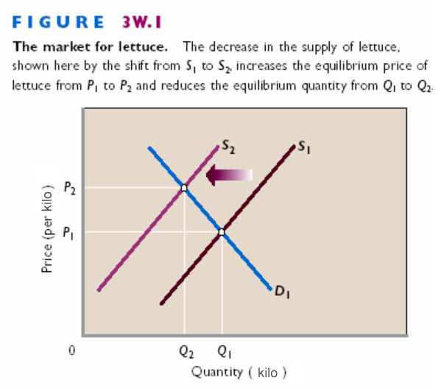
Every so often we hear on the news that extreme weather has severely reduced the size of some crop such as lettuce, apples, or cherries. Suppose, for example, that a severe freeze destroys a sizable portion of the lettuce crop. This circumstance implies a significant decline in supply, which we represent as a leftward shift of the supply curve from S₁ to S₂ in Figure 3W.1. At each price, consumers desire as much lettuce as before, so the freeze does not affect the demand for lettuce. That is, demand curve D₁ does not shift. What are the consequences of the reduced supply of lettuce for equilibrium price and quantity? As shown in Figure 3W.1, the leftward shift of the supply curve disrupts the previous equilibrium in the market for lettuce and drives the equilibrium price up from P₁ to P₂. Consumers respond to that price hike by reducing the quantity of lettuce demanded from Q₁ to Q₂. Equilibrium in the market is restored, now at P₂ and Q₂. Consumers who are willing and able to pay price P₂ obtain lettuce; consumers unwilling or unable to pay that price do not. Some consumers continue to buy as much lettuce as before, even at the higher price. Others buy some lettuce but not as much as before, and still others forgo lettuce altogether. The latter two groups use the money they would have spent on lettuce to obtain other products, say, carrots, whose price has not gone up. Relative to lettuce, those products now deliver greater value than before.
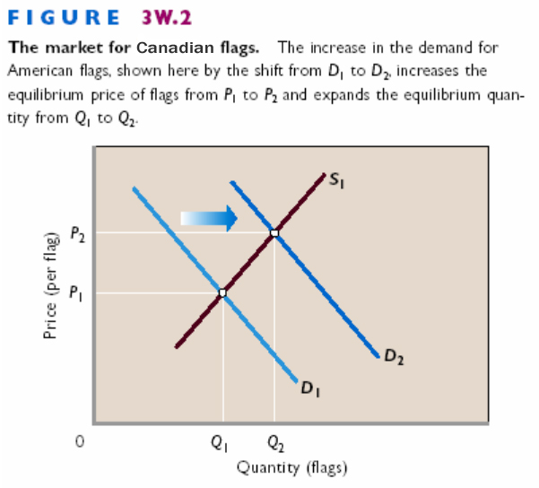
Canadian Flags
Consider an example in which demand suddenly changes while supply remains constant. Canadian patriotism surged following the adoption of a newly designed national flag in 1965. One manifestation of that patriotism was increased utility from Canadian flags. So Canadians demanded more flags than before at any given price. That is, the demand for Canadian flags increased, initially without a corresponding increase in supply. We depict this situation in Figure 3W.2 as the rightward shift of the demand curve from D₁ to D₂. This increase in demand for flags drove up their equilibrium price to P₂. Producers responded to the higher price by increasing the number of flags supplied, as from Q₁ to Q₂. At the higher price and quantity, the market again achieved equilibrium. In summary, the demand for flags increased, the price of flags increased, and the quantity of flags supplied increased. The supply of flags did not change; it is the entire curve or schedule and remained in place. (Eventually, the potential for high profit lured new producers of flags into the market, shifting the supply curve rightward and returning the price closer to P₁.)

Pink Salmon
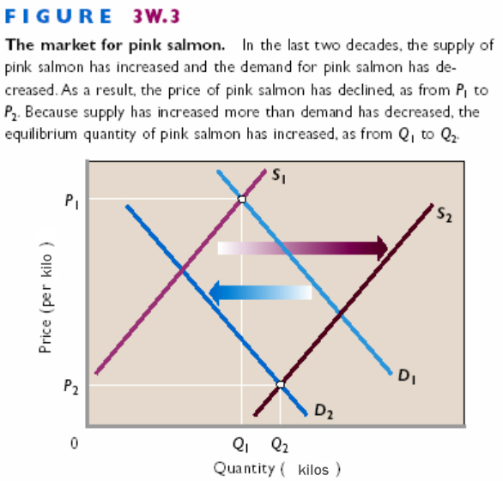
Now let’s see what happens when both supply and demand change at the same time. Two decades ago, people who caught salmon earned as much as $2 for each kilo of pink salmon—the type used mainly for canning— brought to the buyer. In Figure 3W.3 that price is represented as P₁, at the intersection of supply curve S₁ and demand curve D₁. The corresponding quantity of pink salmon is represented as Q₁ kilos. Over the past two decades, supply and demand changed in the market for pink salmon. On the supply side, improved technology in the form of larger, more efficient fishing boats greatly increased the catch and lowered the cost of obtaining it. Also, high profits at price P₁ encouraged many new fishers to enter the industry. As a result of these changes, the supply of pink salmon greatly increased and the supply curve shifted to the right, as from S₁ to S₂ in Figure 3W.3. Over the same years, the demand for pink salmon decreased, as represented by the leftward shift from D₁ to D₂ in Figure 3W.3. That decrease resulted from increases in consumer income and reductions of the price of substitute products. As buyers’ incomes increased, consumers shifted demand away from canned fish and toward higher-quality fresh or frozen fish, including more-valued Atlantic, Chinook, Sockeye, and Coho salmon. Moreover, the emergence of fish farming, in which salmon are raised in ocean net pens, lowered the prices of these substitute species. That, too, reduced the demand for pink salmon. The altered supply and demand reduced the price of pink salmon to as low as $.20 per kilo, as represented by the drop in price from P₁ to P₂ in Figure 3W.3. Both the supply increase and the demand decrease helped reduce the equilibrium price. However, in this particular case the equilibrium quantity of pink salmon increased, as represented by the move from Q₁ to Q₂. Both shifts of the curves reduced the equilibrium price, but equilibrium quantity increased because the increase in supply exceeded the decrease in demand.

Gasoline
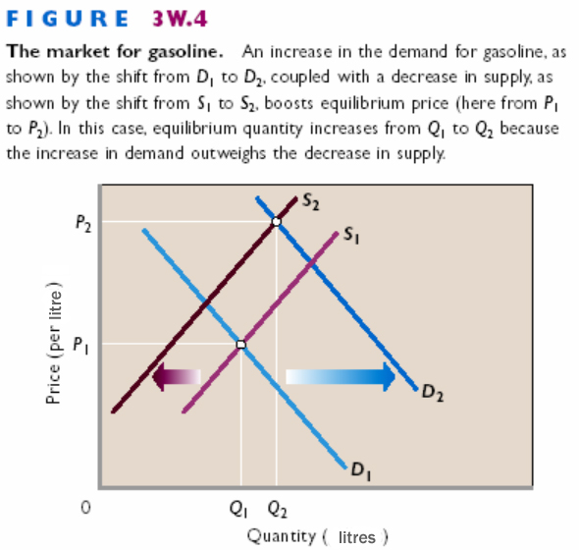
The price of gasoline has been particularly variable in Canada over the past several years. Consider a single episode: the sharp increase in gasoline prices that occurred in the first part of 2002. What caused the price of gasoline to rise from $.55 a litre to $.80 a gallon, or even higher, in just a few months? We begin in Figure 3W.4 with the price of a litre of gasoline at P₁. Both supply and demand factors upset this equilibrium. Because of supply uncertainties relating to Middle East politics and warfare, the price of oil increased in early 2002. Oil is a resource used to make gasoline, so any rise in its price increases the cost of producing gasoline. Such cost increases reduce the supply of gasoline, as represented by the shift of the supply curve from S₁ to S₂ in Figure 3W.4. The demand for gasoline increased during this same period. We show this as the rightward shift of the demand curve from D₁ to D₂. Incomes in general were rising because the Canadian and U.S. economies were recovering from the slowdown of 2001. Rising incomes increase demand for all normal goods, including gasoline. Also, long security lines at airports caused people to travel more by automobile and less by airplanes. That, together with the increased number of low-gas-mileage SUVs and light trucks on the road, also increased the demand for gasoline. The decline in gasoline supply and increase in gasoline demand boosted the price of gasoline, as represented by the price increase from P₁ to P₂ in Figure 3W.4. Because the increase in demand outweighed the decrease in supply, the equilibrium quantity of gasoline increased from Q₁ to Q₂. In other situations the price of gasoline in Canada has declined over periods in which demand has increased. You should test your understanding of supply and demand analysis by explaining how such a price decrease could occur.

Sushi
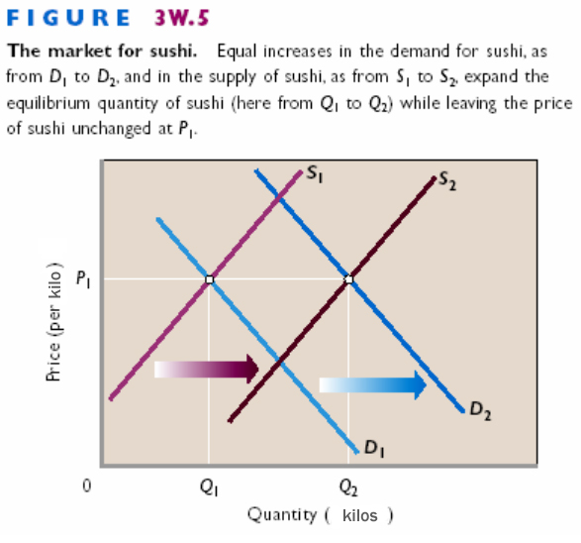
Sushi bars are springing up at a rapid rate in Canadian cities. Consumption of this raw-fish delicacy from Japan has soared in Canada in recent years. Nevertheless, the price of sushi has remained relatively constant. Supply and demand analysis helps explain this circumstance of increased quantity and constant price. A change in tastes has increased the Canadian demand for sushi. Many consumers of sushi find it highly tasty when they try it. And, as implied by the growing number of sushi bars in Canada, the supply of sushi has also expanded. We represent these supply and demand changes in Figure 3W.5 as the rightward shift of the demand curve from D₁ to D₂ and the rightward shift of the supply curve from S₁ to S₂. Observe that the equilibrium quantity of sushi increases from Q₁ to Q₂ and equilibrium price remains constant at P₁. The increase in supply, which taken alone would reduce price, has perfectly offset the increase in demand, which taken alone would raise price. The price of sushi remains constant, but the equilibrium quantity greatly expands because both the increase in demand and the increase in supply expand purchases and sales. Simultaneous increases in demand and supply can cause price to either rise, fall, or remain constant, depending on the relative magnitudes of the supply and demand increases. In this case, price remained constant.

3W.2 Preset Prices
In Chapter 3 of the textbook we saw that an effective government-imposed price ceiling (legal maximum price) causes quantity demanded to exceed quantity supplied—a shortage. An effective government-imposed price floor (legal minimum price) causes quantity supplied to exceed quantity demanded—a surplus. Put simply: Shortages result when prices are set below, and surpluses result when prices are set above, equilibrium prices. We now want to establish that shortages and surpluses may occur in markets other than those in which government imposes price floors and ceilings. Such market imbalances occur where the seller or sellers set prices in advance of sales and the actual equilibrium price turns out to be too low or too high to obtain equilibrium. Consider the following two examples.

Olympic Figure Skating Finals
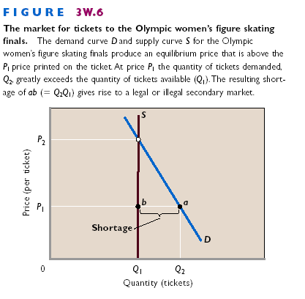
Tickets for the women’s figure skating championship at the Olympics are among the world’s “hottest tickets.” The popularity of this event and the high incomes of buyers translate into tremendous ticket demand. The Olympic officials set the price for the tickets in advance. Invariably, the price, although high, is considerably below the equilibrium price that would equate quantity demanded and quantity supplied. A severe shortage of tickets therefore occurs in this primary market—the market involving the official ticket office. The shortage, in turn, creates a secondary market in which buyers bid for tickets held by initial purchasers rather than the original seller. Scalping tickets—selling them above the ticket price—may be legal or illegal (a black market), depending on local laws. Scalping occurs only in markets where shortages occur at preset prices. Figure 3W.6 shows how the shortage in the primary ticket market looks in terms of supply and demand analysis. Demand curve D represents the strong demand for tickets, and supply curve S represents the supply of tickets. The supply curve is vertical because there are a fixed number of tickets printed to match the capacity of the arena. At the printed ticket price of P₁, the quantity of tickets demanded, Q₂, exceeds the quantity supplied, Q₁. The result is a shortage of ab—the horizontal distance between Q₂ and Q₁ in the primary market. If the printed ticket price had been the higher equilibrium price P₂, no shortage of tickets would have occurred. But at the lower price P₁, a shortage and secondary ticket market will emerge among those buyers willing to pay more than the printed ticket price and those sellers willing to sell their purchased tickets for more than the printed price. Wherever there are shortages and secondary markets, we can safely assume that price was set below the equilibrium price. (Refer to Chapter 3’s Last Word on scalping for other implications of below-equilibrium prices.)

Olympic Curling Preliminaries
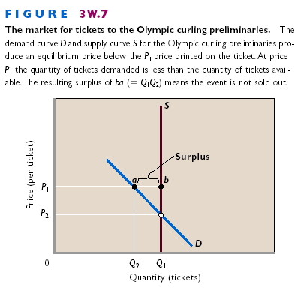
Contrast the shortage of tickets for the women’s figure skating finals at the Olympics to the surplus of tickets for one of the preliminary curling matches. For the uninitiated, curling is a sport in which participants slide a heavy round object called a “stone” down the ice toward a target while people called “sweepers” use brooms to alter the course of the stone when desired. Curling is a popular spectator sport in a few nations such as Canada, but it draws few fans in most countries. So the demand for tickets to most of the preliminary curling events is not strong. We demonstrate this weak demand as D in Figure 3W.7. As in our previous example, the supply of tickets is fixed by the size of the arena and is shown as vertical line S. We represent the printed ticket price as P₁ in Figure 3W.7. In this case the printed price is considerably greater than the equilibrium price of P₂. At the printed ticket price, quantity supplied is Q₁ and quantity demanded is Q₂. So a surplus of tickets of ba (= Q₁Q₂) occurs. No scalping occurs prior to the event and there are numerous empty seats. Only if the Olympic officials had priced the tickets at the lower price P₂ would the event have been a sell-out. (Actually, the Olympic officials try to adjust to demand realities for curling contests by holding them in smaller ice arenas than used for figure skating and by charging less for tickets. Nevertheless, the stands are rarely full for the preliminary contests, which compete against final events in other winter Olympic sports.)
• Given demand, decreases in supply boost equilibrium price and reduce equilibrium quantity; given supply, increases in demand boost equilibrium price and equilibrium quantity.

• Depending on the relative magnitudes of the changes in supply and demand, simultaneous changes in supply and demand can increase, reduce, or leave unchanged equilibrium price.

• Preset prices that are below-equilibrium prices cause shortages that give rise to legal or illegal selling in secondary markets; preset prices that are above-equilibrium prices cause surpluses of unsold goods.

QUICK

REVIEW

CONSIDER THIS . . . Taking Back a “Gift”
In the past, it was common for rock superstars (or hip-hop or country superstars) to price their concert tickets below the market-clearing price. The tickets were usually rationed on a first-come, first served basis, and ticket scalping was common. Why should these superstars want to subsidize their fans—at least those fortunate enough to obtain tickets—with below-equilibrium prices? Why not set ticket prices at a higher, market-clearing level and realize more income from the tour? The answer is that long lines of fans waiting hours or days for bargain-priced tickets caught the attention of the press. (Some of the people in the lines, however, were there to buy tickets for resale at higher prices!) The millions of dollars of free publicity that resulted from the press coverage undoubtedly stimulated CD sales, from which much of any musician’s income is derived. Thus a “gift” of below equilibrium ticket prices from a rock star to fans also benefited the star. In the past few years, many stars have rethought this strategy. Ticket prices for rock concerts have skyrocketed, sometimes to more than $200 for the most desirable seats. Why the change of heart? According to concert promoters, the growing practice of illegally downloading songs and albums from the Internet has not only reduced royalty income to the superstars but also reduced the value of free publicity. If concert-goers and others are downloading CDs rather than buying them, why subsidize concert-goers with below-equilibrium ticket prices? The superstars are, in effect, taking back a gift.

3W.3 Non-priced Goods: The North American Bison
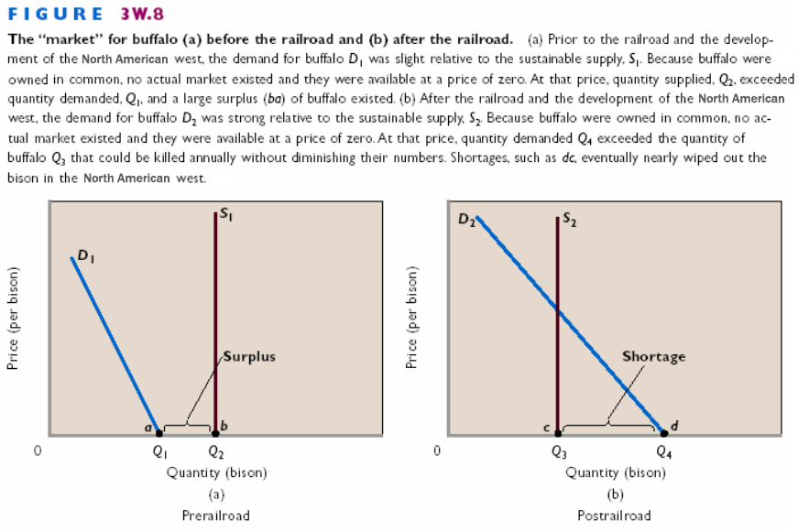
We can extend our discussion of shortages and surpluses by applying those ideas to non-priced goods (or factors). Such goods (or factors) are owned in common by society and available for the taking on public lands. Because they are not bought and sold in markets, their price is effectively zero. We are speaking, for example, of clams and seashells on public beaches, fish and reptiles in public waters, and wild game and mushrooms on public land. Although there is no actual market for these non-priced goods, supply and demand analysis provides keen insights about them. Consider the plight of the North American bison (commonly called the “buffalo”). Once numbering in the hundreds of thousands across the plains and plateaus of the North American west, these animals were nearly wiped out by hunters and loss of habitat during the 1800s. What happened? Buffalo roamed on the vast public lands in the North American west. They were, in effect, a non-price good owned in common by the inhabitants and available for the taking. Before the railroad expanded westward, only native North Americans hunted the buffalo. Because the number of native North Americans was small and their means of taking buffalo primitive, the number of buffaloes killed each year did not threaten the sustainable buffalo population. Although there was no actual market for buffalo, we can apply supply and demand analysis to this situation. The vertical supply curve S₁ in Figure 3W.8a represents the sustainable supply of buffalo—the stable population size based on reproduction rates, death rates, and available habitat. The supply curve is vertical in this non-market situation because the number of buffalo is independent of “price.” In reality, there is no price other than zero for non-priced goods. The demand curve D₁ in Figure 3W.8a represents the weak demand for buffalo prior to the westward expansion. This is a hypothetical demand curve showing the quantity of buffalo that would be demanded at each price if such a price existed. Figure 3W.8a indicates that at price zero the quantity of buffalo demanded was Q₁ compared to the quantity supplied of Q₂. So there was a large surplus of buffalo, represented by distance ba (= Q₂Q₁) in this early period of North American history. Bison were plentiful and there was no immediate threat to their sustainable supply. This situation changed dramatically as the railroad penetrated the North American west. The railroad brought many more hunters, who sold buffalo hides for use in coats and rugs. Moreover, many individuals shot hundreds of buffalo a day simply for “sport.” The increase in hunters, in essence, reflected an increase in the demand for buffalo. The railroad also enabled economic development that converted public lands to private farms and ranches. Those land-use changes decreased the available range for buffalo and thus their sustainable supply. Figure 3W.8b illustrates the circumstance for the buffalo following the railroad’s extension into the North American west. The demand curve for buffalo D₂ is positioned much farther to the right than demand curve D₁ in Figure 3W.8a. This reflects the increased buffalo hunting enabled by train transportation. The sustainable supply curve S₂ is positioned to the left of the S₁ curve in the prior period, reflecting diminished habitat. Because buffalo continued to be owned in common, their price remained zero. At price zero in Figure 3W.8b, the quantity of buffalo supplied is Q₃ and the quantity demanded is Q₄. The surplus of buffalo in the pre-railroad era gave way to a shortage, as represented by distance dc (= Q₄Q₃). Moreover, the shortage was relative to the sustainable level of the herd, not the actual number of buffalo available to hunters. Each year, given the zero price, hunters shot more buffalo than were being naturally reproduced. So the sustainable supply of buffalo declined each year. In Figure 3W.8b, this would be depicted as successive leftward shifts of the supply curve. Eventually, the combination of zero price, excess demand, and declining supply nearly exhausted (used up) the availability of buffalo in the North American west. The plight of the buffalo occurred because there was no price mechanism to equate quantity supplied and quantity demanded and no profit incentive to sustain the herd size. Non-priced goods tend to get over-consumed and eventually exhausted. This tendency holds for all non-priced goods that face excess demand, including fish in public waters, clams and oysters on public beaches, water in some rivers, trees used for fuel in sub-Saharan Africa, and so on. Where price does not ration and demand is strong relative to supply, society must devise some other rationing mechanism to limit consumption. Modern management of fish and game, for example, uses rationing mechanisms such as licenses (which limit the number of fishers and hunters), seasons (which limit the time of fishing and hunting), and limits (which limit the number of fish and animals taken). Those mechanisms were not in place during the period in which the buffalo declined. Today, there are about 500,000 bison in the North America. Although that number is small relative to the pre-railroad era, the remaining herds are generally thriving. Hunting of buffalo is not allowed on public lands such as national and provincial parks. Buffalo numbers have increased so dramatically that park officials are considering selective shooting to thin the herd. Moreover, in recent decades some private landowners have introduced buffalo on their ranches. A non-priced good, once owned only in common, is being converted to a private, positively priced good produced on private land, as cattle are, and bought and sold in markets. If this conversion is successful, buffalo will become far more common in the North American west because there will be a profit incentive to increase their numbers.

• A surplus of a non-priced good (a good owned in common) occurs when, at zero price, the quantity available (quantity supplied) exceeds the quantity demanded.

• A shortage of a non-priced good owned in common occurs when, at zero price, the quantity demanded exceeds the quantity available (quantity supplied).

• Faced with increases in demand, non-priced goods tend to be over-consumed and eventually exhausted unless they are rationed by non-price means.

QUICK

REVIEW

3W.4 Consumer and Producer Surplus
Our final goal for this chapter is to extend the analysis of supply and demand. Specifically, we want to examine the following reality: Consumers and producers obtain “benefit surpluses” through market transactions. These surpluses vary in size among the separate buyers and sellers.

Consumer Surplus
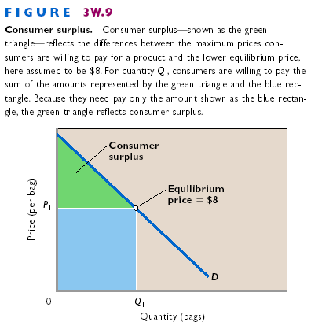
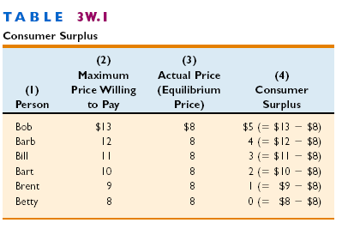
The benefit surplus received by a consumer or consumers in a market is called consumer surplus—the difference between the maximum price a consumer is (or consumers are) willing to pay for a product and the actual price. In nearly all markets, consumers individually and collectively gain greater total utility in dollar terms (total satisfaction) from their purchases than the amount of their expenditures (= product price X quantity). This utility surplus arises because all consumers pay the equilibrium price even though many would be willing to pay more than that price to obtain the product. Consider Figure 3W.9, where we assume the equilibrium price, P₁, of oranges is $8 per bag. The portion of the demand curve D lying above the $8 equilibrium price shows that many consumers of oranges would be willing to pay more than $8 per bag rather than go without oranges. Consider Table 3W.1, for example, where column 2 reveals that Bob is willing to pay a maximum of $13 for a bag of oranges; Barb, $12; Bill, $11; Bart, $10; and Brent, $9. Betty, in contrast, is willing to pay only the $8 equilibrium price. Because all six buyers listed in Table 3W.1 obtain the oranges for the $8 equilibrium price (column 3), five of them obtain a consumer surplus. Column 4 shows that Bob receives a consumer surplus of $5 (= $13 - $8); Barb, $4 (= $12 - $8); Bill, $3 (= $11 - $8); Bart, $2 (=$10 - $8); and Brent, $1 (=$9 - $8). Only Betty receives no consumer surplus because her maximum willingness to pay of $8 matches the $8 equilibrium price. Obviously, most markets have more than six people. Suppose there are many other consumers besides Bob, Barb, Bill, Bart, Brent, and Betty in the market represented by Figure 3W.9. It is reasonable to assume that many of these additional people are willing to pay more than $8 for a bag of oranges. By adding together the individual consumer surpluses obtained by our named and unnamed buyers, we obtain the collective consumer surplus in this specific market. To obtain the Q₁ bags of oranges represented in Figure 3W.9, consumers collectively are willing to pay the total amount shown by the sum of the green triangle and blue rectangle under the demand curve and to the left of Q₁. But consumers need pay only the amount represented by the blue rectangle (= P₁ X Q₁). So the green triangle is the consumer surplus in this market. It is the sum of the vertical distances between the demand curve and the $8 equilibrium price at each quantity up to Q₁. Alternatively, it is the sum of the gaps between maximum willingness to pay and actual price, such as those we calculated in Table 3W.1. Consumer surplus and price are inversely (negatively) related. Given the demand curve, higher prices reduce consumer surplus; lower prices increase it. To test this, draw in an equilibrium price above $8 in Figure 3W.9 and observe the reduced size of the triangle representing consumer surplus. When price rises, the gap narrows between the maximum willingness to pay and the actual price. Next, draw in an equilibrium price below $8 and see that consumer surplus increases. When price falls, the gap widens between maximum willingness to pay and actual price.

Producer Surplus
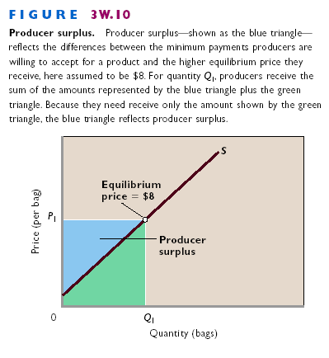
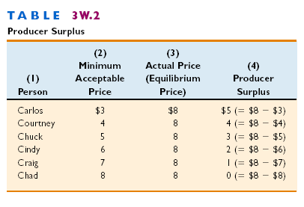
Like consumers, producers also receive a benefit surplus in markets. This producer surplus is the difference between the actual price a producer receives (or producers receive) and the minimum acceptable price. Sellers collectively receive a producer surplus in most markets because most sellers are willing to accept a lower-than-equilibrium price if that is required in order to sell the product. That lower acceptable price is shown by the portion of the supply curve in Figure 3W.10 lying to the left of and below the assumed $8 equilibrium price. Suppose that Carlos, Courtney, Chuck, Cindy, Craig, and Chad are six of the many sellers of oranges in the market. Due to differences in production costs, suppose that Carlos’ minimum acceptable payment for a bag of oranges is $3, as shown in column 2 of Table 3W.2, whereas Courtney’s minimum acceptable payment is $4, Chuck’s is $5, Cindy’s is $6, Craig’s is $7, and Chad’s is $8. But each seller receives as payment the equilibrium price of $8. As shown in column 4, Carlos thus obtains a producer surplus of $5 (= $8 - $3); Courtney, $4 (= $8 - $4); Chuck, $3 (= $8 - $5); Cindy, $2 (= $8 - $6); Craig, $1 (= $8 - $7); and Chad, zero (= $8 - $8). By summing the producer surpluses of these sellers along with those of other sellers, we obtain the producer surplus for the entire market for oranges. In Figure 3W.10, producers collect revenues of P₁ X Q₁, which is the sum of the blue triangle and the green triangle. As shown by the supply curve, however, revenues of only those illustrated by the green triangle would be required to entice producers to offer Q₁ bags of oranges for sale. The sellers therefore receive a producer surplus shown by the blue triangle. That surplus is the sum of the vertical distances between the supply curve and the $8 equilibrium price at each of the quantities to the left of Q₁. There is a direct (positive) relationship between equilibrium price and the amount of producer surplus. Given the supply curve, lower prices reduce producer surplus; higher prices increase it. If you pencil in a lower equilibrium price than $8, you will see that the producer surplus triangle gets smaller. The gaps between the minimum acceptable payments and the actual prices narrow when the price falls. If you pencil in an equilibrium price above $8, the size of the producer surplus triangle increases. The gaps between minimum acceptable payments and actual prices widen when the price increases.

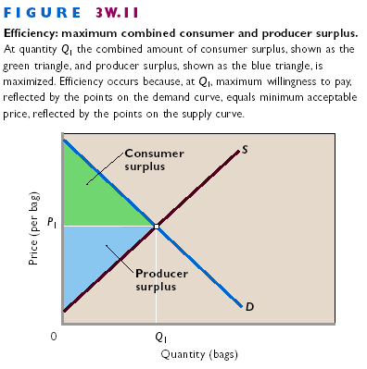
Efficiency Revisited
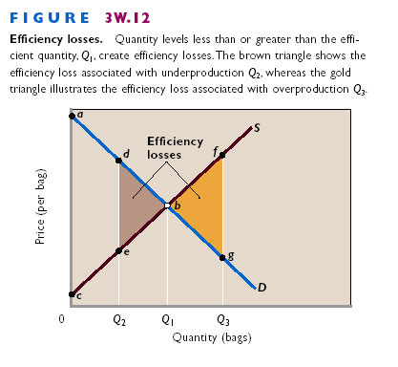
In Figure 3W.11 we bring together the demand and supply curves of Figures 3W.9 and 3W.10 to show the equilibrium price and quantity and the previously described regions of consumer and producer surplus. All markets that have downward-sloping demand curves and upward-sloping supply curves yield consumer and producer surplus. The equilibrium quantity in Figure 3W.11 reflects economic efficiency. In the terminology of Chapter 2, productive efficiency is achieved because competition forces producers to use the best techniques and combinations of resources in growing and selling oranges. Production costs of each level of output are minimized. Allocative efficiency is achieved because the correct quantity of output—Q₁— is produced relative to other goods and services. Points on the demand curve in Figure 3W.11 measure the marginal benefit (MB) of oranges at each level of output. Points on the supply curve measure the marginal cost (MC) of oranges at each output level. The demand and supply curves intersect at the equilibrium output Q¹, indicating that MB = MC. (For the significance of the MB = MC equality for efficiency, review the discussion relating to textbook Figure 2.2.) Our analysis of consumer and producer surplus provides another way of thinking about efficiency. Each point on a demand curve identifies not only the marginal benefit of the corresponding unit of output but also the maximum willingness to pay for it. Willingness to pay derives from the benefit that a product provides. Similarly, each point on the supply curve identifies not only the marginal cost of a good but also the minimum acceptable price for the good. To stay profitable, sellers must receive minimum prices that “cover” their marginal costs. In Figure 3W.11 the maximum willingness to pay for each bag of oranges up to Q₁ exceeds the corresponding minimum acceptable price. So each of these bags adds a positive amount (= maximum willingness to pay minus minimum acceptable price) to the total of consumer and producer surplus. Only at the equilibrium price Q₁, where maximum willingness to pay for the last unit equals minimum acceptable price for that unit, does society exhaust all the opportunities to add to combined consumer and producer surplus. So allocative efficiency occurs where the triangle representing “consumer surplus x producer surplus” is at its maximum size. Other things equal, competitive markets produce equilibrium prices and quantities that maximize the sum of consumer and producer surplus. Allocative efficiency occurs at quantity levels where three conditions exist:
• MB = MC (text Figure 2.2).
• Maximum willingness to pay = minimum acceptable price.
• Combined consumer and producer surplus is at a maximum.

Efficiency Losses
Figure 3W.12 demonstrates efficiency losses—reductions of combined consumer and producer surplus—associated with underproduction or overproduction of a product. Suppose that output is Q₂ rather than the efficient level Q₁. The sum of consumer and producer surplus, previously abc, falls to adec. So the combined consumer and producer surplus declines by the amount of the brown triangle to the left of Q₁. That triangle represents an efficiency loss to buyers and sellers. And since buyers and sellers are members of society, it represents an efficiency loss (or a so-called “deadweight loss”) to society. For output levels from Q₂ to Q₁, the maximum willingness to pay by consumers (as reflected by points on the demand curve) exceeds the minimum acceptable price of sellers (as reflected by points on the supply curve). By failing to produce a product for which a consumer is willing to pay, say, $10, and for which a producer is willing to accept $6, society suffers a $4 loss of net benefits. The brown triangle in Figure 3W.12 shows the total loss of such net benefits due to the underproduction at Q₂. In contrast, suppose that the amount of oranges produced is Q₃ rather than the efficient level of Q₁. In Figure 3W.12 the combined consumer and producer surplus therefore declines by bfg—the gold triangle to the right of Q₁. This triangle subtracts from the total consumer and producer surplus of abc that would occur if the quantity had been Q₁. For all units beyond Q₁, the consumer’s maximum willingness to pay is less than the producer’s minimum acceptable price. Producing an item for which the maximum willingness to pay is, say, $7 and the minimum acceptable price is $10 subtracts $3 from society’s net benefits. Such production is uneconomical and creates an efficiency loss (or deadweight loss) for society. The gold triangle bfg to the right of Q₁ in Figure 3W.12 shows the total efficiency loss from overproduction at Q₃. We are again reminded that there can be too much as well as too little of a good thing. Under most conditions, however, a competitive market ensures that the “right amount” of a particular good gets produced.

THE

Efficiency Gains from Generic Drugs

LASTword

When a Generic Drug Becomes Available, the Price of the Drug Falls, Consumer Surplus Rises, and Society Experiences an Efficiency Gain.
A patent on a new prescription drug gives the pharmaceutical company that developed it an exclusive right to produce and sell the medication for 20 years from the time of patent application. Because the Health Canada’s approval process averages 8 years, the exclusive right may last for as few as 12 years. The purpose of drug patents is to encourage research and development (R&D) leading to new medications. With patent protection, a firm can earn high profits on its popular brand-name medicines. Those high profits provide a return on past development costs and help fund more R&D. Although competitors can and often do develop similar drugs, they cannot copy and sell the patented medication. Such drugs as Zocor (for high cholesterol), Celebrex (for arthritis), and Cipro (for infections) are examples of best-selling brand-name, patented drugs. When a patent expires, any pharmaceutical company can produce and sell the drug under the generic name for the medication. Because such generic drugs have the same chemical composition as the branded drug, they directly compete against it. The generic price is lower than the branded price, and the branded price may fall to compete. So the price of the drug (at least on average) drops as “generics” claim a share of the market. Medical insurance plans often provide incentives for patients to buy generic drugs when they become available. Today, generics make up about 40 percent of all prescription drugs sold. It is useful to see how patent expiration and the competition from generic drugs relate to consumer surplus and efficiency gains. Because Figure 3W.12 is adequate for our analysis, we need not replicate it here. The patent gives the firm monopoly power that allows it to charge a higher-than-competitive price. Suppose that the sole seller’s profit-maximizing price is D on demand curve D in Figure 3W.12. At that price society incurs an efficiency loss of edb because quantity is Q₂ instead of the greater amount Q¹ that would be purchased under competitive conditions. The firm accepts this lower quantity of sales because the restricted amount supplied enables the high price D and resulting high profit. The expiration of the patent creates competition from generics, which reduces the price of the medication from D to, say, B in Figure 3W.12. If you pencil in horizontal price lines at D and B, and compare the consumer surplus triangles above the lines, you can see that consumer surplus rises when the price falls. As the price of the medication drops from D to B, output increases from Q₂ to Q₁. In this case, the efficiency loss dbe totally disappears. In other cases, it may decline but not disappear, depending on the extent of consumer (or physician) loyalty to the branded drug. Patents aid consumers and society by encouraging R&D and new medicines. Patent expiration and generics are also good for consumers and society because they lower prices, increase consumer surplus, and enhance efficiency.

QUICK

REVIEW
• Consumer surplus is the difference between the maximum price that a consumer is willing to pay for a product and the lower price actually paid.
• Producer surplus is the difference between the minimum price that a producer is willing to accept for a product and the higher price actually received.
• At the equilibrium price and quantity in competitive markets, marginal benefit equals marginal cost, maximum willingness to pay equals minimum acceptable price, and the total of consumer surplus and producer surplus is maximized. These individual conditions each define allocative efficiency.

SUMMARY

3W.1 About changes in supply and demand
• A decrease in the supply of a product increases its equilibrium price and reduces its equilibrium quantity. In contrast, an increase in the demand for a product boosts both its equilibrium price and its equilibrium quantity.
• Simultaneous changes in supply and demand affect equilibrium price and quantity in various ways, depending on the relative magnitudes of the changes in supply and demand. Equal increases in supply and demand, for example, leave equilibrium price unchanged.

3W.2 About pre-set prices
• Sellers set prices of some items such as tickets in advance of the event. These items are sold in the primary market that involves the original seller and buyers. If preset prices turn out to be below the equilibrium prices, shortages occur and scalping in legal or illegal secondary markets arises. The prices in the secondary market then rise above the preset prices. In contrast, surpluses occur when the preset prices happen to exceed the equilibrium prices.

3W.3 About non-priced goods
• Non-priced goods such as fish in public waters and game on public lands are owned in common and therefore not bought and sold in markets. A surplus of a non-priced good occurs when the sustainable quantity of the good exceeds the quantity demanded. A shortage of a non-priced good occurs when the quantity demanded exceeds the sustainable quantity. In this latter case, the good tends to be over-consumed and, without protection, may eventually be exhausted.

3W.4 What consumer and producer surplus is
• Consumer surplus is the difference between the maximum price that a consumer is willing to pay for a product and the lower price actually paid. Collectively, consumer surplus is represented by the triangle under the demand curve and above the actual price.
• Producer surplus is the difference between the minimum price that a producer is willing to accept for a product and the higher price actually received. Collectively, producer surplus is shown by the triangle above the supply curve and below the actual price.
• Graphically, the combined amount of producer and consumer surplus is represented by the triangle to the left of the intersection of the supply and demand curves that is below the demand curve and above the supply curve. At the equilibrium price and quantity in competitive markets, marginal benefit equals marginal cost, maximum willingness to pay equals minimum acceptable price, and the combined amount of consumer surplus and producer surplus is maximized.
• Output levels that are either less than or greater than the equilibrium output create efficiency losses—reductions in the combined amount of consumer surplus and producer surplus. Underproduction creates efficiency losses because output is not being produced for which maximum willingness to pay exceeds minimum acceptable price. Overproduction creates efficiency losses because output is being produced for which minimum acceptable price exceeds maximum willingness to pay.

TERMS AND CONCEPTS
non-priced goods goods (or factors) owned in common by society and available for the taking on public lands; because they are not bought and sold in markets, their price is effectively zero, p. 9
consumer surplus the difference between the maximum price a consumer is willing to pay for a product and the actual price, p. 12
producer surplus the difference between the actual price a producer receives and the minimum acceptable price, p. 14
efficiency losses reductions of combined consumer and producer surplus, p. 17

STUDY QUESTIONS

1. Suppose the supply of apples sharply increases because of perfect weather conditions throughout the growing season. Assuming no change in demand, explain the effect on the equilibrium price and quantity of apples. Explain why quantity demanded increases even though demand does not change.
2. Assume the demand for lumber suddenly rises because of a rapid growth of demand for new housing. Assume no change in supply. Why does the equilibrium price of lumber rise? What would happen if the price did not rise under the demand and supply circumstances described?
3. Suppose both the demand for olives and the supply of olives decline by equal amounts over some time period. Use graphical analysis to show the effect on equilibrium price and quantity.
4. Assume that both the supply of bottled water and the demand for bottled water rise during the summer but that supply increases more rapidly than demand. What can you conclude about the directions of the impacts on equilibrium price and equilibrium quantity?
5. For each stock in the stock market, the number of shares sold daily equals the number of shares purchased. That is, the quantity of each firm’s shares demanded equals the quantity of its shares supplied. So, if this equality always occurs, why do the prices of stock shares ever change?
6. Why are shortages or surpluses more likely with preset prices, such as those on tickets, than flexible prices, such as those on gasoline?
7. Use this table to answer the questions that follow:
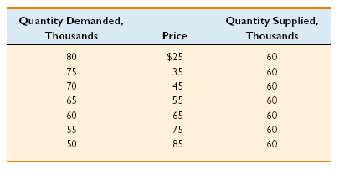
a. If this table reflects the supply of and demand for tickets to a particular World Cup soccer game, what is the stadium capacity?
b. If the preset ticket price is $45, would we expect to see a secondary market for tickets? Explain why or why not. Would the price of a ticket in the secondary market be higher than, the same as, or lower than the price in the primary (original) market?
c. Suppose for some other World Cup game the quantities of tickets demanded are 20,000 lower at each ticket price than shown in the table. If the ticket price remains $45, would the event be a sell-out? Explain why or why not.
8. Advanced Analysis Most scalping laws make it illegal to sell—but not to buy—tickets at prices above those printed on the tickets. Assuming that is the case, use supply and demand analysis to explain why the equilibrium ticket price in an illegal secondary market tends to be higher than in a legal secondary market.
9. Why are there legal daily “limits” on the number of fish that can be caught in the nation’s public waters whereas there are no such limits on the number of fish that can be bought at a fish market or grocery store?
10. Distinguish between the terms “maximum willingness to pay” and “minimum acceptable price.” How do they relate, respectively, to consumer and producer surplus?
11. “Freely made exchanges in competitive markets benefit both buyers and sellers.” Use the concepts of consumer surplus and producer surplus to verify this statement.
12. Draw a supply and demand graph and identify the areas of consumer surplus and producer surplus. Given the demand curve, what impact will an increase in supply have on the amount of consumer surplus shown in your diagram? Explain why.
13. Refer to Table 3W.1. If the six people listed in the table are the only consumers in the market and the equilibrium price is $11 (not the $8 shown), how much consumer surplus will the market generate?
14. Refer to Table 3W.2. If the six people listed in the table are the only producers in the market and the equilibrium price is $6 (not the $8 shown), how much producer surplus will the market generate?
15. Use the ideas of marginal benefit and marginal cost and the ideas of consumer surplus and producer surplus to explain why economists say competitive markets are efficient. Why are below- or above-equilibrium levels of output inefficient, according to these two sets of ideas?
16. (Last Word) How does a generic drug differ from its brand-name, previously patented equivalent? Explain why the price of a brand-name drug typically declines when an equivalent generic drug becomes available? Explain how that drop in price affects consumer surplus and allocative efficiency.

Internet Application Question
1. Gasoline prices—how high (or low) now? Go to the website of the Gasticker.com, www.garnetknight.com/gas/ and follow the links to find the current retail price of gasoline in your area. How does the current price of regular gasoline compare with the price in the past? What must have happened to either supply, demand, or both to explain the observed price change?

