Benetton Group:
Evolution of Communication Strategy

This case was written by Senthil Ganesan with the help of Vamsi Krihna Thota, ICRAI Knowledge Center. It is intended to be used as the basis for class discussion rather than to illustrate either effective or ineffective handling of a management situation.

The case was compiled from published sources.

______________________________________________________________________________
© 2003, ICFAI Knowledge Center, Hyderabad, India

The purpose of advertising is not to sell more. It’s to do with institutional publicity, whose aim is to communicate the company's values (...) We need to convey a single strong image, which can be shared anywhere in the world.
- Luciano Benetton, Founder and Chairman1

When Life magazine makes a cover about war, it makes the cover to inform, but also to sell the magazine and to sell the advertising pages inside the magazine -- Chivas Regal and all the others. So Time magazine and all the others make a cover to inform and to sell. To do what I do, I do that to sell but also to inform. And as soon as you inform, people point a finger at you and say, "You are exploiting!" No. It's the people who don't even inform [who are exploiting]. I don't care about the rejection; I'm not afraid to be rejected. Actually, it's a big honor in this world

- Oliviero Toscani, Benetton Creative Director and Photographer (1982 – 2000)2

Benetton Group*: Evolution of Communication Strategy

Introduction

Benetton, the Italian retailer was engaged in the manufacturing and distribution of clothing, undergarments, shoes, cosmetics and accessories. Benetton also licensed its brand name to various manufacturers of sunglasses, stationery, cosmetics, linens, watches, toys, steering wheels, golf equipment, designer condoms and luggage. The group’s important brands included United Colors of Benetton (UCB), Sisley, PlayLife and Killer Loop. During fiscal 2002, Benetton reported revenues of €1.99 billion and net income of €128 million. Benetton spent €102 million on advertising and promotion during the year (see Exhibit I for revenue split-up and Exhibit II for financial highlights). In addition to retail outlets around the world, Benetton also operated megastores (3000 square foot stores) in such cities as Paris, Rome, Kobe, Osaka, New York, London, Moscow and Lisbon. As of 2002, the company operated in about 120 countries through its 5000 retail stores and employed about 7250 people.

Benetton was well known for its colorful and provocative advertisements (Benetton termed its advertising and marketing activities as Communication Strategy). The company employed unusual, controversial advertising techniques and themes that used “shock value” and the power of photography to grab viewers’ attention. Unlike most advertisements which centered around a company’s product or image, Benetton’s advertising campaigns focused on social and political issues like racial integration, AIDS awareness, war, poverty, child labor, death, pollution etc. The advertisements initially succeeded in raising the brand's profile, but eventually began to cause dissatisfaction among customers, retailers, government bodies and various international non-profit organizations.

Some of Benetton’s most memorable advertisements were a priest and a nun kissing, a just born baby with uncut umbilical cord, a black stallion and a white mare mating, a colorful mix of condoms, a black woman breast- feeding a white baby, the photo of an AIDS victim and his family taken moments before his death, the bloody uniform of a dead Bosnian soldier (See Exhibit: II for Benetton’s advertisements).

Following the controversy surrounding a particularly provocative campaign called “We, On Death Row,” Oliviero Toscani, Benetton’s Creative Director and Photographer, resigned from the company in May 2000. Benetton realized that it had crossed even the boundaries of unconventional advertising. Various surveys suggested that some loyal customers had been put off by this campaign. One industry expert commented about Toscani3:
“He has left a famous brand badly besmirched. Many of the things done in that name have encountered a great deal of public resentment, hostility and boycott. It can be overcome, but not easily.”

Following Toscani’s departure, 28-year-old Fabrica (Benetton’s Communication department) student James Mollison took over as Benetton’s Creative Director. Under Mollison, it seemed Benetton was reverting to a more traditional advertising strategy.

Background Note

The Benetton family (consisting of three brothers and a sister) established the Benetton chain in a small Italian town in 1955. To support his family, Luciano Benetton (born in 1935), dropped out of school to sell apparel. His sister Guiliana (b.1937) worked as a knitter in a local factory. Recognizing the potential for a new business, Luciano and Guiliana decided to start their own apparel company. With thirty thousand lire, Guiliana bought a knitting machine and put together a collection of 18 brightly colored sweaters. These sweaters were immediately sold to the local stores. As the business grew, the remaining two brothers joined the company. Each of the four siblings took responsibility for one aspect of the business. Luciano concentrated on marketing. Guiliana directed the design department. Gilberto (b.1941) handled administration and finance. Carlo (b.1943) managed production. Benetton was formally incorporated in 1965 as “Maglificio di Ponzano Veneto dei Fratelli Benetton.”

The Benetton family initially sold their apparel through leading Italian department stores. But as the business picked up, the company entered into an agreement to open an exclusive store for marketing the apparel. The first store, opened in 1969, was an immediate success. Shortly thereafter, Benetton opened a similar store in Paris. Unlike most small producers, who opted for the widest possible distribution, the Benetton family decided to create a network of exclusive distributors, and used sub-contractors. By 1975, Benetton had become a major player in Italy with about 200 shops (not all of them carrying the Benetton name). To appeal to different segments of population, Benetton opened stores under different brand names, which included Sisley, Tomato, Merceria and 012. Over a period of time, these brand names were rolled into the Benetton name.

During the late 1960s and the early 1970s, Benetton rapidly expanded by setting retail outlets in France, West Germany, Britain, Switzerland, and the Scandinavian countries. By the mid- 1980s, the chain had built a significant presence in the major US cities and in Japan. Benetton’s popularity grew with a impressive list of clientele- Princess Caroline of Monaco and Princess Diana of Wales. In addition to setting up retail outlets across the world, Benetton also set up manufacturing facilities in France, Scotland, Spain and the US. In 1986, Benetton went public by offering 15.6 million common shares (10% of the company). Employees were also offered shares.

During the 1990s, Benetton went on an acquisition spree and purchased companies such as Rollerblade (inline skates), Prince Tennis (racquets), Nordica ski boots, Nordica skis (originally Kästle), racquetball-racquet maker Ektelon and snowboard brand Killer Loop. However, these brands performed poorly and Benetton decided to divest all of them. In January 2003, Benetton sold Nordica to skiwear firm Tecnica for €38 million. Two months later, Benetton announced that it would also sell Rollerblade to Tecnica for around €20 million. Benetton also reached an agreement with Lincolnshire Management Inc., a US private equity fund for the sale of Prince and Ektelon brands for about €36.5 million.

In 1994, Benetton set up Fabrica, a communications research center. Fabrica (from the latin word meaning workshop) concentrated on communication projects ranging from cinema to graphics, from industrial design to music, from publishing to new media to photography. The research center housed several film, video and music labs, art, photo and design studios. Luciano described Fabrica as: “a bridge between a visionary dream: between utopia and the reality a world facing changes that would have been unimaginable only a few years ago.” Fabrica invited students from different countries, with creative talents, offering them year- long fellowships. Among Fabrica’s successful projects were the film “Blackboards,” which won a special award at the Cannes Film Festival in 2000, the film “Dayereh,” which won a Golden Lion at the Venice Film Festival in 2000 and the film “No Man’s Land, co-produced by Fabrica, which won the Oscar for the Best Foreign Film in 2002.

Exhibit: I

Benetton: Geographic revenue distribution by business segment
Business Sectors /Geographic Area | Euro | The Americas | Asia | Other Areas | 9 Months 2002 | 9 Months 2001
Casual Wear | 849.9 | 66.2 | 109.2 | 144.6 | 1169.9 | 1162.1
Sportswear and Equipment | 75.5 | 85.0 | 20.6 | 21.1 | 202.2 | 245.8
Manufacturing and Others | 69.1 | 0.8 | 2.3 | 17.0 | 89.2 | 110.2
Total 9 months- 2002 | 994.5 | 152 | 132.1 | 182.7 | 1461.3 | 1518.1
Total 9 months- 2001 | 1033 | 164.8 | 143.8 | 175.8 | 1518.1
*Figures in € Million
**Business Sectors are as follows:
- Casual Wear, representing the Benetton brands (United Colors of Benetton, Undercolors and Sisley)
- Sportswear and Equipment: Playlife, Nordica, Prince, Rollerblade and Killer Loop brands.
- Manufacturing and Others: Sales of raw materials, semi-finished products, industrial services and revenues and expenses from real estate activity.

Source: www.benetton.com

Exhibit: II

Benetton: Eight-Year Financial Highlights
Year | 2002 | 2001 | 2000 | 1999 | 1998 | 1997 | 1996
Revenues (million euro) | 1992 | 2098 | 2018 | 1982 | 1980 | 1878 | 1483
Net Income (million euro) | 128 | 163 | 174 | 166 | 151 | 150 | 127
Source: www.benetton.com

Communication Strategy

From the early 1980s, Benetton believed in pursuing an unconventional communication strategy. As one company document put it4:

“Benetton believes that it is important for companies to take a stance in the real world instead of using their advertising budget to perpetuate the myth that they can make consumers happy through the mere purchase of their product. The company has opted for a communication strategy in which issues and not clothes, play the lead part. The company has decided to devote some of its advertising budget to communicate on themes relevant to young and old people worldwide.”

Until the 1980s, Benetton advertisements had largely focused on its products and logo (stylized knot of yarn with word Benetton printed under it, contained within a dark green rectangle). In 1982, Luciano hired Oliviero Toscani, a prominent fashion and advertisements photographer to head Benetton’s advertising department. Toscani’s initial advertisements were conventional. They showed groups of young people wearing Benetton clothing. But Luciano and Toscani soon realized that Benetton advertisements had to stand apart from the rest of the competition. They decided to promote Benetton as a life style brand.

Toscani’s first theme featured teenagers and kids from culturally diverse nations. Colorfully dressed in Benetton attire, the kids engaged in a variety of playful acts (see figure: (i)). By linking the varying colors in the Benetton collection to the diverse “colors” of its world customers, Toscani portrayed a picture of racial harmony and world peace. It was from these advertisements that the trademark “United Colors of Benetton” emerged.
Figure (i)
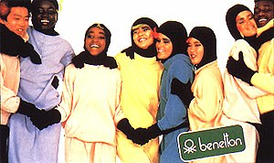

Source: www.benetton.com

In 1984, Benetton launched a similar campaign titled “All the colors in the World,” showing groups of teenagers and kids from different countries and ethnic groups dressed in Benetton clothing, with the company logo in the corner. While the company received several letters of praise for company’s message on racial integration, it evoked negative sentiments especially in South Africa, England and the US.

In 1985, Benetton’s advertisements included two black boys kissing each other (see figure: (ii)), with little US and USSR flags in their hair and painted on their cheeks with the tagline “United Colors of Benetton.” In 1986, the two little black boys appeared again, united by a globe and a chain with the peace symbol. The globe became a symbol of unification, and appeared on all the posters that year. Themed advertisements were launched for countries engaged in political battles with each other: England and Argentina, Israel and Germany, Iran and Iraq, Israelis and Arabs, etc. The message read: “All colors are equal, just as all men are equal.”

Figure (ii)
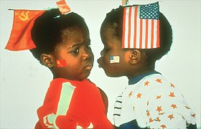
Source: www.benetton.com

In 1988, Benetton started blending culture and legends. New advertisements featured Adam and Eve, Joan of Arc and Marilyn Monroe (see figure: (iii)), Leonardo de Vinci and Julius Caesar, all captioned with the slogan: “United Superstars of Benetton.” Similar campaigns featured animals- a wolf and a lamb (see figure: (iv)) with the tagline: “United Friends of Benetton.”

Figure (iii)
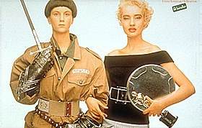

Source: www.benetton.com

Figure (iv)
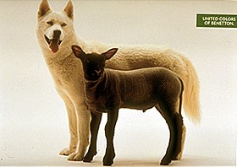
Source: www.benetton.com
In 1989, Benetton decided to cancel its agreement with outside advertising agencies and develop campaigns in house. Toscani’s photos were discussed by the advertising team and then shown to Luciano for final approval. With less than ten people managing the entire process, Benetton could produce advertisements, at about one-third the cost of its competitors.

Since Benetton’s clothing was sold in various markets with different style preferences, Toscani turned his focus to photos that stimulated thinking. His new advertisements neither showed the products nor the logo. The knot logo was replaced with a small green rectangle with the tagline “United Colors of Benetton.” Luciano explained this decision5:

“Using these images in this unconventional way is an effort by Benetton to break through the complacency that exists in our society due to the constant flow of even the most horrendous realities communicated through conventional media such as the evening news or the morning paper. By removing these images from their familiar contexts and putting them in a new context they are more likely to be noticed and given the attention they deserve as the viewer becomes involved in the process of answering the questions: What does this image mean? Why does this image appear with a Benetton logo? How do I feel about the subject of the image? What can I do?”

Famous advertisements during the late 1980s included a black hand and a white hand linked by a handcuff and a black woman breast-feeding a white baby. The black woman- white baby advertisement was severely criticized by many who thought that Benetton was reminding blacks of the days of slavery when black women breast-fed white babies. However, Benetton maintained that such photos symbolized universal brotherhood. Other advertisements with a similar message included a white wolf and a black sheep nose to nose, a black child sleeping among a pile of white teddy-bears, a little black hand on a big white hand, a piano duo showing little white hands being helped by big black hands, two children (one black, the other white) facing each other sitting on their potties (see figure: (v)), tubes of personality tests, miners and bakers united by the black of the soot or coal and the white of the flour.

Figure (v)

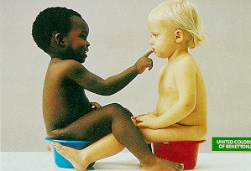
Source: www.benetton.com

In 1991, Toscani introduced a number of advertisements that attempted to draw public attention to important social problems. The advertisements included a cemetery (signifying war deaths), many different brightly colored condoms and a baby with an umbilical cord (see figure: (vi)). One advertisement featuring a priest and nun kissing offended the religious sentiments of many, including the Pope. The image of the baby with the umbilical cord evoked mixed responses. In the company’s view, the advertisement simply conveyed the beauty of new life and the universal idea of love. The photo triggered off a huge controversy throughout Europe. Many wanted it to be banned. But some liked it. For example, the image was exhibited in a Flemish museum as part of a show celebrating the images of motherhood.

Figure (vi)


Source: www.benetton.com

In 1992, Toscani introduced political themes in Benetton’s advertisements. He selected various photojournalistic images related to the AIDS crisis, environmental disaster, political violence, war, exile, etc. These appeared in various journals and magazines as well as on billboards without written text except for the conspicuous insertion of the green and white Benetton logo. Toscani explained the company’s strategy6:

“Unlike traditional adverts, our images usually have no copy and no product, only our logo. They do not show you a fictitious reality in which you will be irresistible if you make use of our products. They do not tell anyone to buy our clothes, they do not even imply it. All they attempt to do is promote a discussion about issues which people would normally glide over if they approached them from other channels, issues we feel should be more widely discussed.”

In spite of the controversy his advertisements had generated, Toscani went one step further by embracing “reality advertising.” Advertisements included: a dying AIDS victim with his family at his bedside, an African guerrilla holding a Kalashnikov and a human leg bone (see figure: (vii)), a boat overcrowded with Albanians, a group of African refugees, a car in flames after a Mafia bombing, a family weeping before the bloodied corpse of a Mafioso and two Indians caught in a flood in Calcutta.

Figure (vii)
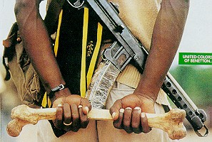
Source: www.benetton.com

Benetton also launched an advertisement with a series of masculine and feminine genitals, of different ages and of different colors with the label “United Colors of Benetton.” A more shocking advertisement showed close-ups of various parts of the human body (pubis, arms, stomach, bottom) tattooed with the English abbreviation “HIV Positive.” The tattoo mark was similar to the numbers tattooed by Nazis on concentration camp prisoners. Some advertisements also promoted homosexuality: two smiling men cheek to cheek, two women- one white and the other black, holding an Asian baby, wrapped in the same blanket, etc. Other controversial advertisements included a black stallion mounting a white mare, three identical human hearts, with stickers announcing different ethnic groups “white, black, yellow” (see figure: (viii)). The hearts portrayed that all were same inside, no matter what the outside skin color was.

Figure (viii)
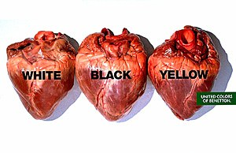

Source: www.benetton.com

In January 2000, Benetton launched a year- long $15 million global advertising campaign called “We, on Death Row.” This campaign, which featured 26 US prisoners who had been sentenced to death (see figure: (ix)) appeared on billboards and in major publications in Europe, America and Asia and on its website. Toscani developed the campaign after spending more than two years visiting death row prisoners in several American prisons.

The advertisements featured full color faces of death-row inmates, printing their names and dates of execution. A special booklet and video was also released that projected the reality and futility of capital punishment. The booklet included photos of the inmates and interviews about their life and the punishment. The booklet also contained carefully selected quotes from the Dalai Lama and the Pope, challenging the right of the state to execute its citizens. Benetton believed that if the public saw these inmates as “people,” then they would be less inclined to see them executed.

Figure (ix)
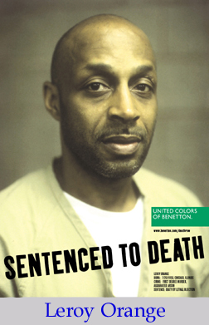

Source: www.benetton.com

The campaign resulted in widespread protests from individuals and governments. The families of the victims and prisoners objected strongly to the campaign and accused Benetton of glamorizing murderers while ignoring the crimes they had committed. Many resented that the campaigns did not mention how the prisoners felt about the serious crimes they had committed. One website called Pro-death penalty.com wrote7:

“While Benetton tries to improve their market share in the US, they are causing unnecessary pain and distress to the families of the innocent people killed by the men the campaign intends to humanize.”

Responding to such allegations, Mark Major, Director of Communications for Benetton US in New York defended the campaign8:

“We don’t develop contrived marketing campaigns that are merely designed to sell products. When we talk about death row or AIDS or war or peace, it’s not a contrived topic. It’s definitely something that people at Benetton feel very strongly about. We don’t apologize for the fact that dual purposes can be achieved. We can raise brand awareness that we are a company that cares about capital punishment and we can get people engaged in the topic.”

The state of Missouri (US) where the inmates in question were imprisoned filed a suit against Benetton, arguing that it had been misled regarding the use of the photos. This lawsuit was settled in June 2001 when Benetton agreed to write letters of apology to the four Missouri families whose relatives were murdered by the inmates featured in the ads and to donate $50,000 to the Missouri Crime Victims Compensation Fund. In the US, retailer Sears canceled an exclusive $100 million contract to sell a line of Benetton clothes, calling the death row images “terribly insensitive.” Sears ended its contract even after Benetton agreed to allow the retailer to preview future ads. Toscani had hoped that this campaign would have a positive impact in the US where about 98 inmates had been executed in 1999. Toscani believed that the sharp criticism in the US was not justified as Europe had more or less banned the death penalty. But, due to the increasing furor, Toscani resigned in May 2000.

In September 2001, Benetton launched a campaign called International Year of Volunteers (see figure: (x)), in collaboration with the United Nations (UN). “Volunteers” was Benetton’s first campaign after Toscani’s exit and was developed by new Creative Director James Mollison. The campaign emphasized that devoting one’s time and energy to others led the way to self-improvement and a better quality of life. A special issue of Colors Magazine was published for the campaign, devoted entirely to voluntary effort. Collaboration with the UN was an ongoing effort for Benetton. The company and the UN first worked together in 1996 for the World Food Summit organized by the FAO (Food and Agriculture Organization of the UN) to discuss the problem of hunger in developing countries. The following year Benetton and the UN came together again for a worldwide campaign celebrating the 50th anniversary of the Declaration of Human Rights. In 1999, Benetton organized a fund raising campaign for Kosovo with the collaboration of UNHCR (United Nations High Commission for Refugees). Such campaigns were shown throughout the world in newspapers, weekly magazines, women’s and lifestyle magazines and also on billboards located in major cities.

Figure (x)
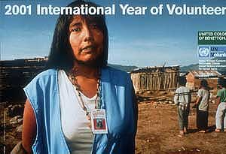

Source: www.benetton.com

Other campaigns following Toscani’s exit suggested that Benetton was changing its communication strategy. The company started showcasing advertisements featuring exuberant models frolicking in colorful knitwear against a white background (see figure: (xi)). The models used in the campaign were not professionals. One model was a poet who performed at local coffee houses. Others were discovered on the street in bars or riding the subway. Developed with a budget of $10 million dollars, this campaign was available in print, catalog and TV media.

Figure (xi)
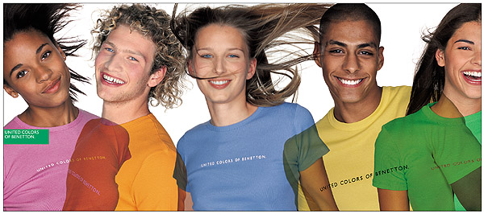
Source: www.benetton.com

An important aspect of Benetton’s communication strategy was its Colors magazine. Launched in 1991, Colors targeted young people across the world. The magazine was launched in four bilingual languages: English-Italian, English-German, English-Spanish and English-French, in an attempt to break the barriers of language and culture throughout the world. By 2002, the magazine was sold in eighty countries. Each edition of the magazine took an issue- war, religion, race, birth, immigration, ecology, travel, slavery, (see figure: (xii)), etc. “The Race Issue”, which featured a computer-generated picture of the Queen, changing her race to Indian, created a huge furor in the English press, but brought Benetton massive publicity. Over the years, the magazine had featured more than 5000 models, including Wodaabe warriors in Nigeria, Colombian soldiers, boy scouts in Oman, etc. In May 2003, Benetton launched the 56th volume of Colors, which featured “Violence” as the central issue.

Figure (xii)
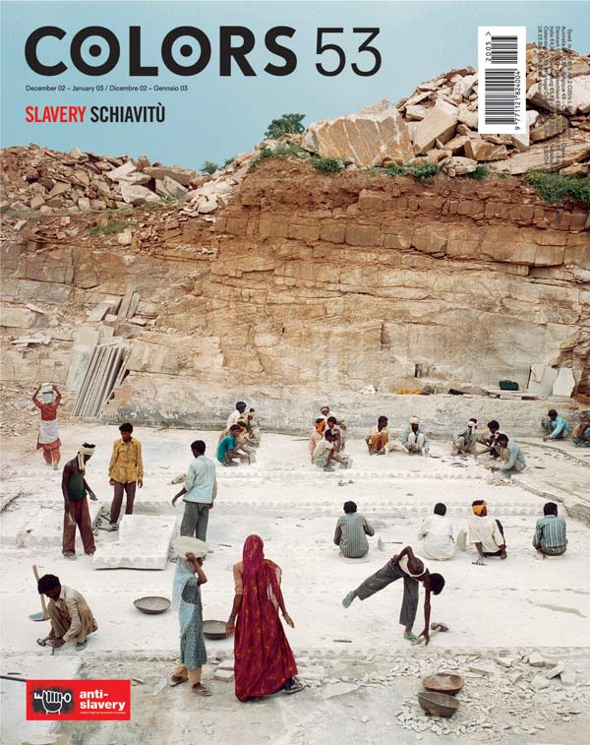

Source: www.benetton.com

Apart from advertisements for billboards and magazines, Benetton also created a number of catalogs titled “People and Places.” Catalog themes included Young People in Tokyo, Ponzano (Italy), Corleone (Italy), China, India, etc. Another theme was Sunflowers, which featured children suffering from Down’s Syndrome (a disease caused by chromosomal abnormalities). In 1998, Benetton used images of Arabs and Jews living and working together in Israel. Titled “Enemies,” the cover showed a 24-year-old Israeli student kissing her 22-year-old Bedouin boyfriend. The catalog included photos of an Arab grocer and a Jewish customer, Jewish and Arab youth leaders, a mixed kindergarten of Jewish and Arab kids (see figure: (xiii)) and a music band consisting of Jews and Arabs.

Figure (xiii)
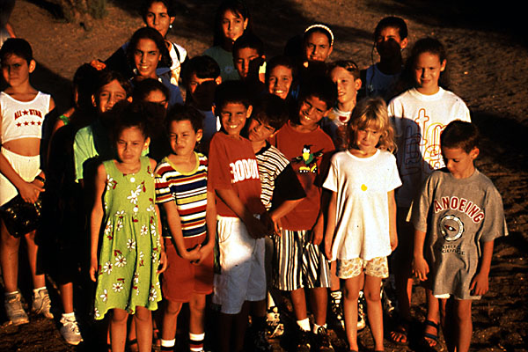

Source: www.benetton.com

Over the years, many newspapers in various countries had refused to accept Benetton advertisements. In 1995, government authorities in Germany banned some Benetton advertisements, which featured child labor, the human body stamped “HIV Positive,” and a bird stuck in an oil slick. The advertisement featuring the newborn baby with the uncut umbilical cord was withdrawn from the media in Italy, France and the UK. The photo showing a priest and a nun kissing was promptly banned by the Italian Advertising Authority (The Vatican took a stern view but in England, this advertisement won the Eurobest Award). Benetton was also sued by many retail outlets, which believed the provocative advertisements drove away customers. But the more the company’s advertisements were banned, the more publicity Benetton seemed to get.

Oliviero Toscani’s Advertising Philosophy

Toscani believed that the industry as a whole had to change the way advertisements were used as consumer-spending patterns had changed over the years. He emphasized the need for creativity9:

“To capture their (consumer’s) attention, advertising must become an artistic product in itself, like a play or a film. That has never happened because the only things that condition the industry are money and marketing managers, who are idiots. All they know how to do is repeat what’s already been done.”

Toscani explained his role in Benetton10:

“Nobody ever told me my job was to sell anything. I’m responsible for the company’s communications; I’m not responsible for its economics. Mr. Benetton has given me incredible freedom to propose issues that should be communicated. To be really contemporary, an up-to-date company, we must take our communication in another direction. Not the one usually followed by most companies, in the apparel business, at least- when there’s an obvious connection between product, model and merchandising. I’m aware that, having a relatively big budget, it would be like throwing money away if we only explained that our product is better than the competition’s. Advertising should give something more... That’s my work, to report something that exists. We can’t be like ostriches who put their head in the sand.”

Toscani saw himself not as an advertiser, but as a reporter-photographer. He believed in communicating to the world in a less traditional way. Toscani identified a number of drawbacks in traditional advertising11:

“There is a crisis in advertising. The industry is lagging behind social trends, but it’s so rich and powerful that it’s very difficult for it to change. In the early twentieth century advertising focused on a company’s buildings and machines. After that it started presenting products. Then, since all products started looking alike, they could no longer be at the heart of the message. So in the 1960s advertisers started showing leggy models to sell cars. The long legs offered added value. The product took a back seat and what was sold was a symbol. The problem with this technique is that the message is always based on consumers’ shortcomings and makes them feel guilty. It tells them, ‘if you haven’t got this product, you’re out of it. On the other hand, if you buy a certain brand of sports shoes you can play like Ronaldo even if you can’t kick a ball.”

Due to his radical campaigns, many people in the advertising industry hated Toscani. But Toscani believed he had achieved his objective. Since he had joined Benetton, the company’s sales had grown more than twenty times. As he once remarked12:

“Most good ads are forgotten after six months, but who still remembers the Benetton ad with the priest kissing the nun? Ten years later and people remember! That’s immortality!”

Looking Ahead
One leading business school publication summarized Benetton’s advertisements13:
“They seem to take the virtuous stand for the betterment of humanity and thus create a sense of power in the viewer who agrees with the safe, politically correct message, even if the message is made with shocking images. By empowering the viewer, the consumer, the company associates itself with engineered feelings of empowerment and righteousness. Through the use of such images Benetton as a company has become an icon for this kind of protest in advertising which tries to claim the ability for social change. In reality Benetton creates an empowered viewer who will buy their product through shock value, empowerment, and memorability.”
Following Toscani’s exit, Benetton announced it would revert to a more conventional advertising strategy. The company’s website highlighted its advertising strategy for the future:
“We need to have models wearing our clothes by UCB in our advertisements. We need to show consumers that we are an actual clothing line, and not a political or governmental company. By picturing our stylish clothes, we will attract more business. Consumers want to buy our clothes because they are attractive and have a high quality reputation. People who respect our clothing line are the only ones that actually buy it, despite the political issues that we represent. If we can undo the damage that we have already caused in the minds of many consumers by ceasing to offend them, our sales will greatly increase. Let’s show the world that we make great clothing, not that we have controversial opinions on various subjects.”
From 2001, Benetton’s advertisements started featuring conventional images- teenagers in colorful Benetton clothing. Benetton, however, maintained that the company would still continue with its “socially responsible” status by focusing on non-controversial themes like racial discrimination, poverty, child labor, AIDS awareness, etc. To that effect, in early 2003, Benetton in association with UN’s World Food Programme, launched a year- long $16 million communication campaign, called Food for Life. This campaign covered around 30 countries and the stories and photos taken from these countries were used in Colors, under the title “Hunger.” The images in this campaign showed crisis and poverty.
When questioned about Benetton’s new strategy of using models and products to advertise, Toscani just commented: “It’s a waste of money.” However, he was supportive of the company’s decision not to move away from highlighting social causes. As 2003 got underway, Benetton management, advertising gurus and customers alike wondered the impact the new philosophy of product- based advertisements would have on Benetton’s brand building efforts and sales.

Exhibit: II
Benetton’s famous advertisements
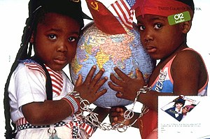
Picture 1
Globe Campaign (1986)
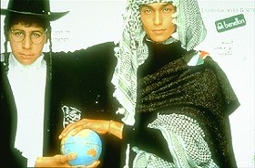
Picture 2
Israeli and Arab (1987)

Picture 4
Black and White Hand (1990)
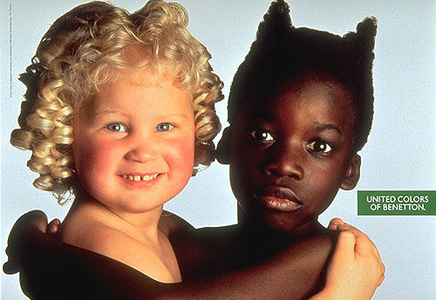
Picture 5
An angelic-looking white child embracing a black one whose hair shaped into devil's horns created a lot of consternation among Black groups in the US (1991)
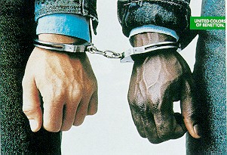
Picture 3
A black hand and a white hand linked by handcuff (1989)
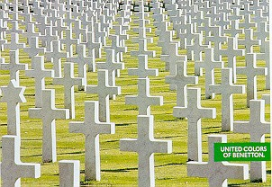
Picture 6
War Cemetery (1991)

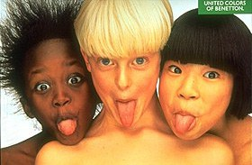
Picture 7
Tongues (1991). In the Middle East, this image was considered pornographic.
Picture 8
Girl with Doll (1992)

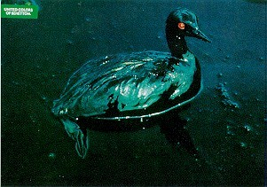
Picture 9
A bird stuck in an oil slick (1992)

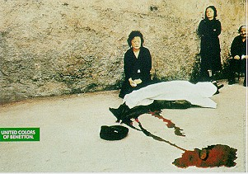
Picture 10
Killing in Kosovo (1992)

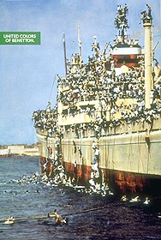
Picture 11
A boat overcrowded with Albanians (1992)
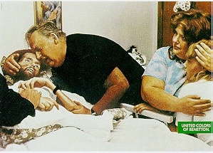
Picture 12
A man (David Kirby) dying of AIDS surrounded by his family members (1992)

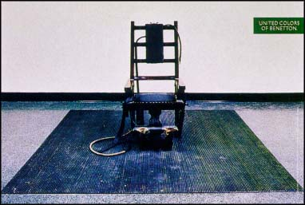
Picture 13
An empty electric chair for execution (1992)
Picture 14
Bosnia Soldier (1994)

Picture 17
Food for Peace (2003). Morno, 60, and Rose, 22 fought on opposite sides of the Civil war in Sierra Leone Food aid encouraged the disarmament process and they and other ex- combatants, now receive rations while retraining as tailors.

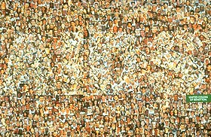
Picture 15
Faces of AIDS (1994)

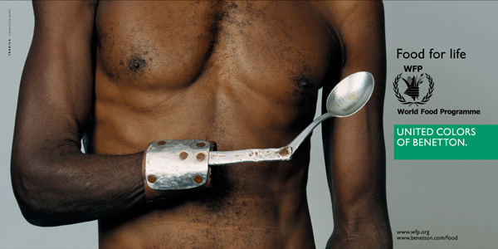
Picture 16
Food for Life (2003)
Picture 18
Food For Work (2003). Bagmina, 15, is now free to find work in Kabul, Food aid supports her while she looks for a job.

Source: www.benetton.com

Bibliography

Magazines/Journals/Newspapers

- Carlos Jarillo and Jon Martinez, “Benetton S.p.A.,” Harvard Business School Publishing, 19th January 1989.
- Sergio Signorelli and James Heskett, “Benetton (A),” Harvard Business School Publishing, 6th February 1989.
- “Through the lenses of gender and ethnicity,” Maclean’s, 27th May 1991.
- “More controversy, please, we’re Italian,” The Economist, 1st February 1992.
- Gabriele Di Mateo, “The notorious campaign of Luciano Benetton,” Print, November/December 1993.
- Henry Giroux, “Benetton: buying social change,” Business & Society Review (1974), Spring 1994.
- Olivia Snaije, “Benetton’s jarring campaign altered advertising’s landscape,” Christian Science Monitor, 31st May 1995.
- Joshua Levine, “Even when you fail, you learn a lot,” Forbes, 11th March 1996.
- Serra A Tinic, “United Colors and untied meanings: Benetton and the commodification of social issues,” Journal of Communication, Summer 1997.
- Melanie Wells, “Benetton puts fresh face on advertising campaign,” USA Today, 17th June 1997.
- Andy Beckett, “Benetton’s new babies..,” The Guardian, 28th July 1997.
- Tim Rich, “Toscani and his critics,” Print, March/April 1998.
- “The United Colors of..,” Middle East, April 1998.
- John O’Reilly, “Advertising or exploitation,” The Guardian, 21st September 1998.
- Silvia Sansoni, “The odd couple,” Forbes, 19th October 1998.
- Sophie Boukhari, “The art of advertising,” The Unesco Courier, December 1998.
- Malcolm Clark, “Benetton on death row,” New Statesman, 24th January 2000.
- Hank Stuever, “Radical chic: Benetton takes on the death penalty,” Washington Post, 25th January 2000.
- Ann-Christine Diaz, “A shock to the system,” Advertising Age’s Creativity, February 2000.
- Rance Crain, “Jerry and Oliviero duke it out over what’s vital in advertising,” Advertising Age, 10th April 2000.
- Debra Ollivier, “The colorful dissenter of Benetton,” www.salon.com, 17th April 2000.
- Mercedes Cardona, Alice Cuneo and Eric Lyman, “Benetton ad shift expected in the wake of Toscani exit,” Advertising Age, 8th May 2000.
- Kevin Michael Grace, “Shock-Talk,” Report/Newsmagazine (Alberta Edition), 8th May 2000.
- Peter Gwin, “United colors of the condemned,” Europe, November 2000.
- Andrew Clark, “Interview: Luciano Benetton, Chairman, Benetton,” The Guardian, 16th December 2000.
- John Lloyd, “Come on: look at me,” New Statesman, 29th January 2001.
- Charles Davis, “A killer campaign,” Columbia Journalism Review, Jan/Feb 2001.
- “Benetton’s advertisements acquitted in Germany,” Managing Intellectual Property, February 2001.
- Sandra Dolbow, “Benetton bounces back,” Brandweek, 12th February 2001.
- Leigh Gallagher, “About face,’ Forbes, 19th March 2001.
- Arnaldo Camuffo, Pietro Romano and Andrea Vinelli, “Back to the future: Benetton transforms its global network,” MIT Sloan Management Review, Fall 2001.
- Eric Lyman, “The true colors of Toscani,” Ad Age Global, September 2001.
- Ann-Christine Diaz, “Photography,” Creativity, November 2001.
- “United Colors of Benetton,” Warsaw Business Journal, 25th February 2002.
- Paul Hochman, “The brand killer,” FSB: Fortune Small Business, May 2002.
- Stephen Armstrong, “Altered images,” The Guardian, 27th May 2002.
- Jamie Ivey, “Benetton gambles on colour of the future,” Corporate Finance, June 2002.
- Michele Lee, “Benetton offers internships at design institute,” Media Asia, 1st November 2002.
- Allison Fass, Robert Lenzner and Bernard Condon, “Follow-Through,” Forbes, 3rd February 2003.
- “Arresting images/ Benetton ads take a sober look at world hunger,” San Francisco Chronicle, 8th March 2003.
- Atifa Hargrave-Silk, “Benetton uses ad budget on UN Humanitarian campaign,” Media Asia, 4th April 2003.

Websites
- www.benetton.com
- www.businessweek.com
- www.cnnfn.com
- www.economist.com
- www.fortune.com

1 www.benetton.com
2 Debra Ollivier, “The colorful dissenter of Benetton,” www.salon.com, 17th April 2000 * Benetton Group was controlled by Edizione Holding, a holding company, which owned businesses in garment making, catering (Autogrill), telecommunications (Telecom Italia and Blu), services (Host Marriott Services) and highways (Autostrade). Edizione owned 71% of Benetton Group, while the Benetton family owned 100% of Edizione Holding.
3 Mercedex Cardona, Alice Cuneo and Eric Lyman, “Benetton ad shift expected in the wake of Toscani exit,” Advertising Age, May 8, 2000.
4 www.benetton.com
5 Oliviero Toscani’s Advertising Philosophy, The Center for Interactive Advertising, www.ciadvertising.org.
6 Oliviero Toscani’s Advertising Philosophy, The Center for Interactive Advertising, www.ciadvertising.org.
7 Deborah Feyerick, “Victim’s rights advocates denounce Benetton’s death row ads,” www.cnn.com, January 18, 2000.
8 Evantheia Schibsted, “Shock It to You,” Business 2.0, May 2000.
9 Sophie Boukhari, “The art of advertising,” The Unesco Courier, Paris, December 1998.
10 Oliviero Toscani’s Advertising Philosphy, The Center for Interactive Advertising, www.ciadvertising.org
11 Sophie Boukhari, “The art of advertising,” The Unesco Courier, Paris, December 1998.
12 Eric Lyman, “The True Colors of Toscani,” Ad Age Global, September 2001, Volume 2, Issue 1.
13 http://www.ecit.emory.edu/ (Emory Center for Interactive Teaching)

