Chapter 21

Using the information in Figure 1, answer questions 1–3:

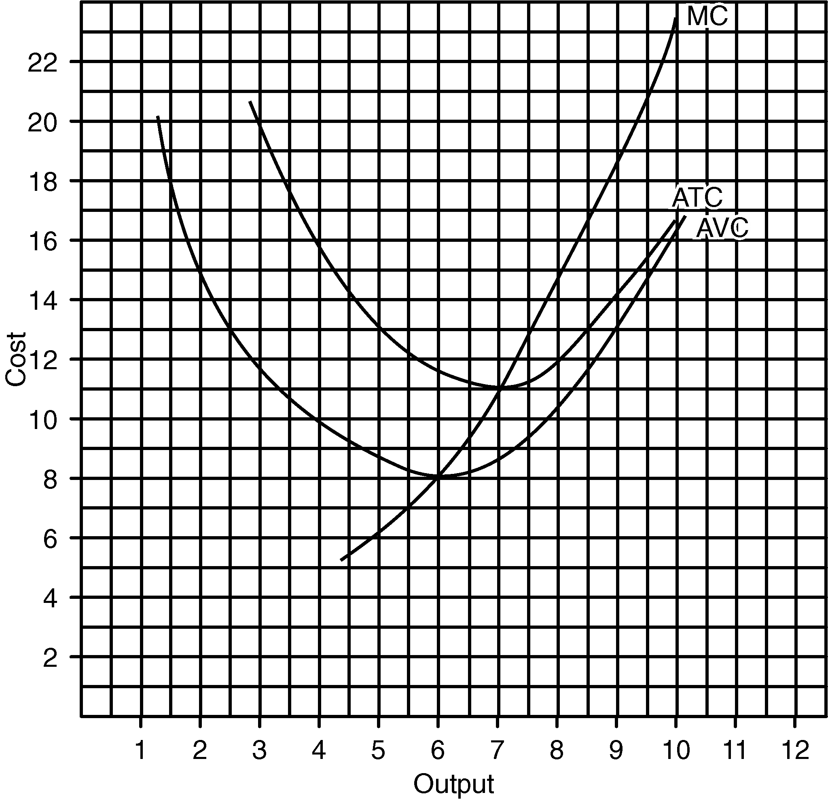
1. What will the firm do in the short run if the price is
(a) $14?
(b) $10?
- $7?

2. What will the firm do in the long run if the price is
(a) $14?
(b) $10?
- $7?

3. What will the firm do in the short run and in the long run if the price is
(a) $13?
(b) $9?
(c) $6?
Using the information in Figure 2, answer questions 4–6:
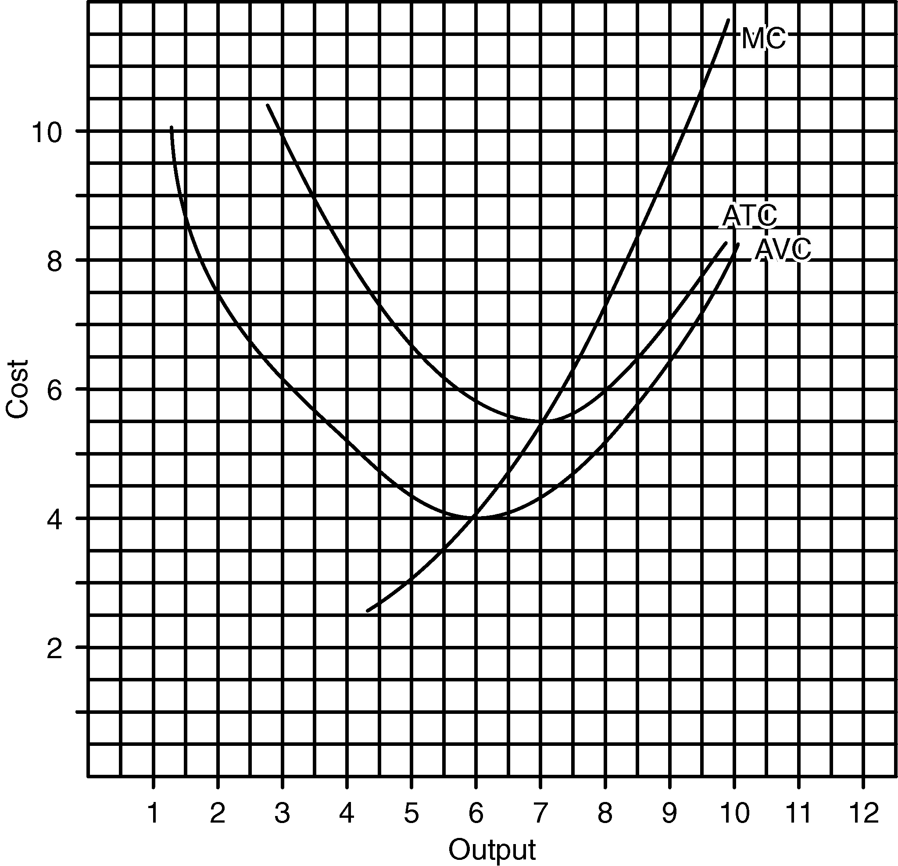
4. What will the firm do in the short run if the price is
(a) $7?
(b) $5?
- $3?

5. What will the firm do in the long run if the price is
(a) $7?
(b) $5?
- $3?

6. What will the firm do in the short run and in the long run if the price is
(a) $8?
(b) $4.50?
- $3.50?

Using the information in Figure 3, answer questions 7–11:
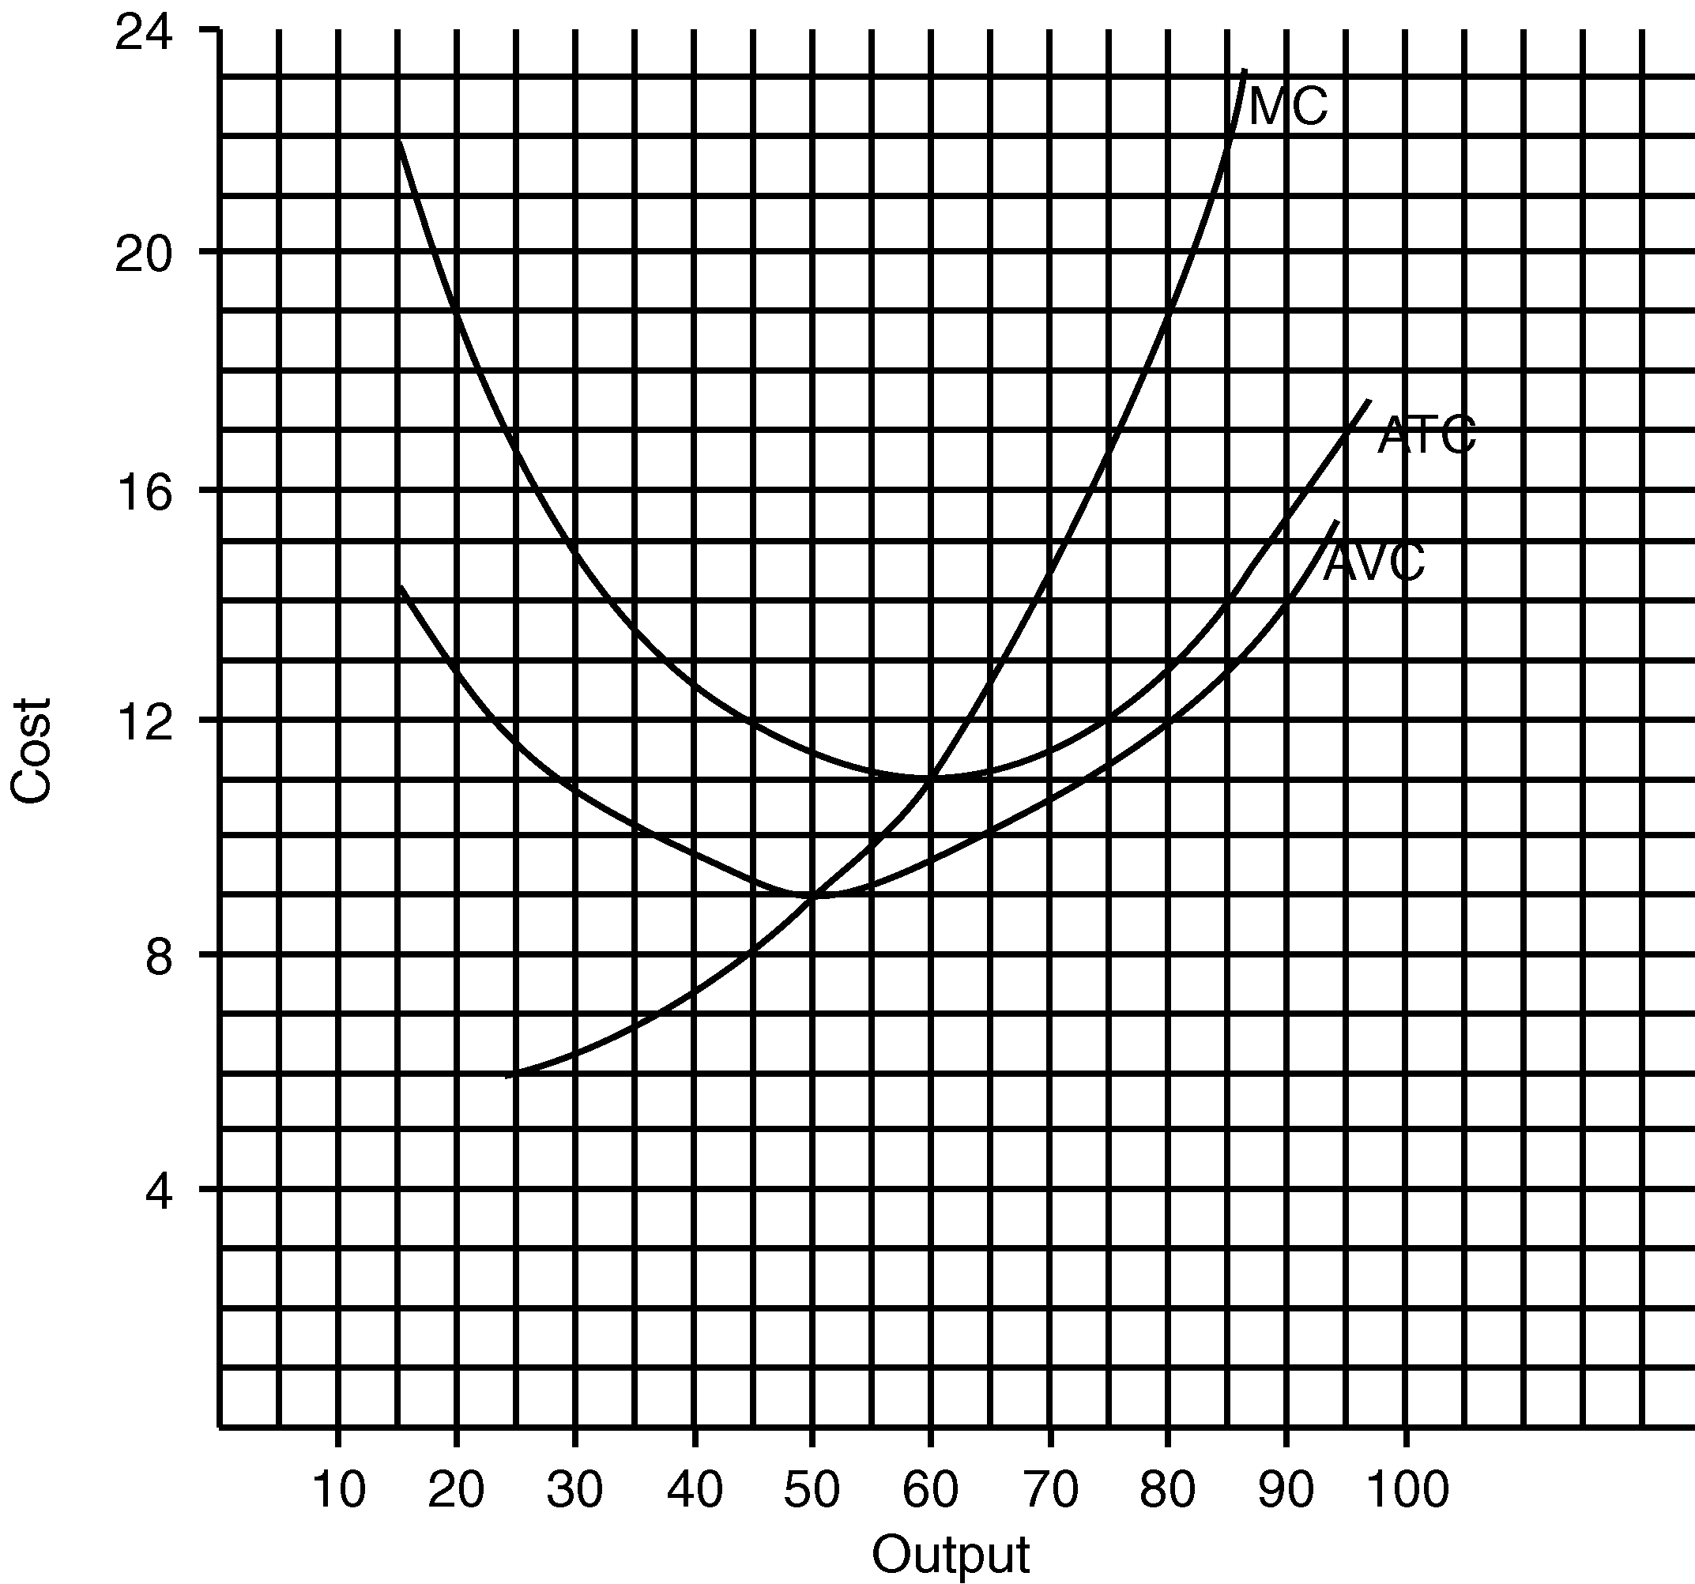
- What is the lowest price the firm would accept in the short run?

8. What is the lowest price the firm would accept in the long run?

9. On Figure 3, label the shut-down and break-even points.

10. On Figure 3, label the short-run and long-run supply curves.

11. Fill in Table 1.

Table 1
If price What would the firm do in the Output in the
were (a) short run? (b) long run? short run
$16
12
10
8

Table 2
If price What would the firm do in the Output in the
were (a) short run? (b) long run? short run
$7 __
6 __
5 __
4 __

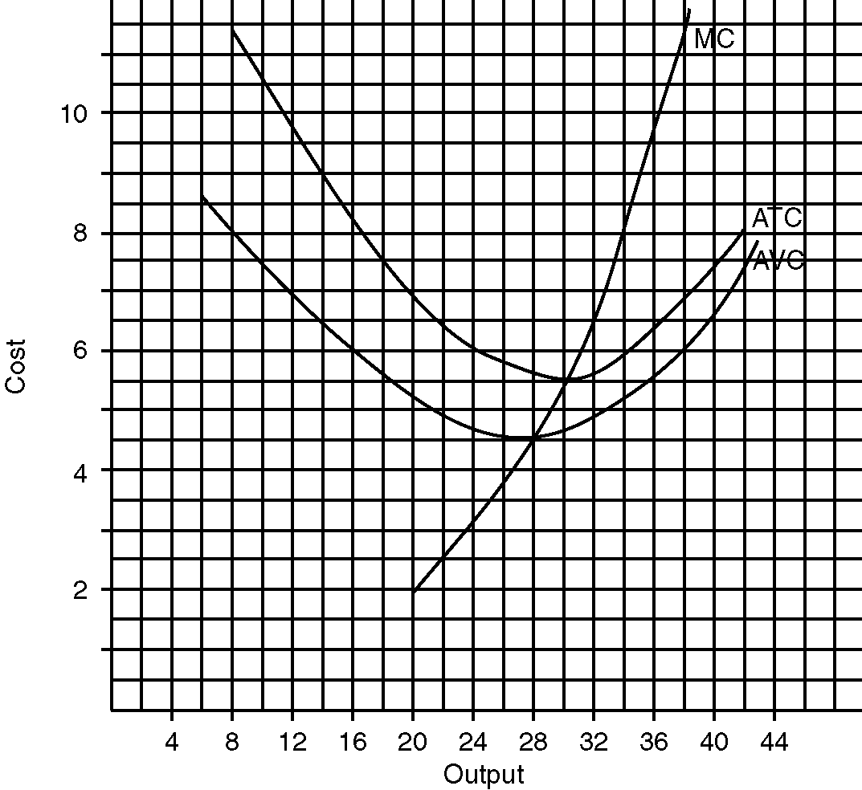
Using the information in Figure 4, answer 12–16:

12. What is the lowest price the firm would accept in the short run?

13. What is the lowest price the firm would accept in the long run?

14. On Figure 4, label the shut-down and break-even points.

15. On Figure 4, label the short-run and long-run supply curves.

16. Fill in Table 2.
17. Answer parts (a)–(e):

Assume fixed cost of $20 and a price of $15.

Table 3
Average Average Average
Variable Total Fixed Variable Total Marginal
Output Cost Cost Cost Cost Cost Cost
1 10
2 15
3 18
4 22
5 28
6 39
7 56

- Fill in Table 3.
- On a piece of graph paper draw the demand, marginal revenue, marginal cost, average variable cost, and average total cost curves. Label the shut-down and break-even points, and the short-run and long-run supply curves.
- Answer each of these questions:
(1) In the short run, the lowest price the firm would accept would be $ _____.
(2) In the long run, the lowest price the firm would accept would be $_____.
(3) The firm's most efficient output is _____.
- The output at which the firm will produce is _____.
- Calculate total profit.
(e) Fill in Table 4.

Table 4

If price What would the firm do in the Output in the
were (a) short run? (b) long run? short run
$4 ____________
8 ____________
10 ____________
11 ____________

18. Answer parts (a)–(e)

Assume fixed costs of $300 and a price of $220.

Table 5
Average Average Average
Variable Total Fixed Variable Total Marginal
Output Cost Cost Cost Cost Cost Cost
1 200
2 350
3 450
4 580
5 760
6 1000
7 1400

- Fill in Table 5.

(b) On a piece of graph paper draw the demand, marginal revenue, marginal cost, average variable cost, and average total cost curves. Label the shut-down and break-even points, and the short-run and long-run supply curves.

- Answer each of these questions:

(1) In the short run, the lowest price the firm would accept would be $_____.
(2) In the long run, the lowest price the firm would accept would be $_____.
(3) The firm's most efficient output is _____.
- The output at which the firm will produce is _____.

(d) Calculate total profit.

(e) Fill in Table 6.

Table 6

If price What would the firm do in the Output in the
Were (a) short run? (b) long run? short run
$250
180
145
130

Table 7

Output Price Total Revenue Marginal Revenue
1 $4
2 4
3 4
4 4
5 4
6 4
7 4

19. (a) Fill in the total revenue and marginal revenue columns of Table 7.

(b) Draw a graph of the firm's demand and marginal revenue curves (actually the same curve) on a piece of graph paper.

