S1. In the garden pea, orange pods (orp) are recessive to green pods (Orp), and sensitivity to pea mosaic virus (mo) is recessive to resistance to the virus (Mo). A plant with orange pods and sensitivity to the virus was crossed to a true-breeding plant with green pods and resistance to the virus. The F1 plants were then testcrossed to plants with orange pods and sensitivity to the virus. The following results were obtained:
160 orange pods, virus sensitive
165 green pods, virus resistant
36 orange pods, virus resistant
39 green pods, virus sensitive
400 total
A. Conduct a chi square analysis to see if these genes are linked.
B. If they are linked, calculate the map distance between the two genes.
Answer:
A. Chi square analysis.
1. Our hypothesis is that the genes are not linked.
2. Calculate the predicted number of offspring based on the hypothesis. The testcross is
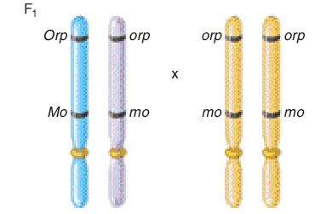
The predicted outcome of this cross under our hypothesis is a 1:1:1:1 ratio of plants with the four possible phenotypes. In other words, 1/4 should have the phenotype orange pods, virus sensitive; 1/4 should have green pods, virus resistant; 1/4 should have orange pods, virus resistant; and 1/4 should have green pods, virus sensitive. Since there were a total of 400 offspring, our hypothesis predicts 100 offspring in each category.
3. Calculate the chi square.
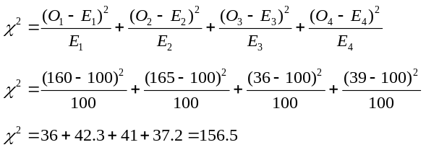
4. Interpret the chi square value. The calculated chi square value is quite large. This indicates that the deviation between observed and expected values is very high. For three degrees of freedom in table 2.1, such a large deviation is expected to occur by chance alone less than 1% of the time. Therefore, we reject the hypothesis that the genes assort independently. As an alternative, we may infer that the two genes are linked.

B. Calculate the map distance.
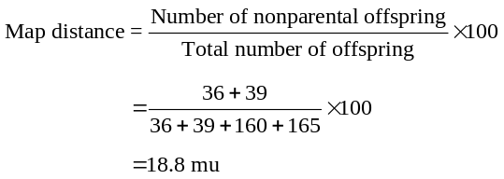
The genes are approximately 18.8 mu apart.
S2. Two recessive disorders in mice, droopy ears and flaky tail, are caused by genes that are located 6 mu apart on chromosome 3.
A true-breeding mouse with normal ears (De) and a flaky tail (ft) was crossed to a true-breeding mouse with droopy ears (de) and a normal tail (Ft). The F1 offspring were then crossed to mice with droopy ears and flaky tails. If this testcross produced 100 offspring, what is the expected outcome?
Answer: The testcross is
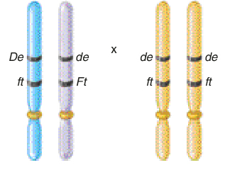
The parental offspring are
Dede ftft normal ears, flaky tail
dede Ftft droopy ears, normal tail
The recombinant offspring are
dede ftft droopy ears, flaky tail
Dede Ftft normal ears, normal tail
Since the two genes are located 6 mu apart on the same chromosome, 6% of the offspring will be recombinants. Therefore, the expected outcome for 100 offspring is
3 droopy ears, flaky tail
3 normal ears, normal tail
47 normal ears, flaky tail
47 droopy ears, normal tail
S3. The following X-linked recessive traits are found in fruit flies: vermilion eyes are recessive to normal (red) eyes, miniature wings are recessive to normal (long) wings, and sable body is recessive to normal (gray) body. A cross was made between wild-type males and females with vermilion eyes, miniature wings, and sable bodies. The heterozygous females from this cross, which had a wild-type phenotype, were then crossed to males with vermilion eyes, miniature wings, and sable bodies. The following outcome was obtained:
Males and Females
1,320 vermilion eyes, miniature wings, sable body
1,346 red eyes, long wings, gray body
102 vermilion eyes, miniature wings, gray body
90 red eyes, long wings, sable body
42 vermilion eyes, long wings, gray body
48 red eyes, miniature wings, sable body
2 vermilion eyes, long wings, sable body
1 red eyes, miniature wings, gray body
A. Calculate the map distance between the three genes.
B. Is positive interference occurring?
Answer:
A. The first step is to determine the order of the three genes. We can do this by evaluating the pattern of inheritance in the double crossovers. The double crossover group occurs with the lowest frequency. Thus, the double crossovers are vermilion eyes, long wings, sable body and red eyes, miniature wings, gray body. Compared to the parental combinations of alleles (vermilion eyes, miniature wings, sable body and red eyes, long wings, gray body), the gene for wing length has been reassorted. Two flies have long wings associated with vermilion eyes and sable body, and one fly has miniature wings associated with red eyes and gray body. Taken together, these results indicate that the wing length gene is found in between the eye color and body color genes.
Eye color——wing length——body color
We now calculate the distance between eye color and wing length, and between wing length and body color. To do this, one strategy is to rearrange the data according to gene pairs:
vermilion eyes, miniature wings = 1,320 + 102 = 1,422
red eyes, long wings = 1,346 + 90 = 1,436
vermilion eyes, long wings = 42 + 2 = 44
red eyes, miniature wings = 48 + 1 = 49
The recombinants are vermilion eyes, long wings and red eyes, miniature wings. The map distance between these two genes is
(44 + 49)/(1422 + 1436 + 44 + 49) x 100 = 3.2 mu
Likewise, the other gene pair is wing length and body color.
miniature wings, sable body = 1,320 + 48 = 1,368
long wings, gray body = 1,346 + 42 = 1,388
miniature wings, gray body = 102 + 1 = 103
long wings, sable body = 90 + 2 = 92
The recombinants are miniature wings, gray body and long wings, sable body. The map distance between these two genes is
(103 + 92)/(1,368 + 1,388 + 103 + 92) x 100 = 6.6 mu
With these data, we can produce the following genetic map:
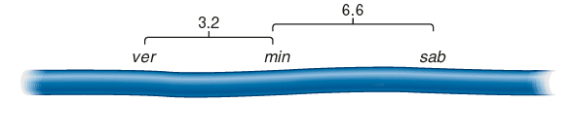
B. To calculate the interference value, we must first calculate the coefficient of coincidence.
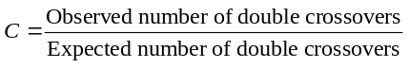
Based on our mapping in part A, the percentage of single crossovers equals 3.2% (0.032) and 6.6% (0.066). The expected number of double crossovers equals 0.032 times 0.066, which is 0.002, or 0.2%. There were a total of 2,951 offspring produced. If we multiply 2,951 times 0.002, we get 5.9, which is the expected number of double crossovers. The observed number was 3. Therefore:
C = 3/5.9 = 0.51
I = 1 – C = 1 – 0.51 = 0.49
In other words, approximately 49% of the expected double crossovers did not occur due to interference.
S4. Around the same time as the study of Creighton and McClintock described in figure 5.6, Curt Stern conducted similar experiments with Drosophila. He had strains of flies with microscopically detectable abnormalities in the X chromosome. In one case, the
X chromosome was shorter than normal due to a deletion at one end. In another case, the X chromosome was longer than normal because an extra piece of the Y chromosome was attached at the other end of the X chromosome where the centromere is located. He had female flies that had both abnormal chromosomes. On the short X chromosome, a recessive allele (car) was located that results in carnation colored eyes, and a dominant allele (B) that causes bar-shaped eyes was also found on this chromosome. On the long X chromosome in this female fly were located the wild-type alleles for these two genes (designated car+ and B+), which confer red eyes and round eyes. Stern realized that a crossover between the two X chromosomes in the female fly would result in recombinant chromosomes that would be cytologically distinguishable from the parental chromosomes. If a crossover occurred between the B and car genes on the X chromosome, this is expected to produce a normal-sized X chromosome and an abnormal chromosome with a deletion at one end and an extra piece of the Y chromosome at the other end.
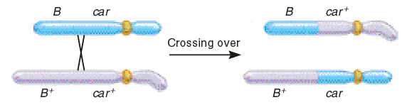
Stern crossed these female flies to male flies that contained a normal X chromosome with the car allele and the allele for normal-shaped (round) eyes (car B+). Using a microscope, it was possible for him to discriminate between the morphologies of parental chromosomes (like those contained within the original parental flies) and recombinant chromosomes that may be found in the offspring. What would be the predicted phenotypes and chromosome characteristics in the offspring if crossing over did or did not occur between the X chromosomes in the female flies of this cross?
Answer: To demonstrate that genetic recombination is due to crossing over, it was necessary for Stern to correlate recombinant phenotypes (due to genetic recombination) with the inheritance of recombinant chromosomes (due to crossing over). Since he knew the arrangement of alleles in the female fly, it was possible for him to predict the phenotypes of parental and nonparental offspring. The male fly could contribute the car and B+ alleles (on a cytologically normal X chromosome) or contribute a Y chromosome. In the absence of crossing over, the female fly could contribute a short X chromosome with the car and B alleles or a long X chromosome with the wild-type alleles. If crossing over occurred in the region between the car and B alleles, the female fly could also contribute recombinant X chromosomes. One possible recombinant X chromosome would be normal-sized and carry the car and B+ alleles while the other recombinant X chromosome would be deleted at one end with a piece of the Y chromosome at the other end and carry the car+ and B alleles. When combined with an X or Y chromosome from the male, the parental offspring would have carnation, bar eyes or wild-type eyes; the nonparental offspring would have carnation, round eyes or red, bar eyes.
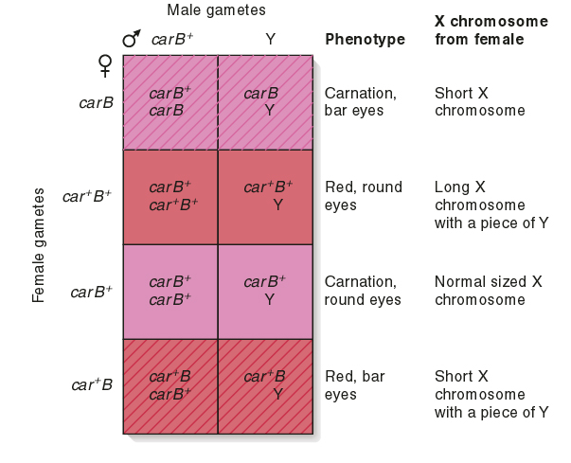
The results shown in the Punnett square are the actual results that Stern observed. His interpretation was that crossing over between homologous chromosomes (in this case, the X chromosome) accounts for the formation of offspring with recombinant phenotypes.
S5. There is a limit to the relationship between map distance and the percentage of recombinant offspring. Even though it is possible for two genes on the same chromosome to be much more than 50 mu apart, we do not expect to obtain greater than 50% recombinant offspring in a testcross. You may be wondering why this is so. The answer lies in the pattern of multiple crossovers. At the pachytene stage of meiosis, a single crossover in the region between two genes will produce only 50% recombinant chromosomes (see fig. 5.1b). Therefore, to exceed a 50% recombinant level, it would seem like it would be necessary to have multiple crossovers within the tetrad.
Let’s suppose that two genes are far apart on the same chromosome. A testcross is made between a heterozygous individual, AaBb, and a homozygous individual, aabb. In the heterozygous individual, the dominant alleles (A and B) are linked on the same chromosome and the recessive alleles (a and b) are linked on the same chromosome. Draw out all of the possible double crossovers (between two, three, or four chromatids) and determine the average number of recombinant offspring, assuming an equal probability of all of the double crossover possibilities.
Answer: A double crossover occurring between the two genes could involve two chromatids, three chromatids, or four chromatids. There are two different ways that crossover could involve three chromatids. The possibilities for all types of double crossovers are shown here:

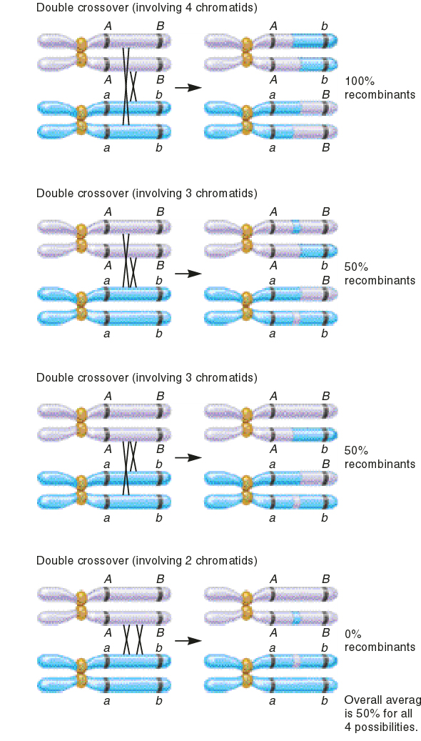
This drawing considers the situation where two crossovers are expected to occur in the region between the two genes. Since the tetrad is composed of two pairs of homologues, there are several possible ways that a double crossover could occur between homologues. Since all of these double crossing over events are equally probable, we take the average of them to determine the maximum recombination frequency. This average equals 50%.

