Chapter 6
Interactions Between Cells and the Extracellular Environment

Chapter Scope
Many important activities that occur between cells and the extracellular environment that involve the plasma membrane are fully explored in this chapter. To a large extent the protein and phospholipid molecules that make up much of the chemical composition of the plasma membrane regulate the passage of materials either in to or out of the cell’s interior. This complex membrane also exhibits channels or pores through which many selected substances enter and exit by simple diffusion as they travel from higher to lower concentrations. In addition, metabolic gases such as O₂ and CO₂ easily follow their respective concentration differences (gradients) in to and out of the cell. This simple mode of transport also applies to most triglycerides, steroids, and other fat-soluble (nonpolar) molecules that can diffuse across cell membranes based on the fact that they are soluble in the nonpolar phospholipid core.
However, the entry of many other nutrients from the extracellular environment such as simple sugars (for example, glucose) and amino acids (for example, phenylalanine) is not simple, and therefore, requires selective protein “carriers” (facilitated diffusion). Other selected molecules not only require membrane carriers but also require the expenditure of ATP molecules to deliver the metabolic energy needed to “pump” these molecules “uphill” in the direction that opposes the concentration gradient (active transport). Sodium ions (Na⁺) and potassium ions (K⁺), for example, are driven in opposite directions by primary active transport pumps located in the cell membrane. This pumping actions leads to the separation of charged ions on either side of the cell membrane and results in the electrical membrane potential. Various stimuli can produce changes in the membrane potentials that lead to the formation of electrical impulses. These impulses are generated in the brain and elsewhere and conducted throughout the nervous system. These impulses will be described greater detail in the next few chapters as they race along the membranes of neurons (chapters 8, 9, and 10) and of muscle fibers (chapter 12).
The movement of the body’s solvent, water across membranes is an extraordinary form of simple diffusion (osmosis). In osmosis, only water moves as it flows from a region of higher water concentration to an area of lower water concentration). The concentration of solutes in various solutions of the body, such as plasma, is regulated by homeostasis and can be measured at approximately 300 milliosmoles (300 mOsm) per liter of water. Nerve receptors (osmoreceptors) in the hypothalamus region of the brain help monitor body water concentration; and with the cooperation of specific hormones, such as antidiuretic hormone (ADH), regulate the loss of water primarily from the kidney (chapter 16).

I. EXTRACELLULAR ENVIRONMENT
The extracellular environment surrounding cells consists of a fluid compartment, in which molecules are dissolved, and a matrix of polysaccharides and proteins that give form to the tissues. Interactions between the intracellular and extracellular environment occur across the plasma membrane.

A. Multiple Choice
___ 1. Which of the following statements about the extracellular environment is false?
a. Chemical regulators secreted from other cells of the body interact with target cells by way of the extracellular environment.
b. Body cells receive nourishment from the extracellular environment.
- Most body water (about 67%) is found in the extracellular environment.
- Cellular waste products formed from metabolism are released into the extracellular environment.
e. All of these statements about the extracellular environment are true.
___ 2. Which of the following is not a function of blood plasma?
a. Transport oxygen from the lungs to the body cells.
b. Form bile for elimination of products from the liver.
c. Transport nutrients derived from digested food in the intestine to body cells.
d. Distribute hormones and other regulatory molecules to their target cells.
e. All of these are functions of blood plasma.

___ 3. The fluid that exists primarily in the hydrated gel of ground substance, is known as
a. tissue fluid.
b. interstitial fluid.
c. intracellular fluid.
d. blood plasma.
e. Both a & b are correct.
___ 4. Collagen and elastin are special protein fibers that make up the connective tissue found characteristically as part of the
a. extracellular matrix.
b. ground substance.
c. plasma membrane.
d. blood plasma.
___ 5. The gel-like ground substance that comprises part of the extracellular matrix contains glycoproteins (carbohydrate-protein combinations) and polysaccharide-type molecules, known as
a. collagen.
b. matrix metalloproteinases (MMPs).
c. glycogen.
d. proteoglycans.
e. lactic acid.
___ 6. Matrix metalloproteinases (MMPs) are an important family of enzymes because they use zinc as an ion cofactor (“metallo-”); and because they
a. attack potentially infectious agents.
b. strengthen the extracellular matrix.
c. break down collagen fibers.
d. help prevent the loss of blood plasma.
speed up metabolism in the cells.
___ 7. Which of the following does not describe integrins?
a. Integrins are a unique class of glycoprotein molecules.
b. Integrins extend from the cytoskeleton within the cytoplasm to the extracellular matrix.
c. Integrins sort of “glue” cells to their surrounding extracellular matrix.
d. Integrins integrate the intracellular to the extracellular compartments.
e. Integrins require zinc ions as a cofactor.
___ 8. Which of the following substances is not allowed to enter the plasma (cell) membrane by simple diffusion?
a. ions
b. proteins
c. water
d. lipid-soluble molecules
___ 9. Which of the following processes is not an example of carrier-mediated transport?
a. osmosis
b. facilitated diffusion
c. active transport
d. All of these processes are carrier-mediated.

B. True or False/Edit
___ 10. Approximately 20% of the extracellular fluid is blood plasma.
___ 11. Blood plasma is also known as interstitial fluid.
___ 12. Before entering a cell, all materials delivered by blood plasma must first pass through interstitial fluid.
___ 13. The glycoprotein and proteoglycan structure that is most responsible for the intricate bonding that exists between the epithelium and its underlying connective tissue is called ground substance.
___ 14. Integrins are a unique class of cell glycoproteins that physically join the intracellular to the extracellular compartments and thereby may serve to relay signals between them.
___ 15. Active transport includes simple diffusion, osmosis, and facilitated diffusion.

II. Diffusion and Osmosis
Net diffusion of a molecule or ion through a cell membrane always occurs in the direction of its lower concentration. Nonpolar molecules can penetrate the phospholipid barrier, and small inorganic ions can pass through channels in the membrane. The net diffusion of water through a membrane is known as osmosis.

A. Multiple Choice
___ 16. The energy that “drives” the random motion of molecules during diffusion comes from
a. thermal (heat) energy.
b. metabolic energy.
c. potential energy.
d. kinetic energy.
___ 17. The movement of molecules or ions “uphill” from regions of lower to regions of higher concentrations is known as
a. active transport.
b. facilitated diffusion.
c. osmosis.
d. simple diffusion.
e. None of these descriptions are correct.
___ 18. Which of the following substances can not cross the plasma (cell) membrane by simple diffusion?
a. O₂
b. steroid hormone
c. CO₂
d. urea
e. All of these substances can cross by simple diffusion.
___ 19. The rate of diffusion as measured by the number of diffusing molecules passing through the membrane per unit time is dependent on all of the following factors, except
a. “steepness” of the concentration gradient.
b. simultaneous passage of water molecules.
c. permeability of the membrane to the diffusing substances.
d. surface area of that membrane.
___ 20 Molecules that are osmotically active
a. include plasma proteins such as albumin.
b. cannot readily diffuse across the plasma membrane.
c. help regulate the flow of water between the tissues and the blood.
d. do not include water.
e. All of these statements are correct.
___ 21. Osmotic pressure is best defined as the force
a. generated by the solute gradient across the membrane.
b. exerted by the osmotically active solutes.
c. exerted to oppose the movement of water (osmosis).
d. generated by the membrane to pump water out of the cell.
___ 22. Which of the following statements regarding osmotic pressure is false?
a. Pure water has an osmotic pressure of zero.
b. A 360 g/L glucose solution has twice the osmotic pressure of a 180 g/L glucose solution.
c. The greater the solvent concentration, the greater its osmotic pressure.
d. All of these statements regarding osmotic pressure are true.
___ 23. A 1.0 m glucose solution added to a 2.0 m NaCl solution would form a solution with a total osmolality of
a. 2.0 Osm.
b. 3.0 Osm.
c. 4.0 Osm.
d. 5.0 Osm.
___ 24. The milliosmolality of normal human plasma is about
a. 180 mOsm.
b. 300 mOsm.
c. 0.3 mOsm.
d. 1.86 mOsm.
___ 25. Which solution is not isotonic to plasma?
a. 0.3 m glucose
b. 5% dextrose
c. 0.15 m NaCl
d. normal saline
e. All of these solutions are isotonic to plasma.
___ 26. Red blood cells (RBCs) bled into sea water will ________, since sea water is ________.
a. crenate; hypotonic
b. hemolyse; hypotonic
c. crenate; hypertonic
d. hemolyse; hypertonic
___ 27. Osmoreceptors, specialized neurons that monitor the osmolality of blood plasma, are located in the
a. hypothalamus.
b. pituitary.
c. kidney.
d. heart.

B. True or False/Edit
- Simple diffusion may be a term used to describe the random movement of either solute molecules or solvent molecules.
___ 29. Some carrier-mediated processes may occur across the membrane of dead cells.
___ 30. When a concentration difference exists across a membrane, the diffusion of those molecules that are permeable will strictly be from the area of higher concentration to the area of lower concentration.
___ 31. Steroid molecules are able to diffuse across cell membranes without carriers because steroids are nonpolar (without charge) molecules.
___ 32. O₂ and CO₂ gas exchange across any body cell membrane occurs by simple diffusion down their respective concentration gradients.
___ 33. Osmosis can be described as the net diffusion of water in the direction of a less dilute toward a more dilute solution.
___ 34. Larger polar molecules, such as glucose, require special carrier proteins embedded in the membrane for transport.
___ 35. Many tiny ion channels in cell membranes are composed of proteins that serve as “gates” that can open or close in response to particular physiological stimuli.
___ 36. The resting neuron membrane is twenty times more permeable to Na⁺ ions than to K⁺ ions.
___ 37. Microvilli are tiny folds projecting from the apical membranes of epithelial cells found in the intestine and the kidney tubules, that serve to increase the surface area of these membranes for absorption.
___ 38. Osmosis is the net diffusion of water (the solute) across semipermeable membranes.
___ 39. The plasma membrane of some cells contain varying numbers of aquaporins, special water channels that may be inserted and removed from the membrane in response to regulatory molecules.
___ 40. Edema is the excessive accumulation of fluid in the tissues that can result from an abnormal increase in the production of plasma proteins, such as albumin.
___ 41. The greater the solute concentration of a solution, the greater its osmotic pressure.
___ 42. One mole of glucose contains the same number of atoms or molecules as one mole of sucrose.
___ 43. One mole of glucose contains the same number of atoms or molecules as one mole of NaCl.
___ 44. Osmolality is determined by the ratio of solute to solvent particles in a solution, not by the chemical nature of the solute molecules.
___ 45. A solution may be isosmotic but not isotonic — as demonstrated when red blood cells are placed in a 0.3 m urea solution.
___ 46. Urea molecules diffuse easily across most cell membranes.
___ 47. Antidiuretic hormone (ADH) acts on the kidney to promote water loss from the body by opposing the reabsorption of water by the nephron.
___ 48. One purpose for prescribing low-salt diets for those with hypertension is to lower plasma osmolality, reduce stimulation of the osmoreceptors, release less ADH from the posterior pituitary, lose more water as urine from the blood, with lowered blood volume and lowered blood pressure as the final objective.

III. Carrier — Mediated Transport
Molecules such as glucose are transported across plasma membranes by special protein carriers. Carrier-mediated transport in which the net movement is down a concentration gradient, and which is therefore passive, is called facilitated diffusion. Carrier-mediated transport that occurs against a concentration gradient, and which therefore requires metabolic energy, is called active transport.

A. Multiple Choice
___ 49. Which of the following is not a characteristic of membrane carrier proteins?
a. specificity
b. competition
c. denaturation
d. saturation
___ 50. The transport of glucose molecules from outside the cell, across the membranes, and into most tissue cells (excluding the intestine or kidney tubule) occurs by the process of
a. active transport.
b. simple diffusion.
c. facilitated diffusion.
d. coupled transport.
___ 51. Which condition would not be present in someone with the disease, diabetes mellitus?
a. glycosuria
b. increased production of the hormone, insulin
c. hyperglycemia
d. decreased transport of glucose through plasma membranes
e. decreased level of glucose in the blood plasma
___ 52. Which ion is pumped out of all cells by active transport; such that it can be used as a regulatory signal ion for neurotransmitter release, muscle contraction, and many other cellular activities?
a. sodium
b. chloride
c. potassium
d. calcium
e. phosphate
___ 53. In the primary active transport sequence of events, the hydrolysis of ATP releases energy that is believed required to
- move the cell closer to the target molecule or ion.
- attract the molecule or ion to the “recognition site.”
- phosphorylate, and thus change the shape of, the carrier protein.
- release the transported molecule or ion from the carrier protein.
- change the shape of the cell membrane to engulf the molecule or ion.
___ 54. Which of the following functions is not served by the steep Na⁺/K⁺ concentration gradient?
a. It provides energy for the coupled transport of other molecules across the cell membrane.
b. It keeps Na⁺ and water molecules inside the cells.
c. It can be adjusted by thyroid hormones to help regulate the basal metabolic rate (BMR) of the body.
d. It serves to produce electrical impulses in nerve and muscle tissue.
___ 55. In the process of secondary active transport called membrane counter-transport (antiport), calcium ion (Ca²⁺)
a. passively diffuses into the cell as Na⁺ is actively moved out of the cell.
b. passively diffuses out of the cell as Na⁺ is actively moved out of the cell.
c. is actively moved out of the cell as Na⁺ passively diffuses into the cell.
d. is actively moved into the cell as Na⁺ passively diffuses out of the cell.

___ 56. Which of the following structures is not considered a junctional complex that connects adjacent epithelial cells to each other and limits paracellular transport?
a. Integrin proteins
b. Tight junctions
c. Adherens junctions
d. Desmosomes
___ 57. The type of junctional complex in which the plasma membranes of two cells come very close together and are “glued” by interactions between proteins that span each membrane and connect to the cytoskeleton of each cell, best describes the
a. integrin proteins.
b. tight junctions.
c. adherens junctions.
d. desmosomes.

B. True or False/Edit
___ 58. When entering the cell, two amino acids may compete for the same carrier protein located in the cell membrane.
___ 59. When the concentration of molecules to be transported rises outside of a cell, the membrane carrier proteins will transport at increasing rates until all carriers are saturated, reaching a peak rate known as the transport maximum (T_{m})
___ 60. The letters GLUT designate transport carriers for the facilitated diffusion of specific amino acid molecules.
___ 61. The transport of glucose by GLUT carriers in skeletal muscle is a form of passive transport (facilitated diffusion) whereas glucose movement across the epithelium of such areas as the kidney tubules and the small intestine may be by active transport.
___ 62. Active transport (countertransport) is responsible for keeping the intracellular concentration of calcium (Ca²⁺) ions very low in living cells.
___ 63. Both sodium and potassium ion transport requires energy as each is “pumped” across living cell membranes and down their corresponding concentration gradients.
___ 64. All cells in the body have variable numbers of Na⁺/K⁺ membrane pumps that are constantly active.
___ 65. Secondary active transport (coupled transport) may be either cotransport (symport) if moved in the same direction as Na⁺ or countertransport (antiport) if moved in the direction opposite that of Na⁺.
___ 66. Paracellular transport refers to the movement of materials through epithelial cells during absorption, whereas transcellular transport describes the limited diffusion and osmosis that may occur through the very tiny spaces between epithelial cells.
___ 67. The term bulk transport applies to the movement of many molecules either into (endocytosis) or out of (exocytosis) the cell.
___ 68. Epithelial cells exhibit organelle polarity as shown by exocytotic vesicles that bud from the Golgi complex fuse with the plasma membrane located near its basolateral, or bottom surface whereas the nucleus and endoplasmic reticulum are located more towards the apical or top surface.

IV. The Membrane Potential
As a result of the permeability properties of the plasma membrane, the presence of nondiffusible negatively charged molecules inside the cell, and the action of the Na⁺/K⁺ pumps, there is an unequal distribution of charges across the membrane. As a result, the inside of the cell is negatively charged compared to the outside. This difference in charge, or potential difference, is known as the membrane potential.

A. Multiple Choice
___ 69. Which of the following substances would not be considered a “fixed” anion within the cytoplasm of a cell?
a. certain steroid molecules
b. phosphate groups of ATP
c. certain cellular proteins
d. certain organic molecules

___ 70. To which of the following cations is the cell membrane most permeable?
a. sodium
b. potassium
c. calcium
d. iron
___ 71. The cation found in higher concentration inside than outside the cell is
a. sodium.
b. potassium.
c. calcium.
d. hydrogen.
___ 72. The Nernst equation is most often used to estimate the cell's
a. resting membrane potential.
b. osmotic pressure.
c. threshold potential.
d. equilibrium potential for Na⁺ ions or for K⁺ ions.
___ 73. Using the Nernst equation, the equilibrium potential for Na⁺ is
a. -90 mV.
b. -70 mV.
c. 0 mV.
d. +60 mV.
___ 74. A “less negative” membrane potential means
a. it is “more positive” than the resting potential.
b. it is a number closer to zero mV.
c. the resting membrane potential has moved closer to the sodium equilibrium.
d. All of these statements describe the term “less negative.”

B. True or False/Edit
___ 75. The electrical properties of cells are based both on the differences in concentrations of specific ions across the membrane and on the permeability of the plasma membrane to each ion.
___ 76. “Fixed” anions cannot penetrate the cell membrane.
___ 77. The intracellular Na⁺ concentration is lower than the extracellular Na⁺ concentration.
___ 78. The equilibrium potential is a theoretical voltage — that is, it does not occur naturally in living cells.
___ 79. A resting membrane potential of -70 mV prevents any diffusion of Na⁺ out of the cell.
___ 80. Due the efforts of the Na⁺/K⁺ pumps, the resting cell has both Na⁺ and K⁺ concentrations in perfect equilibrium across the membrane.
___ 81 The resting membrane potential of most cells averages -70 mV and should be distinguished from the theoretical equilibrium potentials for sodium (+60 mV) or potassium (-90 mV) that are calculated to establish the extremes.
___ 82. Mathematical expressions such as the Nernst equation demonstrate that the membrane potential of a cell can be influenced greatly by factors such as a change in the concentration of any involved ion and by a change in the permeability of the membrane to such ions.
___ 83. The resting cell membrane is most permeable to potassium ion (K⁺) so that any increase in the extracellular concentration of potassium ion will rapidly depolarize the cell.
___ 84. The Na⁺/K⁺ pumps not only act to counter the leakage of ions across the cell membrane but also transports two Na⁺ out of the cell for every three K⁺ that it moves into the cell.

V. cell signaling
Cells communicate by signaling each other chemically. These chemical signals are regulatory molecules released by neurons and endocrine glands, and by different cells within an organ.

A. Multiple Choice
___ 85. Which of the following is not a general category of signals used by cells to communicate with one another?
a. gap junctions
b. paracrine signaling
c. synaptic signaling
d. endocrine signaling
e. All of these are included in cell signaling.
___ 86. The secretion of regulatory molecules within an organ that diffuse locally through the extracellular matrix to stimulate their target cells, best describes
a. gap junctions.
b. paracrine signaling.
c. synaptic signaling.
d. endocrine signaling.
___ 87. Which of the following forms of signaling uses neurotransmitter molecules?
a. gap junctions
b. paracrine signaling
c. synaptic signaling
d. endocrine signaling
___ 88. During cell communication, signal molecules must bind to specific receptor proteins that are located
a. on the outer surface of the target cell plasma membrane.
b. in the cytoplasm of the target cell.
c. within the nucleus of the target cell.
d. Receptor proteins may be found in any of the above locations.
___ 89. Which of the following regulatory molecules is not large or polar, and therefore does not have to bind to receptor proteins located on the outer surface of the target cell plasma membrane?
a. steroid hormone
b. insulin
c. acetylcholine (ACh)
d. epinephrine (epi)

B. True or False/Edit
___ 90. Cell signaling describes the many different processes used by cells to communicate with each other.
___ 91. Gap junctions are important structures that belong to the category of “synaptic signaling” between cells.
___ 92. As opposed to endocrine signaling, paracrine signal molecules diffuse locally throughout an organ communicating among target cells located within that organ.
___ 93. Regulatory molecules such as epinephrine, acetylcholine, and insulin are nonpolar and can diffuse through the cell membrane to enter target cells.

Chapter Review

A. Completion
94. Passive transport of molecules or ions from regions of high to regions of low concentrations is called __________; and is due to __________ energy rather than metabolic energy.
95. The rate of diffusion depends on: the __________ difference or gradient that exists on two sides of the membrane; the __________ (selectivity) of the cell membrane to the diffusing substance; and is directly proportional to the membrane __________ (for example, microvilli).
96. Lipids such as steroids are ______(polar/nonpolar) molecules and, thus, __________ can/cannot) pass easily through phospholipid layers of the membrane.
97. Osmosis is the simple __________ of __________ molecules from __________ (more/less) dilute solutions to __________ (more/less) dilute solutions.
98. Solute molecules can exert force on the movement of solvent (water). The solute concentration is measured in units called __________, which is directly related to the ___________ pressure of a solution.
99. All solutions with the same number of solute particles as plasma are __________, such as __________% NaCl and __________% glucose solutions; and in such solutions, red blood cells (RBCs) __________ (do/do not) gain or lose water.
100. However, increasing the number of solute particles in such solutions results in a __________- tonic (hyper/iso/hypo) solution in which RBCs would __________ (crenate/hemolyse); while solutions with fewer solutes than plasma are __________- tonic (hyper/iso/hypo) in which RBCs would ______(crenate/hemolyse).
101. Water homeostasis is regulated mainly by __________- receptors located in the ______of the brain, which control the release of ______hormone from the ______pituitary gland; and which directs the kidneys to ______(lose/reabsorb) body water.
102. Like enzyme proteins, carrier-mediated transport proteins are characterized by __________, __________, and ______. Carrier-mediated transport without the use of energy is __________ and is called ____________; whereas carrier-mediated transport requiring metabolic energy is __________ and is called __________.
103. For example, the “uphill” Na⁺/K⁺ pump maintains the Na⁺ concentration high __________ (inside/outside) the cell and K⁺ concentration high __________ (inside/outside).
104. Of these two ions, __________ is the more diffusible, and is attracted into the cell by “fixed” __________ (anions/cations).
105. Due to this separation of ions the cell membrane potential at rest is approximately __________ mV, and it is maintained by expending __________ energy in the form of __________.

B. Sequencer
106. Abandoned in the hot desert for long periods of time without water, you have become dehydrated. Your body will sense this water loss and will initiate efforts to correct or compensate for this imbalance (notice this is negative feedback at work!). Read the following list of events and place them in the proper sequence.
The last one (8) has been done for you.
Lower volume of urine is excreted from the body
Heightened sense of thirst with drinking behavior as the posterior pituitary is stimulated
Blood volume falls; plasma osmolality (solute/solvent) rises
Blood volume rises; plasma osmolality (solute/solvent) falls
Water retention is promoted along the kidney tubules
8 Normal plasma osmolality is restored (homeostasis)
Osmoreceptors in the hypothalamus are activated
_____ Antidiuretic hormone (ADH) is released into the bloodstream

C. Crossword Puzzle —Membrane Transport and the Membrane Potential

Across
2. the resting membrane potential is a __________ number, in millivolts
5. as electrolytes dissolve in water they come apart, or
7. when all membrane carriers are saturated, known as the T_{m} or transport __________
11. the form of transport that includes simple diffusion and osmosis
12. ions may pass through membranes along tiny passageways called __________
14. fingerlike projections or membrane folds; increase the cell surface area for absorption
15. what you receive for solving this puzzle

16. first two letters in the name of the hormone, ADH
19. more than one female egg cell
20. movement of materials “uphill” against concentration gradients is called active __________
21. density of solute molecules per volume of solvent
24. number of Na⁺ ions pumped out of the cell as two K⁺ ions are pumped into the cell by the Na⁺/K⁺ pump
25. specific membrane protein made by the cell for transport
29. where a bath can be taken
31. negative ions (such as, proteins)
32. can be abbreviated Osm
33. another name for primary active transport carriers
36. net diffusion of water across a membrane
37. passive carrier-mediated transport
39. boy or girl scout attribute
40. one example of a sugar solute molecule found in this chapter
41. charged particles
42. condition when concentrations of substances across a membrane are no longer different
44. cell membranes are considered to be semi- or __________ permeable
46. what happens to red blood cells when placed in ocean water (hypertonic)
47. hormone lacking in the disease diabetes mellitus
48. a solution with the same osmolality as plasma
51. units used to measure the charge difference across cell membranes
52. organ affected greatly by an excess of K⁺ ions in plasma
53. neurons sensitive to the osmotic pressure and osmolality of plasma
Down
1. genetic material necessary for synthesizing membrane carrier proteins
3. a difference in concentration between two solutions
4. one of three characteristics membrane carriers have in common with enzymes
6. osmotic pressure of pure water
8. example of an osmotically active solute in the plasma
9. change in ice on a hot summer day
10. membrane property — allow some to cross but not others
11. chemical composition of the membrane “core”
13. abbreviation in professional basketball
15. solution with a greater osmotic pressure and osmolality than plasma (for example, sea water)
17. secondary active transport, (for example, glucose uptake from kidney tubule)
18. the body's solvent
22. home for a feathered friend
23. form of energy used to drive the membrane “pumps”
26. the fluid portion of the blood
27. Avogadro’s number of molecules; a small furry animal
28. passive movement from an area of high to one of low concentration
30. organ where the hypothalamus and osmoreceptors are located
34. primary intracellular cation
35. what happens to red blood cells when placed in a fresh water lake (hypotonic)
38. artificial removal of waste materials when kidneys fail
43. negative ions trapped within the 600 cell are known as __________
45. diffusion always occurs from higher to __________ concentrations
49. the number of negative charges on a cloride ion
50. worn on a baseball player’s head

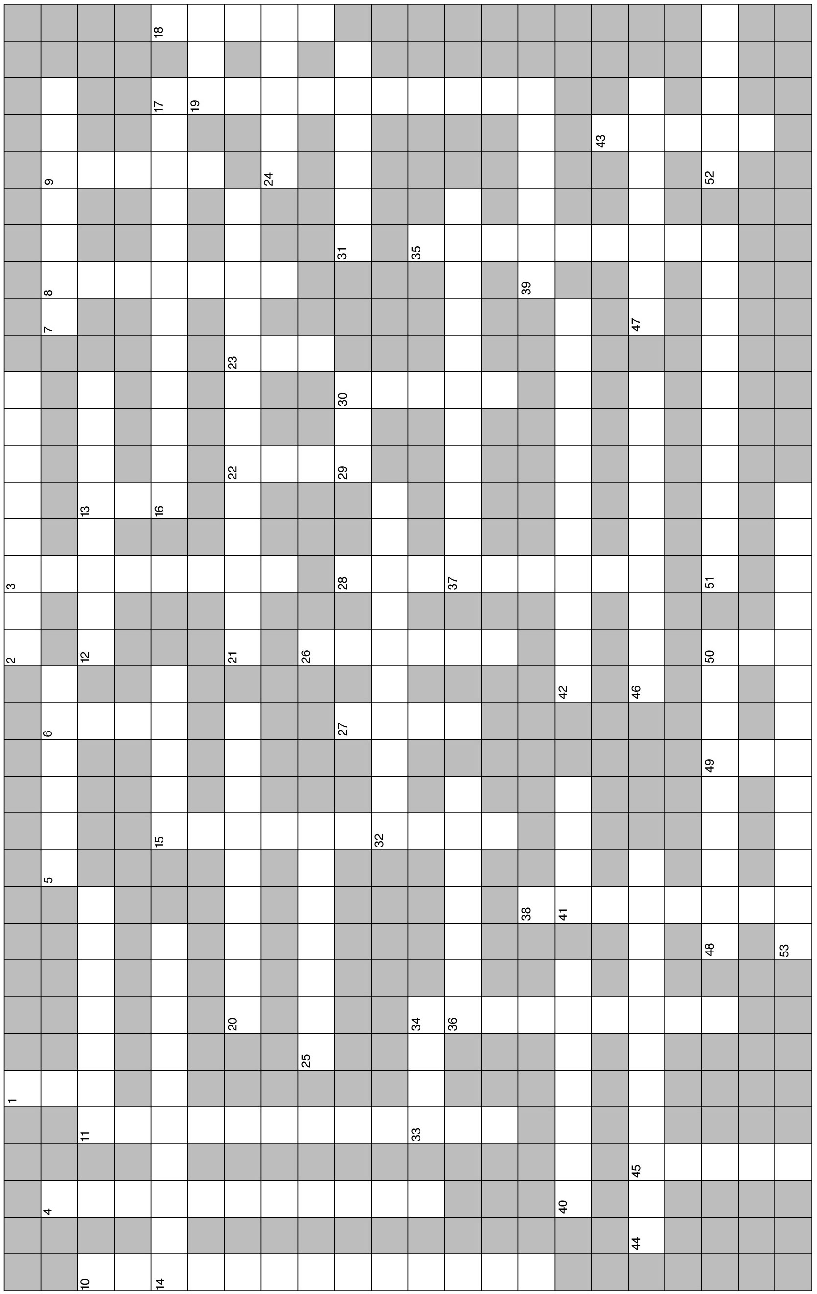

D. Essay

Essay Tutorial
This essay tutorial will answer the first essay question found in the “Review Activities” section of your Human Physiology textbook. Please read question 1 in the “Test Your Understanding of Concepts and Principles” located at the end of chapter 6 and let me guide you through one possible answer. Watch for key terms in boldface type, helpful tips and general suggestions on writing the essay or short-answer questions. Enjoy!
107. Describe the conditions required to produce osmosis, and explain why osmosis occurs under these conditions.

Note: This question is actually has two parts. First we will describe the conditions producing or causing osmosis, then we will explain why osmosis occurs. Let's begin as we often do by defining the key word in the question — osmosis.
Answer. Osmosis is the net simple diffusion of water molecules (solvent) across a cell membrane that is permeable to water (note: not all membranes are permeable to water, such as those in portions of the kidney nephron). The conditions required for osmosis are: (1) the membrane must be relatively impermeable to the solutes on either side; and (2) the concentration of water must be higher on one side of the membrane than on the other. Osmosis now will occur from the side where water concentration is higher (more dilute!) to the side where water concentration is lower (less dilute!). The “impermeable” solutes are unable to cross the membrane and, thus, are said to be osmotically active since water will flow in the direction of these solutes in the attempt to “dilute” them. Finally, it is important to observe that when water (which is not compressible) moves throughout the body, the volume of that part of the body changes.
How did it go? OK, got time for a few more?
108. You are a paramedic at the scene of an accident. You have three glucose (dextrose) solutions in your truck for starting intravenous fluid (IV) treatment — 1%, 5%, and 10% dextrose in water. Which of these solutions is isotonic, which is hypertonic, and which is hypotonic? Describe clearly what would happen if each of these solutions is infused separately.

109. Compare and contrast the terms osmolality and osmotic pressure — using the terms solute, solvent, and the ratio  in your explanation.
110. Neuron sensors and hormone effectors participating in a negative feedback loop maintain body water homeostasis. Discuss this loop by describing the sensors, the effectors, and the response of the body to conditions of both too much water intake and too little body water intake (dehydration).

111. Describe the interaction between the “fixed anions” and the Na⁺/K⁺ pump in creating the resting membrane potential. Include the permeability of the membrane to each substance and the role metabolic energy (ATP) plays in forming the membrane potential.

Answers — Chapter 6

- Extracellular Environment
- 1. c, 2. b, 3. e, 4. a, 5. d, 6. c, 7. e, 8. b, 9. a
- 10. T, 11. F—Interstitial fluid is also known as tissue fluid, 12. T, 13. F—Replace “ground substance” with “basal lamina,”
14. T, 15. F—Replace “Active” with “Passive”
- Diffusion and Osmosis
- 16. a, 17. a, 18. e, 19. b, 20. e, 21. c,
22. c, 23. d, 24. b, 25. e, 26. c, 27. a
- 28. T, 29 T, 30. F—Some diffusion will be in the opposite direction, as well,
31. T, 32. T, 33. F—Switch “less” for “more,” 34. T, 35. T, 36. F—Switch “K⁺” and “Na⁺,” 37. T, 38. F—Replace “solute” with “solvent,” 39. T, 40. F—Replace “increase” with “decrease,” 41. T, 42. T,
43. F—One mole of NaCl splits to form two moles of atoms, 44. T, 45. T, 46. T, 47. F—ADH promotes water reabsorption (not loss), 48. T
- Carrier-Mediated Transport
- 49. c, 50. c, 51. b, 52. d, 53. c, 54. b, 55. c, 56. a, 57. c
- 58. T, 59. T, 60. F—Replace “amino acid” with “glucose,” 61. T, 62. T, 63. F—Replace “down” with “against,” 64. T, 65. T, 66. F—Switch “Paracellular” with “transcellular,” 67. T, 68. F—Switch “basolateral, or bottom” with “apical, or top,”
- The Membrane Potential
- 69. a, 70. b, 71. b, 72. d, 73. d, 74. d
- 75. T, 76. T, 77. T, 78. T, 79. F—Na⁺ will diffuse out of the cell due to its steep concentration gradient, 80. F—A cell at rest has both Na⁺ and K⁺ ions actively separated across the membrane—the basis for the membrane potential, 81. T, 82. T, 83. T,
84. F—Switch “Na” for “K”
- Cell Signaling
- 85. e, 86. b, 87. c, 88. d, 89. a
- 90. T, 91. F—Gap junctions and synaptic signaling are very different,
92. T, 93. F—These molecules are large and polar, thus cannot enter cells,
Chapter Review
- 94. diffusion; thermal,
95. concentration; permeability; surface area, 96. nonpolar; can, 97. diffusion; water; more; less, 98. osmoles; osmotic, 99. isotonic; 0.9; 5.0; do not, 100. hyper; crenate; hypo; hemolyse, 101. osmo; hypothalamus; ADH; posterior; reabsorb, 102. specificity; competition; saturation; passive; facilitated diffusion; active; active transport, 103. outside; inside, 104. K⁺; anions, 105. -70; metabolic; ATP
- 106. 6, 3, 1, 7, 5, 8, 2, 4

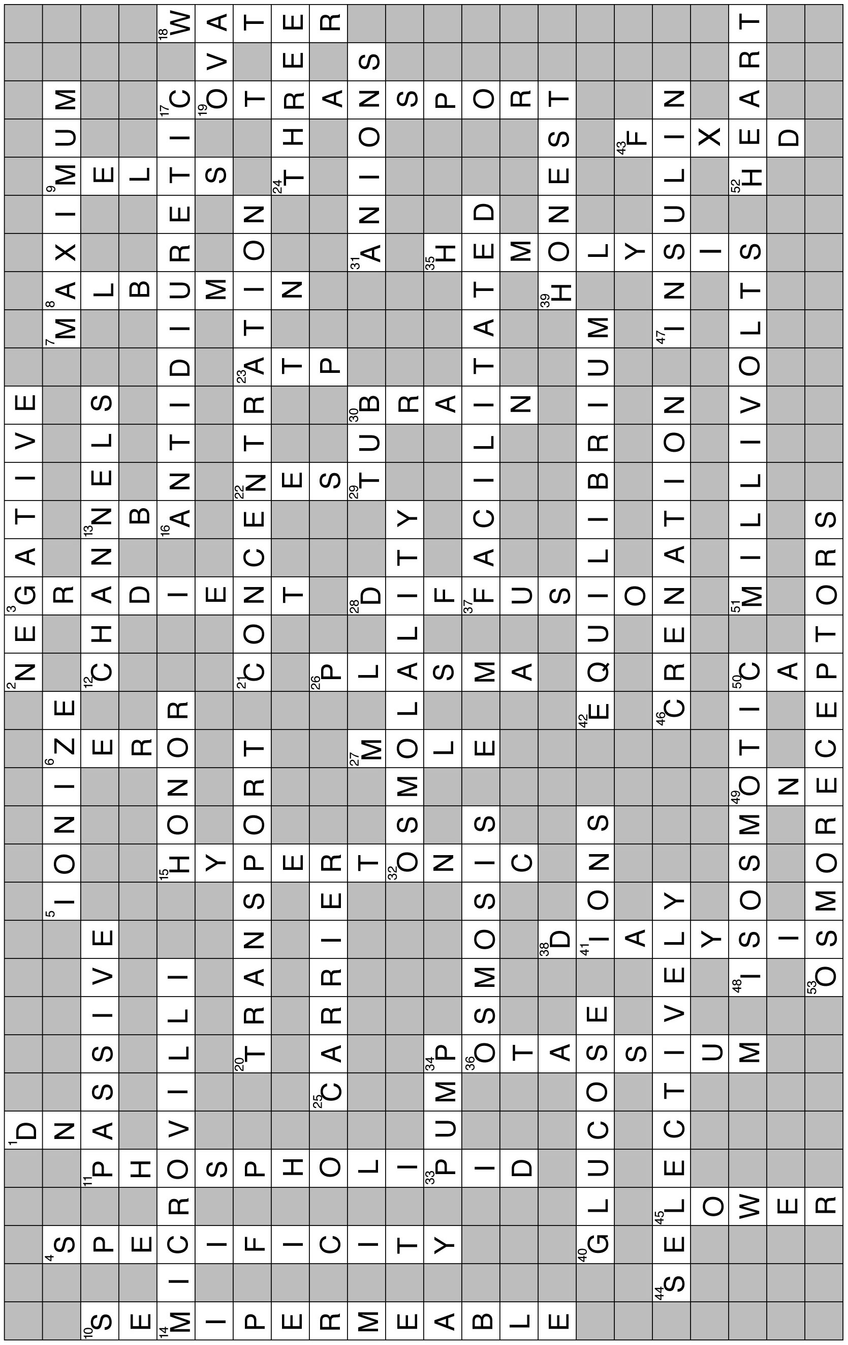
- Crossword Puzzle

