The McGraw-Hill Guide to Success for Medisoft Advanced Version 17
- Sanderson’s Computers in the Medical Office (CiMO), 8e
- Sanderson’s Case Studies for use with Computers in the Medical Office, 8e
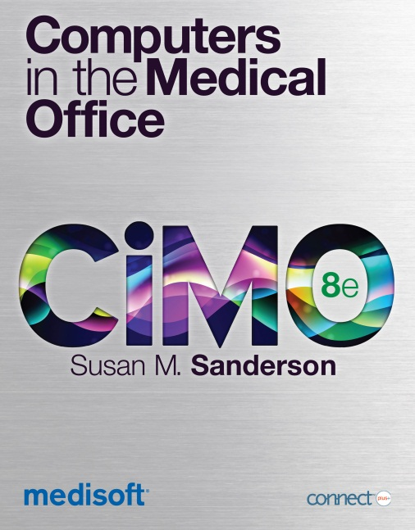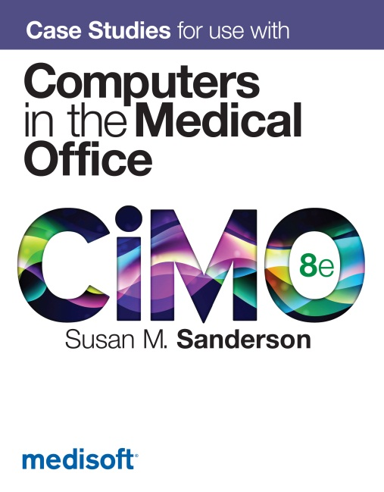

Contents

Chapter 1
Welcome to Medisoft® Version 17

Chapter 2
Installation Options, Part I: Getting Started with the Instructor Version

Chapter 3
Installation Options, Part II: Getting Started with the Student At-Home Version

Chapter 4
Student Data Files

Chapter 5
Instructions on Loading the Student Data File for Case Studies for use with Computers in the Medical Office 8e (CSMO8e) Without Removing the Computers in the Medical Office 8e (CiMO8e) Student Data.

Chapter 6
Backup and Restore

Chapter 7
Using USB Flash Drives

Chapter 8
FAQs: Frequently Asked Questions from Students and Instructors

Chapter 9
Instructor Resources

Chapter 10
Technical Support

Chapter 1 Welcome to Medisoft® Version 17
Here’s what you can expect:
Because you’ve adopted a McGraw-Hill text, we’re providing you with Medisoft Version 17. This guide will walk you through the installation process to help you successfully install both Medisoft and the related student data files.
The following McGraw-Hill titles are compatible with Medisoft Version 17:
Author/Title/ISBNs | Live Medisoft V17 via CD-ROM | Simulated Medisoft V17 via Connect Plus
Sanderson, Computers in the Medical Office (CiMO), 8e  0073402133, 9780073402130 | X | X
Sanderson, Case Studies for use with Computers in the Medical Office, 8e  0077445333, 9780077445331 | X
Newby/Carr, Insurance in the Medical Office: From Patient to Payment, 7e –coming 1/2013  0073374598, 9780073374598 |  | X
Valerius, Medical Insurance: An Integrated Claims Process Approach, 6e –coming 1/2013  0073513717, 9780073513713 |  | X

Note: The complimentary CD you have received with Medisoft Version 17 is for use with McGraw-Hill titles only. Using this software with textbooks by other publishers is prohibited. Unlike our competitors, McGraw-Hill is able to provide our adopters with a special release of Medisoft that will allow your students to utilize the full capabilities of the software the way it is used within a medical practice.


The Instructor Version distributed with our textbooks is a fully functioning version of Medisoft, while the Student At-Home version is a demo version that allows up to 150 patient records to be entered. The demo version available on the Medisoft website allows fewer than 25 new patient records to be entered, which is not enough to complete all the exercises in the text. When the demo version downloaded from the Medisoft website is used and the maximum number of patients is exceeded, patient records begin to disappear without warning.
Need help? Contact McGraw-Hill’s Customer Experience Group (CXG).

Visit the CXG website at www.mhhe.com/support. Browse our FAQs (Frequently Asked Questions) and product documentation, and/or contact a CXG representative.

Call us at 800-331-5094.

General Hours (Central Standard Time)
Monday-Thursday 8:00 A.M. to 11:00 P.M.
Friday 8:00 A.M. to 6:00 P.M.
Sunday 6:00 P.M. to 11:00 P.M.
CXG is available Sunday through Friday.

Editor’s Note:
Our goal in writing this manual was to provide a complete reference document for using Medisoft Version 17. You will notice that various steps/directions are repeated in several different chapters. This cross referencing was intentional. We realize you will likely not read this document cover-to-cover, so material is organized so that you may easily locate complete information pertaining to a specific task. We hope all of this information is helpful to you and your students.

Chapter 2 Installation Options, Part I: Getting Started with the Instructor Version
The following topics are covered in this chapter:
- System Requirements and Compatibility
- Medisoft Version 17 Supported Operating Systems
- Product Options
- Removing a (all) Previous Version(s) of Medisoft
  - Step 1: Removing a Previous Version of Medisoft (v16)
  - Step 2: Removing Previous Medisoft Folders and Data
- Installing Medisoft Version 17
- Downloading the Student Data to Your Computer’s Hard Drive
- IT Security Settings
- Steps for Removing Medisoft Version 17
- Tips for Instructors: Best Practice

System Requirements and Compatibility
Hardware Requirements
Workstation (Minimum)
Single-User/Advanced/Network Professional
Component | Minimum Requirement
CPU (Processor) | Intel Pentium 4 1.0GHz
RAM (Memory) | 1 GB
Storage Space | 500MB
Optical Drive | N/A
Network Card (NIC) | N/A
Screen Display Setting | 32-Bit color display (minimum screen display of 1024 X 768)
External Storage Device | USB flash drive for storing backup copies of the working database

Workstation (Recommended)
Single-User/Advanced/Network Professional
Component | Minimum Requirement
CPU (Processor) | Intel Core 2 Duo 1.6GHz
RAM (Memory) | 2GB (4GB for 64-bit)
Storage Space | 1GB
Optical Drive | DVD-ROM
Network Card (NIC) | 100Mbps
Screen Display Setting | 32-Bit color display (minimum screen display of  1024 X 768)
External Storage Device | USB flash drive for storing backup copies of the working database
Note: Your system must meet the minimum system requirements for the operating system. Please refer to Microsoft’s website for the minimum system requirements for each operating system.

McGraw-Hill and McKesson do not recommend Medisoft be run on a Microsoft Home version operating system. If any issues occur with installing Medisoft using a Home version, students may contact McGraw-Hill's Customer Experience Group (CXG) if assistance is needed. (See chapter 9 for CXG's contact information.) A McGraw-Hill CXG representative can work with students to troubleshoot issues and determine if using a Microsoft Home operating system is feasible. Keep in mind that Medisoft software was developed by McKesson and intended to run within the professional setting of a doctor's office. Students who are running a Home operating system may run into difficulty.
Medisoft Version 17 Supported Operating Systems
Note: Medisoft Version 17 is a 32-Bit application. On a supported 64-Bit platform, the application will run in 32-Bit mode.
Recommended
The following operating systems are recommended for use with Medisoft v17.
Workstation:
Single-User/Advanced/Network Professional
- Windows XP Professional SP3 32-Bit
- Windows 7 Professional 32-Bit
- Windows 7 Professional 64-Bit
- Windows 7 Ultimate 32-Bit
- Windows 7 Ultimate 64-Bit

Supported
Below are additional supported operating systems for use with Medisoft v17.
Workstation
Single-User/Advanced /Network Professional
- Windows Vista Business SP1 32-Bit
- Windows Vista Business SP1 64-Bit

- Microsoft Small Business Server products are not supported
- Microsoft Home operating systems are not supported
- Operating systems not listed are not supported

Again, McGraw-Hill and McKesson do not recommend Medisoft be run on a Microsoft Home version operating system. If a Home version is attempted, students may contact McGraw-Hill's Customer Experience Group (CXG) if assistance is needed.
Product Options
McGraw-Hill Instructor Version | The instructor version of Medisoft distributed with McGraw-Hill textbooks is a fully functioning version of the software. Your students will be able to utilize the full capabilities of the Medisoft software, allowing for an enhanced educational experience and providing students with real knowledge of how the software is used within a medical practice.
McGraw-Hill Student At-Home Version | The Student At-Home Version is a demo version that allows up to 150 patient records to be entered, rather than the 25 allowed by the demo version that can be downloaded directly from McKesson. Students may purchase the Student At-Home Version separately so that they can use the software while off campus.  For complete details about the Student at-Home Version, see Chapter 3 of this guide.

See Chapter 8 for what the Instructor CD and Student CD look like.
Removing a (all) Previous Version(s) of Medisoft
Warning: The information in this manual relates to Medisoft Advanced Version 17. If your campus is using a previous version of Medisoft, you will need to delete all old files before you can successfully install Version 17. Follow these steps to successfully delete a previous version of Medisoft:
- Delete the previous Medisoft program.
- Delete the Medisoft folder located in the Program Files.
- Delete the Medidata folder.
*files are located on the C: drive.
Helpful Tip: If you need to save your old Student Data Files, (Medidata), the following directions indicate how to do so. However, we recommend deletion of all previous files.
Step 1: Removing a Previous Version of Medisoft

1. Click the Start button.

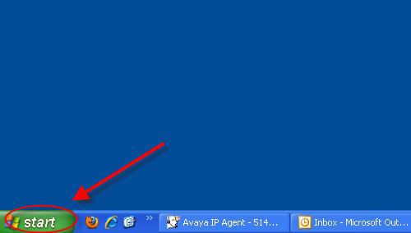
2. Locate and select the Control Panel.

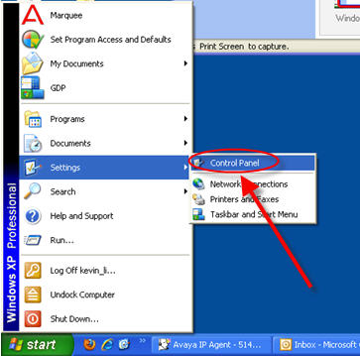
3. Double click Add or Remove Program.

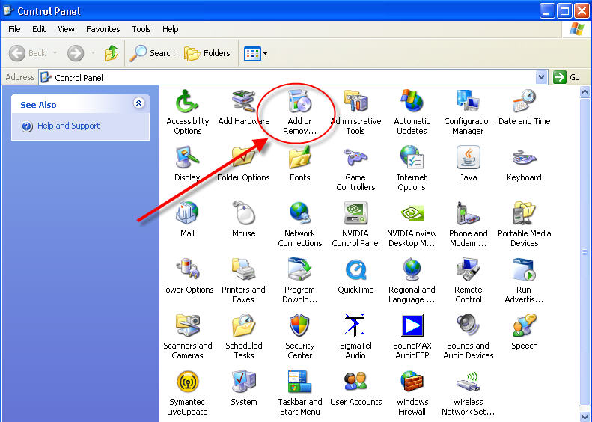
- The list of programs installed on the computer is listed alphabetically. Locate and click Medisoft Advanced 16 from the list of programs. Click Remove. Click Yes at the confirmation to remove the program.

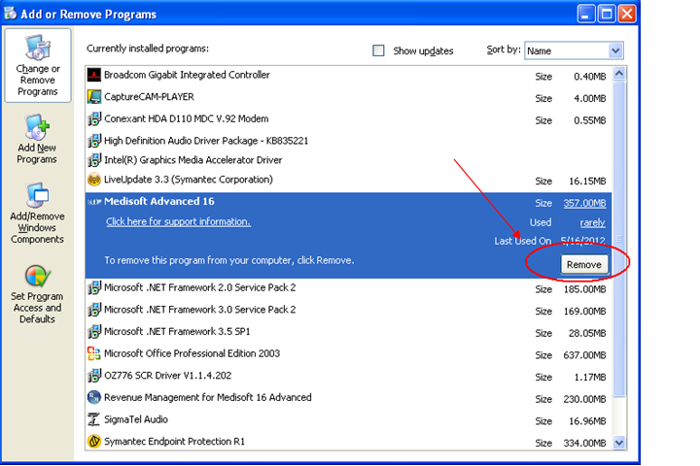

- Next, locate and click Revenue Management for Medisoft 16 Advanced from the list of programs. Click Remove. Click Yes at the confirmation to remove the program.
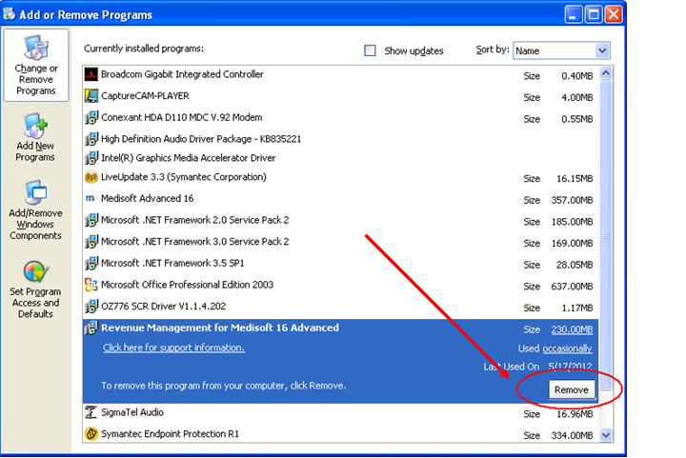
6. Wait until the Uninstall process is complete, and restart your computer.
Step 2: Removing Previous Medisoft Folders and Data

- Double click My Computer (XP) or Computer (Vista or Windows7).

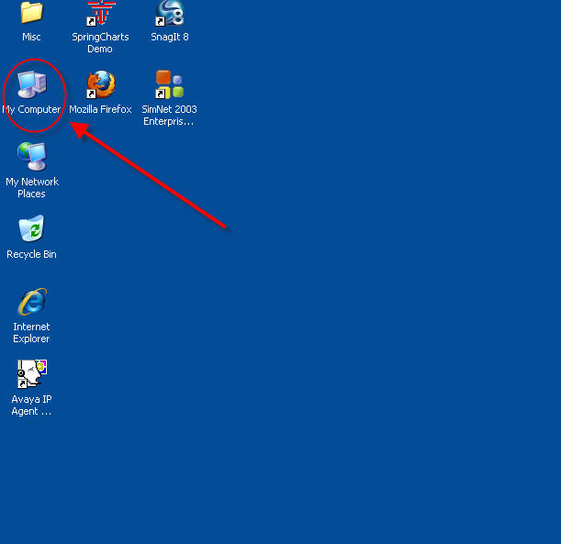

2. Double click Local Disk (C:).
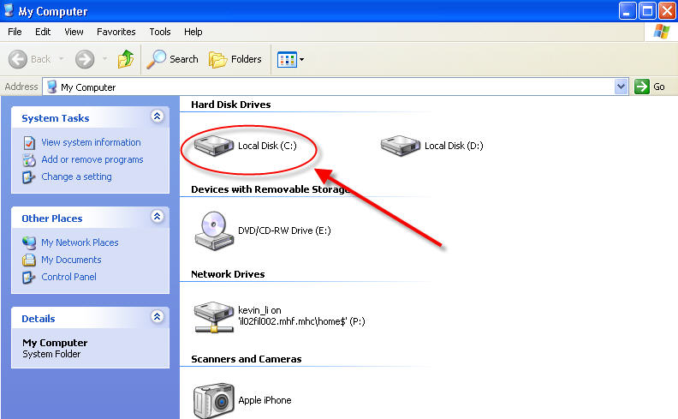
3. Locate the Program Files folder. Double click to open.

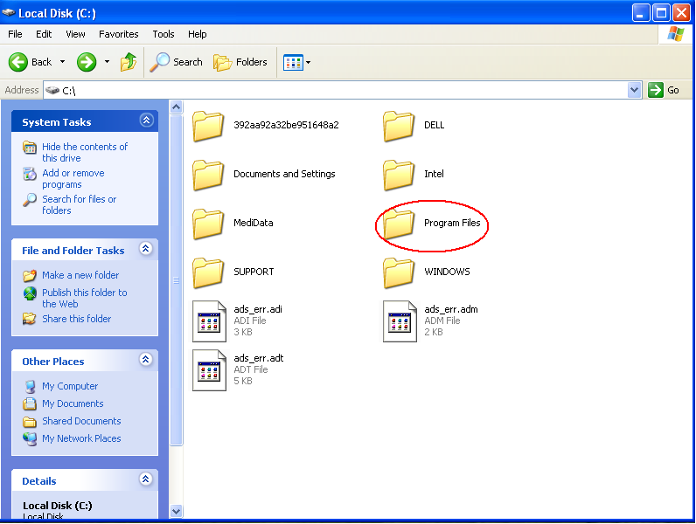

- Right click the Medisoft folder to delete.
*Note: If you have a 64-Bit Operating System, also delete the Medisoft folder from the “Program Files (x86)” folder.
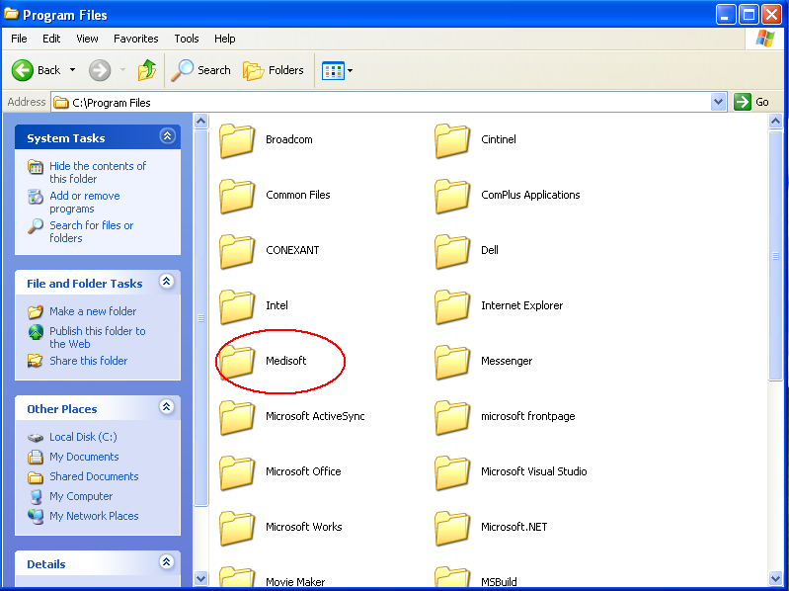

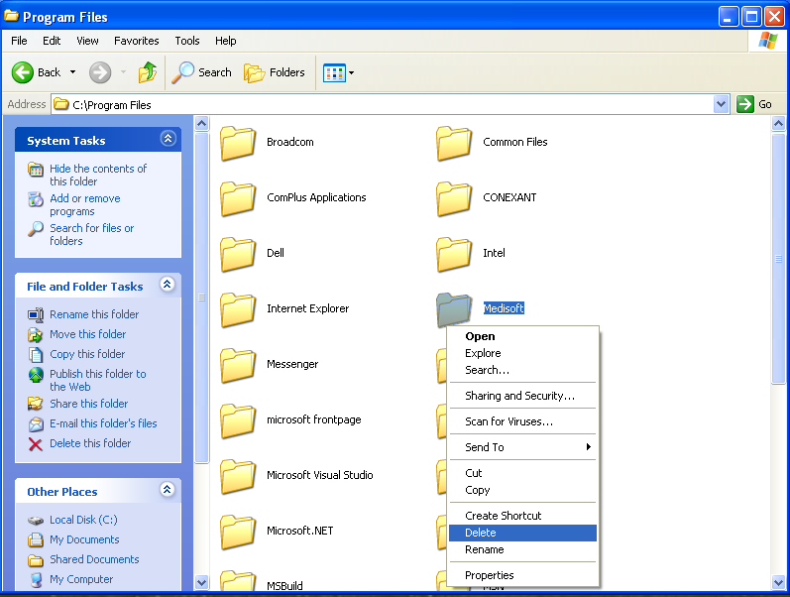
- Locate the Medidata folder on the Local Disk (C:).
If you want to save the Version 16 data, right click the Medidata folder, and click
Rename.
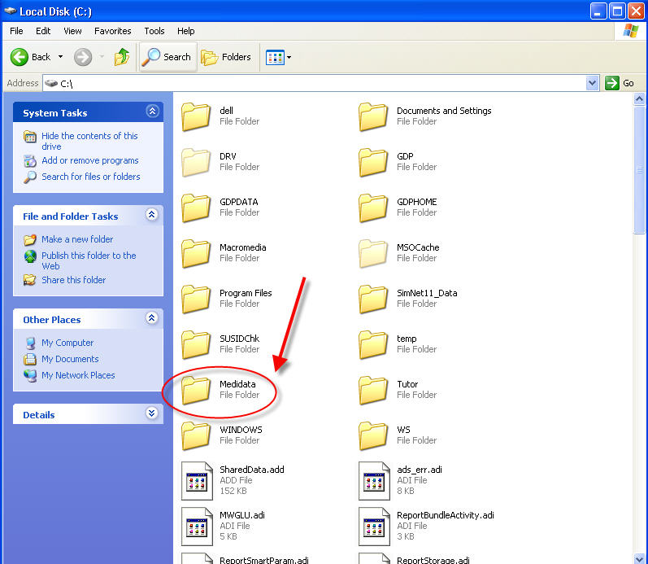

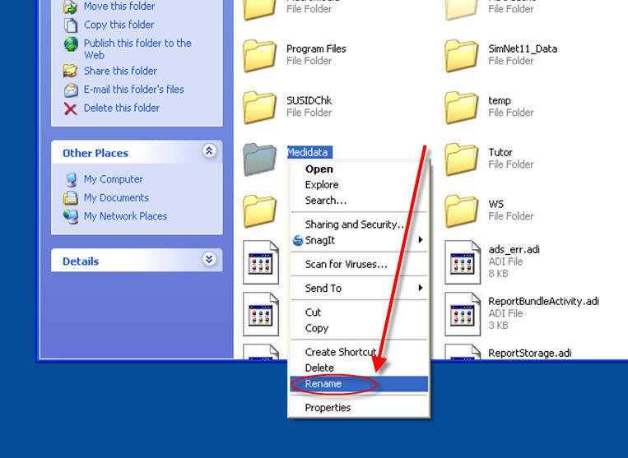

6. Rename the folder “OldMedidata.” (This allows you to keep your previous Medidata folder separate from Medisoft Version 17.)
7. If you want to delete the files completely, right click the Medidata folder, and select Delete.
McGraw-Hill recommends deletion of previous versions of Medidata.
***Be sure to empty the computer’s recycle bin to complete the deletion process.

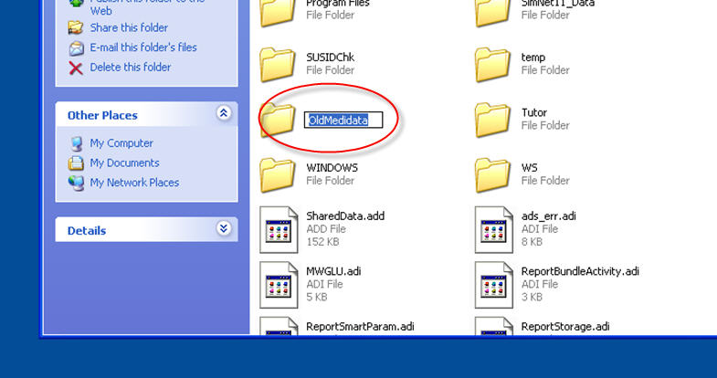

Installing Medisoft Version 17



IMPORTANT: Before beginning the installation process, carefully read these directions, and follow the steps outlined.
Installation Instructions for Medisoft Advanced Version 17, Standard Installation
1. Insert the Medisoft®17 CD in the local CD-ROM drive. The Installation window appears.
Note: If the Installation window does not appear automatically, click Start and select Run. The Run window appears. In the Run window in the Open field, type X:\AUTORUN (where X is your CD-ROM drive letter) and click OK. The Installation window appears.

- In the Installation window, click Install Medisoft.

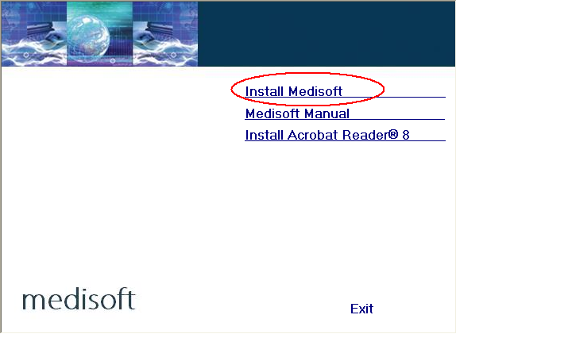
3. In the Welcome window, click Next. The End User License Agreement appears.

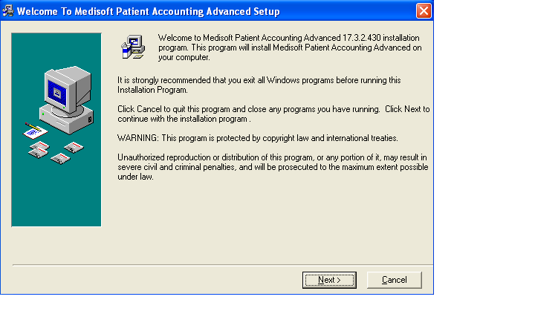
4. In the End User License Agreement window, click the I accept the agreement button. By accepting this agreement and following the installation instructions, you are granted the license. Then click Next.
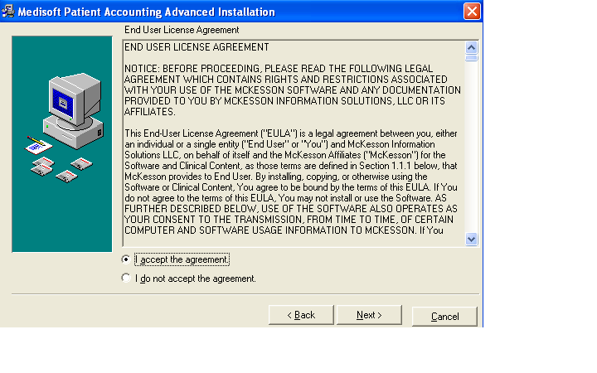
- In the Subscription Agreement window, click the I accept the agreement button, and then click Next.

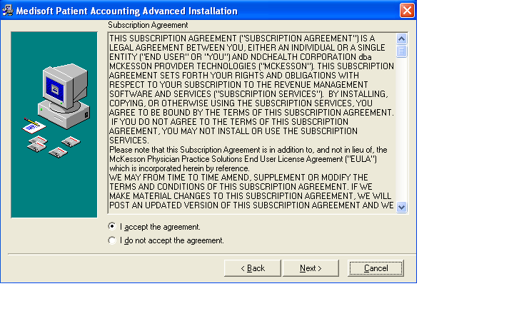

6. In the Select Destination Directory window, click Next. Note: the default setting saves the Medisoft program to the Program Files folder on your computer’s C: drive. (If you are using Windows 7, it may default to the root drive, C:\Medisoft.)
*Note: If you have a 64-Bit Operating System, click Browse and type the following:
C:\Program Files (x86)\Medisoft. Then click Next.
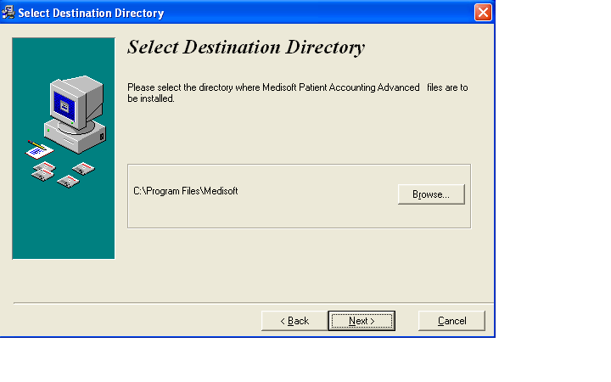
7.. In the Ready to Install window, click Next.

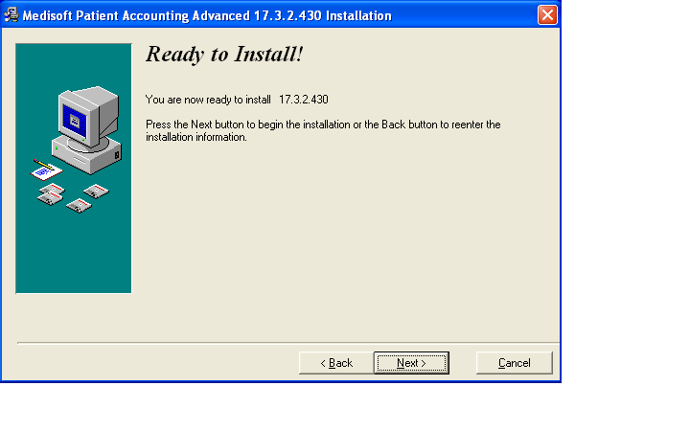
8. The Installing window appears and tracks the progress of the installation. During the installation process, Medisoft Patient Accounting and Revenue Management files will be installed. The next three screen shots show this process.
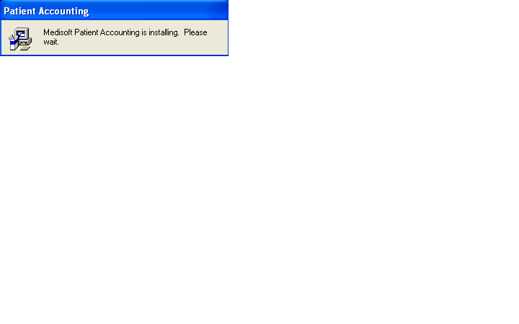

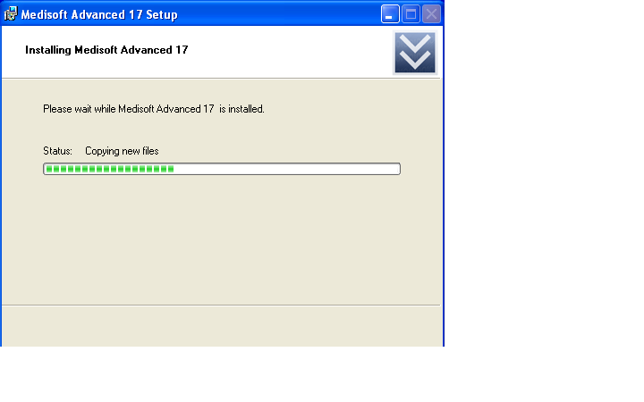

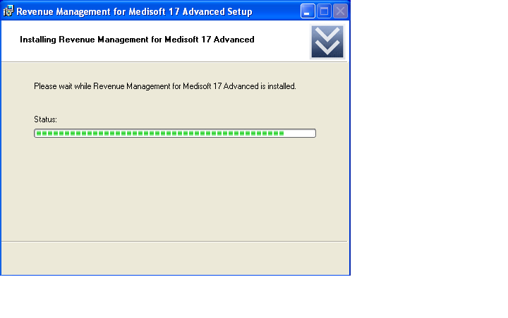
9. The Installation Completed window appears.
Important: Uncheck the Launch Medisoft Patient Accounting Advanced box so that the program does not launch at this time. Click Finish. The installation program closes.

Warning: Do not launch the program after installation. Proceed to the Student Data installation steps. In order to complete assignments in the textbooks, students must install the Student Data File before they can proceed.

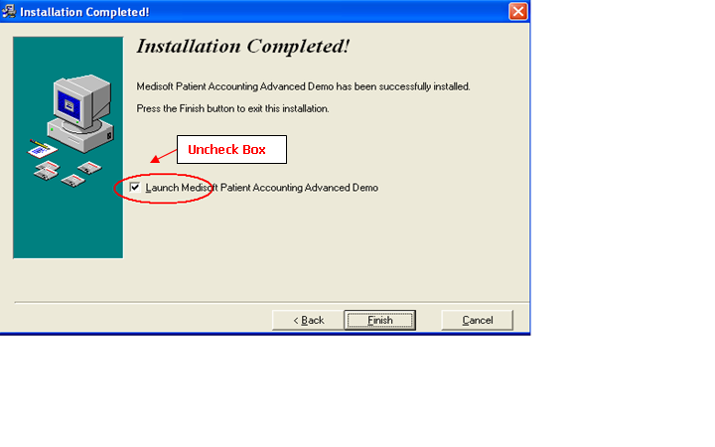
10. When the box is no longer checked. Click Finish.

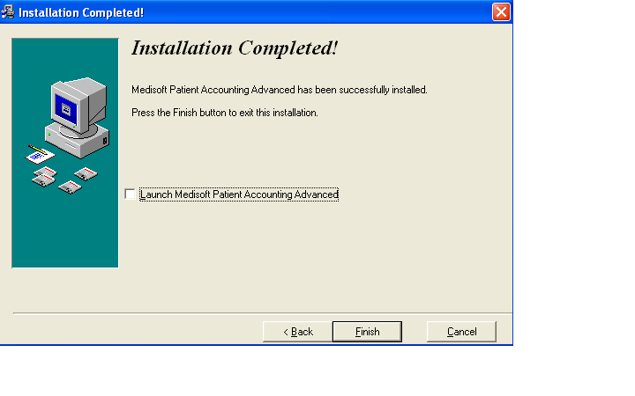
Note: If you have used Medisoft previously (e.g. Version 16) and still have the previous student data file saved on your computer, you will receive a data conversion message the first time Medisoft opens after installation. Consider backing up data before completing data conversion.
If you are working with Medisoft with more than one McGraw-Hill product, each time you open a new practice, that particular practice also needs to be converted. Data conversion must take place until all practices have been converted to the current version.
Downloading the Student Data to Your Computer’s Hard Drive
- Go to your textbook’s Online Learning Center website. The website address (URL) for your textbook is listed in the table on in Chapter 3 of this guide as well as on the back of the textbook.*Note: The following steps use CIMO, 8e to show you what this will look like.

- On the opening screen, you will see this statement: Students, need help with Medisoft or the student data files? Click on the Student Edition link and then the Medisoft CiMO Tools link. This will take you directly to the Medisoft Student Resources page in the student center with the “CiMO8e” Student Data File.

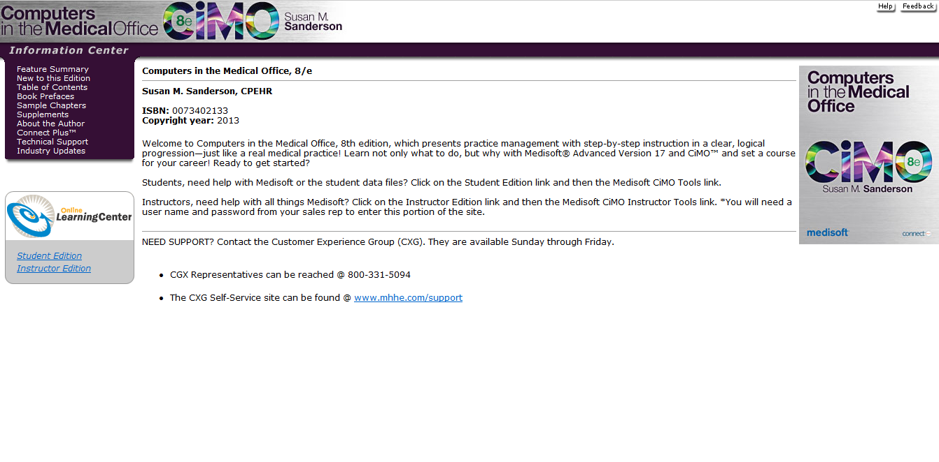
- Click the link for the CIMO8e.zip file and download the file to your computer desktop. This installer provides the patient database you will use to complete the Medisoft exercises in the textbook.
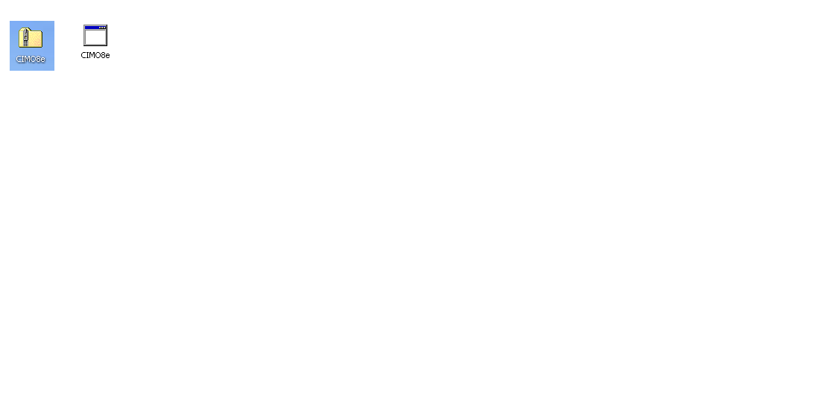
WARNING: Students, before you run the CIMO8e.exe file, be sure that Medisoft is closed and NOT only minimized on your computer!
4. Double-click to open the CIMO8e.zip folder. A file called CIMO8e.exe appears. Double-click CIMO8e.exe to execute it.

5. The Student Data File Installation Wizard begins initializing, and the McGraw-Hill End User License Agreement window opens. When you’ve read the license agreement and accept the terms, click the I Agree button.

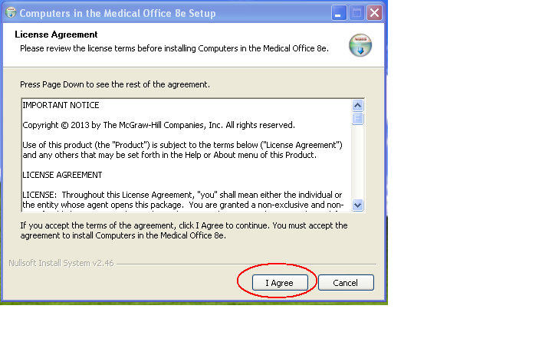
6. You are now ready to begin the installation of the Student Data Files. The installation process will completely overwrite any existing Medidata files. Before you continue with the installation, be sure you want to overwrite the existing Medidata files.
Note: See Chapter 2 for instructions on removing previous data. If you want to save the existing Medidata files on your computer, you will need to save them under a different name, such as C:\OldMedidata.
When you are ready to begin installation of the Student Data Files, click the Install button.

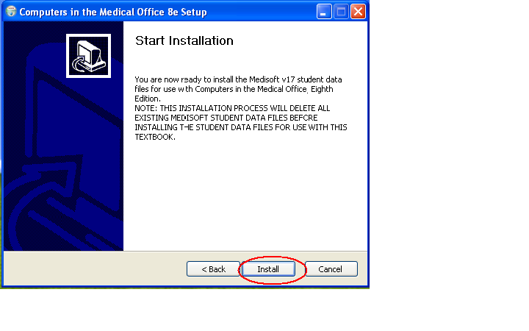
7. The Student Data installation progress bar indicates the progress of the installation.

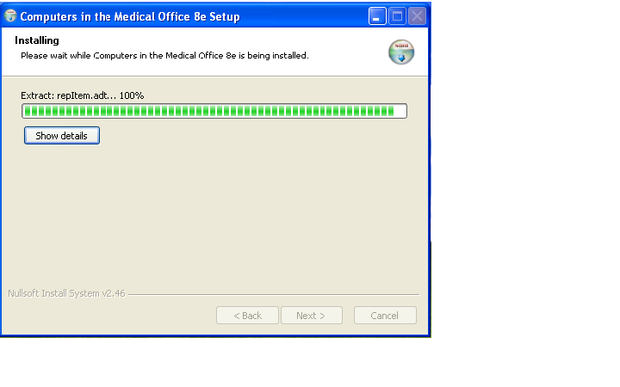
8. Once the Student Data Files are installed, a dialog box indicating the completion of the installation appears. Click the Finish button to close the installation application.

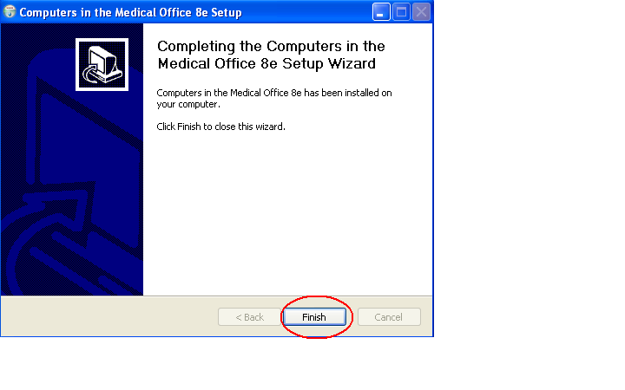
9. You are now ready to use the Student Data Files within Medisoft. To start Medisoft, click the Medisoft Advanced icon on the desktop or by use the Start menu (Start > All Programs > Medisoft > Medisoft Advanced).
IT Security Settings
The Medidata folder located on the C: drive needs to be set to Full Control for the current user.

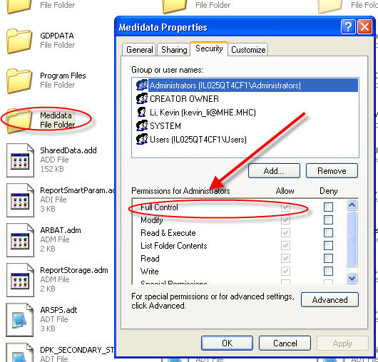

The Medisoft folder located on C: /Program Files/Medisoft also needs to be set to Full Control for the current user.
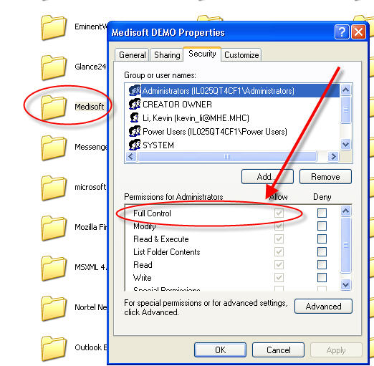

Steps for Removing Medisoft Version 17
This chapter has illustrated the steps to properly install the Instructor Version of Medisoft Version 17 and download the Student Data File located on the Textbook’s Online Learning Center website. If students need to uninstall for any reason, they should follow the steps listed below.
1. Students should open the Control Panel from the Start Menu, and double click the Add/Remove Programs icon. For Windows Vista or Windows 7, they should click the Uninstall a Program link.
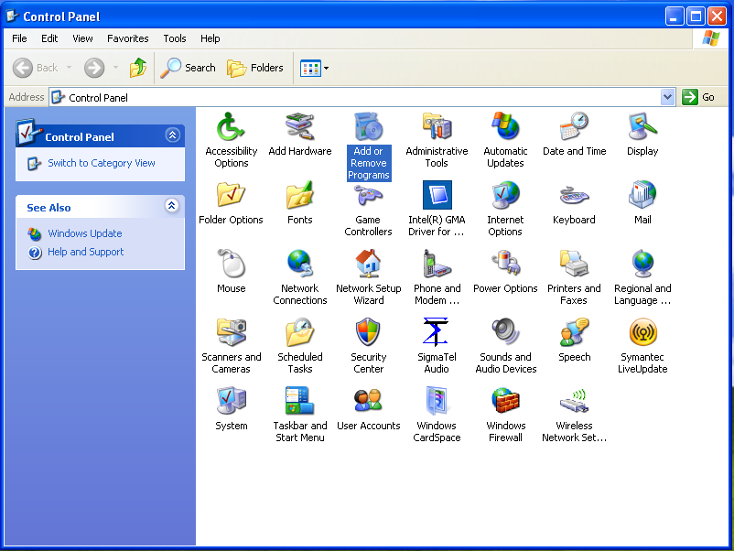
2. You will uninstall Medisoft and the additional programs it uses separately. Locate and click Medisoft Advanced 17. Click Remove. Click Yes at the confirmation to remove the program.
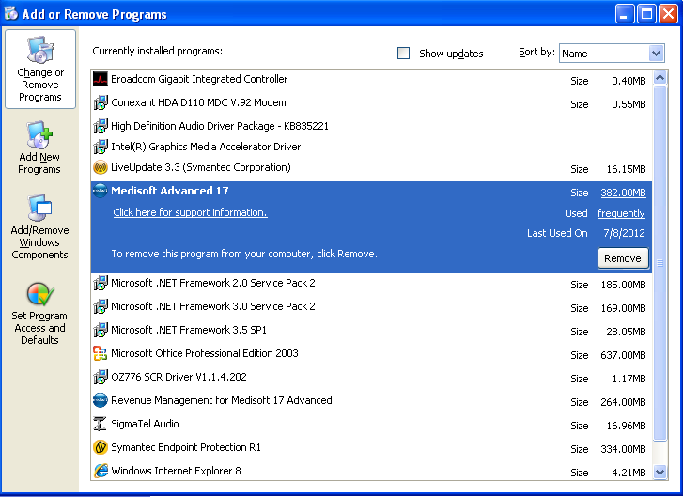
3. Locate and click Revenue Management for Medisoft 17 Advanced. Click Remove. Click Yes at the confirmation to remove the program.
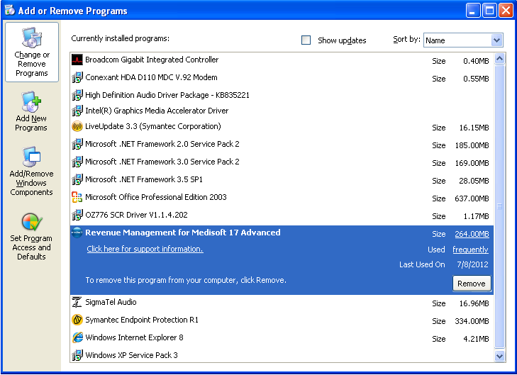
Next Steps—removing the program files and student data:
You will also need to remove the program files and the student data. Detailed directions on how to remove the program files and student data are included at the beginning of this chapter. See the section titled “Removing Previous Medisoft Folders and Data” on page 6. ***And remember, please be sure to empty the computer’s recycle bin to complete the deletion process.

Tips for Instructors: Best Practice
Be sure the program installs completely. And make sure that the files are in the system BEFORE beginning work.
—Ursula Cole, MEd, CMA (AAMA), Platt College

If possible, please close all other programs on your computer before running Medisoft (including email) to allow for optimal performance. For Windows 7 users, make sure to also close the gadgets on your desktop.
—CXG Representative

Chapter 3 Installation Options, Part II: Getting Started with the Student At-Home Version

The following topics are covered in this chapter:
- Common Questions
- System Requirements and Compatibility
- Medisoft Version 17 Supported Operating Systems
- For Instructors: Helpful Information for Getting Students Set Up with the Student At-Home Version
- Step 1: Installing Medisoft Student At-Home Version 17
- Step 2: Downloading the Student Data File
- Steps for Removing Medisoft Version 17

What Is the Student At-Home Version of Medisoft?
The Student At-Home Version is a version that allows up to 150 patient records to be entered. Students may purchase the Student At-Home Version so that they can use the software while off campus. You or your institution may determine that students need to purchase the Student At-Home version. It is used by students taking an online course and by students who complete assignments or practice at home, away from the computer lab. It is also used in self-study courses.
How Do Students Purchase the Student At-Home Version of Medisoft?
The Student At-Home version can be purchased just like a textbook. It can be purchased as a standalone product (ISBN 0077445252, 9780077445256) or as part of a bundle with a McGraw-Hill Medisoft textbook.
Can Students Use the Demo Version of Medisoft Available on the Medisoft Website?
No. The demo version available on the Medisoft website allows for fewer than 25 new patient records to be entered, which is not enough to complete all the exercises in the text. When the demo version downloaded from the Medisoft website is used and the maximum number of patients is exceeded, patient records begin to disappear without warning.
How Does the Version of Medisoft Provided to Instructors for Use on Campus Differ from the Student At-Home Version?
The version of Medisoft that is provided to instructors is the version McKesson (the corporation that develops Medisoft) sells to doctors’ offices. McGraw-Hill’s agreement with McKesson allows this version to be installed on each school-owned computer used by students using a McGraw-Hill Medisoft text on one campus. This does not include computers removed from the campus or owned by students.
Why Is the Student At-Home Version Called a Demo?
Do not be alarmed by the word Demo on the software. This is the full version of the software. “Demo” is a designation from the McKesson Corporation.

System Requirements and Compatibility
Hardware Requirements
Workstation (Minimum)
Single-User/Advanced/Network Professional
Component | Minimum Requirement
CPU (Processor) | Intel Pentium 4 1.0GHz
RAM (Memory) | 1 GB
Storage Space | 500MB
Optical Drive | N/A
Network Card (NIC) | N/A
Screen Display Setting | 32-Bit color display (minimum screen display of 1024 X 768)
External Storage Device | USB flash drive for storing backup copies of the working database

Workstation (Recommended)
Single-User/Advanced/Network Professional
Component | Minimum Requirement
CPU (Processor) | Intel Core 2 Duo 1.6GHz
RAM (Memory) | 2GB (4GB for 64-bit)
Storage Space | 1GB
Optical Drive | DVD-ROM
Network Card (NIC) | 100Mbps
Screen Display Setting | 32-Bit color display (minimum screen display of 1024 X 768)
External Storage Device | USB flash drive for storing backup copies of the working database
Note: Your system must meet the minimum system requirements for the operating system. Please refer to Microsoft’s website for the minimum system requirements for each operating system.
McGraw-Hill and McKesson do not recommend Medisoft be run on a Microsoft Home version operating system. If any issues occur with installing a Home version, students may contact McGraw-Hill's Customer Experience Group (CXG) if assistance is needed. (See chapter 9 for CXG's contact information.) A McGraw-Hill CXG representative can work with students to troubleshoot issues and determine if using a Microsoft Home operating system is feasible. Keep in mind that Medisoft software was developed by McKesson and intended to run within the professional setting of a doctor's office. Students who are running a Home operating system may run into difficulty.
Medisoft Version 17 Supported Operating Systems
Note: Medisoft Version 17 is a 32-Bit application. On a supported 64-Bit platform, the application will run in 32-Bit mode.
Recommended
The following are the recommended operating systems for use with Medisoft v17.
Workstation:
Single-User/Advanced /Network Professional
- Windows XP Professional SP3 32-Bit
- Windows 7 Professional 32-Bit
- Windows 7 Professional 64-Bit
- Windows 7 Ultimate 32-Bit
- Windows 7 Ultimate 64-Bit
Supported
Below are additional supported operating systems for use with Medisoft v17.
Workstation
Single-User/Advanced /Network Professional
- Windows Vista Business SP1 32-Bit
- Windows Vista Business SP1 64-Bit

- Microsoft Small Business Server products are not supported
- Microsoft Home operating systems are not supported
- Operating systems not listed are not supported

Again, McGraw-Hill and McKesson do not recommend Medisoft be run on a Microsoft Home version operating system. If a Home version is attempted, students may contact McGraw-Hill's Customer Experience Team (CXG) if assistance is needed.
For Instructors: Helpful Information for Getting Students Set Up with the Student At-Home Version
If you have students using the Student at-Home Version 17, advise them of the following steps below.
1. The student needs to first install Medisoft Version 17 on his or her personal computer. The Medisoft Version 17 software is on the CD packaged with the textbook. Complete installation directions appear in the next section.
2. The student should download the student data file for Medisoft Version 17 to his or her personal computer. The student data file is located on the textbook Online Learning Center website. The table below lists the McGraw-Hill textbooks that are available with Medisoft Version 17 along with the URL for the textbook’s Online Learning Center. Complete installation directions appear later in this chapter.
Textbook Title, Edition, and ISBNs | Textbook Author | Website URL for Student Data File Installer
Computers in the Medical Office (CiMO), 8e  0073402133,  9780073402130 | Sanderson | www.mhhe.com/cimo8e
Case Studies for Use with Computers in the Medical Office, 8e  0077445333,  9780077445331 | Sanderson | www.mhhe.com/cimo8e
Step 1: Installing Medisoft Student At-Home Version 17
1. Students should close any open applications before installing Medisoft.

2. Students then insert the Medisoft installation CD-ROM into the CD-ROM drive. The CD-ROM contains an autorun function that will automatically open the Medisoft installation window.

If the installation window does not open automatically:

XP users: click the Windows Start Button, and select Run from the Start Menu. Type D:/autorun.exe in the text box (where D is your CD-ROM drive), and click the OK button.

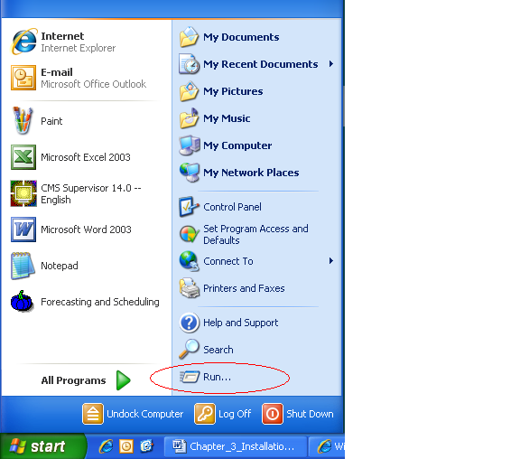

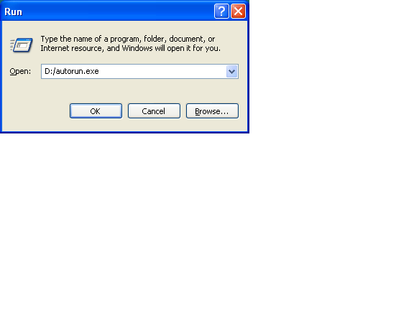

Vista and Windows 7 users: click the Windows Start Button and type E:/autorun.exe in the text box (where E is your CD-ROM drive), and press Enter.

3. In the Medisoft installation window, students should click the Install Medisoft link.
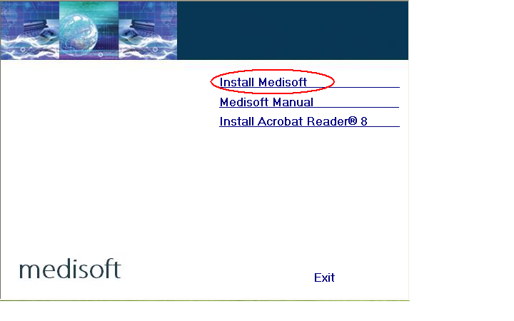
4. A Welcome message appears. Students should click the Next button.
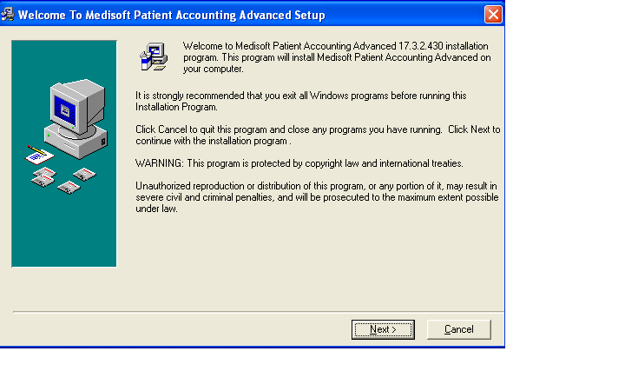
5. The Medisoft End User License Agreement window opens. When the student has read the license agreement and accepted the terms, the students should click the I accept the agreement button and then click Next.
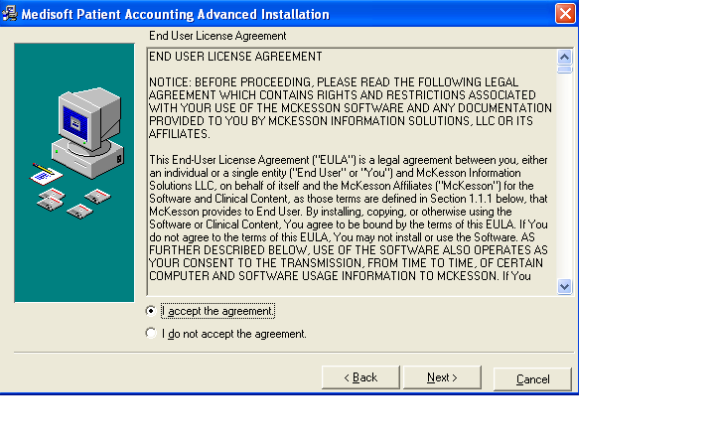
6. The Subscription Agreement window opens. In the Subscription Agreement window, students should click the I accept the agreement button, and then click Next.
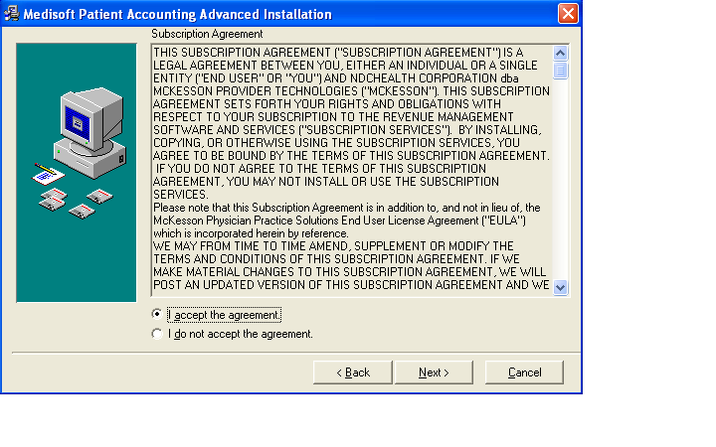
7. In the Select Destination Directory window, click Next. Note: the default setting saves the Medisoft program to the Program Files folder on your computer’s C: drive. (If you are using Windows 7, it may default to the root drive, C:\ Medisoft DEMO.)
*Note: If you have a 64-Bit Operating System, click Browse and type the following:
C:\ProgramFiles (x86)\Medisoft DEMO. Then click Next.
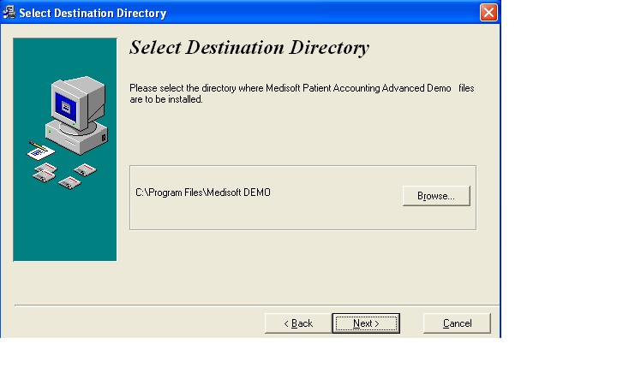
8. Students are now ready to begin the installation of the Medisoft software. They should click the Next button to begin the installation.
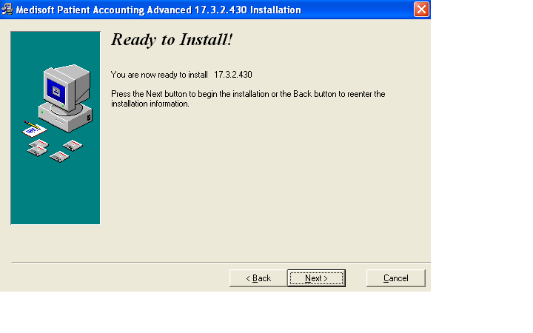
9. The Medisoft installation progress bar indicates the progress of the installation. During the installation process, Medisoft Patient Accounting and Revenue Management files will be installed.
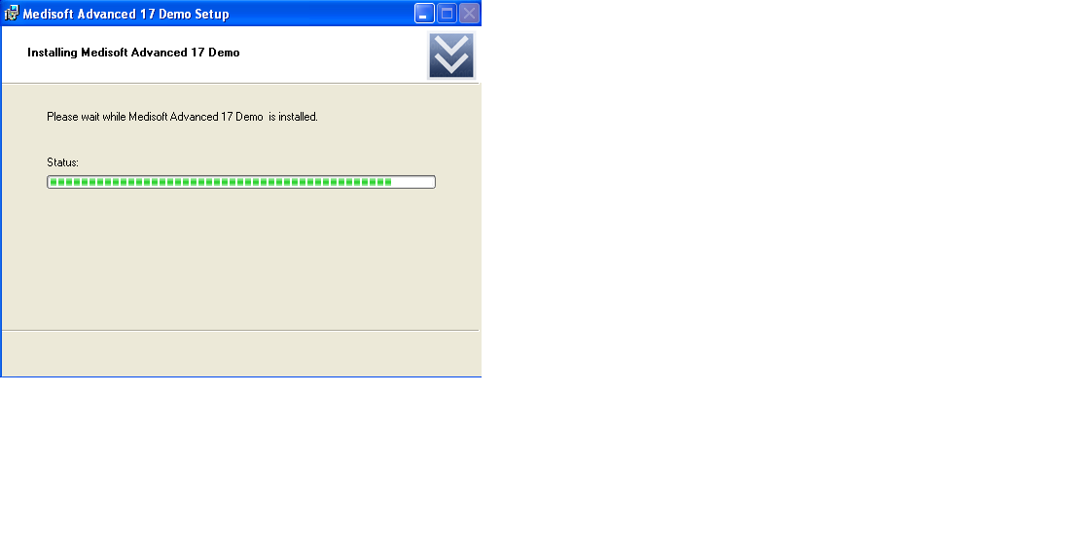

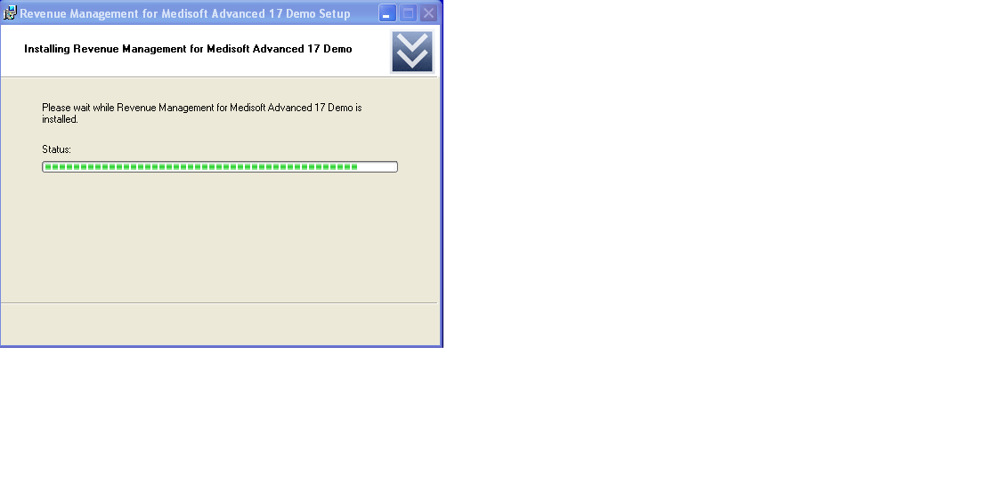
10. The Installation Completed window appears.

Important: Uncheck the Launch Medisoft Patient Accounting Advanced box so that the program does not launch at this time. Click Finish. The installation program closes.
Warning: Do not launch the program after installation. Proceed to the Student Data File installer steps. In order to complete assignments in the textbooks, you must install the student data file before you can proceed.

11. When the box is no longer checked, click Finish.
12. When the Medisoft installation application has closed, students should click the Exit link on the Medisoft installation window.
Step 2: Downloading the Student Data File
- Go to the Online Learning Center website www.mhhe.com/cimo8e.

- On the opening screen, you will see this statement: Students, need help with Medisoft or the student data files? Click on the Student Edition link and then the Medisoft CiMO Tools link. This will take you directly to the Medisoft Student Resources page in the student center with the “CiMO8e” Student Data File.

- Click the link for the CiMO8e.zip file and download the file to your computer desktop. This installer provides the patient database you will use to complete the Medisoft exercises in the textbook.
WARNING: Students, before you run the CIMO8e.exe file, be sure that Medisoft is closed and NOT only minimized on your computer!

4. Double-click to open the CIMO8e.zip folder; a file called CIMO8e.exe appears. Double-click CIMO8e.exe to execute it.

5. The Student Data File Installation Wizard begins initializing, and the McGraw-Hill End User License Agreement window opens. When students have read the license agreement and accept the terms, they should click the I Agree button.

6. Students are now ready to begin the installation of the Student Data Files. It is important to note that the installation process will completely overwrite existing Medidata files. Before students continue with the installation, be sure they want to overwrite the existing Medidata files.
*Refer to chapter 2, pages 9-10 for complete details on saving Version 16 data.
When they are ready to begin the installation of the Student Data Files, they should click the Install button.

7. The Student Data File installation progress bar indicates the progress of the installation.

8. Once the Student Data Files are installed, a dialog box indicates the completion of the installation. Students should click the Finish button to close the installation application.
9. Students are now ready to use the Student Data Files within Medisoft. They should start Medisoft by clicking the Medisoft Advanced icon on the desktop or by using the Start menu (Start > All Programs > Medisoft > Medisoft Advanced).
10. The main Medisoft window appears with the Open Practice dialog box displayed, and the CIMO8e practice selected. To open the CIMO8e practice data, students should click the OK button.
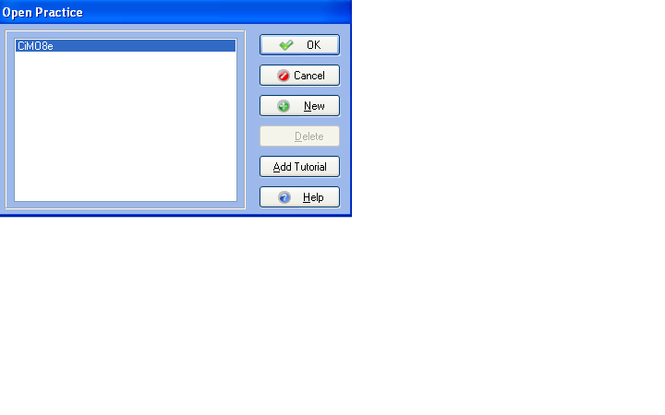

11. When students click the OK button, the dialog box closes, and the title bar at the top of the Medisoft window displays Medisoft Advanced 17 – CIMO8e, indicating that the CIMO8e student data is now loaded.

When you open the CiMO8e practice, you may receive a message regarding duplicate reports. If you see this message, simply click Yes to All. The practice will open and you will not be prompted again.
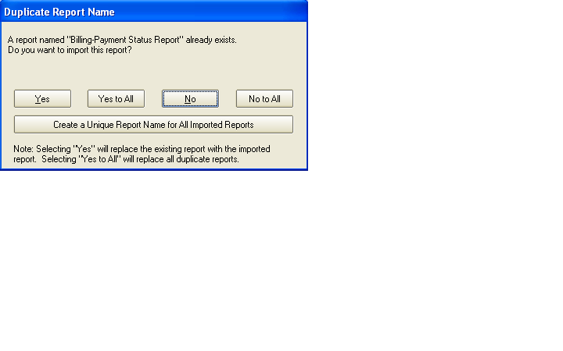

WARNING!
  - DATA PROGRESSES WITH EACH CHAPTER.

As students use the Medisoft software, their answers (data) build in each progressive chapter. Before students go on to a new chapter, their data should be correct so as to avoid issues in later chapters. Incorrect answers prohibit the student from moving forward effectively with the software, and instructors should encourage students to correct their work.
However, there is a chapter backup tool for data restoration if a student inputs incorrect answers and does not correct his or her work. The backup and restore feature ensures that students are able to progress through the text exercises correctly. The backup tool is password protected on the Instructor’s Edition of the Online Learning Center website. Contact your McGraw-Hill sales representative for instructor access to the Online Learning Center website. For complete details on the data restoration tool for instructors, see Chapter 8 in this guide.

Steps for Removing Medisoft Version 17
This chapter has illustrated the steps to properly install the Student At-Home Version of Medisoft Version 17 and download the Student Data File located on the Textbook’s Online Learning Center website. If students need to uninstall for any reason, they should follow the steps listed below.
1. Students should open the Control Panel from the Start Menu, and double click the Add/Remove Programs icon. For Windows Vista or Windows 7, they should click the Uninstall a Program link.
2. Locate and click Medisoft Advanced 17 Demo. Click Remove. Click Yes at the confirmation to remove the program.

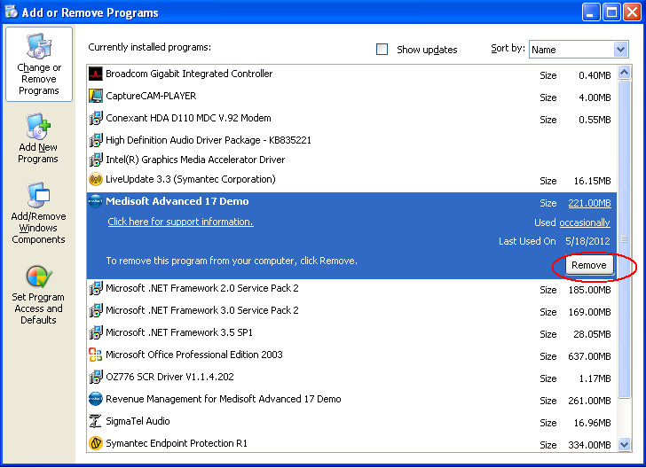

3. Next locate and click Revenue Management for Medisoft 17 DEMO. Click Remove. Click Yes at the confirmation to remove the program.
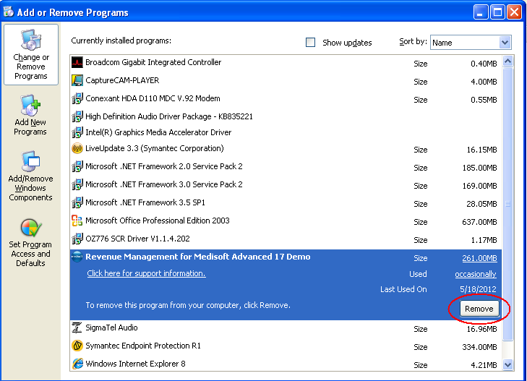

Next Steps—removing the program files and student data:
You will also need to remove the program files and the student data. Detailed directions on how to remove the program files and student data are included in chapter 2. See the section titled “Removing Previous Medisoft Folders and Data” on page 6. ***And remember, please be sure to empty the computer’s recycle bin to complete the deletion process.

TIP:
If possible, please close all other programs on your computer before running Medisoft (including email) to allow for optimal performance. For Windows 7 users, make sure to also close the gadgets on your desktop.
—CXG Representative

Chapter 4 Student Data Files
What Are the Student Data Files?
These data files contain the patients’ personal and medical information that will be used throughout the course. Student Data Files are specific to each McGraw-Hill textbook.
Where Do I Find the Student Data Files?
The Student Data Files are located in the textbook’s Online Learning Center. An executable file (.exe) installs the data files on students’ computers. The Student Data Files need to be installed one time only. Your students will then modify the information as they work through the course.
The table below lists the McGraw-Hill textbooks that are available with Medisoft Version 17 and the URL for each textbook’s Online Learning Center.
Textbook Title, Edition, and ISBNs | Textbook Author | Website URL for Student Data File Installer
Computers in the Medical Office (CiMO), 8e  0073402133, 9780073402130 | Sanderson | www.mhhe.com/cimo8e
Case Studies for use with Computers in the Medical Office, 8e  0077445333, 9780077445331 | Sanderson | www.mhhe.com/cimo8e
How Do I Download the Student Data Files?
Helpful Hints
- Before downloading the Student Data Files, be sure Medisoft is installed.
- The directions and screen shots below relate to CiMO, 8e. Exact files names will vary based on your textbook.

Note: Reminder to Students: Open the student data files using Medisoft. Do not attempt to open the student data file outside of the Medisoft program.

Downloading the Student Data to Your Computer’s Hard Drive
- Go to your textbook’s Online Learning Center website. The website address (URL) for your textbook is listed in the table on in Chapter 3 of this guide as well as on the back of the textbook.*Note: The following steps use CIMO, 8e to show you what this will look like.

- On the opening screen, you will see this statement: Students, need help with Medisoft or the student data files? Click on the Student Edition link and then the Medisoft CiMO Tools link. This will take you directly to the Medisoft Student Resources page in the student center with the “CiMO8e” Student Data File.

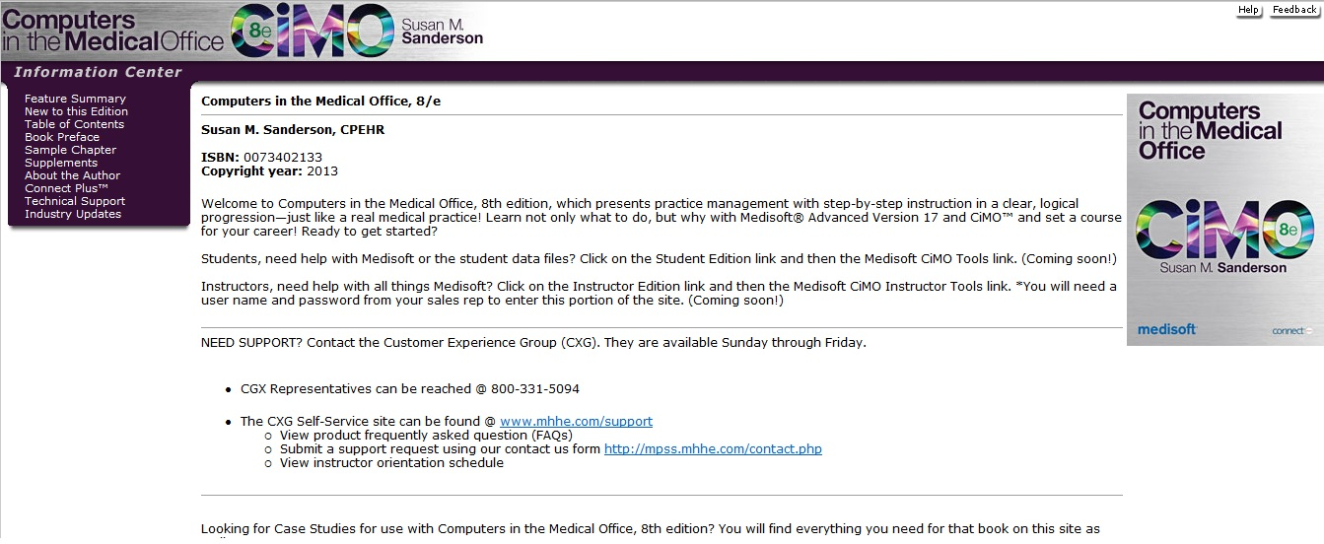

- Click the link for the CIMO8e.zip file and download the file to your computer desktop. This installer provides the patient database you will use to complete the Medisoft exercises in the textbook.
WARNING: Students, before you run the CIMO8e.exe file, be sure that Medisoft is closed and NOT only minimized on your computer!
4. Double-click to open the CIMO8e.zip folder. A file called CIMO8e.exe appears. Double-click CIMO8e.exe to execute it.

5. The Student Data File Installation Wizard begins initializing, and the McGraw-Hill End User License Agreement window opens. When you’ve read the license agreement and accept the terms, click the I Agree button.

6. You are now ready to begin the installation of the Student Data Files. The installation process will completely overwrite any existing Medidata files. Before you continue with the installation, be sure you want to overwrite the existing Medidata files.
Note: See Chapter 2 for instructions on removing previous data. If you want to save the existing Medidata files on your computer, you will need to save them under a different name, such as C:\OldMedidata.
When you are ready to begin installation of the Student Data Files, click the Install button.

7. The Student Data installation progress bar indicates the progress of the installation.

8. Once the Student Data Files are installed, a dialog box indicating the completion of the installation appears. Click the Finish button to close the installation application.

9. You are now ready to use the Student Data Files within Medisoft. To start Medisoft, click the Medisoft Advanced icon on the desktop or by use the Start menu (Start > All Programs > Medisoft > Medisoft Advanced).
10. The main Medisoft window appears with the Open Practice dialog box displayed, and the CIMO8e practice selected. To open the CIMO8e practice data, click the OK button.

11. When you click the OK button, the dialog box closes, and the title bar at the top of the Medisoft window displays Medisoft Advanced – CIMO8e, indicating that the CIMO8e student data is now loaded.

When you open the CiMO8e practice, you may receive a message regarding duplicate reports. If you see this message, simply click “Yes to All.” The practice will open and you will not be prompted again.
Mapping the Database to Medisoft
If you have successfully installed Medisoft but your computer freezes after you have attempted to run the program, (by double clicking the Medisoft icon on your computer) you will need to manually map the database. This issue has been reported by some Vista and Windows 7 users.

To map the database to Medisoft, hold the F7 key on your keyboard while double clicking the Medisoft Advanced icon on the desktop or use the Start menu (Start > All Programs > Medisoft > Medisoft Advanced). Click Browse.

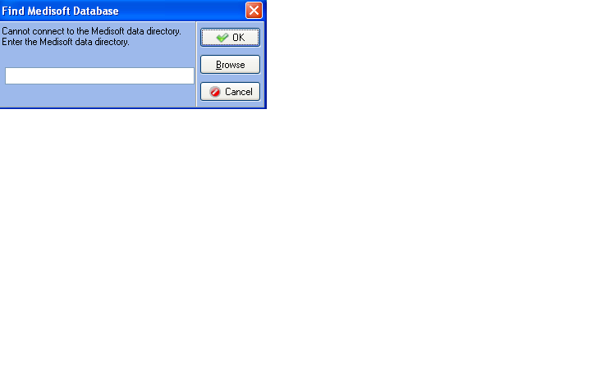
Double click the MediData file (located on the C:\ drive.)
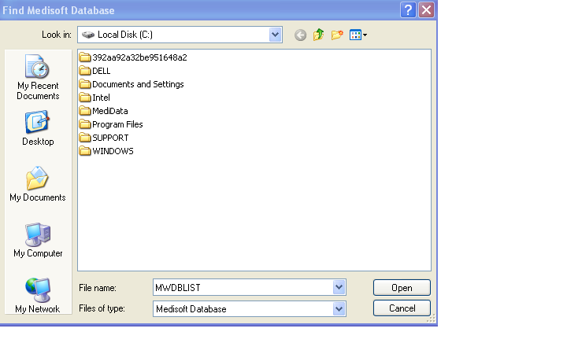
Click on the file named MWDBList.ADT and click Open.
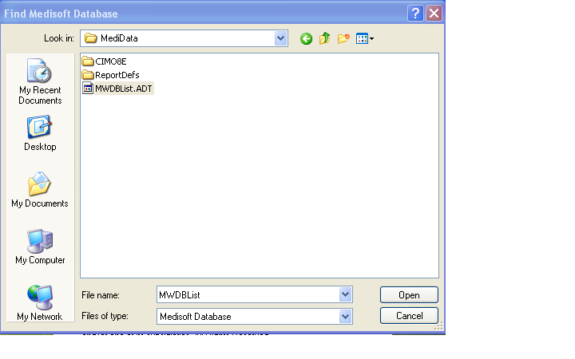
You will see the database listed in the dialog box. Click Ok.
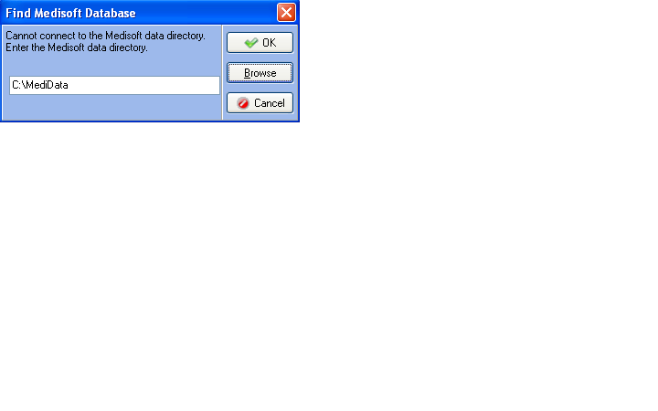
Chapter 5: Instructions on Loading the Student Data File for Case Studies for use with Computers in the Medical Office 8e (CSMO8e) Without Removing the Computers in the Medical Office 8e (CiMO8e) Student Data.
Background: The Medisoft student data files associated with each McGraw-Hill textbook that uses Medisoft Version 17 software contain the patients’ personal and medical information that will be used throughout each course. Each data file is specific to the textbook with which it is associated. The Student Data File installer, located at each textbook’s Online Learning Center, are executable files that install the data files on students’ computers. Because the Student Data File installers are designed to set up only one practice at a time in Medisoft, each time an installer is used to load data, the practice setup for the previous practice is erased.
Therefore, if your computer contains the practice data for CiMO8e, and you want to set up the practice data for CSMO8e without erasing the CiMO8e practice, you need to follow the instructions below rather than use the Case Studies Student Data File installer. The instructions take you through the steps of creating the Medisoft practice setup for CSMO8e manually so that you do not erase the CiMO8e practice setup; then you restore the Case Studies student data using a backup file called CSMO8e.mbk. After you follow the instructions below, both the CIMO8e and the CSMO8e practices will be listed in the Open Practice dialog box in Medisoft, and you will be able to switch between them simply by selecting the desired practice name.
NOTE: Whether or not you use the Case Studies Student Data File installer, it is important to understand that the Medisoft backup files (files with the .mbk extension) that you create while doing the exercises in CiMO 8e are not erased when you run the Case Studies installer. Medisoft backup files (usually located in a folder under C:\ . . . \My Documents) are always stored separately from the program’s setup files, which are located on the C: drive at C:\Medidata. However, you will not be able to access your Medisoft backup files for CiMO until you run the CIMO8e installer again to recreate the CIMO8e practice setup. Once you have the CIMO8e practice set up (CIMO8e will be displayed in the Open Practice dialog box rather than CSMO8e), you can restore your latest backup file using the Restore option on the file menu.
Instructions: Follow these steps to create a new practice in Medisoft called CSMO8e and restore the Medisoft backup file containing the Case Studies student data (CSMO8e.mbk). These steps will load the student data for Case Studies without removing the CiMO practice setup and student data.
- Download the file CSMO8e.mbk from the textbook’s Online Learning Center to a folder on your hard drive where you will be saving your work. For example, C:\My Documents\Case Studies 8e.

- From the Windows desktop, while holding down the F7 key, use the Start menu to open the Medisoft program as follows: Click Start > All Programs > Medisoft > Medisoft Advanced. When the Find Medisoft Database dialog box appears, release the F7 key.

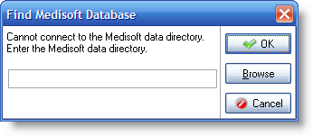
- Enter C:\Medidata in the Find Medisoft Database dialog box, and click OK.
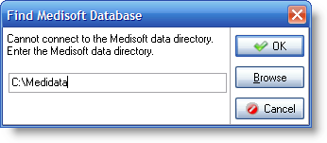
- The Open Practice dialog box appears, listing the name(s) of the current data sets. Click the New button to create a new data set.
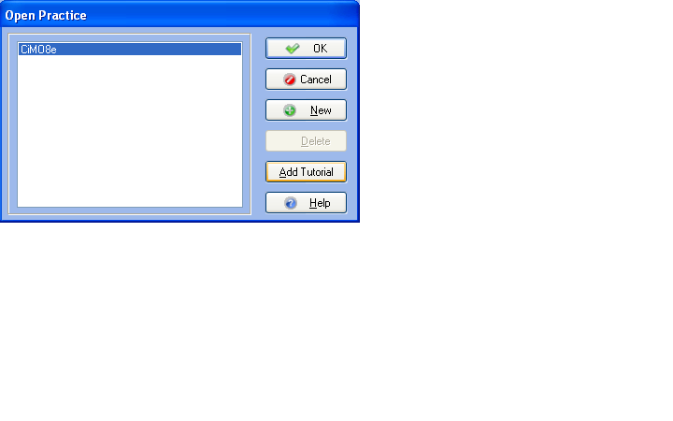
(Note: If no data sets have been created in C:\Medidata, an Information dialog box will appear instead, displaying the message, “This is not an existing root directory. Do you want to create a new one?” Click Yes. When the Create Data dialog box is displayed, click the Create a New Set of Data option.)

- The Create a New Set of Data dialog box appears. In both the upper and lower boxes, key CSMO8e. Then click the Create button.
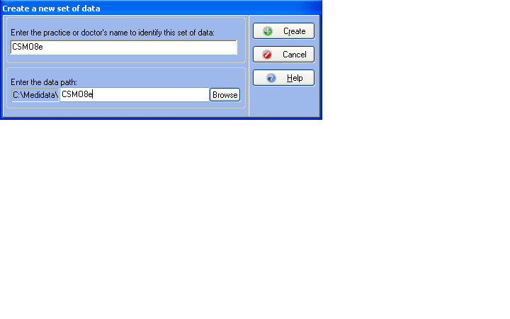
- A Confirm dialog box is displayed. Click the Yes button to confirm that you want to create the new directory.
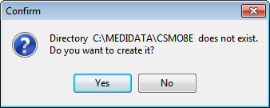
- After several moments, the Practice Information dialog box appears. In the Practice Name box, key Polaris Medical Group. The remaining boxes can remain blank.

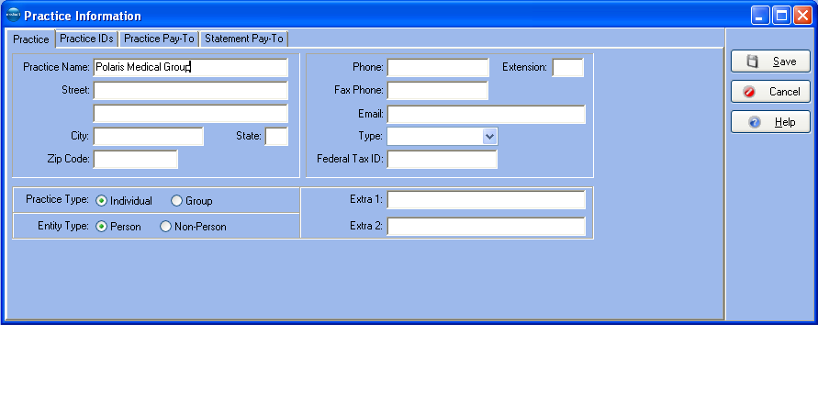
- Click the Save button. The main window of the Medisoft program is displayed with the name of the new data set, CSMO8e, listed on the title bar.

- To restore the CSMO8e.mbk file from its storage place on your hard drive to the new data set, first open the File menu and select Restore Data. When the Warning dialog box is displayed, click OK.
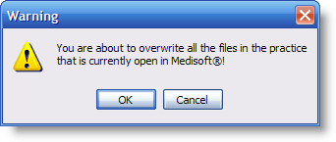
- The Restore dialog box appears. In the Backup File Path and Name box at the top of the dialog box, use the Find button to locate the folder on the hard drive where you stored the CSMO8e.mbk file (in step 1 above). With the appropriate folder selected, click the OK button.

- When you click OK, the CSMO8e.mbk file is listed in the Existing Backup Files box.

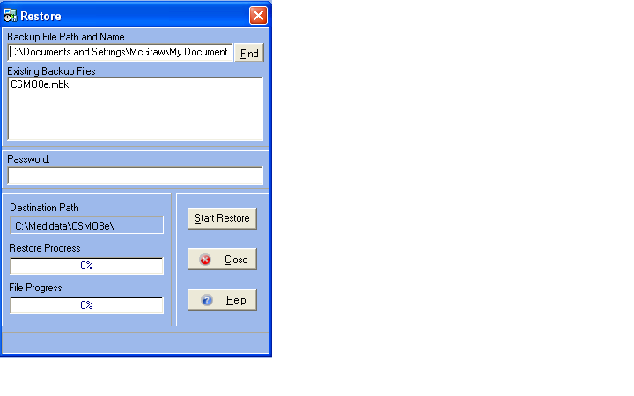
- Click on the CSMO8e.mbk file in the Existing Backup Files box to select it, and then click the Start Restore button.
- When the Confirm dialog box is displayed, click OK.
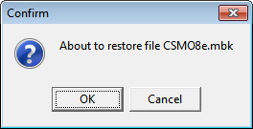
- After the database is restored, a message appears, indicating that the restore is complete. Click OK.
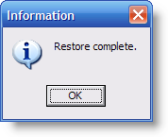
- Click the Close button to close the Restore dialog box.
- The Restore dialog box closes. The CSMO8e database is now ready for use.

Tips for Instructors: Best Practice
“It is important when students are beginning their work, to open up the right medical practice. (student data files) This can be verified by looking at the top of the screen and it will say CSM08e or CIMO8e. This needs to be done before restoring their work.”
“Having both practices is great for schools that use files in two different classes or use both books in one class. Students can continue practice in the CIMO files while working in Case Studies.”
“As an instructor using two data files I always include a suffix at the end when backing up the days work and save by date as I am sometimes working with two different files on the same day. Example: Chp30626csmo and Chp20626cimo”
—Susan Holler, MSEd, CMRS, Bryant and Stratton College

Chapter 6 Backup and Restore
Data Progresses with Each Chapter
Warning!
As students use the Medisoft software, their answers become part of the data in each progressive chapter. Before students begin a new chapter, their data should be correct. Incorrect answers prohibit the student from moving forward effectively.
Instructors should encourage students to correct their work. However, there is a chapter backup tool for data restoration that can be used if a student inputs incorrect data and does not enter corrections. The backup tool is password protected on the Instructor’s Edition of the Online Learning Center website. Contact your McGraw-Hill sales representative for instructor access to the website. For complete details on the data restoration tool, see Chapter 8 in this guide.
How Do Students Back Up Their Work?
When entering data in Medisoft, students should back up their work regularly. We recommend backing up after each chapter or whenever a student ends a work session. If students don’t finish a full chapter by the time class ends for the day, they should back up the work they have completed.
A backup copy of the database files prevents students’ work from being lost if the hard drive fails or if they accidentally delete data while working. If your students are working in an instructional environment where they share computers, such as in a computer lab, it is essential that they back up their work on exiting the program and then restore it at the beginning of the next session, to be sure they are working with their own data.
When backing up data, have students follow these steps:
1. In Medisoft, students can back up their data at any time using the Backup Data option on the File menu. However, by default, Medisoft also gives students the option to back up their data each time they exit the program.
2. Click the Exit option on the File menu to exit Medisoft. The Backup Reminder dialog box appears.

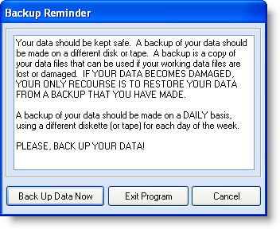
3. To begin the backup process, students should click the Back Up Data Now button.
4. The Medisoft Backup dialog box appears. Students should back up their data to the folder where they will be storing their coursework. In this example, the folder C:\ …\My Documents\CIMO\ is used. If the Destination File Path and Name box at the top of the dialog box does not show the correct folder, students should use the Find button to locate the correct folder on their computer.
Once the correct destination folder is displayed in the Medisoft Backup dialog box, students are ready to key in their own backup file name at the end of the path name . In this example, the file name StudentID-c4.mbk is used (based on the Student’s ID, the chapter in the CiMO 8e textbook they are working on, and the .mbk extension.) File naming conventions will vary depending on how students organize their work.
(NOTE: The extension .mbk stands for Medisoft Backup Data file. All Medisoft backup files must end with this extension.)
5. Depending on the last time the program was used, and whether a backup file already exists in the destination folder, the end of the path may or may not display a file with the .mbk extension. To check whether a backup file name exists (it will also be displayed in the Existing Backup Files box in the dialog box), press the right arrow key on the keyboard to move the cursor to the end of the path name. If no file with a .mbk extension appears, students should simply key in the new file name, Student ID-c4.mbk, inserting their ID number for “Student ID.” If a backup file is already displayed, they should use the backspace key to delete the old file name and key in the new name.

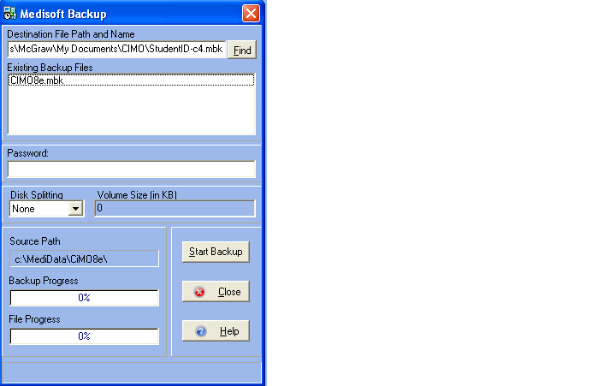

The end of the path should now read: \StudentID-c4.mbk. (NOTE: the file CIMO8e.mbk displayed in the Existing Backup Files box in this example is an already existing backup file in the CIMO folder).
6. Students should click the Start Backup button. Medisoft backs up the data under the new name and displays an Information box indicating that the backup is complete. They should not close out of the dialog box until the status bar is at 100%.
Students should be careful to select the correct file from their flash drive to restore from their existing backup files.
7. Students should click the OK button to close the Information dialog box and then click the Close button to close the Backup dialog box. To exit the Medisoft program, they should click Exit on the File menu.
Why Should Students Backup Their Data?
For safekeeping, students should copy their new backup file from the current drive on the computer to an external storage device, such as a flash drive or a CD-ROM. Having a separate backup copy prevents their work from being lost if the current drive fails or if they or someone else accidentally deletes data on the computer.
Students should create a backup file of their work each time they have completed a chapter. In the real world, they will need to know how to back up and restore data to comply with HIPAA regulations.
How Can Students Restore Their Data?
If students are sharing a computer with other students in an instructional environment, it is essential that they back up their work on exiting the program and then restore it at the beginning of the next sessions so that they will be sure that they are working with their own data. If your students are sharing a computer, have them follow these steps to restore their latest backup file before each Medisoft session.
To restore the file StudentID-c4.mbk to C:\Medidata\CIMO8e:
1. Students should copy their backup file from their external storage device to the assigned location on the computer they are using. (Students should ask their instructor if they are not sure which folder this is or students can restore the file directly from the flash drive.)
2. Students should then start Medisoft.
3. They should check the program’s title bar at the top of the screen to make sure the CIMO8e data set is active. If it is not, they should use the Open Practice option on the File menu to select it. (The data set used as reference in these directions relates to the CiMO, 8e textbook. Exact names will vary based on the textbook you are using.)
4. They should then open the File menu and click Restore Data.
5. When the Warning box appears, they should click OK. The Restore dialog box appears.
6. They should locate their assigned storage folder on the hard drive (the folder used in step 1 above, or on the flash drive itself using the Find button if necessary.) In the list of existing backup files displayed for that folder, they should locate StudentID-c4.mbk and click it to attach it to the Backup File Path and Name at the top of the dialog box. The end of the path name should read \ . . . \StudentID-c4.mbk.
7. The Destination Path at the bottom of the box will automatically display C:\Medidata\CIMO8e. The dialog box should now look like this:

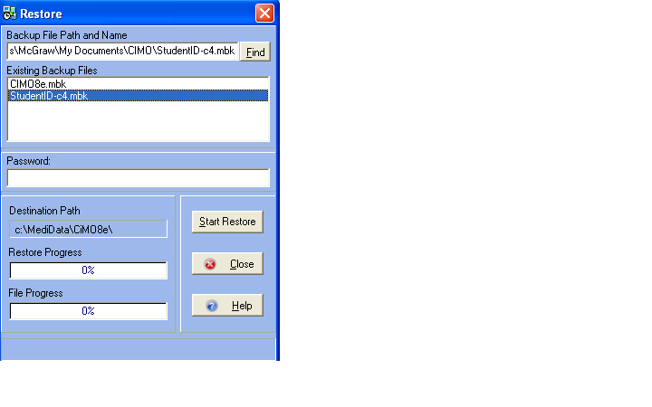
8. They should click the Start Restore button.
9. When the Confirm box appears, they should click OK.
10. An Information box appears indicating that the restore is complete. They should click the OK to continue, and then they should click the Close button to close the Restore dialog box.
11. The Restore dialog box disappears. They are now ready to begin the new session.
Backup and Restore Issues
Users of Medisoft Version 17 SP3 may experience occasional problems backing up and restoring files. The suggested “fix” from McKesson is to exit Medisoft, wait a minute or two, and launch the program again. Most times this eliminates the message that prevents users from successfully backing up and restoring files.
Read the information that follows if you are experiencing any problems with backup or restore.
Creating a Backup File
Once you select Backup Data on the File menu, you will see the standard Backup Warning dialog box. Click the OK button.

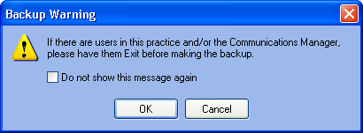

After clicking OK, you may see the following Information dialog box. If this occurs, click the OK button, and then exit Medisoft.
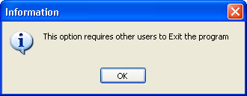

Wait a minute or two, and then restart Medisoft. You should now be able to backup your data.
Restoring a Backup File
Once you select Restore Data on the File menu, you will see the standard Warning dialog box. Click the OK button.
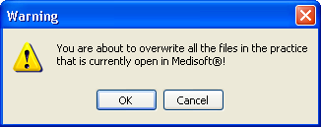
After clicking OK, you may see the following Error dialog box. If this occurs, click the OK button, and then exit Medisoft.

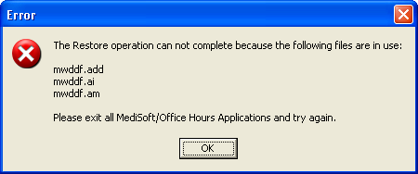

Wait a minute or two, and then restart Medisoft. You should now be able to restore your data.

- Tips for Instructors: Best Practice
“Remind students that are just starting when they need to back up and restore; some students are quick and want to just open Medisoft and start or close Medisoft and exit without performing these important steps. If they want to make sure that that their chapter exercises are saved they should do a backup at the end of each chapter or exercise that is fully completed. When starting a new Medisoft session they need to restore the data from their last session.”
—Nikita Carr, CPC, CMBS, Centura College

“Remember to create a backup of your work before exiting Medisoft. To help you keep track of your work, name the backup file after the chapter you are working on, for example, Chapter 4.mbk (the file extension will be added for you). You should back up your work to your computer’s hard drive and to a USB (jump) drive. Having the file stored in 2 places will be very helpful if you experience any computer problems along the way!”
—Amy L. Blochowiak, MBA, ACS, AIAA, AIRC, ARA, FLHC, FLMI, HCSA, HIA, HIPAA, MHP, PCS, SILA-F, Northeast Wisconsin Technical College

“Back up and restore. My students back up and restore t their files to a flash drive. When I explain the backup and restore process to the students for the first time, I have them write down on the inside front cover of their textbook the following:
Beginning of class: Restore
End of class: Back up
After this, at the beginning of each class I remind them to look inside the front cover of their book to tell me what we will do with the data on our flash drives. At the end of class I ask them to look in their book and to tell me what they will do with the data and our flash drives. I find this very effective from day one so that they will always remember to look to see what to do.
“Naming backup files. I explain to my students that the backup files must have the common file extension .mbk (I emphasize it stands for make a backup). I have my students name each backup file according to chapter name and exercise. For example, if at the end of class they were on chapter 6 exercise 3, their backup file would be named ch63.mbk. This helps them remember where they left off and also helps me when I want to check/view their progress. Also, if an error occurs that cannot be corrected or data becomes corrupt, students can just use their previous chapter’s backup file and repeat the exercises. That is good practice for them and also what they would have to do out in the working world.”
—Robin Maddalena, CMT, Branford Hall Career Institute
“Be sure to back up your data EACH and EVERY time you exit the program. As in the real world, things can go wrong. You don’t want to have to re-create work you’ve already done.”
—Ursula Cole, MEd, CMA (AAMA), Platt College
“If you have short classes, such as two hour periods, it would be beneficial for the instructor to alert the students that the end of the class is approaching in order for them to have sufficient time to bacl up their work (students become so focused on their data input that some of them do not watch the time.)
—Carol E. Charie, CPC, Sanford Brown

Chapter 7 Using USB Flash Drives
What Is a USB Flash Drive?
USB (Universal Serial Bus) flash drives are compact file storage devices used to save information externally. The end of the flash drive is inserted into the USB port on the computer. Once attached, it operates in much the same way as a disk or CD drive.
The most common uses of flash drives are to transport and store personal files such as documents, pictures, and videos.
Flash drives are also called USB memory sticks, jump drives, and thumb drives.
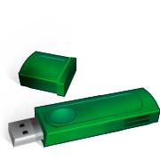

What Size Flash Drive Is Required for Medisoft Files?
Saving and transporting Medisoft files requires a minimum flash drive size of 256 MB.
How Is a Flash Drive Safely Removed?
1. Right click the Removable Storage icon on the bottom right corner of your screen, and click Safely Remove Hardware when it pops up.

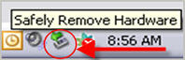

2. Locate the flash drive (usually labeled Generic Volume) on the Stop a Hardware device window, click to select it, and click OK.

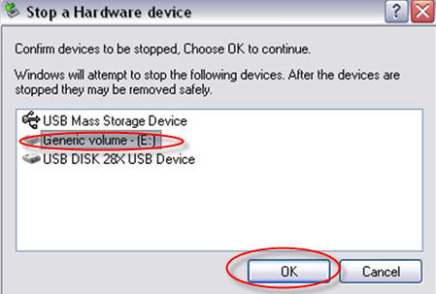
3. When the Safe to Remove Hardware message appears, remove the flash drive.
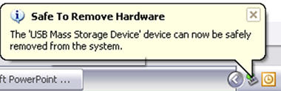
Tips for Instructors: Best Practice
Consider collecting flash drives from your students at the end of class time to ensure that they don’t add personal files (such as photos and music) without leaving adequate room for class work. (McGraw-Hill provides technical support for student data files only, not for students’ personal files.)
“On our campus the computer labs are used by more then one class and so if students want to be sure that the data that they are using is theirs they will back up and restore files using their flash drives.
“Flash drives can be collected by the instructor at the end of class for many purposes, grading, making sure extra junk is not on it, to make sure the student is prepared to work in class because the flash drive is there, etc.”
—Nikita Carr, CPC, CMBS, Centura College

“My students are given brand new flash drives on the first day of class along with their textbooks. Students are provided with a label to put their name on their flash drive. I collect the flash drives at the end of each class and hand them out at the beginning of each class. My students take their Career Development class the same term. I put the flash drives in a disposable food box with a lid and a label with my name on it and the class name and time. The box is kept in the main academic office and their Career Development instructor utilizes the drives for that class as well. Their flash drives are kept until the end of the term when we give them to the students for their own use. Keeping their flash drives for the term accomplishes the following:
- Students will ALWAYS have their flash drives in class and never have unproductive class time.
- Students will not transport viruses into the classroom from their own computer.
- Most importantly, students will not be able to copy their backup files in order to give them to another student.”
—Robin Maddalena, CMT, Branford Hall Career Institute

Chapter 8 FAQs: Frequently Asked Questions from Students and Instructors
How do I install Medisoft Version 17?
- Refer to Chapter 2 of this guide for detailed instructions on installing the Instructor version.
- Refer to Chapter 3 of this guide for detailed instructions on installing the Student At-Home version.

Where do I find the student data files?
- Refer to Chapter 4 of this guide for detailed instructions.
- The website address (URL) for your text’s Online Learning Center can be found in Chapter 4 and on the back cover of the textbook you are using.

When I install the student data files, why am I unable to bring up the program?
- You or your students must install Medisoft Version 17 before using the student data installer. The student data installer will not work if it is run before Medisoft has been installed.
- You cannot open Medisoft files by clicking them. Medisoft files can be opened only through Medisoft.
- Also see Chapter 4 of this guide for detailed instructions.

How and why should I back up and restore my data?
- Refer to Chapter 6 of this guide for detailed instructions on backing up and restoring data.
- Students should routinely save their work in case data gets corrupted or they want to move data to another location where Medisoft is installed.
- Backing up and restoring Medisoft data will be required in the real world environment of a doctor’s office.

When I purchased the program, why did I receive the demo version of Medisoft?
- The Student At-Home version with the word Demo on it is the full version of the software. “Demo” is a designation from the McKesson Corporation. You and your students are working with the fully functioning version of Medisoft. This version allows data for up to 150 patients to be entered.

Does Medisoft Version 17 work with Windows Vista or Windows 7?
- Yes. See System Requirements in Chapter 2 for complete information.

How can instructors learn more about teaching Medisoft?
- You can view the training video on the CIMO 8e Online Learning Center at www.mhhe.com/cimo8e.
- Or you can attend one of our regularly scheduled online webinars. To learn more about the webinars, contact your McGraw-Hill sales representative. (To find your McGraw-Hill sales representative, go to www.mhhe.com and click Find My Sales Rep.)

Why is the software called Medisoft Advanced or McKesson Ambulatory Solutions?
- Medisoft Advanced Version 17 and McKesson Ambulatory Solutions are the names assigned by the McKesson Corporation, and this matches the CD that came with your textbook. Examples of what the McGraw-Hill Instructor Version CD and the McGraw-Hill Student Version CD look like are included below.

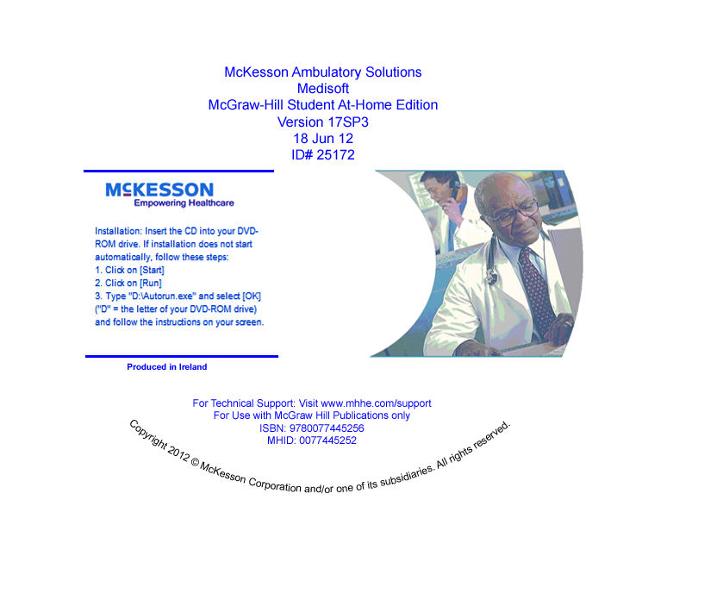
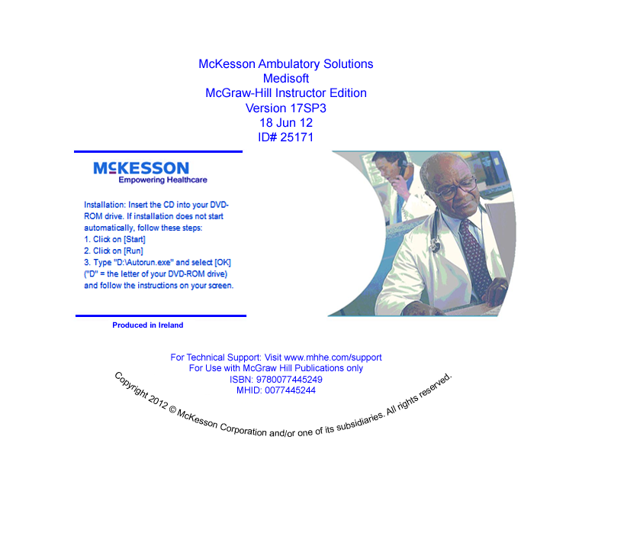

How can I contact my McGraw-Hill sales representative?
- Visit www.mhhe.com and click Find My Sales Rep. Enter your school name or zip code to obtain your local sales representative’s name and contact information.
Chapter 9 Instructor Resources
You can rely on the following materials to help you and your students work through the material in the book, all of which are available on the book’s website, www.mhhe.com/cimo8e (Instructors can request a password through their sales representative):
Supplement | Features
Instructor’s Manual  (organized by Learning Outcomes) | -Lesson plans  -Answer keys for all end of chapter exercises  -Answer keys for Medisoft exercises with screenshots
PowerPoint Presentations  (organized by Learning Outcomes) | -Key terms  -Key concepts  -Teaching notes
Electronic Testbank | -EZ Test Online (computerized)  -Word version  -Questions have tagging for Learning Outcomes, level of difficulty, level of Bloom’s Taxonomy, and feedback
Tools to Plan Course | -Correlations of the Learning Outcomes to accrediting bodies such as CAHIIM, ABHES, and CAAHEP  -Sample syllabi and lesson plans  -Conversion guide for CiMO 7e to CiMO 8e  -Asset Map-clickable PDF with links to all key supplements, broken down by Learning Outcomes, as well as information on the content available through Connect Plus.
Medisoft® Advanced Version 17 Tools | -McGraw-Hill Guide to Success for CiMO 8e  -Technical support information  -First day of class PowerPoint presentation  -Installation videos and directions  -Student Data File  -Backup and restore videos, directions, and files for live Medisoft® use. (The Medisoft® backup files are an important resource if students make mistakes with their data and you want them to have the correct data to start the next chapter.)  -Certificate of completion
CMS-1500 and UB-04 Forms | -Electronic versions of both forms
Case Studies for use with Computers in the Medical Office, 8e | This book provides a capstone simulation using Medisoft® Advanced Version 17. It offers students enhanced training that is meant to improve their qualifications for a variety of medical office jobs. Extensive hands-on practice with realistic source documents teaches students to input information, schedule appointments, and handle billing, reports, and other essential tasks. The book provides additional activities, including more complex activities for advanced students. On the website you will find:  -Instructor’s Manual with sample syllabi and answer keys  -PowerPoint presentations  -Conversion guides  -Correlations to accrediting bodies  -Asset Map  -Information on how to load Student Data File for this book and CiMO at the same time
Technical Support | Need help? Contact McGraw-Hill’s Customer Experience Group (CXG). Visit the CXG website at www.mhhe.com.support. Browse our FAQs (Frequently Asked Questions) and product documentation, and/or contact a CXG representative. CXG is available Sunday through Friday.
Webinars | Want to learn more about this product? Attend one of our online webinars. To learn more about the webinars, please contact your McGraw-Hill sales representative. To find your sales representative, go to www.mhhe.com and click “Find My Sales Rep.”
Chapter-by-Chapter Backup Files
There is a tool for data restoration should a student input incorrect answers (data). As the term continues; incorrect answers prohibit the student from moving forward effectively with the software.
The chapter-by-chapter backup files allow you to restore the Medisoft data on your students' computers to the beginning of any chapter. Medisoft backup files always have the .mbk file extension. Each file represents a completed chapter. For example, CiMO8eChap9.mbk is the file for completed Chapter 9 that will allow the student to start with Chapter 10.
Follow these steps to utilize the chapter backup files:
- Go to the textbook Online Learning Center website www.mhhe.com/cimo8e.
- Log in as an instructor to the Instructor Edition.
- Click the Medisoft CiMO Instructor Tools link.
- Download the Medisoft Chapter backup files onto your computer's hard drive.

Exercise Solutions
Exercise solutions are posted on the textbook’s Online Learning Center website.
Contact your local McGraw-Hill Sales Representative if you need instructor-level access to the Online Learning Center website.
Tips for Instructors: Best Practice
“I believe it is very important to restate in each chapter that following each step, in order and in its entirety is important because missing even one small step/piece of information will cause the learner to be in the wrong place/have the wrong information entered or prevent the learner from moving forward successfully.”
—Philip Mayo, CPC, Premier Education Group/Seacoast Career Schools

“I advise instructors it is imperative that they tell the students they MUST read ALL instructions/directions in the text and on their screen to avoid errors and losing data.”
—Carol E. Charie, CPC, Sanford Brown
“I find that demonstrating each step on an LCD projector first, ensuring all learners are watching and not typing, and then allowing the user to practice is the best approach. Show them, allow them to practice, and then reinforce what they have learned and why they have learned it is the best way to ensure complete student success.”
—Philip Mayo, CPC, Premier Education Group/Seacoast Career Schools
“Oh my! First and foremost, as an instructor, I have a place to go without having to consult a bunch of handwritten notes and sticky notes that are scattered throughout my teacher edition. Second, as a curriculum person, this is a great reference when looking for other titles that are compatible with Medisoft which can be added to the curriculum as we need new material for courses. And finally, as a trainer of faculty, this is kind of like that great all-purpose tool I can hand over and say, ‘And here’s where you find the answers to your questions after you’ve worked through the Medisoft program. . . .’ BLESS YOU!!!!!”
—Ursula Cole, MEd, CMA, (AAMA), Platt College
“I suggest that instructors walk around the computer lab to monitor student progress with the data input because some students “forge” ahead in an attempt to make their screen look like the illustration in the text and they don’t follow the instructions carefully. This problem has existed for as long as I have been teaching, and many teachers say the same—it is why errors are made and what causes additional time and work to restore data. Students need to have it firmly stated that incorrect work is not acceptable and only harms them at the end of the day.”
—Carol E. Charie, CPC, Sanford Brown

Chapter 10 Technical Support

Need help? Contact McGraw-Hill’s Customer Experience Group (CXG).

Visit the CXG website at www.mhhe.com/support. Browse our FAQs (Frequently Asked Questions) and product documentation, and/or contact a CXG representative.

Call us at 800-331-5094.

General Hours (Central Standard Time)
Monday-Thursday 8:00 A.M. to 11:00 P.M.
Friday 8:00 A.M. to 6:00 P.M.
Sunday 6:00 P.M. to 11:00 P.M.
CXG is available Sunday through Friday.

How Can Instructors Learn More About Teaching Medisoft?
- You can view the training video on the CIMO 8e Online Learning Center at www.mhhe.com/cimo8e.
- Or you can attend one of our regularly scheduled online webinars. To learn more about the webinars, please contact your McGraw-Hill sales representative. To find your McGraw-Hill representative, go to www.mhhe.com and click Find My Sales Rep.

