Chapter 11: Applying Excel
The completed worksheet is shown below.

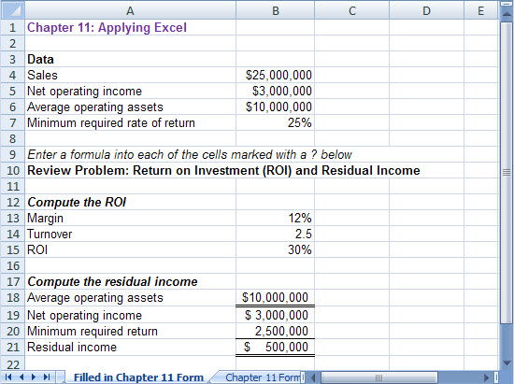

Chapter 11: Applying Excel (continued)
The completed worksheet, with formulas displayed, is shown below.

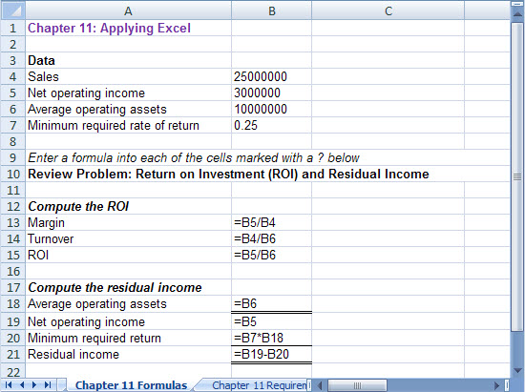

Chapter 11: Applying Excel (continued)
1. With the changes in average operating assets, the result is:

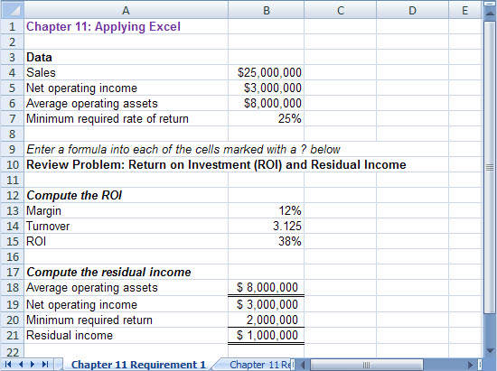

An increase in average operating assets will increase both the ROI and residual income.

ROI = Net operating income/Average operating assets

Residual income = Net operating income – Required return
Required return = Minimum required rate of return × Average operating assets

ROI increases because average operating assets is in the denominator of ROI. Residual income increases when average operating assets decreases because a reduction in the average operating assets results in a reduction of the required return.

Chapter 11: Applying Excel (continued)
2. With the revised data, the worksheet should look like this:

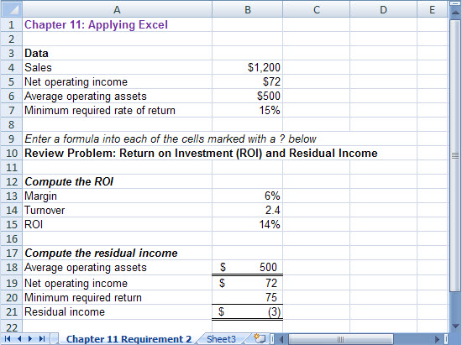

a. As shown above, the ROI is 14%.

b. As shown above, the residual income is $(3).

c. Because the ROI of 14% is less than minimum required return of 15%, the residual income is negative.

