Chapter 12: Applying Excel
The completed worksheet is shown below.

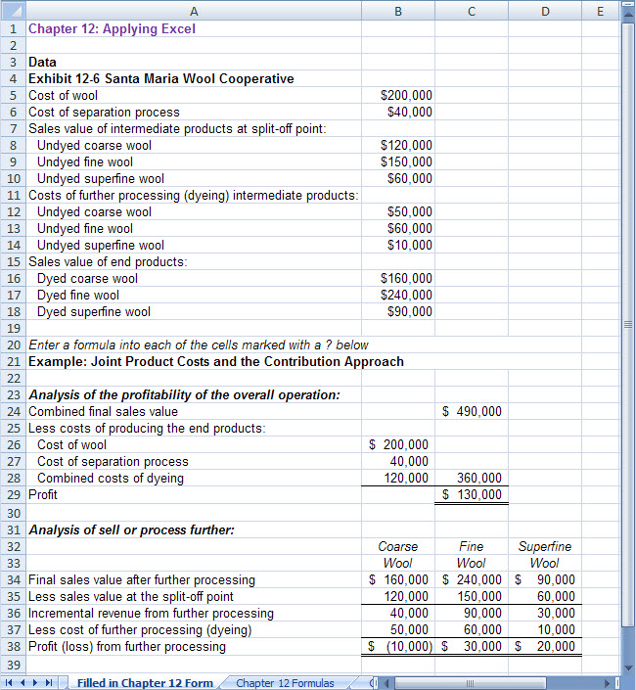

Chapter 12: Applying Excel (continued)
The completed worksheet, with formulas displayed, is shown below.

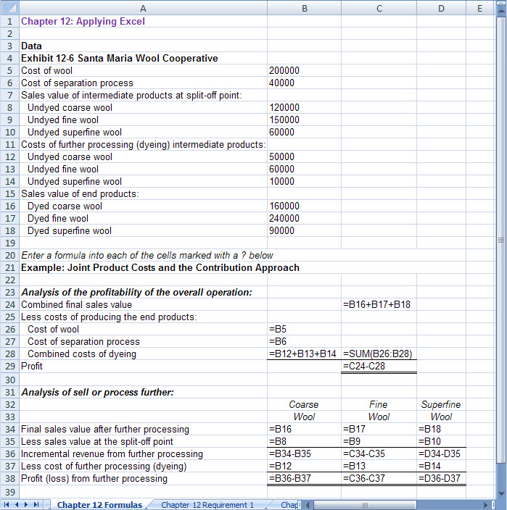

Chapter 12: Applying Excel (continued)
1. With the change in the cost of further processing undyed course wool, the result is:

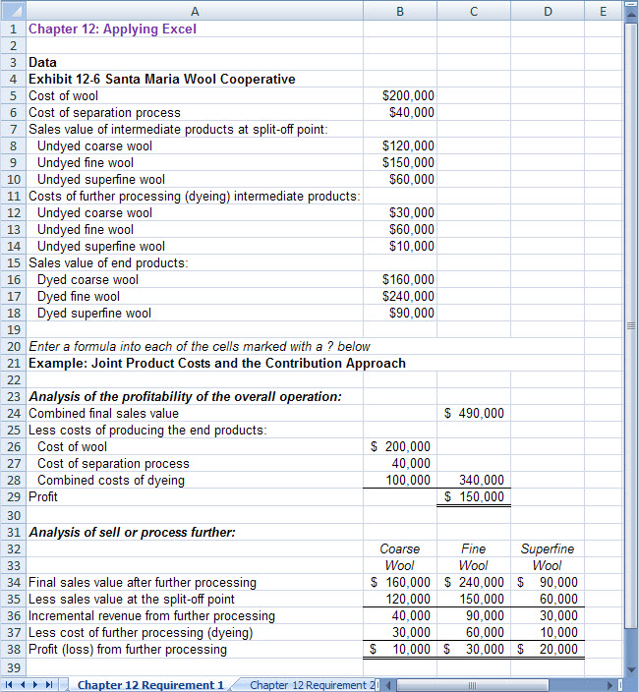

With the reduction in the cost of further processing undyed coarse wool, it is now profitable to process undyed coarse wool into dyed coarse wool.

Chapter 12: Applying Excel (continued)
2. With the revised data, the worksheet should look like this:

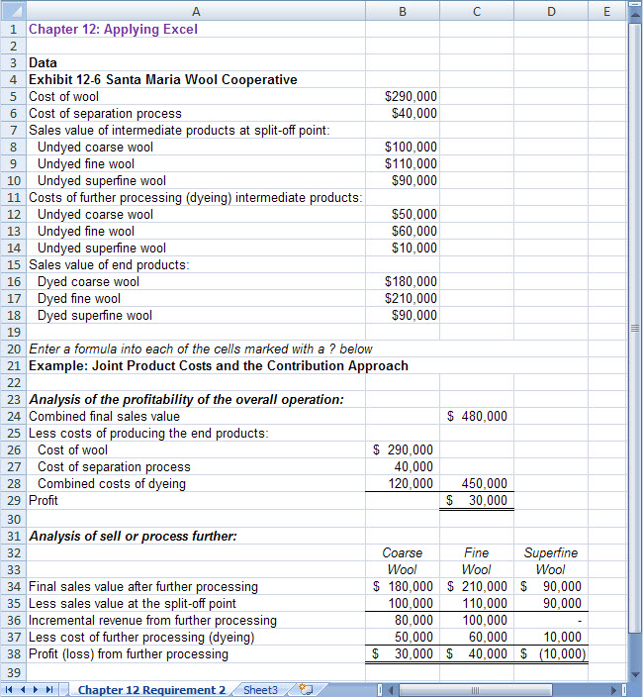

Chapter 12: Applying Excel (continued)
a. The profit of the overall operation is now $30,000 if all intermediate products are processed into final products.

b. The profits from further processing are shown below.

 | Coarse | Fine | Superfine
 | Wool | Wool | Wool
Profit (loss) from further processing | $30,000 | $40,000 | $(10,000)

c. To maximize profit, the company should process undyed coarse wool into dyed coarse wool and undyed fine wool into dyed fine wool. However, undyed superfine wool should be sold as is rather than processed into dyed superfine wool. If this plan is followed, the overall profit of the company should be $40,000 as shown below:

Combined sales value  ($180,000 + $210,000 + $90,000) |  | $480,000
Less costs of producing the end products:
Cost of wool | $290,000
Cost of separation process | 40,000
Combined costs of dyeing  ($50,000 + $60,000) | 110,000 | 440,000
Profit |  | $ 40,000

