Chapter 2: Applying Excel
The completed worksheet is shown below.

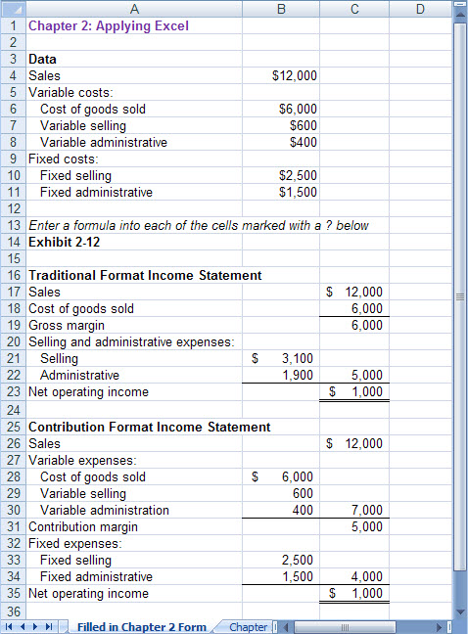

Chapter 2: Applying Excel (continued)
The completed worksheet, with formulas displayed, is shown below.

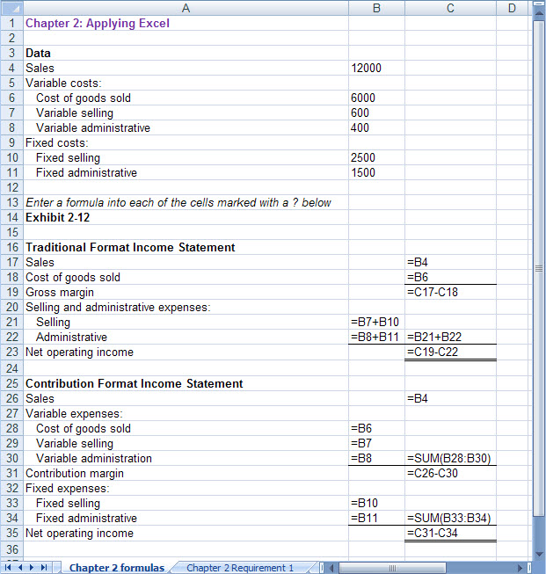

[Note: To display formulas in Excel 2007, select Office Button > Excel options > Advanced > Show formulas in cells instead of their calculated amounts. To display the formulas in other versions of Excel, consult Excel Help.]

Chapter 2: Applying Excel (continued)
1. When the variable selling cost is changed to $900, the worksheet changes as show below:

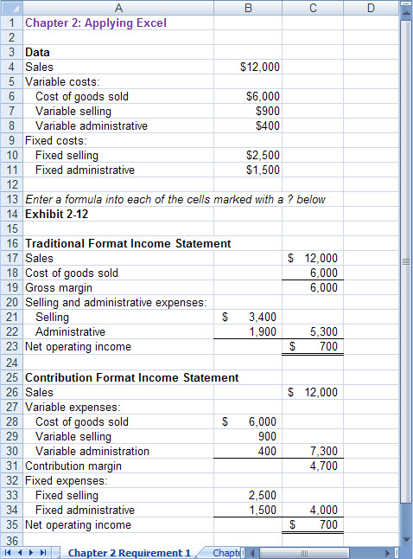

The gross margin is $6,000; the same as it was before. It did not change because the variable selling expense is deducted after the gross margin, not before it on the traditional format income statement.

Chapter 2: Applying Excel (continued)
2. The new worksheet appears below:

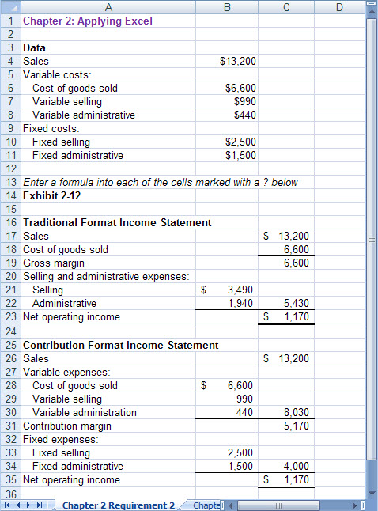

Chapter 2: Applying Excel (continued)
The variable costs increased by 10% when the sales increased by 10%, however the fixed costs did not increase at all. By definition, total variable cost increases in proportion to activity whereas total fixed cost is constant. (In the real world, cost behavior may be messier.)

The contribution margin also increased by 10%, from $6,000 to $6,600, because both of its components—sales and variable costs—increased by 10%.

The net operating income increased by more than 10%, from $700 to $1,170, because even though sales and variable expenses increased by 10%, the fixed costs did not increase by 10%.

