Chapter 3: Applying Excel
The completed worksheet is shown below.

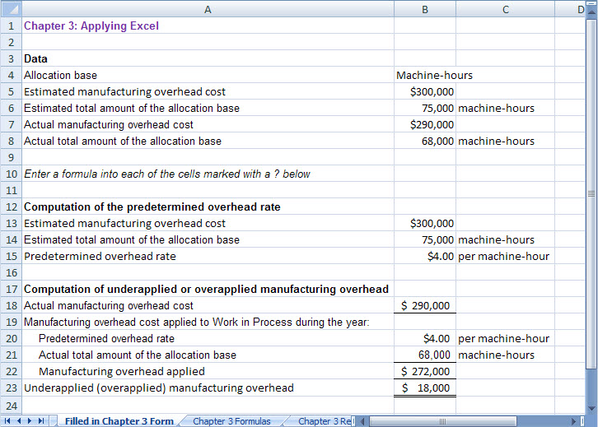

Chapter 3: Applying Excel (continued)
The completed worksheet, with formulas displayed, is shown below.

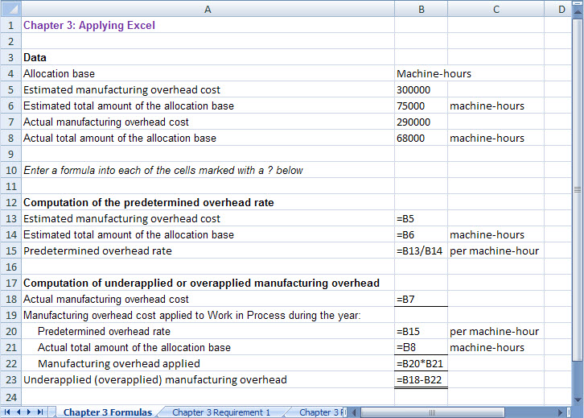

[Note: To display formulas in Excel 2007, select Office Button > Excel options > Advanced > Show formulas in cells instead of their calculated amounts. To display the formulas in other versions of Excel, consult Excel Help.]

Chapter 3: Applying Excel (continued)
1. When the estimated total amount of the allocation base is changed to 60,000 machine-hours, the worksheet changes as show below:

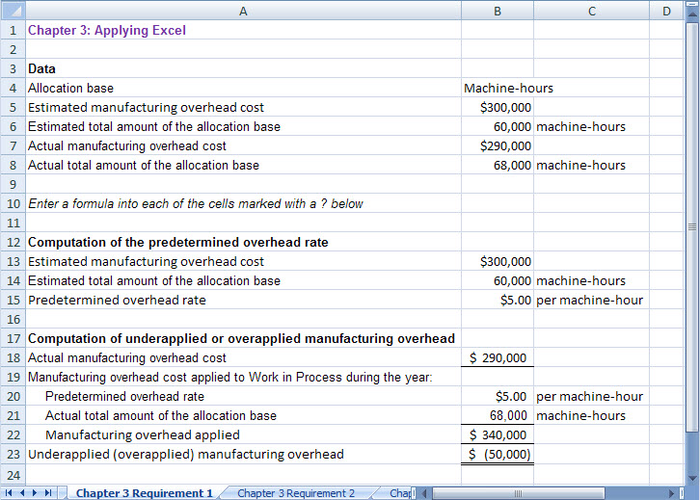

The predetermined overhead rate has increased from $4.00 per machine-hour to $5.00 per machine-hour because the estimated total amount of the allocation base has decreased from 75,000 machine-hours to 60,000 machine-hours. The same amount of estimated overhead cost is spread across fewer machine-hours.

Chapter 3: Applying Excel (continued)
2. With all of the changes in the data, the worksheet should look like the following:

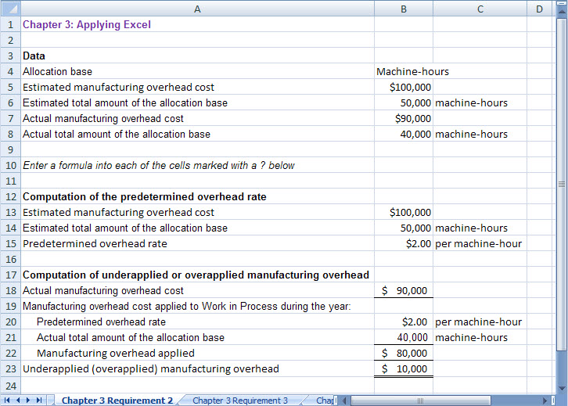

Chapter 3: Applying Excel (continued)
3. When the estimated total amount of the allocation base is changed to 40,000 machine-hours, the worksheet looks like the following:

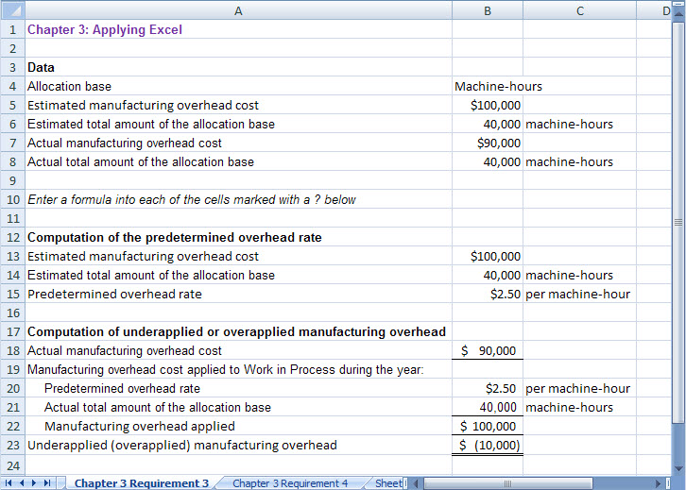

The manufacturing overhead is now overapplied by $10,000 rather than underapplied by $10,000 as it was when the estimated total amount of the allocation base was 10,000 machine-hours higher. This occurred because the predetermined overhead rate was $2.00 per machine-hour when the estimated total amount of the allocation base was 50,000 machine-hours and is now $2.50 per machine-hour as a consequence of the reduction in the estimated total amount of the allocation base to 40,000 machine-hours. Because the predetermined overhead rate is now larger and everything else is the same, more overhead was applied. In this case, the result is a switch from underapplied to overapplied overhead.

Chapter 3: Applying Excel (continued)
4. When the estimated total amount of the allocation base is changed to back to 50,000 machine-hours and the actual manufacturing overhead cost is changed to $100,000, the worksheet looks like the following:

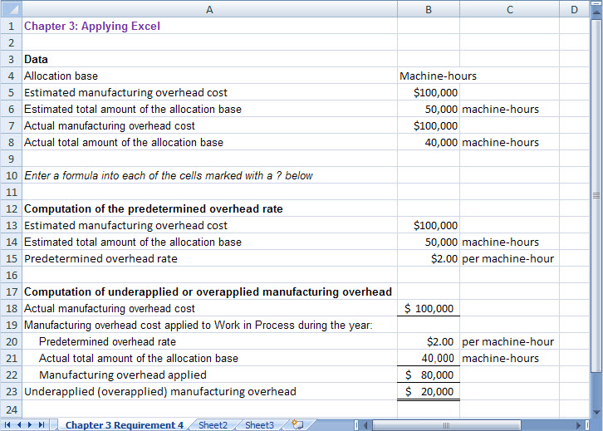

In part 2 above, manufacturing overhead was underapplied by $10,000. Manufacturing overhead is now underapplied by $20,000. This occurred because the actual manufacturing overhead cost increased by $10,000—from $90,000 to $100,000. Thus, the amount of the underapplied overhead also increased by $10,000.

