Chapter 5: Applying Excel
The completed worksheet is shown below.

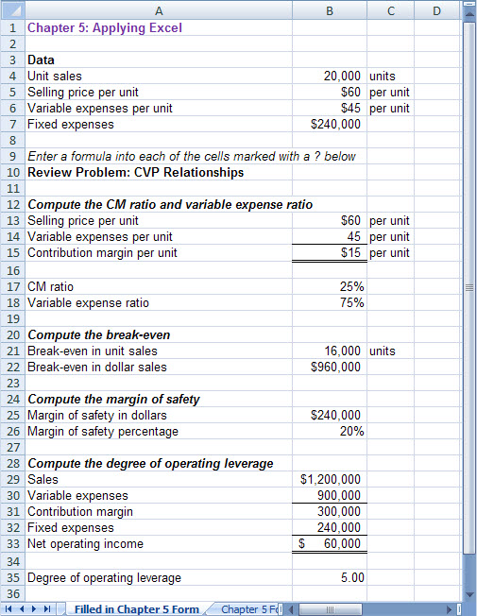

Chapter 5: Applying Excel (continued)
The completed worksheet, with formulas displayed, is shown below.

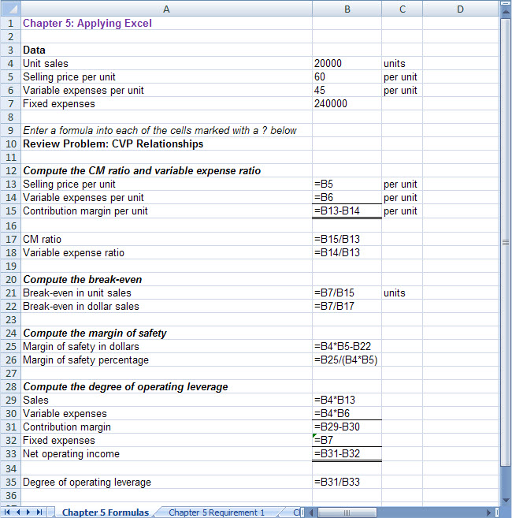

Chapter 5: Applying Excel (continued)
1. When the fixed expenses are changed to $270,000, the worksheet changes as shown below:

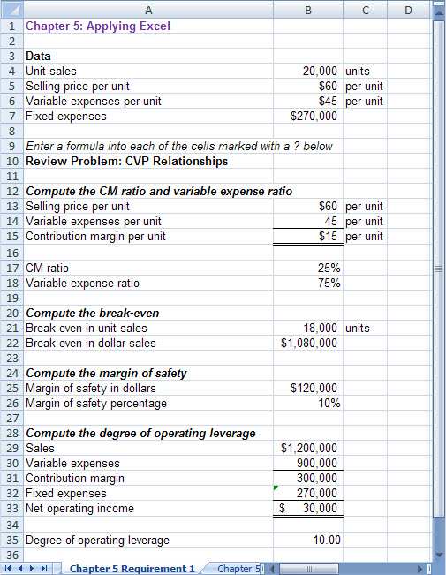

The margin of safety percentage is now 10%, whereas it was 20% before. This change occurred because the increase in fixed expenses increased the break-even point and hence reduced the margin of safety available for the current level of unit sales.

Chapter 5: Applying Excel (continued)
2. With the changes in the data, the worksheet should look like this:

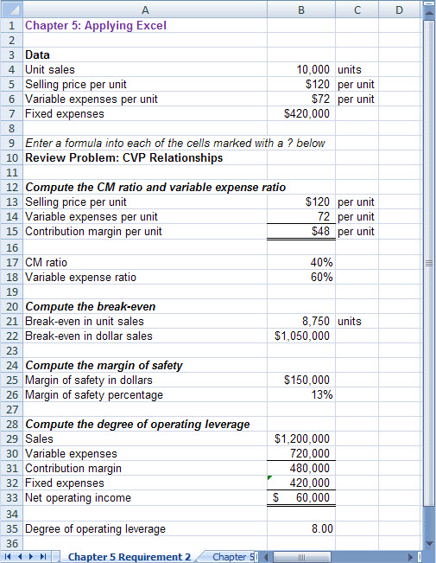

The margin of safety percentage is 13% and the degree of operating leverage is 8.

Chapter 5: Applying Excel (continued)
3. The degree of operating leverage can be used to estimate the expected percentage increase in net operating income from a 15% increase in unit sales as follows:

Percentage change in net operating income = Degree of operating leverage × Percentage change in sales = 8.00 × 15% = 120%

An increase of 120% over the current net operating income of $60,000 would result in net operating income of $132,000. This is verified in part (4) that follows.

Chapter 5: Applying Excel (continued)
4. Increasing the unit sales by 15% results in net operating income of $132,000—an increase of 120% over the previous net operating income of $60,000.

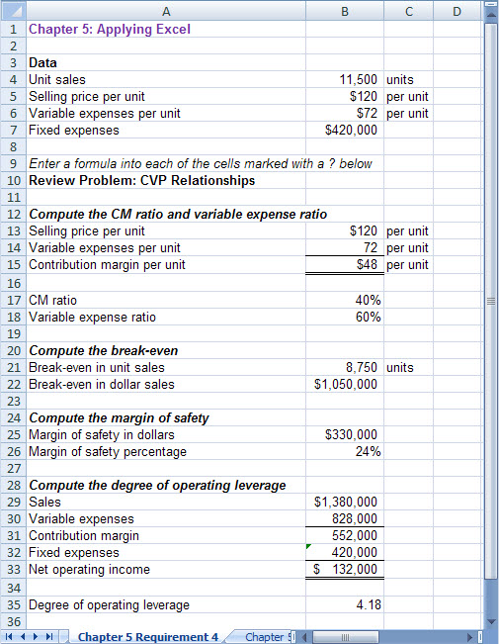

Chapter 5: Applying Excel (continued)
5. a. The initial plan for the Western Hombre motorcycle is summarized below:

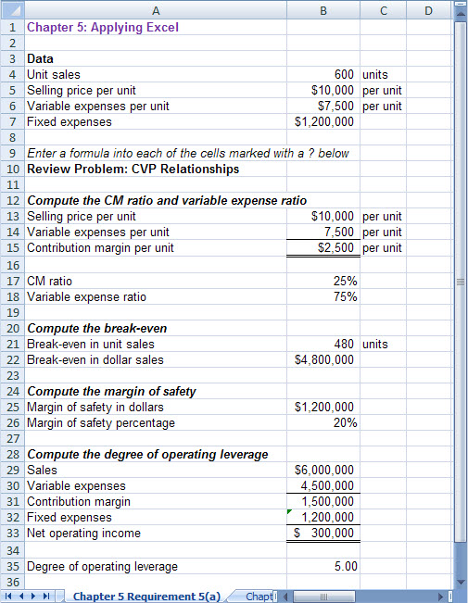

Chapter 5: Applying Excel (continued)
5. b. The modified plan for the Western Hombre motorcycle is summarized below:

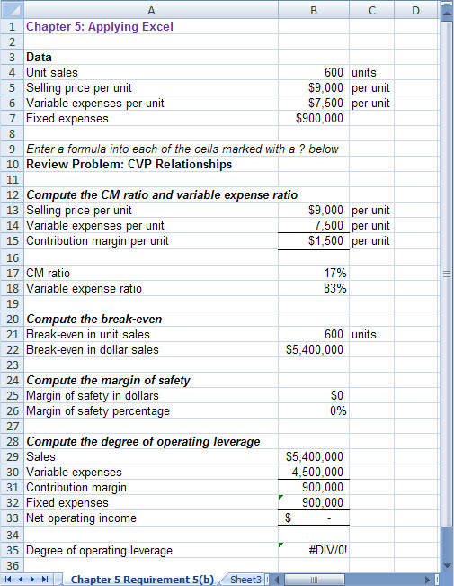

Chapter 5: Applying Excel (continued)
This does not appear to be a good plan. At best, Thad would only break even—and that assumes that 600 units would still be sold despite the drastic reduction in advertising expenses. The margin of safety is zero which means that any decrease in sales to below 600 units would result in a loss.

The degree of operating leverage is displayed in the worksheet as #DIV/0!. This means that Excel is unable to compute the degree of operating leverage because the divisor is 0. The divisor is 0 because the degree of operating leverage is the contribution margin divided by the net operating income and the net operating income is zero. Technically, the degree of operating leverage is undefined when net operating income is zero.

