Chapter 7: Applying Excel
The completed worksheet is shown below.

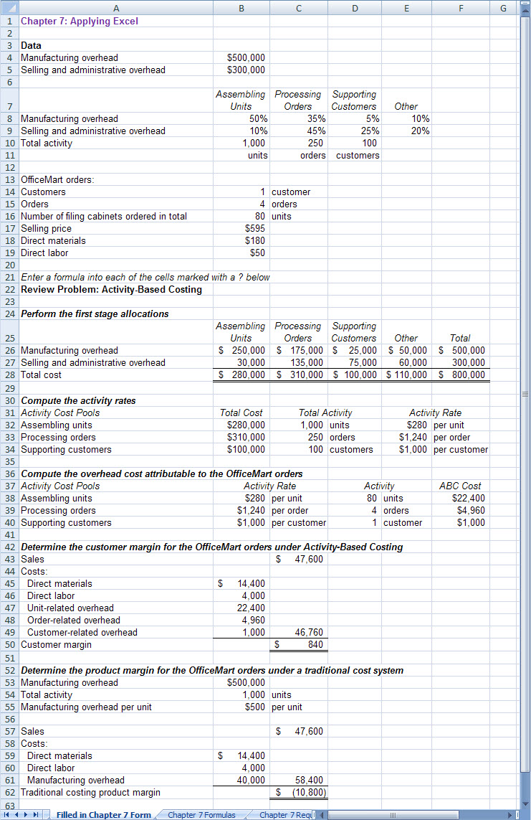

Chapter 7: Applying Excel (continued)
The completed worksheet, with formulas displayed, is shown below.

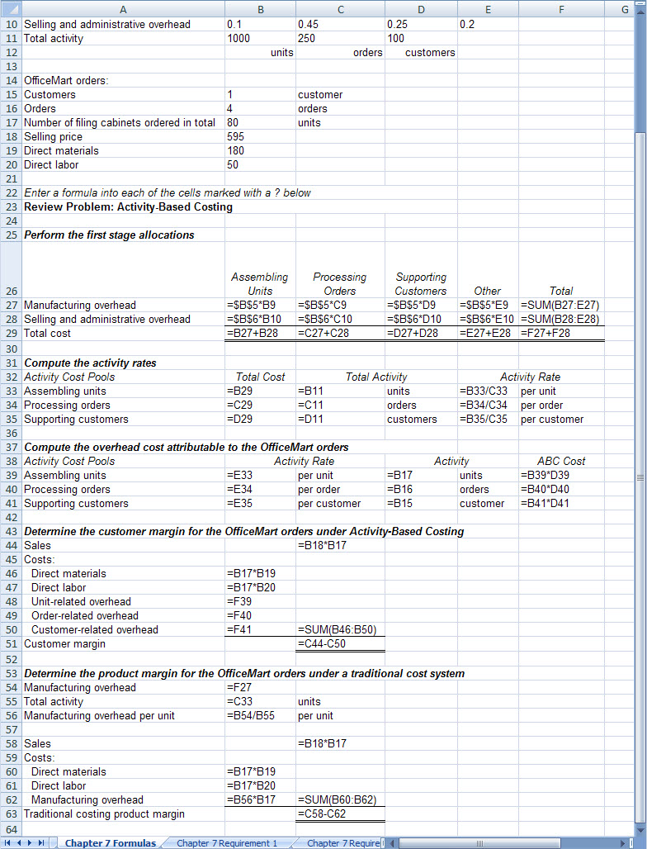

Chapter 7: Applying Excel (continued)
1. When the number of units ordered by OfficeMart is doubled to 160 units, the result is:

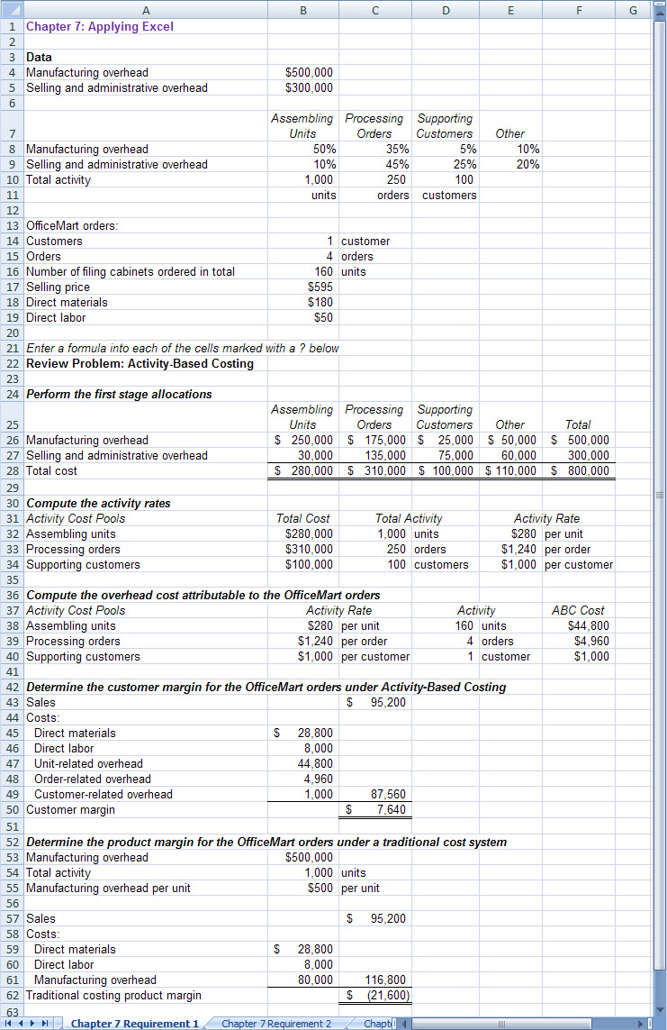

Chapter 7: Applying Excel (continued)
a. The customer margin under activity-based costing at 80 units was only $840, whereas the customer margin at 160 units is $7,640. The number of units ordered has doubled, but the customer margin is almost ten times what it was. The customer margin would have doubled only if all of the costs were strictly variable with respect to the number of units ordered. This is not the case under activity-based costing. Under activity-based costing, the substantial order-related and customer-related overhead costs have not changed at all even though the number of units ordered doubled.

b. The product margin under traditional costing has exactly doubled, going from a loss of $10,800 to a loss of $21,600, because all of the costs included in the product margin under traditional costing are assumed to be strictly variable with respect to the number of units ordered.

c. Assuming that the activity-based costing system was carefully designed and implemented, it will provide a more accurate picture of what happens to profits as the number of units ordered increases. If some of the fixed manufacturing overhead costs are order-related and customer-related costs and some are not attributable to particular orders or customers at all, then allocating all of the manufacturing overhead costs based on the number of units as in traditional costing will seriously distort costs. Moreover, if some of the selling and administrative costs are caused by the number of units ordered, the number of orders, and the number of customers, the activity-based costing system will more accurately assign these costs than the traditional costing system, which does not assign them to units, orders, or customers at all.

Chapter 7: Applying Excel (continued)
2. With the changes in the data, the worksheet should look like this:

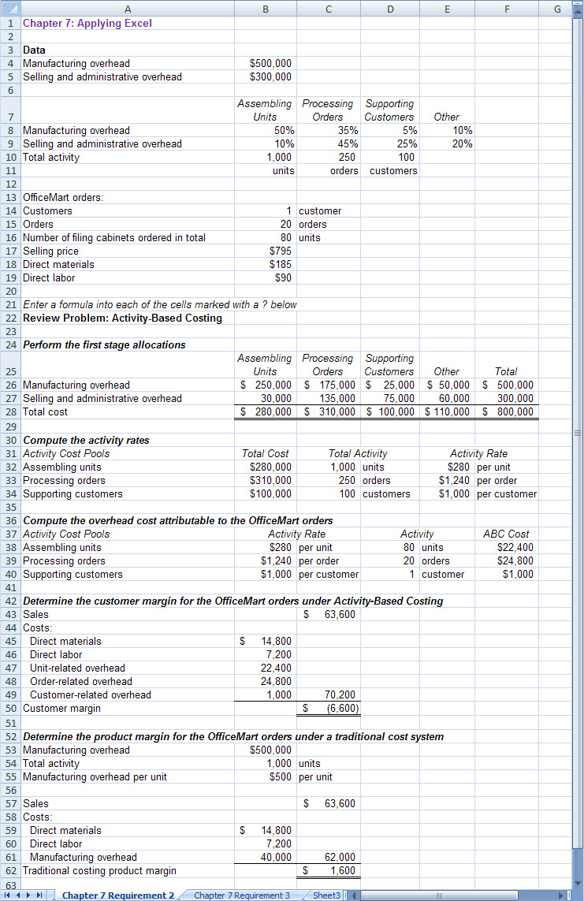

Chapter 7: Applying Excel (continued)
a. The customer margin under activity-based costing is now $(6,600).

b. The product margin under traditional costing is now $1,600.

c. Even though the number of units ordered is exactly the same, the profitability picture has shifted radically and is summarized below:

 | Lower-end,  Fewer orders,  More units per order | Higher-end,  More orders,  Fewer units per order
Customer margin, activity-based costing | $840 | $(6,600)
Product margin, traditional costing | $(10,800) | $1,600

The reasons for these changes are complex. One reason is that the difference between the selling price and the direct materials and direct labor costs has increased.

 | Lower-end,  Fewer orders,  More units per order | Higher-end,  More orders,  Fewer units per order
Selling price | $595 | $795
Direct materials | 180 | 185
Direct labor | 50 | 90
Excess of selling price over direct material and direct labor | $365 | $520

Under the traditional costing method, $500 of manufacturing overhead is allocated to each. Consequently, the product margin is $20 per unit. When 80 units are ordered, the result is a total product margin of $1,600 (= $20 per unit × 80 units).

Under activity-based costing, the additional costs of processing 20 orders rather than 4 orders increases the order-related overhead from $4,960 to $24,800. This swamps the fact that the selling price has gone up a lot more than the direct materials and direct labor costs.

Chapter 7: Applying Excel (continued)
3. With the change in the selling and administrative percentages, the result is:

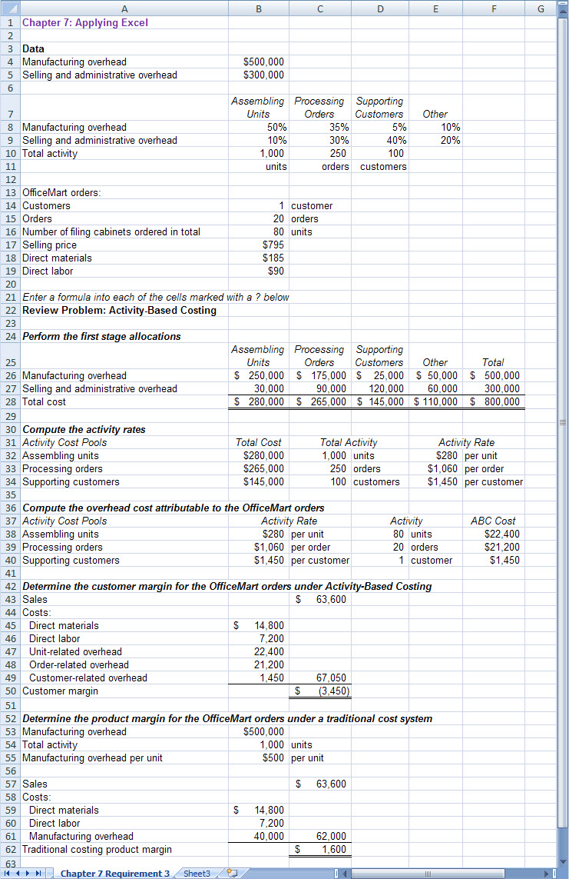

Chapter 7: Applying Excel (continued)
a. The customer margin under activity-based costing has improved from $(6,600) to $(3,450) because costs have shifted from the order-related activity cost pool to the customer-related activity cost pool. The average number of orders per customer is 2.5 (= 250 orders ÷ 100 customers). Since in this part we assume that this customer had 20 orders, this customer would be assigned much more order-related cost than most customers. Consequently, when the percentages change and result in costs being shifted from the order-related cost pool to the customer-related cost pool, this particular customer margin will improve. The customer margins for customers who place few orders will look worse.

b. Shifting selling and administrative costs from the order-related cost pool to the customer-related cost pool has no effect on product margins under traditional costing for two reasons. First, selling and administrative costs are not assigned to products under traditional costing. Second, the order-related and customer-related cost pools do not exist under traditional costing.

