Chapter 8: Applying Excel
The completed worksheet is shown below.

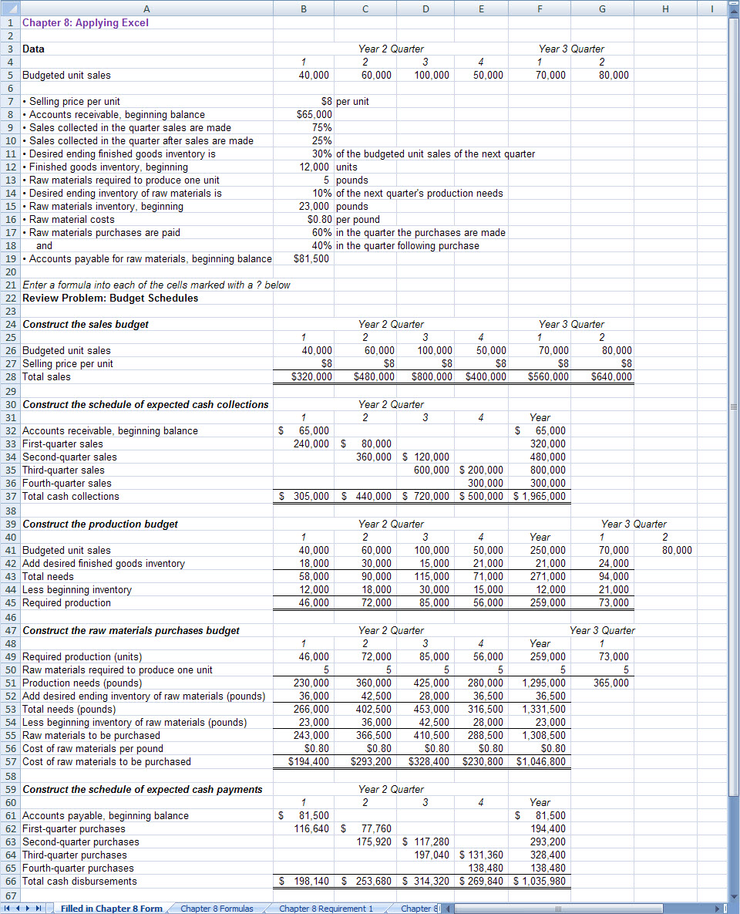

Chapter 8: Applying Excel (continued)
The completed worksheet, with formulas displayed, is shown below.

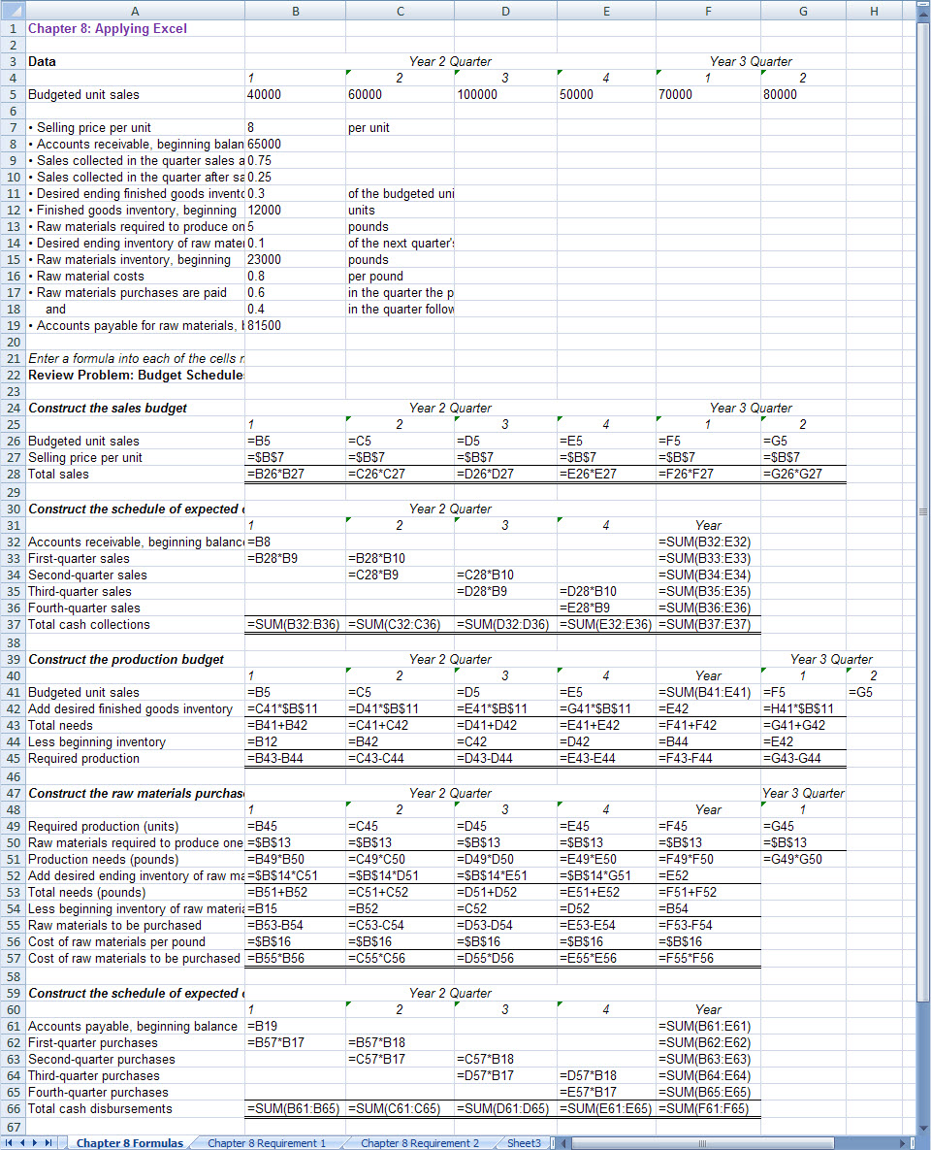

Chapter 8: Applying Excel (continued)
1. When the budgeted unit sales in the second quarter are increased from 60,000 units to 75,000 units, the result is:

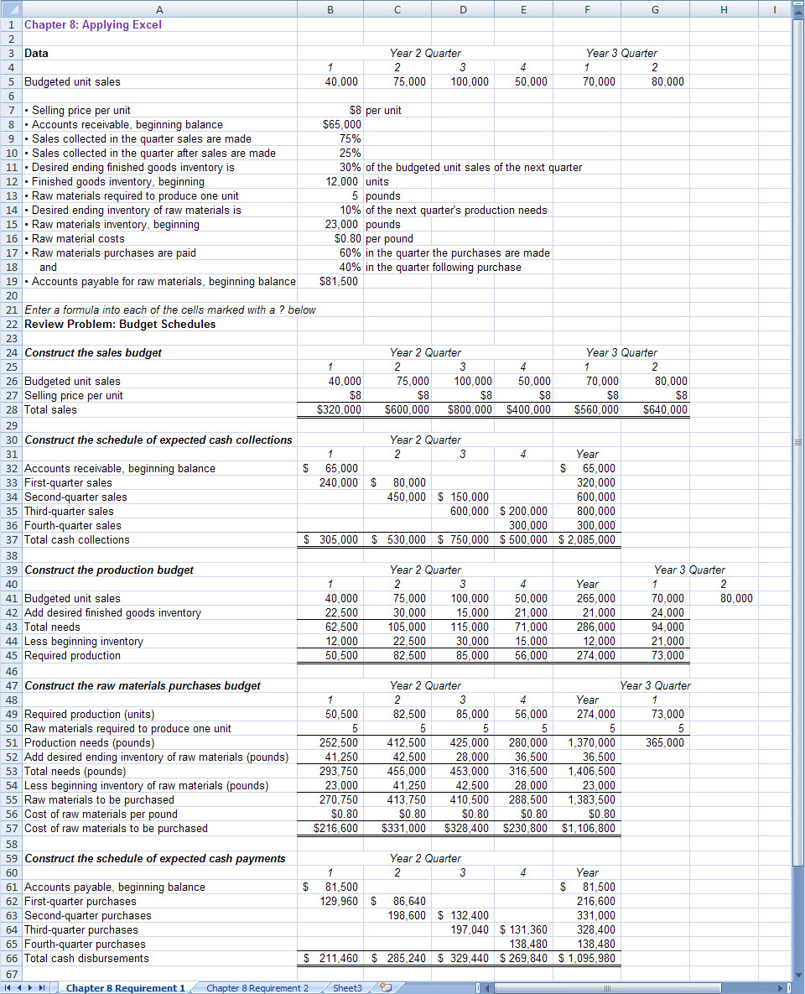

Chapter 8: Applying Excel (continued)
The cash disbursements for raw materials have increased from $1,035,980 to $1,095,980 because the increased unit sales in the second quarter require additional purchases of raw materials.

Chapter 8: Applying Excel (continued)
2. With the revised sales budget, the worksheet should look like this:

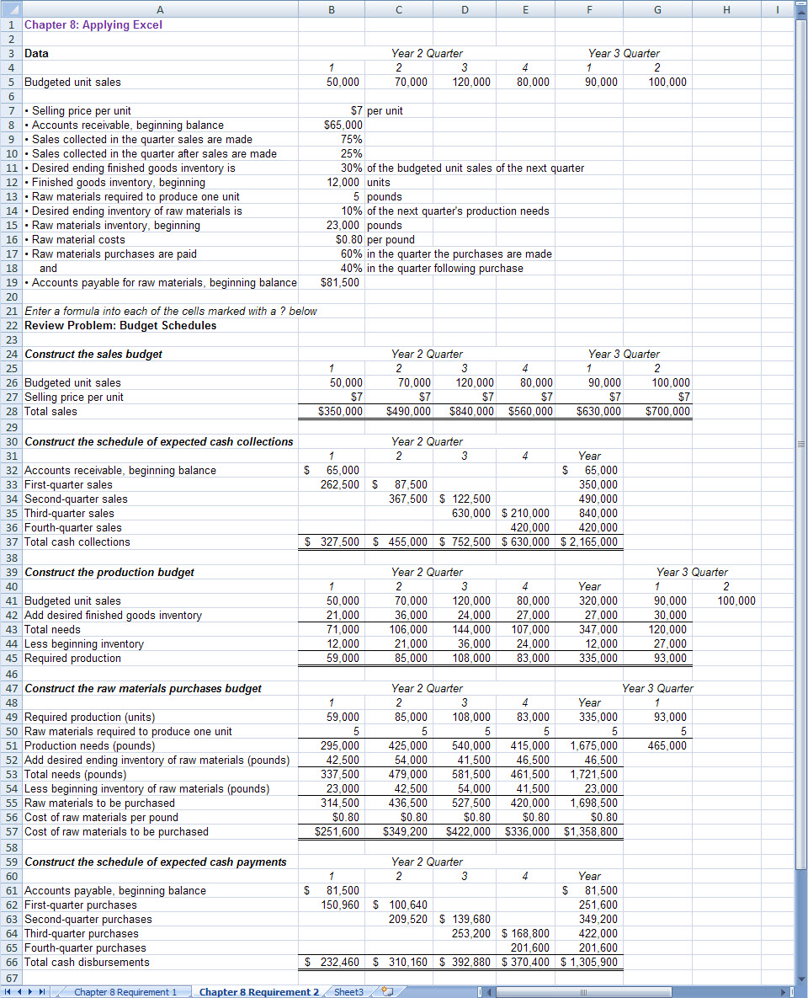

Chapter 8: Applying Excel (continued)
a. The total expected cash collections for the year under this revised budget are $2,165,000.

b. The total required production for the year under this revised budget is 335,000 units.

c. The total cost of raw materials to be purchased for the year under this revised budget is $1,358,800.

d. The total expected cash disbursements for raw materials for the year under this revised budget are $1,305,900.

e. The production constraint of 90,000 units per quarter is a problem in the third quarter of Year 2 and may be a problem later in Year 3. This problem can be approached in a variety of ways. First, the excess capacity in the first and second quarters could be used to build up finished goods inventories beyond the usual levels. Second, management could investigate acquiring another of the milling machines. Third, improvement efforts can be focused on the milling machine; if these efforts are successful, the capacity of the milling machine can be increased and consequently the capacity of the entire plant can be increased. Fourth, management could investigate hiring another company with such a milling machine to do some of the work.

