Group Exercise: Anger Control Role Play

Objectives
1. To demonstrate that emotions can be managed.

2. To develop your interpersonal skills for managing both your own and someone else’s anger.

Introduction
Personal experience and research tell us that anger begets anger. People do not make their best decisions when angry.
Angry outbursts often inflict unintentional interpersonal damage by triggering other emotions (e.g., disgust in observers and subsequent guilt and shame in the angry person). Effective managers know how to break the cycle of negative emotions by defusing anger in themselves and others. This is a role playing exercise for groups of four. You will have a chance to play two different roles. All the roles are generic, so they can be played as either a woman or a man.

Instructions
Your instructor will divide the class into groups of four. Everyone should read all five roles described. Members of each foursome will decide among themselves who will play which roles. All told, you will participate in two rounds of role playing (each round lasting no longer than eight minutes). In round one, one person will play Role 1 and another will play Role 3; the remaining two group members will play Role 5. In round two, those who played Role 5 in the first round will play Roles 2 and 4. The other two will switch to Role 5.

ROLE 1: THE ANGRY ( OUT-OF-CONTROL) SHIFT SUPERVISOR
You work for a leading electronics company that makes computer chips and other computer-related equipment. Your factory is responsible for assembling and testing the company’s most profitable line of computer microprocessors. Business has been good, so your factory is working three shifts. The day shift, which you are now on, is the most desirable one. The night shift, from 11 PM to 7:30 AM is the least desirable and least productive. In fact, the night shift is such a mess that your boss, the factory manager, wants you to move to the night shift next week. Your boss just broke this bad news as the two of you are having lunch in the company cafeteria. You are shocked and angered because you are one of the most senior and highly rated shift supervisors in the factory. Thanks to your leadership, your shift has broken all production records during the past year. As the divorced single parent of a 10-year-old child, the radical schedule change would be a major lifestyle burden. Questions swirl through your head. “Why me?” “What kind of reliable child-care will be available when I sleep during the day and work at night?” “Why should I be ‘punished’ for being a top supervisor?” “Why don’t they hire someone for the position?” Your boss asks what you think.
When playing this role, be as realistic as possible without getting so loud that you disrupt the other groups. Also, if anyone in your group would be offended by foul language, please refrain from cursing during your angry outburst.

ROLE 2: THE ANGRY ( UNDER-CONTROL) SHIFT SUPERVISOR
Same situation as in Role 1. But this role will require you to read and act according to the tips for reducing chronic anger in the left side of Table 5–6 (reprinted on the following page). You have plenty of reason to be frustrated and angry, but you realize the importance of maintaining a good working relationship with the factory manager.

ROLE 3: THE ( HARD-DRIVING) FACTORY MANAGER
You have a reputation for having a “short fuse.” When someone gets angry with you, you attack. When playing this role, be as realistic as possible. Remember, you are responsible for the entire factory with its 1,200 employees and hundreds of millions of dollars of electronics products. A hiring freeze is in place, so you have to move one of your current supervisors. You have chosen your best supervisor because the night shift is your biggest threat to profitable operations. The nightshift supervisor gets a 10% pay premium. Ideally, the move will only be for six months.

ROLE 4: THE (MELLOW) FACTORY MANAGER
Same general situation as in Role 3. However, this role will require you to read and act according to the tips for responding to angry provocation in the right side of Table 5–6. You have a reputation for being results-oriented but reasonable. You are good at taking a broad, strategic view of problems and are a good negotiator.

ROLE 5: SILENT OBSERVER
Follow the exchange between the shift supervisor and the factory manager without talking or getting actively involved. Jot down some notes (for later class discussion) as you observe whether the factory manager did a good job of managing the supervisor’s anger.
Table 5–6 How to Manage Anger in Yourself and Others

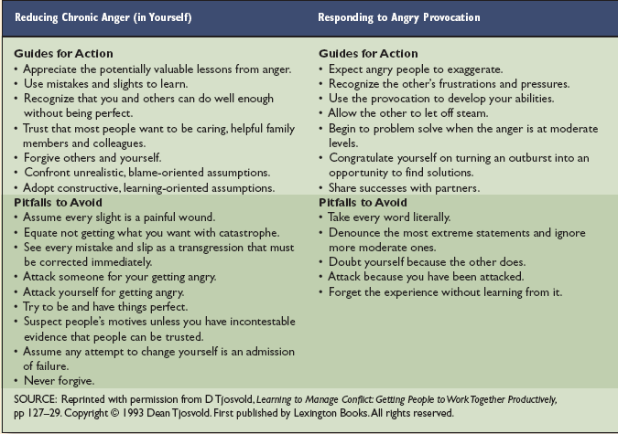

Questions for Discussion
1. Why is uncontrolled anger a sure road to failure?

2. Is it possible to express anger without insulting others? Explain.

3. Which is more difficult, controlling anger in yourself or defusing someone else’s anger? Why?

4. What useful lessons did you learn from this role-playing exercise?

