Chapter 6
Interactions Between Cells and the Extracellular Environment

Chapter Scope
The important activities that occur between cells and the extracellular environment that involve the plasma membrane, are fully explored in this chapter. To a large extent the protein and phospholipid molecules that make up the composition of the plasma membrane regulate the passage of materials either into or out of the cell’s interior. The membrane does have pores through which many substances enter and exit by simple diffusion, traveling from higher to lower concentrations. In addition, metabolic gases such as O₂ and CO₂ follow their respective concentration differences (gradients) into and out of the cell. Finally, most triglycerides, steroids, and other fat — soluble (nonpolar) molecules may also diffuse across cell membranes based on their solubility in the phospholipid core.
The entry of many nutrients from the extracellular environment such as simple sugars (for example, glucose) and amino acids (for example, phenylalanine) is not simple, and therefore, requires selective protein “carriers” (facilitated diffusion). Other molecules not only require membrane carriers but also require that ATP’s metabolic energy be expended in the effort to “pump” these molecules “uphill” in the direction that opposes the concentration gradient (active transport). Sodium ions (Na⁺) and potassium ions (K⁺) are separated from each other by active transport pumps located in the cell membrane. This separation of charged ions results in the electrical membrane potential, which in turn, leads to the formation of electrical impulses. Generated in the brain and elsewhere, and conducted throughout the nervous system, these impulses will be described in the next few chapters — running along sensory and motor neurons (chapters 8, 9, and 10) and along muscle fibers (chapter 12).
The movement of water across membranes is a unique form of simple diffusion, flowing from a region of high water concentration to an area of low water concentration (osmosis). The concentration of solutions in the body, such as plasma, is regulated by homeostasis and equals approximately 300 milliosmoles (300 mOsm) per liter of water. Nerve receptors (osmoreceptors) in the brain monitor body water concentration and, with the cooperation of specific hormones, such as antidiuretic hormone (ADH), regulate the loss of water primarily from the kidney (chapter 16).

I. EXTRACELLULAR ENVIRONMENT
The extracellular environment surrounding cells consists of a fluid compartment, in which molecules are dissolved, and a matrix of polysaccharides and proteins that give form to the tissues. Interactions between the intracellular and extracellular environment occur across the plasma membrane.
A. Multiple Choice
___ 1. Which of the following statements about the extracellular environment is false?
a. Chemical regulators secreted from other cells of the body interact with target cells by way of the extracellular environment.
b. Body cells receive nourishment from the extracellular environment.
- Most body water (about 67%) is found in the extracellular environment.
- Cellular waste products formed from metabolism are released into the extracellular environment.
e. All of these statements about the extracellular environment are true.
___ 2. Which of the following is not a function of blood plasma?
a. Transport oxygen from the lungs to the body cells.
b. Form bile for elimination of products from the liver.
c. Transport nutrients derived from digested food in the intestine to body cells.
d. Distribute hormones and other regulatory molecules to their target cells.
e. All of these are functions of blood plasma.
___ 3. The fluid that exists primarily in the hydrated gel of ground substance, is
a. tissue fluid
b. interstitial fluid
c. intracellular fluid
d. blood plasma
e. a & b only
___ 4. Collagen and elastin are special protein fibers that make up the connective tissue found characteristically as part of the
a. extracellular matrix
b. ground substance
c. plasma membrane
d. blood plasma
___ 5. The gel-like ground substance that comprises part of the extracellular matrix contains glycoproteins (carbohydrate-protein combinations) and polysaccharide-type molecules, known as
a. collagen
b. matrix metalloproteinases (MNPs)
c. glycogen
d. proteoglycans
e. lactic acid
___ 6. Matrix metalloproteinases (MMPs) are an important family of enzymes because they use zinc as an ion cofactor (“metallo-”) and because they
a. attack potentially infectious agents
b. strengthen the extracellular matrix
c. break down collagen fibers
d. help prevent the loss of blood plasma
e. speed up metabolism in the cells
___ 7. Which of the following substances is not allowed to enter the plasma (cell)
membrane by simple diffusion?
a. ions
b. proteins
c. water
d. lipid-soluble molecules
___ 8. Which of the following processes is not an example of carrier-mediated transport?
a. osmosis
b. facilitated diffusion
c. active transport
d. All of these processes are carrier-mediated.
B. True or False/Edit
___ 9. Approximately 20% of the extracelluar fluid is blood plasma.
___ 10. Blood plasma is also known as interstitial fluid.
___ 11. Before entering a cell, all materials delivered by blood plasma must first pass through interstitial fluid.
___ 12. The structure, composed mainly of glycoproteins and proteoglycans and that is most responsible for the intricate bonding that exists between the epithelium and its underlying connective tissue is called ground substance.
___ 13. Active transport includes simple diffusion, osmosis, and facilitated diffusion.

II. Diffusion and Osmosis
Net diffusion of a molecule or ion through a cell membrane always occurs in the direction of its lower concentration. Nonpolar molecules can penetrate the phospholipid barrier, and small inorganic ions can pass through channels in the membrane. The net diffusion of water through a membrane is known as osmosis.

A. Multiple Choice
___ 14. The energy that “drives” diffusion processes comes from
a. thermal (heat) energy
b. metabolic energy
c. potential energy
d. kinetic energy
___ 15. The movement of molecules or ions “uphill” from regions of lower to regions of higher concentrations is known as
a. active transport
b. facilitated diffusion
c. osmosis
d. simple diffusion
e. None of these descriptions is correct.
___ 16. Which of the following substances can not cross the plasma (cell) membrane by simple diffusion?
a. O₂
b. steroid hormone
c. CO₂
d. urea
e. All of these substances can cross by simple diffusion.
___ 17. The rate of diffusion as measured by the number of diffusing molecules passing through the membrane per unit time is dependent on all of the following factors, except
a. “steepness” of the concentration gradient
b. simultaneous passage of water molecules
c. permeability of the membrane to the diffusing substances
d. surface area of that membrane
___ 18. Molecules that are osmotically active
a. include plasma proteins such as albumin
b. cannot readily diffuse across the plasma membrane
c. help regulate the flow of water between the tissues and the blood
d. do not include water
e. All of these statements are correct.
___ 19. Osmotic pressure is best defined as the force
a. generated by the solute gradient across the membrane
b. exerted by the osmotically active solutes
c. exerted to oppose the movement of water (osmosis)
d. generated by the membrane to pump water out of the cell
___ 20. Which of the following statements regarding osmotic pressure is false?
a. Pure water has an osmotic pressure of zero.
b. A 360 g/L glucose solution has twice the osmotic pressure of a 180 g/L glucose solution.
c. The greater the solvent concentration, the greater its osmotic pressure.
d. All of these statements regarding osmotic pressure are true.
___ 21. A 1.0 m glucose solution added to a 2.0 m NaCl solution would form a solution with a total osmolality of
a. 2.0 Osm
b. 3.0 Osm
c. 4.0 Osm
d. 5.0 Osm
___ 22. The milliosmolality of normal human plasma is about
a. 180 mOsm
b. 300 mOsm
c. 0.3 mOsm
d. 1.86 mOsm
___ 23. Which solution is not isotonic to plasma?
a. 0.3 m glucose
b. 5% dextrose
c. 0.15 m NaCl
d. normal saline
e. All of these solutions are isotonic to plasma.
___ 24. Red blood cells (RBCs) bled into sea water will ________, since sea water is ________.
a. crenate; hypotonic
b. hemolyse; hypotonic
c. crenate; hypertonic
d. hemolyse; hypertonic
___ 25. Osmoreceptors, specialized neurons that monitor the osmolality of blood plasma, are located in the
a. hypothalamus
b. pituitary
c. kidney
d. heart

B. True or False/Edit
___ 26. Simple diffusion may describe the movement of either solute or solvent molecules.
___ 27. Some carrier - mediated processes may occur across the membrane of dead cells.
___ 28. When a concentration difference exists across a membrane, the diffusion of those molecules that are permeable will strictly be from the area of higher concentration to the area of lower concentration.
___ 29. Steroid molecules are able to diffuse across cell membranes without carriers because steroids are nonpolar molecules.
___ 30. O₂ and CO₂ gas exchange across the cell membrane occurs by simple diffusion down their respective concentration gradients.
___ 31. Osmosis can be described as water movement in the direction of less dilute to more dilute solutions.
___ 32. The resting neuron membrane is twenty times more permeable to Na⁺ ions than to K⁺ ions.
___ 33. Microvilli are tiny folds projecting from the apical membranes of epithelial cells found in the intestine and the kidney tubules, that serve to increase the surface area of these membranes for absorption.
___ 34. Osmosis is the net diffusion of water (the solute) across semipermeable membranes.
___ 35. The plasma membrane of some cells contain varying numbers of aquaporins, special water channels that may be inserted and removed from the membrane in response to regulatory molecules.
___ 36. Edema is the excessive accumulation of fluid in the tissues that can result from an abnormal increase in the production of plasma proteins, such as albumin.
___ 37. The greater the solute concentration of a solution, the greater its osmotic pressure.
___ 38. One mole of glucose contains the same number of atoms or molecules as one mole of sucrose.
___ 39. One mole of glucose contains the same number of atoms or molecules as one mole of NaCl.
___ 40. Osmolality is determined by the ratio of solute to solvent particles in a solution, not by the chemical nature of the solute molecules.
___ 41. A solution may be isosmotic but not isotonic — as demonstrated when red blood cells are placed in a 0.3 m urea solution.
___ 42. Urea molecules diffuse easily across most cell membranes.
___ 43. Antidiuretic hormone (ADH) acts on the kidney to promote water loss from the body by opposing the reabsorption of water by the nephron.
___ 44. One purpose for prescribing low-salt diets for those with hypertension is to lower plasma osmolality, reduce stimulation of the osmoreceptors, release less ADH from the posterior pituitary, lose more water as urine from the blood, with lowered blood volume and lowered blood pressure as the final objective.

III. Carrier — Mediated Transport
Molecules such as glucose are transported across the cell membranes by special protein carriers. Carrier-mediated transport in which the net movement is down a concentration gradient, and which is therefore passive, is called facilitated diffusion. Carrier-mediated transport that occurs against a concentration gradient, and which therefore requires metabolic energy, is called active transport.

A. Multiple Choice
___ 45. Which of the following is not a characteristic of membrane carrier proteins?
a. specificity
b. competition
c. denaturation
d. saturation
___ 46. The transport of glucose molecules from outside the cell, across the membranes, and into most tissue cells (excluding the intestine or kidney tubule) occurs by the process of
a. active transport
b. simple diffusion
c. facilitated diffusion
d. coupled transport
___ 47. Which condition would not be present in someone with the disease, diabetes mellitus?
a. glycosuria
b. increased production of the hormone, insulin
c. hyperglycemia
d. decreased transport of glucose through plasma membranes
e. decreased level of glucose in the blood plasma
___ 48. Which ion is pumped out of all cells by active transport; such that it can be used as a regulatory signal ion for neurotransmitter release, muscle contraction, and many other cellular activities?
a. sodium
b. chloride
c. potassium
d. calcium
e. phosphate
___ 49. In the primary active transport sequence of events, the hydrolysis of ATP releases energy that is believed required to
- move the cell closer to the target molecule or ion
- attract the molecule or ion to the “recognition site”
- phosphorylate, and change the shape of, the carrier protein
- release the transported molecule or ion from the carrier protein
- change the shape of the cell membrane to engulf the molecule or ion
___ 50. Which of the following functions is not served by the steep Na⁺/K⁺ concentration gradient?
a. It provides energy for the coupled transport of other molecules across the cell membrane.
b. It keeps Na⁺ and water molecules inside the cells.
c. It can be adjusted by thyroid hormones to help regulate the basal metabolic rate (BMR) of the body.
d. It serves to produce electrical impulses in nerve and muscle tissue.
___ 51. In the process of secondary active transport called membrane counter-transport (antiport), calcium ion (Ca²⁺)
a. passively diffuses into the cell as Na⁺ is actively moved out of the cell
b. passively diffuses out of the cell as Na⁺ is actively moved out of the cell
c. is actively moved out of the cell as Na⁺ passively diffuses into the cell
d. is actively moved into the cell as Na⁺ passively diffuses out of the cell

B. True or False/Edit
___ 52. Two amino acids can compete for the same carrier protein located in the cell membrane.
___ 53. The letters GLUT designate transport carriers for the facilitative diffusion of specific amino acid molecules.
___ 54. Secondary active transport (counter-transport) is responsible for keeping the intracellular concentration of calcium (Ca²⁺) ions very low.
___ 55. Across the cell membrane, both sodium and potassium ions are “pumped” down their concentration gradients.
___ 56. All cells in the body have variable numbers of Na⁺/K⁺ membrane pumps that are constantly active.
___ 57. The term bulk transport applies to the movement of many molecules either into (endocytosis) or out of (exocytosis) the cell.

IV. The Membrane Potential
As a result of the permeability properties of the cell membrane, the presence of nondiffusible negatively charged molecules inside the cell, and the action of the Na⁺/K⁺ pumps, there is an unequal distribution of charges across the membrane. As a result, the inside of the cell is negatively charged compared to the outside. This difference in charge, or potential difference, is known as the membrane potential.

A. Multiple Choice
___ 58. Which of the following substances would not be considered a “fixed” anion within the cytoplasm of a cell?
a. certain steroid molecules
b. phosphate groups of ATP
c. certain cellular proteins
d. certain organic molecules
___ 59. To which of the following cations is the cell membrane most permeable?
a. sodium
b. potassium
c. calcium
d. iron
___ 60. The cation found in higher concentration inside than outside the cell is
a. sodium
b. potassium
c. calcium
d. hydrogen
___ 61. The Nernst equation is most often used to estimate the cell's
a. resting membrane potential
b. osmotic pressure
c. threshold potential
d. equilibrium potential for Na⁺ ions or for K⁺ ions
___ 62. Using the Nernst equation, the equilibrium potential for Na⁺ is
a. -90 mV
b. -70 mV
c. 0 mV
d. +60 mV
___ 63. A “less negative” membrane potential means
a. it is “more positive” than the resting potential
b. it is a number closer to zero mV
c. the resting membrane potential has moved closer to the sodium equilibrium
d. All of these statements describe the term “less negative.”

B. True or False/Edit
___ 64. “Fixed” anions cannot penetrate the cell membrane.
___ 65. The intracellular Na⁺ concentration is lower than the extracellular Na⁺ concentration.
___ 66. The equilibrium potential is a theoretical voltage — that is, it does not occur naturally in living cells.
___ 67. A resting membrane potential of -70 mV prevents any diffusion of Na⁺ out of the cell.
___ 68. A cell at rest has both Na⁺ and K⁺ concentrations in perfect equilibrium across the membrane.
___ 69. The resting membrane potential of most cells averages -70 mV and should be distinguished from the theoretical equilibrium potentials for sodium (+60 mV) or potassium (-90 mV) that are calculated to establish the extremes.
___ 70. Mathematical expressions such as the Nernst equation demonstrate that the membrane potential of a cell can be influenced greatly by factors such as a change in the concentration of any involved ion and by a change in the permeability of the membrane to such ions.

V. cell signaling
Cells communicate by signaling each other chemically. These chemical signals are regulatory molecules released by neurons and endocrine glands, and by different cells within an organ.
A. Multiple Choice
___ 71. Which of the following is not a general category of signals used by cells to communicate with one another?
a. gap junctions
b. paracrine signaling
c. synaptic signaling
d. endocrine signaling
e. All of these are included in cell signaling.
___ 72. The secretion of regulatory molecules within an organ that diffuse locally through the extracellular matrix to stimulate their target cells, describes
a. gap junctions
b. paracrine signaling
c. synaptic signaling
d. endocrine signaling
___ 73. Which of the following forms of signaling uses neurotransmitter molecules?
a. gap junctions
b. paracrine signaling
c. synaptic signaling
d. endocrine signaling
___ 74. During cell communication, signal molecules must bind to specific receptor proteins that are located
a. on the outer surface of the target cell plasma membrane
b. in the target cell cytoplasm
c. within the nucleus of the target cell
d. Receptor proteins may be found in any of the above locations.
___ 75. Which of the following regulatory molecules is large or polar, and therefore must bind to receptor proteins located on the outer surface of the target cell plasma membrane?
a. steroid hormone
b. insulin
c. acetylcholine (Ach)
d. epinephrine (epi)
B. True or False/Edit
___ 76. Cell signaling describes the many different processes used by cells to communicate with each other.
___ 77. Gap junctions are important structures that belong to the category of “synaptic signaling” between cells.
___ 78. As opposed to endocrine signaling, paracrine signal molecules diffuse locally throughout an organ communicating among target cells located within that organ.
___ 79. Regulatory molecules such as epinephrine, acetylcholine, and insulin, are nonpolar and can diffuse through the cell membrane to enter target cells.

Chapter Review

A. Completion
80. Passive transport of molecules or ions from regions of high to regions of low concentrations is called __________; and is due to __________ energy rather than metabolic energy.
81. The rate of diffusion depends on: the __________ difference or gradient that exists on two sides of the membrane; the __________ (selectivity) of the cell membrane to the diffusing substance; and is directly proportional to the membrane __________ (for example, microvilli).
82. Lipids such as steroids are ______(polar/nonpolar) molecules and, thus, __________ can/cannot) pass easily through phospholipid layers of the membrane.
83. Osmosis is the simple __________ of __________ molecules from __________ (more/less) dilute solutions to __________ (more/less) dilute solutions.
84. Solute molecules can exert force on the movement of solvent (water). The solute concentration is measured in units called __________, which is directly related to the ___________ pressure of a solution.
85. All solutions with the same number of solute particles as plasma are __________, such as __________% NaCl and __________% glucose solutions; and in such solutions, red blood cells (RBCs) __________ (do/do not) gain or lose water.
86. However, increasing the number of solute particles in such solutions results in a __________- tonic (hyper/iso/hypo) solution in which RBCs would __________ (crenate/hemolyse); while solutions with fewer solutes than plasma are __________- tonic (hyper/iso/hypo) in which RBCs would ______(crenate/hemolyse).
87. Water homeostasis is regulated mainly by __________- receptors located in the ______of the brain, which control the release of ______hormone from the ______pituitary gland; and which directs the kidneys to ______(lose/reabsorb) body water.
88. Like enzyme proteins, carrier-mediated transport proteins are characterized by __________, __________, and ______. Carrier-mediated transport without the use of energy is __________ and is called ____________; whereas carrier-mediated transport requiring metabolic energy is __________ and is called __________.
89. For example, the “uphill” Na⁺/K⁺ pump maintains the Na⁺ concentration high __________ (inside/outside) the cell and K⁺ concentration high __________ (inside/outside).
90. Of these two ions, __________ is the more diffusible, and is attracted into the cell by “fixed” __________ (anions/cations).
91. Due to this separation of ions the cell membrane potential at rest is approximately __________ mV, and it is maintained by expending __________ energy in the form of __________.

B. Sequencer
92. Abandoned in the hot desert for long periods of time without water, you have become dehydrated. Your body will sense this water loss and will initiate efforts to correct or compensate for this imbalance (notice this is negative feedback at work!). Read the following list of events and place them in the proper sequence. The last one (8) has been done for you.
Lower volume of urine is excreted from the body
Heightened sense of thirst with drinking behavior as the posterior pituitary is stimulated
Blood volume falls; plasma osmolality (solute/solvent) rises
Blood volume rises; plasma osmolality (solute/solvent) falls
Water retention is promoted along the kidney tubules
8 Normal plasma osmolality is restored (homeostasis)
Osmoreceptors in the hypothalamus are activated
_____ Antidiuretic hormone (ADH) is released into the bloodstream

C. Crossword Puzzle —Membrane Transport and the Membrane Potential

Across
2. the resting membrane potential is a __________ number, in millivolts
5. as electrolytes dissolve in water they come apart, or
7. when all membrane carriers are saturated, known as the T_{m} or transport __________
11. the form of transport that includes simple diffusion and osmosis
12. ions may pass through membranes along tiny passageways called __________
14. fingerlike projections or membrane folds; increase the cell surface area for absorption
15. what you receive for solving this puzzle

16. first two letters in the name of the hormone, ADH
19. more than one female egg cell
20. movement of materials “uphill” against concentration gradients is called active __________
21. density of solute molecules per volume of solvent
24. number of Na⁺ ions pumped out of the cell as two K⁺ ions are pumped into the cell by the Na⁺/K⁺ pump
25. specific membrane protein made by the cell for transport
29. where a bath can be taken
31. negative ions (such as, proteins)
32. can be abbreviated Osm
33. another name for primary active transport carriers
36. net diffusion of water across a membrane
37. passive carrier-mediated transport
39. boy or girl scout attribute
40. one example of a sugar solute molecule found in this chapter
41. charged particles
42. condition when concentrations of substances across a membrane are no longer different
44. cell membranes are considered to be semi- or __________ permeable
46. what happens to red blood cells when placed in ocean water (hypertonic)
47. hormone lacking in the disease diabetes mellitus
48. a solution with the same osmolality as plasma
51. units used to measure the charge difference across cell membranes
52. organ affected greatly by an excess of K⁺ ions in plasma
53. neurons sensitive to the osmotic pressure and osmolality of plasma
Down
1. genetic material necessary for synthesizing membrane carrier proteins
3. a difference in concentration between two solutions
4. one of three characteristics membrane carriers have in common with enzymes
6. osmotic pressure of pure water
8. example of an osmotically active solute in the plasma
9. change in ice on a hot summer day
10. membrane property — allow some to cross but not others
11. chemical composition of the membrane “core”
13. abbreviation in professional basketball
15. solution with a greater osmotic pressure and osmolality than plasma (for example, sea water)
17. secondary active transport, (for example, glucose uptake from kidney tubule)
18. the body's solvent
22. home for a feathered friend
23. form of energy used to drive the membrane “pumps”
26. the fluid portion of the blood
27. Avogadro's number of molecules; a small furry animal
28. passive movement from an area of high to one of low concentration
30. organ where the hypothalamus and osmoreceptors are located
34. primary intracellular cation
35. what happens to red blood cells when placed in a fresh water lake (hypotonic)
38. artificial removal of waste materials when kidneys fail
43. negative ions trapped within the 600 cell are known as __________
45. diffusion always occurs from higher to __________ concentrations
49. the number of negative charges on a cloride ion
50. worn on a baseball player’s head

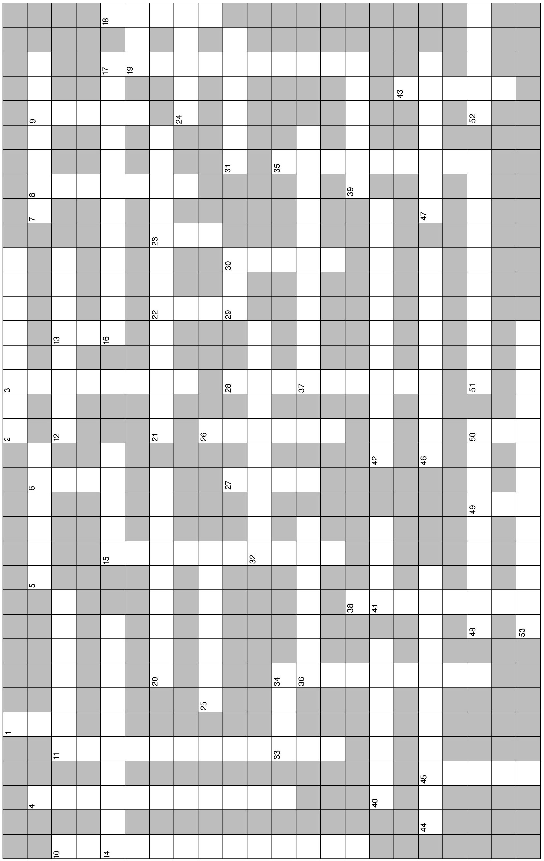

D. Essay

Essay Tutorial
This essay tutorial will answer the first essay question found in the “Review Activities” section of your Human Physiology textbook. Please look for question 1. at the end of chapter 6, read it carefully, and let me guide you through one possible answer. Watch for key terms in bold-face type, helpful tips and general suggestions on writing the essay or short-answer questions. Enjoy!
93. Describe the conditions required to produce osmosis, and explain why osmosis occurs under these conditions.

Note: This is really two questions in one. First we will describe the conditions producing or causing osmosis, then we will explain why osmosis occurs. Let's begin as we often do by defining the key word in the question — osmosis.
Answer. Osmosis is the net simple diffusion of water molecules (solvent) across a cell membrane that is permeable to water (note: not all membranes are permeable to water, such as those in portions of the kidney nephron). The conditions required for osmosis are: (1) the membrane must be relatively impermeable to the solutes on either side; and (2) the concentration of water must be higher on one side of the membrane than on the other. Osmosis now will occur from the side where water concentration is higher (more dilute!) to the side where water concentration is lower (less dilute!). The “impermeable”' solutes are unable to cross the membrane and, thus, are said to be osmotically active since water will flow in the direction of these solutes in the attempt to “dilute” them. Finally, it is important to observe that when water (which is not compressible) moves throughout the body, the volume of that part of the body changes. How did it go? OK, got time for a few more?
94. You are a paramedic at the scene of an accident. You have three glucose (dextrose) solutions in your truck for starting intravenous fluid (IV) treatment — 1%, 5%, and 10% dextrose in water. Which of these solutions is isotonic, which is hypertonic, and which is hypotonic? Describe clearly what would happen if each of these solutions is infused separately.

95. Compare and contrast the terms osmolality and osmotic pressure — using the terms solute, solvent,
and the ratio in your explanation.

96. Body water homeostasis is maintained by neuron sensors and hormone effectors participating in a negative feedback loop. Describe this loop, the sensors, the effectors, and the response of the body to too much and too little body water.

97. Describe the interaction between the “fixed anions” and the Na⁺/K⁺ pump in creating the resting membrane potential. Include the permeability of the membrane to each substance and the role metabolic energy (ATP) plays in forming the membrane potential.

Answers — Chapter 6

- Extracellular Environment
- 1. c, 2. b, 3. e, 4. a, 5. d, 6. c, 7. b, 8. a
- 9. T, 10. F—Interstitial fluid is also known as tissue fluid, 11. T, 12. F—Replace “ground substance” with “basal lamina,” 13. F—Replace “Active” with “Passive”
- Diffusion and Osmosis
- 14. a, 15. a, 16. e, 17. b, 18. e, 19. c,
20. c, 21. d, 22. b, 23. e, 24. c, 25. a
- 26. T, 27. T, 28. F—Some diffusion will be in the opposite direction, as well,
29. T, 30. T, 31. F—Switch “less” for “more,” 32. F—Switch “K⁺” and “Na⁺,” 33. T, 34. F—Replace “solute” with “solvent,”35. T, 36. F—Replace “increase” with “decrease,” 37. T, 38. T, 39. F—One mole of NaCl splits to form two moles of atoms, 40. T, 41. T, 42. T, 43. F—ADH promotes water reabsorption (not loss), 44. T
- Carrier-Mediated Transport
- 45. c, 46. c, 47. b, 48. d, 49. c, 50. b,
51. c
- 52. T, 53. F—Replace “amino acid” with “glucose” 54. T, 55. F—Replace “down” with “against,” 56. T, 57. T
- The Membrane Potential
- 58. a, 59. b, 60. b, 61. d, 62. d, 63. d
- 64. T, 65. T, 66. T, 67. F—Na⁺ will diffuse out of the cell due to its steep concentration gradient, 68. F—A cell at rest has both Na⁺ and K⁺ ions actively separated across the membrane—the basis for the membrane potential, 69. T, 70. T
- Cell Signaling
- 70. e, 71. b, 72. c, 73. d, 74. A
- 75. T, 76. F—Gap junctions and synaptic signaling are very different,
77. T, 78. F—These molecules are large and polar, thus cannot enter cells,
79. F—These molecules are large and polar; thus cannot enter cells
Chapter Review
- 80. diffusion; thermal,
81. concentration; permeability; surface area, 82. nonpolar; can, 83. diffusion; water; more; less, 84. osmoles; osmotic, 85. isotonic; 0.9; 5.0; do not, 86. hyper; crenate; hypo; hemolyse, 87. osmo; hypothalamus; ADH; posterior; reabsorb, 88. specificity; competition; saturation; passive; facilitated diffusion; active; active transport, 89. outside; inside, 90. K⁺; anions, 91. -70; metabolic; ATP
- 92. - 6, 3, 1, 7, 5, 8, 2, 4

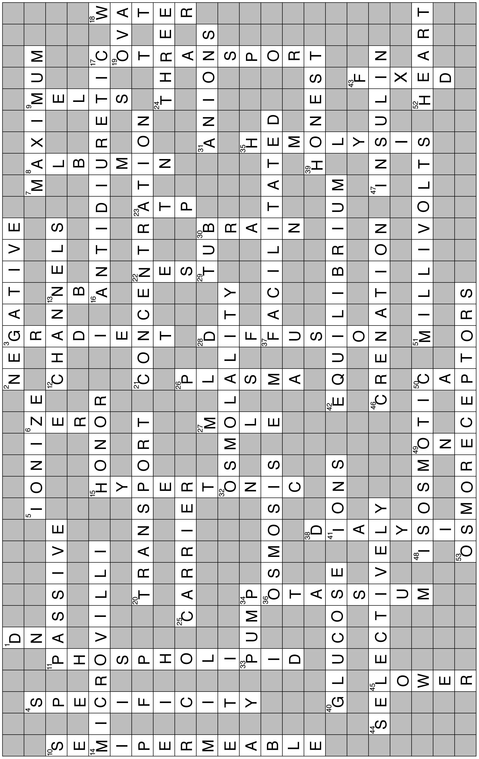
- Crossword Puzzle

