Chapter 14
Cardiac Output, Blood Flow, and Blood Pressure

Chapter Scope
The last chapter introduced blood, the structure and function of the heart and the blood vessels. This chapter follows with descriptions of the many complex factors that specifically control cardiac output; and the normal regulation of blood flow and blood pressure throughout the body. As we shall see, blood will always flow from blood vessels in areas of higher pressure toward those in areas of lower pressure. Blood flow is also related to the volume of blood pumped from the heart each minute (cardiac output) and the degree of vascular constriction, or peripheral resistance, that circulating blood encounters as it spurts away from the heart. A thorough knowledge of these cardiovascular dynamics can help form the basis for proper diagnosis and treatment of conditions when blood flow and blood pressures are not normal. Such abnormal conditions occur in hypertension, circulatory shock, and congestive heart failure.

I. Cardiac Output
The pumping ability of the heart is a function of the beats per minute (cardiac rate) and the volume of blood ejected per beat (stroke volume). The cardiac rate and stroke volume are regulated by autonomic nerves and by mechanisms intrinsic to the cardiovascular system.

A. Multiple Choice
- With a cardiac rate of 70 bpm and a stroke volume of 70 ml, the cardiac output is equal to
a. 70 ml per minute
b. 140 ml per minute
c. 1400 ml per minute
d. 4900 ml per minute
- The total blood volume (in liters) of an adult is approximately
a. 3 L
b. 6 L
c. 9 L
d. 12 L
e. 15 L
- Which chemical has a negative chronotropic effect on the cardiac rate by hyperpolarizing the sinoatrial (SA) node and thus decreasing the rate of its spontaneous firing?
a. acetylcholine (ACh)
b. norepinephrine (NE)
c. epinephrine
d. None of these chemicals slows the heart in this manner.
- The cardiac control centers are located in the
a. hypothalamus region of the brain
b. medulla oblongata of the brainstem
c. cerebral cortex
d. pituitary gland
e. cerebellum region of the brain
- Which of the following variables does not contribute directly to the stroke volume ejected from the ventricle?
a. the end-diastolic volume (EDV) of blood in the ventricle before systole
b. the total peripheral resistance or impedance to the flow of blood through the arteries
c. the increase in parasympathetic (vagus) nerve stimulation of the SA node and myocardium
d. the contractility or strength of ventricular contraction
- The Frank-Starling law of the heart states that the
a. cardiac rate times stroke volume equals cardiac output
b. afterload is proportional to the total peripheral resistance
c. stroke volume is proportional to the end-diastolic volume (EDV)
d. cardiac output varies directly with the blood pressure
- The volume of blood pumped from the left ventricle through the systemic circulation is ________ that pumped from the right ventricle through the pulmonary circulation.
a. greater than
b. equal to
c. less than
- A positive inotropic effect would cause a(n)
a. increase in the contractility of the heart
b. decrease in the cardiac rate
c. increase in the end-diastolic volume (EDV)
d. increase in the flow of K⁺ into the myocardium
- Which statement about veins is false?
a. Veins contain about 66% (two-thirds) of the total circulating blood volume.
b. Venous pressure averages about 100 mm Hg.
c. Sympathetic stimulation can contract the smooth muscles located in the walls of veins.
d. Due to the structure of the walls, veins have a higher compliance than the walls of arteries.
e. Veins are called capacitance vessels due to their capacity to expand and hold more blood.

B. True or False/Edit
- A positive chronotropic effect is one caused by excitatory chemicals causing Na⁺ and Ca²⁺ channels to open, which depolarize the SA node membranes and thus result in an increase in the cardiac rate.
- In exercise, the initial cardiac rate increase occurs because the vagus nerve inhibition of the SA node is decreased.
- Sensory feedback information from pressure receptors located in the carotid sinus and the aortic arch is interpreted by the cardiac control centers.
- Preload refers to the total peripheral resistance opposing the ejection of blood out of the ventricle.
- The lower the peripheral resistance, the lower the stroke volume (that is, they are directly proportional).
- The Frank-Starling law of the heart describes the built-in, or intrinsic property of heart muscle in which changes in the end-diastolic volume produce changes in the strength of ventricular contraction.
- Parasympathetic (vagal) stimulation of the heart has a negative chronotropic effect, but it has no direct inotropic effect.
- Contraction of the diaphragm during inhalation lowers the pressure in the chest and in the heart; thereby increasing the return of venous blood to the heart.

II. Blood Volume
Fluid in the extracellular environment of the body is distributed between the blood and the tissue fluid compartments by filtration and osmotic forces acting across the walls of capillaries. The function of the kidneys influences blood volume because urine is derived from blood plasma. The hormones ADH and aldosterone act on the kidneys to help regulate the blood volume.

A. Multiple Choice
- Most of the water in the body (two-thirds) is found in the
a. intracellular compartment
b. blood plasma
c. extracellular environment
d. interstitial fluid

- Which statement about colloid osmotic pressure of the plasma is false?
a. It is the osmotic pressure exerted by the presence of plasma proteins.
b. It is normally a very high pressure if measured in the tissue fluid.
c. It is essentially equal to the oncotic pressure of the plasma.
d. It has been estimated to be 25 mm Hg.
e. It usually favors the movement of water by osmosis into capillaries.
- Starling forces refer to the
a. ejection pressures exerted by the heart during contraction
b. pressures exerted by the peripheral resistance blood vessels that dilate and constrict, affecting the cardiac output
c. opposing hydrostatic and colloid osmotic pressures that determine the distribution of fluid across the capillary wall
d. pressures that influence the return of venous blood to the heart
- Which of the following is not a cause of edema?
a. high blood pressure in the arteries
b. blood congestion or obstruction in the veins
c. an increase in capillary permeability causing plasma proteins to leak into tissue fluid
d. liver disease or kidney disease which results in a drop in the levels of plasma proteins
e. All of these are causes of edema.
- Both the blood volume and the urine volume are regulated ultimately by the amount of glomerular filtrate reabsorbed in the kidney, which, in turn, is normally adjusted by the
a. amount of fluid consumed during the day
b. action of specific hormones on the kidneys
c. neuron control of bladder function
d. frequency of micturition (urination)
- Which statement about antidiuretic hormone (ADH) is false?
a. ADH is a hormone also known as vasopressin.
b. ADH is synthesized by neurons located in the hypothalamus.
c. Receptors (osmoreceptors) release ADH when the plasma osmolality rises.
d. ADH decreases water reabsorption from the glomerular filtrate and increases water loss in the form of urine.
e. All of these statements regarding ADH are true.
- Which of the following statements about aldosterone is false?
a. It is a steroid hormone.
b. It is secreted by the cortex region of the adrenal gland.
c. It promotes the excretion of both salt and water in proportionate amounts from the kidneys.
d. Its secretion is stimulated during salt deprivation, when the blood volume and pressure are reduced.
e. Unlike ADH, aldosterone does not act to dilute the blood.
- The juxtaglomerular apparatus (JGA) of the kidney
a. is stimulated by increased blood flow and blood pressure in the renal arterioles
b. secretes the enzyme called renin into the blood
c. secretes the angiotensin converting enzyme (ACE)
d. filters blood and reabsorbs water
- Which of the following actions is not used by angiotensin II to produce a rise in blood pressure?
a. vasoconstriction of smooth muscle in the walls of small arteries
b. stimulation of thirst centers located in the hypothalamus to drink more water
c. stimulation of the heart, causing an increase in myocardial contractility
d. stimulation of the adrenal cortex to secrete aldosterone, which then acts to reabsorb salt from the kidney
- Atrial natriuretic factor (ANF) is a hormone that
a. is secreted from the atria of the heart when blood volume is high
b. works to oppose the action of aldosterone on the kidneys
c. promotes the excretion of salt (and water follows) from the kidneys
d. antagonizes the various actions of angiotensin II, resulting in both a decrease in the secretion of aldosterone and vasodilation.
e. All of these statements describe the ANF.

B. True or False/Edit
- The blood pressure that is exerted against the inner wall of the capillary, causing the filtration of plasma and the formation of tissue fluid is called hydrostatic pressure.
- Hydrostatic pressure can also be the pressure measured in the tissues outside the capillary which opposes the filtration pressure of the blood.
- The protein concentration of tissue fluid (ECF) is greater than the protein concentration of blood plasma.
- A positive value for the net Starling forces at the venule end of a capillary favors the return of fluid into that portion of the capillary.
- About 15% of fluid filtered from the arteriolar end of the capillary (amounting to at least 2 L per day) is returned to the blood as lymph rather than being absorbed into the venular end of the capillary.
- Capillaries of the kidney that filter plasma and begin the formation of urine, are called glomeruli.
- After drinking several large glasses of water, your plasma osmolality would decrease, stimulating osmoreceptors, that, in turn, stimulate the release of ADH from the posterior pituitary.
- Water is a diuretic substance because water intake inhibits the secretion of antidiuretic hormone (ADH) and causes a larger volume of urine to be excreted.
- Very high blood volume stimulates specialized stretch receptors located in the left atrium of the heart, that, in turn, send signals to inhibit ADH secretion, ultimately reducing the blood volume.
- A drug inhibiting angiotensin-converting enzyme (ACE) would be expected to cause an increase in both the total peripheral resistance and blood pressure.

C. Label the Figure — The Renin-Angiotensin-Aldosterone System
Figure 14.11 in the text is a very important flow diagram. It summarizes the renin-angiotensin-aldosterone system and its negative feedback control over blood flow and blood pressure. Before looking up the figure in the text, give yourself a pretest by attempting to complete the empty flow diagram shown below in figure 14.1. Later, correct or complete your work using the text. If you erase your answers, this diagram can also help prepare for the next exam! Don’t worry if you have difficulty following the flow of this outline because this important concept will also be discussed again later in the kidney chapter (chapter 17).
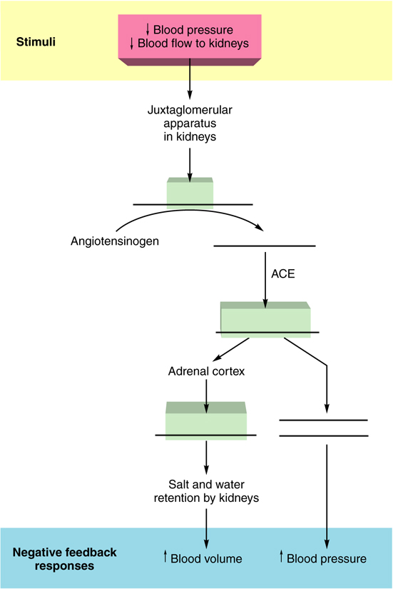
Figure 14.1 The negative feedback control of blood volume and pressure by the renin-angiotensin-aldosterone system. ACE = angiotensin-converting enzyme.

III. Vascular Resistance to Blood Flow
The rate of blood flow to an organ is related to the resistance to flow in the small arteries and arterioles that serve the organ. Vasodilation decreases resistance and increases flow, whereas vasoconstriction increases resistance and decreases flow. Vasodilation and vasoconstriction occur in response to intrinsic and extrinsic regulatory mechanisms.

A. Multiple Choice
- From the following list, which of these tissues receives the least amount of blood under resting conditions?
a. coronary arteries of the heart
b. liver
c. kidneys
d. skeletal muscles
e. brain
- Which factor does not result in an increase in the resistance to blood flow through a vessel?
a. a vessel with longer length
b. “thicker” blood with higher viscosity
c. blood flowing at a higher velocity
d. decrease in the radius of the blood vessel
e. All of these factors increase the resistance to blood flow.
- The blood vessel that can become narrower through vasoconstriction and thereby provide the greatest resistance to the flow of blood, is the
a. artery
b. arteriole
c. capillary
d. venule
e. vein
- Vasodilation of skeletal muscles that occurs during “fight-or-flight” reactions is caused mainly by the
a. alpha-adrenergic stimulation of vascular smooth muscle, primarily with norepinephrine (NE) as the neurotransmitter.
b. cholinergic sympathetic stimulation of vascular smooth muscle with acetylcholine (ACh) as the neurotransmitter
c. beta-adrenergic stimulation of vascular smooth muscle with epinephrine from the adrenal medulla as the hormone
d. adrenergic parasympathetic stimulation of vascular smooth muscle with norepinephrine as the neurotransmitter
e. Both b and c result in vasodilation of skeletal muscles.
- Two organs that use both myogenic and metabolic intrinsic mechanisms to help maintain relatively constant flow rates despite wide fluctuations in blood pressures are the
a. heart and brain
b. liver and kidneys
c. genitals and skin
d. brain and kidneys
- Which metabolic or chemical condition produced by local cell activity does not promote vasodilation within that organ?
a. a decrease in oxygen concentrations
b. an increase in carbon dioxide concentrations
c. an increase in the tissue pH
d. an increase in the release of adenosine or K⁺
e. All of these chemical conditions promote vasodilation.

B. True or False/Edit
- The rate of blood flow through a blood vessel is proportional to the pressure difference between the upstream and downstream regions of the blood vessel.
- As the frictional resistance to blood flow through blood vessels increases, the blood flow itself will decrease.
- The flow of blood to tissues can be decreased by dilation of its arterioles and increased by constriction of its arterioles.
- The endothelium of the tunica intima produces nitric oxide, bradykinin, and prostacyclin — all chemicals that promote vascular smooth muscle contraction (vasoconstriction).
- Autoregulation is the ability of organs to use both myogenic and metabolic intrinsic mechanisms to maintain the blood flow rates relatively constant through these organs.
- The myogenic response of cerebral vessels to excessively high blood pressure results in vasoconstriction that may prevent a cerebrovascular accident (stroke) in the brain.
- The increase in blood flow to skeletal muscles and other organs (vasodilation) that occurs during physical exercise; and that is due to the increase in metabolism and the accumulation of metabolic products, is called reactive hyperemia.

IV. Blood Flow to the Heart and Skeletal Muscles
Blood flow to the heart and skeletal muscles is regulated by both extrinsic and intrinsic mechanisms. These mechanisms provide increased blood flow when the metabolic requirements of these tissues are raised during exercise.

A. Multiple Choice
- Which of the following is not an adaptation of the heart to stress, such as exercise?
a. Heart muscle contains large amounts of the oxygen-binding pigment, myoglobin.
b. Heart muscle has large amounts of stored enzymes for metabolism when anaerobic.
c. Heart muscle has large numbers of mitochondria.
d. Heart muscle capillaries run very close to each myocardial fiber for rapid gas exchange.
e. All of these are adaptations of the heart to stress.
- Which of the following local products of metabolism would not dilate the smooth muscle of coronary blood vessels during exercise?
a. increased carbon dioxide levels
b. decreased pH levels
c. decreased oxygen levels
d. increased extracellular K⁺ and the secretion of adenosine
e. All of these metabolic products would cause dilation of coronary blood vessels during exercise.
- Which of the following changes is not responsible for the increase in blood flow to skeletal muscle during progressively intense exercise?
a. increase in total blood flow (cardiac output)
b. metabolic (intrinsic) vasodilation in the exercising muscles
c. diversion of blood away from the viscera and skin
d. diversion of blood away from the heart and brain
e. All of these increase blood flow in exercising muscle.
- During heavy exercise, the
a. stroke volume usually decreases
b. end-diastolic ventricular volume usually decreases
c. afterload (peripheral resistance) usually increases, especially in the skeletal muscles
d. proportion of blood volume ejected per stroke (ejection fraction) is increased
e. cardiac output stays relatively constant

B. True or False/Edit
- The enormous density of coronary capillaries within the heart myocardium brings blood flow within 10 µm of each myocardial fiber, promoting the rapid diffusion of gases between the capillary blood and each heart cell.
- Unlike blood flow in most other organs, the flow of blood in the coronary vessels decreases during systole and increases during diastole.
- During exercise, most dilation of the coronary vessels is produced by the sympathoadrenal activation of beta-adrenergic receptors “fight-or-flight” medicated by epinephrine.
- Pain and fatigue occur much more quickly during rhythmic isotonic skeletal muscle contractions than would occur during sustained isometric contractions.
- During the “fight-or-flight” response to stress, the combined stimulation of cholinergic receptors by ACh and beta-adrenergic receptors by epinephrine in skeletal muscle results in profound vasodilation and an increase in blood flow.
- As the vascular resistance in blood vessels is decreased, the rate of blood flow is increased.
- During exercise, the five-fold increase in cardiac output (from 5 L per minute to about 25 L per minute) is primarily due to an increase in cardiac stroke volume, not cardiac rate.
- Only 8 days of endurance training is needed to increase the blood volume by as much as 0.5 L (500 ml); thus raising the cardiac output and improving the delivery of oxygen to skeletal muscles during exercise.

V. Blood Flow to the Brain and Skin
Intrinsic control mechanisms help to maintain a relatively constant blood flow to the brain. Blood flow to the skin, by contrast, can vary tremendously in response to regulation by sympathetic nerve stimulation.

A. Multiple Choice
- Which statement about blood flow to the brain (cerebral flow) and skin (cutaneous flow) is false?
a. Cerebral blood flow normally remains remarkably constant at about 750 ml per minute.
b. The brain can not tolerate low rates of blood flow.
- c. Blood flow through the skin can fluctuate dramatically.
d. The skin can tolerate low rates of blood flow.
e. Cerebral blood flow is regulated primarily by extrinsic (away from the vessel) mechanisms.
- During inadequate ventilation, such as hypoventilation, the
a. blood carbon dioxide concentration rises
b. cerebral arterioles constrict
c. pH of the cerebrospinal fluid (CSF) goes up, and becomes a larger number
d. blood flow to the brain decreases
- Which event in the skin does not occur when the ambient (outside) temperature is cold?
a. Sympathetic nerve activity will stimulate vasoconstriction in cutaneous blood vessels, reducing blood flow to the skin.
b. Arteriovenous anastomoses constrict, bypassing the skin surface; yet diverting small amounts of blood to superficial capillary loops and causing “rosy cheeks.”
c. Total cutaneous blood flow rises, causing generalized redness throughout the skin surfaces.
d. Inner body temperatures are maintained relatively constant as less heat is lost.
- Sweat glands secrete the polypeptide bradykinin, that
a. stimulates vasodilation and increased blood flow in the skin
b. reduces sweat production and heat loss through evaporation
c. lubricates the skin and hair follicles
d. causes the “blanching” of skin during extreme cold
e. gives concentrated sweat its normal salty taste

B. True or False/Edit
- Blood flow through the brain is regulated primarily by intrinsic (local, autoregulation) mechanisms; whereas blood flow through the skin is regulated mainly by extrinsic (from outside) mechanisms.
- Those brain regions that are most active and have the highest metabolic activity accumulate chemicals locally, resulting in the delivery of more blood to that area.
- The great tolerance of the skin to very low ambient temperatures is partly due to the fact that such temperatures reduce the metabolic rate in the tissues of cold skin.
- Control centers in the medulla oblongata mediate changes in sympathetic nerve activity; and are responsible for both the blushing (vasoconstriction) and “cold sweat” (vasodilation) responses of cutaneous blood vessels.

VI. Blood Pressure
The pressure of the arterial blood is regulated by the blood volume, total peripheral resistance, and the cardiac rate. Regulatory mechanisms adjust these factors in a negative feedback manner to compensate for deviations. Arterial pressure rises and falls as the heart goes through systole and diastole.

A. Multiple Choice
- The blood vessel with the greatest total cross-sectional area is the
a. artery
b. arteriole
c. capillary
d. venule
e. vein
- Which of the following is not one of the three most important variables affecting blood pressure?
a. cardiac rate
b. stroke volume (blood volume)
c. total peripheral resistance
d. coronary artery vasodilation
- Increased activity of the sympathoadrenal system
a. causes vasodilation in the arterioles
b. causes cardiac output to fall
c. raises total peripheral resistance
d. ultimately increases renal blood flow and urine output
- Baroreceptors increase the frequency of action potentials to the medulla oblongata control centers, when the
a. blood pressure falls in the aorta and carotid arteries
b. aortic arch and carotid sinus walls are stretched
c. cardiac rate and the cardiac output decreases
d. arterial blood gas concentrations are too high
- Which statement about the medulla oblongata region of the brainstem, is false?
a. It receives sensory nerve action potentials from the baroreceptors located in the carotid sinus and aortic arch.
b. It uses autonomic nerves to direct various target tissues.
c. It helps regulate vasoconstriction and vasodilation of blood vessels, and thus total peripheral resistance.
d. It houses cardiac control centers for the regulation of heart rate.
e. All of these statements regarding the medulla oblongata region of the brainstem are true.
- Which statement about the left atrial stretch receptors is false?
a. They respond to an increase in venous return to the heart.
b. They stimulate sympathetic nerve activity, causing a reflex tachycardia.
c. They inhibit ADH secretion from the hypothalamus, resulting in urinary loss of water and a decrease in blood volume.
d. They cause vasoconstriction in peripheral arterioles.
e. They stimulate the increased secretion of atrial natriuretic factor (ANF), resulting in an increase in urinary salt and water excretion.
- Which statement about the sounds of Korotkoff is false?
a. They are heard when vibrations occur in the arterial walls as blood flows noisily through a pinched artery.
b. They are used to detect defects in the cardiac valves that produce the “lub-dub” sounds.
c. They are only present when blood pressures are between the high systolic and the low diastolic pressure extremes.
d. The quality of these sounds is different in persons with high blood pressure than in those with low blood pressure.
e. The last sound occurs when the cuff pressure is equal to the diastolic pressure.
- A person whose blood pressure is 135/85 mmHg has a pulse pressure of _____ mmHg.
a. 35
b. 50
c. 60
d. 85
- 135

- The mean arterial pressure (MAP) in a person whose blood pressure reads 135/85 mmHg is approximately _____ mmHg?
a. 98
b. 100
c. 102
d. 110
e. 120

B. True or False/Edit
- The greatest resistance to blood flow in the arterial system is found in the capillaries.
- Vasodilation of arterioles downstream (away from the heart) decreases the peripheral resistance and results in a lower arterial blood pressure upstream (closer to the heart).
- Blood pressure is measured in units of centimeters of water (cm H₂O).
- A mean arterial pressure of 120 mm Hg indicates that the blood pressure is 120 mm higher than the atmospheric pressure.
- The spring-loaded or mercury-containing instruments used to measure blood pressure are known as stethoscopes.
- Baroreceptors are stretch receptors located in the aortic arch and carotid sinuses regions, monitoring the degree of stretch in the walls of these arteries as pressure changes.
- The vagus and glossopharyngeal nerves carry sensory action potentials from baroreceptors to the vasomotor control center in the pons region of the brainstem.
- Manual massage of the carotid sinus regions can mimic high blood pressure and thereby, through the baroreceptor reflex, can slow any existing tachycardia and lower blood pressure.
- Antidiuretic hormone (ADH) and aldosterone increase blood pressure by increasing blood volume, while angiotensin II increases blood pressure by stimulating vasoconstriction.
- Nothing is heard through a stethoscope when listening to normal blood flow through an artery because normal flow is smooth or laminar (in layers).
- The first sound of Korotkoff is heard when pressure in the cuff equals the pressure in the artery during the diastole phase of the heart.
- Since the pulse is produced by the rise in pressure from diastolic to systolic levels, the difference between these two pressures is known as pulse pressure.
- The mean arterial pressure is simply the average pressure, calculated as halfway between the systolic and diastolic pressures.
- When rising from a lying to a standing position the baroreceptor reflex is activated, increasing the systolic pressure by 5 to 10 mm Hg, whereas the diastolic pressure either remains unchanged or is slightly reduced.

VII. Hypertension, Shock, and Congestive Heart Failure
An understanding of the normal physiology of the cardiovascular system is prerequisite to the study of its pathophysiology, or mechanisms of abnormal function. Since the mechanisms that regulate cardiac output, blood flow, and blood pressure are highlighted in particular disease states, a study of pathophysiology at this time can augment your understanding of the mechanisms involved in normal function.

A. Multiple Choice
- Which of the following is not a cause of hypertension?
a. sustained high stress, activating the sympathetic nervous system
b. myocardial infarction (MI)
c. kidney disease or renal artery disease
d. high-salt diet
- Which mode of treatment would not be used to treat hypertension?
a. angiotensin II to help constrict peripheral arterioles
b. various diuretics to decrease blood volume and increase urine volume
c. beta-adrenergic blocking drugs to decrease cardiac rate
d. ACE inhibitors, calcium antagonists, and various vasodilators to decrease peripheral resistance
e. lifestyle changes: stop smoking, limit alcohol intake, weight reduction, reduce salt ingestion, and regular physical exercise
- Dangerously low blood volume can lead to hypovolemic shock, a condition that
a. activates the sympathoadrenal system and the baroreceptor reflex, resulting in peripheral vasoconstriction and tachycardia
b. activates the renin-angiotensin-aldosterone system, resulting in salt and water retention
c. results in decreased cardiac output and lowered blood pressure
d. results in a person with low blood pressure, rapid pulse, cold and clammy skin, and little urine excretion
e. All of these statements describe hypovolemic shock.
- The vasodilator substance released during anaphylactic shock that may follow a severe allergic reaction, for example to penicillin or bee stings, is
a. aldosterone
b. angiotensin II
c. histamine
d. antidiuretic hormone (ADH)
e. nitric oxide

B. True or False/Edit
- About 90% of the hypertensive population in the United States have secondary hypertension that is the result of complex and poorly understood processes.
- The majority of people with hypertension have what is also, somewhat illogically, known as essential hypertension.
- Circulatory shock occurs when there is inadequate blood flow and/or oxygen utilization by the tissues.
- Congestive heart failure (CHF) is heart failure that occurs when the cardiac output is insufficient leading to the accumulation of fluid within the myocardial fibers of the heart.

Chapter Review

A. Completion
102. Cardiac rate is _______________ (increased/decreased) by sympathoadrenal stimulation and _______________ (increased/decreased) by parasympathetic stimulation of the SA node (pacemaker) region of the heart. The end-diastolic volume is also known as the _______________ load (pre/after), while the _______________ load (pre/after) refers to the total peripheral resistance to blood flow in the arterioles. An increased venous return _______________ (increases/decreases) preload, and will ultimately _______________ (increase/decrease) the contractility of the ventricles that will eject more blood from the heart. 103. The organ most responsible for regulating the total blood volume is the _______________. Tissue fluid (ECF) is formed from _______________ and roughly 85% will return to the _______________. The pressure that forces fluid out of the arteriolar end of capillaries is called _______________ pressure, while the _______________ _______________ pressure of the plasma encourages the return of fluid to the venular end of capillaries. 104. Any extra tissue fluid (the remaining 15%) becomes _______________ fluid and is returned to the blood via _______________ vessels or remains in the tissues, causing swelling or _______________. 105. Reabsorption of water from the kidney filtrate is regulated by _______________ hormone made by the hypothalamus, while the hormone _______________ is secreted by the adrenal _______________ (cortex/medulla) to promote the _______________ (loss/retention) of salt (and water). 106. The law relating the vascular and the resistance to the flow of blood in blood vessels is _______________ law. Vasoconstriction of arterioles usually occurs due to stimulation by the _______________ branch of the autonomic nervous system, whereas the local myogenic response to _______________ (high/low) blood pressure would also cause vasoconstriction. 107. The heart normally respires __________ because its capillary supply, myoglobin, and enzyme content are all _______________ (high/low); consequently, during exercise the coronary arteries dilate due to _______________ (intrinsic/extrinsic) or accumulated metabolic factors. 108. The heart rate increases due to the _______________ (increased/decreased) activity of the vagus nerve and the _______________ (increased/decreased) activity of the sympathetic nerves to the SA node. Cardiac rate multiplied by _______________ volume equals cardiac _______________. 109. High blood pressure to the brain causes cerebral vessels to _______________ (constrict/dilate), while accumulation of metabolites causes local _______________ (constriction/dilation). As body temperature falls, _______________ nerve fibers cause cutaneous arterioles and shunts called arteriovenous _______________ to _______________ (constrict/dilate). 110. Baroreceptors located in the _______________ _______________ and _______________ _______________ send sensory action potentials to the cardiac control centers in the _______________ _______________, which regulates both cardiac _______________ and peripheral _______________ through efferent nerves of the _______________ nervous system. 111. Normal blood flow is smooth or _______________, yet compression by a sphygmomanometer cuff causes _______________ flow, which is heard as the sounds of _______________. 112. If systolic pressure is 122 and diastolic pressure is 74 mmHg, then pulse pressure = _______________ mmHg and mean arterial pressure = ________________ mmHg. Essential hypertension or _______________ hypertension may be the result of many factors, whereas _______________ hypertension is the direct result of known, specific, diseases. 113. Circulatory shock occurs when there is inadequate delivery of _______________ to the organs of the body. This is also seen in congestive heart failure where “congestion” refers to the accumulation of _______________ (arterial/venous) blood surrounding the heart that has failed.

B. Crossword Puzzle — Cardiac Output, Blood Flow, and Blood Pressure

Across
1. another common term for a heart attack
4. the vagus nerve, for example
6. first heart sound (AV valves close)
9. one activity that can increase the return of venous blood to the heart
11. very important oxygen-carrying molecules found in cardiac fibers
13. measure of the total number of particles in plasma — exerting pressure for water to move
14. trace element in the body — also used to make kettles
17. the kind of resistance most responsible for regulating blood pressure
18. organs most responsible for the regulation of fluid and electrolytes in the blood
20. pressure of the blood forcing fluid from the arteriolar ends of capillaries to tissues
22. another student in your class, for example
23. vibrational sounds heard with a stethoscope over partially constricted blood vessels
25. maximum pressure generated by the contraction of the ventricles
26. dietary ingredient that, when restricted, can lower blood pressure
28. type of breathing common in dogs to assist in temperature regulation
29. a courtroom experience; or a bout of exercise
30. property of “self” control some organs have over blood flow
32. accumulation of extracellular fluid (ECF) in the tissue spaces
33. vasodilation control due to the accumulation of local chemicals around blood vessels
36. hormone causing vasoconstriction and the release of aldosterone from the adrenal cortex
37. your mental condition required to conquer this puzzle
39. that part of the adrenal gland that secretes aldosterone
40. also known as primary hypertension; it is the most common type
42. description of a person at risk for heart disease
43. abbreviation for the average driving force required for blood flow through the arterial system
45. the Frank-_______________ law of the heart
46. osmotic pressure due to the presence of proteins in the blood or tissue spaces
49. pressure equal to the difference between systolic and diastolic pressures
51. heart rate X stroke volume = ____________ output
52. blood vessel action that can raise blood pressure
53. if successful in an athletic contest, you have _______________
54. end-diastolic volume (EDV) present in the ventricles prior to systole
Down
2. enzyme from the juxtaglomerular apparatus of the kidneys [it reduces urinary salt and water excretion]
3. body tissue where arteriovenous anastomoses operate to shunt blood away from capillary beds
5. hormone synthesized by the hypothalamus but released from the posterior pituitary
7. stretch receptors located in the carotid sinus and aortic arch
8. the law describing the effects of pressure difference and vessel resistance on blood flow
10. a condition of high blood pressure
12. not tight
15. muscle used as “pumps” to assist the return of venous blood to the heart
16. abbreviation for the hormone also known as vasopressin
19. heart sound caused by closure of the semilunar valves
21. pressure in the aorta following a beat that acts to reduce the stroke volume
24. abbreviation for the pacemaker node of the heart
26. autonomic nerves that speed up the heart rate and increase the force of ventricular contractions
27. artery whose sinuses contain baroreceptors
30. the division of the nervous system that regulates the heart and blood vessel diameters
31. blood vessel action that reduces peripheral resistance
34. pressure recorded when Korotkoff sounds just disappear
35. one circulatory region of the body that can regulate its own blood flow both metabolically and myogenically
38. anaphylactic or neurogenic are examples
41. name for extracellular fluid that returns to the blood via the thoracic duct
44. major blood vessel, the arch of which contains baroreceptors
47. the capacitance blood vessels
48. following vasoconstriction, blood pressure usually will
50. Frank-Starling _______________ of the heart

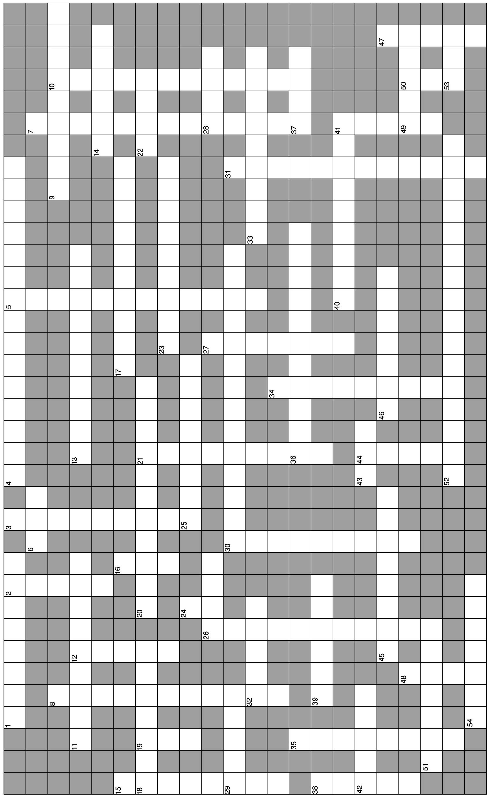

C. Essay

Essay Tutorial
This essay tutorial will answer the first essay question found in the “Review Activities” section of your Human Physiology textbook. Please look for Essay Question 1. at the end of chapter 14, read it carefully, and let me guide you through one possible answer. Watch for key terms in bold-face type, helpful tips and general suggestions on writing the essay or short-answer questions. Enjoy!
114. Define the terms contractility, preload, and afterload, and explain how these factors affect the cardiac output.

Answer. Contractility refers to the strength of a ventricular contraction. The greater the contractility, the more force is applied to the blood in the ventricles and the greater volume of blood is ejected from the heart. Preload refers to the amount of work the heart has to perform to eject the blood present in the ventricles immediately prior to contraction. Because ventricular contraction (systole) has not yet occurred, this volume of blood is called the end-diastolic volume. Afterload is the total resistance to the ejection of blood from the ventricle that the heart has to overcome to successfully deliver blood to the tissues. Cardiac output is stroke volume multiplied times cardiac rate. Therefore, as ventricular contractility increases, stroke volume increases and cardiac output will increase. As preload (end-diastolic volume) increases, the Frank-Starling law of the heart states that the stroke volume will increase, also increasing cardiac output. As the afterload increases, however, stroke volume decreases and cardiac output falls. A decrease in afterload or stroke volume will have the opposite effect, thus raising the cardiac output.
How did you do on this one? Don’t give up. Keep on trying!
115. Define hydrostatic and osmotic pressures, explain the role they play in the formation of tissue fluid from blood, and list the various factors that can cause the excess accumulation of tissue fluid (edema).

116. Describe the role each of the following substances has on the kidney regulation of blood volume:
(1) antidiuretic hormone (ADH), (2) aldosterone, (3) angiotensin II, and (4) atrial natriuretic factor.

117. Explain how the baroreceptor reflex operates to compensate for cardiovascular changes that occur upon rising from bed in the morning to a standing position. Note that this represents another example of negative feedback regulation of homeostasis.

Answers — Chapter 14

- Cardiac Output
- 1. d, 2. b, 3. a, 4. b, 5. c, 6. c, 7. b, 8. a, 9. b
- 10. T, 11. T, 12. T, 13. F—Replace “preload” with “afterload,” 14. F—When one is “lower,” the other is “higher” (they are inversely proportional), 15. T, 16. T, 17. T
- Blood Volume
- 18. a, 19. b, 20. c, 21. e, 22. b, 23. d,
24. c, 25. b, 26. c, 27. e
- 28. T, 29. T, 30. F—Replace “greater” with “less,” 31. F—Replace “positive” with “negative,” 32. T, 33. T, 34. F—Osmoreceptors would stop firing and ADH levels would decrease, 35. T,
36. T, 37. F—Replace “increase” with “decrease”
- Label the Figure— The Renin-Angiotensin-Aldosterone System
See figure 14.11 in the text
- Vascular Resistance and Blood Flow
- 38. a, 39. c, 40. b, 41. e, 42. d, 43. c
- 44. T, 45. T, 46. F—Switch “increased” and “decreased,” 47. F—Replace “contraction (vasoconstriction) with “relaxation (vasodilation) ,” 48. T,
49. T, 50. F—Replace “reactive” with “active”
- Blood Flow to the Heart and Skeletal Muscles
- 51. b, 52. e, 53. d, 54. d
- 55. T, 56. T, 57. F—Intrinsic (local) metabolites are primarily responsible for vasodilation, 58. F—Switch “rhythmic isotonic” and “sustained isometric,”
59. T, 60. T, 61. F—Switch “stroke volume” and “cardiac rate,” 62. T
- Blood Flow to the Brain and Skin
- 63. e, 64. a, 65. c, 66. a
- 67. T, 68. T, 69. T, 70. F—Switch “vasoconstriction” and “vasodilation”
- Blood Pressure
- 71. c, 72. d, 73. c, 74. b, 75. e, 76. d,
77. b, 78. b, 79. c
- 80. F—Replace “capillaries” with “arterioles,” 81. T, 82. F—Replace “cm H₂O” with “mm Hg,” 83. T, 84. F—Replace “stethoscope” with “sphygmomanometer,” 85. T, 86. F—Replace “pons” with “medulla oblongata,” 87. T, 88. T, 89. T, 90. F—Replace “diastole” with “systole,” 91. T, 92. F—Mean systemic arterial pressure = 1/3 pulse pressure + diastolic pressure, 93. F—Switch “systolic” with “diastolic”
- Hypertension, Shock, and Congestive Heart Failure
- 94. b, 95. a, 96. e, 97. c
- 98. F—Replace “secondary” with “primary,” 99. T, 100. T, 101. F—Congestive heart failure occurs when fluids accumulate just outside the entrance to the “failed” side of the heart
Chapter Review
- 102. increased, decreased, pre, after; increases, increases, 103. kidney, blood, blood; hydrostatic, colloid osmotic, 104. lymph, lymphatic, edema, 105. antidiuretic, aldosterone, cortex, retention, 106. Poiseuille’s; sympathetic, high, 107. aerobically, high, intrinsic, 108. decreased, increased; stroke, output,
109. constrict, dilation; sympathetic, anastomoses, constrict, 110. carotid sinus, aortic arch, medulla oblongata, rate, resistance, autonomic,
111. laminar, turbulent, Korotkoff, 112. 48, 90; primary, secondary,
113. oxygen, venous

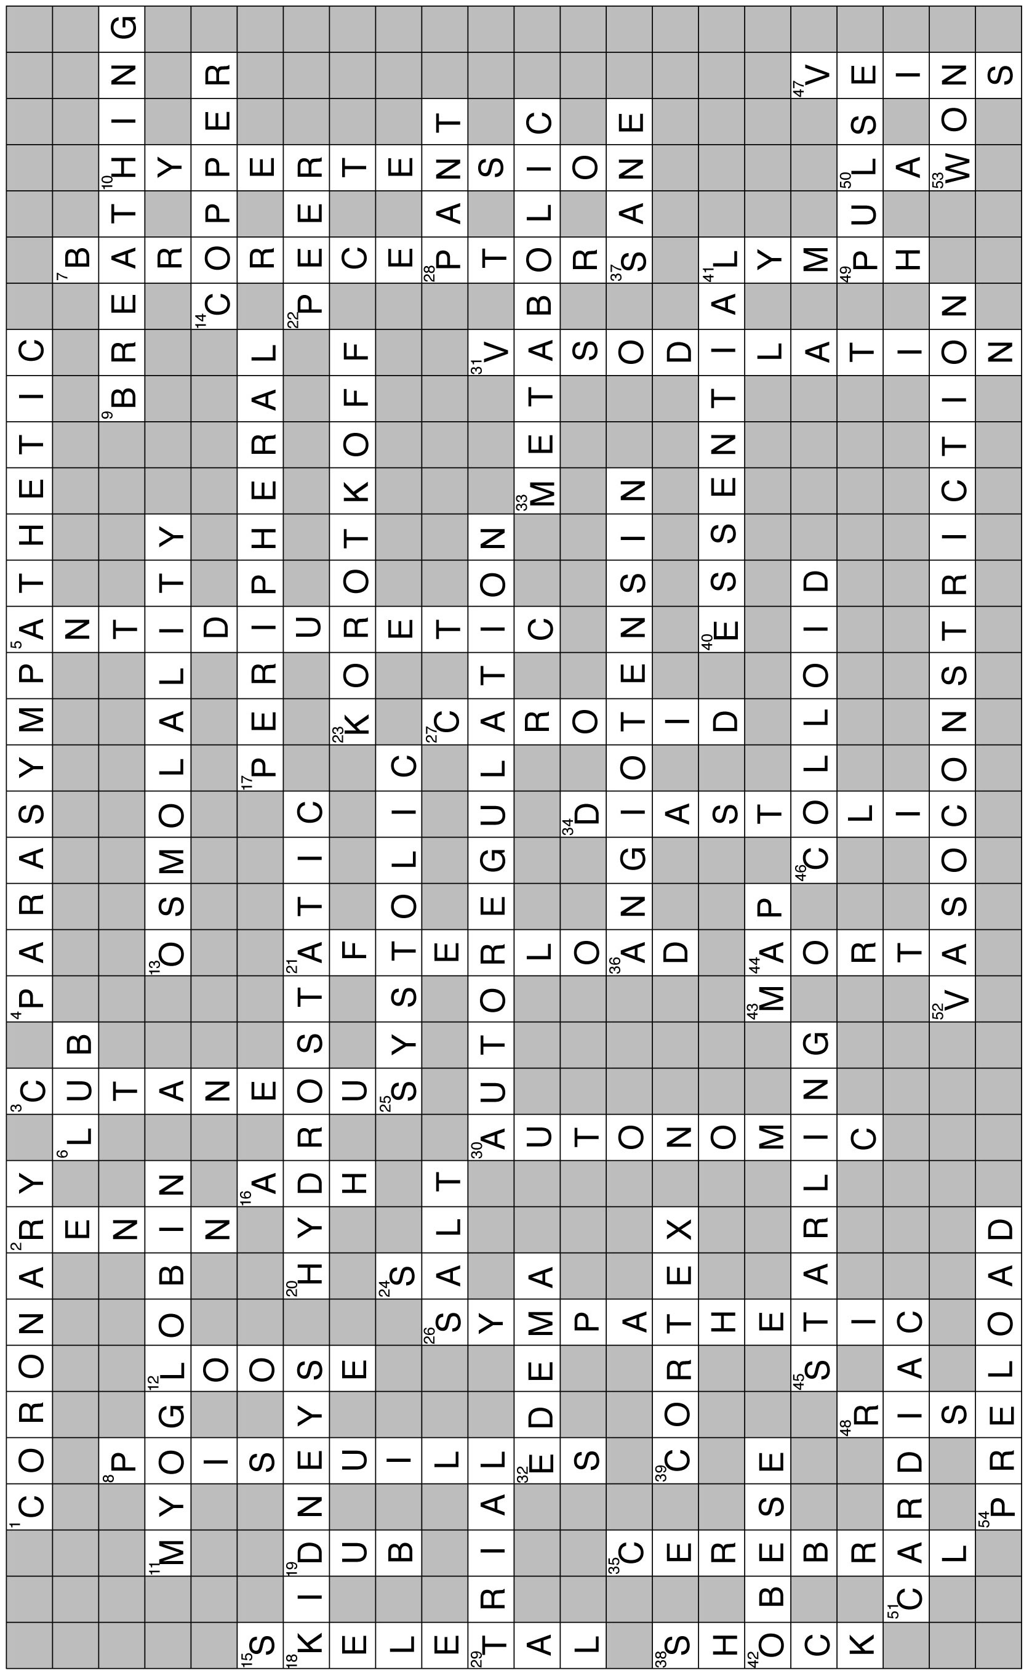
- Crossword Puzzle

