Chapter 1: Social Studies anD Interdisciplinary Instruction: A Look at Social Studies

KEY TERMS

social studies
standards for teaching the social studies
good citizens
social studies learners
zone of proximal development
English language learners
ten themes for social studies
anthropology
economics
production
distribution
exchange
consumption of products
social sciences
history
geography
location
political science
civics
sociology
curriculum standards for the social studies
integrated instruction
citizen actors
social interaction
social context
interact
communicate
decision-making process
scope and sequence

Chapter Focus

The purpose of this chapter is to inform teachers that social studies at the elementary and middle school levels is made up of six social sciences: anthropology, economics, history, geography, political science, and sociology. It is important that teachers understand each of the six social sciences in order to effectively teach an integrated curriculum. Incorporating all the social sciences in social studies instruction will help students become good democratic citizens capable of making informed decisions.

Chapter One Objectives
The students reading this chapter will be able to:

- Articulate their understanding of the six social sciences that make up social studies and their focuses.

- Explain how the social sciences can be integrated for instruction.

- Identify the ten themes for social studies developed by The National Council for the Social Studies.

- Describe the steps in teaching social studies as a decision-making process.

LECTURE OUTLINE
Introduction
Teaching Social Studies
The Social Sciences
Anthropology
Economics
History
Geography
Political Science—Civics Education
Sociology
Integrating the Social Sciences
Skills Needed to Become a Good Citizen Actor
Building Curriculum for Integrated Instruction and Social Studies Integration
The Decision-Making Process
Defining the Process
Illustrative Examples of Integrated Social Studies Activities
Celebrating Lewis and Clark in an Interdisciplinary Unit
NCSS Standards Linked Lesson Plan
Chapter Summary
Children’s Books
Teaching Resources
References

TRANSPARENCY T-1

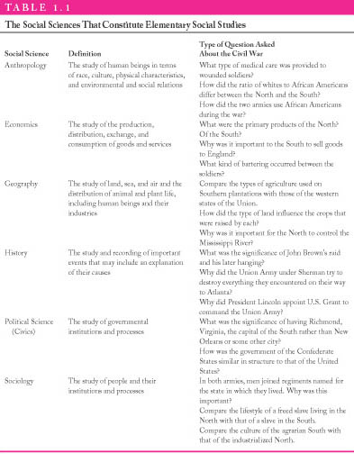

DISCUSSION QUESTIONS
1. Have students recall a favorite memory of learning social studies. Ask students to identify examples of integrated social studies instruction.

2. Ask students to volunteer words that come to mind when they hear “citizen.” Record student responses on the board. Use as a springboard for discussing “citizen actors.”

3. Have students discuss how their own experiences in social studies did or did not address the goal of citizen action.

4. Ask students to explain how integrated social studies instruction develops good democratic citizens.

SUGGESTED CLASS ACTIVITIES

1. Divide students into six groups: one for each of the social sciences. Assign each group to a different social science written on separate pieces of chart paper hanging around the room. Give students 2-3 minutes to write down any information related to the social science that was presented in the chapter. Have groups rotate to the next social science. This time students must add new information to the chart trying not to repeat what a previous group has written. Repeat process until each group has circulated to each of the six social sciences. Students may use the text for assistance.

2. Have students conduct a search of their local newspaper for articles about issues based on the social sciences. Students can use these articles to develop an outline for the decision-making process.

3. Divide the class into small groups. Distribute a copy of an elementary or middle school level social studies text to each group. Have students identify two or more related National Council of the Social Studies (NCSS) themes.

4. The scenarios described in the chapter introduction illustrate the point that social studies can be taught in an integrated approach. Divide the class into small groups and have each group discuss ways that teachers could make social studies instruction integrated. Have the students develop a useful list of “things to do” when teaching integrated social studies.

- Have students in pairs or small groups attend a local governmental meeting, such as
city council, library board, school board, etc. Later in class, have each group present the items on the agenda that were discussed, problems confronted by the agency, as well as any interaction with or between other governmental agencies.

ADDITIONAL SUGGESTED READINGS

Gavin, C. L., and Andrea, M. P. (1999). Essential questions for elementary social studies:
Curriculum reform for social action. Social Studies & the Young Learner, 11(3), 12-15.

Potter, L. A., Needles, K., and Wilairat, M. (2003). Teaching with documents: The
purchase of the Louisiana Territory. Social Education, 67 (2), 100-106.

ADDITIONAL INSTRUCTIONAL MEDIA

1. Overhead transparency T-1.

2. Chart paper for classroom activity #1.

3. Sets of published elementary and middle school social studies textbooks.

4. Newspaper articles with topics focusing on the social studies.

5. Websites
- http://www.ca.sandia.gov/outreach/2020/2020Tsrat.html
Includes a number of useful instructional approaches such as jigsaw and cooperative learning.

- http://busboy.sped.ukans.edu/~soess/index.html
This site provides resources as well as a discussion forum to discuss the teaching of social studies content.

- http://www/asanet.org.teaching.htm
The American Sociological Association provides university faculty information related to teaching approaches and curriculum for sociology based content.

