CHAPTER 2: SOCIAL STUDIES AND INTEGRATED INSTRUCTION:
A LOOK AT INTERDISCIPLINARY INSTRUCTION

KEY TERMS

high-order thinking
hands-on learning
spiral curriculum
interdisciplinary instruction
engaged learners
thematic units

CHAPTER FOCUS

The purpose of this chapter is to help teachers develop an integrated approach to the teaching of social studies. Implementing an integrated approach encourages students to become engaged learners who will develop a genuine interest in social studies. The chapter outlines interdisciplinary instruction and its essential elements.

CHAPTER TWO OBJECTIVES

The students reading this chapter will be able to:

1. Explain the importance of providing opportunities for students to engage in decision-making activities.

2. Explain how the language arts can be effectively incorporated in the teaching of integrated social studies.

- Demonstrate how to develop an interdisciplinary social studies lesson.

LECTURE OUTLINE

Introduction
Interdisciplinary Instruction
Traditional versus Interdisciplinary Instruction: Philosophical and Psychological
Underpinnings
Essential Elements of Literacy Learning
Goals of Interdisciplinary Instruction
Interdisciplinary Instruction and the Social Studies
NCSS Standards Linked Lesson Plan
Chapter Summary
Teaching Resources
References

TRANSPARENCIES T-2, T-3

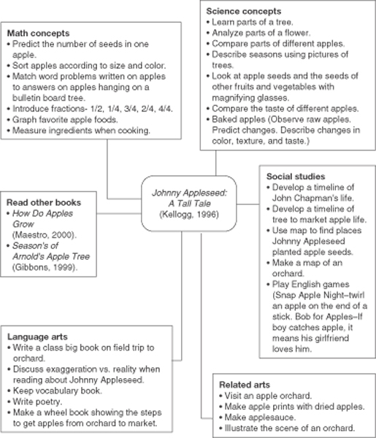

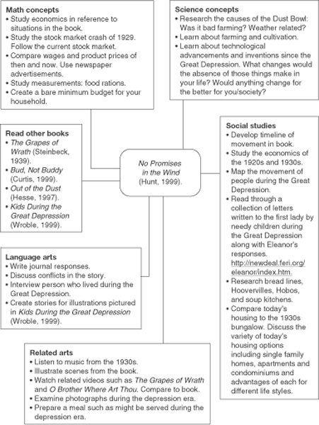

DISCUSSION QUESTIONS

1. Have students reflect on their interest in the social studies. Are their feelings positive or negative? Ask students to brainstorm ways that they could develop more positive attitudes and feelings toward teaching the social studies.

2. Invite students to decide how much instructional time should be devoted to the teaching of social studies in a primary, intermediate, and middle school classroom. Have students explain their rationale.

3. Through a discussion with students, construct a list of guidelines to involve children in classroom decision-making activities.

4. Have students brainstorm ways to make social studies instruction more appealing to elementary and middle school students.

SUGGESTED CLASS ACTIVITIES

1. Divide students into small groups. After reading a lesson from an elementary social studies text, have each group work together to discuss how the lesson might be adapted to incorporate listening, speaking, reading, and writing.

2. Have students in small groups read a multicultural children’s literature selection and brainstorm a list of concepts about the culture that they learned. Allow students time to construct an instructional thematic web following the examples given in the chapter.

3. Have the students write a letter to parents explaining how they teach social studies as an interdisciplinary approach.

4. Divide students into small groups. Distribute catalogues of supplemental materials useful for teaching social studies. After they examine the different catalogues, have the students select the ones that appeal to them and discuss why.

ADDITIONAL SUGGESTED READINGS

Chilcoat, G. W., and Ligon, J. A. (2000). Issues-centered instruction in the elementary
social studies classroom. Theory & Research in Social Education, 28 (2), 220-72.

Morris, R. V., Morgan-Fleming, B., and Burley, H. (2000). Walking on their own feet:
Reflective inquiry in the elementary school social studies classroom. Southern
Social Studies Journal, 26(1), 20-32.

Yeager, E. A. (2000). Thoughts on wise practice in the teaching of social studies. Social
Education, 64 (6), 352-353.

ADDITIONAL INSTRUCTIONAL MEDIA

1. Transparencies T-2, T-3.

2. Sets of published elementary and middle school social studies textbooks.

3. A variety of catalogues of supplemental materials useful for teaching social studies.

- Video:
- Reading, Thinking, and Concept Development: A Professional Development Series. (1991). 80 minutes. Available from www.films.com for $49.95 plus shipping and handling.

