CHAPTER 3: CLASSROOM ASSESSMENT IN SOCIAL STUDIES

KEY TERMS

assessment
convergent questions
divergent questions
evaluation
formal assessment
informal assessment
formative evaluation
summative evaluation
Bloom’s taxonomy
Multiple Intelligences
alternative assessments
rubric
portfolio assessment
manipulatives
self-assessment

CHAPTER FOCUS

The purpose of this chapter is to discuss methods of assessment and evaluation tools appropriate for measuring students’ learning in the social studies. Different methods of assessment are presented, including alternative, manipulatives, projects, portfolios, and rubrics. The ultimate goal of assessment and evaluation is to improve teaching and student learning. Assessment is an ongoing, integral aspect of the social studies curriculum.

CHAPTER THREE OBJECTIVES

The students reading this chapter will be able to:

1. Explain the difference between assessment and evaluation in social studies.

2. Consider what kinds of assessment are most useful for providing students with effective social studies instruction.

- Implement Bloom’s taxonomy in social studies instructional objectives.

LECTURE OUTLINE

Introduction
Classroom Assessment in Social Studies
Assessment versus Evaluation
Formative and Summative Evaluations
Bloom’s Taxonomy
Knowledge
Comprehension
Application
Analysis
Synthesis
Evaluation
Gardner’s Multiple Intelligences
Methods of Assessment
Assessment Tools
Alternative Assessment
Rubrics
Portfolio Assessment
Projects
Manipulatives
Chapter Summary
Teaching Resources
References

TRANSPARENCIES T-4 through T-10

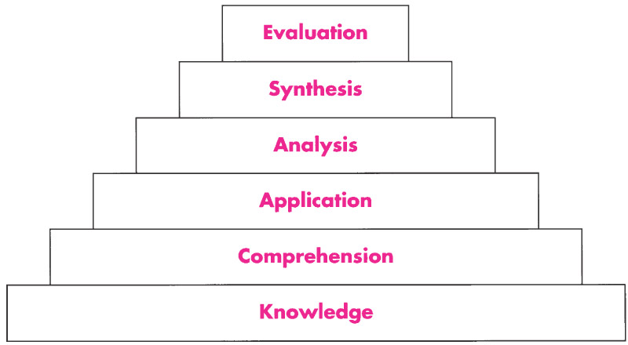

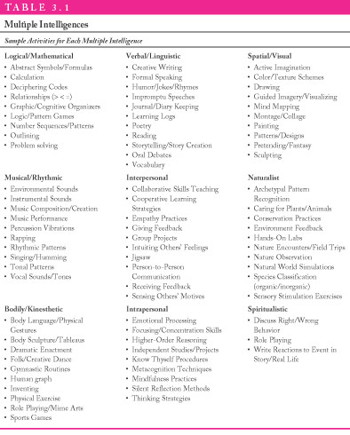

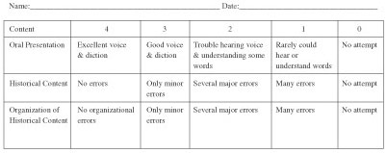

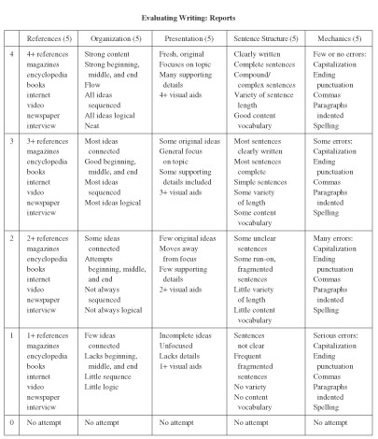

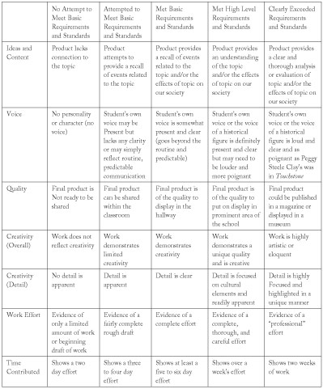

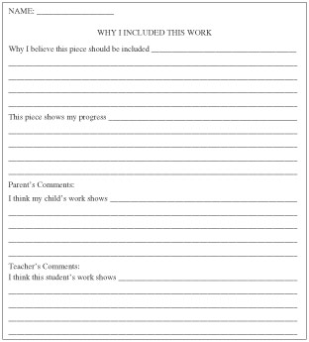

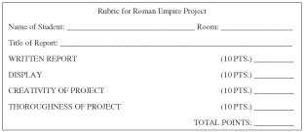

DISCUSSION QUESTIONS

1. Have the students brainstorm ways that teachers have assessed their learning. With the class, categorize their responses as formal and informal assessment techniques.

2. Ask students if they agree with evaluating teacher effectiveness on the basis of student achievement. Have students explore the relationship between instruction and student learning.

3. Discuss the difference between assessment and evaluation. Have students brainstorm examples of each to be used for social studies instruction.

4. Discuss the advantages and disadvantages of using rubrics as an assessment tool.

SUGGESTED CLASS ACTIVITIES

1. Divide the class into small groups. Distribute a copy of a social studies textbook manual to each group. Have the students examine and take notes on the assessment strategies presented in various chapters of the manual. Have students discuss which examples of assessment are more appropriate than others.

2. Have students in pairs examine several chapter questions in a student social studies textbook. Have students identify which level(s) of Bloom’s taxonomy are exemplified most often.

3. Distribute samples of student report cards. Have the students examine the report cards to determine the social studies instructional goals and objectives being measured. Have students brainstorm a list of assessment techniques that could have been used in reporting students’ grades on the report card.

ADDITIONAL SUGGESTED READINGS

Chappuis, S., and Stiggins, R. J. (2002). Classroom assessment for learning. Educational
Leadership, 60 (1) 40-43.

Marcello, J.S. (1999). A teacher’s reflections on teaching and assessing in a standards-
based classroom. Social Education, 65(6), 338-342.

Stiggins, R. J. (2002). Assessment crisis: The absence of assessment for learning. Phi
Delta Kappan, 83(10), 758-65.

ADDITIONAL INSTRUCTIONAL MEDIA

1. Transparencies T-4 through T-10.

2. Sets of published elementary and middle school social studies textbooks.

3. Samples of student report cards for examining grades in social studies.

- Videos
- A Portfolio for Assessing Progress. The Psychological Corporation. Available from Harcourt Brace, 555 Academic Court, San Antonio, TX, 78204.
Videotape includes a viewer’s guide, teacher’s manual, and guides for scoring individual student portfolios.

- Alternative Assessments. Insight Media. 22 minutes. Available from 2162 Broadway, New York, NY, 10024.

- Perspectives on Assessment and Evaluation. Films for the Humanities and Sciences. 29 minutes. Available from www.films.com.

