Chapter 4: Multicultural and Bilingual Education: Making the Connections in Social Studies

KEY TERMS

prejudice
diversity
multicultural education
bilingual education

CHAPTER FOCUS

The purpose of this chapter is to provide strategies and techniques that teachers can use to consider multicultural and bilingual education when planning social studies instruction. Using such strategies helps ensure that all students are respected, thus developing a culturally responsive classroom. Students will then develop positive attitudes and perspectives towards others. In a society that continues to become more diverse, it is important that citizens be able to interact with individuals from diverse backgrounds.

CHAPTER FOUR OBJECTIVES

The students reading this chapter will be able to:

1. Develop a greater understanding of the different cultures as well as their own.

2. Articulate their understanding of the changing demographics in United States classrooms and the need to incorporate multicultural and bilingual education in social studies content.

3. Develop strategies and techniques when planning social studies instruction to help students develop positive attitudes toward different cultural, racial, and ethnic groups.

4. Develop strategies and techniques for making social studies content more accessible for English language learners.

LECTURE OUTLINE

Introduction
Multicultural Unit of Study
Phase One: Bombardment of Experiences
Phase Two: Focusing through Guided and Individualized Reading
Stage One: Viewing the Character from the Outside
Stage Two: Comparing Oneself to the Character
Stage Three: Identifying with the Character
Stage Four: Developing Empathy
Phase Three: Point of View
Phase Four: Creating a Character through Language Experience
Phase Five: Becoming an Ally
Cultural Awareness
The Complex Diversity within the Asian and Pacific American Communities
Understanding Mexican Culture
The Mexican American Community
Personal Observation of the Mexican American Community
English Language Learners in the Social Studies Classroom
Cultural Sensitivity through Interdisciplinary Teaching Strategies
Facilitating Access to Social Studies for English Language Learners
NCSS Standards Linked Lesson Plans
Chapter Summary
Multicultural Children’s Books
Teaching Resources
References

TRANSPARENCIES T-11, T-12

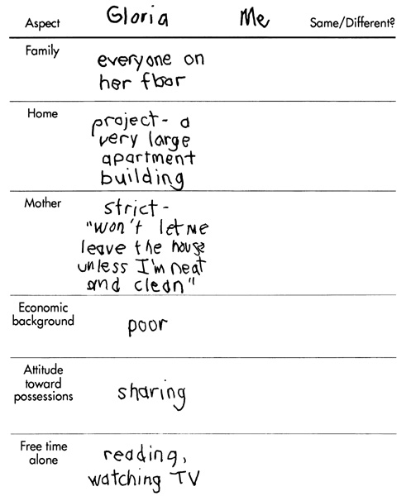

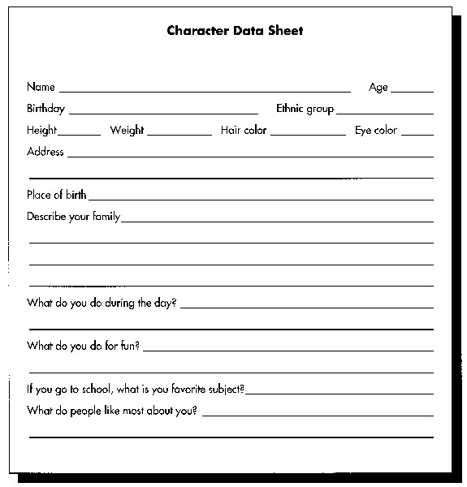

DISCUSSION QUESTIONS

1. Ask students what they know about the U.S. Census. Use current census data to lead a discussion on demographic information about the students in American classrooms.

2. Have students recall memories of racial, ethnic, and linguistic differences in their elementary classrooms when they were growing up. Ask students to identify ways that their teachers recognized student diversity.

3. Ask students to identify ways in which their own upbringing and education prevented them from learning about and appreciating the experiences and contributions of other cultural, ethnic, racial, and linguistic groups to society.

SUGGESTED CLASS ACTIVITIES

1. Have students in groups take turns telling their cultural history. Ask students to share with the entire class to recognize student diversity within the classroom.

2. Have students in pairs examine a few social studies textbooks from different publishing companies to determine what cultural, racial, and ethnic groups are represented. As a class, create a chart to tally the different groups.

3. Using the bibliography of children’s literature in the chapter, have students select a book and develop a list of questions for each of the stages in Phase Two. Students can use the example in the chapter for guidance.

4. Have students select a chapter from a social studies textbook. After they examine the chapter, ask students to develop a list of strategies and techniques that teachers could use to make the content of the chapter more comprehensible for English language learners. Students can refer to the chapter for suggestions provided by Echevarria, Vogt and Short (2000).

ADDITIONAL SUGGESTED READINGS

Field, S. L. (2001). Perspectives and elementary social studies: Practice and promise. In
O. L. Davis, Jr., E. A. Yeager, & S. J. Foster (Eds.), Historical empathy and perspective taking in the social studies (pp. 115-138). Lanham, MD: Rowman & Littlefield.

Gaudelli, W. (2001). Reflections on multicultural education: A teacher's experience.
Multicultural Education, 8(4), 35-37.

Lee, P., and Ashby, R. (2001). Empathy, perspective taking, and rational understanding.
In O. L. Davis, Jr., E. A. Yeager, & S. J. Foster (Eds.), Historical empathy and perspective taking in the social studies (pp. 21-50). Lanham, MD: Rowman & Littlefield.

Mathis, J. B. (2001). Respond to stories with stories: Teachers discuss multicultural
children's literature. Social Studies, 92(4), 155-160.

Reid, W. A. (2000). Curriculum as an expression of national identity. Journal of
Curriculum and Supervision, 15, 113-122.

Smith, R. W. (2000). The influence of teacher background on the inclusion of
multicultural education: A case study of two contrasts. Urban Review, 32 (2), 155-176.

Strickland, J. (2001). Multicultural literature in rural schools: A social studies unit that
promotes cultural awareness. Southern Social Studies Journal, 27(1), 20-37.

ADDITIONAL INSTRUCTIONAL MEDIA

1. Transparencies T-11, T-12.

2. Sets of published elementary and middle school social studies textbooks.

3. Children’s literature, such as the ones cited in the chapter.

4. Websites
- http://www.YesICanKids.gov
A colorful, interactive connection for children written in both Spanish and English. Included is a list of popular stories students can read as well as artwork by children.

- http://www.census.gov
With an update every five minutes, people can check on their state’s census profile.

