CHAPTER 5: SOCIAL STUDIES FOR ALL LEARNERS

KEY TERMS

gifted
learning disabled
attention deficit disorder
educationally challenged learner
inclusion
differentiated instruction
flexible grouping
interdisciplinary teaching
multigenre writing
individualized education plan (IEP)
scaffoldling instruction
visual impairment
hearing impairment
reader response
handhelds

CHAPTER FOCUS

The purpose of this chapter is to prepare teachers for teaching in an inclusion environment. Students in today’s classrooms differ in academic ability, interests, and learning styles. This chapter identifies and discusses students identified with learning difficulties and presents teaching strategies specific for these learners’ needs. Teachers can differentiate instruction using a variety of strategies to ensure that all learners, struggling and gifted, have successful learning opportunities.

CHAPTER FIVE OBJECTIVES

The students reading this chapter will be able to:

1. Articulate the characteristics of students labeled as gifted, learning disabled, and educationally challenged.

2. Explain why social studies content can be thought-provoking and engaging to all learners.

3. Develop teaching strategies to enhance the learning of social studies content for all students.

4. Develop a thematic interdisciplinary unit for social studies and incorporate the use of children’s literature.

LECTURE OUTLINE

Introduction
A Look at the Gifted Learner
Suggested Classroom Strategies
A Look at the Students with Learning Disabilities
Specific Teaching Strategies
A Look at Students with Other Educational Challenges
The Visually Impaired Learner
The Hearing Impaired Learner
The Learner with Attention-Deficit Disorders
A Case for Children’s Literature
Travels Back through Time
The Civil War
Native Americans
Chapter Summary
NCSS Standards Linked Lesson Plan
Children’s Books
Teaching Resources
References

TRANSPARENCIES T-13 through T-15

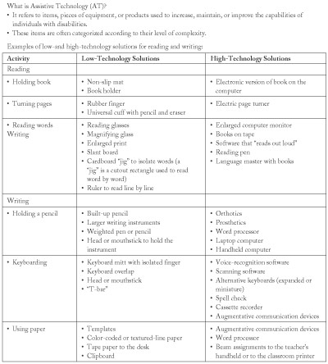

DISCUSSION QUESTIONS

1. Ask students to develop a “T” chart discussing the advantages and disadvantages of an inclusion classroom. Since inclusion can vary depending on the school district, include in the discussion students who are gifted, educationally challenged, and limited-English-proficient students.

2. Using a K-W-L chart, ask students to list what they know about teaching in an inclusion environment. In the “W” column, ask students to list what questions they have about teaching in an inclusion environment. Use these questions to guide classroom discussion and activities.

3. After a reading of the chapter and classroom discussion, have students complete the “L” column in the K-W-L chart with what they have learned about teaching in an inclusion environment. Ask students if they feel they have learned enough strategies to meet the needs of diverse learners in an inclusion environment.

4. Ask students in groups to develop a list of reasons why children’s literature is a valuable teaching resource.

SUGGESTED CLASS ACTIVITIES

1. Divide the class into small groups, one group for each unique population of students discussed in the chapter (i.e., ADHD, visually impaired learner, gifted). Have groups discuss the following: (a) General information and characteristics about the specific group of learners, (b) Assistive technology that can be used, (c) Modifications for the classroom environment, and (d) Helpful learning strategies for the specific group of learners. Have groups present information to the entire class.

2. Have students develop a floor plan of their classroom environment that would accommodate the needs of diverse students.

3. Have students, working with partners, examine samples of students’ Individualized Educational Plans (IEPs) from a school district. On the basis of the student’s levels of performance, goals and objectives, have students develop of list of teaching strategies that would enhance the student’s learning.

ADDITIONAL SUGGESTED READINGS

Lederer, J. M. (2000). Reciprocal teaching of social studies in inclusive elementary
classrooms. Journal of Learning Disabilities, 33(1), 91-106.

Reeder, J. (2003). More than one definition of “exceptional.” English Journal, 92(4), 54-
56.

Taylor, H. E., and Larson, S. M. (2000). Teaching elementary social studies to students
with mild disabilities. Social Education, 64(4), 232-235.

ADDITIONAL INSTRUCTIONAL MEDIA

1. Websites
- TESOL
http://www.tesol.edu/index.html
The official site for Teachers of English to Speakers of Other Languages, Inc, a national organization for educators who teach nonnative speakers of English.

- National Clearinghouse for Bilingual Education
http://www.ncbe.gwu.edu/
A national clearinghouse providing information for bilingual educators and teachers who work with learners who are nonnative speakers of English.

2. Organizations providing material for certain disabilities:
- American Foundation for the Blind
15 West 16th Street
New York, NY 10011

- American Printing House for the Blind
1839 Frankfurt Avenue
Louisville, KY 40206

- Captioned Films for the Deaf
Special Office for Materials Distribution
Indiana University Audiovisual Center
Bloomington, IN 47401

3. “T” chart and “K-W-L” chart.

4. Samples of student’s Individualized Educational Plan (IEP) from a school district.

