CHAPTER 6: FACILITATING LEARNING THROUGH STRATEGIC INSTRUCTION IN SOCIAL STUDIES

KEY TERMS

learning strategies
constructivist
expository
linguistic
musical
logical-mathematical
spatial
body and kinesthetic
intrapersonal
interpersonal
naturalistic
spiritualistic
activating prior knowledge
guided learning experiences
inquiry-based
project method
schema
K-W-L
graphic organizers
sequencing of strategies
perspective
visual literacy
concept muraling

CHAPTER FOCUS

The purpose of this chapter is to provide teachers with strategies that help students gather, organize, relate, and retain knowledge in the social studies. Strategic instruction allows teachers to plan their instruction to incorporate students’ unique learning styles and motivations to learn. Teachers can help students understand and relate concepts by developing interdisciplinary units of study that combine children’s literature with the social studies textbook and apply a variety of learning strategies.

CHAPTER SIX OBJECTIVES

The students reading this chapter will be able to:

1. Define the characteristics of Gardner’s Multiple Intelligences and describe how his
theory has implications for elementary social studies instruction.

2. Develop instructional lessons that incorporate Gardner’s Multiple Intelligences.

3. Identify the characteristics of the constructivist view of learning and describe its
application to teaching elementary social studies.

4. Develop instructional lessons that incorporate strategies that activate student learning.

LECTURE OUTLINE

Introduction
Gardner’s Multiple Intelligences
Brain Research and Strategic Instruction in Social Studies
Constructivism
Inquiry-Based Social Studies
Project-Based Learning
Strategies to Activate Learning
Strategic Sequencing
History as a Perspective
Concept Muraling
Technology and Reading Strategies
Strategies for Diverse Students
NCSS Standards Linked Lesson Plan
Chapter Summary
Children’s Books
Teaching Resources
References

TRANSPARENCIES T-16 through T-22

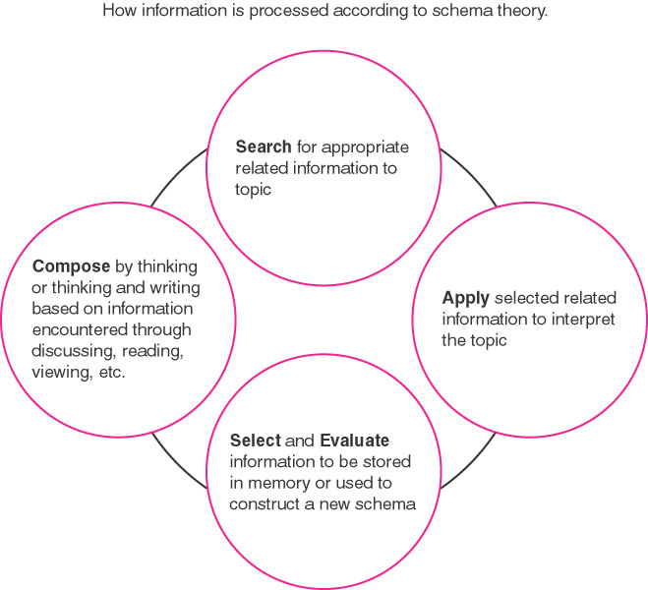

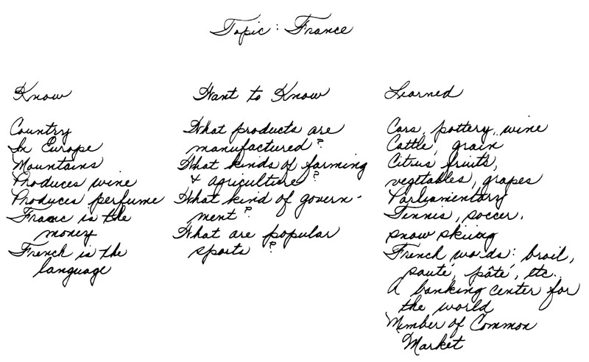

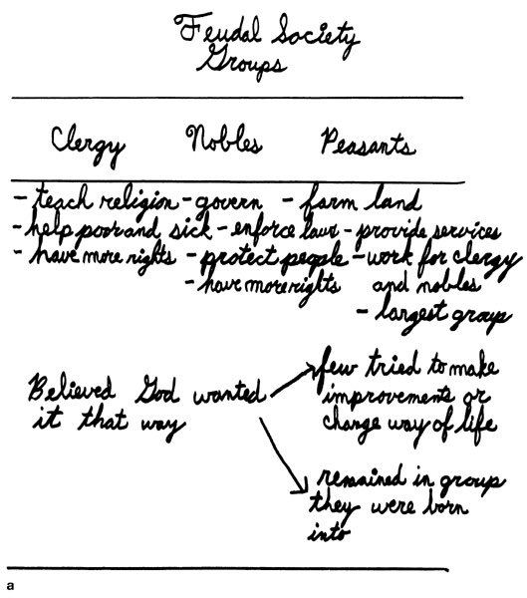

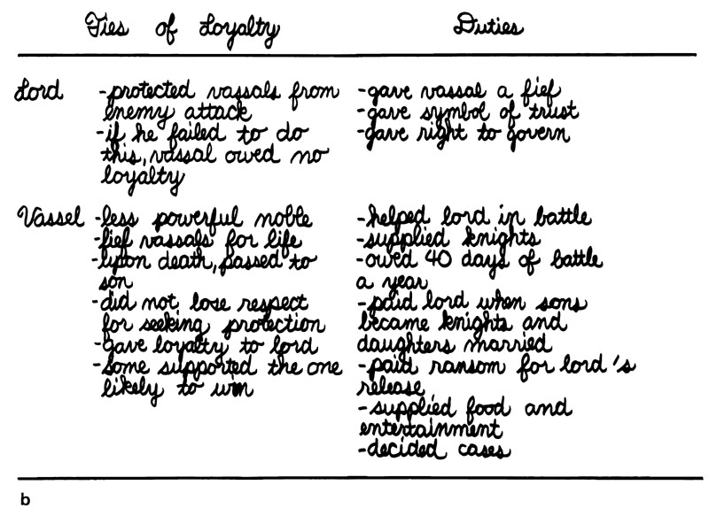

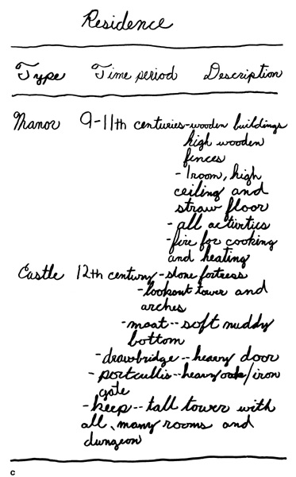

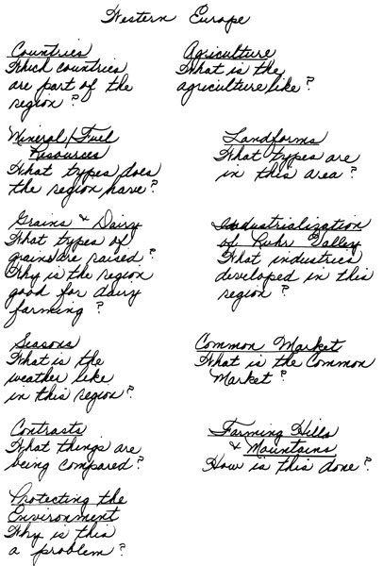

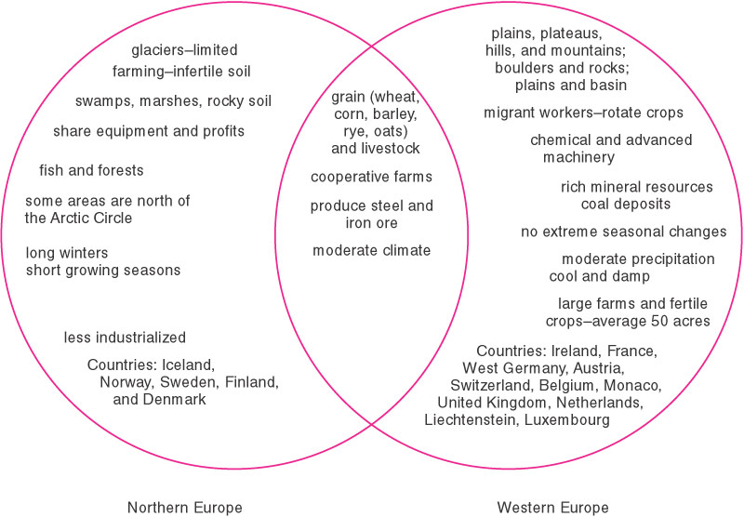

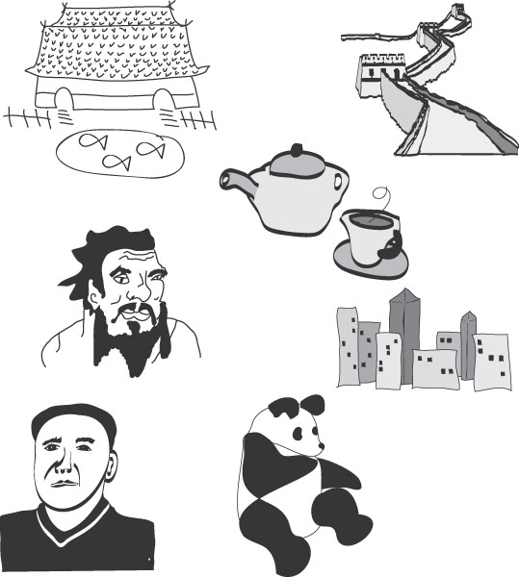

DISCUSSION QUESTIONS

1. Ask students which strategic instructional approach they feel most comfortable with in teaching social studies. Why?

2. Ask students to compare different strategic instructional approaches, discussing the pros and cons of each.

3. Choose a children’s historical fiction book to read aloud to class. (See chapter bibliography.) After reading the book to the class, have students pose questions that could be collected for an inquiry study. Discuss the benefits of inquiry-based social studies instruction.

SUGGESTED CLASS ACTIVITIES

1. After students understand the use of a variety of graphic organizers, have groups present information from the chapter. Challenge students to develop their own graphic organizer.

2. Have students select a unit of study that they would teach in an elementary social studies classroom. With use of Gardner’s Multiple Intelligences, have students develop a list of suggested multiple intelligence activities to accompany their unit of study.

3. Have groups, using a social studies textbook as a resource, brainstorm ideas to create project-based learning activities for different units of study presented in the textbook.

4. Make a transparency copy of an excerpt selected from nonfiction text. Follow the steps for modeling thinking suggested in the chapter to model the thinking process for students. Distribute sample excerpts of nonfiction text to students and have partners practice the steps for modeling their thinking.

ADDITIONAL SUGGESTED READINGS

Dye. G. A. (2000). Graphic organizers to the rescue. Helping students link—and
remember—information. Teaching Exceptional Children, 32(3), 72-76.

Hardiman, M. M. (2001). Connecting brain research with dimensions of learning.
Educational Leadership, 59(3), 52-55.

King-Friedrich, J. (2001). Brain-friendly techniques for improving memory. Educational
Leadership, 59(3), 76-79.

ADDITIONAL INSTRUCTIONAL MEDIA

1. Overhead transparencies T-16 through T-22.

2. Video
- Multiple Intelligences: Other Styles of Learning. (1993). 30 Minutes. Available from www.films.com for $129.95 plus shipping and handling.

- Website
  - http//www.strategictransitions.com/inspiration.html
Provides various graphic organizer templates, including concept maps and outlines.

- Selected collection of children’s picture books.

- Sets of published elementary and middle school social studies textbooks.

- Example excerpts from nonfiction text (i.e., magazine article, newspaper article, textbook paragraph).

