CHAPTER 7: COMMUNICATING IN SOCIAL STUDIES:
READING, WRITING, AND DISCUSSING

KEY TERMS

read aloud
prewriting
drafting
revising
editing
publishing/sharing
narrative
poetic
expository
persuasive
propaganda
aesthetic reading
efferent reading
oral history
literature circles
SQ3R
PQRST
literature response journals
QAR
RAFT
RESPONSE
cooperative learning
field trips

CHAPTER FOCUS

The purpose of this chapter is to discuss the importance of developing a social studies curriculum that stresses the skills of reading, writing, and discussing. By incorporating such skills in interdisciplinary instruction, the classroom teacher can assist students in developing values and skills needed to become good democratic citizens. This chapter presents a variety of methods used for incorporating reading, writing, and discussing within an integrated social studies curriculum.
CHAPTER SEVEN OBJECTIVES

The students reading this chapter will be able to:

1. Incorporate reading, writing, and discussing into the social studies curriculum.

2. Identify the steps of the writing process and various forms of writing.

3. Apply various learning strategies for reading, writing, and discussing social studies.

LECTURE OUTLINE

Introduction
Reading
Children’s Literature
Nonfiction and Informational books
Writing
Prewriting
Drafting
Revising
Editing
Publishing/Sharing
Portfolios
Writing and Social Studies
Multigenre Writing for Research
Aesthetic and Efferent Reading and Writing
Historical Documents: Diaries, Journals, Letters, and Newspapers
Oral History
Current Events
Discussion
Reading, Writing, and Discussing as Learning Strategies
SQ3R
PQRST
Literature Response Journals
RAFT
RESPONSE: An Interactive Approach to Study Skills
Cooperative Learning
Field Trips
NCSS Standards Linked Lesson Plan
Chapter Summary
Children’s Books
Teaching Resources
References

TRANSPARENCIES T-23 through T-28

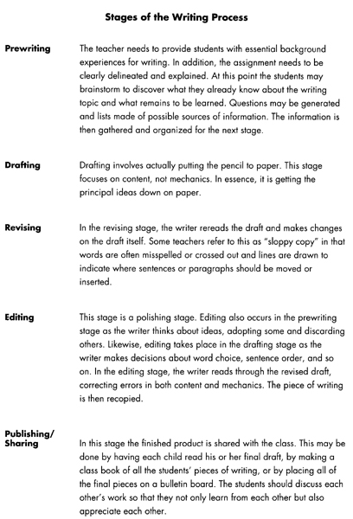

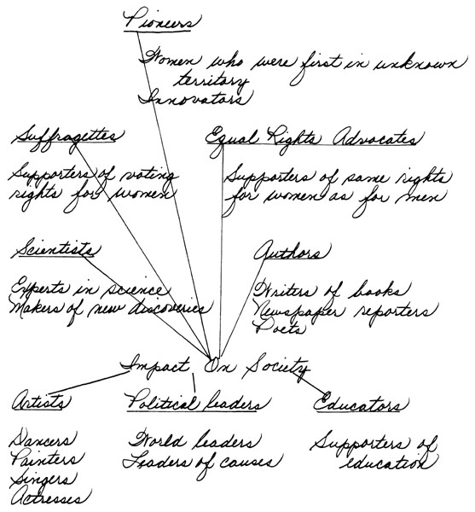

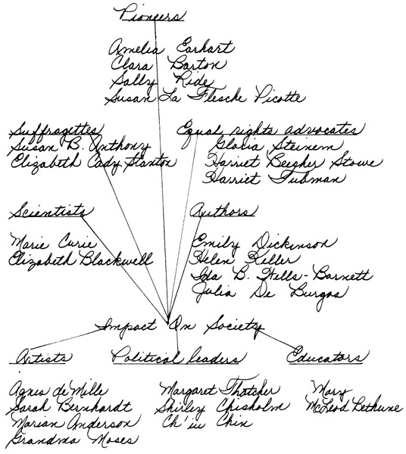

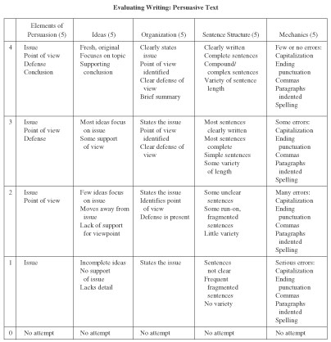

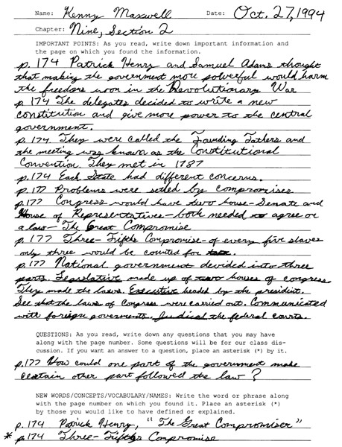

DISCUSSION QUESTIONS

1. Ask students to define and describe a democratic classroom environment. What kinds of activities does the teacher need to incorporate into the social studies curriculum to promote a democratic environment?

2. Divide students into small groups and have them discuss the advantages and disadvantages of cooperative grouping. Ask students to suggest different discussion techniques that could be used in addition to small group discussion (i.e., debate, panel discussion, student report).

3. Discuss the steps of the writing process and various forms of writing. Ask students to brainstorm writing activities that could be incorporated into a social studies unit of study.

4. Using a debate format, ask students to support the idea of incorporating reading, writing, and discussing in social studies curriculum. Ask students to reference NCSS standards.

SUGGESTED CLASS ACTIVITIES

1. Using the RESPONSE activity, assign students a section of the chapter to read and write a RESPONSE. Students can discuss results in groups. Ask students to give suggestions on how they could incorporate this writing activity into their social studies instruction.

2. Divide class into small groups. Have each group develop a thematic social studies unit incorporating reading, writing, and discussing activities along with a list of notable trade books. Students should follow the NCSS standards linked lesson plans included in each textbook chapter.

3. Have students in groups examine a published elementary and middle school social studies textbook to determine the text structure and features. Have students develop a two-column chart with “feature” and “purpose” as headings. Groups can present information to class and compare the text features of different publishing companies. Discuss how this information can be developed into a lesson to teach to elementary and middle school students.

4. Have students in groups examine several children’s nonfiction trade books to determine the text structure and features. Have students develop a two-column chart with “feature” and “purpose” as headings. Groups can present information to class and compare the text features of different nonfiction trade books. Discuss how this information can be developed into a lesson to teach to elementary and middle school students.

ADDITIONAL SUGGESTED READINGS

Tompkins, G. (2000). Teaching writing: Balancing process and product. (3rd Ed.). Upper Saddle River, NJ: Prentice Hall.

Vacca, R. T., & Vacca, J. L. (2002). Content area reading. Boston: Allyn and Bacon.

ADDITIONAL INSTRUCTIONAL MEDIA

1. Overhead transparencies T-23 through T-28.

2. Sets of published elementary and middle school social studies textbooks.

3. A selection of notable children’s nonfiction trade books.

