CHAPTER 8: EARLY CHILDHOOD SOCIAL STUDIES

KEY TERMS

early childhood
egocentrism
concrete
real
relevant
nonverbal communication

CHAPTER FOCUS

The purpose of this chapter is to discuss interdisciplinary social studies instruction appropriate for teaching kindergarten through grade two. Social studies content can be naturally integrated into early childhood curriculum, which begins with children’s egocentrism and eight circles of awareness as the foundation. Building on this foundation, teachers can select methods and materials that are developmentally appropriate for teaching social studies to young children.

CHAPTER EIGHT OBJECTIVES

The students reading this chapter will be able to:

1. Explain the rationale for interdisciplinary instruction in early childhood social studies.

2. Explain children’s eight circles of awareness.

3. Develop interdisciplinary lessons appropriate for teaching preschool through grade
two.

LECTURE OUTLINE

Introduction
Early Childhood
Curriculum Content and Social Studies
Egocentrism and Eight Circles of Awareness
Methods and Developmental Limitations
Techniques of Interdisciplinary Instruction
Speaking and Listening Vocabulary
Dictating and Writing Stories
Books, Magazines, and Other Printed Materials
Drawing Pictures and Writing Print
Nonverbal Communication
Field Trips and Print in the Environment
Music
NCSS Standards Linked Lesson Plan
Chapter Summary
Children’s Books
Teaching Resources
References

TRANSPARENCIES T-29 through T-32

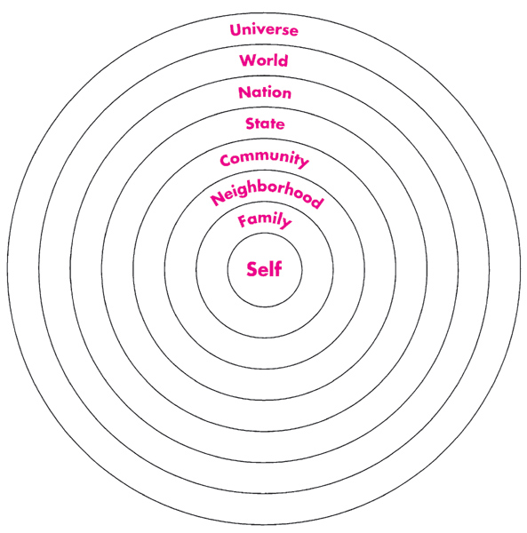

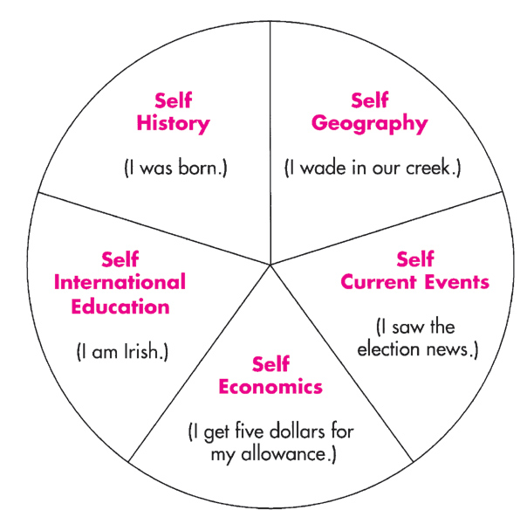

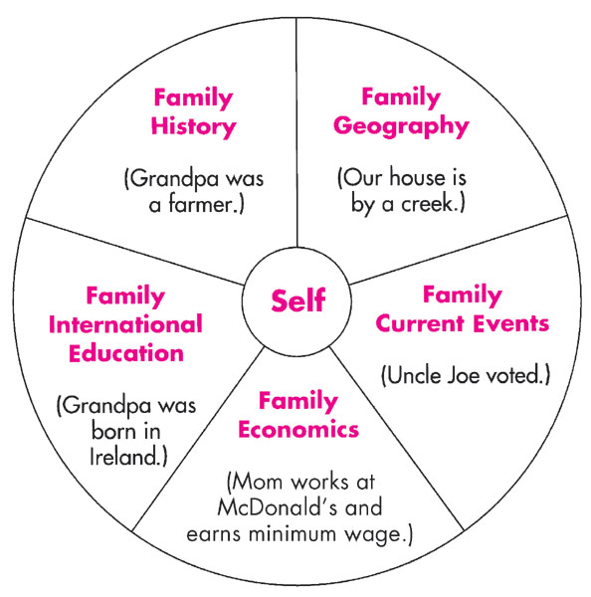

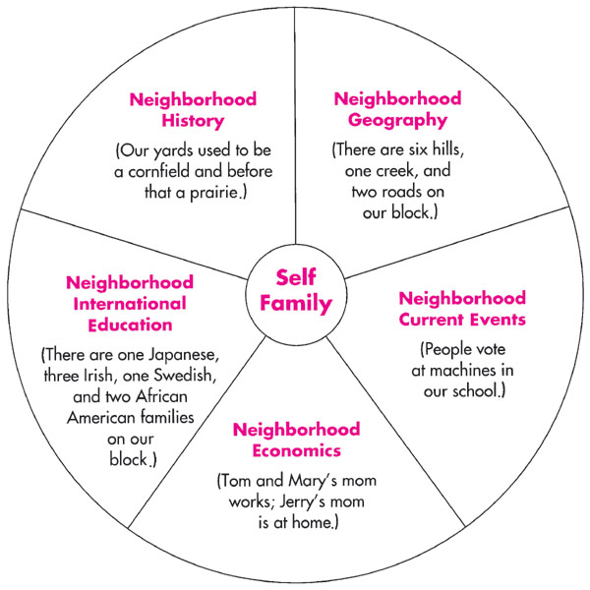

DISCUSSION QUESTIONS

1. Ask students what they believe is the main purpose of teaching early childhood social studies. Does their belief relate to the NCSS?

2. The chapter introduction argues that teachers should begin teaching social studies in preschool instead of waiting until the fourth grade. Ask students to give reasons to support this argument.

SUGGESTED CLASS ACTIVITIES

1. Divide students into five small groups, one for each of the content areas of social studies curriculum for preschool through grade three: current topics, economics, geography, history, and international and global education. Have each group develop a list of activities that would be developmentally appropriate for early childhood curriculum. Be sure that students include concrete materials and relevant activities.

2. Have students working in pairs choose a specific topic for discussion of a child’s movement through the eight circles of awareness. Students can refer to the example of hair color given in the chapter.

3. Using one of the five social studies curriculum areas and the circles of awareness concept, have students develop a NCSS standards linked lesson plan for a primary grade level.

ADDITIONAL SUGGESTED READINGS

Brown, E. E. (2000). Playground or battleground? The new ABCs. Social Studies, 91(5),
207-213.

Fleer, M. (2002). Sociocultural assessment in early years education: Myth or reality?
International Journal of Early Years Education, 10(2), 105-120.

Hyson, M. (2002). Preparing tomorrow's teachers: NAEYC announces new standards.
Young Children, 57(2), 78-79.

Rushton, S. P. (2001). Applying brain research to create developmentally appropriate
learning environments. Young Children, 56(5), 76-80.

Wassermann, S. (2000). Serous players in the primary classroom: Empowering children
though active learning experiences (2nd ed.). New York: Teachers College Press.

ADDITIONAL INSTRUCTIONAL MEDIA

1. Overhead transparencies T-29 through T-32.

