CHAPTER 10: ANOTHER TIME, ANOTHER PLACE: BRINGING
SOCIAL STUDIES TO LIFE THROUGH LITERATURE

KEY TERMS

literary genre
picture books
region
mural
biography
reader response theory
historical fiction
journals

CHAPTER FOCUS

The purpose of this chapter is to provide teachers with examples of how to integrate children’s literature and social studies instruction. Using a variety of literary genre such as historical fiction, nonfiction, poetry, and biographies with related writing and discussion activities, teachers can bring social studies to life for children. Additionally, teachers can incorporate technology with nonfiction and fiction to enhance children’s comprehension and historical understandings.

CHAPTER TEN OBJECTIVES

Students reading this chapter will be able to:

1. Apply literary genre to integrated social studies instruction.

2. Develop thematic units for the teaching of social studies.

3. Develop writing and discussion activities related to literary genre to help students’ comprehension of historical events.

LECTURE OUTLINE

Introduction
Across the U.S.A. (and Around the World) with Picture Books
The Northeast
The Southeast
The Midwest and Great Plains
The Southwest
The Far West
Linking the Regions Together
Extending Our World
Meeting Famous People Face-to-Face through Biographies
Becoming an Expert on Biographers and Their Subjects
Sharing Personal Responses to Historical Fiction through Journals
Historical Fiction Response Journals
Character Journals
Putting It All Together: Thematic Social Studies Units
Thematic Concept: Change
An Investigative Thematic Unit: Quest for Freedom
Researching
Reading
Political Freedom for a Nation
Freedom from Persecution-The Holocaust
Writing
Technology and Science
NCSS Standards Linked Lesson Plan
Chapter Summary
Children’s Literature
Teaching Resources
References

TRANSPARENCIES T-35 and T-36

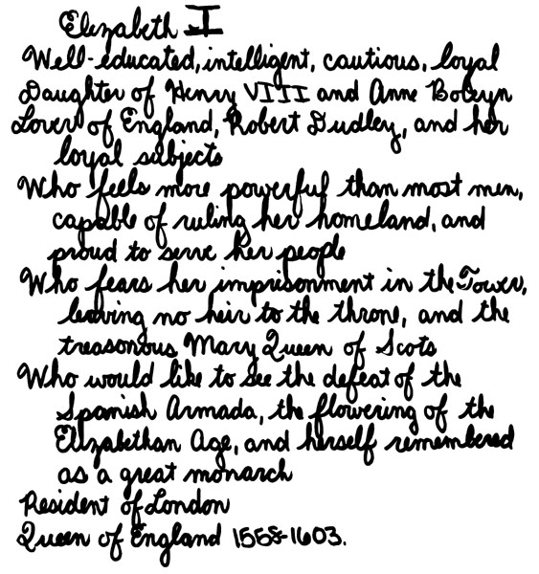

DISCUSSION QUESTIONS

1. Ask students to provide reasons why incorporating historical fiction in social studies instruction helps build children’s historical and geographical knowledge and understanding. How can children’s literature “breath life” into an elementary social studies program?

2. Ask the class to brainstorm ways that reading and writing activities can be included in social studies curriculum.

3. Using a comparison/contrast chart, ask students to list the elements of traditional social studies textbooks and children’s literature. Discuss the pros and cons of using only one approach versus using a combination of both resources in social studies instruction.

SUGGESTED CLASS ACTIVITIES

1. Students can work in groups to write a reader’s theater script. For primary to intermediate grades, students may want to select an appropriate historical fiction picture book. For the middle school grades, students can select an excerpt or chapter from a historical fiction novel. Students can then perform a reader’s theater for the class.

2. Have students in pairs read a picture book biography. After reading the book, students can write a bio-poem following the format and example in the chapter.

3. Read aloud from a historical fiction book. After reading, have students write their personal responses to the literature using a journal format.

4. Have students select one topic to be studied as a social studies and science interdisciplinary unit. Using the Twin Texts Meet Technology model, have students create a trio: nonfiction title, fiction title, and related website.

ADDITIONAL SUGGESTED READINGS

Brill, M. T. (2002). Nonfiction: The fun of fiction with facts. Illinois Reading Council
Journal, 30 (1), 30-35.

George, M. A., & Stix, A. (2000). Using multilevel young adult literature in middle
school American studies. Social Studies, 91(1), 25-31.

Olson, E. T. (2002). Mississippi River Chautauqua: Past, present, and future. Middle
Ground, 5 (4), 37-39.

Vacca, R. T. & Vacca, J. L. (2002). Content area reading. Boston: Allyn and Bacon.

ADDITIONAL INSTRUCTIONAL MEDIA

1. Overhead transparencies T-35 and T-36.

- A variety of picture book biographies.

- A historical fiction book to be read aloud to students for journal response writing.

- Comparison/contrast chart.

