CHAPTER 11: GEOGRAPHY: EXPLORING THE WHOLE WORLD THROUGH INTERDISCIPLINARY INSTRUCTION

KEY TERMS

geography
mental map
region
tribe

CHAPTER FOCUS

The purpose of this chapter is to provide teachers with practical ideas, strategies, and resources for incorporating geographic subject matter into a social studies program. Each of the six essential elements as identified by the National Geographic Standards are linked to example units and classroom activities. Using an integrated method with a variety of children’s literature and reading and writing activities, teachers will help students realize that geography is a part of their everyday lives.

CHAPTER ELEVEN OBJECTIVES

Students reading this chapter will be able to:

- Define the Geography for Life standards and explain their importance in teaching
geography.

- Identify the six essential elements of the standards and incorporate them into an
integrated social studies curriculum.

- Incorporate a variety of activities, children’s literature, and the use of Internet sites in
the teaching of geography.

LECTURE OUTLINE

Introduction
A Look at the Geography for Life Standards
The Geographic Skills
The Six Essential Elements of Geography
The World in Spatial Terms
Around the World with Exciting Books
Mental Maps
Using Literature to Teach Mapping Skills
Treasure Maps
Places and Regions—A Primary Unit about Native American Regions
Physical Systems—How Climate and Weather Affect Our Lives
Human Systems—Westward Expansion in the United States
Environment and Society—Protecting Our Earth
The Uses of Geography—Reflective Decision Making
NCSS Standards Linked Lesson Plan
Chapter Summary
Children’s Literature
Teaching Resources
References

TRANSPARENCIES T-37 through T-40

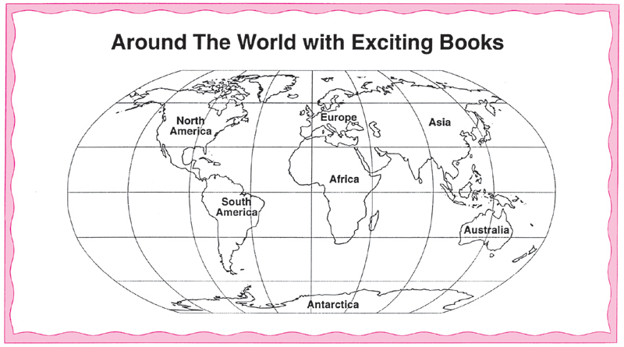

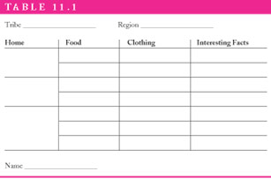

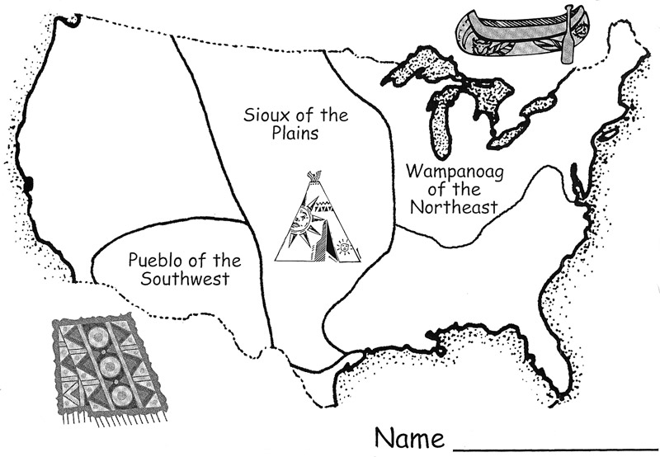

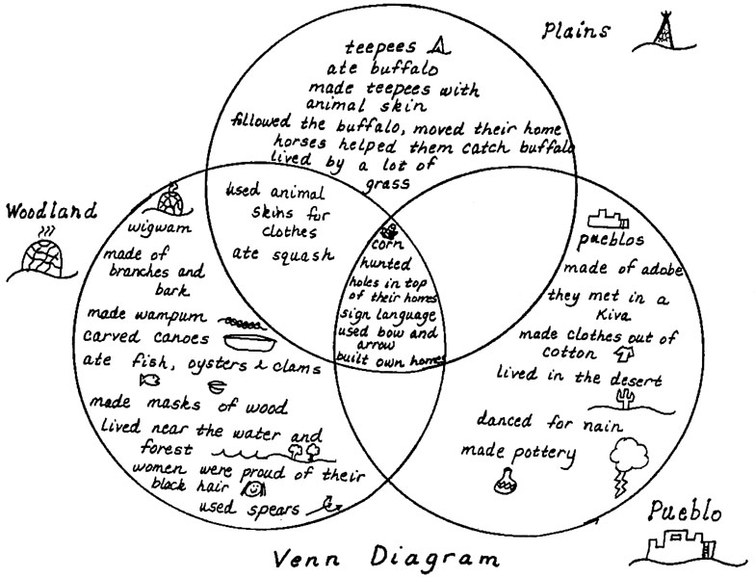

DISCUSSION QUESTIONS

1. Ask students to give reasons why the study of geography is an important part of the social studies curriculum.

2. Have students reflect on their interest and knowledge of geography. Are their feelings positive or negative? Do they feel that they have a broad knowledge base of geography? Ask students to brainstorm ways that they could develop more positive attitudes and feelings toward teaching of geography.

3. Ask students what methods presented throughout the chapter do they feel are effective ways to teach geography.

4. Ask students in groups to brainstorm a list of valuable resources for teaching geography.

SUGGESTED CLASS ACTIVITIES

1. Divide the class into small groups. Distribute a copy of an elementary or middle school level social studies textbook to each group. Have students examine the scope and sequence charts to determine how the study of geography is incorporated throughout the curriculum. Discuss how often geography is represented and the types of suggested activities throughout the text.

2. Have students in groups examine an outdated and a current political map of the world. Ask students to make a list of similarities and differences.

3. Teaching map and globe skills requires special resources. While out in the field, have students survey the types of resources available in elementary and middle school classrooms. Ask students to develop a list of resources that they would want in their classroom.

- Have students locate an article in a local-area newspaper that explores a geography
topic. Students can present their article to the class giving its relevance to geography and suggest possible activities that could be incorporated for classroom instruction.

5. Have students select one of the six essential elements of the standards for geography and develop a NCSS standards linked lesson plan.

ADDITIONAL SUGGESTED READINGS

Fisher, C., & Binns, T. (Eds). (2000). Issues in geography teaching. New York:
Routledge/Falmer.

National Council for Geographic Education. (2000). How to help children become
geographically literate. Jacksonville, AL: NCGE (2000).

ADDITIONAL INSTRUCTIONAL MEDIA

1. Overhead transparencies T-37 through T-40.

2. Sets of published elementary and middle school social studies textbooks.

3. Copies of outdated and current political maps of the world.

- Copies of local-area newspapers.

