CHAPTER 14: SOCIAL STUDIES AND THE ARTS: FROM INNER JOURNEYS TO FARAWAY LANDS

KEY TERMS

media
visual arts
color
form
shape
design

CHAPTER FOCUS

The purpose of this chapter is to discuss how social studies content is the ideal curriculum for the integration of the arts. This chapter will assist teachers in integrating social studies and the various arts disciplines including music, drama, and the visual and media arts. In addition, many suggestions are offered for applying Howard Gardner’s Multiple Intelligences to integrated social studies and the arts lessons.

CHAPTER FOURTEEN OBJECTIVES

Students reading this chapter will be able to:

1. Articulate their understanding of the value of integrating the arts and social studies
instruction.

2. Develop integrated lessons applying Howard Gardner’s Multiple Intelligences to the
various arts and social studies content.

3. Identify ways in which the various arts are essential skills to teach in elementary school.

LECTURE OUTLINE

Introduction
Integrating Social Studies and the Arts
The Golden Years
Music Is the Universal Language of Mankind
Visual Arts—The Illustrated Dictionary of Our Time
Children Are Drama
Initiating Drama in the Classroom
Preparatory Reflection
Investigating Resources
Developing and Utilizing Specialized Planning Approaches
Resources and Ideas for Drama
Drama and Thematic Strands of the Social Studies Curriculum
Putting It All Together in Interdisciplinary Instruction
NCSS Standards Linked Lesson Plan
Chapter Summary
Children’s Literature
Teaching Resources
References

TRANSPARENCIES T-45 through T-47

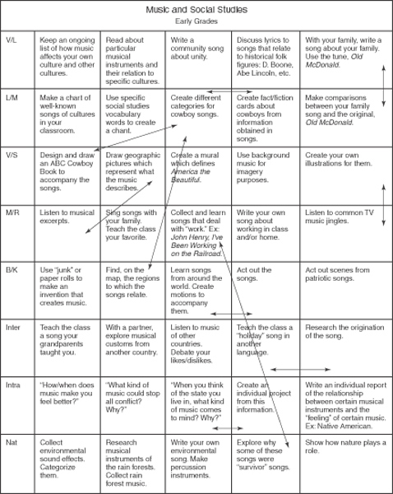

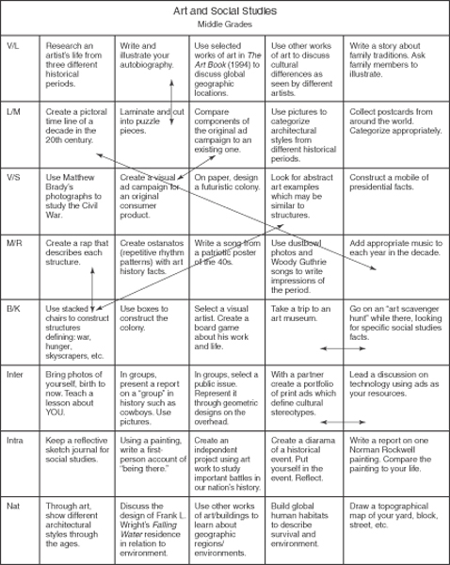

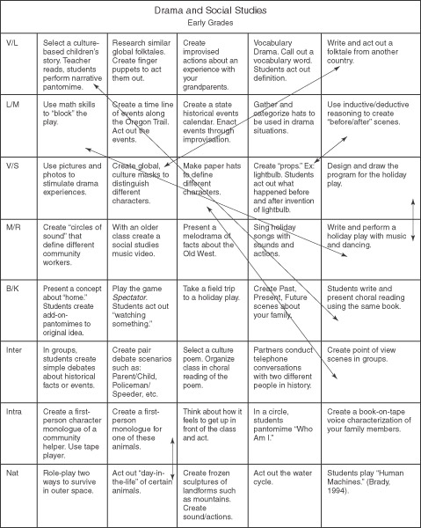

DISCUSSION QUESTIONS

1. Have students recall ways that the arts were integrated throughout their social studies instruction during the elementary and middle school years. Discuss how activities could be included in instruction so that the emphasis is not taken away from the social studies content.

2. Ask students to discuss the benefits of integrating the arts in to social studies instruction during the elementary and middle school years. Do they see any disadvantages to this approach?

3. Ask students to brainstorm the expertise they bring to the classroom in using arts in social studies instruction. Discuss other resources for bringing arts into the social studies curriculum.

SUGGESTED CLASS ACTIVITIES

1. Have the students, working with partners, examine a social studies textbook to identify possible themes that could be used for integrating the arts. With the use of one of the Multiple Intelligences Grids found throughout the chapter, have students design a unit for a chosen theme that incorporates the multiple intelligences and the arts.

2. Have students select a grade level and social studies topic of their choice to develop a “Unit Tree.” Students can refer to an example of a unit tree found in the chapter.

3. Have students read a children’s literature book suggested in the chapter and complete an arts activity. Students should be able to explain how they made connections between the content of the book and the art.

ADDITIONAL SUGGESTED READINGS

Fennessey, S. M. (2000). History in the spotlight: Creative drama and theatre practices
for the social studies classroom. Westport, CT: Heinemann.

McDonald, N., & Fisher, D. (2000). Tell them I sing: A dialogue on integrating curricula.
General Music Today, 14 (1), 13-18.

Morris, R. V. (2001). Drama and authentic assessment in a social studies classroom.
Social Studies, 92 (1), 41-44.

Nielsen, F. (2001). Singing American history. Teaching History: A Journal of Methods,
26 (2), 89-97.

Sartorius, T. C. (2001). Art across the curriculum: Tea for three? Arts & Activities, 129
(5), 30-32.

ADDITIONAL INSTRUCTIONAL MEDIA

1. Overhead transparencies T-45 through T-47.

2. Sets of published elementary and middle school social studies textbooks.

