E1. A trait of pneumococci is the ability to synthesize a capsule. There needs to be a blueprint for this ability. The blueprint for capsule formation was being transferred from the type IIIS to the type IIR bacteria. (Note: At the molecular level, the blueprint is a group of genes that encode enzymes that can synthesize a capsule.)
E2. A. There are different possible reasons why most of the cells were not transformed.
1. Most of the cells did not take up any of the type IIIS DNA.
2. The type IIIS DNA was usually degraded after it entered the type IIR bacteria.
3. The type IIIS DNA was usually not expressed in the type IIR bacteria.
B. The antibody/centrifugation steps were used to remove the bacteria that had not been transformed. It enabled the researchers to determine the phenotype of the bacteria that had been transformed. If this step was omitted, there would have been so many colonies on the plate it would have been difficult to identify any transformed bacterial colonies, since they would have represented a very small proportion of the total number of bacterial colonies.
C. They were trying to demonstrate that it was really the DNA in their DNA extract that was the genetic material. It was possible that the extract was not entirely pure and could contain contaminating RNA or protein. However, treatment with RNase and protease did not prevent transformation, indicating that RNA and protein were not the genetic material. In contrast, treatment with DNase blocked transformation, confirming that DNA is the genetic material.
E3. 1. Isolate and purify DNA from resistant bacteria.
2. In three separate tubes, add DNase, RNase, or protease.
3. Add sensitive bacteria to each tube. A small percentage may be transformed.
4. Plate on petri plates containing tetracycline.
Expected results: Tetracycline-resistant colonies should only grow when the DNA has been exposed to RNase and protease, but not to DNase.
E4. A. There are several possible explanations why 30% of the DNA is in the supernatant. One possibility is that not all of the DNA was injected into the bacterial cells. Alternatively, some of the cells may have been broken during the shearing procedure, thereby releasing the DNA.
B. If the radioactivity in the pellet had been counted instead of the supernatant, the following figure would be produced:
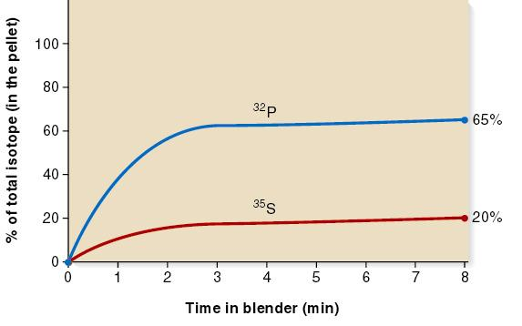
C. 32P and 35S were chosen as radioisotopes to label the phages because phosphorous is found in nucleic acids, while sulfur is found only in proteins.
D. There are multiple reasons why less than 100% of the phage protein is removed from the bacterial cells during the shearing process. Perhaps the shearing just is not strong enough to remove all of the phages. Perhaps the tail fibers remain embedded in the bacterium and only the head region is sheared off.
E5. It does not rule out the possibility that RNA is the genetic material because RNA and DNA both contain phosphorus. One way to distinguish RNA and DNA is to provide bacteria with radiolabeled uracil in order to label RNA or provide bacteria with radiolabeled thymine to label DNA. (Note: Uracil is found only in RNA and thymine is found only in DNA.) If they had propagated T2 phage in E. coli cells exposed to radiolabeled uracil, the phages would not be radiolabeled. However, if they had propagated phage in E. coli cells exposed to radiolabeled thymine, the T2 phages would be radiolabeled. This would indicate that T2 phages contain DNA and not RNA because radiolabeled uracil would not label the genetic material of T2 bacteriophage.
E6. This is really a matter of opinion. The Avery, MacLeod, and McCarty experiment seems to indicate directly that DNA is the genetic material since DNase prevented transformation while RNase and protease did not. However, one could argue that the DNA is required for the rough bacteria to take up some other contaminant in the DNA preparation. It would seem that the other contaminant would not be RNA or protein. The Hershey and Chase experiments indicate that DNA is being injected into bacteria, although quantitatively the results are not entirely convincing. Some 35S-labeled protein was not sheared off, so the results do not definitely rule out the possibility that protein could be the genetic material. But the results do indicate that DNA is the more likely candidate.
E7. 1. You can make lots of different shapes.
2. You can move things around very quickly with a mouse.
3. You can use mathematical formula to fit things together in a systematic way.
4. Computers are very fast.
5. You can store the information you have obtained from model building in a computer file.
E8. A. The purpose of chromatography was to separate the different types of bases.
B. It was necessary to separate the bases and determine the total amount of each type of base. In a DNA strand, all the bases are found within a single molecule, so it is difficult to measure the total amount of each type of base. When the bases are removed from the strand, each type can be purified, and then the total amount of each type of base can be measured with a spectrophotometer.
C. His results would probably not be very convincing if done on a single species. The strength of his data was that all species appeared to conform to the AT/GC rule, suggesting that this is a consistent feature of DNA structure. In a single species, the observation that A = T and G = C could occur as a matter of chance.
E9. If the RNA was treated with RNase, the plants would not be expected to develop lesions. If treated with DNase or protease, lesions would still occur because RNA is the genetic material, and DNase and protease do not destroy RNA.

