C1. The four processes are cell division, cell differentiation, cell movement, and cell death. Cell division is needed to produce a multicellular organism. In other words, cell division is needed for growth. Cell differentiation is needed to create different cell types. Each cell type is differentiated to carry out its own specialized function. Cell movement is needed during embryonic development to create an embryo with the proper organization of cells and germ layers. And finally, cell death is needed to create certain bodily structures. For example, in the early embryonic development of mammals, the hand is initially a flattened, oval structure. The fingers are formed when cell death occurs in the regions between each finger.
C2. A. False, the head is anterior to the tail.
B. True.
C. False, the feet are posterior to the hips. Along the dorso-ventral axis, they are about the same.
D. True.
C3. A. This would likely be a mutation in a segmentation gene, because mutations in certain segmentation genes have fewer segments. In this case, it could be a loss-of-function mutation in a gap gene.
B. This would likely be a mutation in a homeotic gene because the characteristics of one segment have been converted to the characteristics of a different segment.
C. This would likely be a mutation in a homeotic gene because the characteristics of two segments have been converted to the characteristics of two different segments.
C4. A. True.
B. False, because gradients are also established after fertilization during embryonic development.
C. True.
C5. A parasegment is only a transient demarcation that divides the developing embryo. The segments become permanent regions that develop their own morphological characteristics. The expression of certain genes, such as ftz and even-skipped, occur in parasegments. Ftz is expressed in the odd-numbered parasegments and even-skipped is expressed in the even-numbered parasegments. This expression occurs prior to the formation of the segments.
C6. A. This is a mutation in runt, which is a pair-rule gene.
B. This is a mutation in knirps, which is a gap gene.
C. This is a mutation in patched, which is a segment-polarity gene.
C7. A morphogen is a molecule, such as a transcription factor, that influences the morphological fate of a cell or group of cells. A morphogen exerts its effects by affecting a genetic hierarchy that ultimately leads to the expression of genes that govern cell locations and morphologies. If a morphogen is expressed in the wrong place, an abnormal morphology results. An example is the phenotype called antennapedia in which a leg is found in place of an antenna. Examples of morphogens in Drosophila include Bicoid, Hunchback, Giant, Krüppel, and the homeotic gene products.
C8. Positional information refers to the phenomenon whereby the spatial locations of morphogens and CAMs provide a cell with information regarding its position relative to other cells. In Drosophila, the formation of a segmented body pattern relies initially on the spatial location of maternal gene products. These gene products lead to the sequential activation of the segmentation genes.
C9. The two processes are similar in that they set up concentration gradients that can lead to the spatial activation of genes in particular regions of the embryo. When the gradients are established in the oocyte, the morphogen becomes incorporated into cells during the cleavage and cell division stage of embryogenesis. In this case, the morphogen is already inside. Later in development, when a morphogen is secreted from a particular cell or group of cells, the morphogen must bind to cell surface receptors to elicit its effects.
C10. The anterior portion of the antero-posterior axis is established by the action of Bicoid. During oogenesis, the mRNA for Bicoid enters the anterior end of the oocyte and is sequestered there to establish an anterior (high) to posterior (low) gradient. Later, when the mRNA is translated, the Bicoid protein in the anterior region establishes a genetic hierarchy that leads to the formation of anterior structures. If Bicoid was not trapped in the anterior end, it is likely that anterior structures would not form.
C11. The Bicoid protein is a morphogen that causes the anterior portions of the embryo to form properly. It functions as a transcription factor. Other genes, such as hunchback, are stimulated by Bicoid in a concentration-dependent manner. In this case, hunchback is stimulated only in the anterior portion of the embryo. In a general sense, the concentration dependence of gene activation leads to the activation of genes in particular regions of the embryo, leading to the stimulation of a few broad bands and eventually to a segmented pattern.
C12. Maternal gene products influence the formation of the main body axes including the antero-posterior, dorso-ventral, and terminal regions. They are needed very early in development. Zygotic genes, particularly the three classes of the segmentation genes, are necessary after the axes have been established. The segmentation genes are expressed (after fertilization) during embryogenesis.
C13. A homeotic gene governs the final fate of particular segments in the adult animal. A gain-of-function mutation is due to an aberrant expression of a homeotic gene in the wrong place. This causes the region to develop inappropriate characteristics. A loss-of-function allele usually causes a segment to develop characteristics that are normally found in the anterior adjacent segment.
C14. The coding sequence of homeotic genes contains a 180 bp consensus sequence known as a homeobox. The protein domain encoded by the homeobox is called a homeodomain. The homeodomain contains three conserved sequences that are folded into α−helical conformations. The arrangement of these a helices promotes the binding of the protein to the major groove of the DNA. Helix III is called the recognition helix because it recognizes a particular nucleotide sequence within the major groove. In this way, homeotic proteins are able to bind to DNA in a sequence-specific manner and thereby activate particular genes.
C15. Since the nanos gene product plays a role in the development of posterior structures, such a larva would probably develop with two anterior ends.
C16. It would normally be expressed in the three thoracic segments that have legs (T1, T2, and T3).
C17. When a loss-of-function mutation occurs in a homeotic gene, the segment(s) where the homeotic gene is normally expressed will have the characteristics of the adjacent anterior segment(s). For a gain-of-function mutation, a homeotic gene is expressed in the wrong place. The segment where it is incorrectly expressed will have inappropriate characteristics (like legs where the antennae should be). Therefore, the phenotypic consequence of a gain-of-function mutation is that one or more segments will have characteristics of segments that could be anywhere else in the fly. (Note: It is possible that a gain-of-function mutation could resemble a loss-of-function mutation if the gain-of-function mutation resulted in the abnormal expression of a homeotic gene in the segment that is adjacent and posterior to the segment where the homeotic gene is normally expressed.)
A. Gain-of-function allele.
B. Either a loss-of-function or gain-of-function mutation could explain this phenotype; a loss-of-function mutation is more likely since it is easier to mutate a gene and eliminate its function.
C. Gain of function allele.
C18. A. When a mutation inactivates a gap gene, a contiguous section of the larva is missing.
B. When a mutation inactivates a pair-rule gene, some regions that are derived from alternating parasegments are missing.
C. When a mutation inactivates a segment-polarity gene, portions are missing at either the anterior or posterior end of the segments.
C19. A maternal effect gene is expressed in the nurse cells surrounding a developing oocyte, and the gene products (i.e., mRNA or protein) are transferred to the oocyte. Since the nurse cells are diploid, the phenotype of the resulting individual (after oocyte fertilization) actually depends on the diploid genotype of the nurse cells (which is the same as the diploid genotype of the mother). Zygotic genes are expressed after fertilization. (Note: Some genes are both maternal effect and zygotic; they are expressed in the nurse cell and after fertilization. For this question, however, let’s assume that a gene is likely to be one or the other, but not both.)
A. Nanos is a maternal effect gene; the nanos mRNA accumulates in the oocyte.
B. Antp is a zygotic gene. It is a homeotic gene that is turned on in embryonic development after the segmentation genes have been expressed.
C. Bicoid is a maternal effect gene; the bicoid mRNA accumulates in the oocyte.
D. Lab is a zygotic gene. It is a homeotic gene that is turned on in embryonic development after the segmentation genes have been expressed.
C20. Proper development in mammals is likely to require the products of maternal effect genes that play a key role in initiating embryonic development. The adult body plan is merely an expansion of the embryonic body plan. Because the starting point for the development of an embryo is the oocyte, this explains why an enucleated oocyte is needed to clone mammals. The oocyte is needed to establish the embryonic body plan.
C21. A. In this case, the A-1 cell behaves like a B-1 cell. The A-1 cell produces the lineage of the B-1 cell.
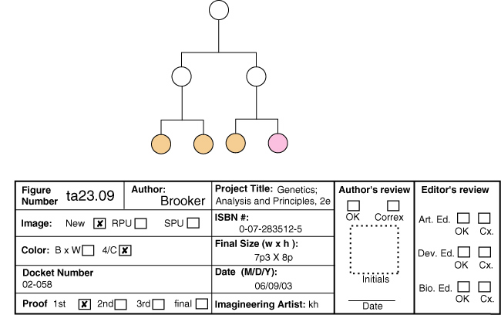
B. In this case, the B-1 cell behaves like an A-1 cell. The B-1 cell produces the lineage that the A-1 cell would normally produce.
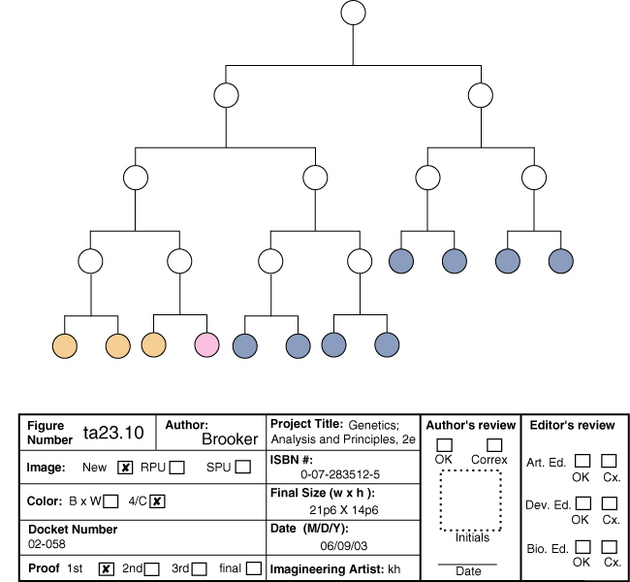
C22. A heterochronic mutation is one that alters the timing when a gene (involved in development) is normally expressed. The gene may be expressed too early or too late, which causes certain cell lineages to be out of sync with the rest of the animal. If a heterochronic mutation affected the intestine, the animal may end up with too many intestinal cells if it is a gain-of-function mutation or too few if it is a loss-of-function mutation. In either case, the effects might be detrimental because the growth of the intestine must be coordinated with the growth of the rest of the animal.
C23. Drosophila has eight homeotic genes located in two clusters (antennapedia and bithorax) on chromosome 3. The mouse has four Hox complexes designated HoxA (on chromosome 6), HoxB (on chromosome 11), HoxC (on chromosome 15), and HoxD (on chromosome 2). There are a total of 38 genes in the four complexes. Among the first six genes, five of them are homologous to genes found in the antennapedia complex of Drosophila. Among the last seven, three of them are homologous to the genes of the bithorax complex. Like the bithorax and antennapedia complexes in Drosophila, the arrangement of Hox genes along the mouse chromosomes reflects their pattern of expression from the anterior to the posterior end. With regard to differences, the mouse has a larger number of homeotic genes, and gene knockouts do not always lead to transformations that resemble the anterior adjacent segment.
C24. Cell differentiation is the specialization of a cell into a particular cell type. In the case of skeletal muscle cells, the bHLH proteins play a key role in the initiation of cell differentiation. When bHLH proteins are activated, they are able to bind to enhancers and activate the expression of many different muscle-specific genes. In this way, myogenic bHLH proteins turn on the expression of many muscle-specific proteins. When these proteins are synthesized, they change the characteristics of the cell into those of a muscle cell. Myogenic bHLH proteins are regulated by dimerization. When a heterodimer forms between a myogenic bHLH protein and an E protein, it activates gene expression. However, when a heterodimer forms between myogenic bHLH proteins and a protein called Id, the heterodimer is unable to bind to DNA. The Id protein is produced during early stages of development and prevents myogenic bHLH proteins from promoting muscle differentiation too soon. At later stages of development, the amount of Id protein falls, and myogenic bHLH proteins can combine with E proteins to induce muscle differentiation.
C25. Genes involved with cell differentiation and homeotic genes are similar in that they control genetic regulatory pathways. These types of genes typically encode transcription factors that regulate the expression of many genes. The main difference lies in the magnitude of the genetic control. MyoD, for example, controls the differentiation of skeletal muscle cells, and this cell type can be found in many different regions of the body. A homeotic gene controls the development of an entire segment of the body; a segment of a body has many different types of cells that are organized in a particular way.
C26. A totipotent cell is a cell that has the potential to create a complete organism.
A. In humans, a fertilized egg is totipotent, and the cells during the first few embryonic divisions are totipotent. However, after several divisions, embryonic cells lose their totipotency and, instead, are determined to become particular tissues within the body.
B. In plants, most living cells are totipotent.
C. Because yeast are unicellular, one cell is a complete individual. Therefore, yeast cells are totipotent; they can produce new individuals by cell division.
D. Because bacteria are also unicellular, one cell is a complete individual. Therefore, bacteria are totipotent; they can produce new individuals by cell division.
C27. A meristem is an organized group of actively dividing cells. A plant may have one or more shoot meristems that produce offshoots that give rise to structures such as leaves and flowers. The root meristem grows in the opposite direction and gives rise to the roots. The pattern of meristem growth is a primary determinant in the overall morphology of the plant. For example, if a shoot meristem produces offshoots at close intervals, leaves that are very close together result. In contrast, if a shoot meristem rarely produces offshoots giving rise to leaves, the plant will have very few leaves. This explains why some plants are bushy and others have sparsely located leaves.
C28. Animals begin their development from an egg and then form antero-posterior and dorso-ventral axes. The formation of an adult organism is an expansion of the embryonic body plan. Plants grow primarily from two meristems, a shoot and root meristem. At the cellular level, plant development is different in that it does not involve cell migration, and most plant cells are totipotent. Animals require the organization within an oocyte to begin development. At the genetic level, however, animal and plant development are similar in that they involve a genetic hierarchy of transcription factors that govern pattern formation and cell specialization.
C29. A. Carpel-stamen-stamen-carpel
B. Sepal-sepal-carpel-carpel
C. Carpel-carpel-carpel-carpel

