Chapter 3
Cell Structure and Genetic Control

Chapter Scope
In this chapter the organic molecules we carefully assembled in chapter 2 will be used to construct a model of a typical cell. For now, the cell we build can be any tissue cell — a neuron, muscle fiber, epithelial cell or connective tissue cell. However, this image of your completed cell should be stored in your memory so that instant recall of its internal structure is available to you during the next three chapters when: cytoplasmic enzyme activities are described (chapter 4); cell respiration and metabolism in and around the mitochondria are featured (chapter 5); and, detailed descriptions of membrane transport, including osmosis and diffusion, are presented (chapter 6).
Currently the plasma (cell) membranes along with those membranes of the interior organelles are the focus of intense research efforts. The plasma membrane is composed primarily of polar and hydrophilic molecules called phospholipids, along side molecules of protein (often with carbohydrates attached), and cholesterol molecules. This active, ever-changing cell boundary appears to be ultimately regulated by the DNA in the nucleus. Within the cell’s cytoplasm are the various organelles, some with their own surrounding membranes and some without, yet all are suspended in a flexible network of fluid and fibers that make up the cytoskeleton. Learning the structure and function of the cell organelles now is important. It will prepare you for understanding why these organelles are found within certain specialized cells and the roles they play as these cells interact with each other and with other tissues of the body.
The genetic information encoded within and expressed by the molecules of DNA controls the cell’s major activities from the nucleus. The overall purpose of DNA as described here is to: (1) direct the synthesis of RNA, which in turn, directs the synthesis of proteins for use inside the cell and those that will be packaged and secreted outside the cell; (2) prepare the cell for division (mitosis); and (3) oversee the formation of sperm and egg gametes (meiosis).

I. Plasma Membrane and Associated Structures
The cell is the basic unit of structure and function in the body. Many of the functions of cells are performed by particular subcellular structures known as organelles. The plasma (cell) membrane allows selective communication between the intracellular and extracellular compartments and aids cellular movements.

A. Multiple Choice
- The plasma (cell) membrane is composed primarily of protein and
a. phospholipids.
b. carbohydrates.
c. nucleic acids.
d. amino acids.
- Which of the following is not a function of protein in the plasma membrane?
a. structural support
b. DNA synthesis
c. enzymatic control of chemical reactions
d. receptors for hormones and other regulatory molecules
e. cellular “markers” or antigens
- Which of the following organic molecules is not commonly found to play an active role in the plasma (cell) membrane?
a. carbohydrates
b. protein
c. cholesterol
d. nucleic acids
- The process whereby the body protects itself from invading microorganisms and to remove extracellular debris by surround and engulfing particles, is known as
a. phagocytosis.
b. pinocytosis.
c. receptor-mediated invagination.
d. apoptosis.
e. senescence.
- Which of the following cell types are capable of eating objects larger than they are during phagocytosis? a. red blood cells (erythrocytes)
b. neutrophils (type of white blood cell)
c. epithelial cells
d. macrophages
e. Both b & d are capable of this activity.
- Exocytosis, an example of which of the following processes?
a. phagocytosis
b. pinocytosis
c. receptor-mediated invagination
d. secretory vesicle fusion and content release
- The formation of a food vacuole primarily results from the process of
a. phagocytosis.
b. pinocytosis.
c. receptor-mediated invagination.
d. exocytosis.
- Cholesterol particles and certain viruses such as those that cause hepatitis, polio, and AIDS, enter the body cells by the process of
a. diffusion.
b. phagocytosis.
c. pinocytosis.
d. receptor-mediated endocytosis.
e. amoeboid movement.

B. True or False/Edit
- The hydrophobic core of plasma (cell) membranes restricts the passage of fat and fat-soluble molecules into and out of the cell.
- The specialized functions and selective transport properties of the plasma (cell) membrane are believed to be due to its protein content.
- The flexibility of the plasma (cell) membrane is partly due to the unique ratio between cholesterol and phospholipid molecules present in the membrane.
- Certain white blood cells (WBCs) and liver cells can help protect the body from invading microorganisms by the process of cellular “eating,” or pinocytosis.
- Phagocytosis by macrophages of senescent (aged) cells and those cells that die by suicide (apoptosis) is considered normal and an ongoing process in the body.
- Both cilia and flagella are composed of microtubule protein pairs arranged in a characteristic “9 + 2” arrangement.
- Sperm cells are the only cells in the human body that have cilia.

II. Cytoplasm and Its Organelles
Many of the functions of a cell that are performed in the cytoplasmic compartment result from the activity of specific structures called organelles. Among these are the lysosomes, which contain digestive enzymes, and the mitochondria, where most of the cellular energy is produced. Other organelles participate in the synthesis and secretion of cellular products.

A. Multiple Choice
- Worn-out organelles and phagocytic by-products are characteristically digested within the structure known as a
a. primary lysosome.
b. secondary lysosome.
c. residual body.
d. secretory vesicle.

- DNA molecules can be found both in the nucleus and in __________________ other structures that are capable of reproducing themselves in the cytoplasm.
a. ribosomes
b. lysosomes
c. the Golgi complex
d. mitochondria
e. the endoplasmic reticulum
- The organelle that stores calcium ions (Ca²⁺) in striated (skeletal) muscle cells and is involved in steroid hormone metabolism is the
a. ribosome.
b. lysosome.
c. Golgi complex.
d. mitochondria.
e. endoplasmic reticulum
- Membranes folded into cristae with matrix material involved in the production of ATP (energy), are characteristics of the organelle known as the
a. ribosome.
b. lysosome.
c. Golgi complex.
d. mitochondria.
e. endoplasmic reticulum.
- Autophagy, a process that destroys worn-out organelles so that they can be continuously replaced, is one function of the
a. cytoskeleton.
b. lysosome.
c. Golgi complex.
d. mitochondria.
e. endoplasmic reticulum.
- Organelles, known as “protein factories” because proteins are assembled here as directed by the genetic information delivered by messenger RNA, refer to the
a. mitochondria.
b. lysosome.
c. Golgi complex.
d. ribosomes.
e. endoplasmic reticulum.
- The organelle composed of a 30S and a 50S subunit is the
a. mitochondria.
b. lysosome.
c. Golgi complex.
d. ribosomes.
e. endoplasmic reticulum.
- The organelle consisting of several flattened sacs with cavities, called cisternae; with one side of the sacs facing the endoplasmic reticulum and the other side facing the plasma membrane, best describes
a. mitochondria.
b. lysosome.
c. Golgi complex.
d. ribosomes.

B. True or False/Edit
- Microtubules and microfilaments help form the cell’s framework or cytoskeleton while associating with contractile proteins that provide movement of materials within the cell cytoplasm fluid matrix.
- The movement of molecular “cargo” along the microfilament and microtubule “railways” of the cell’s cytoskeleton generally requires “motor” molecules such as myosin, kinesins, and dyneins.
- Most, if not all, molecules in the cell have a limited life span, and thus must be continuously destroyed and replaced.
- Most, if not all, of the mitochondria in the cells of an adult were derived from that individual’s mother, that is, derived from mitochondria present in her ovum upon fertilization.
- Protein assembly is made possible at the endoplasmic reticulum with the help of specialized enzymes, called ribozymes.
- Smooth granular endoplasmic reticulum would naturally be abundant in cells that are active in protein synthesis, such as salivary gland cells involved in secretion.
- Vesicles that bud off the flattened sacs of the Golgi complex may become lysosomes, storage granules of secretory products, or become added sections to the plasma membrane.
- The phenomenon of “tolerance” to certain substances, such as drugs, may be accompanied by an increase in the granular endoplasmic reticulum, particularly in liver cells.
- Mitochondria may be able to reproduce themselves, especially in cells that require greater than normal energy outputs.

C. Label the Figure — The Generalized Cell and the Principal Organelles
It is important to be able to recognize and identify the principal organelles and other important structures of a cell. In figure 3.1 below, write the name of the organelle or structure indicated on the numbered answer line. Then check your work against figure 3.1 in the text and correct any mistakes. How is your spelling? Can you recall the major functions of each organelle and structure?
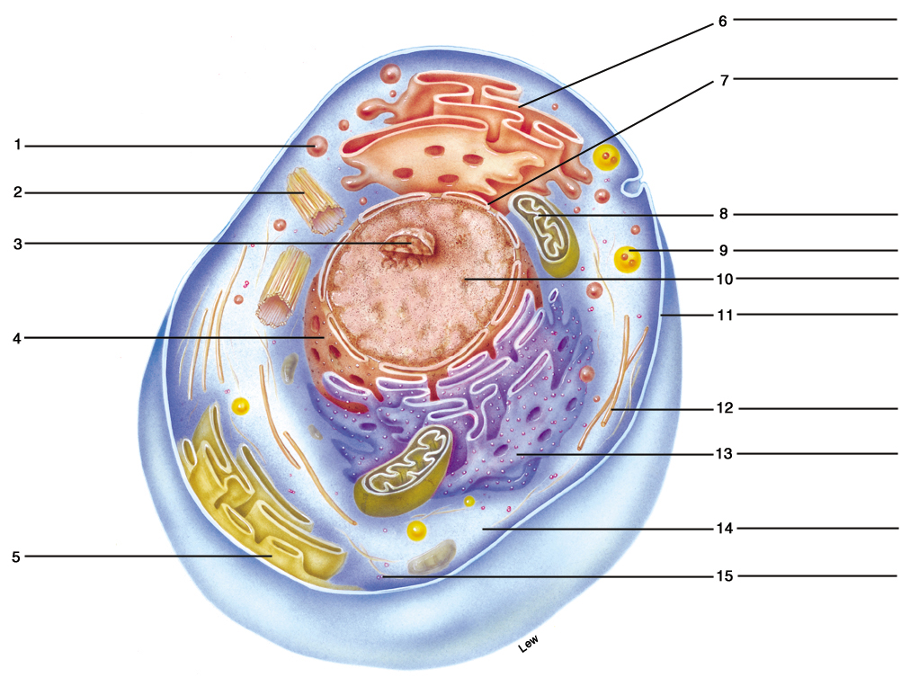

Figure 3.1 The generalized cell and the principal organelles.

III. Cell Nucleus and Gene Expression
The nucleus is the organelle that contains the DNA of a cell. A gene is a length of DNA that codes for the production of a specific polypeptide chain. In order for genes to be expressed, they must first direct the production of complementary RNA molecules. That process is called genetic transcription.

A. Multiple Choice
- The inner and outer membranes that enclose the nucleus of the cell are together known as the nuclear
a. sac.
b. envelope.
c. pore complex.
d. bag.
- Which of the following statements about the gene is not correct?
a. A gene is a length of DNA.
b. Genes are normally found within the nucleus of the cell.
c. The expression of a gene leads to the formation of a polysaccharide chain.
d. Messenger (mRNA) is made from DNA in the process of transcription.
- The dark regions of the nucleus, known as nucleoli, contain genes that code form the production of
a. messenger RNA (mRNA).
b. ribosomal RNA (rRNA).
c. transfer RNA (tRNA).
d. complementary DNA.
- Which of the following statements best describes the term, genome?
a. the zygote formed by the union of the males sperm and female ovum
b. the smallest possible gene in the chromosome
c. another name for the nucleus (home for the DNA)
d. all of the genes in a particular individual or all of the genes in a particular species
e. all of the protein (polypeptide) molecules coded for by the genes
- Which statement about the term, proteome, is false?
a. Proteome refers to all of the proteins produced by the genome.
b. Proteins produced by the cell greatly outnumber the number of genes.
c. All proteins in the proteome have currently been identified.
d. Scientific study of the proteome should yield important medical applications.
e. Proteome proteins may bind with other molecules such as carbohydrates or lipids.
- The positively charged proteins that form spools about which two turns of the negatively charged DNA strands are wound, are known as
a. histones.
b. enzymes.
c. ribozymes.
d. nuclear pore complexes.
- The relatively extended form of DNA within the cell nucleus that is active in genetic transcription (formation of mRNA for protein synthesis), is known as
a. chromatin.
b. euchromatin.
c. heterochromatin.
d. nucleosomes.
- In the nucleus, the process by which the enzyme RNA polymerase directs the synthesis of messenger RNA (mRNA), is best known as
a. promotion.
b. spooling.
c. genetic expression.
d. transcription.
e. translation.
- The nitrogenous base in DNA that is not found in RNA is
a. adenine.
b. guanine.
c. thymine.
d. cytosine.
e. uracil.

- Which of the following is not a type of ribonucleic acid (RNA)?
a. messenger
b. mitochondrial
c. transfer
d. ribosomal
- Introns (noncoding DNA) and exons (coding DNA) are parts of a gene responsible for directly ordering the synthesis of
a. pre-mRNA.
b. mRNA.
c. rRNA.
d. tRNA.
- The RNA type that diffuses through nuclear pores to direct the assembly or synthesis of new protein molecules at the ribosomes is
a. pre-mRNA.
b. mRNA.
c. rRNA.
d. tRNA.

B. True or False/Edit
- The movement of protein and RNA molecules through the nuclear pores and into the cytoplasm is a selective, energy-requiring process.
- The primary structure of a protein is determined directly by the sequence of bases in the mRNA molecule arriving at the ribosome.
- Genetic expression occurs in two stages: first genetic translation and then genetic transcription.
- One or more dark areas found in each nucleus, which contain DNA (genes) that code for the production of ribosomal RNA (rRNA), are known as nuclear pore complexes.
- The Human Genome Project began as an international effort to sequence the entire human genome; and has established that humans only have about 100,000 genes.
- Euchromatin refers to the highly condensed, blotchy-looking, DNA-containing areas within the cell nucleus containing genes that are permanently inactivated.
- Cells of the early growing embryo are said to be “totipotent,” or “stem” cells, because as development proceeds, these cells can become any cell in the body.
- During gene activation, the deacetylation of histone proteins produces a less condensed, more open configuration of the chromatin, allowing the DNA to be “read” by transcription factors.
- Specific molecules, such as hormones entering the nucleus from elsewhere in the body, can serve as transcription factors that start or initiate the transcription of DNA to mRNA.
- Only DNA and mRNA are double-stranded nucleic acids.
- Positively charged histone proteins spool around negatively charged strands of DNA molecules in the nucleus to form larger chromatin particles called nucleosomes.
- All three types of RNA are formed from the genetic information contained in the DNA of the nucleus.
- The synthesis of RNA molecules from DNA is called genetic translation.
- The genes located within the nucleoli code for the production of messenger RNA (mRNA).
- Noncoding segments of DNA scattered along a gene that do not participate in transcription of the genetic code are called exons.
- SnRNPs (pronounced “snurps”), make up small, ribosome-like bodies called spliceosomes that reform mRNA molecules after introns have been spliced from pre-mRNA.

IV. Protein Synthesis and Secretion
In order for a gene to be expressed, it first must be used as a guide, or template, in the production of a complementary strand of messenger RNA. This mRNA is then itself used as a guide to produce a particular type of protein whose sequence of amino acids is determined by the sequence of base triplets (codons) in the mRNA.

A. Multiple Choice
- Translation is best defined as the synthesis of
a. mRNA, tRNA, and rRNA from DNA in the nucleus.
b. pre-mRNA only from DNA in the nucleus.
c. specific proteins from the mRNA base sequence code.
d. new, complementary strands of DNA in the nucleus.
- The RNA type characterized by bending on itself to form a cloverleaf structure that twists further into an upside down “L” shape is called
a. pre-mRNA.
b. mRNA.
c. rRNA.
d. tRNA.
- Aminoacyl-tRNA synthetase is an enzyme that joins a specific ____________ molecule to the end of the tRNA molecule to which it is complementary.
a. nucleic acid.
b. amino acid.
c. pentose sugar.
d. protein.
e. nucleotide.
- Which of the following is not a function of the Golgi apparatus?
a. preparing proteins for in-cell use
b. further modification of new proteins (for example, glycoproteins or glycolipids)
c. organizing proteins by function and destination
d. packaging the final proteins and shipping them to their destination

B. True or False/Edit
- The sequence of three bases (a base triplet) in tRNA is called a codon, while the complementary triplet in mRNA is called an anticodon.
- Proteins that are synthesized for specific functions within a particular cell possess a hydrophobic leader sequence that permits the entry of these proteins into the cisterna of the rough endoplasmic reticulum.
- The formation of insulin, a protein (polypeptide) hormone, occurs first at the granular endoplasmic reticulum forming preproinsulin, which is then directed into the cisternae and reduced to form proinsulin, which is then spliced and joined together to make the final form of insulin for secretion.
- The Golgi complex and endoplasmic reticulum are primarily responsible for applying the finishing touches on proteins destined for secretion out of the cell, for incorporation into the plasma membrane, and for packaging into lysosomes.

V. DNA Synthesis and Cell Division
When a cell is going to divide, each strand of the DNA within its nucleus acts as a template for the formation of a new complementary strand. Organs grow and repair themselves through a type of cell division known as mitosis. The two daughter cells produced by mitosis contain the same genetic information as the parent cell. Gametes contain only half the number of chromosomes as their parent cell and are formed by a type of cell division called meiosis.

A. Multiple Choice
- The enzyme required to replicate DNA is called
a. aminoacyl-tRNA synthetase.
b. RNA polymerase.
c. DNA polymerase.
- The phase of the cell cycle during which DNA replicates itself is known as the ____________ phase.
a. G₂
b. G₁
c. S
d. M

- One very important tumor suppressor gene that indirectly blocks the uncontrolled stimulation of cell division common in cancer, is known as
a. an oncogene.
b. a centrosome.
c. p53.
d. cyclin D.
- The cellular structures composed of protein microtubules that form spindle fibers and pinch off newly formed daughter cells during cell division, best describe the
a. nucleoli.
b. mitochondria.
c. centrosomes and centrioles.
d. Golgi and endoplasmic reticulum.
e. ribosomes.
- Which of the following share identical base sequences?
a. two homologous chromosomes
b. two chromatids
c. DNA transcribed to mRNA
d. mRNA translated to tRNA
e. two X sex chromosomes
- Which of the following statements about meiosis is false?
a. Each daughter cell is genetically identical to the parent cell.
b. Final daughter cells are gametes, either four sperm or a single ova.
c. Each daughter cell contains a total of twenty-three chromosomes.
d. Each daughter cell receives, at random, either the maternal or the paternal chromosome from each homologous pair.
e. Crossing-over or mixing of maternal and paternal chromosomes may occur.

B. True or False/Edit
- DNA is the only type of molecule in the body capable of replicating itself.
- “Semiconservative” means only one of the two DNA strands is needed to synthesize pre-mRNA during transcription.
- The nondividing cell is in a part of its life cycle known as interphase, which is further subdivided into G₁, S, and G₂ phases.
- Knockout mice are strains of mice in which a defective copy of a specific targeted gene has been inserted into stem cells of a mouse embryo, producing a chimera, or mix of normal and mutant gene types.
- There are two main forms of cell death, apoptosis during which cells swell and burst; and necrosis, during which cells shrink as the plasma membranes become bubbled and their nuclei condenses.
- Caspases, are the family of normally inactive enzymes that, when activated are called “executioners” of the cell because they set into motion the sequence of events that activate other enzymes in the nucleus that fragment the DNA, leading to cell death, or apoptosis.
- The lysosomes of the cell may play an essential role in the activation of the caspase enzymes and resulting apoptosis in cells programmed for death.
- The nucleus contains twenty-three homologous pairs of autosomal chromosomes, or forty-six chromosomes total.
- Homologous chromosomes have identical DNA base sequences.
- Genes that promote the formation of cancer (oncogenes) may cause uncontrolled cell division by activating a specialized group of proteins known as cyclins.
- Polycythemia is defined as an abnormal increase in the number of circulating red blood cells (RBCs) in the blood, and therefore, is an example of hypertrophy.
- The enzyme, telomerase, duplicates the end regions (or telomeres) of the DNA and, therefore, is found in cells that divide continuously, such as hematopoietic stem cells and perhaps, cancer cells.
- At the end of meiosis, each parent cell has undergone two divisions, forming four daughter cells with randomly shuffled homologous chromosomes.
- The process of crossing-over during which pieces of one chromosome of a homologous pair can be exchanged with those of the other homologous chromosome, occurs during metaphase II of meiosis.

Chapter Review

A. Completion
89. The plasma membranes of cells are dynamic blends of organic molecules, such as ____________,____________, and ____________, of which the ____________ molecules are thought most responsible for ____________transport and other specialized functions of the membrane.
90. “Amoeboid” movements of the cell require cytoplasmic extensions known as ____________, which pull the cell along. Other tiny hair like projections, or ____________, from epithelial cells lining the respiratory passages transport sticky ____________; while those of the female __________ tract carry the female gamete or ____________. Movement is always toward the __________ (inside/outside) of the body. The flagellum is only found on ____________ cells, the male gamete.
91. The three methods of endocytosis are ____________, ____________, and ____________-______endocytosis. The reverse process, the secretion of proteins and other molecules from secretory vesicles to the ____________-cellular (intra/extra) fluid, is known as ____________.
92. The organelle that is capable of dividing by itself and that contains DNA derived from the ____________ (ovum/sperm) is the ____________.

93. Complete the following descriptions of DNA and RNA structure.

Nucleotides:

DNA
(1) __________ sugar
(2) phosphate
(3) __________ base
(a) two purines:
adenine
__________
(b) two pyrimidines:
__________
__________

RNA
- __________ sugar
(2) __________
(3) nitrogenous _______
(a) two purines:
__________
__________
(b) two pyrimidines:
__________
cytosine

In DNA, the base adenine always binds to ____________, and the base cytosine always binds to ____________. In RNA, the only difference in binding is that adenine binds to ____________.
94. Chromatin in a nondividing cell is composed of ____________and positively charged proteins called ____________. These proteins spool around negatively charged DNA molecules to form particles known as ____________. Histones may act to ____________ (stimulate/repress) the expression of genes. The familiar form of DNA is the short, stubby ____________, which is seen only when it is ____________ (active/inactive) in the ____________ (dividing/nondividing) cell. From our parents we inherit genetic information through our ____________, which orders the transcription and ____________ (synthesis) of only one type of organic molecule: ____________.
95. Of the forty-six chromosomes in an adult, ____________ (#) are called autosomes and the remaining ____________ (#) are the sex chromosomes. In other words, of the twenty-three pairs of chromosomes in an adult, ____________ (#) pairs are called autosomes and the remaining ____________ (#) pair(s) is(are) sex chromosomes.

B. Sequencer — Cellular Events
96. In sequence, number the following cellular events as they should occur, starting from the uptake of amino acids into the cytoplasm and ending with the synthesis of a new protein for secretion to the outside of the cell.
Note: Step 1 has been done for you.
___ Newly formed polypeptide (protein) is transported to the Golgi apparatus.
___ Translation occurs as mRNA, tRNA, and rRNA assemble amino acids, forming a growing
polypeptide chain with a leader sequence.
___ RNA polymerase unzips the DNA and directs the synthesis of pre-mRNA (transcription).
1 Amino acids from the blood and extracellular fluid are transported into the cell’s cytoplasm.
___ The leader sequence is removed during polypeptide synthesis; and, after completion, the new
protein floats in the cisternae destined for export.
___ Newly made proteins are released from the cell membrane by exocytosis.
___ Aminoacyl-tRNA synthetase enzymes locate specific incoming amino acids and bind them to
their respective tRNA molecules prior to transcription.
___ Vesicles with new proteins enclosed leave the Golgi apparatus and fuse with the cell membrane.
___ New mRNA diffuses out of the nucleus to the ribosomes attached to the rough endoplasmic
reticulum.
___ Newly synthesized proteins are modified and packaged into specialized vesicles.
Now, return to the figure of a cell you labeled in Section II, part C (figure 3.1), and place the
numbers from the sequence you completed above where they belong on the figure. This will
illustrate the sequence of protein synthesis.

C. Crossword Puzzle — Cell Structure and Genetic Control

Across
1. Gene’s “code” sequence of 3 bases
5. Body cells with the highest amount of cholesterol
6. Sequence of 3 bases on messenger (mRNA)
7. The lipid-protein barrier that separates the intracellular from the extracellular
9. Phosphate, sugar, and a nitrogen base
13. Undigested waste in a lysosome is a residual ______
14. Interphase, G_{1,} S, G₂, and mitosis are parts of the cell’s ______
19. The cell with all its component parts is considered a single ______
20. The network of tubules for packaging proteins
21. A dalmatian dog has these
22. Microtubular structure found in all sperm
24. A long, narrow ditch
26. Another name for a tavern
27. The RNA codon for the DNA triplet-AAA
29. Also known as reduction division
30. Membranous sac formed during endocytosis
31. Growth due to an increase in cell number
32. Organelle where mRNA is translated and new proteins are made
35. The process of protein assembly at the ribosome
37. Sex chromosomes designating a female
38. Nonmembranous mass of two rodlike centrioles
Down
1. Small nail; or sailing term
2. Vegetable much like a bean, with pods; soup
3. A type of endocystosis known as “cell eating”
4. Regions of noncoding DNA within a gene
5. DNA replication with one new and one original strand
8. The “A” in DNA or RNA
10. The RNA codon for the DNA triplet-ATC
11. Membrane-bound vesicle with powerful enzymes
12. The process of engulfing by the membrane
15. DNA in a nondividing cell
16. Structure that produces ribosomal RNA for ribosomes
17. The “powerhouse” of the cell
18. Face of the telephone, rotary or push button
22. Another name for triglyceride molecules
23. Granular or agranular ______ reticulum
25. Adenine or guanine
28. The inner fluid portion of mitochondria
29. Month after April
33. Part of a nucleotide is a nitrogen ______
34. The planet Earth has only one ______
36. Genetic defect involving lysosomes, ______-Sachs disease

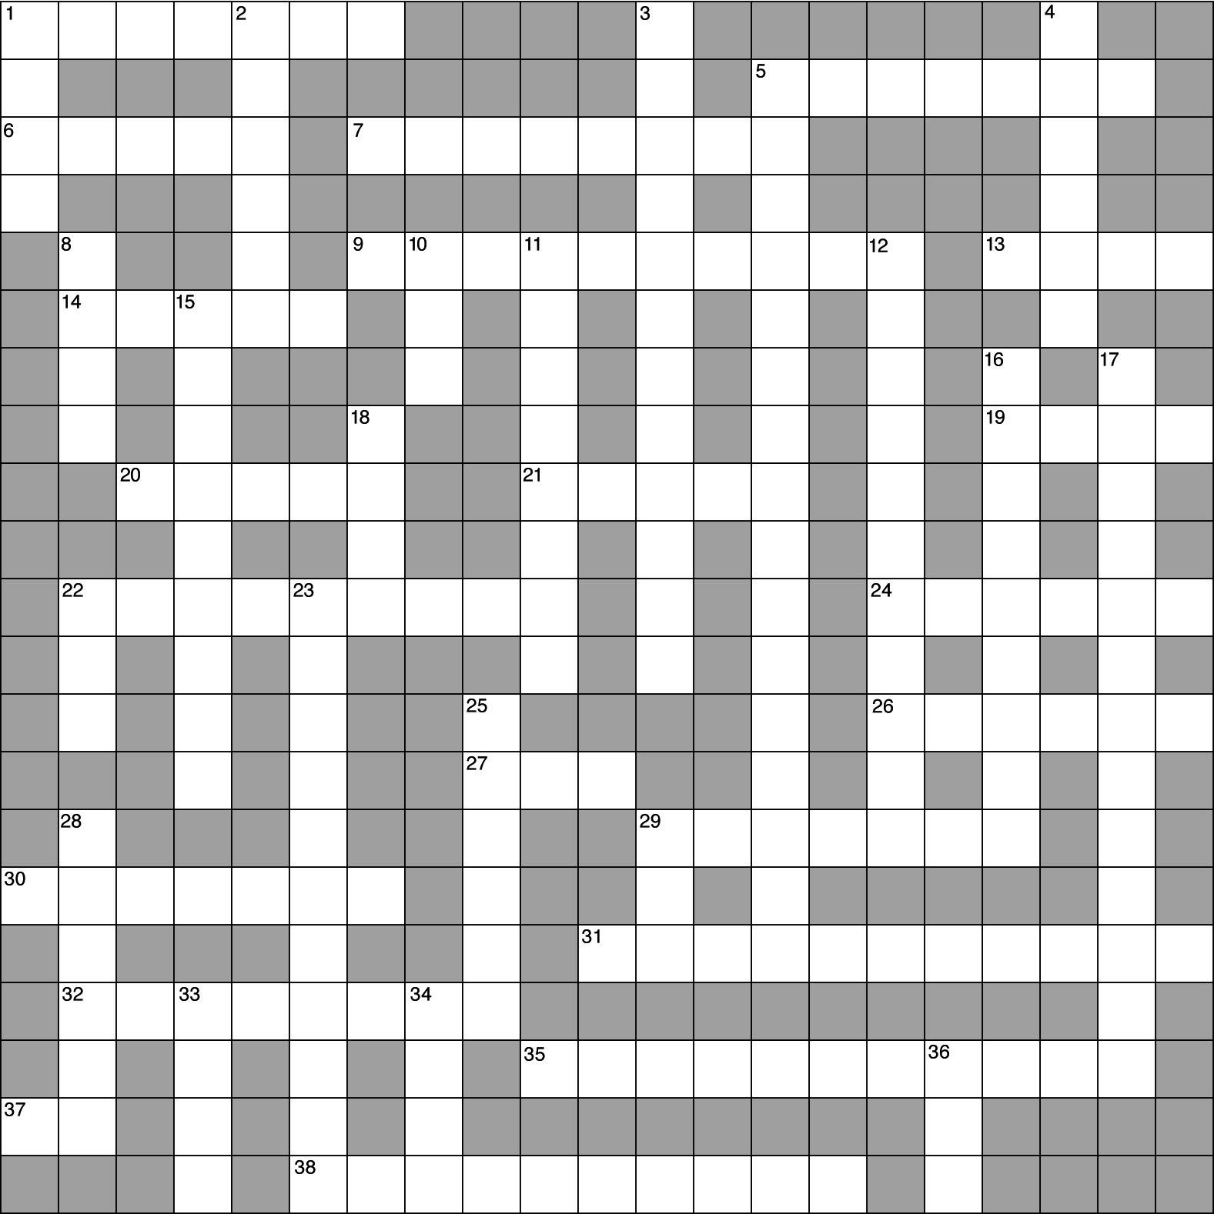

D. Essay

Essay Tutorial
This essay tutorial will answer the first essay question found in the “Test Your Understanding of Concepts and Principles” section located at the end of chapter 3 of your Human Physiology textbook. Please read question 1 carefully, and let me guide you through one possible answer. Watch for key terms in boldface type, helpful tips and general suggestions on writing the essay or short-answer questions. Enjoy!

97. Give some specific examples that illustrate the dynamic nature of the plasma membrane.
Answer. The word “dynamic” implies that the plasma membrane is not static — that it is energetic, vigorous, and has a tendency to change spontaneously. The “examples” will come from analysis of the membrane composition. The major molecules of plasma membrane structure and specialized function are the proteins — suspended inside, outside, and throughout the phospholipid bilayer “core” — which are able to move laterally and act in a variety of ways. These actions of proteins include:
- Structural support or cell shape — including plasma membrane extensions, such as cilia and flagella. With proteins are cholesterol molecules blended into the membrane to alter its flexibility, which is needed by red blood cells to squeeze through capillaries.
- Cell movements — pseudopod formation during amoeboid movements, such as phagocytosis. Also, all forms of endocytosis (pinocytosis and phagocytosis) and exocytosis are included.
- Membrane transport — movement of certain molecules across the plasma membrane, a process known as selective permeability.
- Control of chemical reactions at the plasma membrane by controlling the enzymes (which are proteins) present on the membrane surfaces.
- Protein receptor molecules for hormones and other regulatory molecules that arrive at the outer membrane surface. Some of these receptors initiate endocytosis and exocytosis (see 2., above).
- Cellular “markers” or antigens that identify blood and tissue types. Glycoprotein and glycolipids are examples.

OK! How did you do? Now try to answer a few of mine, below.
98. Compare and contrast the structure and function of microtubules in the cell. Include their roles in such structures as cytoskeleton, cilia, flagella, centrioles, and spindle fibers in your answer.

99. Discuss the origin, the three types, and the various functions of lysosomes in the cytoplasm of cells.

100. List and describe the four types of ribonucleic acid (RNA), their structural differences, and the role each plays in protein synthesis.
101. In two columns, list the similarities and differences between mitosis and meiosis.
Mitosis Meiosis

Answers — Chapter 3

- Plasma Membrane and Associated Structures
- 1. a, 2. b, 3. d, 4. a, 5. e, 6. d, 7. a, 8. d
- 9. F—Replace “restricts” with “does not restrict,” 10. T, 11. T,
12. F—Replace “pinocytosis” with “phagocytosis,” 13. T, 14. T, 15. F—Replace “cilia” with “flagella”
- Cytoplasm and Its Organelles
- 16. b, 17. d, 18. e, 19. d, 20. b, 21. d, 22 d, 23. c
- 24. T, 25. T, 26. T, 27. T, 28. F—Replace “endoplasmic reticulum” with “ribosomes,” 29. F—Replace “Smooth” with “Rough,”
30. T, 31. F—Replace “granular” with “agranular,” 32. T
- See figure 3.1 in the text
- Cell Nucleus and Gene Expression
- 33. b, 34. c, 35. b, 36. d, 37. c, 38. a, 39. b, 40. d, 41. c, 42. b, 43. a, 44. b
- 45. T, 46. T, 47. F—Switch “translation” with “transcription,”
48. F—Replace “nuclear pore complexes” with “nucleoli,” 49. F—Replace “100,000” with “30,000-40,000,” 50. F—Replace “Euchromatin” with “Heterochromatin,”
51. T, 52. T, 53. T, 54. F— “mRNA” is single-stranded, 55. T, 56. T, 57. F—Replace “translation” with “transcription,”
58. F—Replace “messenger RNA (mRNA)” with “ribosomal RNA (rRNA),” 59. F—Replace “exons” with “introns,” 60. T
- Protein Synthesis and Secretion
- 61. c, 62. d, 63. b, 64. a
- 65. F—Switch “tRNA” and “mRNA,”
66. F—Leader sequences are found only on proteins for export, 67. T, 68. T
- DNA Synthesis and Cell Division
- 69. c, 70. c, 71. c, 72. c, 73. b, 74. a
- 75. T, 76. F— “Semiconservative” means that half of the DNA formed during replication is new; the other half is original, 77. T, 78. T, 79. F—Switch “apoptosis” with “necrosis,” 80. T, 81. F—Replace “lysosome” with “mitochondria,” 82. F—There are twenty-two pairs of autosomes, or forty-four total, 83. F—Replace “identical” with “different,” 84. T, 85. F—Replace “hypertrophy” with “hyperplasia,” 86. T,
87. T, 88. F—Replace “metaphase II” with “prophase I.”
VI. Chapter Review
- 89. protein; phospholipid; cholesterol; protein; selective, 90. pseudopods; cilia; mucus; genital; ovum; outside; sperm,
91. phagocytosis; pinocytosis; receptor-mediated; extra; exocytosis,
92. ovum; mitochondrion
93. (1) deoxyribose (1) ribose
(2) (2) phosphate
(3) nitrogenous (3) base
(a) guanine (a) adenine,
(b) thymine, guanine
cytosine (b) uracil
cytosine
thymine; guanine; uracil,
94. DNA, histones; nucleosome; repress; chromosome, inactive, dividing; DNA, translation, protein. 95. forty-four; two; twenty-two; one
- 96. 7, 5, 3, 1, 6, 10, 2, 9, 4, 8

- Crossword Puzzle
