Chapter 12
Muscle: Mechanisms of Contraction and Neural Control

Chapter Scope
Perhaps the most obvious body action is the voluntary contraction of skeletal muscles and the movement of bones. Here is a chapter devoted to the complete description and analysis of this process. Skeletal muscle is uniquely composed of individual muscle fibers. When activated by an electrical impulse from a motor neuron each individual fiber shortens or contracts following a precise sequence of events. According to the sliding filament theory muscle fiber contraction occurs as actin and myosin protein filaments slide over one another pulling the two ends of the fiber toward its center.

Skeletal muscle contractions are controlled by voluntary nerve impulses that originate in the brain, travel along somatic motor neurons and ultimately activate motor end plates located on the membrane of every fiber. Skeletal muscle normally will not contract unless stimulated by action potentials from these efferent nerves. These impulses are tempered and coordinated with sensory input from muscle spindles, Golgi tendon organs, and joint receptors, collectively known as proprioceptors. Some of this supportive information need only travel to the spinal cord and back along a lower motor neuron spinal reflex pathway, whereas other reflexes are more complex.

Continued research interest in exercise and skeletal muscle fitness has prompted interesting updates on structural and functional descriptions of slow-twitch and fast-twitch fibers, the muscle fatigue phenomenon, and the energy requirements of skeletal muscle training. The last section summarizes the important differences in the structure and function of cardiac muscle with that of smooth muscle. The fundamental distinctions from each other and from skeletal muscle are highlighted. Cleverly, this final discussion serves as a nice introduction to the two chapters on the cardiovascular system that follow (chapters 13 and 14).

I. Skeletal Muscles
Skeletal muscles are composed of individual muscle fibers that contract when they are stimulated by a motor neuron. Each motor neuron branches to innervate a number of muscle fibers, and all of these fibers contract when their motor neuron is activated. Activation of varying numbers of motor neurons, and thus varying numbers of muscle fibers, results in gradations in the strength of contraction of the whole muscle.

A. Multiple Choice
- In a skeletal muscle contraction
a. the origin is pulled toward the insertion
b. flexor muscles increase the angle of a joint
c. extensors and flexors may be found at the same joint
d. the prime mover of any skeletal movement is called the antagonistic muscle
e. None of these statements regarding skeletal muscle contractions is correct.
- The “string” in cooked, stringy stew meat best describes this part of the muscle anatomy.
a. epimysium
b. fascicle
c. perimysium
d. myofiber
e. endomysium
- The actual muscle cell, a syncytium of several embryonic myoblast cells with such components as nuclei, mitochondria, glycogen, and sarcoplasm, is also known as a
a. fascicle
b. tendon
c. myofiber
d. myofibril
e. None of these terms describe the actual muscle cell.
- In the body (in vivo), each muscle fiber receives __________ axon(s) from a (an) __________ motor neuron, which always liberates the specific neurotransmitter __________.
a. one; somatic; ACh
b. many; autonomic; norepinephrine (NE)
c. many; somatic; norepinephrine (NE)
d. one; autonomic; ACh
- Which of the following muscles is controlled by the greatest number of small motor units, resulting in fine neural control over the strength of muscle contraction?
a. gastrocnemius
b. biceps brachii
c. deltoid
d. extraocular
e. gluteus

B. True or False/Edit
___ 6. Antagonistic muscle action occurs when flexors and extensors act on the same joint.
___ 7. A muscle that is contracting is called the agonist muscle.
___ 8. The connective tissue tendons, epimysium, perimysium, and endomysium are one continuous noncontractile unit within muscle.
___ 9. Like most other cells in the body, skeletal muscles have a single, centrally located nucleus as a control center.
___ 10. Unlike other cells in the body, skeletal muscle fibers contain multiple nuclei because they are formed during embryonic development from the union of several immature myoblast cells.
___ 11. A single motor unit is composed of one somatic motor neuron and all of the muscle fibers innervated (excited) by the axon branches.
___ 12. All motor units to a given muscle (for example, gastrocnemius) innervate the same number of muscle fibers.
___ 13. Recruitment of larger motor units (with more fibers per unit) occurs when greater strength is needed.

II. Mechanisms of Contraction
The A bands within each muscle fiber are composed of thick filaments and the I bands contain thin filaments. Movement of cross bridges that extend from the thick to the thin filaments causes sliding of the filaments, and thus muscle tension and shortening. The activity of the cross bridges is regulated by the availability of Ca²⁺, which is increased by electrical stimulation of the muscle fiber. Electrical stimulation produces contraction of the muscle through the binding of Ca²⁺ to regulatory proteins within the thin filaments.

A. Multiple Choice
___ 14. The cytoplasm (sarcoplasm) of each muscle fiber (or cell) contains small, densely-packed parallel arrangements of subunits known as
a. myofibrils
b. fibers
c. filaments
d. fascicles
e. None of these terms is correct.
___ 15. The I bands within a longitudinal section of a myofibril sarcomere are seen as the __________ bands, composed primarily of the protein __________.
a. dark; actin
b. dark; myosin
c. light; actin
d. light; myosin
___ 16. That part of the myofibril striation pattern of a sarcomere where actin and myosin filaments overlap is a dark area known as the
a. A band.
b. I band.
c. H band.
d. Z line (disc).
e. sarcomere.
___ 17. During an isotonic muscle contraction, which statement about the shortening of adjoining sarcomeres is false?
a. The distance between the two Z lines of each sarcomere appears to shorten.
b. The A bands of adjoining sarcomeres appear to shorten in length.
c. The I bands of adjoining sarcomeres appear to shorten in length.
d. The H bands of adjoining sarcomeres appear to shorten.
___ 18. Which statement about the thin actin filaments is false?
a. They are polymers of hundreds of globular G-actin subunits.
b. They are also known as filament-actin or F-actin.
c. They are arranged in a double row of subunits and twisted to form a helix.
d. The grooves within the actin filaments contain the regulatory protein called troponin.
e. All of these statements about actin filaments are true.
___ 19. Normal relaxation of skeletal muscle is most directly the result of
a. a decrease in ATP concentrations within the sarcomere
b. fewer action potentials on the muscle fiber membrane
c. more acetylcholine (ACh) neurotransmitter molecules broken down in the synapse
d. active transport of calcium ion (Ca²⁺) out of the sarcoplasm and into the sarcoplasmic reticulum
___ 20. The strength of a muscle’s contraction is affected by the
a. number of muscle fibers within the muscle that are stimulated to contract
b. thickness of each muscle fiber within the muscle
c. initial length of the muscle fibers when they are at rest
d. Only a and b are correct.
e. All of these factors affect the strength of contraction.

B. True or False/Edit
___ 21. In the center of each A band is a thin, dark Z line (Z disc).
___ 22. The basic or smallest subunit of striated muscle contraction is the sarcomere.
___ 23. In a sarcomere, the M lines at the center of the thick filament (A band) serve as an anchor for the thick filaments and help them stay together during a contraction.
___ 24. The elastic protein, titin runs through the entire thick filament from one end of the A band to the other end, contributing to the elastic recoil of muscles as they return to there resting length.
___ 25. Shortening of the protein filaments called actin and myosin produces shortening of the sarcomere.
___ 26. Cross bridges are actually the globular “heads” of the myosin protein molecules that extend out toward the actin molecules and function as myosin ATPase enzymes.
___ 27. Splitting of ATP by myosin ATPase is required before myosin cross bridges attach to actin; and at the end of the power stroke, a new ATP must be attached to release the cross bridge.
___ 28. Each tropomyosin molecule covers a distance of approximately seven G-actin subunits within the groove of the longer F-actin molecule.
___ 29. When a muscle fiber is stimulated to contract, calcium ions (Ca²⁺) are released by passive diffusion through membrane channels called calcium release channels and will bind directly to tropomyosin molecules located in the fiber sarcoplasm.
___ 30. Transverse tubules (or T tubules) are formed from and continuous with the muscle cell membrane and therefore, are capable of conducting action potentials.
___ 31. Excitation-contraction coupling refers to the opening of voltage-regulated Ca²⁺ channels along the transverse tubules by electrical action potentials that lead (directly or indirectly) to the opening of calcium release channels along the sarcoplasmic reticulum and thus, to the release of Ca²⁺ that stimulates muscle contraction.
___ 32. Muscle contraction is sustained by continuous neural stimulation of voltage-regulated Ca²⁺ channels along the transverse tubules so that the calcium release channels of the sarcoplasmic reticulum remain open, thus ensuring Ca²⁺ sustained release.
___ 33. Since the Ca²⁺-ATPase pumps that return Ca²⁺ from the sarcoplasm to the sarcoplasmic reticulum are powered by the hydrolysis of ATP, energy is need both for muscle relaxation as well as for muscle contraction.

C. Sequencer — Muscle Excitation-Contraction Coupling
34. Arrange the numbers the following events involved in stimulation of muscle contraction and
relaxation (excitation-contraction coupling) in proper order from 1 to 10. Note: The first event has
been done for you. If you get stuck, sneak a peek at table 12.3 in the text.
action potentials are conducted along transverse tubules
cross-bridges are exposed as the troponin complex moves tropomyosin
action potentials in the T tubules promote Ca²⁺ release
1 somatic neuron action potentials release ACh molecules
with ATP, cross-bridges pull the thin over the thick filaments
without action potentials, Ca²⁺ is pumped away from troponin and into the sarcoplasmic reticulum
released Ca²⁺ binds to troponin, changing its structure
ACh binds to its sarcolemma receptors and produces new action potentials
contraction cycles continue as long as Ca²⁺ and fresh ATP are present in the sarcomere
ATP-activated myosin cross-bridges attach to actin

III. CONTRACTIONS OF SKELETAL MUSCLES
Contraction of muscles generates tension, which allows muscles to shorten and thereby perform work. The contraction strength of skeletal muscles must be sufficiently great to overcome the load on a muscle in order for that muscle to shorten.
___ 35. When an isolated muscle is electrically stimulated outside of the body (in vitro), which of the following events does not occur?
a. Increasing the stimulus voltage increases the strength of the twitch.
b. Increasing the stimulus frequency may lead to consecutive twitches that “ride piggyback” and summate.
c. Increasing the stimulus frequency may lead to tetanus.
d. All of these events occur during electrical stimulation of an isolated muscle.
___ 36. Which of the following best demonstrates an isometric contraction?
a. lifting a chair up and over your head
b. sliding the chair horizontally across the room
c. sitting in the chair reading (and enjoying!) this text
d. gluing together the chair that just broke
- None of these statements demonstrates an isometric contraction.
___ 37. When a force exerted on a muscle overcomes the force exerted by that muscle contraction, the
muscle contraction serves as a shock absorber as it lengthens – a contraction known as a/an
- isometric contraction
- complete tetanus
- treppe (staircase effect)
- eccentric contraction
___ 38. Which statement about skeletal muscle fibers in the body (in vivo) is false?
a. The membranes of skeletal muscle fibers conducts action potentials just like those of neurons.
b. When activated, each individual muscle fiber contraction is an all-or-none twitch.
c. Activation of a single somatic motor neuron will activate every single muscle fiber in that motor unit only.
d. Contractions of whole muscles are produced with varying strength (graded) by increasing or decreasing the number of motor units that are activated.
e. All of these statements about skeletal muscle fibers are true.
___ 39. Which of the following statements regarding the muscle contraction phenomenon known as treppe is false?
a. It may represent a warm-up effect, perhaps due to an increase in intracellular calcium ions.
- It assumes that all the fibers in the muscle are stimulated maximally.
- Twitches in fresh muscle will be successively stronger when maximally stimulated up to a new maximum.
d. Treppe is also known as the staircase effect.
e. All of these statements about treppe are true.
___ 40. When examining a force-velocity curve made from a contracting muscle,
a. an inverse relationship between load and velocity of shortening is shown
b. the force (load) is always greater than the muscle tension generated
c. the contraction strength varies at each load
d. as the load increases the velocity of muscle shortening increases
e. with an isotonic contraction, the velocity of contraction is zero
___ 41. Complete muscle tetanus is the same as muscle tetany.
___ 42. The process of lifting a barbell up and over one’s head is an example of an isometric muscle contraction.
___ 43. A muscle contraction with shortening that moves a load is called isotonic.
___ 44. At the far right of the force-velocity curve where there is a maximum load with the muscle unable to shorten, the muscle contraction is now isometric.
___ 45. Series elastic component refers to noncontractile connective tissues of the muscle that are pulled tight first before muscles can shorten.
___ 46. The elastic recoil of the thoracic structures demonstrates an example of the series elastic component of muscle contraction during expiration.
___ 47. Maximum muscle tension is produced at 100% of its normal (or “ideal”) resting length, such that at 60% or less of this resting length, further contraction cannot occur.

IV. Energy Requirements of Skeletal Muscles
Skeletal muscles generate ATP through aerobic and anaerobic respiration and through the use of phosphate groups donated by creatine phosphate. The aerobic and anaerobic abilities of skeletal muscle fibers differ according to muscle fiber type, which are described according to their speed of contraction, color, and major mode of energy metabolism

A. Multiple Choice
___ 48. Skeletal muscle at rest obtains most of its energy from the breakdown, or catabolism of
a. stored glycogen molecules within the muscle fiber
b. imported glucose molecules extracted from the blood
c. aerobic respiration of fatty acid molecules within the muscle fiber
d. All of these sources of energy are used by resting muscle.
___ 49. During sustained muscle activity, the rapid regeneration of ATP molecules is accomplished mainly by the
a. transfer of phosphate from high-energy phosphocreatine molecules in the muscle fiber
b. hydrolysis of stored glycogen in the muscle fiber
c. uptake and aerobic combustion of glucose molecules from the blood
d. uptake and oxidation of free fatty acid molecules from the blood
___ 50. Slow-twitch skeletal muscle fibers
a. are also known as type IIX fibers
b. are found predominantly in the intraocular muscles of the eye
c. are able to sustain contractions for long periods of time
d. have fewer capillaries, mitochondria, and less total myoglobin
e. All of these statements regarding slow-twitch muscle fibers are correct.
___ 51. Type IIX fast-glycolytic skeletal muscle fibers
a. contain large amounts of the red pigment myoglobin
b. respire anaerobically, primarily using glycogen for fuel
c. can maintain contractions for long periods of time
d. have lower than normal amounts of the enzyme myosin ATPase
e. All of these statements regarding fast-glycolytic skeletal fibers are correct.
___ 52. Which of the following does not seem to be responsible for the onset of fatigue that occurs during
moderate rhythmic exercise?
a. anaerobic respiration in fast-twitch fibers that depletes reserve glycogen
b. depletion of reserve glycogen in slow-twitch fibers
c. lactic acid production from glucose metabolism that lowers muscle sarcoplasm pH
- rapid depletion of muscle fiber ATP
- All of these factors seem to be involved in the onset of fatigue during moderate exercise.
___ 53. Which statement about the effects of endurance training on skeletal muscles is false? Endurance training results in
a. an increase in the size and number of mitochondria
b. less lactic acid is formed at any given level of exercise
c. an increase in myoglobin content in the muscle
d. an increase in the number of muscle fibers within the muscle
e. an increase in the intramuscular triglyceride content and increased fat utilization

B. True or False/Edit
___ 54. Skeletal muscles respire aerobically for the first minute or so of moderate-to-heavy exercise and after 2 minutes begin to respire more anaerobically.
___ 55. The term lactate (or anaerobic) threshold refers to the percentage of the maximal oxygen uptake at which a significant rise in blood lactate levels occurs.
___ 56. During moderate-to-heavy exercise, the increased facilitated diffusion of glucose into the muscle fibers is promoted by an increase in the number of GLUT4 carrier proteins placed within the muscle fiber plasma membrane.
___ 57. After exercise has stopped, continued heavy breathing is necessary to repay the oxygen debt incurred primarily from losses to hemoglobin and myoglobin, and for metabolism of
lactic acid.
___ 58. The enzyme creatine phosphokinase is also an isoenzyme since it is found in both heart and skeletal muscle, a fact that is used for clinical diagnoses of heart diseases.
___ 59. Myoglobin is a red pigment that is similar to hemoglobin in that both are vital for the delivery of oxygen mainly to the fast-glycolytic (type IIX) muscle fibers.
___ 60. The soleus muscle of the leg is a muscle useful in posture and therefore composed predominantly of slow-oxidative (type I) muscle fibers.
___ 61. The size of the motor units composed of slow-twitch muscle fibers tend to be larger (have more fibers) than the motor units of fast-twitch fibers.
___ 62. Since motor units are recruited from smaller numbers to larger numbers when increasing muscular effort is required, the smaller motor units with slow-oxidative (type I) endurance fibers are used most often in routine muscle activity.
___ 63. Fatigue during sustained maximal contraction may be due to accumulation of extracellular K⁺ - reducing the membrane potential of muscle fibers and interfering with their production of action potentials.
___ 64. True muscle fatigue usually starts with anaerobic depletion of muscle glycogen causing the accumulation of lactic acid that lowers the pH and somehow interferes with the ability of the sarcoplasmic reticulum to release Ca²⁺ during excitation-contraction coupling.

V. Neural Control of Skeletal Muscles
Skeletal muscles contain stretch receptors called muscle spindles that stimulate the production of impulses in sensory neurons when the muscle is stretched. These sensory neurons can synapse with alpha motoneurons, which stimulate the muscle to contract in response to the stretch. Other motor neurons, called gamma motoneurons, stimulate the tightening of the spindles and thus increase their sensitivity.

A. Multiple Choice
___ 65. Lower motor neurons (motoneurons) that exit the spinal cord to stimulate skeletal muscle contraction are activated by all of the following influences except
a. sensory feedback from the muscles and tendons
b. firing of autonomic motor neurons to skeletal muscles
c. excitatory effects from higher motor neurons
d. inhibitory effects from higher motor neurons
___ 66. The Golgi tendon organs are sensitive to muscle __________, while the muscles spindle apparatus is sensitive to muscle __________.
a. diameter; tension
b. length; diameter
c. tension; length (stretch)
___ 67. Which statement about the muscle spindle apparatus is false?
a. Nuclear bag fibers and nuclear chain fibers are intrafusal muscle fibers.
b. Sudden, rapid stretch of a muscle activates the secondary endings only.
c. Sudden, rapid stretch of a muscle results in a more powerful reflex contraction.
d. The frequency of action potentials produced in primary and secondary endings is proportional to the length of the muscle.
___ 68. Which statement about gamma motoneurons is false?
a. They innervate (stimulate) the intrafusal muscle fibers to contract.
b. They are thinner, more slowly conducting motoneurons than the alpha motoneurons.
c. Stimulation leads to tightening of the spindles and firing of action potentials along sensory neurons.
d. Stimulation directly causes visible muscle contraction and skeletal movements.
e. Stimulation results in only isometric contraction of the intrafusal fibers in the muscle spindles.
___ 69. Muscle stretch (monosynaptic) reflexes
a. are dependent on descending activation from higher motor neurons
b. involve sensory neurons, spinal cord interneurons and motor neurons only
c. are not present in all skeletal muscles
d. include the knee jerk reflex response to striking the patellar tendon
e. None of these statements regarding muscle stretch reflexes is correct.
___ 70. Which statement about Golgi tendon organs is false?
a. They continuously monitor tensions in the tendons during active contraction of, or passive stretching of, a muscle.
b. Their sensory neurons synapse with interneurons of the spinal cord.
c. They inhibit alpha motoneurons to the muscle involved via inhibitory postsynaptic potentials (IPSPs).
d. They are part of a disynaptic pathway of impulses from the receptor to the effector.
e. All of these statements about Golgi tendon organs are true.
___ 71. The major extrapyramidal tract(s) descending from higher brain centers is(are) the
a. reticulospinal tract
b. ventral corticospinal tract
c. lateral corticospinal tract
d. alpha and gamma motoneuron tracts
___ 72. Which higher center of the brain does not participate in the control of lower motor neurons?
a. basal ganglia (cerebral nuclei)
b. cerebellum
c. reticular formation (medulla oblongata and pons)
d. cerebral cortex (precentral gyrus)
e. All of these higher centers influence motor neuron control over lower motor neurons.

B. True or False/Edit
___ 73. Dorsal roots of spinal nerves contain sensory or efferent nerves, while ventral roots contain motor or afferent nerves.
___ 74. Most of the neurons in the spinal cord are sensory neurons.
___ 75. Those interneuron fibers that conduct impulses across the midline of the spinal cord to synapse on the opposite side are part of commissural tracts.
___ 76. Muscles that require the finest degree of control, such as the muscles of the hand, have the highest density of muscle spindles.
___ 77. Intrafusal fibers are located inside spindles, whereas extrafusal fibers are the stronger, more “ordinary” muscle fibers located outside the spindle.
___ 78. Primary (annulospiral) endings and secondary (flower-spray) endings are two types of motor (afferent) neuron endings found in muscle spindles.
___ 79. The effect of gamma motoneurons functions to tighten intrafusal fibers in the spindles, and thereby increase their sensitivity when the larger external muscle is passively stretched.
___ 80. About 90% of descending motor tracts synapse with interneurons in the spinal cord, with the remaining 10% forming synapses with alpha and gamma lower motoneurons.
___ 81. Upper motor neurons usually stimulate both alpha and gamma motoneurons to the agonist muscle simultaneously while inhibiting, via interneurons, both alpha and gamma motoneurons to the antagonistic muscle.
___ 82. Before exercise, slowly stretching your muscles can help avoid painful spasms by firing mostly the secondary endings in the muscle spindles and by activating the Golgi tendon organ reflex that promotes muscle relaxation.
___ 83. When the agonist muscles are stimulated to contract, simultaneously IPSPs are also formed by spinal cord interneurons that inhibit the antagonistic muscles involved in the action.
___ 84 All cerebellum control over the activity of lower motoneurons is indirect through other brain areas and is always inhibitory.

VI. Cardiac and Smooth Muscle
Cardiac muscle, like skeletal muscle, is striated and contains sarcomeres that shorten by sliding of thin and thick filaments. But while skeletal muscle requires nervous stimulation to contract, cardiac muscle can produce impulses and contract spontaneously. Smooth muscles lack sarcomeres, but they do contain actin and myosin that produce contractions in response to a unique regulatory mechanism.

A. Multiple Choice
___ 85 Which statement about cardiac and smooth muscle is false?
a. Both are involuntary effectors.
b. Both are regulated by autonomic motor neurons.
c. Cardiac muscle, but not smooth muscle, contain sarcomeres.
d. Ca²⁺ is involved in cardiac muscle but not smooth muscle excitation-contraction coupling.
e. All of these statements regarding cardiac and smooth muscle are true.
___ 86. Smooth muscle
a. contains actin and myosin filaments arranged in striations
b. like skeletal muscle has a well-developed sarcoplasmic reticulum and sarcomeres
c. when stretched eight times its resting length, may still contract
d. contains 16:1 more thick myosin than thin actin filaments
e. All of these statements regarding smooth muscle are correct.
___ 87. Which statement about smooth muscle activation is false?
a. Ca²⁺ enters through voltage-sensitive calcium gates in the membrane.
b. More membrane depolarization allows more Ca²⁺ entry, producing stronger smooth muscle contraction.
c. Ca²⁺ binds to calmodulin molecules inside the fibers to initiate the formation of cross-bridges.
d. Smooth muscle cell activation leads to all-or-none muscle contractions.
e. Smooth muscle cell contractions are slow due to slower ATPase and sustained because cross-bridges can enter a latch state.
___ 88. Which statement about single-unit or multiunit smooth muscles is false?
a. Single-unit smooth muscles are intrinsically myogenic in that they contract in response to stretch.
b. Single-unit smooth muscles display pacemaker activity in which certain cells stimulate others in the muscle.
c. Multiunit smooth muscles have numerous gap junctions or electrical synapses.
- Multiunit muscle contractions require stimulation by separate nerve fibers.

B. True or False/Edit
___ 89. Cardiac muscle intercalated discs are actually electrical synapses, or gap junctions.
___ 90. Unlike the contraction of skeletal muscle that is all-or-none, cardiac muscle contraction strength is graded based on the number of muscle cells stimulated.
___ 91. Smooth muscle is commonly found arranged in a circular or longitudinal pattern around tubes, vessels, and hollow organs.
___ 92. Unlike those in striated muscles, the thin filaments of smooth muscle cells are quite long and attach either to regions of the plasma membrane or to cytoplasmic protein structures called dense bodies.
___ 93. During excitation-contraction coupling in smooth muscle, calcium ions enter mainly from the extracellular fluid and bind to troponin molecules in the cytoplasm.
___ 94. Myosin light chain kinase (MLCK) is an enzyme in smooth muscle that helps catalyze the formation of myosin cross bridges between actin and myosin molecules during contraction.
___ 95. Unlike striated muscle activation which require all-or-none action potentials, smooth muscle cells can produce contractions from variable or graded potentials.
___ 96. The stronger the depolarization of the smooth muscle membrane the more Ca²⁺ will enter, the more MLCK enzymes will be activated, the more cross-bridges will bind to actin, resulting in a stronger contraction.
___ 97. The arrector pili muscles in the skin and the ciliary muscles attached to the lens of the eye are examples of single-unit muscles which require nerve stimulation.

- Chapter Review

A. Crossword Puzzle — Muscle: Mechanisms of Contraction and Neural Control

Across
1. type II skeletal muscle fiber twitch speed
4. higher brain center for muscle action, the basal __________ (old name)
5. series __________ component
9. muscle filament composition of the I band
12. simple knee jerk reflex neuron pathway
14. all-or-__________
17. motor neurons traveling to skeletal muscles
18. neurotransmitter released from all motor axons
20. “piggyback” of a twitch on top of another, stronger twitch
22. contraction during which the muscle does shorten
23. one single muscle cell
24. nuclear __________ fibers are loose in the muscle spindle apparatus
25. color of slow-twitch fibers due to myoglobin pigmentation
27. another name for a reflex pathway
30. innervation to the antagonist muscles while agonists contract
33. descending tracts controlling fine voluntary movements
34. name for the muscle being moved
35. the smallest unit of muscle contraction
36. actin or myosin, for example
Down
2. sustained muscle contraction
3. high-energy phosphate molecule required for contraction and relaxation of muscles
4. tendon organs inhibiting the agonist muscle contractions
6. the ion required for muscle excitation-contraction coupling
7. includes the brain and spinal cord
8. name of motoneurons to muscle spindles
10. the appearance of actin molecules
11. contractions during which the muscle does not shorten
13. excitation of both alpha and gamma motoneurons simultaneously
15. muscle whose contractions open the angle of joints
16. one complete contraction-relaxation cycle of a muscle
19. collective name for descending higher motor neurons involving many brain nuclei is __________ pyramidal
20. the sensory apparatus within the muscle responding to the stretch of a muscle
21. efferent
26. motoneurons innervating the extrafusal muscle fibers
28. actin and myosin form cross-__________
29. inability to maintain muscle tension any longer — perhaps due to a lack of ATP
31. thick sarcomere filament
32. Ca²⁺ is stored in the terminal cisternae of the __________ plasmic reticulum

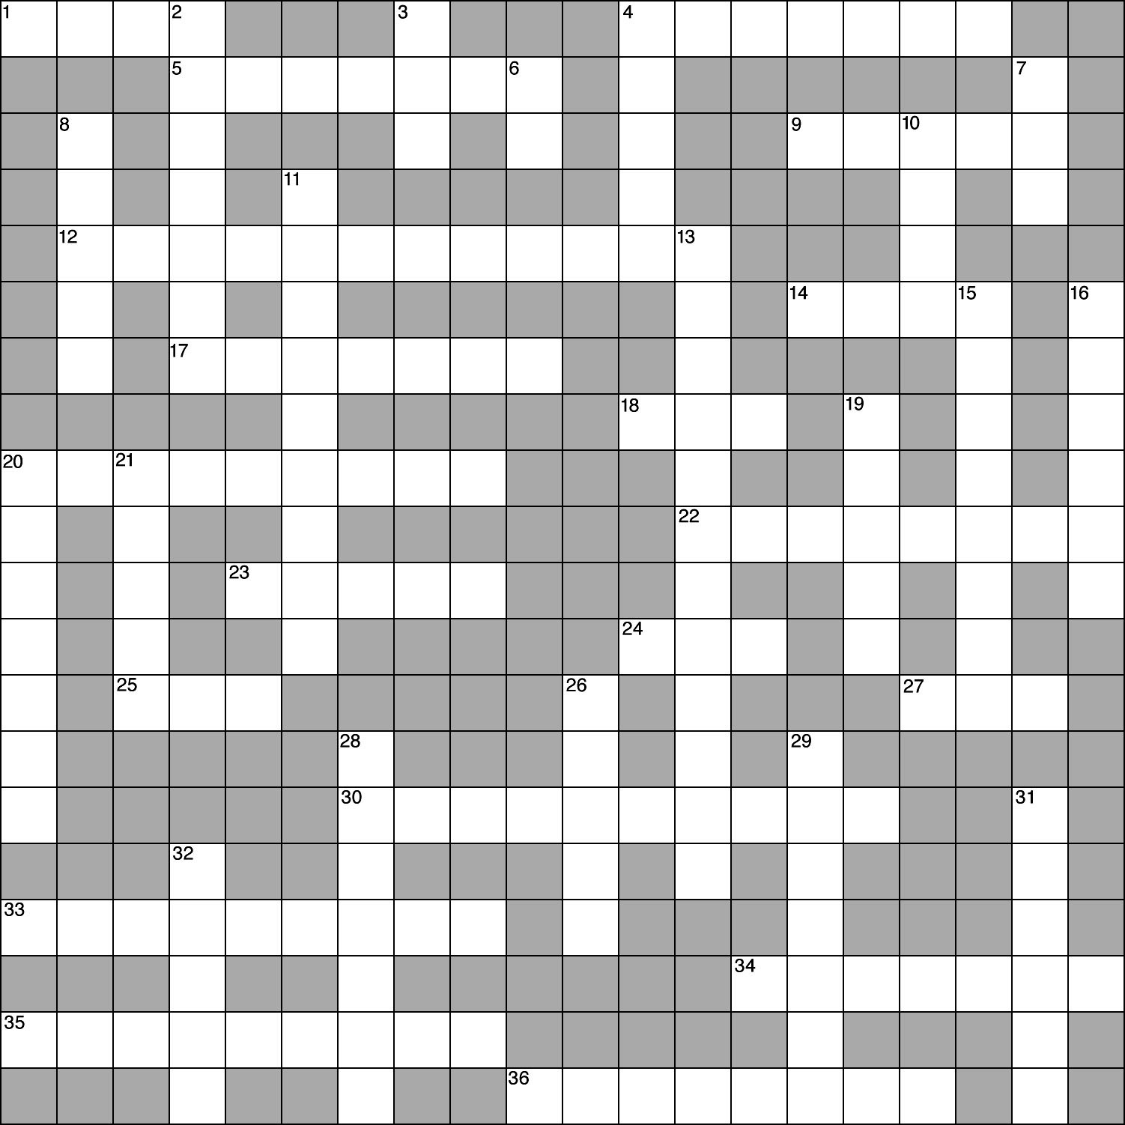

B. Essay

Essay Tutorial
This essay tutorial will answer the first essay question found in the “Review Activities” section of your Human Physiology textbook. Please read Essay Question 1. in the “Test Your Understanding of Concepts and Principles” section located at the end of chapter 12 and let me guide you through one possible answer. Watch for key terms in boldface type, helpful tips and general suggestions on writing the essay or short-answer questions. Enjoy!
98. Using the concept of motor units, explain how skeletal muscles in vivo produce graded and sustained contractions.
Note: First define motor units, since our question is centered around them, and then define graded and sustained while we progress through the answer.

Answer. A motor unit is one somatic motor neuron together with all of its axon collaterals and muscle fibers innervated (stimulated) by these collaterals. Motor units may be small with only a few fibers per motor neuron, or large with one neuron innervating thousands of muscle fibers to contract. Larger motor units produce more powerful contractions, so that to some degree muscle contractions are graded based on the size of the motor unit fired. Usually smaller units are fired first, with larger units activated when greater strength is required. In vivo (in the body), graded contractions of whole muscle are produced by variations in the number of motor units that are activated, and the smooth, sustained contractions (called tetanus) are produced by rapid, asynchronous stimulation of different motor units, both large and small.
This wasn't so bad was it? Here are a few of mine.
99. Explain the statement, “one muscle fiber is one muscle cell.” As best you can, draw and completely label one muscle fiber. (When you have done your best, refer to figure 12.6 in the text to complete your drawing.)

100. Go into the muscle sarcomere and describe a cross bridge between actin and myosin, revealing as much as possible about their chemical structures and interactions with ATP.

101. Describe the various components of the muscle spindle apparatus. Distinguish among the parts that are contractile and noncontractile; and those that are sensory and motor. (Hint: Could we use a table format here?)

102. Draw the pathway that action potentials take from Golgi tendon organs to the spinal cord and back to the muscle undergoing rapid contraction. (Hint: This is a disynaptic reflex.)

103. Explain why slow-twitch fibers are red, adapted for aerobic respiration, and resistant to fatigue; whereas fast-twitch fibers are white, adapted for anaerobic respiration, and susceptible to fatigue.

104. On a piece of paper make three columns with headings skeletal muscle, smooth muscle, and cardiac muscle. List the structural and functional characteristics of smooth muscle and note which are in common with characteristics of the other muscle types.

Answers — Chapter 12

I. Skeletal Muscles
A. 1.c, 2. b, 3. c, 4. a, 5. d
B. 6. T, 7. T, 8. T, 9. F—Skeletal fibers are multinucleate, 10. T, 11. T, 12. F—Motor units vary in size, even within the same muscle, 13. T
II. Mechanisms of Contraction
A. 14. a, 15. c, 16. a, 17. b, 18. d, 19. d, 20. e
B. 21. F—Replace “A” with “I”, 22. T, 23. T, 24. F—Titin runs from M lines to Z discs, 25. F—Shortening occurs as actin and myosin filaments slide over one another, 26. T, 27. T, 28. T, 29. F—Replace “tropomyosin” with “troponin complex,” 30. T, 31. T, 32. T, 33. T
C. 34. 3, 6, 4, 1, 8, 10, 5, 2, 9, 7
III. Contractions of Skeletal Muscles
A. 35. d, 36. c, 37. d, 38. e, 39. e, 40. a
B. 41. F—Tetany is a painful state of muscle contracture, 42. F—Replace “isometric” with “isotonic”, 43. T,
44. T, 45. T, 46. T, 47. T

IV. Energy Requirements of Skeletal Muscle
A. 48. c, 49. a, 50. c, 51. b, 52. d 53. d
B. 54. F—Switch “aerobically” with “anaerobically,” 55. T, 56. T 57, T,
58. T, 59. F—Replace “fast-twitch (type II) with “slow-twitch (type I)”, 60. T, 61. F—Switch “slow-” and
“fast-,” 62. T, 63. T, 64. T
V. Neural Control of Skeletal Muscles
A. 65. b, 66. c, 67. b, 68. d, 69. d, 70. e, 71. a, 72. e
B. 73. F—Switch “efferent” and “afferent,” 74. F—Replace “sensory” with “interneurons,” 75. T, 76. T,
77. T, 78. F—Replace “motor” with “sensory”, 79. T, 80. T, 81. T, 82. T, 83. T, 84. T
VI. Cardiac and Smooth Muscle
A. 85. d, 86. c, 87. d, 88. c
B. 89. T, 90. F—Switch “skeletal” and “cardiac,” 91. T, 92. T, 93. F—Replace “troponin” with “calmodulin,” 94. T, 95. T, 96. T, 97. F—Replace “single-unit” with “multiunit”

Chapter Review
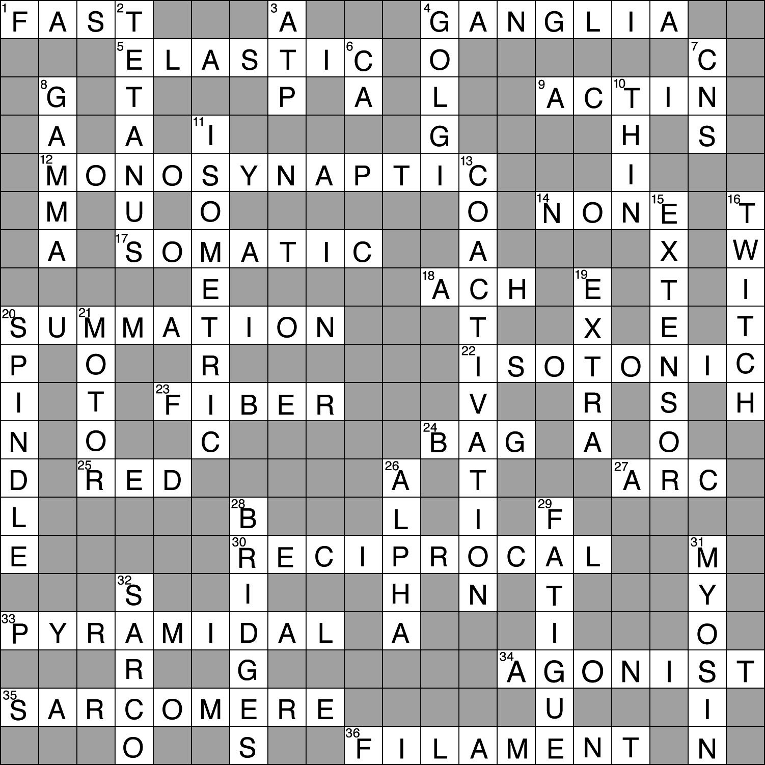
- Crossword Puzzle

