Solutions for the Conceptual Approach Puzzlers may be found in the Instructor’s Resources

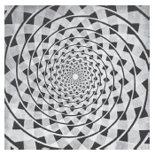
Puzzler 1.2
The background in this photograph produces an illusion called the Fraser spiral. Can you explain what is wrong with this “spiral”?

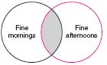
Puzzler 2.1
During a vacation it rained on 13 days; but when it rained in the morning, the afternoon was fine, and every rainy afternoon was preceded by a fine morning. There were 11 fine mornings and 12 fine afternoons. How long was the vacation?

Puzzler 2.2
Lewis Carroll popularized logic by writing comically worded statements and conclusions. The following examples are from his book Symbolic Logic. Determine whether the following conclusions are valid or invalid.

No professors are ignorant. All ignorant people are vain.
Conclusion: No professors are vain.

Babies are illogical. Nobody is despised who can manage a crocodile. Illogical persons are despised.
Conclusion: Babies cannot manage crocodiles.

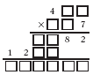
Puzzler 3.3A
Supply the missing digits in this faded document puzzle.

Puzzler 3.3B
One night three men registered at a hotel. They were charged $30 for their room. The desk clerk later realized that she had overcharged them by $5 and sent the refund up with the bellboy. The bellboy knew it would be difficult to split the $5 three ways. Therefore, he kept a $2 “tip” and gave the men only $3. Each man had originally paid $10 and was given back $1. Thus the room cost each man $9, and together they paid $27. This total plus the $2 tip is $29. What happened to the other dollar?

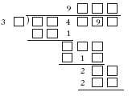
Puzzler 3.4A
Supply the missing digits in this faded document puzzle.

Puzzle 3.4B
Krypto is a commercially produced game containing cards numbered from 1 through 25. The object is to combine the numbers on five cards that are randomly selected so as to obtain the number on a sixth card, the target number. Any of the four basic operations may be used, but each of the five cards must be used once and only once. How can each of the following sets of cards be used with all four operations to obtain the target numbers?
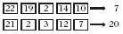

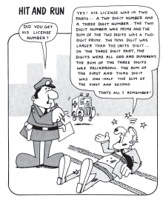
Puzzler 4.1
Did you get his license number?

Yes! His license was in two parts…A two digit number and a three digit number. The two digit number was prime and was the sum of the two digits was a two-digit prime. The tens digit was larger than the units digit…In the three digit part, the digits were all odd and different. The sum of the three digits was palindromic. The sum of the first and third digit was one-half the sum of the first and second.

That’s all I remember!

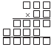
Puzzler 4.2
This faded document puzzle uses only the prime digits 2, 3, 5, and 7.
How can these numbers be placed in the boxes to create a valid product?

Puzzler 5.1
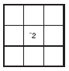
A square array of numbers in which the sum of numbers in any horizontal row, vertical column, or diagonal is always the same is called a magic square. Enter the numbers below into the given grid to produce a magic square.

-10 -8 -6 -4 0 2 4 6

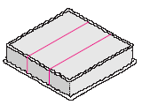
Puzzler 5.2
After a cake has been cut into three equal pieces, as shown here, a hostess discovers that four people each want an equal share of the cake. How can she make one more straight cut so that each of the four people gets the same amount of cake?

Puzzler 5.3A

Diophantus (ca. 250 B.C.) was a great mathematician who brought fame to Alexandria. The brief record we have of his life is related in the following description. His boyhood lasted$\frac{1}{6}$ of his life; his beard grew after$\frac{1}{\text{12}}$ more; he married after$\frac{1}{7}$ more; and his son was born 5 years later. The son lived to one-half his father’s age, and the father died 4 years after his son. How many years did Diophantus live?

Puzzler 5.3B
In his will Farmer Smith bequeathed his 17 horses to his three sons in the following manner: $\frac{1}{2}$of his horses to the oldest son, Al; $\frac{1}{3}$of his horses to the middle son, Garry; and $\frac{1}{9}$of his horses to the youngest son, Greg. Being fairly capable with fractions, the boys computed their shares to be 8$\frac{1}{2}$ horses, 5$\frac{2}{3}$ horses, and 1$\frac{8}{9}$ horses. However, each boy was disappointed at the prospect of getting parts of a horse, and they fell to quarreling about their predicament. At that point Farmer Smith’s neighbor rode up and, after being informed of their dilemma, proposed the following solution. First he donated his horse, to make a total of 18 horses. Then he $\frac{1}{2}$ gave of the 18 horses to Al, $\frac{1}{3}$ of the 18 to Garry, and $\frac{1}{9}$ of the 18 to Greg. How many horses did each boy receive? What was the total number of these horses? Seeing their satisfaction with his solution, Farmer Smith’s neighbor jumped on his horse and rode away. Why was his solution possible?

Puzzler 6.1
A truck driver noticed that the mileage on the truck odometer was 72,927. A number that reads the same from left to right as from right to left is called a palindromic number. Four hours later the driver was surprised to find that the odometer showed another palindromic number. What was the truck’s average speed during this 4-hour period?

Puzzler 6.2A
Ken bought some items at the Five and Ten store. All the items cost the same, and the total number of items was the same as the number of cents in the cost of each item. His bill was $6.25. How many items did he buy?

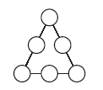
Puzzler 6.2B
How can the decimals .1, .2, .3, .4, .5, and .6 be placed in the circles so that the sum of he three numbers on each side of the triangle is .9?

Puzzler 6.3
Two engineering students were discussing the need for engines that conserve energy. One student told of three new devices that could be installed in an engine: one saved 20 percent on fuel, another saved 30 percent, and the third saved 50 percent. “But that’s not possible,” said the other student, “that’s a savings of 100 percent—the engine wouldn’t require any fuel!” What is the total percent of fuel that could be saved if all three devices were used?

Puzzler 6.4
A moat filled with crocodiles surrounds an old abandoned castle. The outer and inner edges of the moat form two squares with the same center. The width of the moat is 20 feet. How can a person with no objects other than two 19-foot planks cross the moat to the castle?

Puzzler 7.2
The school ski team drove 120 miles into the mountains at an average speed of 40 miles per hour. The return trip was completed at an average speed of 60 miles per hour. When the coach computed the average speed for the entire trip, she was surprised to find that it was not 50 miles per hour (the average of 40 and 60). What was the average speed for the trip?

Puzzler 7.3
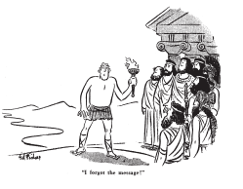
Cryptology is the science of coding and decoding secret messages. Try to break the following code. It is a statement by the nineteenth-century mathematician Pierre Laplace.

CA CW GZJHGBHYRZ AOHA H
WVCZQVZ MOCVO YZFHQ MCAO
AOZ VLQWCXZGHACLQ LK
FHJZW LK VOHQVZ WOLERX YZ
ZRZSHAZX AL AOZ GHQB LK AOZ
JLWA CJILGAHQA WEYPZVAW LK
OEJHO BQLMRZXFZ.

Hint: Make a frequency distribution showing the number of times each letter occurs. The four most often used letters in English are e, t, a, and o, in that order. Substitute these letters in that order for the first, second, third, and fourth most frequently used letters in the code. The letters h, n, i, and s also occur with high frequency in our language. Substitute these letters for the fifth, sixth, seventh, and eighth most frequently used letters in the code.


Puzzler 8.1
How can the faces of two cubes be numbered so that when they are rolled, the resulting sum is any whole number from 1 to 12 and each sum has the same probability of occurring?

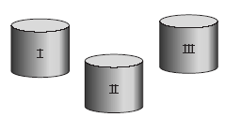
Puzzler 8.2
Suppose you have three containers for marbles. Container I holds 1 black marble and 1 white marble; container II holds 1 black and 2 white; and container III holds 1 black and 1 white. If a marble is selected at random from container I and put into container II and a marble is selected at random from container II and put into container III, what is the probability of drawing a black marble from container III?


Puzzler 9.1A
Cross out eight line segments and leave two squares.

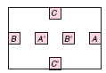
Puzzler 9.1B
It is possible to connect A to A', B to B', and C to C' so that no curves intersect and the curves are drawn in the interior of the rectangle. How can this be done?


Puzzler 9.2
Using only four more matchsticks, divide this region into four congruent regions. (Hint: Some of the matchsticks may be broken.)


Puzzler 9.3A
How can four triangles be formed by using six matchsticks that touch only at their endpoints (do not cross)?

Puzzler 9.3B
Some wildlife researchers, having pitched camp, set out on an exploratory trip. They walked 15 miles due south, then 15 miles due east, where they saw a bear. Walking 15 miles due north, they returned to their camp. What was the color of the bear?

Puzzler 9.4
Subtracting 80 from a certain twentieth century year (date) with a 180_ rotation symmetry yields a nineteenth-century year with both horizontal and vertical lines of symmetry. What are these two years?

Puzzler 10.1
A Celsius thermometer and a Fahrenheit thermometer are both placed into a liquid simultaneously. After a time, the temperature measures the same number on both scales. What is the temperature of the liquid? (Hint: Guess and check by using the formulas in Exercises and Problems 10.1, exercise 20.)

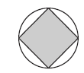
Puzzler 10.2A
The area of the inscribed square is what percent of the area of the circle?

Puzzler 10.2B
Suppose a cable fits tightly around the equator of the earth. If an additional piece is to be spliced in so that the cable can be raised 6 feet above the earth (at all points), approximately how much additional cable will be needed?


Puzzler 10.3
A cylindrical can such as the one shown here is full of water. If you pour
the water from the can, how will you know when one-half the water is gone if you have no measuring device?

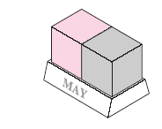
Puzzler 11.1
The desk calendar at the right consists of two cubes on a stand. How can you number each face on each cube so that the date for each day of any month can be represented above the name of the month? (Note: A single-digit day such as day 3 should be represented by 03.)

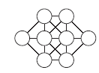
Puzzler 11.2
How can the whole numbers from 1 to 8 be placed in the circles of the figure shown here so that any two connected circles do not contain consecutive whole numbers? If we agree that all solutions that can be obtained through rotations and reflections of this diagram are the same, then there is only one solution. Find this unique solution.

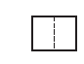
Puzzler 11.3
There is a standard rectangular metric-size sheet of paper which, when cut in half, yields two smaller sheets that are each similar to the original sheet. What is the ratio of the length of the original sheet to the width?*

