Self Exercise: The Conflict Iceberg

Instructions
This is a useful tool for understanding the full context of an interpersonal or intergroup conflict. First, identify a conflict situation that has involved and perhaps frustrated you lately (such as a broken friendship, a disagreement at school or work, or a family feud). Next, work your way down the conflict iceberg by writing some brief notes about the apparent issue, the personalities involved, relevant emotions, and so forth. The goal is to achieve “awareness of interconnection.” In the spirit of functional or cooperative conflict, see if the other party to the conflict would be willing to complete this exercise from his or her perspective. Use the information gathered from one or both parties to move toward some sort of resolution. Importantly, be very honest with yourself because you may be a major obstacle or problem in the conflict situation. How can a similar conflict be avoided in the future?

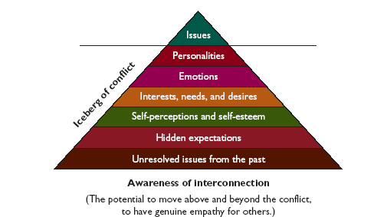

SOURCE: Figure from K Cloke and J Goldsmith, Resolving Conflicts at Work: A Complete Guide for Everyone on the Job (San Francisco: Jossey-
Bass, 2000), p 114. Copyright © 2000, John Wiley & Sons, Inc. Reprinted with permission of John Wiley & Sons, Inc.
Hidden expectations
Self-perceptions and self-esteem
Interests, needs, and desires
Emotions

