Excel Worksheets

to accompany

Amphibian Sounds
An Accounting Practice Set

by Hema Wijewardena

Prepared by Samantha Sin

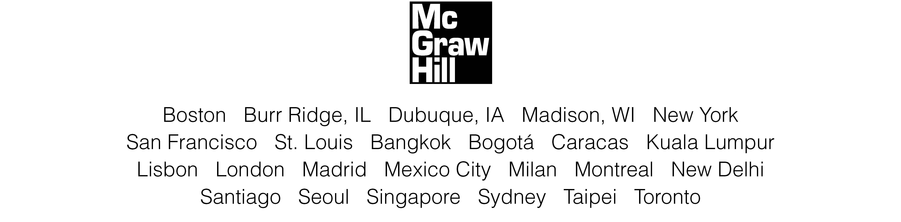

McGraw-Hill Higher Education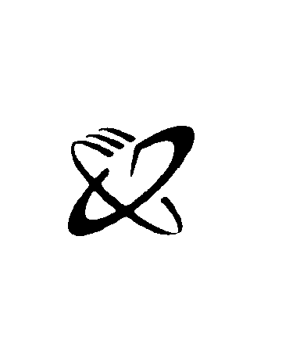
A Division of The McGraw-Hill Companies

Copyright © 2002 McGraw-Hill Australia Pty Limited
Additional owners of copyright are named in on-page credits.

Apart from any fair dealing for the purposes of study, research, criticism or review,
as permitted under the Copyright Act, no part may be reproduced by any process
without written permission. Enquiries should be made to the publisher, marked for
the attention of the Publishing Manager, at the address below.

Copying for educational purposes
Under the copying provisions of the Copyright Act, copies of parts of this book may
be made by an educational institution. An agreement exists between the Copyright
Agency Limited (CAL) and the relevant educational authority (Department of Education, university, VET, etc.) to pay a licence fee for such copying. It is not necessary to keep records of copying except where the relevant educational authority has undertaken to do so by arrangement with the Copyright Agency Limited.

For further information on the CAL licence agreements with educational institutions,
contact the Copyright Agency Limited, Level 19, 157 Liverpool Street, Sydney NSW 2000. Where no such agreement exists, the copyright owner is entitled to claim payment in respect of any copies made.

Published in Australia by
McGraw-Hill Australia Pty Limited
4 Barcoo Street, Roseville NSW 2069, Australia
Developmental Editor: Valerie Reed
Production Manager: Jo Munnelly

