Chapter 9
E9.9 Sales
Contribution for January = profit + fixed costs
= £35,000 + £70,000
= £105,000

£ sales value at break-even point = fixed costs
contribution to sales ratio %

Contribution to sales ratio % = fixed costs
£ sales value at break-even point

Contribution to sales ratio % = £70,000 x 100% = 50%
£140,000

Sales = contribution
contribution to sales ratio %
= £105,000/50%
= £210,000

E9.10 Profit
£ sales value at break-even point = fixed costs
contribution to sales ratio %

Contribution to sales ratio % = fixed costs
£ sales value at break-even point

Contribution to sales ratio % = £80,000 x 100% = 25%
£320,000

Contribution for January = 25% x £400,000
= £100,000

Profit for January = contribution - fixed costs
= £100,000 - £80,000
= £20,000

E9.11 Battersby
(i)
Total costs for January and February
January February Difference
Raw materials £150,000 £180,000 £30,000
Direct labour £106,000 £123,500 £17,500
Overheads £209,000 £226,500 £17,500
Total costs £465,000 £530,000 £65,000

Sales January and February
Units 25,000 30,000 5,000
Sales value at £25/unit £625,000 £750,000 £125,000

5,000 extra units produced and sold in February incurred additional total costs of £65,000, which must all be variable.

25,000 units have a variable cost of £65,000 x 25,000 = £325,000
5,000
Total costs of 25,000 units = £465,000

Fixed costs = total costs – variable costs
£465,000 - £325,000 = £140,000

Contribution = sales - variable costs
£625,000 - £325,000 = £300,000

Contribution to sales ratio % = contribution x 100%
sales
£300,000 x 100% = 48%
£625,000

£ sales value at break-even point = fixed costs
contribution to sales ratio %

£ sales value at break-even point = £140,000/48% = £291,667

Number of units at break-even point = £291,667/£25 = 11,667 units
(ii)
Let’s consider the proposed new process

Variable costs per unit in (i) above = £325,000 = £13 per unit
25,000
Sales price per unit = £25
Contribution per unit = £12

If fixed costs are increased by £58,000 to £198,000

Variable costs will be reduced by £4 per unit so the new contribution will be £16 per unit [£12 + £4].

The new contribution to sales ratio % = £16 x 100% = 64%
£25

The new £ sales value at break-even point = new fixed costs
new contribution to sales ratio %

= £198,000/64% = £309,375

Number of units at break-even point = £309,375/£25 = 12,375 units

Unless 12,375 units could be sold at £25 per unit for total sales of £309,375 it would not be worth investing in the new process.

(iii)
You should refer to the relevant sections in Chapter 9 to check your solution.

E9.12 West Country
First find the point of indifference by comparing Dozy against the other options
Extra fixed Variable cost Point of indifference
cost £ savings £/unit units
Beaky 3,500 20 175
Mick 10,500 35 300
Tich 17,500 50 350
So, at the lowest volumes
Dozy is the best option and it is not cheaper to move to Beaky until volumes reach 175

Draw cost graphs for each option to see at which volumes total costs are minimised
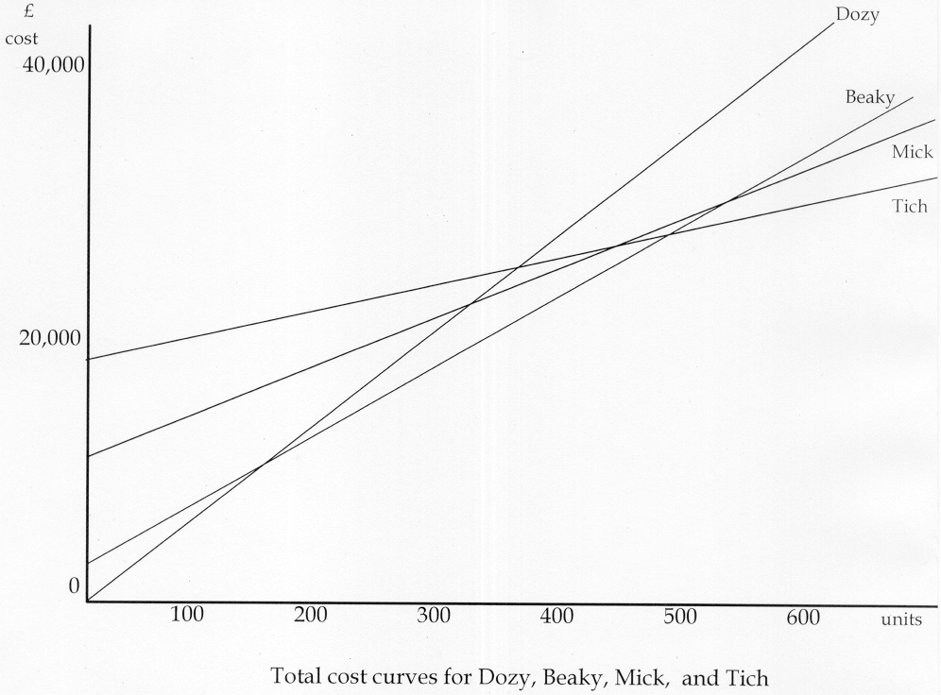

It can be seen from the total cost curves that total costs are minimised under the Dozy option for all volumes up to 175 units

At 175 units
Total costs for the Dozy option are (175 x £70) = £12,250
Total costs for the Beaky option are £3,500 + (175 x £50) = £12,250
Then total costs are minimised under the Beaky option for above 175 units

At 176 units
Total costs for the Dozy option are (176 x £70) = £12,320
Total costs for the Beaky option are £3,500 + (176 x £50) = £12,300

Total costs are minimised under the Beaky option from 175 units up until 466.67 units where the Tich option gives minimum total costs for all volumes above that.

At 466.67 units
Total costs for the Beaky option are £3,500 + (466.67 x £50) = £26,833
Total costs for the Tich option are £17,500 + (466.67 x £20) = £26,833

At 468 units
Total costs for the Beaky option are £3,500 + (468 x £50) = £26,900
Total costs for the Tich option are £17,500 + (468 x £20) = £26,860

It can also be seen that the Mick option is never a viable option at any sales volume.

