Import Existing Lessons
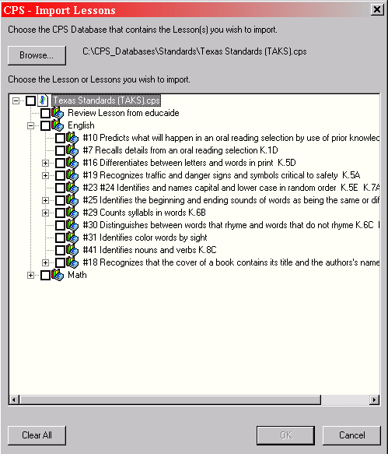
CPS lets you import pre-existing lessons from other CPS databases. This import function is a real time-saver for busy instructors. For example, if you have a lesson in a database for a marketing class that would be beneficial for your management class to review, then you can import the marketing lesson to the management database. This is how you do it:
Import Lessons Dialog

- Start the CPS software with the CPS desktop icon.
- Open the database into which you want to import the lesson, and click the Lessons tab.
- Select the target lesson into which you want to import another lesson.
- Click the Tools button.
- Click the Import command, or right-click the selected lesson name and choose the Import command from the shortcut menu. The Import Lessons dialog window appears.
- Click the Browse button. An Open dialog appears.
- Select the path and file name of the lesson you want to import, and click the Open button. The path and file name appear at the top of the Import Lessons dialog. Any lessons in the database appear in the larger text area of the dialog.
- Select individual lessons from this database by clicking in the box beside each lesson name.

When you select a lesson that has child lessons (lessons underneath it) those child lessons are selected automatically.

- Click the OK button when you have selected all desired lessons. Depending on the lesson sizes and the speed of your processor, this import may take some time. The imported lessons appear on the lesson side of the Lessons tab. You can edit questions and deliver imported lessons the same as you would any you authored with CPS.

- NOTE: When you import a lesson from one database to another, any standards and/or classes in the database from which you are importing, are not imported into the target database. Do this separately using the Import command from the Standards and/or Classes tab.

