PART 1
LEARNING OBJECTIVES
After completing part 1, you will be able to
✓ use your calculator correctly
✓ add, subtract, multiply and divide by touch
✓ perform constant multiplication
✓ accumulate sums products and quotients using the memory keys
✓ perform mixed calculations

KEYBOARD BASICS

Electronic printing calculators have many of the same characteristics as the pocket display calculator or Windows calculator. The major difference is the use of the equal (=) sign. The logic used in a pocket display or Windows calculator is algebraic logic which requires the use of the equal key to obtain a total in all operations. The electronic printing calculator uses arithmetic logic which does not require the equal sign to obtain totals for addition and subtraction.

The input/output method is used for illustration throughout the book. The input portion shows what is entered on the calculator; the output portion shows what prints on the calculator tape. Practice problems are used to reinforce each procedure. The unique memory feature of the electronic calculator is included to provide you with advanced knowledge of problem solving.

To maximize your efficiency, follow these steps.

Electronic Calculator Instructions | Computer Instructions
- Arrange your work area. Place the machine on the right side at an angle if you are right-handed or the left side if you are left-handed. Lefties will have to reverse the fingering.  - Check your posture; make sure that your body is in an upright position with your feet flat on the floor and that you are comfortable.  - Place your textbook next to your calculator so that your free hand can be placed on the page on which you are working.  - Turn on your machine and make sure your Calculator is cleared.  - You may hold your pencil under your thumb and first finger. This avoids wasting valuable time picking up and putting down your pencil when working. | - Position the keyboard at the edge of the desk surface. The H key is used to center the keyboard with your body.  - Your wrists should not rest on the surface in front of the keyboard. Use a wrist pad if necessary to help keep your wrist straight.  - Place your textbook on the right side of your computer next to the numeric keyboard. Use a copy stand if available.  - Start the Windows calculator by selecting Accessories from the menu bar and clicking on Calculator.  - A pencil may be held while using the Windows calculator.

ARRANGEMENT OF KEYBOARD
The ten-key keyboard is identified by the ten numeral keys on it. Below is a fingering chart indicating which finger should touch each numeral key and function key.
FINGER THUMB INDEX MIDDLE RING PINKY
NUMBER 7 8 9
KEYS 4 5 6
1 2 3
0 00
FUNCTION CE KEY TO THE BELOW BELOW TO THE
KEYS LEFT 2 KEY 3 KEY RIGHT

CANON MP12D Electronic Calculator
Courtesy of Canon, USA

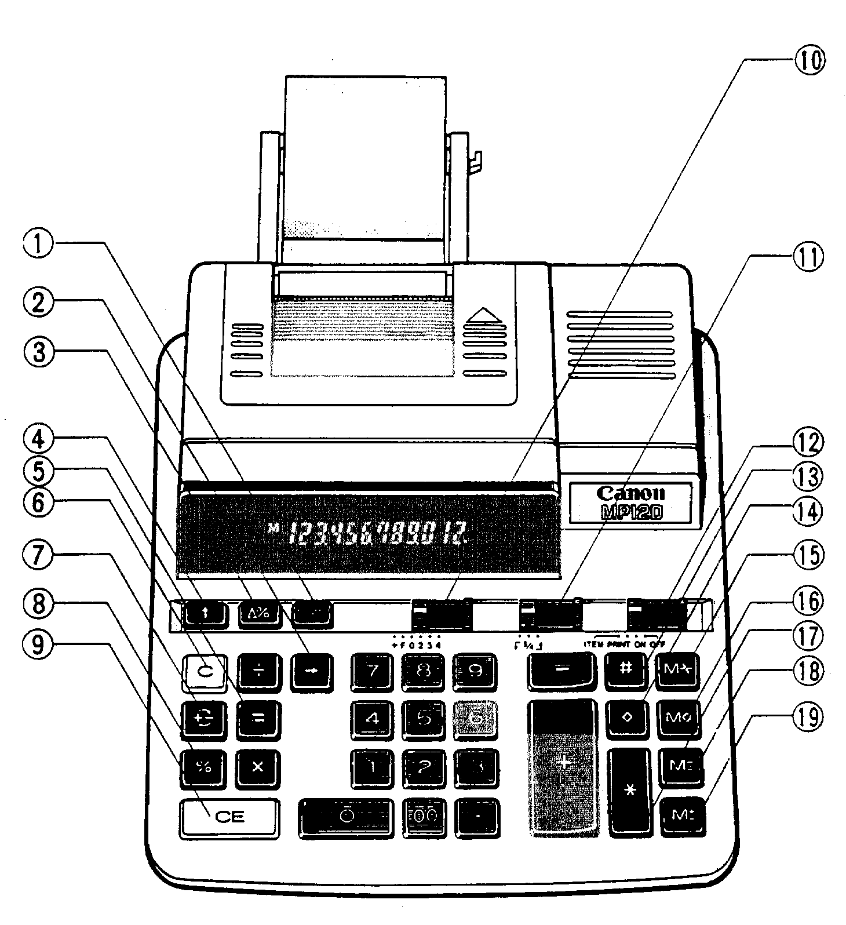

GET ACQUAINTED WITH THE CALCULATOR

The calculator has two kinds of keys: number keys and function keys. How you use the number keys is obvious. The following list describes what each function key does and the symbol used to identify each key. The numbers match the numbers on the calculator illustration on the facing page. The Canon MP12D was used for this supplement.
1 | Mark-up, Mark-down key | MU/MD | computes a mark-up or mark-down of a dollar amount.
2 | Shift key | ➔ | shifts and corrects an entered number.
3 | Delta Percent key | Δ% | computes the dollar amount and percentage of difference in two numbers.
4 | Paper Feed key | ↑ | advances the paper.
5 | Equal key | = | completes a multiplication or division operation.
6 | Clear key | C | clears the machine of all entries except those in memory.
7 | Sign Change key | + – | changes the sign of the number entered.
8 | Percentage key | % | interprets the number in the display as a percentage.
9 | Clear Entry Key | CE | clears incorrect numbers to allow correct re-entry.
10 | Decimal Indicator | +F0234 | determines the number of decimal positions. (+) allows for two decimal places in each entry without pressing the decimal key (add mode). (F) allows the number of decimals places to vary up to the machine’s memory.
11 | Rounding Switch | ↓ 5/4 ↑ | 5/4 automatically rounds your answer at the selected decimal point. ↓ drops off all decimal points past the selected position without rounding. ↑ rounds up one place past the decimal selection.
12 | Power/Print/Item Count | item/ print /on/off | turns the calculator on or off, allows display and print functions; counts the number of items entered.
13 | Non-Add key | # | prints a reference number or date without affecting calculation.
14 | Subtotal key | ⧫ | displays or prints intermediate totals, but does not clear the register.
15 | Total recall Memory key | M * | displays or prints total and clears contents of memory.
16 | Subtotal Recall Memory key | M | displays or prints contents of memory without clearing.
17 | Total key | * | displays or prints total then clears the reg.
18 | Memory Minus key | M− | subtracts the number in display from memory.
19 | Memory Plus key | M+ | adds the number in display to memory.

The Computer Keypad

Function |  | Symbol | Description
1 | Division Key | / | Division function.
2 | Multiplication Key | * | Multiplication function.
3 | Addition Key | + | Addition function.
4 | Subtraction Key | – | Subtraction function.
5 | Total Key | Enter | Completes or totals the operation.
6 | Decimal Key | .Del | Enters a decimal into the number.
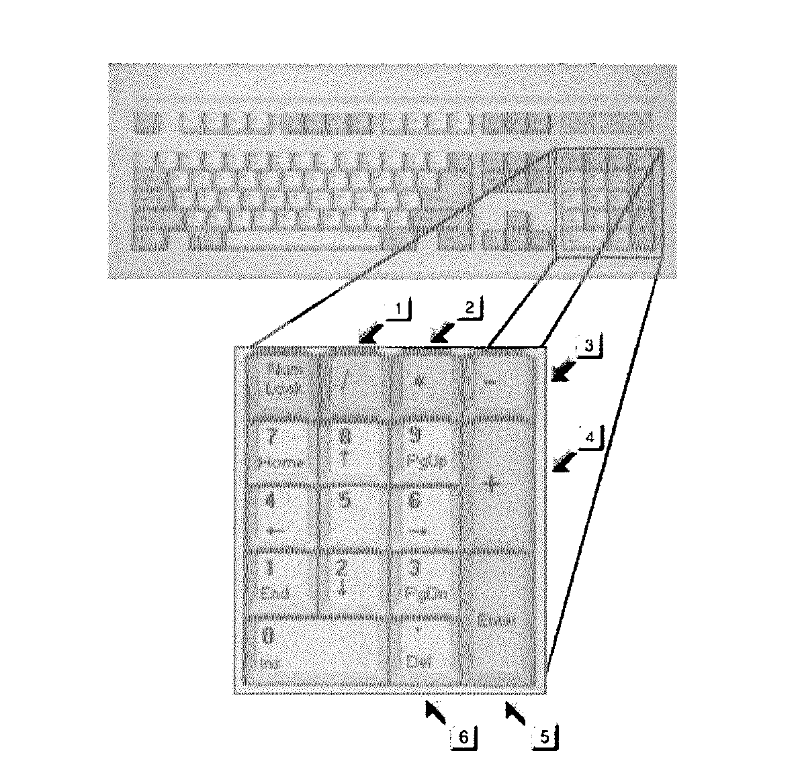

THE COMPUTER CALCULATOR

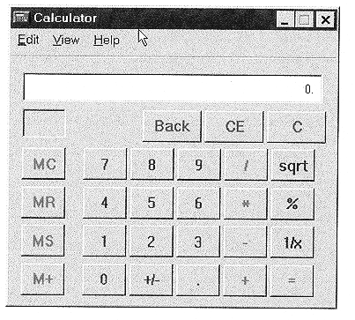
10
2
11
3
1
4
9
8
5
6
7
COMPUTER CALCULATOR |  | KEYBOARD EQUIVALENT KEY | DESCRIPTION
1 | Back  Backspace key | ←Backspace | Removes the last digit of the displayed number.
2 | CE  (clear entry) key | Delete | Clears incorrect numbers to allow correct re-entry.
3 | C (clear all) Key | Esc | Clears the current calculation.
4 | Sqrt (square root) key | Shift@ | Calculates the square root of the displayed number.
5 | % key | Shift% | Displays the result of multiplication as a percentage.
6 | 1/x key | r | Calculates the reciprocal of the displayed number.
7 | +/- | F9 | Changes the sign of the displayed number.
8 | M+ | Ctrl P | Memory add key.
9 | MS | Ctrl M | Memory store key.
10 | MR | Ctrl R | Memory recall key.
11 | MC | Ctrl L | Memory clear key.

GET ACQUAINTED WITH THE COMPUTER NUMERIC KEYPAD

You are living today in the world of computers. The growth of computers and the “information highway” is constantly expanding with new techniques and equipment. All modern computers contain a numeric keypad that works as a calculator when used with a software program. Windows 98 and Windows XP both have a built in calculator program in the Accessories group. The calculator operates with the help of your numeric keypad. You may practice many of the applications in this guide on computer using the Windows Calculator.

Speed drills, employment tests, and business applications may be completed using the Windows Calculator. You should have practice on both the desktop calculator and the computer keypad. Your speed on the computer will most likely be faster.

All electronic calculators and computer numeric keypad contain the same basic functions (add, subtract, multiply and divide). Some of the function keys on a desktop calculator look different from those on the computer numeric keypad, but they serve the same purpose. Remember the computer keypad simulates a pocket calculator and uses algebraic logic. That means the equal key must be used to obtain a total in all operations. In order to be comfortable with all types of calculators and keyboards you must know your keys by touch and practice.

