CHAPTER ELEVEN

The Analysis of the Cash Flow Statement

Stephen H. Penman

The web page for Chapter Eleven runs under the following headings.

What this Chapter is Doing

Method 1 and Method 2 Calculation of Free Cash Flow: VF Corporation

Reformulation of the GAAP Cash Flow Statement: VF Corporation

Adjusting the GAAP Statement for Changes in Cash

Adjusting the GAAP Statement of Cash Flows for Transactions in Financial
Assets

Adjusting the GAAP Statement of Cash Flows for After-tax Net Interest
Payments

A Statement of Cash Generated and Cash Applied

Cash Flow at Apple Inc.: Giving the Wrong Impression

Cash Flow Statements Prepared Under International Accounting Standards

Cash Flow from Delaying Accounts Payable: Home Depot, Inc.

Reader’s Corner

What this Chapter is Doing

Chapter 11 applies the template in Chapter 8 to the reformulation of the cash flow statement. As with the balance sheet and income statement in Chapter 10, the idea is to separate cash flows that are involved in operating activities from those involved in financing activities. Figure 3.3 in Chapter 8 provides the picture. The reformulated cash flow statement reports the four cash flows of the business: C, I, d, F.

In both equity analysis and credit analysis, it is critical to distinguish operating cash flows from financing cash flows. If you count a financing flow as an operating flow you will estimate that the business is generating more cash flow from operations to distribute to claimants. If you are using discounting cash flow valuations to value the equity, you will value the equity incorrectly. If you are calculating the liquidity provided by operations for credit analysis, you also will err.

Remember the basic cash conservation equation that governs the reformulated cash flow statement:
C – I = d + F

The left-hand side is the net cash provided by operations (the free cash flow); the right-hand side is the cash for shareholders and debt holders (or issuers). Put a particular cash flow on the wrong side and you must get both numbers wrong. Unfortunately, GAAP statements make this mistake. They must be reformulated.

Method 1 and Method 2 Calculation of Free Cash Flow: VF Corporation

The web page for Chapter 9 presented a reformulated statement of shareholders’ equity for VF Corporation, and the Chapter 10 web page gave reformulated income statements and balance sheets for the firm. With these reformulated statements, the analyst can calculate free cash flow using Method 1 or Method 2 in Chapter 11:

VF Corporation: Calculation of Free Cash Flow for 1998 (in thousands)
Method 1: | C – I = OI - ΔΝΟΑ
 | Operating income 1998  Net operating assets 1998  Net operating assets 1997  Free cash flow 1998 | $ 2,839,980  2,351,883 | $ 433,985  488,097  $(54,112)
Method 2: | C – I = NFE - ΔΝFO + d
 | Net financial expenses 1998  Net financial obligations 1998  Net financial obligations 1997  Net dividend 1998  Free cash flow 1998 | $ 773,672  485,114 | $ 41,120  (288,558)  193,289  $(54,149)

The two methods must give the same answer, provided income is comprehensive income. But you see here that the free cash flow differs under the two methods. The difference is $37 thousand. This is a familiar number! Look back at the reformulated statement of equity on the web page for Chapter 9. We left $37 thousand in the reformulated equity statement because we could not reconstruct the deferred compensation asset, an operating asset. The free cash flow calculations depend on the income and asset components articulating, and that is not the case for operations. The $54,149 thousand number for Method 2 is the correct calculation.

The two calculations differ only when the reformulation of the equity statement is not done on a comprehensive basis. As this is rare, the two computations usually agree.

Reformulation of the GAAP Cash Flow Statement: VF Corporation

The Chapter 10 web page reformulated balance sheets and income statements for VF Corporation. We now reformulate the cash flow statement. The exhibit below gives VF Corporation's comparative 1998 statement. This statement uses the indirect method of presentation. VF’s statement reports cash provided by operations in 1998 of $432,679 thousand and cash investment of $505,902 thousand, so we might conclude that free cash flow equals $432,679 - $505,902 = $(73,223) thousand. This number disagrees with our calculation of a deficit of $54,149 thousand above. Which is correct?

(next page)

GAAP consolidated statement of cash flows for VF Corporation, 1998. In thousands. Numbers on the left-hand-side flag the adjustments in the reformulated statement that follows, following the adjustment numbers in the text
 |  | FISCAL YEAR ENDED
 |  | January 2,  1999 |  | January 3,  1998
OPERATIONS  ⁽³⁾ ⁽⁴⁾Net Income  Adjustments to reconcile net income  to cash provided by operations:  Depreciation  Amortization of intangible assets  Other, net  Changes in current assets and liabilities:  Accounts receivable  Inventories  Accounts payable  Other, net  Cash provided by operations |  | $ 388,306  128,495  32,890  31,161  (48,771)  (52,406)  (17,013)  (29,983)  432,679 |  | $ 350,942  128,734  27,518  (9,396)  (9,972)  (55,677)  (12,587)  35,099  454,661
INVESTMENTS  Capital expenditures  Business acquisitions  Other, net  Cash invested |  | (189,059)  (299,900)  (16,943)  ------------  (505,902) |  | (154,262)  (16,003)  (13,578)  (183,843)
FINANCING  Increase (decrease) in short-term borrowings  Proceeds from long-term debt  Payment of long-term debt  Purchase of Common Stock  Cash dividends paid  Proceeds from issuance of Common Stock  Other, net  Cash provided (used) by financing |  | 212,457  4,132  (2,998)  (147,398)  (101,660)  45,689  2,115  12,337 |  | 8,745  --  (1,253)  (391,651)  (100,141)  64,964  1,983  (417,353)
⁽¹⁾NET CHANGE IN CASH AND EQUIVALENTS |  | (60,886) |  | (146,535)
CASH AND EQUIVALENTS – BEGINNING OF YEAR |  | 124,094 |  | 270,629
CASH AND EQUIVALENTS – END OF YEAR |  | $63,208 |  | $ 124,094

Here is the reformulation of the GAAP statement, with the adjustments flagged 1, 3, and 4:

________________________________________________________________________

 | VF Corporation: Reformulated Cash Flow Statement, 1998 (in thousands of dollars)
 | Reported cash from operations  Net interest paid after tax ⁽³⁾⁽⁴⁾ |  | 432,679  32,915  465,594
 | Cash investments  Investment in operating cash ⁽¹⁾ | 505,902  3,000 | (508,902)  (43,308)
 | Financing Flow to Claimants  Debt Financing  Short-term borrowing  Long-term borrowing  Decrease in cash equivalents ⁽¹⁾  Payment of long-term debt  Interest paid, after tax ⁽³⁾⁽⁴⁾  Preferred dividends paid | (212,457)  (4,132)  (63,886)  2,998  32,915  3,717 | (240,845)
 | Equity Financing  Common dividends  Repurchase of stock  Issue of common stock  Other | 97,943  147,398  (45,689)  (2,115) | 197,537  (43,308)

The free cash flow deficit of $43,308 thousand in VF’s reformulated statement differs from the “quick method” $54,149 thousand calculated earlier. Look at the possible reasons for this in Chapter 11.

Adjusting the GAAP Statement for Changes in Cash

VF Corporation’s cash and cash equivalents declined by $60,886 thousand in 1998. In the reformulated balance sheet we attributed this to a reduction of investment is cash equivalents (financial assets) of $63,886 thousand and an increase operating cash of $3,000 thousand. So reclassify $3,000 thousand as cash investment in operations and $63,886 thousand as a debt financing flow.

Adjusting the GAAP Statement of Cash Flows for Transactions in Financial
Assets

Genentech Inc. reported the following in the investing and financing sections of its 1995 statement of cash flow (in thousands of dollars):
 | 1995 |  | 1994
Cash flows from investing activities:  Purchases of securities held-to-maturity  Proceeds from maturities of securities  held-to-maturity  Purchases of securities available-for-sale  Proceeds from sales of securities available-  for-sale  Purchases of non-marketable equity securities  Proceeds from sale of a non-marketable equity  security  Capital expenditures  Proceeds from sale of fixed assets  Change in other assets  Net cash used in investing activities | (682,396)  924,345  (353,118)  101,591  -  703  (70,166)  -  (38,651)  (117,692) |  | (1,088,737)  877,139  (22,644)  -  (4,000)  -  (82,837)  -  (1,198)  (322,277)
Cash flows from financing activities:  Stock issuances  Reduction in long-term debt,  including current portion | 54,946  (871) |  | 71,955  (794)

Net cash provided by financing activities | 54,075 |  | 71,161
The purchases and sales of equity securities are investments in and liquidations of operating assets. However, the transactions in debt securities (the first four items in the investment section) are transactions in financial assets, so should be placed in the financing section. This change yields a revised 1995 figure for cash used in investing activities of $108,114 thousand (generated by the remaining three items), a $9,578 thousand reduction of the reported number. The reclassification reduces cash flows from financing activities by $9,578 thousand.

Adjusting the GAAP Statement of Cash Flows for After-tax Net Interest Payments

The third and fourth adjustments to the GAAP statement of cash flows involve interest and the taxes that interest attract. Here are the adjustments made for VF Corporation.

VF Corporation’s net interest payments after tax are calculated as follows (in thousands of dollars):
Interest payments  Interest income  Net interest payments before tax  Tax benefit (38%)  Net interest payments after tax | 59,500  (6,411)  53,089  20,174  $32,915
The after-tax net interest of $32,915 thousand is added back to cash from operations in the reformulated statement above and classified instead as a financing payments to debtholders.

A Statement of Cash Generated and Cash Applied

It is important not to miss the forest for the trees. Calculations aside, what is the picture
drawn in a reformulated statement ? Well, following the reformulated statement for VF Corporation. The firm had a free cash flow deficit in operations of $43,308 thousand because cash investments exceeded cash from operations. The firm raised cash to fill this deficit from the issue of shares, borrowing, and the sale of cash equivalents. It also used cash raised to pay down long-term debt, it paid interest on its net debt, and paid dividends.
Thinking is terms of cash generated and cash applied, the statement can be reformulated as follows:

VF Corporation: Cash Generated and Cash Applied
Cash Generated:
 | Short-term borrowings  Long-term borrowings  Liquidation of cash equivalents  Issue of common stock  “Other” |  | $212,457  4,132  63,886  45,689  12,956  $339,120
Cash Applied:
 | To operations (free cash flow)  Repayment of long-term debt  Net interest, other tax  Preferred dividends  Common dividends  Repurchase of stock |  | $54,149  2,998  32,915  3,717  97,943  147,398  $339,120

We have used the free cash flow number calculated from the reformulated income statement and balance sheet here, and have lumped the discrepancy with the GAAP statement in with the unknown “other” category in the GAAP statement.

Cash Flow at Apple Inc.: Giving the Wrong Impression

The cash flow statement of Apple Inc. demonstrates how the GAAP classifications in the statements can give the wrong impression. The demonstration is in the form of a problem exercise, to which the solution is provided:

Exercise: Cash Flow Analysis for Apple Inc.

Below are the operating and investment sections of the cash flow statement for Apple Inc. for fiscal-year 2010 and prior years. In reading the statement, you should note that transactions in “marketable securities” are transactions in interest bearing securities. Also, “other long-term investments” are investments in operations. The company’s statutory tax rate (including both federal and state taxes) is 38 percent. Apple has no debt obligations on its balance sheet.

- It appears from these numbers—cash from operations minus cash investment—that Apple had negative free cash flow in 2009. This is surprising for a firm that is deemed to be a “cash cow.” Can you explain why this cash cow is reporting a cash flow deficit?

- Calculate the free cash flow generated by Apple in 2009 and 2010. Note that there were $326 million in interest receipts from “marketable securities” in 2009 and $155 million in 2010.

- Apple is indeed a cash cow. It has no debt to pay down and it does not pay dividends, nor does it pay out cash via stock repurchases. What is it doing with its free cash flow?

CONSOLIDATED STATEMENTS OF CASH FLOWS
(In millions)

Three years ended September 25, 2010 |  | 2010 |  |  |  | 2009 |  |  |  | 2008
Cash and cash equivalents, beginning of the year |  | $ | 5,263 |  |  | $ | 11,875 |  |  | $ | 9,352
Operating activities:
Net income |  |  | 14,013 |  |  |  | 8,235 |  |  |  | 6,119
Adjustments to reconcile net income to cash generated by operating activities:
Depreciation, amortization and accretion |  |  | 1,027 |  |  |  | 734 |  |  |  | 496
Stock-based compensation expense |  |  | 879 |  |  |  | 710 |  |  |  | 516
Deferred income tax expense |  |  | 1,440 |  |  |  | 1,040 |  |  |  | 398
Loss on disposition of property, plant and equipment |  |  | 24 |  |  |  | 26 |  |  |  | 22
Changes in operating assets and liabilities:
Accounts receivable, net |  |  | (2,142 | ) |  |  | (939 | ) |  |  | (785 | )
Inventories |  |  | (596 | ) |  |  | 54 |  |  |  | (163 | )
Vendor non-trade receivables |  |  | (2,718 | ) |  |  | 586 |  |  |  | 110
Other current assets |  |  | (1,514 | ) |  |  | 163 |  |  |  | (384 | )
Other assets |  |  | (120 | ) |  |  | (902 | ) |  |  | 289
Accounts payable |  |  | 6,307 |  |  |  | 92 |  |  |  | 596
Deferred revenue |  |  | 1,217 |  |  |  | 521 |  |  |  | 718
Other liabilities |  |  | 778 |  |  |  | (161 | ) |  |  | 1,664
Cash generated by operating activities |  |  | 18,595 |  |  |  | 10,159 |  |  |  | 9,596
Investing activities:
Purchases of marketable securities |  |  | (57,793 | ) |  |  | (46,724 | ) |  |  | (22,965 | )
Proceeds from maturities of marketable securities |  |  | 24,930 |  |  |  | 19,790 |  |  |  | 11,804
Proceeds from sales of marketable securities |  |  | 21,788 |  |  |  | 10,888 |  |  |  | 4,439
Purchases of other long-term investments |  |  | (18 | ) |  |  | (101 | ) |  |  | (38 | )
Payments made in connection with business acquisitions, net of cash acquired |  |  | (638 | ) |  |  | 0 |  |  |  | (220 | )
Payments for acquisition of property, plant and equipment |  |  | (2,005 | ) |  |  | (1,144 | ) |  |  | (1,091 | )
Payments for acquisition of intangible assets |  |  | (116 | ) |  |  | (69 | ) |  |  | (108 | )
Other |  |  | (2 | ) |  |  | (74 | ) |  |  | (10 | )
Cash used in investing activities |  |  | (13,854 | ) |  |  | (17,434 | ) |  |  | (8,189 | )

Solution to Exercise:

- Apple’s reported cash flows give the impression that free cash flow for 2009 is negative, as follows:
Cash generated by operating activities |  | $10,159
Cash investments |  | 17,434
Free cash flow |  | $(7,275)

The problem: GAAP reports the investment of excess cash (in debt securities) as part of investment in operations. The net investment in “marketable securities” in 2009 is:
Purchases of marketable securities | $ | 46,724
Proceeds of maturities of marketable securities |  | (19,790)
Proceeds of sales of marketable securities |  | (10,888)
Net investment in marketable securities | $ | 16,046

Investment (in the business) is overstated by this amount.

 | 2010 |  |  |  | 2009
Cash from operations reported |  |  | $ 18,595 |  |  |  | $10,159
Interest receipts | $155 |  |  |  | $326
Tax on interest receipts @ 38% | (59) |  | 96 |  | (124) |  | 202
Corrected cash from operations |  |  | 18,499 |  |  |  | 9,957
Cash investment reported | $13,854 |  |  |  | $17,434
Net investment in marketable securities | (11,075) |  | 2,779 |  | (16,046) |  | 1,388
Free Cash Flow |  |  | 15,720 |  |  |  | 8,569

As there are no cash dividends or stock repurchases, nor any debt to service, the only thing that Apple can do is buy marketable debt securities with its free cash flow. (These are the securities incorrectly reported as cash investments.)

Cash Flow Statements Prepared Under International Accounting Standards

The following web site prepared by Deloitte Touche Tohmatsu, the accounting firm, gives the layout of financial statements prepared under IASB standards, including the cash flow statement:

http://www.iasplus.com/fs/fs.htm

Chapter 10 gave the balance sheet and income statement prepared under IFRS for Siemens AG, the large German electronic and engineering firm. Here is the IFRS cash flow statement:

(next page)

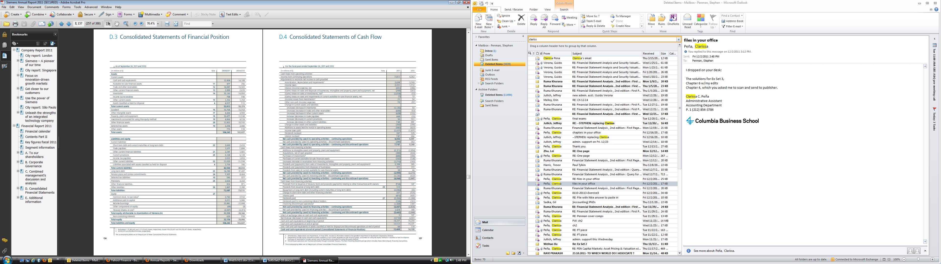
Cash Flow from Delaying Accounts Payable: Home Depot, Inc.

Chapter 11 points out that cash flow from operations can be manipulated by setling off receivables or delaying paying accounts payable. As example of the latter is below.

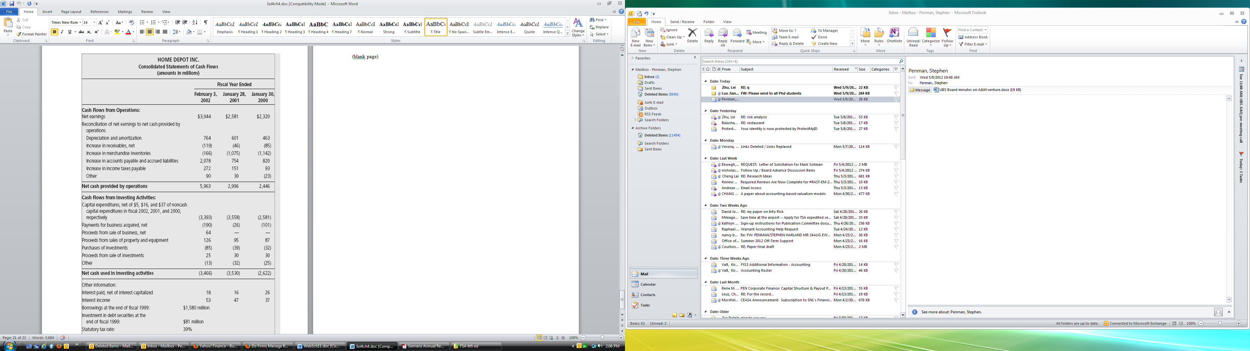

Home Depot’s cash from operations increased from $2.996 billion in 2001 to $5.963 billion in 2002. But you can see that a good deal of that came from the increase in accounts payable and other accrued laibilities: the firm was delaying the payment of their operating obligations. Part of it also came from a reduction in inventory purchases.

Reader’s Corner

Two CEASA papers deal with issues with the statement od cash flow under GAAP:

Nurnberg, H.“Perspectives on the Cash Flow Statement under FASB Statement No. 95.“
CEASA Occasioanl Paper at

http://www4.gsb.columbia.edu/ceasa/research/papers/occasional_papers

Penman, S. The Design of Financial Statements at

http://www.gsb.columbia.edu/ceasa

The following paper looks at the manipulation of reported cash flow:

Shalev, Frankel, and Levy, Do Firms Manage Reported Cash Flow?“ at
http://ssrn.com/abstract=1697922

