CHAPTER TWELVE

The Analysis of Profitability

Stephen H. Penman

The web page for Chapter Twelve runs under the following headings:

What this Chapter is Doing

Financial Leverage: Risk and Return

Analysis of Financial Leverage: Microsoft Corporation

Return on Assets (ROA) and Return on Net Operating Assets (RNOA) for
Dell Computer Corporation

Operating Liability Leverage for an Insurance Company

Profitability Analysis: Home Depot

A Spreadsheet Engine for Profitability Analysis

The Financial Statements for Procter & Gamble for 2005-2008

Readers’ Corner

What this Chapter is Doing

This chapter analyses the income statements and balance sheets that were reformulated in Chapter 10. Financial statements, remember, are the lens on the business. Reformulation sets up the financial statements in a form that reflects the business activities. The analysis in this chapter penetrates the business in order to understand the source of the profitability that is reported in the financial statements.

Figure 12.1 summarizes the analysis of profitability. By the end of this chapter, you should have this scheme firmly in mind. The first task is to distinguish operating profitability from the effects of financing, for it is the operations that generate value. The next task is to understand the sources of the operating profitability.

As you move through the chapter, you will begin to see the payoff to the reformulation exercise of earlier chapters: one gets clean measures of profitability and a clean separation of operating profitability from effects of financing. Understand why (for equity analysis) we calculate return on net operating assets (RNOA) rather than return on assets (ROA). Understand why we use the financial leverage measure, FLEV, rather than
the traditional debt-to-equity ratio when evaluating leverage. Understand why we distinguish financial leverage (FLEV) from operating liability leverage (OLLEV); the Dell Corporation example is very instructive.

The profitability analysis is the culmination of the analysis of the income statement and balance sheet in Chapter 10. But it is also the starting point for valuation in Part Three of the book. So you will appreciate that ultimate payoff to the analysis as you move into valuation in Chapters 13-16.

Financial Leverage: Risk and Return

The financing leverage equation indicates that there is a benefit to financial leverage:

ROCE = RNOA + [FLEV x SPREAD]

where the SPREAD = RNOA – NBC. If a firm adds financing leverage (FLEV), it increases its return to common shareholders, ROCE. But there is a proviso, of course: The return on net operating assets (RNOA) must be higher than the net borrowing cost (NBC) on the net financial obligations, that is, the SPREAD must be positive. There can never be additional return without additional risk, and here is the risk: If the SPREAD turns negative, ROCE is less than RNOA (the leverage is unfavorable). Financial leverage can increase ROCE but it also increases the risk that ROCE will be lower. In the extreme, if the leverage becomes so unfavorable, the shareholders might lose the firm to the debtholders (in bankruptcy).

This point – leverage introduces both risk and return – is an important one when it comes to valuation. Financial leverage increases ROCE and thus residual earnings (holding all else constant). One might make the mistake of thinking that the leverage will increase the value of the equity (based on the present value of expected residual earnings). But all else is not constant for, while leverage may increase the expected ROCE, the additional risk also increases the required return at which the ROCE is charged in the residual earnings calculation. What is the net effect on the value of the equity? Chapter 14 explores this issue.

Analysis of Financial Leverage: Microsoft Corporation

Microsoft has negative financial leverage. Here is an analysis for 1998.

The Effect of Negative Financial Leverage: Microsoft Corp.

For fiscal 1998 Microsoft reported an ROCE of 36.3% on average common equity of $13.702 billion. But Microsoft had no financing debt other than $980 million of convertible preferred stock. And it had considerable financial assets of $11.447 billion from cash generated from its operations. The return on average net financial assets was 8.0% (a significant portion from unrealized gains on financial assets).

The reported ROCE masks the profitability of operations:

$$\begin{aligned}\text{ROCE} = \text{RNOA}−\left[\frac{\text{NFA}}{\text{CSE}} x \left(\text{RNOA}−\text{RNFA}\right)\right] \\ \\ \text{36}\text{.}3\text{\%} = \text{179}\text{.}4\text{\%} − [0\text{.}\text{835} x (\text{179}\text{.}4\text{\%} − 8\text{.}0\text{\%})]\text{.}\end{aligned}$$

The RNOA of 179.4% is weighted down by return on financing activities in the overall ROCE.

A What-If Question: Microsoft has regular stock repurchases. In fiscal 1998 the company used $2.796 billion of its financial assets to repurchase stock. What would the ROCE have been had it not undertaken the stock repurchase?

The answer:

With $2.796 billion more in average financial assets and common equity, the NFA to CSE ratio would have been 0.863 rather than 0.835, and the ROCE would have been:

31.5% = 179.4% − [0.863 x (179.4% − 8.0%)]

Stock repurchases (and dividends) increase ROCE.

Return on Assets (ROA) and Return on Net Operating Assets (RNOA) for
Dell Computer Corporation

Chapter 12 makes the point that the traditional measure of return on assets (ROA) does not measure operating profitability correctly, largely because of the treatment of financial assets and operating liabilities in the two calculations. Some comparisons are given in Table 12.1.
For a further demonstration, look at Dell Inc in Exhibits 10.4 and 10.10 in Chapter 10. Dell reported total assets of $33,652 million at the beginning of fiscal 2011. Its operating income in 2011 (after a tax allocation) was $2,656 million (Exhibit 10.10). Thus the ROA was $2,656/$33,652= 7.9%. Surely this can’t be correct, you say, for a firm as successful as Dell! You would be right. The ROA is strongly influenced by the rate of return on the financial assets that Dell is holding -- $11,749 million in the reformulated balance sheet – and does not incorporate the effect of the large operating liabilities of $23,931 million that reduce the investment in operations. These operating liabilities are an important source of the valuation generation at Dell. ROA gives a misguided impression and leads the equity analyst astray.

Operating Liability Leverage for an Insurance Company

Dell Computer is a rare example of a manufacturing firm with negative net operating assets. The text explains how Dell adds value by having negative NOA: The operations effectively create what a financial firm would call a float -- funds that the shareholders can take and invest elsewhere (and earn additional return). See the Chapter 10 commentary.

Insurance companies work on a float. The float arises from the lag between premiums received from the insured customers and payments made on claims. This float is invested in other investments.

Exhibit 10.16 in Chapter 10 gives the balance sheet for a property-casualty insurer, Chubb Corporation. After a reformulation that distinguishes insurance operations from investment operations, the shareholders’ equity of $15,530 million is represented at follows:

Investment assets $42,660
Net insurance assets (23,043)
Debt (4,087)

Shareholders’ equity $15,530

(If you worked Minicase 10.2 you will see that there are some further minor adjustments, but the numbers here give the picture.) You see that the net operating assets in the insurance business is negative. This is the float. The firm has taken the $23,043 million float and invested it in the investments. Effectively, insurance companies work with high operating liability leverage – so high that operating liabilities are greater than operating assets. Minicase M14.1 explores this issue further, with a focus on valuing the operating liability leverage.

Profitability Analysis: Home Depot

Herewith is a comprehensive profitability analysis of Home Depot for fiscal years 1996 – 1999. Home Depot is the home improvement retailer, operating (in 1999) 878 do-it-yourself warehouse retail stores throughout the US, Canada, and Latin America. At the end of 1999, the shares of the firm traded at $122 billion in market value, sixteenth largest of all US listed firms.

The analysis here follows that in Chapter 12, Figure 12.1, but in reverse. After reformulating the financial statements, the analysis here cuts straight to the quick and identifies the Level 3 drivers of profit margins and turnovers that determine return of net operating assets, RNOA. Then the RNOA is reconciled to ROCE with a (Level 1) financial leverage analysis.

Here are published income statements and balance sheets to work from.

(nest page)

HOME DEPOT, INC.

Income Statements
AMOUNTS IN MILLIONS, EXCEPT PER SHARE DATA |  | FISCAL YEAR ENDED
 |  | JANUARY 31, |  |  | FEBRUARY 1, |  | FEBRUARY 2,
 |  | 1999 |  |  | 1998 |  | 1997
 |  | (52 WEEKS) |  |  | (52 WEEKS) |  | (53 WEEKS)
NET SALES |  | $ 30,219 |  |  | $ 24,156 |  | $ 19,535
Cost of Merchandise Sold |  | 21,614 |  |  | 17,375 |  | 14,101
Gross Profit |  | 8,605 |  |  | 6,781 |  | 5,434
OPERATING EXPENSES:
Selling and Store  Operating |  | 5,341 |  |  | 4,303 |  | 3,529
Pre-Opening |  | 88 |  |  | 65 |  | 55
General and  Administrative |  | 515 |  |  | 413 |  | 324
Non-Recurring Charge |  | -- |  |  | 104 |  | --
Total Operating Expenses |  | 5,944 |  |  | 4,885 |  | 3,908
OPERATING INCOME |  | 2,661 |  |  | 1,896 |  | 1,526
Interest Income (Expense):
Interest and Investment Income |  | 30 |  |  | 44 |  | 25
Interest Expense |  | (37) |  |  | (42) |  | (16)
Interest, net |  | (7) |  |  | 2 |  | 9
Earnings Before Income Taxes |  | 2,654 |  |  | 1,898 |  | 1,535
Income Taxes |  | 1,040 |  |  | 738 |  | 597
NET EARNINGS |  | $ 1,614 |  |  | $ 1,160 |  | $ 938
BASIC EARNINGS PER SHARE |  |  | $ 1.10 |  | $ 0.80 |  | $ 0.65

Weighted Average Number of Common |  |  |  | 1,471 |  | 1,459 |  | 1,438
Shares Outstanding
 | Comprehensive Income
Net Income |  |  | 1,614 |  |  | 1,160 |  | 938
Currency Translation Adjustments |  |  | (33) |  |  | (30) |  | 8
Comprehensive Income |  |  | 1,581 |  |  | 1,130 |  | 946

Balance Sheets
 |  | JANUARY 31, |  | FEBRUARY 1, |  | FEBRUARY 2, |  | JANUARY 28,
 |  | 1999 |  | 1998 |  | 1997 |  | 1996
ASSETS
Current Assets:
Cash and Cash Equivalents |  | $ 62 |  | $ 172 |  | 146 |  | 53
Short-Term Investments |  | -- |  | 2 |  | 412 |  | 55
Receivables, net |  | 469 |  | 556 |  | 388 |  | 325
Merchandise Inventories |  | 4,293 |  | 3,602 |  | 2,709 |  | 2,180
 |  | 109 |  | 128 |  | 54 |  | 59
Total Current Assets |  | 4,933 |  | 4,460 |  | 3,709 |  | 2,672
Property and Equipment, at cost:
Land |  | 2,739 |  | 2,194 |  | 1,855 |  | 1,511
Buildings |  | 3,757 |  | 3,041 |  | 2,470 |  | 1,886
Furniture, Fixtures and Equipment |  | 1,761 |  | 1,370 |  | 1,084 |  | 857
Leasehold Improvements |  | 419 |  | 383 |  | 339 |  | 315
Construction in Progress |  | 540 |  | 336 |  | 284 |  | 308
Capital Leases |  | 206 |  | 163 |  | 117 |  | 92
 |  | 9,422 |  | 7,487 |  | 6,149 |  | 4,969
Less Accumulated Depreciation and Amortization |  | 1,262 |  | 978 |  | 712 |  | 508
Net Property and Equipment |  | 8,160 |  | 6,509 |  | 5,437 |  | 4,461
Long-Term Investments |  | 15 |  | 15 |  | 8 |  | 25
Notes Receivable |  | 26 |  | 27 |  | 40 |  | 55
Cost in Excess of the Fair Value of Net Assets Acquired, net of accumulated amortization |  | 268 |  | 140 |  | 87 |  | 87
Other |  | 63 |  | 78 |  | 61 |  | 54
 |  | $ 13,465 |  | $ 11,229 |  | 9,342 |  | 7,354
LIABILITIES AND STOCKHOLDERS’ EQUITY
Current Liabilities:
Accounts Payable |  | $ 1,586 |  | $ 1,358 |  | 1,090 |  | 825
Accrued Salaries and Related Expenses |  | 395 |  | 312 |  | 249 |  | 198
Sales Tax Payable |  | 176 |  | 143 |  | 129 |  | 113
Other Accrued Expenses |  | 586 |  | 530 |  | 323 |  | 243
Income Taxes Payable |  | 100 |  | 105 |  | 49 |  | 35
Current Installments of Long-Term Debt |  | 14 |  | 8 |  | 2 |  | 2
Total Current Liabilities |  | 2,857 |  | 2,456 |  | 1,842 |  | 1,416
Long-Term Debt, excluding current installments |  | 1,566 |  | 1,303 |  | 1,247 |  | 720
Other Long-Term Liabilities |  | 208 |  | 178 |  | 134 |  | 116
Deferred Income Taxes |  | 85 |  | 78 |  | 66 |  | 37
Minority Interest |  | 9 |  | 116 |  | 98 |  | 77
STOCKHOLDERS’ EQUITY
Common Stock, par value $0.05. Authorized: 2,500,000,000 shares; issuedand outstanding—  1,475,452,000 shares at January 31, 1999 |  | 74 |  | 73 |  | 24 |  | 24
Paid-in Capital |  | 2,854 |  | 2,626 |  | 2,523 |  | 2,408
Retained Earnings |  | 5,876 |  | 4,430 |  | 3,406 |  | 2,579
Accumulated Other Comprehensive Income |  | (61) |  | (28) |  | 2 |  | (6)
 |  | 8,743 |  | 7,101 |  | 5,955 |  | 5,005
Less: Shares Purchased for Compensation Plans |  | 3 |  | 3 |  | 0 |  | (17)
Total Stockholders’ Equity |  | 8,740 |  | 7,098 |  | 5,955 |  | 4,988
 |  | $ 13,465 |  | $ 11,229 |  | 9,342 |  | 7,354

Step 1: Reformulate the statements, including all comprehensive income in the income statement

Reformulated Income Statements

 |  |  |  | 1999 |  |  |  | 1998 |  |  |  | 1997 |  |  |  | 1996
Sales |  |  |  | 30,219 |  |  |  | 24,156 |  |  |  | 19,535 |  |  |  | 15,470
Cost of Merchandise |  |  |  | 21,614 |  |  |  | 17,375 |  |  |  | 14,101 |  |  |  | 11,184
Gross Profit |  |  |  | 8,605 |  |  |  | 6,781 |  |  |  | 5,434 |  |  |  | 4,286
Core operating expenses |  |  |  | 5,429 |  |  |  | 4,368 |  |  |  | 3,584 |  |  |  | 2,836
General and administrative |  |  |  | 515 |  |  |  | 413 |  |  |  | 324 |  |  |  | 270
Core operating income from sales |  |  |  | 2,661 |  |  |  | 2,000 |  |  |  | 1,526 |  |  |  | 1,180
Tax reported |  | 1,040 |  |  |  | 738 |  |  |  | 597 |  |  |  | 464
Tax on financing |  | 3 |  |  |  | (1) |  |  |  | (4) |  |  |  | (6)
Tax on unusual items |  | --- |  | 1,043 |  | 41 |  | 778 |  | --- |  | 593 |  | --- |  | 458
Core operating income from |  |  |  | 1,618 |  |  |  | 1,222 |  |  |  | 933 |  |  |  | 722
sales (after tax)
Non- recurring charge |  |  |  | --- |  |  |  | (104) |  |  |  | ---
Currency translations |  |  |  | (33) |  |  |  | (30) |  |  |  | 8 |  |  |  | 5
Tax for non-recurring charge |  |  |  | --- |  |  |  | 41 |  |  |  | ---
Operating income after tax |  |  |  | 1,585 |  |  |  | 1,129 |  |  |  | 941 |  |  |  | 727
Interest expense |  | (37) |  |  |  | (42) |  |  |  | (16) |  |  |  | (4)
Interest Income |  | 30 |  |  |  | 44 |  |  |  | 25 |  |  |  | 20
 |  | (7) |  |  |  | 2 |  |  |  | 9 |  |  |  | 16
Tax (39%) |  | 3 |  | (4) |  | (1) |  | 1 |  | (4) |  | 5 |  | 6 |  | 10
COMPREHENSIVE INCOME |  |  |  | 1,581 |  |  |  | 1,130 |  |  |  | 946 |  |  |  | 737

The 1996 income statement was not given above. This has been added for further comparisons.

Reformulated Balance Sheets

 |  | 1999 |  | 1998 |  | 1997 |  | 1996
Operating assets |  | 13,384 |  | 11,037 |  | 8,762 |  | 7,199
Operating liabilities |  | (3,136) |  | (2,704) |  | (2,040) |  | (1,567)
NOA |  | 10,248 |  | 8,333 |  | 6,722 |  | 5,632
Financial assets |  | (81) |  | (192) |  | (580) |  | (155)
Financial liabilities |  | 1,580 |  | 1,311 |  | 1,249 |  | 722
NFO |  | 1,499 |  | 1,119 |  | 669 |  | 567
Minority interest |  | 9 |  | 116 |  | 98 |  | 77
CSE |  | 8,740 |  | 7,098 |  | 5,955 |  | 4,988
Average NOA |  | 9,291 |  | 7,528 |  | 6,177 |  | 4,951
Average NFO |  | 1,309 |  | 894 |  | 618 |  | 530
Average equity before minority interest |  | 7,982 |  | 6,634 |  | 5,559 |  | 4,421
As a balance sheet is not available for 1995, average amounts are approximated.
Financial assets are the sum of cash and cash equivalents, short-term investments, long-term investments (debt) and long-term notes receivable, minus part of cash for operating cash. Financial liabilities are long-term debt plus current portion of long-term debt. The net operating assets are not detailed here: You can get see these in the GAAP statement (all items other than those in financial assets and financial liabilities).

Step 2: Carry out common size analysis (Level 3 profit margin analysis)

Common Size Income Statements
(Operating Profit Margin Analysis)

 |  | 1999 |  | 1998 |  | 1997 |  | 1996
Sales |  | $30,219 |  | $24,156 |  | $19,535 |  | $15,470
Gross profit |  | 28.5% |  | 28.1% |  | 27.8% |  | 27.7%
Selling and operating expenses |  | 18.0 |  | 18.1 |  | 18.3 |  | 18.3
General and administrative |  | 1.7 |  | 1.7 |  | 1.7 |  | 1.7
Core operating income from sales |  | 8.8 |  | 8.3 |  | 7.8 |  | 7.6
Taxes on core operating income |  | 3.5 |  | 3.2 |  | 3.0 |  | 3.0
Core operating income after tax |  | 5.4 |  | 5.1 |  | 4.8 |  | 4.6
Operating income after unusual items |  | 5.2 |  | 4.7 |  | 4.8 |  | 4.7
Comprehensive income |  | 5.2 |  | 4.7 |  | 4.8 |  | 4.8
These percentages give expense ratios (for expense items) and profit margins (for income items).
So the common size analysis provides the Level 3 analysis of profit margins.

Step 3: Carry out turnover analysis

Turnover Analysis

Major Balance Sheet Items

As a Percentage of Sales
 |  | 1999 |  | 1998 |  | 1997 |  | 1996
Receivables |  | 1.7% |  | 2.0% |  | 1.8% |  | 1.9%
Inventories |  | 13.1 |  | 13.1 |  | 12.5 |  | 12.7
Property, plant and equipment |  | 24.3 |  | 24.7 |  | 25.3 |  | 24.9
Operating assets |  | 40.4 |  | 41.0 |  | 40.9 |  | 41.0
Operating liabilities |  | 9.7 |  | 9.8 |  | 9.2 |  | 9.1
Asset turnover |  | 3.26 |  | 3.22 |  | 3.16 |  | 3.13
Asset turnover inverse$\left(\text{inverse}:\frac{1}{\text{ATO}}\right)$ |  | 30.7 |  | 31.1 |  | 31.6 |  | 32.0
(Calculations are based on average balance sheet amounts)

This analysis provides the Level 3 analysis of turnovers.

Step 4: Carry out leverage analysis

Leverage Ratios
Financial Leverage (FLEV) |  | 0.164 |  | 0.165 |  | 0.111 |  | 0.115
Operating liability leverage (OLLEV) |  | 0.314 |  | 0.307 |  | 0.292 |  | 0.294
(Leverage ratios are calculated from average balance sheet amounts.)

Step 5: Summarize the determinants of return on net operating assets (RNOA)

As steps 2 and 3 explain profit margins and turnovers, they provide the determinants of RNOA

Analysis of Return on Net Operating Assets

 | 1999 | 1998 | 1997 | 1996
RNOA | 17.06% | 15.0% | 15.2% | 14.8%
Core RNOA | 17.4% | 16.2% | 15.1% | 14.6%
Profit margin | 5.4% | 5.1% | 4.8% | 4.6%
Asset turnover | 3.26 | 3.22 | 3.16 | 3.13
Operating liability leverage 0.314 0.307 0.292 0.294

Step 6: Explaining shareholder profitability (ROCE)

ROCE = RNOA + FLEV[RNOA - NBC]

As an exercise, show that this leveraging equation holds for each year. To get net borrowing cost, you will have to complete the reformulated income statement by adding the financing section (to yield net financial expense after tax).

Postscript: the free cash flow calculation

With the reformulated statements, one can calculate free cash flow using the methods in Chapter 11:

Free Cash Flow Analysis

 | 1999 | 1998 | 1997
Operating income (OI) | 1,585 | 1,129 | 941
Change in NOA (NOA) | 1,915 | 1,611 | 1,090
Free cash flow (OI - NOA) | (330) | (482) | (149)

A Spreadsheet Engine for Profitability Analysis

Profitability analysis converts reformulated income statements and balance sheets into a set of ratios. The inputs are the reformulated statements and the output is the analysis in Figure 12.1 of the text. Here is a spreadsheet program that does it, applied to Nike and Reebok for 2004.

Numbers here can be changed by clicking on the display and changing inputs. Accordingly you can enter the reformulated statements for any firm as inputs and carry out an analysis of that firm. You can also change numbers for a firm to carry out a sensitivity analysis that answers “what-if” questions. For example, you could get the answers to the “what-if” questions in Box 11.6 in the text by changing input numbers. Here are the procedures for profitability analysis.

1. Right click on the display below
2. Select “Worksheet Object” and then Open. You are now in Excel.
3. Choose the firm you want to work with (Nike or Reebok)
4. Change input numbers in the Reformulated Income Statement and Balance Sheet
5. The profitability analysis will be carried out automatically
6. Save your excel worksheet

You can practice with the program by changing numbers for Nike or Reebok and seeing how the profitability results change. You can then input numbers for another company and begin a whole new analysis.

To see how this program is integrated into a complete valuation product, go to the BYOAP feature on the web site for the book.

The Spreadsheet Engine for Profitability Analysis

The Financial Statements for Procter & Gamble for 2005-2008

Minicase M12.1 in this chapter promised that the P&G financial statement, original and reformulated, would be on this web supplement. Using these statements, you can run the analysis on P&G back further in time.

The GAAP Statements:

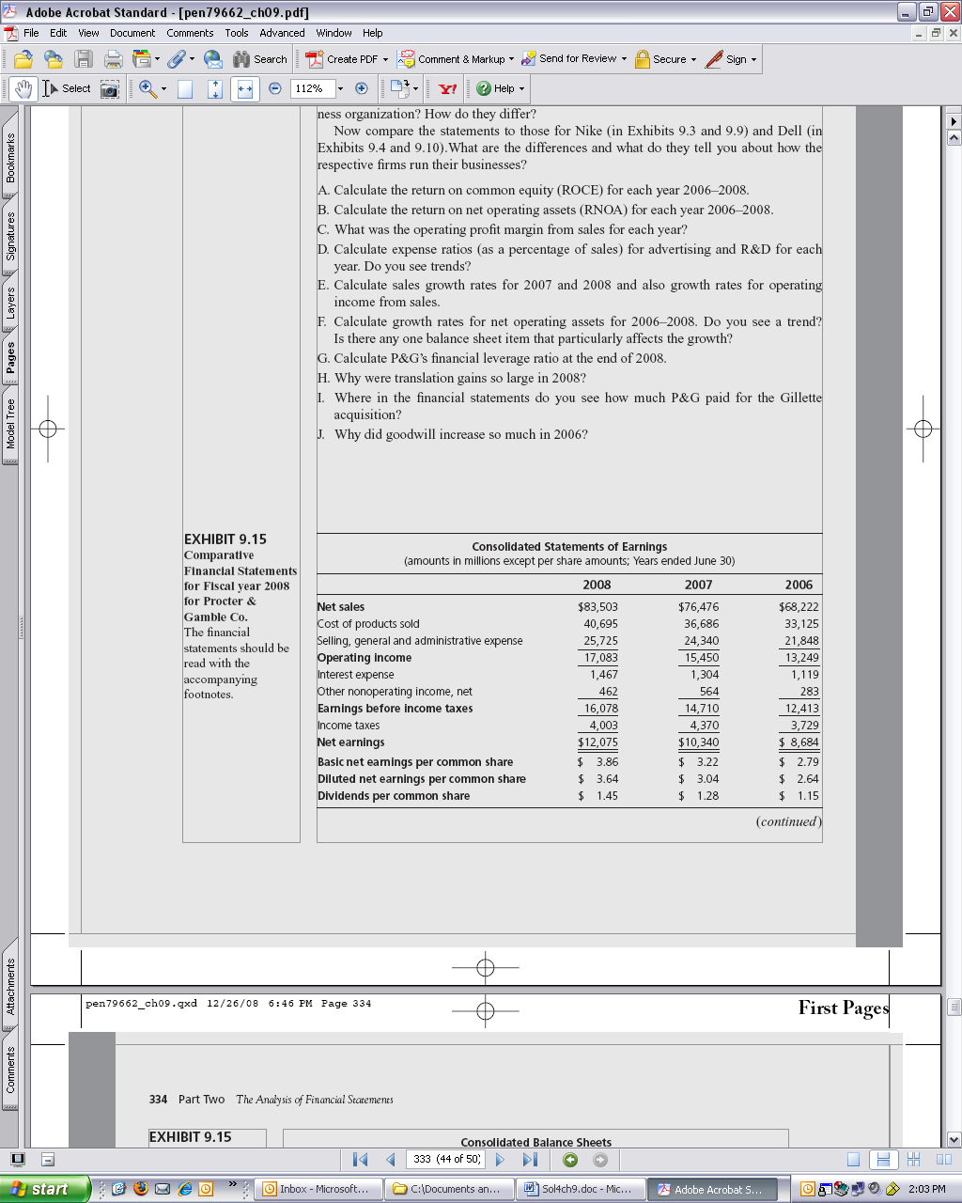

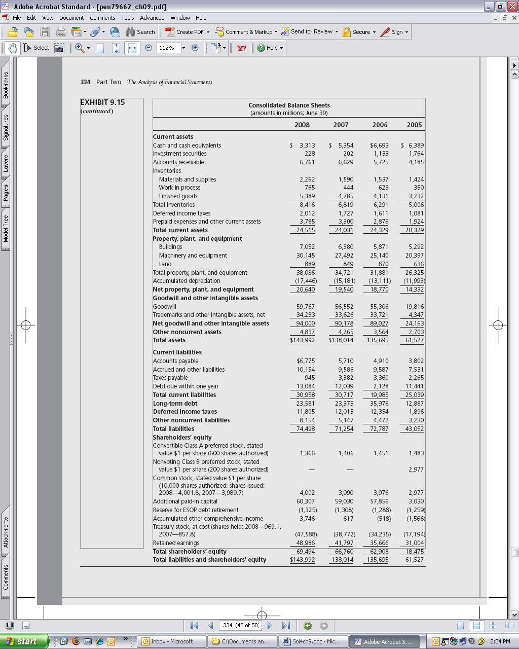

The Reformulated Statements:

Reformulated Statement of Common Shareholders’ Equity
Year ended June 30, 2008

Balance, June 30, 2007 reported | 66,760
Less Preferred Stock¹ | (1,406)
Plus ESOP reserve² | 1,308
Balance of common equity | 66,662

Transactions with common shareholders
Dividends | (4,479)
Share repurchase | (10,047)
Share issue | 2,480
Preferred stock conversion⁴ | 329 | (11,717)

Comprehensive income
Net income | 12,075
Other comprehensive income³ | 3,129
Loss for FIN48 | (232)
Preferred dividend⁵ | (176)
Loss on conversion of preferred stock⁴ | (289) | 14,507
Balance, June 30, 2008 |  | 69,453

Notes:

- Preferred stock is moved to debt portion of the balance sheet.

- An ESOP is an Employee Stock Ownership Plan. In the reformulation, the ESOP reserve is taken out of the equity statement and netted against the ESOP loan in the balance sheet. P&G is guaranteeing the loan to the ESOP, and accounting rules (SOP 76-3) require the firm record the loan guarantee as a liability and to set up a reserve in equity for this. contingency. However, it is highly unlikely that P&G will have to honor the guarantee (and, in any case, the reserve is not a reduction of equity to the full face amount). If one deemed that P&G has a reasonable probability of having to honor the guarantee, the liability would be retained, but with the debit recorded as an asset (claim on the ESOP) rather than in equity.

- Other comprehensive income is listed in the equity statement (largely foreign currency translation gains and hedging losses).

- Preferred stock was converted into equity with a loss to shareholders. The loss from issuing 4.982 million common shares is calculated as follows (based on an average of $66 per share during the year):

Market value of common
shares issued, $66 x 4.982 million = 329
Preferred cancelled 40
289 million

Details of common issued and preferred cancelled are in the equity statement. Note that the common shares are issued at the market price in “transaction with shareholders.”

The conversion of the preferred shared was done by the ESOP, so the cost of conversion is essentially wage cost: P&G pays employees by issuing common shares in conversion of preferred shares held by ESOP. So we treat the $289 million as an expense of operations in the reformulated income statement. (The ESOP loan is a loan to purchase the preferred shares.)

- Preferred dividends are after tax. Preferred dividends get a tax deduction because they are paid to the ESOP.

One could reformulate the equity statement for 2007 and 2006, but we need only extract the comprehensive income:

The comprehensive income for 2007 and 2006 is as follows:

 | 2007 | 2006
Net income | 10,340 | 8,684
OCI | 1,468 | 1,048
Effect of accounting change | (333) | ----
Preferred dividends | (161) | (148)
Loss on conversion of preferred stock by ESOP | (261) | (173)
 | 11,053 | 9,411

Reformulated Income Statements
 |  | 2008 |  | 2007 |  | 2006
Net sales |  | 83,503 |  | 76,476 |  | 68,222
Cost of products sold |  | 40,695 |  | 36,686 |  | 33,125
Gross margin |  | 42,808 |  | 39,790 |  | 35,097
Advertising |  | 8,667 |  | 7,937 |  | 7,122
Research and development |  | 2,226 |  | 2112 |  | 2,075
General and administrative |  | 14,832 |  | 14,291 |  | 12,651
Loss on ESOP preferred stock conversion |  | 289 |  | 261 |  | 173
Operating income (from sales before tax) |  | 16,794 |  | 15,189 |  | 13,076
Tax reported | 4,003 |  | 4,370 |  | 3,729
Tax on net interest | 480 |  | 386 |  | 286
Tax on other OI | (98) | 4,385 | (105) | 4,651 | 32 | 4,047
Operating income from sales (after tax) |  | 12,409 |  | 10,538 |  | 9,029
Other operating income:
Gains on asset sales | 258 |  | 277 |  | (84)
Tax at 38% | (98) | 160 | (105) | 172 | 32 | (52)
Other operating income after tax:
Other comprehensive income |  | 3,129 |  | 1,468 |  | 1,048
Effect of accounting change |  | (232) |  | (333) |  | ------
Operating income |  | 15,466 |  | 11,845 |  | 10,025
Net Financing Expense
Interest expense |  | 1,467 |  | 1,304 |  | 1,119
Interest income |  | 204 |  | 287 |  | 367
Net interest expense |  | 1,263 |  | 1,017 |  | 752
Tax at 38% |  | 480 |  | 386 |  | 286
 |  | 783 |  | 631 |  | 466
Preferred dividends |  | 176 |  | 161 |  | 148
Net financial expense |  | 959 |  | 792 |  | 614
Comprehensive income |  | 14,507 |  | 11,053 |  | 9,411

Notes: Loss on conversion of preferred shares by ESOP (Employee Stock Option Plan) is effectively wages paid to employees, so is included in operating expenses.

Other comprehensive income items are listed in the equity statement. They are all after tax.

Reformulated Balance Sheets

 | 2008 | 2007 | 2006 | 2005
Operating Assets:
Operating cash¹ | 120 | 120 | 120 | 120
Accounts receivable | 6,761 | 6,629 | 5,725 | 4,185
Inventories | 8,416 | 6,819 | 6,291 | 5,006
Deferred income taxes | 2,012 | 1,727 | 1,611 | 1,081
Prepaid expenses and other | 3,785 | 3,300 | 2,876 | 1,924
Property, Plant and Equipment | 38,086 | 34,721 | 31,881 | 26,325
Accumulated depreciation | (17,446)) | (15,181)) | (13,111) | (11,993))
Goodwill | 59,767 | 56,552 | 55,306 | 19,816
Other intangibles | 34,233 | 33,626 | 33,721 | 4,347
Other assets | 4,837 | 4,265 | 3,564 | 2,703
 | 140,571 | 132,578 | 127,989 | 53,494
Operating Liabilities:
Accounts payable | 6,775 | 5,710 | 4,910 | 3,802
Accrued liabilities | 10,154 | 9,586 | 9,587 | 7,531
Taxes payable | 945 | 3,382 | 3360 | 2,265
Deferred taxes | 11,805 | 12,015 | 12,354 | 1,896
Other liabilities | 8,154 | 5,147 | 4,472 | 3,230
 | 37,833 | 35,840 | 34,685 | 18,724
Net Operating Assets (NOA) | 102,738 | 96,738 | 93,306 | 34,770
Financial Obligations:
Debt due in one year | 13,084 | 12,039 | 2,128 | 11,441
Long-term debt | 23,581 | 23,375 | 35,976 | 12,887
Less ESOP reserve | (1,325) | (1,308) | (1,288) | (1,259)
Preferred stock | 1,366 | 1,406 | 1,451 | 1,483
 | 36,706 | 35,512 | 38,267 | 24,552
Financial Assets:
Cash equivalents | 3,193 | 5,234 | 6,573 | 6,269
Investment securities | 228 | 202 | 1,133 | 1,764
 | 3,421 | 5,436 | 7,706 | 8,033
Net financial obligations | 33,285 | 30,076 | 30,561 | 16,519
Common Equity | 69,453 | 66,662 | 62,745 | 18,251

Note: ESOP reserve in equity has been offset against ESOP loan guarantee (in long-term debt). See notes to equity statement.

$120 million of cash on cash equivalents has been treated as working cash.

Other liabilities are largely pension obligations and other employee benefits and thus operating liabilities.

Readers’ Corner

Fro an evaluation of the DuPont scheme of breaking profitability up into profit margin and asset turnover, see

M. Soliman, “The Use of DuPont Analysis by Market Participants,” The Accounting Review (Vol. 83, No. 3, 2008), pp. 823-853.

