EXERCISES FOR CHAPTER 5

With Solutions

Exercise 1. Residual Earnings and Valuation

The following is extracted from the income statement and balance sheet of a firm for 2001. (Amounts in $ thousands)

Operating income (after tax) 17,507
Net financial expenses 3,060
Comprehensive income 14,447

The firm paid out all income in dividends at the end of the year and there were no share issues during 2001. The book value of common equity at the end of 2001 was $100,600. The cost of equity capital is 11%.

(a) Calculate residual income for 2001.

(b) The residual income for 2002 and all subsequent years is expected to be the same as in 2001. Calculate the value of the equity at the end of 2001.

Solution

(a)

First calculate the book value at the beginning of 2001, then calculate residual earnings earned in 2001 on this book value. Residual earnings equals comprehensive income minus a charge against the book value at 11%.

Book Value (2000) = Book Value (2001) – Earnings (01) + Dividends (01)

= 100,600 – 14,447 + 14,447

= 100,600

Residual Earnings (2001) = 14,447 – (0.11 x 100,600)

= 3,381

(b)

Calculate the value of the equity using the residual earnings model.

Value = Book Value + Present Value of RE

As residual income is expected to be a perpetuity,

Value = 100,600 + $\frac{3,\text{381}}{0\text{.}\text{11}}$

= 131,336

------------------------------------------------------------------------------------------------------------

Exercise 2. Valuing a Project

A firm announces that it will invest $150 million in an asset that is expected to generate a 15% rate of return on its beginning-of-period book value for the next five years. The required return for this type of project is 12%; the firm depreciates the cost of assets straight-line over the life of the investment.

What is the value added to the firm from this investment?

Valuing a Project: Solution

First calculate the book value of the asset at the beginning of each year. This is the original cost of the asset less accumulated depreciation to that year. Then calculate earnings as a 15% return on book value. Proceed to apply the residual earnings model to value the project.

Year | 0 | 1 | 2 | 3 | 4 | 5
Depreciation |  | 30 | 30 | 30 | 30 | 30
Book value | 150 | 120 | 90 | 60 | 30 | 0
Earnings (15%) |  | 22.5 | 18 | 13.5 | 9 | 4.5
RE (.12) |  | 4.5 | 3.6 | 2.7 | 1.8 | 0.9
PV of RE (1.12^{t}) |  | 4.02 | 2.87 | 1.92 | 1.14 | .51
Total PV of RE | 10.47
Value of Project | 160.47

The investment added $10.47 million over the cost.

-----------------------------------------------------------------------------------------------------------

Exercise 3. Forecasting Target Prices and Calculating the Market’s Implicit Target Price

Kimberly-Clark Corp (KMB) reported a book value for its 568.6 million common shares of $5,650 million on December 31, 2002. Analysts are forecasting EPS of $3.36 for 2003 and $3.60 for 2004, and the indicated dividend per share is $1.36. Accepting these forecasts as valid, and using a required equity return of 9%, deal with the following.

Prepare a table of target prices for the end of 2004, based on the following forecasts:

  - Residual earnings will remain constant after 2004
  - Residual earnings will grow at 2% after 2004
  - Residual earnings will grow at 4% after 2004

Solution
Prepare the pro forma:
2002 2003 2004
Eps 3.36 3.60
Dps 1.36 1.36
Bps 9.94 11.94 14.18
ROCE 33.8% 30.2%
Residual earnings (RE) 2.465 2.525

With a constant growth rate, the value in 2004 is equal to

Value₂₀₀₄ = Book Value₂₀₀₄ + $\frac{{\text{RE}}_{\text{2005}}}{ρ−g}$

(This is just the residual earnings formula with constant growth.)

RE for 2005 is RE for 2004 growing at the forecasted growth rate:

RE₂₀₀₅ = 2.525 x g
So,

Value₂₀₀₄ = 14.18 + $\frac{2\text{.}\text{525}×g}{1\text{.}\text{09}−g}$

Calculate the expected value at the end of 2004 for the growth rates given in the question:

Growth rate g Value

0% 100.0% $42.24
2% 102.0% 50.98
4% 104.0% 66.71

These calculations demonstrate a point: a target value is always expected book value plus the continuing value:
Target price 2004 = Book Value 2004 + Continuing value

(This exercise in continued in the Web Exercises for Chapter 7)

Exercise 4. Did You Pay Too Much for Book Value?

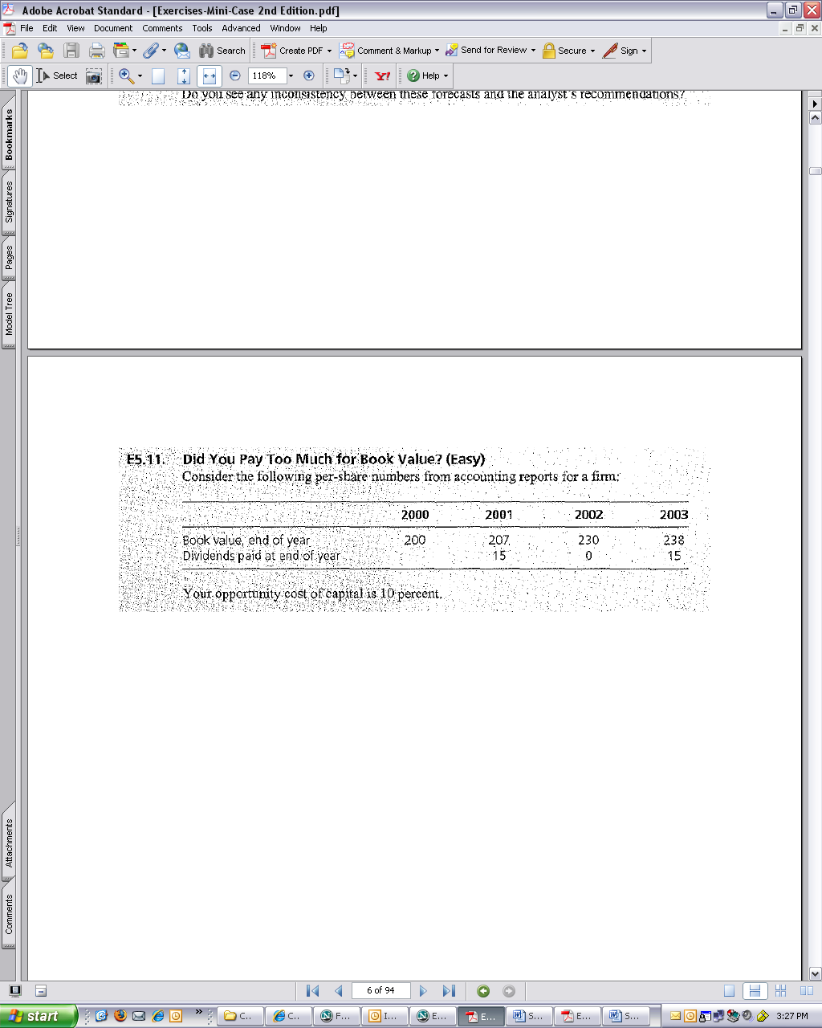
If you paid $220 per share at the beginning of 2001, do you think (with the benefit of hindsight) that you overpaid or underpaid?

Solution:
If you paid 220 at the beginning of 2001, you are expecting that the premium over book value that you paid (20) will be returned in (the present value of) subsequent residual earnings.
Earnings = B_{t} – B_{t-1} + d_{t}
(This is comprehensive income because it is calculated from the changes in the book value which includes the dirty surplus income that may not be reported in net income.)
The conclusion assumes RE beyond 2003 is also expected to be zero.
Another way of looking at it:
Required 3-year stock return = 220 × (1.10³ – 1)
= 72.82
If projected residual earnings are zero after 2003, price should equal the book value of 238 in 2003.
Therefore actual return = P_{T} – P₀ + terminal value of dividends
= 238 – 220 + (15 × 1.10² ) + 15
=51.15
Actual – required return = (21.67)
PV at 2000 = 21.67/(1.10)³ = (16.28)
(which is the ex post loss calculated above)

