SUPPLEMENT TO CHAPTER EIGHT

THE TRANSPORTATION MODEL

LEARNING OBJECTIVES
After completing this supplement you should be able to:
- Describe the nature of a transportation problem.
- Solve transportation problems manually and interpret the results.

SUPPLEMENT OUTLINE
Introduction
Obtaining an Initial Solution
The Intuitive Lowest-Cost Approach
Testing for Optimality
Evaluating Empty Cells: The Stepping-Stone Method
Evaluating Empty Cells: The MODI Method
Obtaining an Improved Solution
Special Problems
Unequal Supply and Demand
Degeneracy
Summary of Procedure
Key Terms
Solved Problems
Discussion and Review Questions
Problems
The Transportation problem involves finding the lowest-cost plan for distributing stocks of goods or supplies from multiple origins to multiple destinations that demand the goods. For instance, a firm might have three factories, all of which are capable of producing identical units of the same product, and four warehouses that stock or demand those products, as depicted in Figure 1. The transportation model can be used to determine how to allocate the supplies available from the various factories to the warehouses that stock or demand those goods, in such a way that total shipping cost is minimized. Usually, analysis of the problem will produce a shipping plan that pertains to a certain period of time (day, week), although once the plan is established, it will generally not change unless one or more of the parameters of the problem (supply, demand, unit shipping cost) changes.
Figure 8S-1

The Transportation problem involves determining a minimum-cost plan for shipping
from multiple sources to multiple destinations

D
demand
D
demand
D
demand
D
demand
S
(supply)
S
(supply)
S
(supply)

The transportation model starts with the development of a feasible solution, which is then sequentially tested and improved until an optimal solution is obtained. The description of the technique on the following pages focuses on each of the major steps in the process in this order:
- Obtaining an initial solution.
- Testing the solution for optimality.
- Improving sub optimal solutions.

OBTAINING AN INITIAL SOLUTION
Intuitive approach Heuristic approach to obtaining an initial solution.
To begin the process, it is necessary to develop a feasible distribution plan. A number of different methods are available for obtaining such a plan. The discussion here will focus on the intuitive approach, a heuristic approach that yields an initial solution that is often optimal or near optimal.

The Intuitive Lowest-Cost Approach
With the intuitive approach, cell allocations are made according to cell cost, beginning with the lowest cost. The procedure involves these steps:
- Identify the cell with the lowest cost.
- Allocate as many units as possible to that cell, and cross out the row or column (or both) that is exhausted by this.
- Find the cells with the next lowest cost from among the feasible cells.
- Repeat steps (2) and (3) until all units have been allocated.
Cell 1-D has the lowest cost ($1) (see Table 2). The factory 1 supply is 100, and the warehouse D demand is 160. Therefore, the most we can allocate to this cell is 100 units. Since the supply of 100 is exhausted, we cross out the costs in the first row along with the supply of 100. In addition, we must adjust the column total to reflect the allocation, which leaves 60 units of unallocated demand in column D.
The next lowest cost is $3 in cell 2-B. Allocating 90 units to this cell exhausts the column total and leaves 110 units for the supply of factory 2 (see Table 3). Also, we cross out the costs for column B.
The next lowest cost (that is not crossed out) is the $5 in cell 3-D. Allocating 60 units to this cell exhausts the column total and leaves 90 units for row 3. We now cross out the costs in column D (see Table 4).
At this point, there is a tie for the next lowest cell cost: cell 3-A and cell 2-C each has a cost of $8. Break such a tie arbitrarily. Suppose we choose cell 3-A. The demand is 80 units, and the remaining supply is 90 units in the row. The smaller of these is 80, so that amount is placed in cell 3-A (see Table 5). This exhausts the column, so we cross out the cell costs in column A. Also, the remaining supply in factory 3 is now 10.
The other cell in the tie, cell 2-C, still remains. The remaining supply in the row is 110 and demand in the column is 120. The smaller of these two amounts, 110, is assigned to the cell, and the row costs are crossed out. The row total is changed to zero, and the column total is changed to 10 units. The only remaining cell with a cost that has not been crossed out is cell
3-C. Both supply and demand are 10 units, so 10 units are assigned to the cell. This completes the initial allocation. (See Table 6.)
Now let's determine if this initial solution obtained using the intuitive method is optimum.

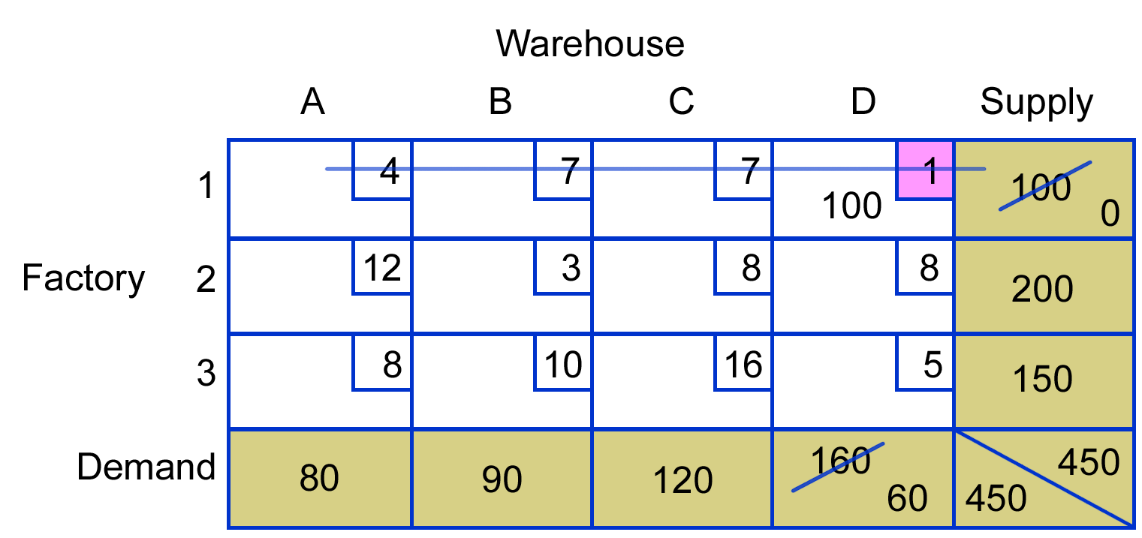

Table 2

Table 3

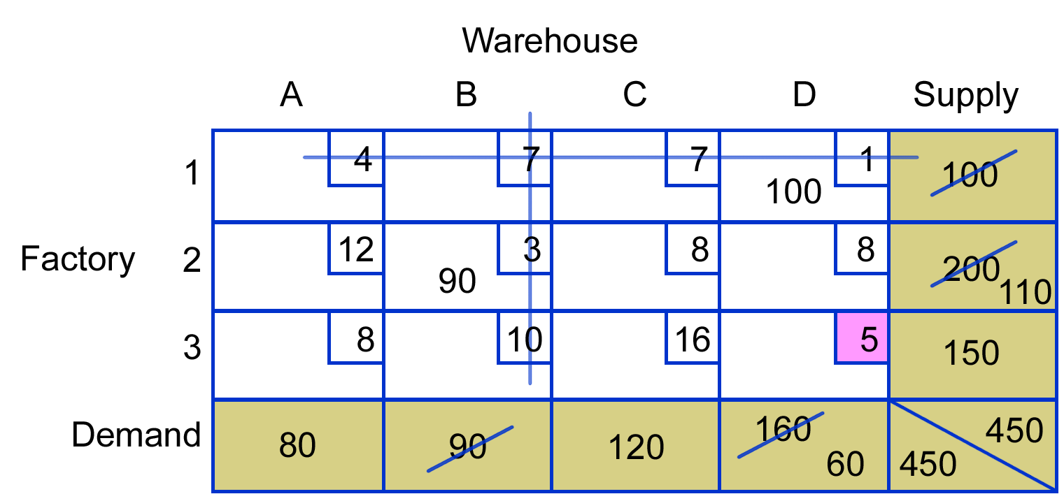

Table 4

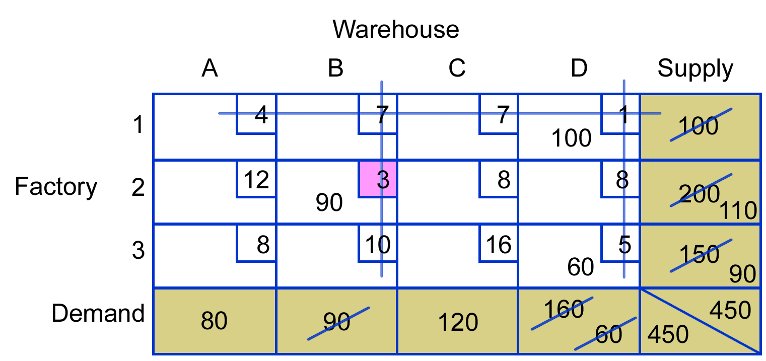

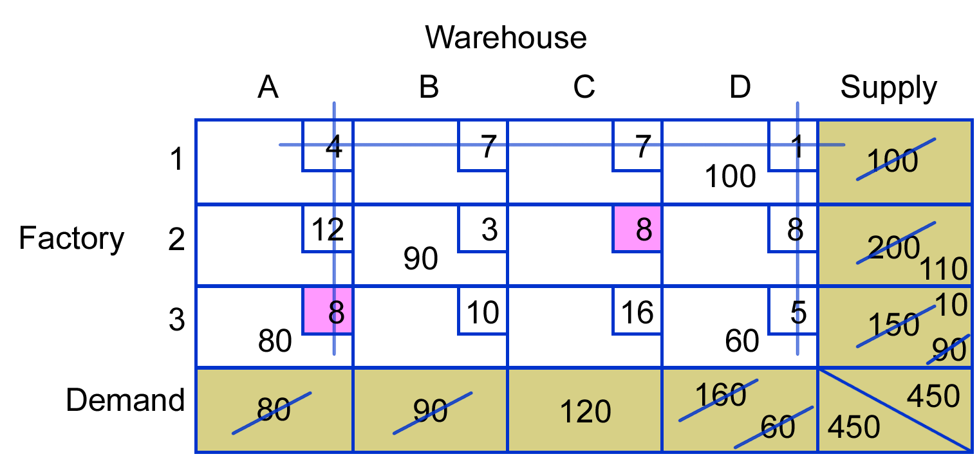

Table 5

Table 6
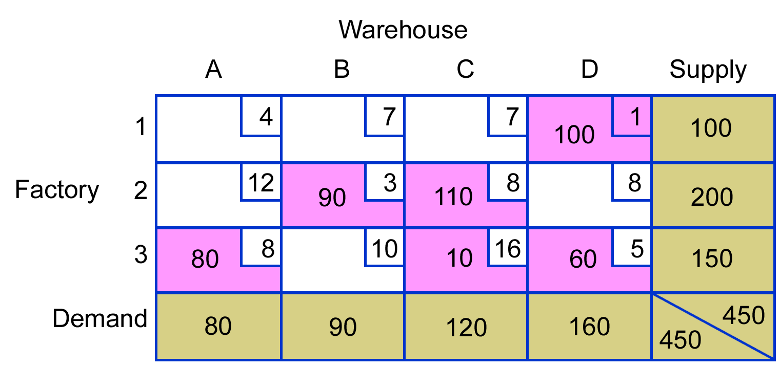
Initial allocation using intuitive approach

TESTING FOR OPTIMALITY
Testing for optimality and revising sub optimal solutions involves analysis of each unused (empty) cell to determine the potential for reducing the total cost of the solution, This is accomplished by transferring one unit into an empty cell and noting its impact on costs. If costs are increased, that implies that using the cell would increase total costs. If costs remain the same, that implies the existence of an alternative option with the same total cost as the current plan. However, if analysis reveals a cost decrease, the implication is that an improved solution is possible. The test for optimality requires that every unused cell be evaluated for potential improvement. Either of two methods can be used: stepping-stone or MODI.

Evaluating Empty Cells: The Stepping-Stone Method
In the stepping-stone method, cell evaluation proceeds by borrowing one unit from a full cell and using it to assess the impact of shifting units into the empty cell. For instance, if a shift of one unit causes an increase of $5, total costs would be increased by $5 times the number of units shifted into the cell. Obviously, such a move would be unwise since the objective is to decrease costs.
Stepping-stone method: Cell evaluation by borrowing one unit from a full cell to assess the impact of shifting units into the empty cell.

Table 7
Evaluation path for cell 1-A
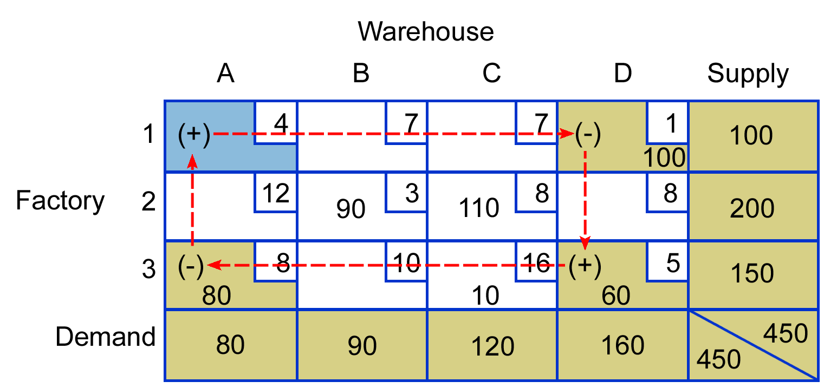
The name stepping-stone derives from early descriptions of the method that likened the procedures to crossing a shallow pond by stepping from stone to stone. Here, the occupied cells are the "stones"; shifting units into empty cells requires borrowing units from occupied cells. To maintain the balance of supply and demand for every row and column, a shift of one unit into an empty cell requires a series of shifts from other occupied cells.
The best way to understand the evaluation process is to consider a simple example. Suppose we want to evaluate cell 1-A (see Table 7). We must shift one unit into that cell, which implies that one unit will be shipped from factory 1 to warehouse A. However, factory 1 has only 100 units it can ship, and all are allocated to warehouse D. Therefore, to ship one unit to warehouse A, we borrow a unit from cell 1-D. This creates two problems: Column A now has one extra unit, and Column D is short one unit (i.e., A has 1 + 80 = 81 units but needs only 80 units, and D has 99 + 60 = 159 but needs 160 units). We remedy these problems by subtracting one unit from cell 3-A and adding it to cell 3-D; this gives column A a total of 1 + 79 = 80 and column D a total of 99 + 61 = 160. (Note: Instead of making each addition or subtraction of the single unit, a + or - sign is simply inserted in the appropriate cell to signify the operation.)
Let's see what effect such a shift would have on costs. For each cell to which a unit was added, the cost will increase by the transportation cost for that cell; for cells that gave up a unit, costs will decrease by the cell's transportation cost. We can summarize this with a T account as follows.

Cell 1-A
+ |  | -
(1-A) | +4 | (1-D) | -1
(3-D) | +5 | (3-A) | -8
 | +9 |  | -9
0
Thus, shifting units around this path would have no impact whatsoever on transportation costs: use of cell 1-A would be an equivalent-cost alternative. Management may prefer to use it for other reasons, or management may prefer to stay with the original solution. In any case, knowledge of such alternatives adds a certain degree of flexibility to decision making.
So far, we have not discovered any improvement potential, but five unused cells still must be analyzed. Before we evaluate the remaining empty cells, it is important to mention that constructing paths using the stepping-stone method requires a minimum number of occupied cells, and unless that number exists, it will be impossible to evaluate all the empty cells in this manner. The number of occupied cells must equal the sum of the number of rows and columns minus 1, or R + C - 1, where R = Number of rows and C = Number of columns. In this example, R = 3 and C = 4, so we must have 3 + 4 - 1 = 6 used or completed cells (which we do have). If there are too few occupied cells, the matrix is said to be degenerate. A method for overcoming this problem is explained later in this supplement.
For now, let's continue evaluating the unused cells. Suppose we now consider cell 2-A. Begin by adding a unit to the empty cell. Moving to the right in row 2, we have what seems to be a choice: borrow a unit from 90 or from 110. However, borrowing from 90 will leave column B one unit short, and since adding and borrowing must involve occupied cells and there are no others in the B column, the 90 cannot be used. Instead, we must borrow from the 110 and add one unit to the 10 in cell 3-C. We can complete our path back to the original cell by subtracting a unit from the 80 units in cell 3-A. The +/- path is shown in Table 8.

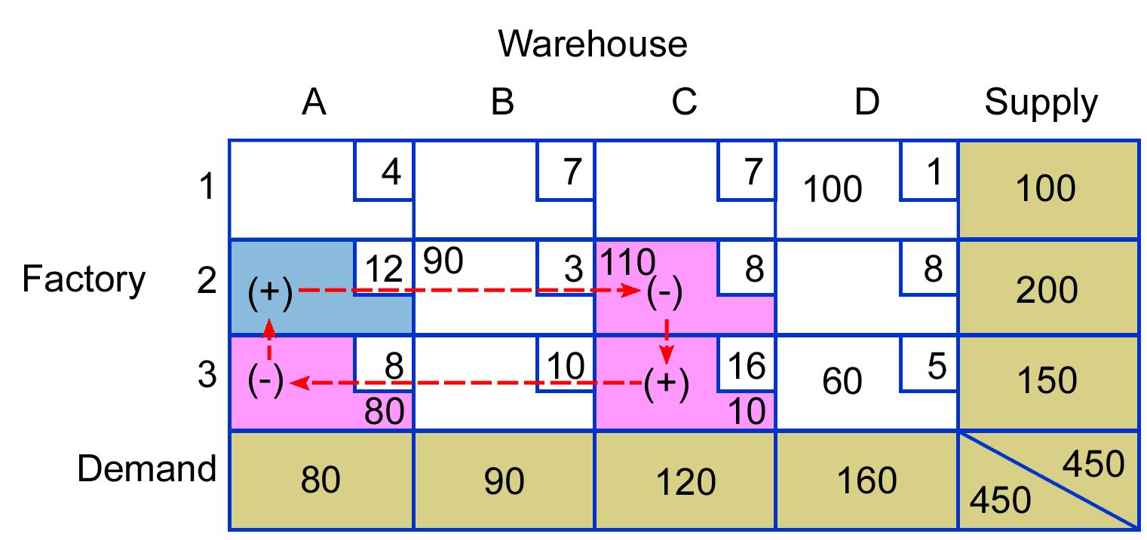

Table 8
Evaluation path for cell 2-A
The impact on total cost for the path associated with cell 2-A would be:

Cell 2-A
+ |  | -
(2-A) | +12 | (2-C) | -8
(3-C) | +16 | (3-A) | -8
 | +28 |  | -16
+12
This means that for every unit shifted into cell 2-A, the total cost would increase by $12. Thus we should avoid shipping units from factory 2 to warehouse A.
At this point, let's consider some helpful rules for obtaining evaluation paths, since you may still be unsure of how to do it.
- Start by placing a + sign in the cell you wish to evaluate.
- Move horizontally (or vertically) to a completed cell (a cell that has units assigned to it). It is OK to pass through an empty cell or a completed cell without stopping. Choose a cell that will permit your next move to another completed cell. Assign a minus sign (-) to the cell.
- Change direction and move to another completed cell. Again, choose one that will permit your next move. Assign a plus sign (+) to the cell.
- Continue this process of moving to completed cells and alternating + and - signs until you can complete a closed path back to the original cell. Make only horizontal and vertical moves.
- You may find it helpful to keep track of cells that have been evaluated by placing the cell evaluation value in the appropriate cell with a circle around it.
Let's try another one, say, 3-B. Start by placing a + sign in cell 3-B. Move to the 90 in cell 2-B, and place a - sign there. Move to the 110 in cell 2-C, and place a + sign there. Move to cell 3-C, and give it a - sign. The path is shown in Table 9.

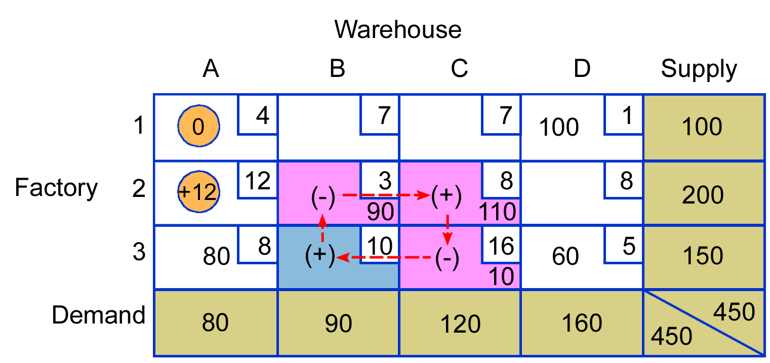

Table 9
Evaluation path for cell 3-B

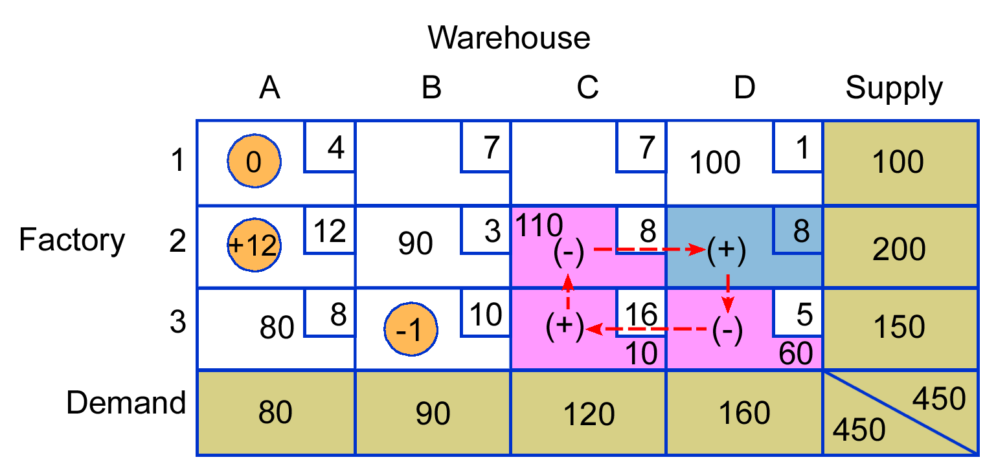
Table 10
Evaluation path for cell 2-D

This one was fairly easy. Let's see what the impact on cost would be:

Cell 3-B
+ |  | -
(3-B) | +10 | (2-B) | -3
(2-C) | +8 | (3-C) | -16
 | +18  -1 |  | -19
-1
The -1 indicates that for each unit we can shift into cell 3-B, our cost will decrease by $1. If we could shift 100 units, we could save $100 over the present solution. However, at this point we are not ready to make any changes since some other empty cell might yield even greater savings, and we can only make one shift per table. Evaluation of cell 2-D is similar to the evaluation of cell 3-B. The evaluation path is shown in Table 10.

The cost impact would be:

Cell 2-D
+ |  | -
(2-D) | +8 | (3-D) | -5
(3-C) | +16 | (2-C) | -8
 | +24 |  | -13
+11
Thus, no improvement is possible.
There are two cells remaining to be evaluated: 1-B and 1-C. The evaluation of cell 1-B is a little more involved than the previous paths. Begin by placing a + in cell 1-B. Move to cell 1-D (100 units) and give it a -. Move vertically to 3-D (60 units) and give it a +. Move to the left and put a - in cell 3-C (10 units). Move up to 110 and put a + in that cell. Move to the left to 90 units (cell 2-B) and give it a - sign, completing the path. The path is shown in Table 11.

Table 11
Evaluation path for cell 1-B
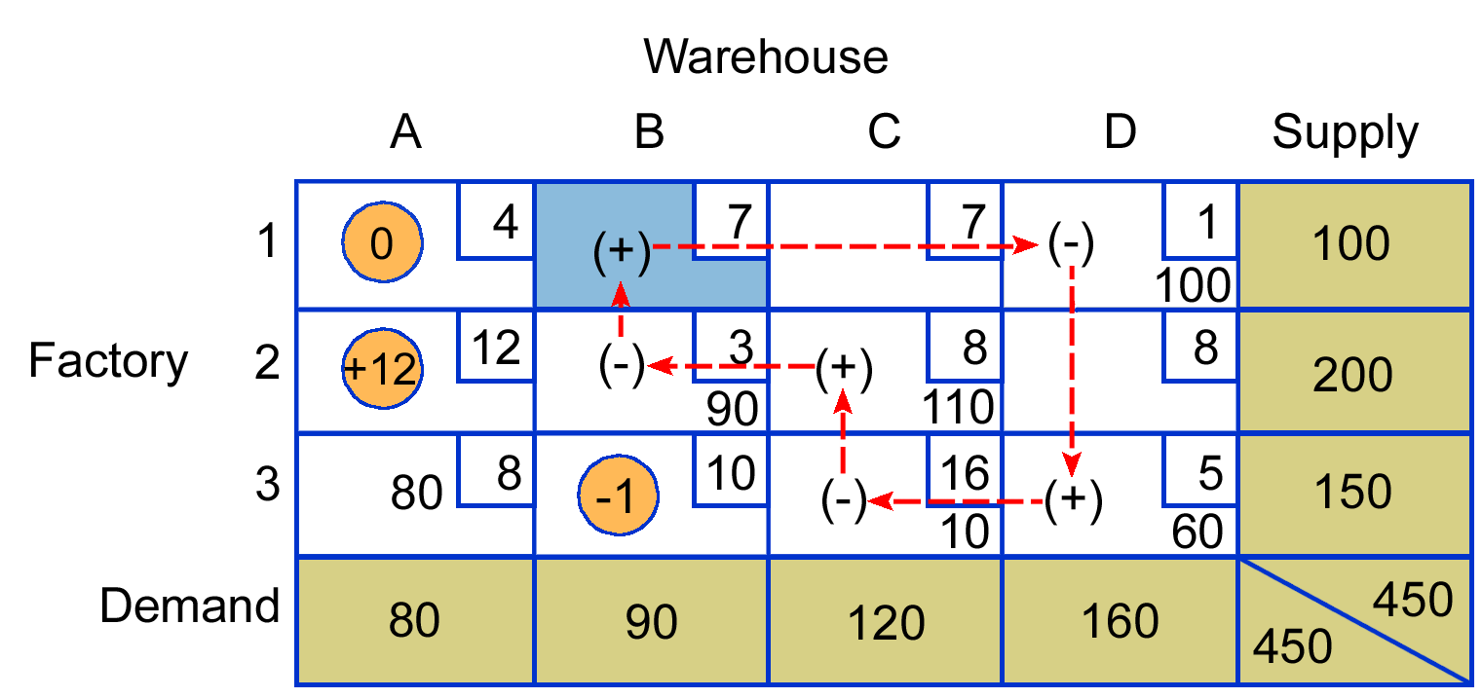
Table 12
Evaluation path for cell 1-C

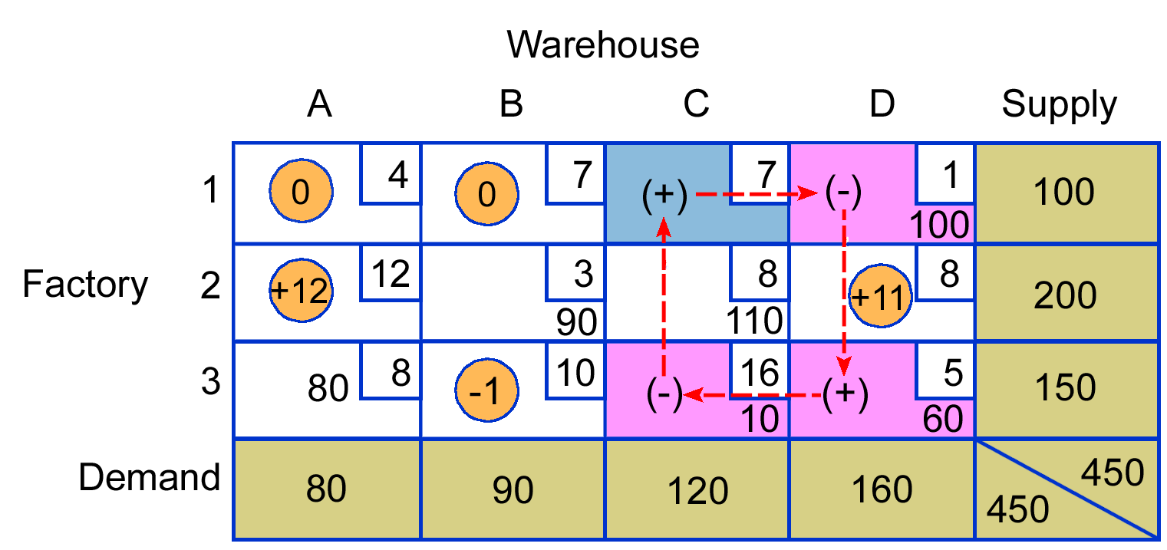

The cost impact of the path would be zero.

Cell 1-B
+ |  | -
(1-B) | +7 | (1-D) | -1
(3-D) | +5 | (3-C) | -16
(2-C) | +8 | (2-B) | -3
 | +20 |  | -20
0
Thus, no improvement is possible using this cell path.

The last empty cell is 1-C. Its evaluation path is shown in Table 12 (above). Begin with 1-C as +, 1-D as -, 3-D as +, and 3-C as -. The cost impact would be:

Cell 1-C
+ |  | -
(1-C) | +7 | (3-D) | -1
(3-D) | +5 | (3-C) | -16
 | +12  -5 |  | -17
-1
Hence, for each unit we can transfer into this empty cell, we improve the cost by $5.
At this point, each of the unused cells has been evaluated. The resulting costs are summarized below.
Cell………. 1-A 2-A 3-B 2-D 1-B 1-C
Cost……… 0 +12 -1 +11 0 -5
Cells that have a positive or zero evaluation present no opportunities for improvement. The fact that 1-A and 1-B are both zero indicates that at least one other equivalent alternative exists. However, they are of no interest because two cells have negative cell evaluations, indicating that the present solution is not an optimum. In a later section, you will learn how to develop an improved solution.
Modified distribution method (MODI) Evaluating empty cells by computing row and column index numbers.

Evaluating Empty Cells: The MODI Method
Another method for evaluating empty cells is the modified distribution method (MODI). It involves computing row and column index numbers that can be used for cell evaluation. In many respects, it is simpler than the stepping-stone method because it avoids having to trace cell evaluation paths. Nevertheless, the cell evaluations it produces are identical to those obtained using the stepping-stone method. Note, however, that if a solution is not optimal, one stepping-stone path must be traced to obtain an improved solution. This is explained in detail in the next section.
The MODI procedure consists of these steps:
- Make an initial allocation using the intuitive method.
- Obtain an index number for each row and column. Do this using only completed cells. Note that there will always be at least one completed cell in each row and in each column.
  - Begin by assigning a zero to the first row.
  - Determine the column index for any completed cells in row 1 using the relationship: Column index = Cell cost - Row index. For example, if a cell cost is $8 per unit, the column index will be 8 - 0 = 8.
  - Each new column value will permit the calculation of at least one new row value, and vice versa. Continue until all rows and columns have index numbers, using only completed cells.
- Obtain cell evaluations for empty cells using the relationship:
Cell evaluation = Cell cost - (Row index + Column index)
Comments:
- Row or column values may be positive, negative, or zero.
- A reallocation requires that new row and column cost values be calculated.
Let's see how the MODI method can be used for cell evaluation.

Table 13
MODI index numbers
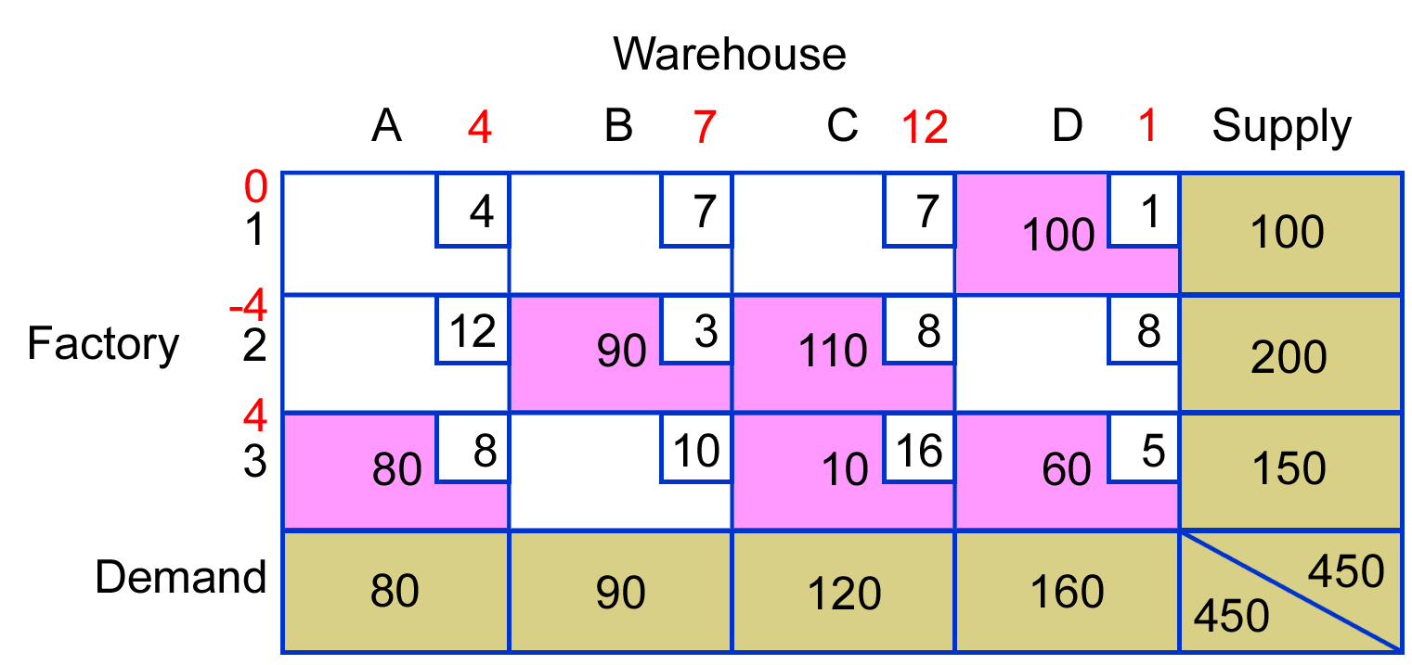
We begin by assigning a zero to row 1 (see Table 13). Since we can only work with occupied cells and since cell 1-D is the only such cell in row 1, we focus on it. Since the sum of the row and column index numbers must add to the cell cost (which is 1), we can see that the index number for column D must be 1. There are no other occupied cells in row 1, so we shift to Column D, cell 3-D. Again, the sum of the row and column index numbers must add to the cell cost (which is 5). Since the column index for D is 1, the index number for row 3 must be 4, as 5 - 1 = 4.
We can use this row 3 index number and the other two occupied cells in row 3 to obtain index numbers for columns A and C. For column A, the A index number plus 4 must equal the 3-A cell cost of 8. Hence, the index for A is 4: 8 – 4 = 4. For C, the index plus 4 must equal 16; hence, the index number is 12.
Next, for row 2, using cell 2-C and a C index of 12, the row index is -4. Then, using cell 2-B, the column index is 7:3 - (-4) = 7. This completes the row and column index numbers.
The cell evaluation for each empty cell is determined by subtracting from the cost of the empty cell the sum of the row and column index numbers:
Cell evaluation = Cell cost - (Row index + Column index)

Table 14
MODI cell evaluation
Cell | Evaluation
1-A | 4 - (0 + 4) = 0
1-B | 7 - (0 + 7) = 0
1-C | 7 - (0 + 12) = -5
2-A | 12 - (-4 + 4) = 12
2-D | 8 - (-4 + 1) = 11
3-B | 10 - (4 + 7) = -1
Table 14 shows all of the evaluations. Note that these agree with the evaluations obtained using the stepping-stone method. Because some evaluations are negative, the solution is not optimal.

OBTAINING AN IMPROVED SOLUTION
The presence of negative cell evaluations is evidence that an improved solution is possible. By the same token, if no negatives appear, an optimum has been achieved.
In this case, there are two cells with negative evaluations: 3-B, with a value of -1, and 1-C, with a value of -5. Select the value that implies more improvement (i.e., -5), and ignore the other.
The implication of the -5 is that a savings of $5 per unit will be realized for every unit that can be shifted into cell 1-C. Recall the path used to evaluate the cell; it is reproduced in Table 15A.

Table 15
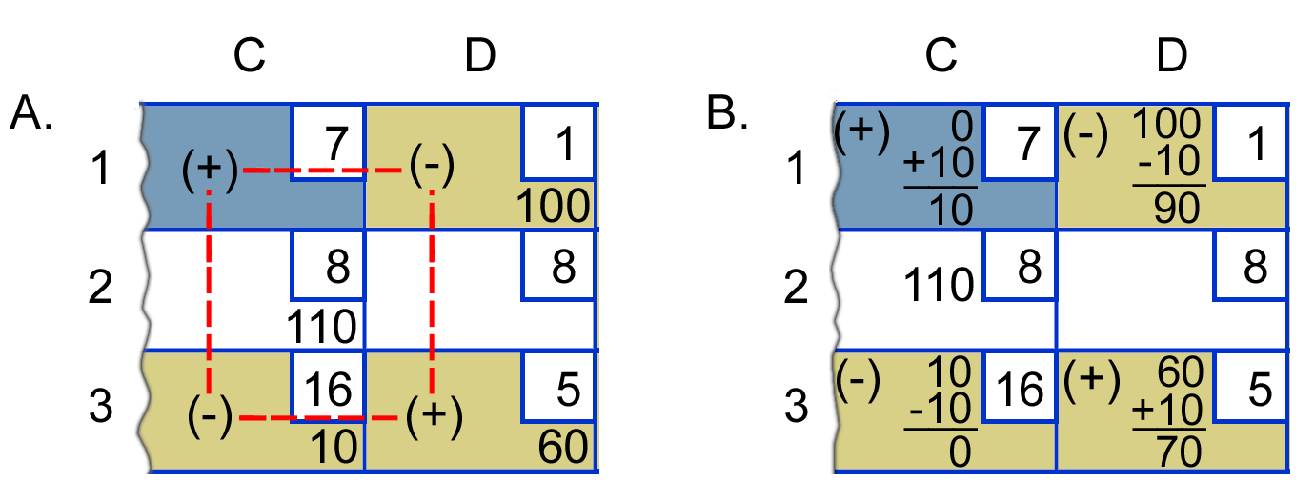
Evaluation path for cell 1-C (see A) and reallocation of 10 units around the path (see B)
In the course of the evaluation, a single unit was added or subtracted to certain cells, as denoted by the + and - signs. We want to repeat that procedure, but instead of shifting one unit, we want to shift as many as possible. The quantities in the cells that have - signs (i.e., 10 in cell 3-C and 100 in cell 1-D) are potential candidates for shifting, since the - sign implies units are subtracted from those cells. It is the smaller of these quantities that is the limiting factor. That is, we can subtract 10 from both numbers (10 and 100), but if we try to subtract 100 from both, we end up with 0 and -90. The negative value would imply shipping from the warehouse back to the factory! Hence, 10 units can be shifted. Always shift the minimum quantity that occupies a negative position in the ± path.
To accomplish the shift, add 10 units to each cell that has a + sign and subtract 10 units from each cell with a - sign. (Because the signs alternate, the row and column totals will still be satisfied,) This is shown in Table 15 (above).
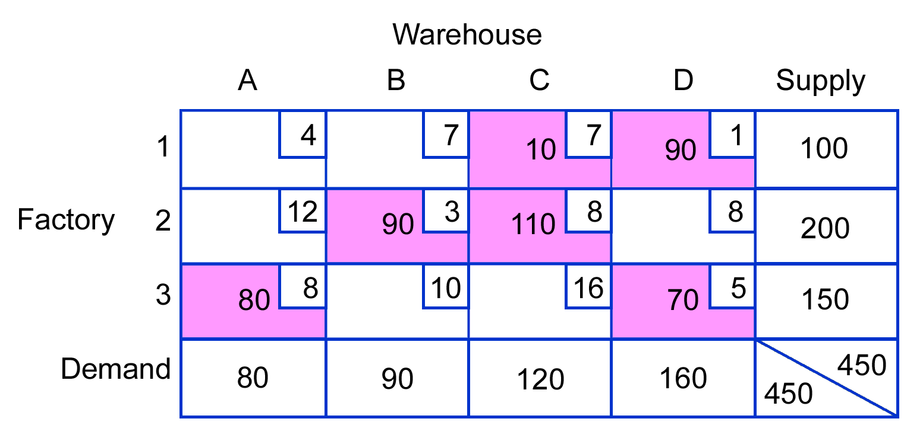
Table 16
Revised solution

The improved solution is shown in Table 16 (above). The total costs are:
 |  | Total Cost
1-C ………… | 10($7) = | $ 70
1-D ………… | 90($1) = | 90
2-B ………… | 90($3) = | 270
2-C ………… | 110($8) = | 880
3-A ………… | 80($8) = | 640
3-D ………… | 70($5) = | 350
 |  | $2,300
Note that the revised solution has a total cost that is $50 less than the previous solution ($2,300 versus $2,350), which is exactly equal to the cell evaluation value times the number of units shifted: -5 X 10 units = -$50.
Is this the optimum? Once again, we must evaluate each empty cell to determine if further improvements are possible. Recall that we must check to see if there are enough completed cells to allow all empty cells to have evaluation paths. Thus,
R + C - 1 = 3 + 4 - 1 = 6
Since there are six completed cells, the second round of cell evaluations can proceed. The cells paths and their values are shown in Tables 8S-17 to 8S-22. Since all are either zero or positive, the solution is the optimum. (Note: MODI could have been used instead of stepping-stone.)

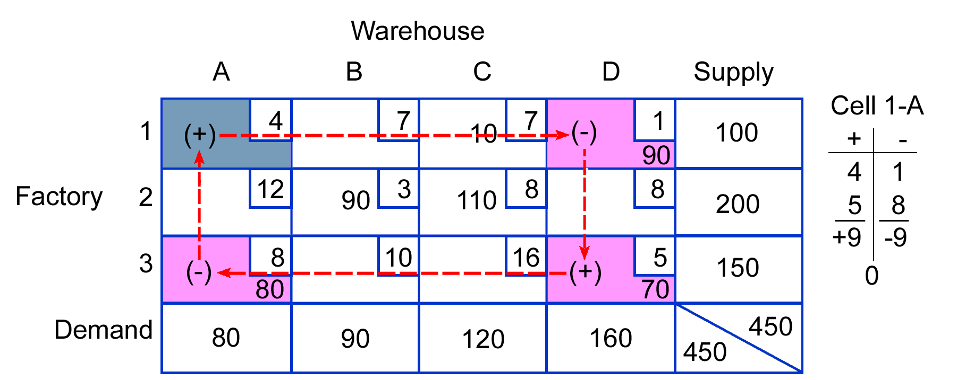
Table 17
Evaluation of cell 1-A

Table 18
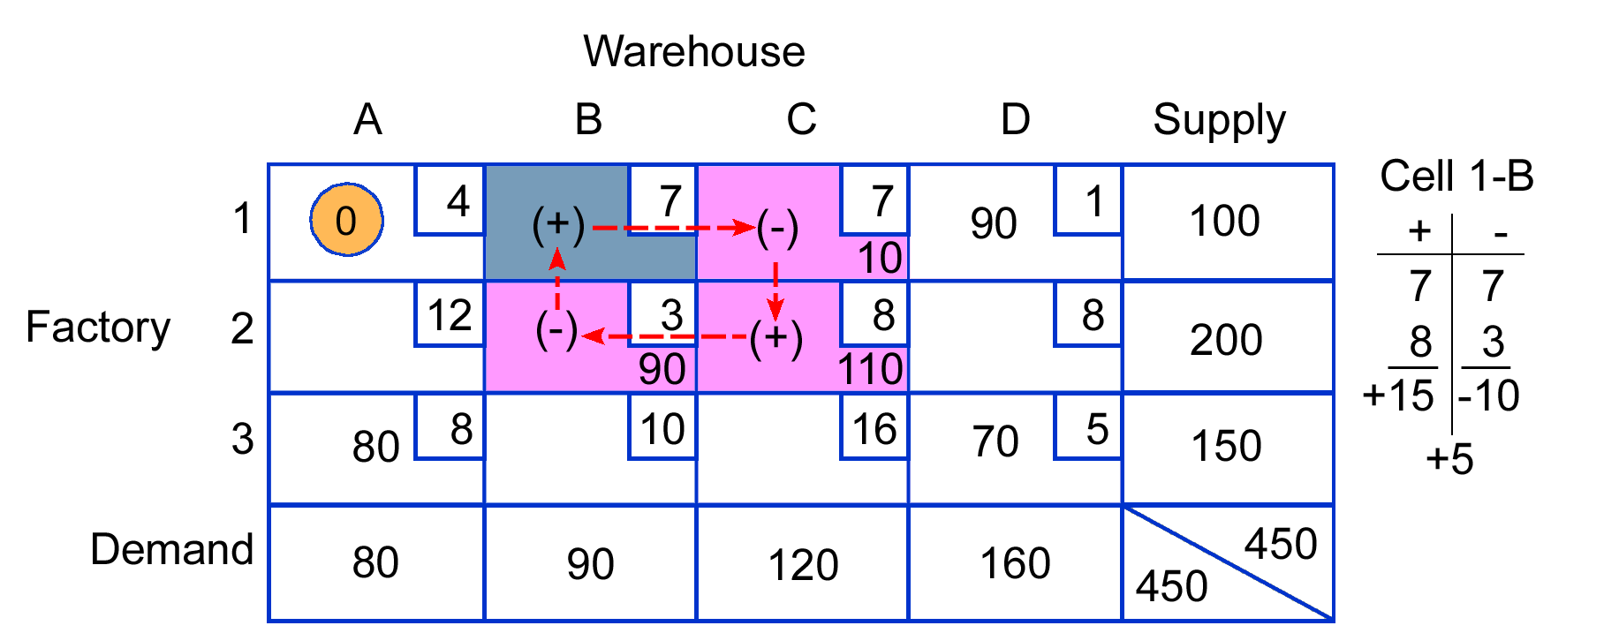
Evaluation of cell 1-B

Table 19
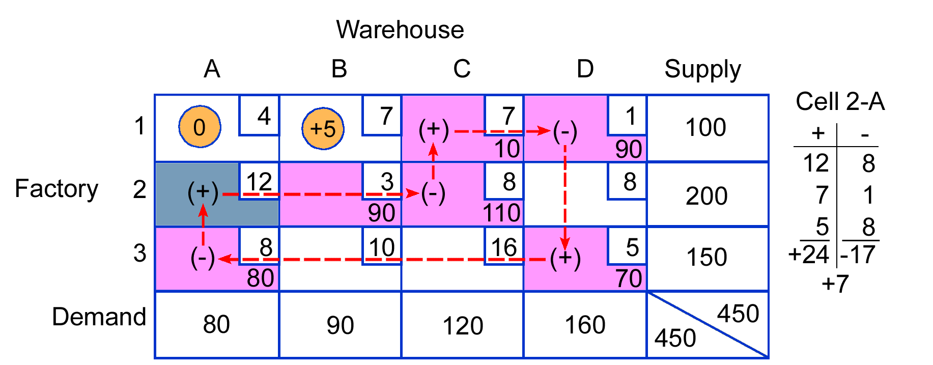
Evaluation of cell 2-A

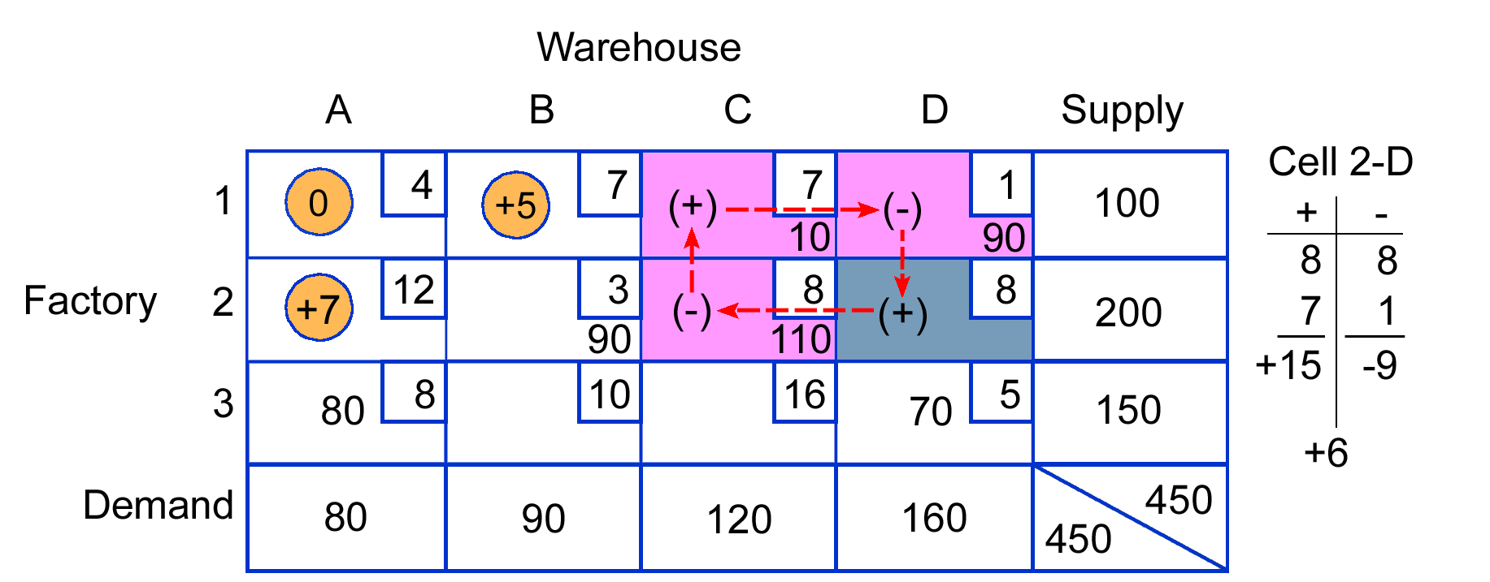
Table 20
Evaluation of cell 2-D

Table 21
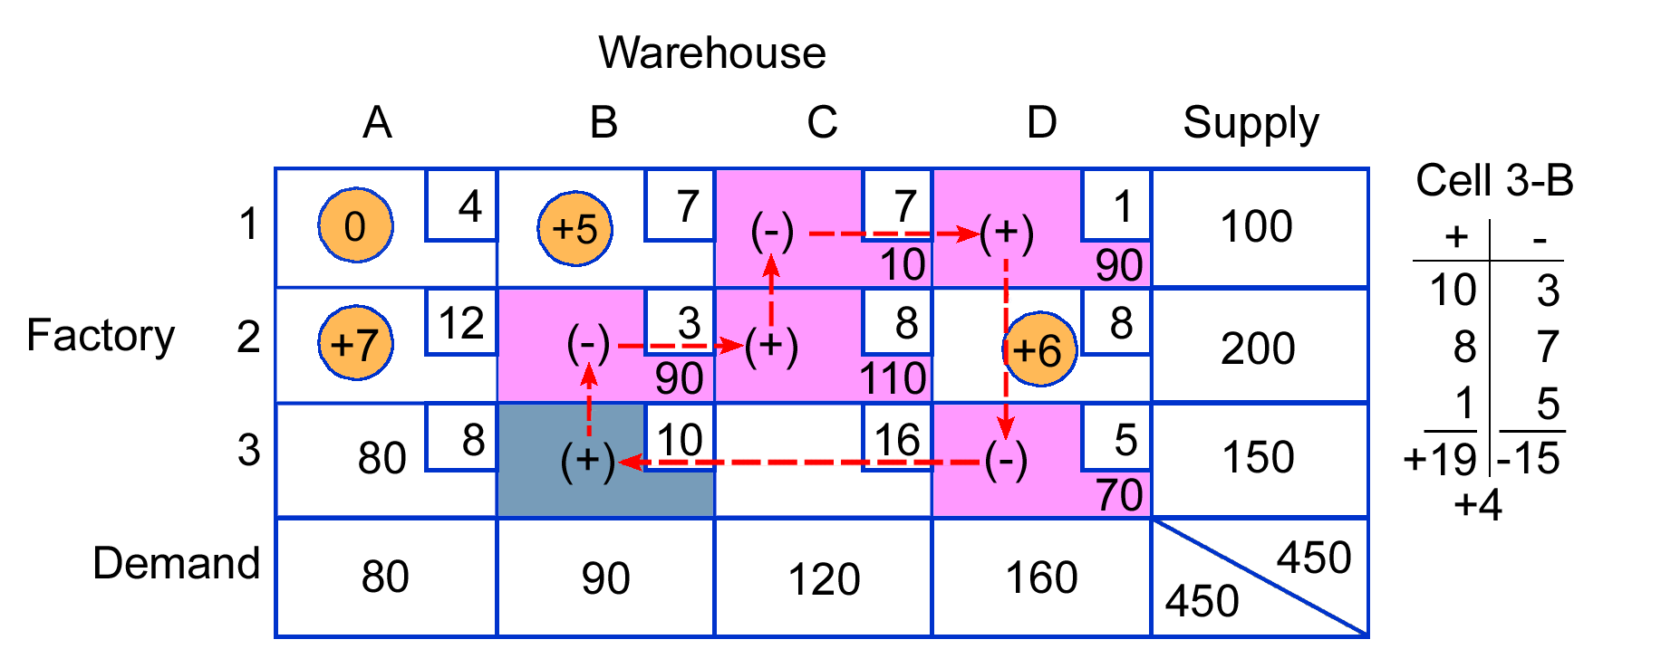
Evaluation of cell 3-B

Table 22
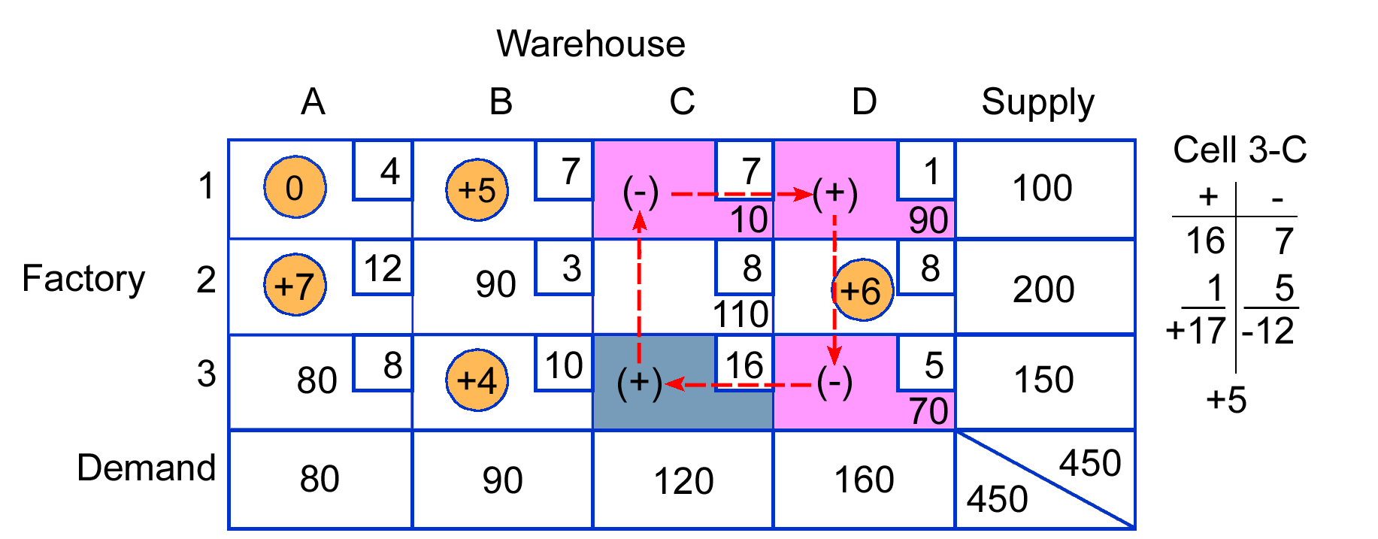
Evaluation of cell 3-C

SPECIAL PROBLEMS
Not all transportation problems are as straightforward as the one just presented. Various irregularities may occur, which require certain adjustments before a solution can be obtained. Two of the most common irregularities are unequal supply and demand, and degeneracy, a term previously noted as referring to an insufficient number of completed cells to allow evaluation of every empty cell.
dummy Imaginary number added. Equal to the difference between supply and demand when these are unequal.

Unequal Supply and Demand
A case in which supply and demand are not equal is illustrated in Table 23. Total supply (capacity) of the two sources is 200 units, but total demand of the destinations is only 170. Thus, the deficiency in demand is 30 units. This condition can be remedied by adding a dummy destination with a demand equal to the difference between supply and demand. Since there is no such destination, no units will actually be shipped, and unit-shipping costs for each dummy cell are $0. Table 24 illustrates this.
Once the dummy has been added, the transportation method can then be applied in the usual manner. The final solution will have a total number of units assigned to the dummy that equals the original difference between supply and demand (see Table 25). These numbers indicate which source(s) (e.g., factories) will hold the extra units or will have excess capacity. In the example shown, factory 1 will ship only 70 units even though it has the capacity to ship 100 units.
The total transportation costs for this distribution plan is:
 |  | Total Cost
1-A ………… | 70($5) = | $ 350
1-Dummy .… | 30($0) = | 0
2-A ………… | 10($4) = | 40
2-B ………… | 90($2) = | 180
 |  | $570
Table 23
Supply exceeds demand by 30 units
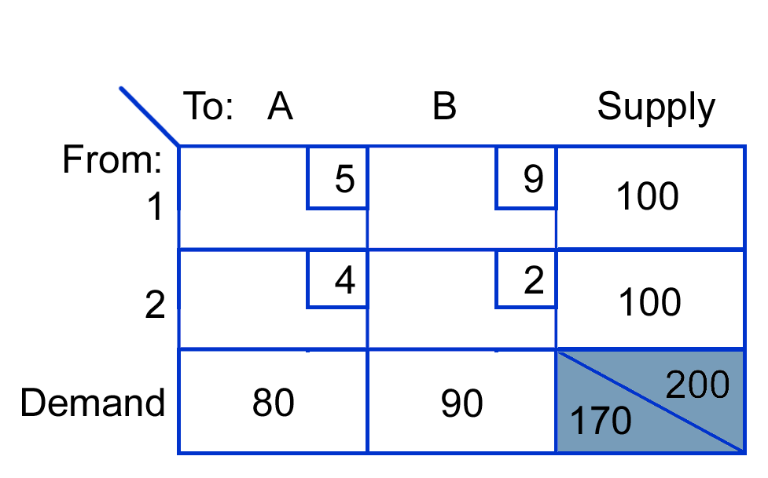

Table 24
A dummy column with a demand of 30 units is added to the matrix; dummy cell costs are zero

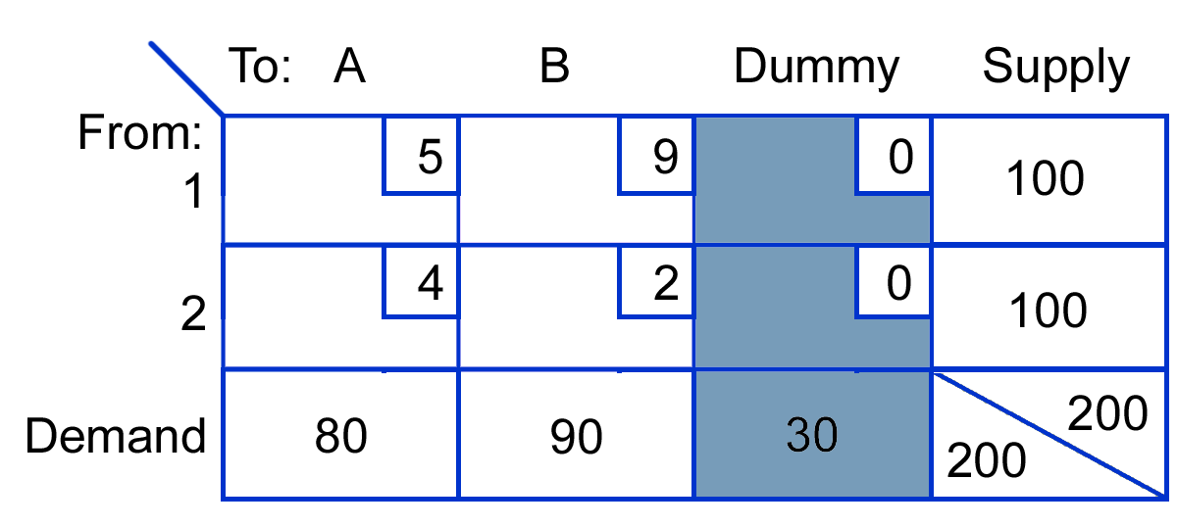

Table 25
Units in the dummy column are not shipped; factory 1 will ship only 70 units

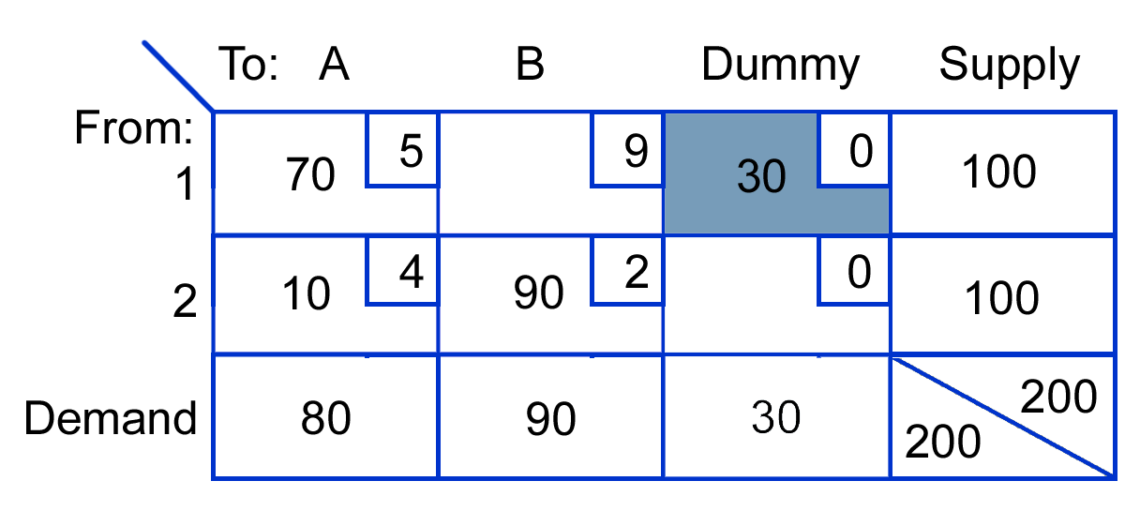
A similar situation exists when demand exceeds supply. In those cases a dummy row (e.g., factory) with a supply equal to the difference between supply and demand must be added. Again, units will not actually be shipped, so transportation costs are $0 for each cell in the dummy row. Units in the dummy row in the final solution indicate the destinations that will not receive all the units they desire and the amount of the shortage for each.
Note: When using the intuitive approach, if a dummy row or column exists, make assignments to dummy cell(s) last.

Degeneracy
degeneracy The condition of too few completed cells to allow all necessary paths to be constructed.
The transportation method involves evaluation of empty cells using completed cells as stepping stones. Degeneracy exists when there are too few completed cells to allow all necessary paths to be constructed. The condition occurs if an allocation (other than the final one) exhausts both the row (supply) and the column (demand) quantities. It can occur in an initial solution or in subsequent solutions, so it is necessary to test for degeneracy after each iteration using R + C - 1.
An example of a matrix with too few completed cells is shown in Table 26. Note that there are only four completed cells, although the necessary number is five:
3 + 3 - 1 = 5. Because of this, it is impossible to develop an evaluation path for cells 1-B, 1-C, 2-A, or 3-A. The situation can be remedied by placing a very small quantity, represented by the symbol ε, into one of the empty cells and then treating it as a completed cell. The quantity is so small that it is negligible; it will be ignored in the final solution.

Table 26
There are too few completed cells; some empty cells cannot be evaluated
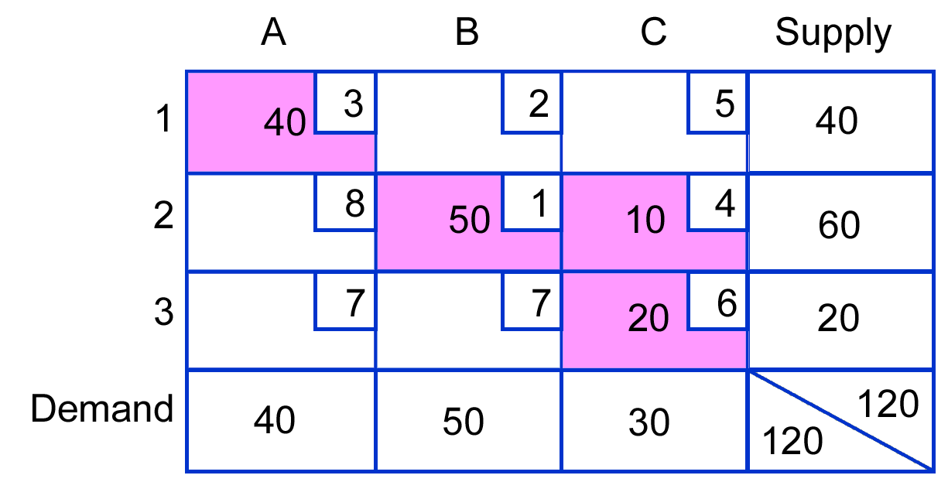

Table 27
Cell 3-A becomes a completed cell with the addition of a very small quantity, represented by the symbol ε

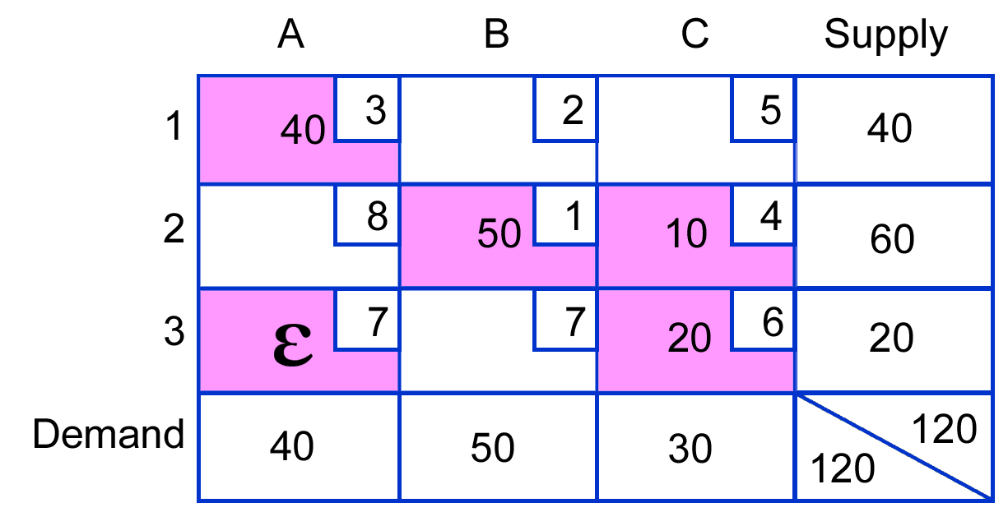
The idea is to select a position for ε that will permit evaluation of all remaining empty cells. For example, putting it in cell 3-A will permit evaluation of all empty cells (see Table 27). Some experimentation may be needed to find the best spot for ε, because not every cell will enable construction of evaluation paths for the remaining cells. Moreover, avoid placing ε in a minus position of a cell path that turns out to be negative because reallocation requires shifting the smallest quantity in a minus position. Since the smallest quantity is ε, which is essentially zero, no reallocation will be possible.
The cell evaluations (not shown) are all positive, so this solution is optimal. (Note that cell 3-A is considered to be a completed cell and is therefore not evaluated.)

SUMMARY OF PROCEDURE
- Make certain that supply and demand are equal. If they are not, determine the difference between the two amounts. Create a dummy source or destination with a supply (or demand) equal to the difference so that demand and supply are equal.
- Develop an initial solution using the intuitive, lowest-cost approach.
- Check that the number of completed cells is equal to R + C - 1. If it isn't, the solution is degenerate and will require insertion of a minute quantity, ε, in one of the empty cells to make it a completed cell.
- Evaluate each of the empty cells. If any evaluations turn out to be negative, an improved solution is possible. Identify the cell that has the largest negative evaluation. Reallocate units around its evaluation path.
- Repeat steps (3) and (4) until all cells have zero or positive values. When that occurs, you have achieved the optimal solution.

Key Terms

degeneracy,
dummy
intuitive lowest-cost approach
modified distribution method (MODI)
stepping-stone method

Solved Problems

Problem 1
Use the intuitive lowest-cost approach to develop an initial solution to the following problem, and then determine if the solution is optimal. If it is not, develop the optimal solution.
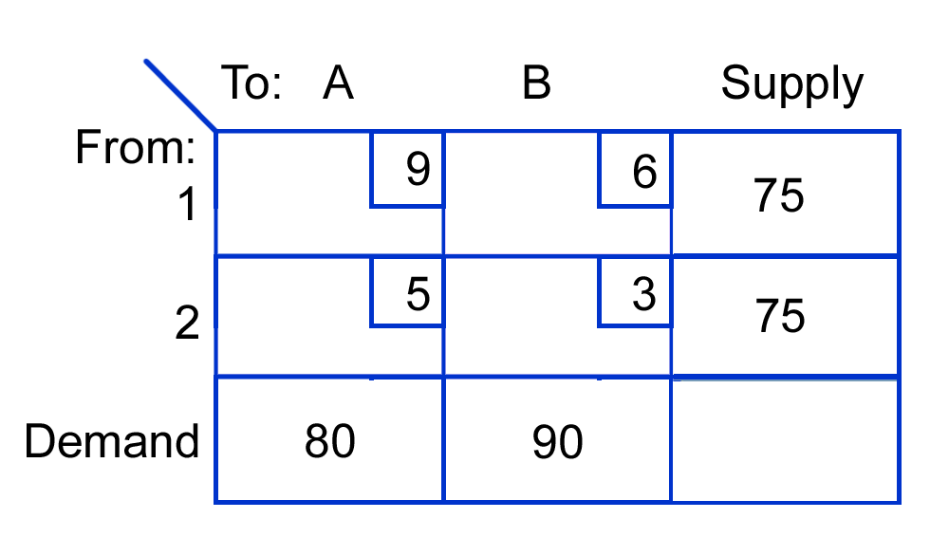

Solution
- First check to see if supply and demand are equal. Total demand = 170 and total supply = 150; therefore, it will be necessary to create a dummy origin (supply) with zero transportation costs in each of its cells (see following table).
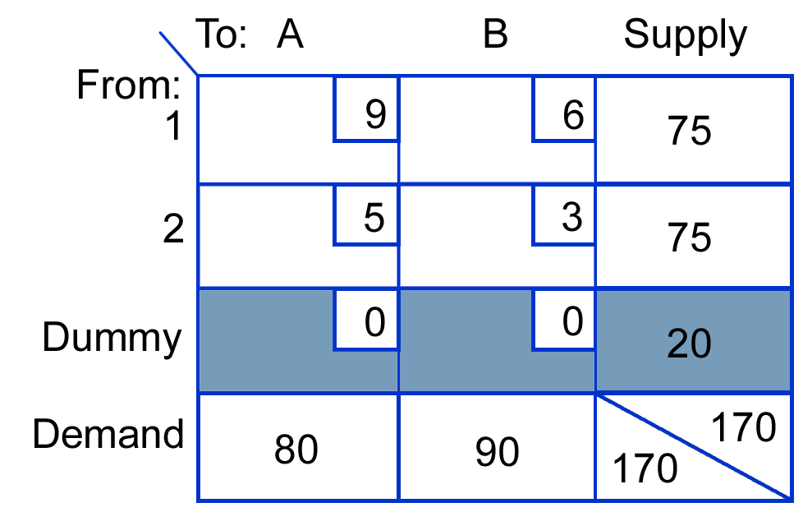
- Find the cell that has the lowest unit transportation cost. When a dummy is present and you are using the intuitive method, leave the dummy allocation until last. Thus, aside from the $0 costs in the dummy row, the lowest cost is $3 for cell 2-B. Assign as many units as possible to this cell. The column total is 90, and the row total is 75. Because 75 is the smaller of the two, assign 75 to cell 2-B. This exhausts the row total, so cross out the 75, and cross out the cell costs for the second row. Revise the column total to 15.
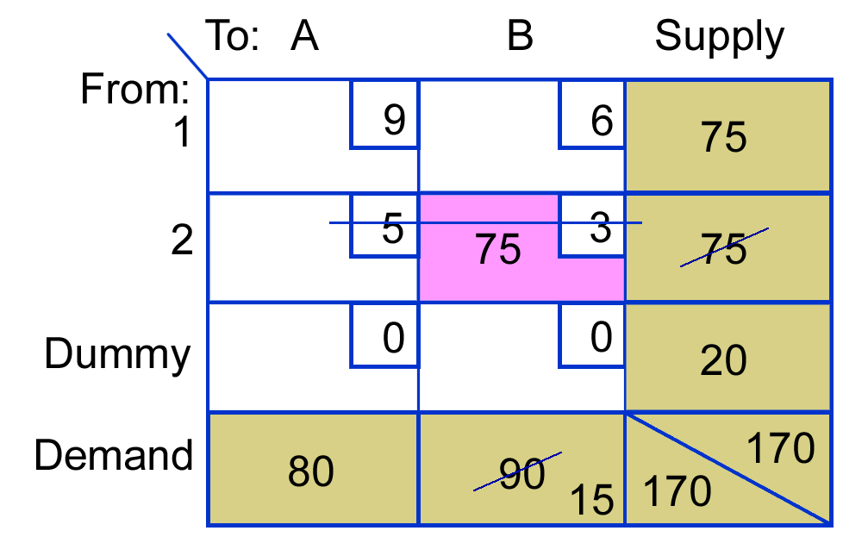
The next smallest cell cost is $6 in cell 1-B. We want to assign as many units as possible to this route (cell). The remaining demand for column B is 15, and the row total is 75. We assign the smaller of these, 15, to cell 1-B, thereby exhausting the column and reducing the row supply to 60. Next we draw a line through the cell costs of column B.
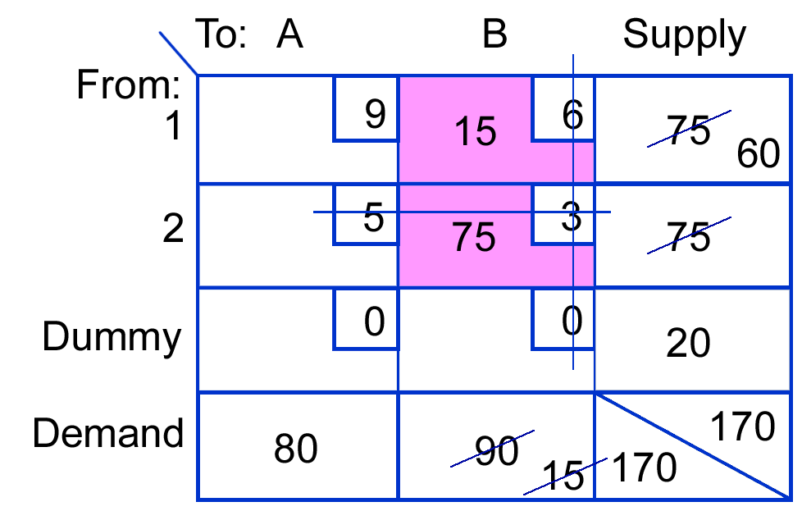
Still ignoring the dummy row, the next lowest cell cost is $9 in 1-A, where a supply of 60 and a demand of 80 exist. We assign the smaller of these, 60 units, to cell 1-A, so row 1 costs must be crossed out. Also, the revised column A total becomes 20.
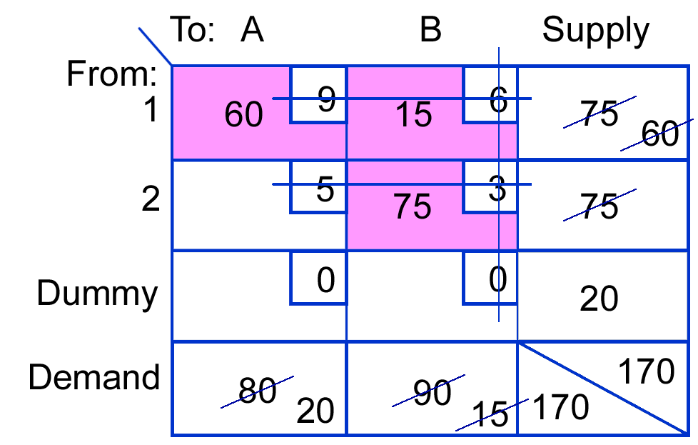
At this point, only the dummy row remains. Cell dummy-A has a supply and a demand of 20; assigning this amount to the cell exhausts both the supply and the demand, finishing the initial allocation.
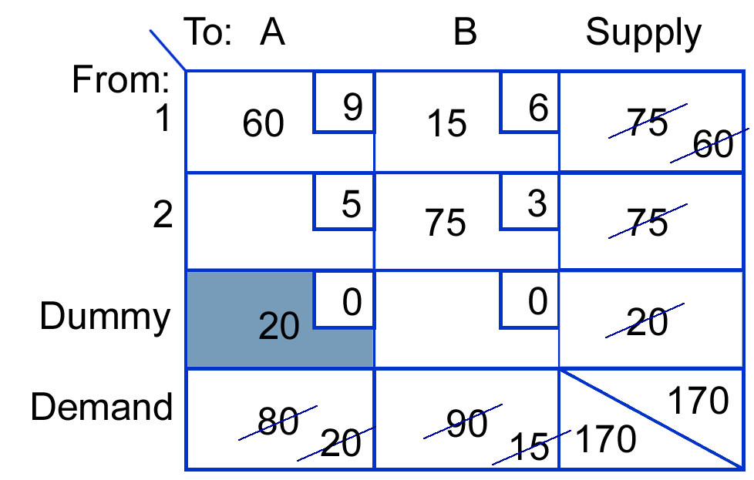
- The next step is to evaluate this solution to determine if it is the optimal solution. First we must check for degeneracy: R + C – 1 = 3 (rows) + 2 (columns) – 1 = 4, the required number of filled or completed cells. Because there are four completed cells, the solution is not degenerate.
The evaluation can use either the stepping-stone method or MODI. Suppose we use MODI. We always begin by placing a zero at the left edge of row 1. This is the row 1 index number. We can use it to find the column index number for any cell in row 1 that is a completed cell. Because both cell 1-A and cell 1-B are completed, we can obtain both of their column index numbers. For completed cells, the sum of the row and the column index numbers must equal the cell cost. For cell 1-A, 0 + Column index = 9, so the column A index must be 9. Similarly, for cell 1-B, 0 + Column index = 6, so the column index must be 6. Next, these index numbers are used to find values of row index numbers for completed cells in their respective columns. Thus, for cell 2-B, 6 + Row index = 3, so the row index must be - 3. For dummy-A, 9 + Row index = 0, so the row index must be –9.
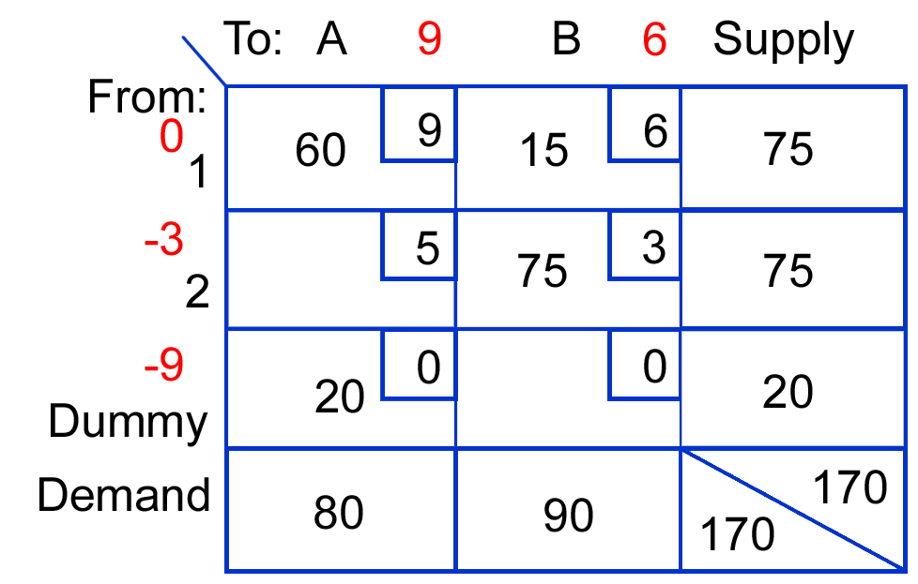
Next, we use these index numbers to evaluate the empty cells. We determine a cell evaluation by subtracting from the cell cost the sum of its row and column index numbers.
Thus, for cell 2-A, we have 5 - (-3 + 9) = -1, and for cell dummy-B, we have 0 - (-9 + 6) = 3.
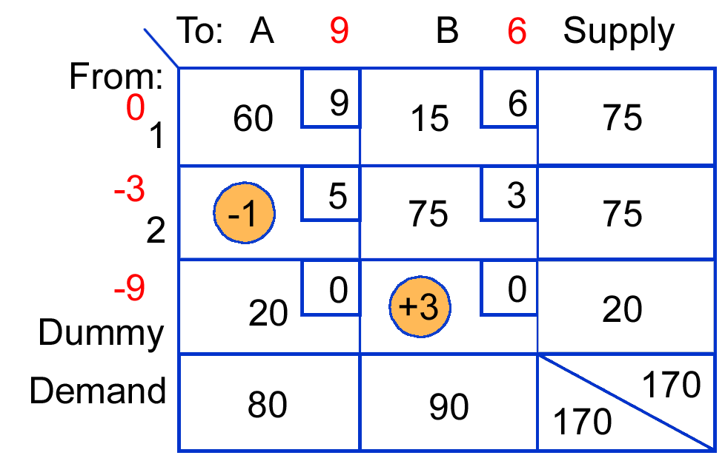
The appearance of a negative cell evaluation tells us this solution can be improved on. When negatives appear, we select the cell with the largest negative as the local point of our effort to improve the solution. Because there is only one such cell, it is the one we select.
- The -1 in cell 2-A tells us that for every unit we can move into this cell, we can reduce the total cost of the solution by $1. Obviously, we would like to put as many units as possible into this cell, but we are limited by the row and column totals (row 2 and column A). We are also constrained by the need for all row and column totals to be maintained. To put units into cell 2-A, we must take them from some other cell, which will be in another row or column. Fortunately, this matter is simple to resolve: Determine the stepping-stone path for cell 2-A, and use it to guide the reallocation. That path is illustrated in the following table.
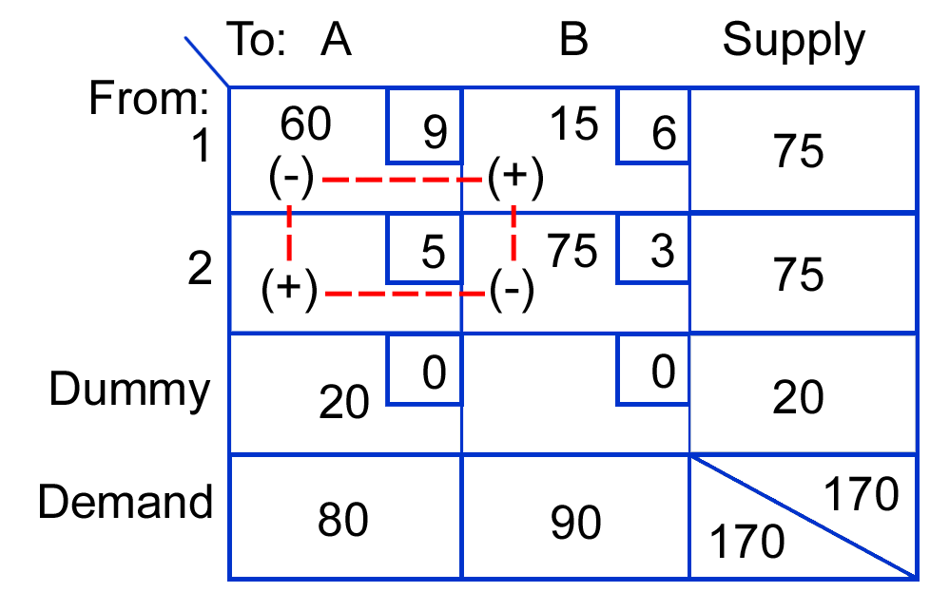
The amount that can be shifted into cell 2-A is the smallest quantity that appears in a negative position of the path. There are two such quantities, 60 and 75. Because 60 is the smaller of these, it is shifted around the entire path (i.e., added where there is a + sign and subtracted where there is a - sign). The result is our revised solution:
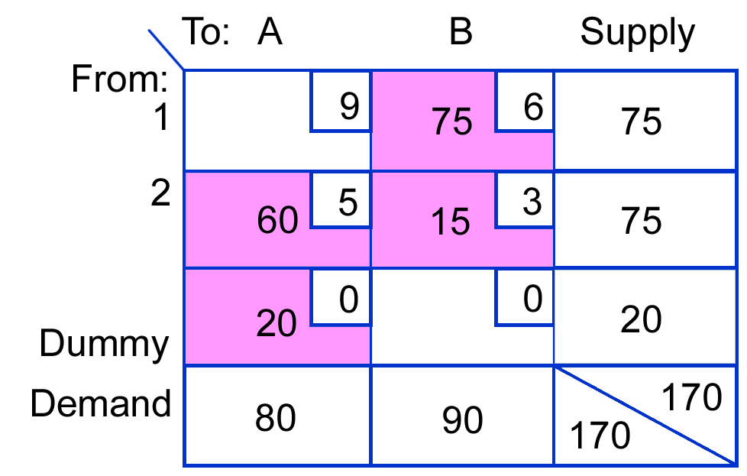
- This improved solution may be optimal, or it may need further revision. To find out, we must evaluate it.
First, we check for degeneracy: R + C - 1 = 3 + 2 - 1 = 4. Because there are four completed cells, the solution is not degenerate.
Next, we develop MODI index numbers using the completed cells. We always begin by assigning an index of 0 to the first row. Then, for any completed cell in the first row, the column index number is the same as the cell cost. Because cell 1-B has a cell cost of 6, the column B index number is 6. Using this value and the cell cost for completed cell 2-B enables us to find the index number for row 2: Cell cost - Column index = Row index. Thus, 3 - 6 = -3. This row 2 index number can be used with the cell cost of completed cell 2-A to find the column A index number, 5 - (-3) = 8, and the index of 8 can be used with the cell cost of dummy-A to find the dummy index number: 0 - 8 = -8. These index numbers are shown in the following table.
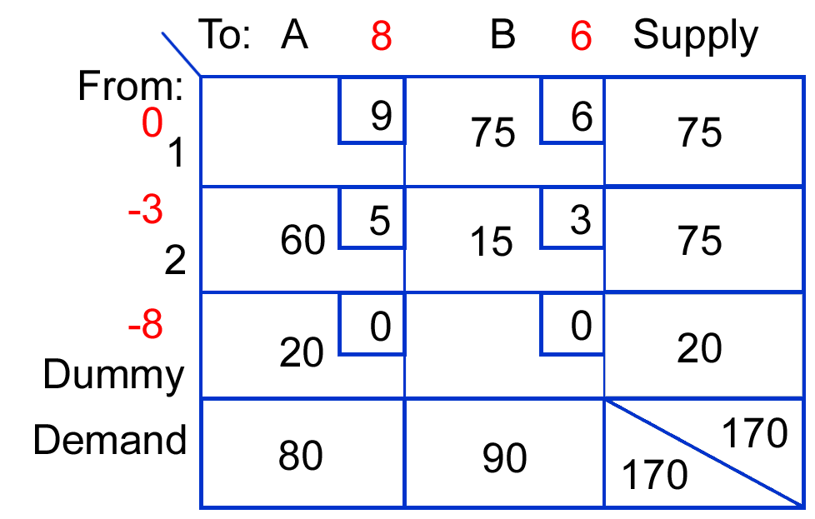
Evaluations for the empty cells can now be determined.
Cell 1-A: 9 (0 + 8) = 1
Cell dummy-B: 0 - (-8 + 6) = 2
Because there are no negative evaluations, the current solution is optimal: Ship 75 units from 1 to B, 60 units from 2 to A, and 15 units from 2 to B. The 20 units in dummy-A means that destination A will be 20 units short of satisfying its demand of 80 units.
The total cost of the optimal solution is $795:
75(6) = | 450
60(5) = | 300
15(3) = | 45
20(0) = | 0
 | 795

Problem 2
A firm that specializes in nonferrous casting must decide between locating a new foundry in Chicago or Detroit. Transportation costs from each proposed location to existing warehouses and transportation costs for existing locations for a certain type of casting are shown in the following table. Each will be able to supply 2,500 units per month. Explain how to determine which location should be chosen on a transportation cost basis.

From  Detroit  to | Cost  per  unit | From  Chicago  To | Cost  per  unit
A ………… | $10 | A ………… | $12
B ………… | 8 | B ………… | 13
C ...……… | 15 | C ………… | 5
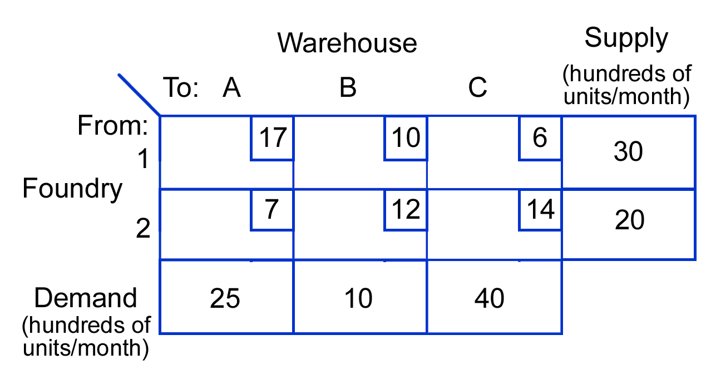

Solution
This decision requires solving two transportation problems, one using Detroit costs and the other using Chicago costs.
- Set up the two transportation matrices.
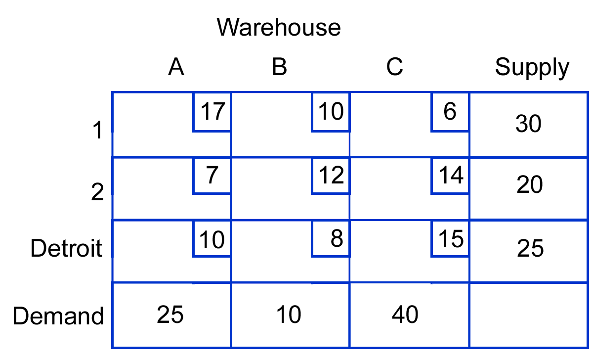
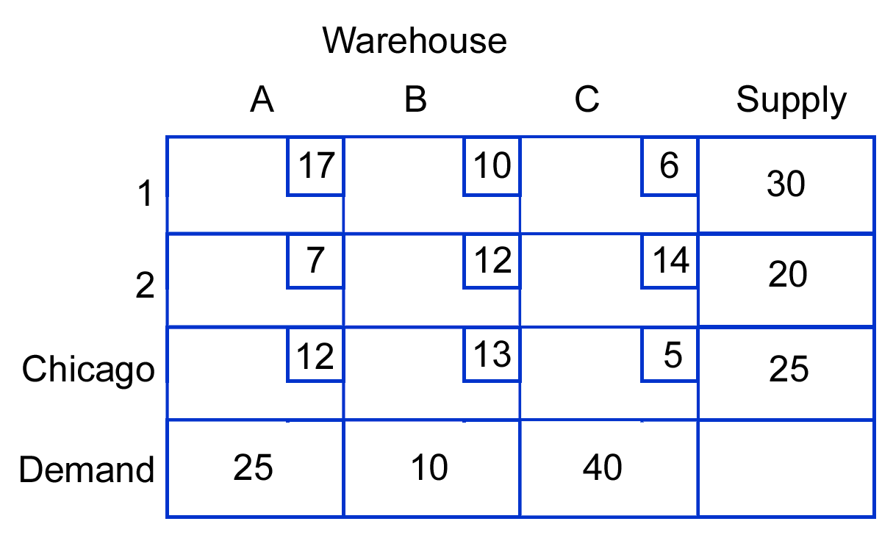
- Solve each problem
- The problem that yields the lowest total cost will indicate the preferred location.

Discussion and Review Questions

- What information do you need to use the transportation model?
- What check must you make before proceeding to develop an initial solution? What corrective action might need to be taken?
- Would it ever make sense to have a situation that required both a dummy row and a dummy column? Explain briefly.
- What is linear about the objective function in a transportation problem?
- Why do the + and - signs alternate in cell evaluation paths?
- How do you know if a solution is optimal?
- What does a zero value for an evaluation path indicate?
- If a solution is not optimal:
- How do you decide which empty cell to shift units into?
- How do you know which cells to include in the shifting operation?
- How do you decide how many units to shift?
- What is meant by the term degeneracy? How is it overcome?
- How is the transportation model useful in location decisions? How does use of the transportation model in location decisions differ from its use as a tool to develop an optimal distribution plan for a given set of sources and destinations?
- How are total costs determined for a given distribution plan?
- What interpretation is given to quantities allocated to dummy destinations? Dummy sources?
- What is the MODI method? How does it differ from the stepping-stone method?

Problems

- Obtain the optimal distribution plan for the following transportation problem. Develop the initial solution using the intuitive lowest-cost approach.
Use the stepping-stone method for cell evaluations.
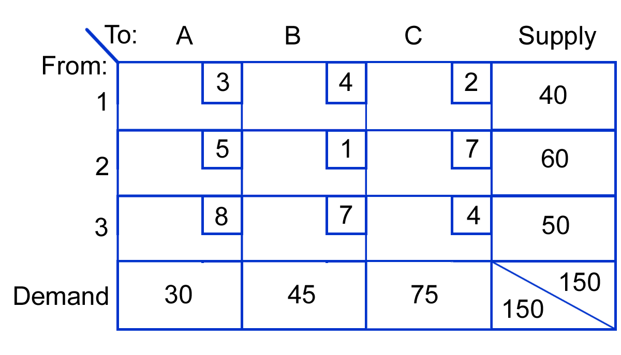
a. b.
 | A | B | C
1 | 15 |  | 25
2 | 15 | 45
3 |  |  | 50
TC = $415

- Use the following transportation table to do the following:
  - Find the optimal solution. Use the intuitive method for the initial solution and MODI for evaluation.
  - What is the total cost?
  - Is there an alternate optimal solution? If so, what is it?
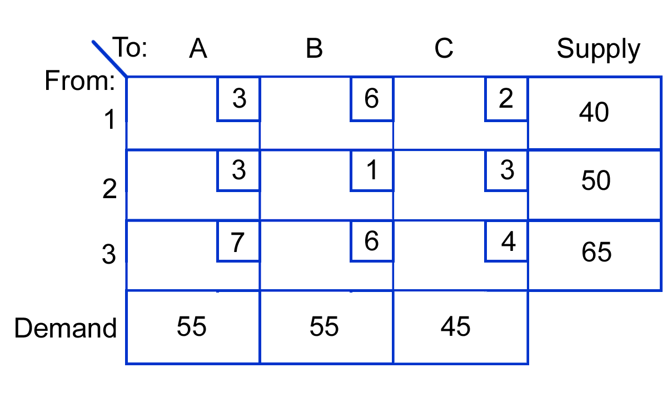
a.
 | 40
 |  | 50
 | 15 | 5 | 45
b. | TC = $485
c. | No alternate solution

a. | A |  | B | C | D
1 |  | 40
2 | 80
3 | 10 | 40 |  | 30 | 50
 | TC = $6,330

- Given the following transportation problem, do each of the following:
  - Develop an initial feasible solution using the intuitive approach.
  - Use the stepping-stone method to evaluate the solution.
  - Repeat part b using MODI.
  - Find the optimal solution.

b. c. d. | A | B |  | C | D
1 | 10 |  | 30
2 | 80
3 |  |  | 50 | 30 | 50
TC = $6,310

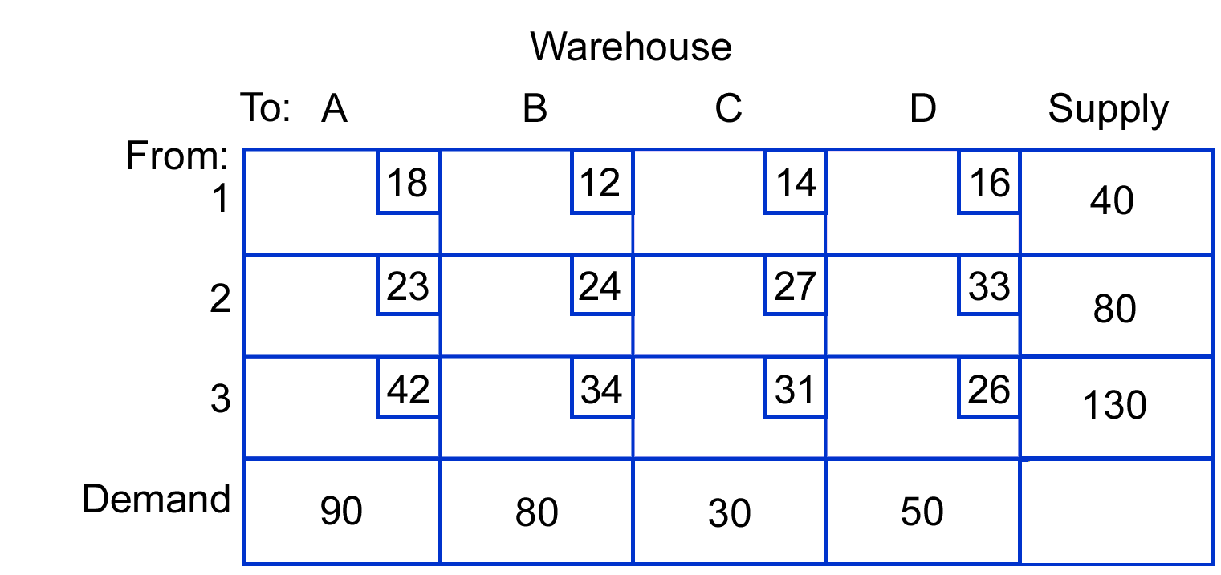
- Determine the optimal distribution plan for the following problem, and compute the total cost for that plan. Use the MODI method for cell evaluation.
 | A | B | C | D | Dummy
1 | 13 |  | 35
2 | 28 | 2 |  | 20 | 6
3 |  | 32
TC = $2,156

 | A | B | C |  | D
1 |  | 40
2 | 80
3 |  | 30 | 30 |  | 50
Dummy | 10 | 10
TC = $5,570

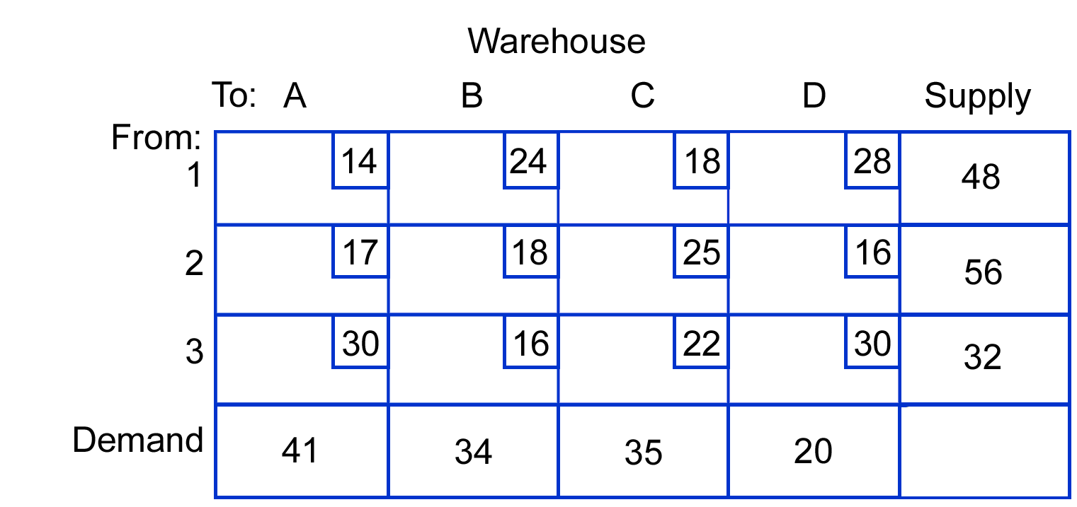

 | A | B | C | D | Dummy
1 | 41 |  | 7
2 |  |  |  | 56
3 |  | 32
Balt. |  | 2 | 28 | 4 | 16
TC = $2,864

- Refer to problem 3. Due to a temporary condition, origin 3 has experienced a capacity reduction of 20 units per period. Using the intuitive method to develop an initial solution, determine a temporary distribution plan that will minimize transportation costs.

- Refer to problem 4. The market supplied by destination D is experiencing a period of rapid growth. Projected demand is for 60 units per period. A new factory with a capacity of 50 units is planned for one of two locations, Baltimore or Philadelphia. Transportation costs are as follows. Which location would result in the lower total cost? Use the MODI method for cell evaluation.
From  Baltimore  to | Cost  per  unit | From  Philadelphia  To | Cost  per  unit
A ………… | $10 | A ………… | $12
B ………… | 8 | B ………… | 13
C ...……… | 15 | C ………… | 5
 | A | B | C | D | Dummy
1 | 41 |  | 7
2 |  | 2 |  | 54
3 |  | 32
Ph. |  |  | 28 | 6 | 16
TC = $2,764

- Use the following transportation table to do the following:
  - Find the optimal solution. Use MODI for evaluation.
  - What is the total cost?
  - Is there an alternate optimal solution? If so, what is it?
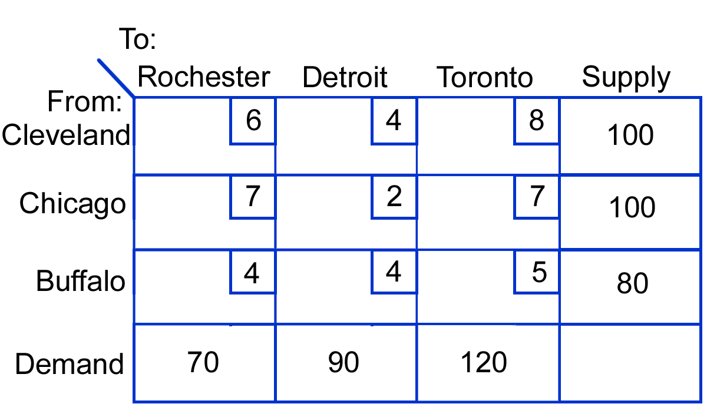
a. | 70 |  | 30
 |  | 90 | 10
 |  |  | 80
b. TC = $1,310
c. No alternate solution
- A soft drink manufacturer has recently begun negotiations with brokers in areas where it intends to distribute new products. Before making final agreements, however, the firm wants to determine shipping routes and costs. The firm has three plants with capacities as follows:
a. | RS1 | RS2 | RS3 | RS4 | RS5
Metro |  | 1 | 23 | 16
Ridge |  | 20 |  |  | 10
Colby | 24 | 1
TC = 67.8

Plant | Capacity  (cases per week)
Metro | 40,000
Ridge | 30,000
Colby | 25,000
b. | RS1 | RS2 | RS3 | RS4 | RS5
Metro |  | 17 | 23
Ridge |  | 4 |  | 16 | 10
Colby | 24 | 1
TC = 67
c. .8 ($800)

The estimated shipping costs per case for the various routes are:
Warehouse | Demand  (cases per week)
SR1 | 24,000
SR2 | 22,000
SR3 | 23,000
SR4 | 16,000
SR5 | 10,000
Determine the optimal shipping plan that will minimize total shipping costs under these conditions:
- Route Ridge-RS4 is unacceptable.
- All routes are acceptable.
- What is the additional cost of the Ridge-RS4 route not being acceptable?

