Introduction to LINDO

Installation
First, make sure LINGO is installed. It takes about two minutes.

Overview
LINDO is now a subset of LINGO. It provides a very simple interface for solving general linear and integer optimization problems. You turn on the LINDO style of input in LINGO by clicking on:
LINGO | Options | Interface | File Format | ltx(LINDO | Apply.

LINDO can solve linear and integer programs. If you wish to solve nonlinear programs then you must switch to LINGO style input by clicking on:
LINGO | Options | Interface | File Format | lng(LINGO) | Apply.

The notable features of the LINDO style input that have made it popular over the past 30 years has been its simplicity and ease of use.

Installation
If LINGO is not yet installed on your computer, you can download the latest “student” version of LINGO from: http://www.lindo.com.
When downloading it, note the name of the file(typically setup.exe) and the directory into which it was downloaded. You install it by running the setup.exe file that was downloaded into this directory. Installation takes about one minute.

Quick Usage
The best way to become familiar with LINDO is to apply it to some of the examples included on the CD-ROM or in the MODELS section at http://www.lindo.com. The following screen shot illustrates some of LINDO’s style.

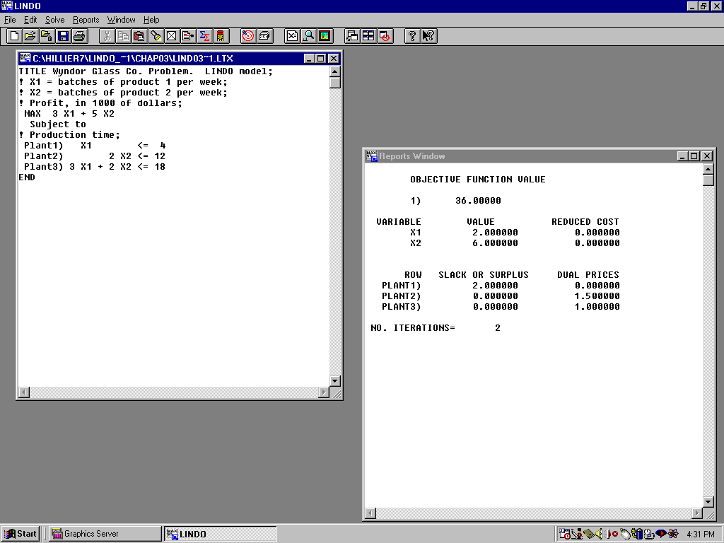

Models can be retrieved from and saved to files using the “File” menu item on the upper left.

Models, such as the Wyndor Glass problem, can be edited in a model window using the “Edit menu item that is second from the left at the top.

A model is solved by clicking on the red “bullseye” menu item on the tool bar at the top.

Solving a model does not automatically generate a solution report. Clicking on the “X=” menu item just to the right of the bullseye will generate a solution report window as seen above.

